Supplementary Information
Affordable Combustion Synthesis of V₂AlC Precursor for V₂CT_{x} MXene
Stepan Vorotilo,¹ Christopher E. Shuck,¹ Mark Anayee,¹ Mikhail Shekhirev,¹ Kyle Matthews,¹ Robert W. Lord,¹ Ruocun (John) Wang,¹ Iryna Roslyk,^{1,2} Vitalii Balitskiy², Veronika Zahorodna², Oleksiy Gogotsi², Yury Gogotsi¹*
¹A. J. Drexel Nanomaterials Institute and Department of Materials Science and Engineering, Drexel University, 3141 Chestnut Street, Philadelphia, Pennsylvania 19104, United States
²Materials Research Centre, 3 Krzhizhanovskogo St, 03142 Kyiv, Ukraine
*Corresponding author e-mail: gogotsi@drexel.edu

Characterization. The phase composition of the investigated materials was determined by X-ray diffraction (XRD) analysis with Ni-filtered Cu K_{α} radiation (Miniflex, Rigaku) operated at 40 kV and 15 mA. Step-scan data (step size of 0.04° and counting time of 1 s) were recorded over a range of 5−90° (2θ). The phase composition was determined by Rietveld refinement of the resulting XRD patterns using GSAS-II [50].
Scanning electron microscopy (SEM; Zeiss Supra 50VP, Germany) was used to observe the morphologies of combustion products, multilayer MXenes, delaminated MXene flakes, and vacuum-filtered films. To image flakes, a dilute solution of V₂CT_{x} was drop cast on a porous alumina membrane (Anodisc, 0.1 µm pore size, Whatman). Raman spectroscopy was conducted on a confocal Raman microscope (Invia, Renishaw, UK) with a He-Ne 633 nm laser through a 63× objective (NA = 0.7). We controlled the power of the laser at ~0.5 W/cm² and used a grating of 1800 gr/mm. The electrical conductivity of as-synthesized MXene films was measured by a four-point probe instrument (ResTest v1, Jandel Engineering Ltd., Bedfordshire, U.K.) with a probe distance of 1 mm. The film density was determined by measuring the film thickness with a micrometer and weighing the films on a precision scale (Mettler Toledo XS104) with 0.1 mg accuracy. Optical microscopy was performed using a Keyence VK-X1050 3D Surface Profiler.
The thermal stability and high-temperature oxidation were studied using thermogravimetric analysis and differential scanning calorimetry (Discovery SDT 650, TA Instruments). Samples were tested in both argon and dry air atmosphere. Mass Spectroscopy (MS) data were collected simultaneously using a Discovery MS connected to the TGA exhaust by a heated capillary. For all measurements, ∼20 mg of vacuum-filtered MXene film was placed into a 90 µL alumina crucible. Each sample was heated from 50 to 1000 °C at a heating rate of 10 °C/min under 100 mL/min flow of Ar or in air.
X-ray photoelectron spectroscopy (XPS) spectra were collected (Physical Electronics, VersaProbe 5000, Chanhassen, MN) using a 200 μm monochromatic Al K_{α} X-ray beam, and a dual charge neutralization system supplying low energy electrons and Ar⁺ ions. The binding energy scale was calibrated using the Fermi level at 0 eV. Survey scans were obtained from 1000 to 0 eV binding energy using a pass energy of 117.4 eV and 0.5 eV steps, while the high-resolution scans were obtained for the F 1s, O 1s, V 2p, and C 1s, core levels using pass energy of 23.5 eV and 0.05 eV steps. Fitting and quantification of the core-level spectra were performed using the CasaXPS software. Backgrounds were fit with the Shirley function, and oxide and metallic components were fit using symmetric and asymmetric pseudo-Voigt functions, respect X-ray photoelectron spectroscopy (XPS) spectra were collected (Physical Electronics, VersaProbe 5000, Chanhassen, MN) using a 200 μm monochromatic Al Kα X-ray beam, and a dual charge neutralization system supplying low energy electrons and Ar+ ions. The binding energy scale was calibrated using the Fermi level at 0 eV. Survey scans were obtained from 1000 to 0 eV binding energy using a pass energy of 117.4 eV and 0.5 eV steps, while the high-resolution scans were obtained for the F 1s, O 1s, V 2p, and C 1s, core levels using pass energy of 23.5 eV and 0.05 eV steps. Fitting and quantification of the core-level spectra were performed using the CasaXPS software. Backgrounds were fit with the Shirley function, and oxide and metallic components were fit using symmetric and asymmetric pseudo-Voigt functions, respectively.
Stability studies were performed by diluting each delaminated MXene solution with deionized water to a 0.1 mg/mL concentration. UV−vis spectroscopy analyses were performed from 200 to 1000 nm (Evolution 201, Thermo Scientific, 10 mm path length quartz cuvette), and the absorbance value at the UV peak maximum (270 nm) was used as the stability metric. The flake size and zeta potential of solutions were measured using a Malvern Panalytical Zetasizer Nano ZS in a folded capillary disposable cuvette. Up to 13 measurements were recorded per sample. The energy storage capacity of SHS-V₂C was estimated by cyclic voltammetry in 3M H₂SO₄ solution (scan rate 2-1000 mV s⁻¹) using mass loading of 2.35 mg cm⁻².
Statistical analysis. Analysis of variance (ANOVA) was performed to study the variations between- and within groups in terms of their respective mean squares (MSQ) which were calculated by dividing each sum of squares by its associated degrees of freedom. The F-ratio was then obtained as the result of dividing MSQ (between groups) and MSQ (within groups). Additionally, P-values were calculated, which correspond to the probability of obtaining an F-ratio as large or larger than the one observed, assuming that the null hypothesis of no difference amongst group means is true. Alpha-level was set at 0.05 (or 5%). Using this level of significance, there is, on average, a 1 in 20 chance of rejecting the null hypothesis when it is true.
Thermal modeling. The adiabatic temperature of combustion (T_{ad}) was calculated using the THERMO thermal analysis software [51]. In light of the highly energetic nature of combustion synthesis, safety measures must be implemented to prevent excessive heating. The reactor's thermal load was computed using the SOLIDWORKS Simulation. A 1-to-1 scale geometric model of the reactor, including the reactor walls, bottom, lid, combustion products, alumina crucible, graphite stand, and alumina gasket, was constructed in the software package (Fig. S1). The simulation starts when the combustion front reaches the alumina crucible, and the combustion products are at their peak temperature (1600 °C [29]). Heat transfer from the hot combustion products to the reactor lid occurs through convection and radiation, while other reactor components (Fig. 2b) are primarily heated by conduction. The temperature profiles in the reactor during SHS of a 60 g batch are shown in Fig. 2c. Although the crucible and graphite support temperatures reach up to 270 °C, the reactor lid, walls, and base maintain temperatures within the suggested safety limits (<100 °C). The simulations demonstrated that increasing the reactive mixture charge mass to 100 g could cause localized heating of the reactor lid up to 123 °C and reactor bottom up to 119 °C, surpassing the manufacturer's safety recommendations. Therefore, in this study, synthesis was not scaled beyond 60 g per batch.
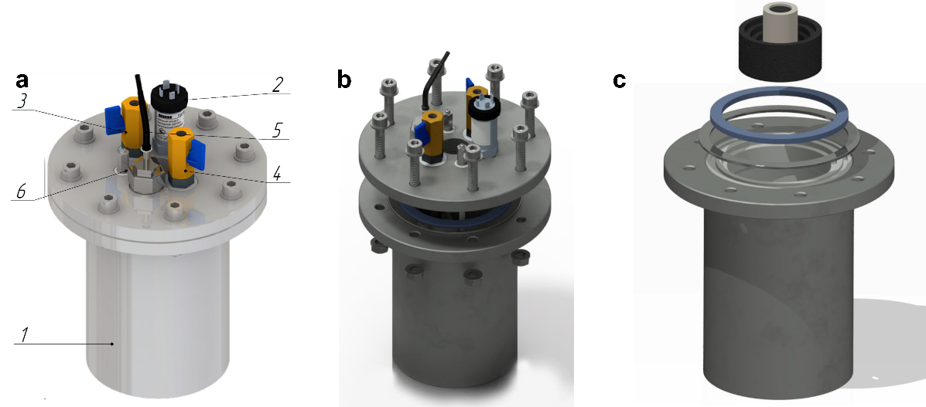
Fig. S1. 3D rendering of the SHS reactor. (a) General view of the SHS reactor: 1) Reactor wall, 2) Pressure sensor, 3) Gas Inlet, 4) Gas Outlet, 5) Thermocouple, 6) Electrodes; (b) Installation of the lid onto the reactor; (c) Installation of graphite stand, alumina crucible, gasket and steel ring in the reactor. The operation of the reactor is shown in Supplementary Video 1.

Characterization of MAX phase samples
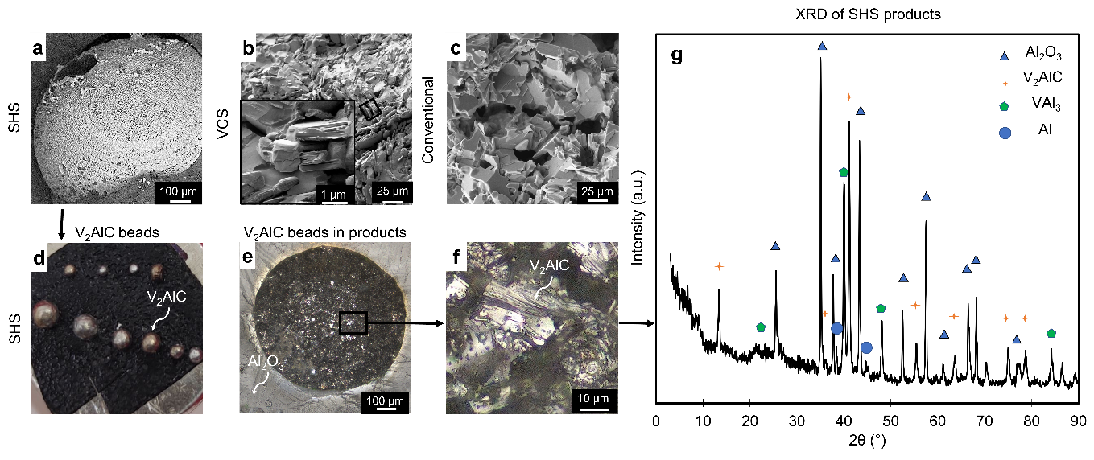
Fig. S2. SEM micrographs showing the microstructure of ceramics synthesized by (a) SHS, (b) VCS, and (c) conventional pressureless sintering synthesis approaches; (d) Digital image of the V₂AlC beads extracted from the SHS product; (e) Optical microscopy image showing Al₂O₃ matrix with V₂AlC beads; (f) Optical micrograph showing the microstructure of an individual V₂AlC bead; (g) XRD pattern from SHS products. Samples were prepared using fine V₂O₅ (Alfa Aesar), 50% excess Al, pressed 10 g pellets, SHS in Ar.

Raman spectroscopy analysis of vacuum-filtered V₂CT_{x} films
Vacuum-filtered V₂CT_{x} films (Fig. S3) produced from SHS, VCS, and conventional precursors had identical Raman spectra with peaks at ~170 cm⁻¹ (in-plane vibration of V₂CFO or V₂CF(OH) and very broader peaks at ~425 cm⁻¹ (corresponding to V₂CF(OH) or V₂C(OH)₂), suggesting that the MAX phase synthesis pathway did not induce a considerable difference in surface terminations of the MXenes [66].
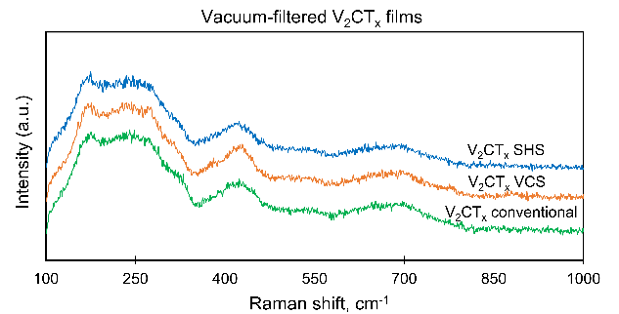
Fig. S3. Raman spectra of vacuum-filtered V₂CT_{x} films. SHS and VCS samples were prepared using fine V₂O₅ (Alfa Aesar), 50% excess Al, pressed 10 g pellets, SHS and VCS in Ar. Etching conditions: 48 h, 40 °C.

XPS study of V₂CT_{x} films after 120-day storage in a desiccator
Table S1. Fitting results for XPS spectra from freestanding SHS-V₂CT_{x} and VCS-V₂CT_{x} films
 |  | SHS Pristine |  |  | VCS Pristine |  |  | SHS Aged |  |  | VCS Aged
Region | Name | Position | FWHM | Conc. | Position | FWHM | Conc. | Position | FWHM | Conc. | Position | FWHM | Conc.
F 1s | F-V | 684.77 | 1.74 | 9.17 | 684.72 | 1.80 | 9.61 | 684.43 | 1.21 | 7.52 | 684.58 | 1.90 | 1.19
V 2p | V (1+) | 513.24 | 1.28 | 16.04 | 513.22 | 1.31 | 18.21 | 513.63 | 1.31 | 8.49 | 513.54 | 1.17 | 0.86
V 2p | V (1+) | 520.74 | 1.57 | 8.02 | 520.72 | 1.70 | 9.10 | 521.13 | 1.71 | 4.24 | 521.04 | 1.50 | 0.43
V 2p | V (3+) | 514.00 | 1.92 | 5.29 | 514.01 | 2.00 | 4.93 | 514.95 | 1.58 | 0.35 | 514.41 | 2.00 | 0.00
V 2p | V (3+) | 521.33 | 3.00 | 2.64 | 521.34 | 3.00 | 2.46 | 522.28 | 3.00 | 0.17 | 521.74 | 1.00 | 0.00
V 2p | V (3+) sat. | 525.10 | 1.00 | 0.08 | 525.11 | 2.50 | 0.07 | 526.05 | 1.00 | 0.01 | 525.51 | 1.00 | 0.00
V 2p | V (4+) | 515.46 | 1.81 | 1.97 | 515.48 | 1.36 | 1.40 | 515.95 | 2.13 | 2.45 | 515.93 | 1.16 | 1.49
V 2p | V (4+) | 522.79 | 3.00 | 0.99 | 522.81 | 3.00 | 0.70 | 523.28 | 3.00 | 1.22 | 523.26 | 2.75 | 0.74
V 2p | V (4+) sat. | 527.26 | 1.00 | 0.00 | 527.28 | 1.00 | 0.00 | 527.75 | 1.00 | 0.04 | 527.73 | 1.00 | 0.00
V 2p | V (5+) | 516.86 | 2.50 | 3.00 | 516.97 | 2.50 | 3.93 | 517.00 | 1.86 | 1.21 | 517.00 | 2.00 | 6.57
V 2p | V (5+) | 524.19 | 5.00 | 1.50 | 524.30 | 5.00 | 1.96 | 524.33 | 2.77 | 0.60 | 524.33 | 2.92 | 3.28
V 2p | V (5+) sat. | 530.56 | 1.00 | 0.04 | 530.67 | 2.50 | 0.06 | 530.70 | 2.50 | 0.02 | 530.70 | 2.50 | 0.10
O 1s | V-O (Tx) | 530.11 | 1.28 | 4.32 | 530.48 | 1.67 | 6.70 | 529.63 | 1.03 | 3.81 | 530.30 | 1.18 | 10.75
O 1s | V-O (oxide) | 530.93 | 1.67 | 14.70 | 530.83 | 1.94 | 12.69 | 530.88 | 2.50 | 5.96 | 530.98 | 2.50 | 11.50
O 1s | V-OH | 532.38 | 2.39 | 4.94 | 532.48 | 3.50 | 6.97 | 531.90 | 2.18 | 12.98 | 531.88 | 1.80 | 11.01
C 1s | C-V | 282.29 | 0.70 | 13.76 | 282.36 | 0.65 | 14.31 | 282.29 | 0.65 | 9.01 | 282.29 | 0.81 | 1.86
C 1s | C-C | 284.63 | 1.42 | 9.44 | 284.46 | 1.25 | 4.51 | 284.72 | 1.35 | 23.27 | 284.69 | 1.34 | 26.36
C 1s | C-O | 285.94 | 1.99 | 3.92 | 285.73 | 1.84 | 2.36 | 286.18 | 1.61 | 13.63 | 286.11 | 1.46 | 17.27
C 1s | C=O | 288.80 | 1.00 | 0.17 | 288.83 | 1.00 | 0.03 | 288.49 | 1.94 | 5.02 | 288.47 | 2.00 | 6.58
Note: concentrations shown in atomic percent
The fitting results above lead to MXene compositions of V_{2.00}C_{1.02}F_{1.07}O_{1.20}N_{0.24} for SHS-V₂CT_{x} and V_{2.00}C_{0.54}F_{0.47}O_{7.92}N_{1.42} for VCS-V₂CT_{x} taking V=2 as the reference point and accounting for the V(1⁺, 3⁺, and 4⁺), C-V, all, V-O (T_{x}) and V-O (oxide), and all components in the V 2p, C 1s, F 1s, O 1s, and N 1s spectra, respectively. Quantification of the VCS-produced sample carries with it significant uncertainty, mainly because of the weak C-V component in the C1s spectra, but nonetheless serves to emphasize that the SHS leads to much cleaner MXene.

Thermal stability of V₂CT_{x}
In the air, weakly bound water desorbs above 75°C, followed by the loss of strongly bound water and surface termination groups at 300°C [67].Gradual oxidation begins at 450°C (as suggested by the evolution of oxidation products H₂O and CO₂) and is followed by a sharp oxidation event at 675°C (presumably oxidation of V₂CT_{x} MXene to V₂O₅) [68]. This sharp oxidation event correlates with the enhanced evolution of CO₂ due to the oxidation of residual carbon. DSC curve (Fig. S4b) indicates a period of endothermic weight loss up to 450 °C, followed by a period of exothermic weight gain (oxygen chemisorption). Weight loss and evolution of CO₂ and H₂O above 650 °C likely correspond to the oxidation of residual carbide and carbon, as well as the evaporation of V₂O₅.
In argon, TG/DTG analysis (Fig. S4d) indicates water loss below 100 °C, followed by multiple weight loss events in 250-400 °C likely caused by the loss of surface termination groups and decomposition of TMAOH. The evolution of CO₂ and H₂O begins after 650 °C due to the onset of gradual decomposition of V₂CT_{x} and is not accompanied by mass gain. A significant weight loss occurs at 825 °C and is presumably caused by the decomposition of MXene into cubic binary carbide coupled with partial oxidation by surface functional groups, as indicated by the evolution of CO₂ and H₂O (Fig. S4f). Above 1050 °C the residual carbides decompose, resulting in the release of CO and increased evolution of CO₂ and H₂O. All weight loss events appear to be predominately endothermic processes (decomposition), except for exothermic events corresponding to oxidation at 850 °C (Fig. S4e).
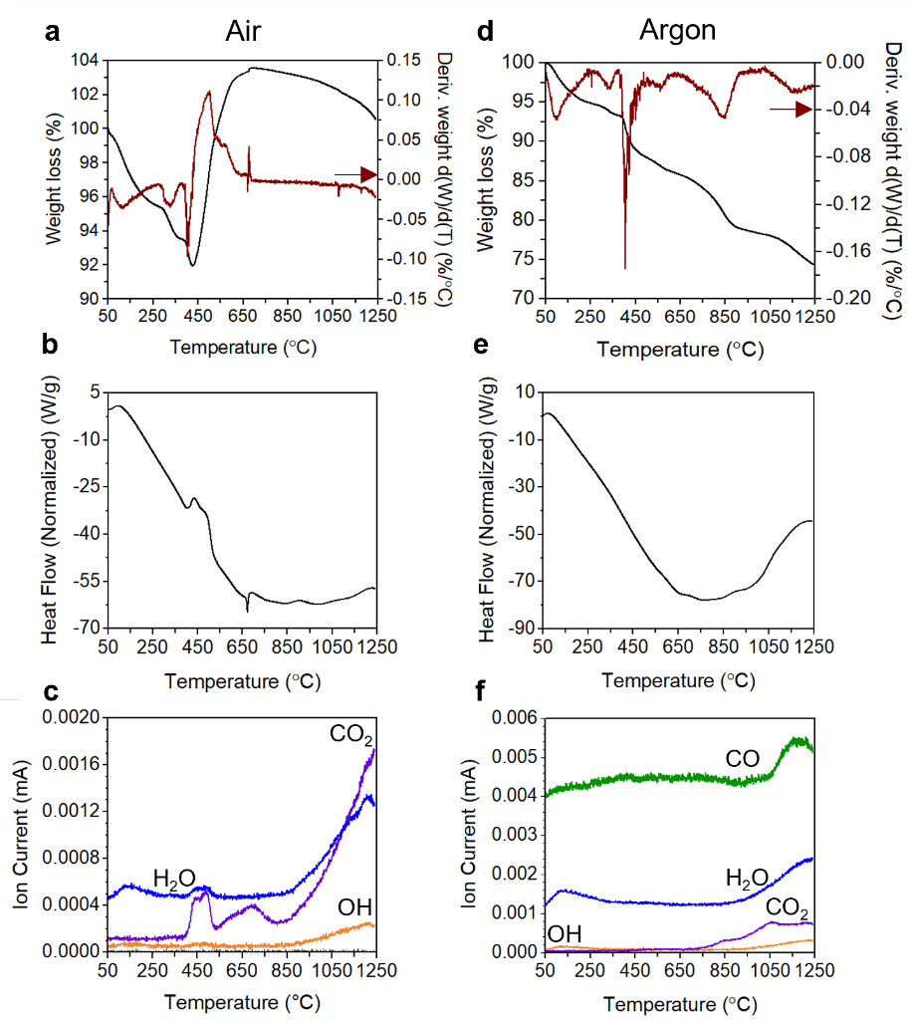
Fig. S4. Thermal analysis of vacuum-filtered films of SHS-V₂CT_{x}. (a,d) Weight loss and the associated derivative weight loss; (b,e) differential scanning calorimetry analysis; (c,f) mass spectra of the main gaseous reaction products. Samples were analyzed under air (a-c) and argon (d-f). Samples were prepared by SHS in Ar using fine V₂O₅ (Alfa Aesar), 50% excess Al, and pressed 10 g pellets.

Parametric study
The size distribution of V₂AlC grains in the ball-milled combustion products was manually measured up to 300 times per sample (Fig. S5). ANOVA test (Table S2) showed that the density of reactive mixture charge, the size of V₂O₅ precursor, and the mass of reactive charge have a statistically significant impact on the size of MAX phase grains (P=2×10⁻⁴⁶, 2×10⁻⁴⁰, and 7×10⁻⁵). Excess Al content, synthesis environment, and ignition mode did not impact the grain size distribution of the MAX phase (P=0.28, 0.046, and 0.06).
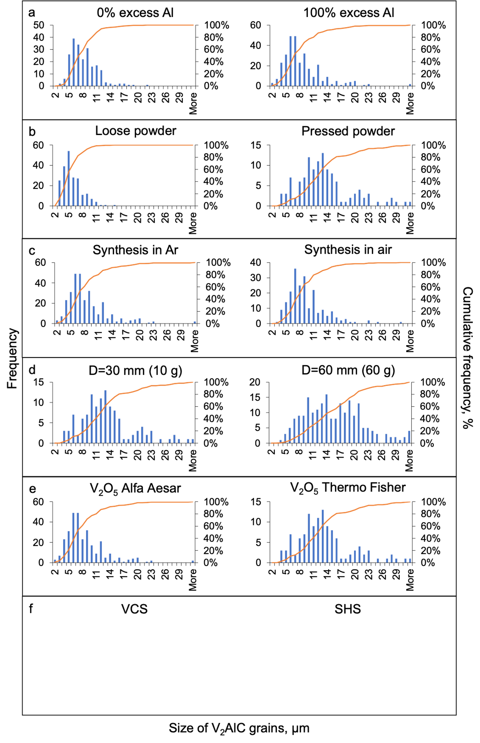
Fig. S5. Influence of combustion synthesis parameters on the particle size distribution of V₂AlC MAX phase. Varied parameters: (a) excess Al; (b) green mixture density; (c) synthesis environment; (d) green mixture mass; (e) V₂O₅ precursor; (f) combustion mode.
For the size of V₂CT_{x} flakes, the most statistically significant factors were the V₂O₅ precursor, the content of excess Al, and the mass of reactive mixture charge (P=4×10⁻¹⁵, 2.75×10⁻¹⁰, and 6.7×10⁻⁴, Table S3), whereas the charge mixture density, reaction environment, and ignition mode were not significant (P=0.108, 0.36, and 0.37). Overall, the two most statistically significant parameters affecting both, the size of the MAX phase and the flake size of derived MXene, were the size of the V₂O₅ precursor and the mass of reactive mixture charge.

Table S2. ANOVA table for the influence of combustion synthesis parameters on the particle size distribution of the V₂AlC MAX phase. MSB is the mean sum of squares between the groups, MSG is the mean sum of squares within groups.
Groups | Average grain size, µm | MSB | MSG | F/F_{crit} | P-value | Impactful?
Varied parameter - reactive mixture density: (1) loose vs. (2) pressed powders
Fixed parameters | 10 g batches, coarse V₂O₅, pressed mixtures, SHS, 50% excess Al, Ar atmosphere
(1) Loose powder | 5.3 | 4350.8 | 15.3 | 283.7/3.86 | 2×10⁻⁴⁶ < 0.05 | Yes
(2) Pressed powder | 12.8
Varied parameter - reactive mixture mass: (1) 10 g vs. (2) 60 g
Fixed parameters | Coarse V₂O₅, pressed mixtures, SHS mode, 50% excess Al, Ar atmosphere
(1) 10 g | 12.8 | 432.1 | 37.6 | 11.5/3.86 | 7×10⁻⁵ < 0.05 | Yes
(2) 60 g | 15.2
Varied parameter - V₂O₅ precursor powders: (1) coarse Thermo Sci vs. (2) fine Alfa Aesar
Fixed parameters | 10 g batches, pressed mixtures, SHS mode, 50% excess Al, Ar atmosphere
(1) Thermo Sci | 12.8 | 6192.2 | 29.7 | 208.3/3.86 | 2×10⁻⁴⁰ < 0.05 | Yes
(2) Alfa Aesar | 8.1
Varied parameter - excess Al: (1) 0 vs. (2) 100 %
Fixed parameters | 10 g batches, fine V₂O₅, pressed mixtures, SHS mode, Ar atmosphere
(1) 0% Al | 7.7 | 20.1 | 17.1 | 1.2/3.86 | 0.28 > 0.05 | No
(2) 100% Al | 8.1
Varied parameter - synthesis environment: (1) air vs. (2) Ar
Fixed parameters | 10 g batches, fine V₂O₅, pressed mixtures, VCS mode, 50% excess Al
(1) Air | 9.0 | 81.1 | 20.3 | 4.0/3.86 | 0.046 ≈ 0.05 | No
(2) Ar | 8.1
Varied parameter - combustion mode: (1) SHS vs. (2) VCS
Fixed parameters | 10 g batches, fine V₂O₅, pressed, 50% excess Al, Ar atmosphere
(1) VCS | 9.0 | 54.8 | 15.7 | 3.5/3.86 | 0.06 > 0.05 | No
(2) SHS | 9.6

Influence of V₂O₅ precursor. V₂O₅ purchased from Thermo Fisher Scientific was composed of 200-300 µm long and 40-80 µm wide strong agglomerates, which upon milling disintegrated into equiaxial individual particles (d_{avg}=1.7 µm, Fig. S6a). V₂O₅ purchased from Alfa Aesar consisted of mildly agglomerated fine particles (d_{avg}=0.8 µm, Fig. S6b). Although ball milling considerably reduced the size of V₂O₅ particles and produced uniformly mixed reactive mixtures (Fig. S6c), the V₂O₅ precursor still had a notable effect on combustion products and the quality of V₂CT_{x} MXene. Utilization of large V₂O₅ (Thermo Fisher) produced larger V₂AlC particles (15.2 vs 8.1 µm, Table S2), but smaller V₂CT_{x} MXenes (900 vs 1310 µm, Table S3). V₂CT_{x} prepared using large V₂O₅ demonstrated overall significantly lower yield (19 vs 41%, Table S4) and oxidation stability in dilute solutions (2-3 h vs 4-9 h), as well as somewhat lower conductivity (340 vs. 650 S/cm, Table S4). It is known that defects, grain boundaries, and particle size of the MAX phase have a profound influence on the MXene etching [69]. Lower yield of V₂CT_{x} from combustion products obtained using large V₂O₅ suggests that a significant part of the MAX phase remained under-etched (Fig. S7d) and that etching parameters should be further optimized based on the employed precursors and combustion synthesis conditions.
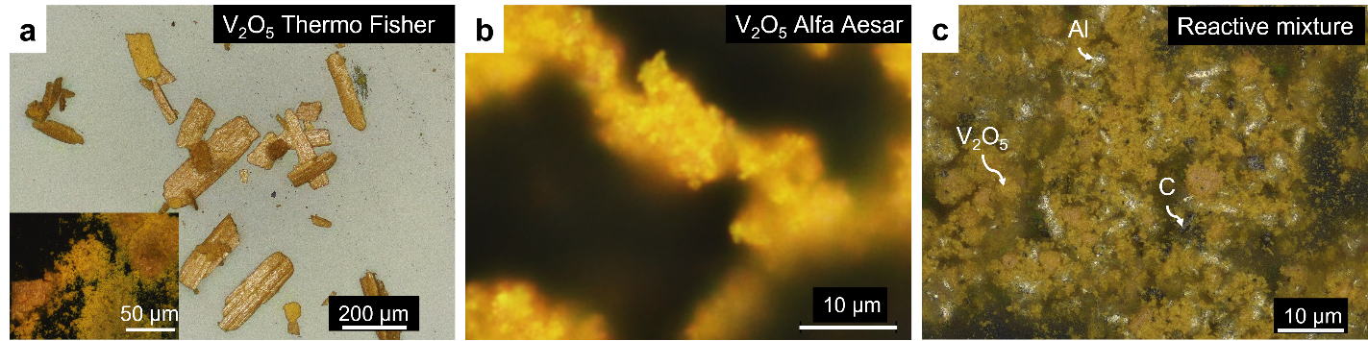
Fig. S6. Optical micrographs showing the microstructure of V₂O₅ precursors and reactive mixture. (a) V₂O₅ purchased from Thermo Fisher Scientific (insert is powder after milling); (b) V₂O₅ purchased from Alfa Aesar; (c) reactive mixture prepared using V₂O₅ purchased from Thermo Fisher Scientific.

Table S3. ANOVA table for the influence of combustion synthesis parameters on V₂CT_{x} flake size. MSB is the mean sum of squares between the groups, MSG is the mean sum of squares within groups
Groups | Average flake size, nm | MSB | MSG | F/F_{crit} | P-value | Impactful?
Varied parameter - reactive mixture density: (1) loose vs. (2) pressed powders
Fixed parameters | 10 g batches, fine V₂O₅, pressed mixtures, SHS, 50% excess Al, Ar atmosphere
(1) Loose powder | 1488 | 353507.3 | 123774.4 | 2.8/4.41 | 0.108  > 0.05 | No
(2) Pressed powder | 1767
Varied parameter - reactive mixture mass: (1) 10 g vs. (2) 60 g
Fixed parameters | Coarse V₂O₅, pressed mixtures, SHS mode, 50% excess Al, Ar atmosphere
(1) 10 g | 1170 | 1897402 | 117547.7 | 16.14/4.35 | 6.7×10⁻⁴  <0.05 | Yes
(2) 60 g | 1767
Varied parameter - V₂O₅ precursor powders: (1) coarse Thermo Sci vs. (2) fine Alfa Aesar
Fixed parameters | 10 g batches, pressed mixtures, SHS mode, 50% excess Al, Ar atmosphere
(1) Thermo Sci | 900 | 952274.5 | 2397.5 | 397.19/4.32 | 4×10⁻¹⁵  <0.05 | Yes
(2) Alfa Aesar | 1308
Varied parameter - excess Al: (1) 0 vs. (2) 100 %
Fixed parameters | 10 g batches, fine V₂O₅, pressed mixtures, SHS mode, Ar atmosphere
(1) 0% Al | 435 | 182634.5 | 625.9 | 291.77/4.66 | 2.75×10⁻¹⁰  <0.05 | Yes
(2) 100% Al | 656
Varied parameter - synthesis environment: (1) air vs. (2) Ar
Fixed parameters | 10 g batches, fine V₂O₅, pressed mixtures, VCS mode, 50% excess Al
(1) Air | 1397 | 30502.1 | 33985.7 | 0.89/4.96 | 0.36  >0.05 | No
(2) Ar | 1498
Varied parameter - combustion mode: (1) SHS vs. (2) VCS
Fixed parameters | 10 g batches, fine V₂O₅, pressed, 50% excess Al, Ar atmosphere
(1) VCS | 1354 | 98341.7 | 113170.7 | 0.86/4.84 | 0.37  >0.05 | No
(2) SHS | 1148

Yield estimation. In a conventional approach to calculating the yield of MXene, the mass of the dry MXene is divided by the mass of the MAX precursor. This approach does not consider the MAX production process. Since the powders produced by combustion synthesis contain Al₂O₃, the conventional calculations would significantly underestimate the MXene yield in comparison to approaches where pure V₂AlC precursor is used. The atom economy approach is more appropriate in this situation. Considering that vanadium is the most expensive element in the production, we instead calculated the vanadium-to-V₂CT_{x} yield. The concentration of the as-prepared MXene (mg/ml) was calculated from a mass of the freestanding film made by vacuum-assisted filtration of 3 ml of MXene dispersion and dried overnight in a vacuum oven at 80 °C. The mass of vanadium atoms in collected delaminated MXene was divided by the mass of vanadium atoms in the precursor powder used for MXene synthesis. We accounted for carbon in the calculations but did not account for surface terminations.
Table S4. Influence of combustion synthesis parameters on yield of V₂CT_{x} MXene and conductivity of vacuum-filtered films
Groups | Yield, w.% V₂CT_{x} to V in the precursor | Conductivity, S/cm
Varied parameter - reactive mixture density: (1) loose vs. (2) pressed powders
Fixed parameters | 10 g batches, fine V₂O₅, pressed mixtures, SHS, 50% excess Al, Ar atmosphere
(1) Loose powder | 37 | 630±20
(2) Pressed powder | 40 | 650±20
Varied parameter - reactive mixture mass: (1) 10 g vs. (2) 60 g
Fixed parameters | Coarse V₂O₅, pressed mixtures, SHS mode, 50% excess Al, Ar atmosphere
(1) 10 g | 18 | 340± 30
(2) 60 g | 19 | 560±30
Varied parameter - V₂O₅ precursor powders: (1) coarse Thermo Sci vs. (2) fine Alfa Aesar
Fixed parameters | 10 g batches, pressed mixtures, SHS mode, 50% excess Al, Ar atmosphere
(1) Thermo Sci | 19 | 340± 30
(2) Alfa Aesar | 40 | 650±20
Varied parameter - excess Al: (1) 0 vs. (2) 100 %
Fixed parameters | 10 g batches, fine V₂O₅, pressed mixtures, SHS mode, Ar atmosphere
(1) 0% Al | 41 | 390±20
(2) 100% Al | 34 | 670±40
Varied parameter - synthesis environment: (1) air vs. (2) Ar
Fixed parameters | 10 g batches, fine V₂O₅, pressed mixtures, VCS mode, 50% excess Al
(1) Air | 38 | 590±20
(2) Ar | 36 | 570±30
Varied parameter - combustion mode: (1) SHS vs. (2) VCS
Fixed parameters | 10 g batches, fine V₂O₅, pressed, 50% excess Al, Ar atmosphere
(1) VCS | 40 | 650±20
(2) SHS | 38 | 590±20

Influence of reactive charge mass (scalability). Scalability was tested using coarse V₂O₅ powders and batches of 3, 10 and 60 g of reactive mixture. SHS of 3 g batches produced a low yield of V₂AlC (<10%), and mixed acid etching of the 3 g samples resulted in a powder consisting predominantly of Al₂O₃. (Fig. S7). Therefore, 3g SHS samples were not used for the fabrication and characterization of delaminated MXenes. Scaling from 10 g to 60 g batches (Fig. S7a,b) slightly improved MXene yield (by 1%, Table S4), but significantly increased flake size (from 1170 to 1770 nm) and conductivity (from 340 to 560 S/cm). The overall yield was sub-optimal due to incomplete etching of the MAX phase (Fig. S7c,d).
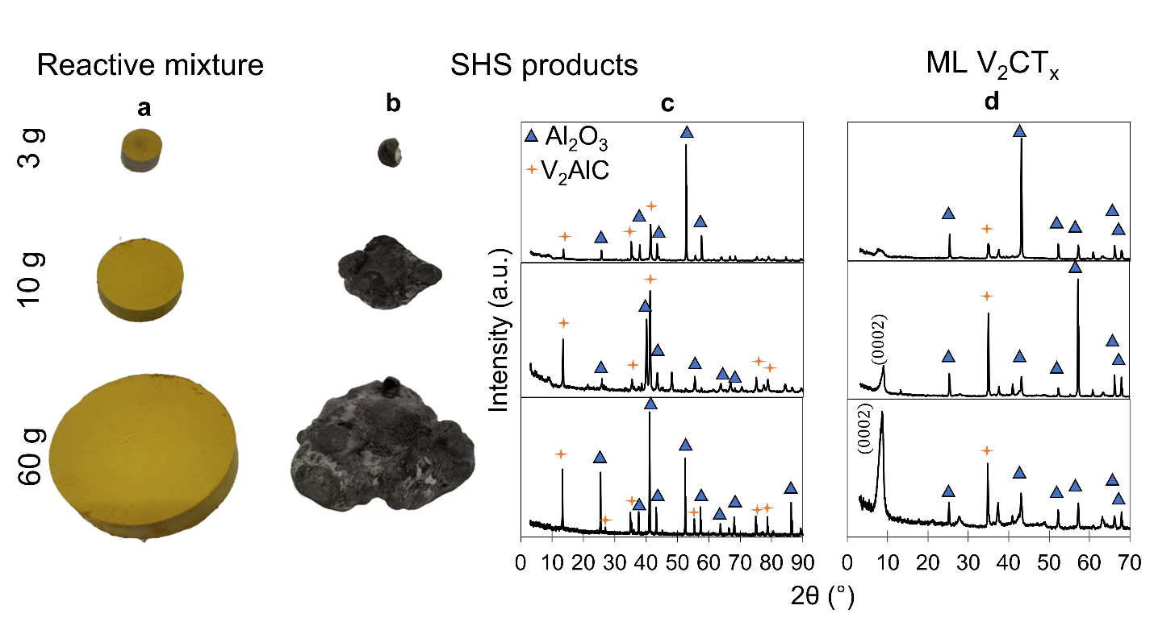
Fig. S7. Scaling up the SHS of V₂AlC from 3 g to 60 g: (a) pressed green mixture pellets; (b) combustion products; (c) XRD patterns of combustion products; (d) XRD of multilayer V₂CT_{x} produced from corresponding combustion products. Coarse V₂O₅, pressed, SHS, 50% excess Al.
Influence of Al content. An increase in the excess Al content from 0 to 100 at.% did not affect the size of the MAX phase (Table S2), but increased the flake size of MXenes (Table S3), decreased the yield of V₂CT_{x} from 41% to 34% (Table S4), and increased the conductivity of vacuum-filtered films from 390 to 670 S/cm. The increase in conductivity can be related to the improved crystallinity of the V₂AlC MAX phase, reduction in oxygen in the lattice (similar to previously reported results for Ti₃AlC₂), or other effects. ⁶⁹
Influence of combustion mode. Although the combustion mode (SHS vs. VCS) didn’t significantly affect the size of MAX phase grains or MXene flakes and did not affect the yield or conductivity of vacuum-filtered films (590 vs. 650 S/cm), it significantly impacted the oxidation stability of V₂CT_{x} both in solutions and vacuum-filtered films. This effect can be attributed to an improved oxygen removal from SHS products due to the pronounced tendency for phase separation of V₂AlC, Al, and V-Al intermetallics from the Al₂O₃ matrix, which was not observed in VCS (Fig. 2, Fig. S2). This phenomenon warrants a more detailed macrokinetic investigation in the future.

