Supplementary Figure

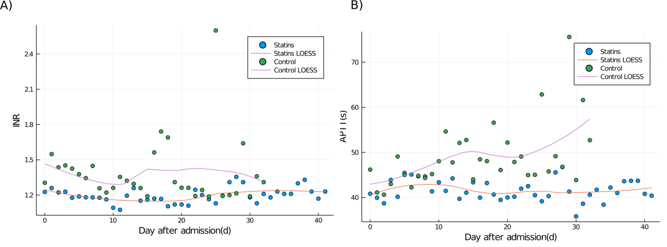
Figure S1: Dynamic profiling of the three indexes reflecting coagulation function with LOESS model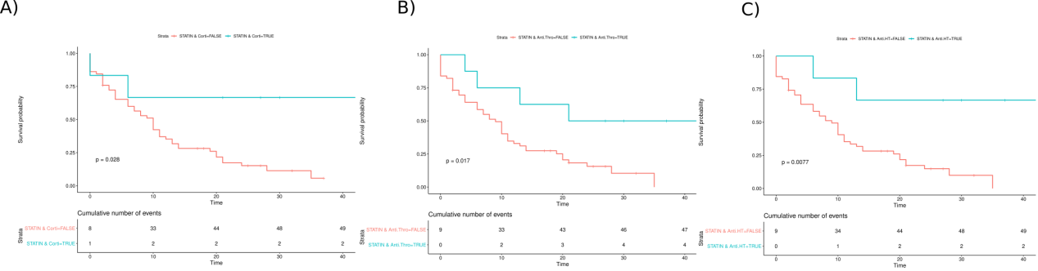

Figure S2: Kaplain-Meyer curve of combination use of drugs

Tables
Table 1: Baseline information of the patients enrolled in the analysis
Variables | Statins (N=11) | Control (N=53) | Total (N=64) | P-value
Sex, no. (%)
Male | 5(45.45) | 37(67.92) | 42(65.63) | 0.12
Female | 6(54.55) | 17(32.08) | 22(34.37) | 0.12
Age, years
Mean±SD | 69.81±19.71 | 69.65±13.44 | 69.68±12.67 | 0.97
Median (IQR) | 71.00(65.00, 76.50) | 70.00(64.50, 80.25) | 70.00(64.5, 79.5) | 0.97
BMI, kg/m²
Mean±SD | 29.07±2.88 | 27.86±4.54 | 28.07±4.30 | 0.40
Median (IQR) | 28.73(24.16, 31.60) | 29.40(27.60, 30.45) | 28.83(25.07, 31.32) | 0.40
Comorbidity, no. (%)
Hypertension | 7(63.63) | 29(54.72) | 36(67.92) | 0.73
Type 2 diabetes | 3(27.27) | 11(20.75) | 14(26.42) | 0.71
Cardiovascular disease | 3(27.27) | 13(24.53) | 16(30.19) | 0.93
Respiratory disease | 0 | 2(3.77) | 2(3.77) | 0.50
Cerebrovascular disease | 2(18.18) | 2(3.77) | 4(7.55) | 0.09
Liver disease | 0 | 2(3.77) | 4(7.55) | 0.50
Physiological index, mean±SD
Heart rate | 92.36±16.54 | 92.13±16.13 | 92.17±16.07 | 0.97
Temperature | 36.34±1.61 | 37.07±2.99 | 36.94±2.81 | 0.51
Respiration rate | 23.00±8.43 | 25.29±9.61 | 24.93±9.40 | 0.51
Systolic pressure | 121.00±14.11 | 128.98±22.49 | 129.84±22.83 | 0.16
Diastolic pressure | 75.91±15.10 | 76.25±15.96 | 76.19±15.70 | 0.95
SpO2(%) | 88.30±12.90 | 89.55±10.52 | 89.33±10.85 | 0.77
Blood test results, mean±SD
White blood cell | 11.86±6.81 | 11.46±5.93 | 11.53±6.03 | 0.85
Neutrophil | 10.30±6.14 | 10.21±5.55 | 10.23±5.61 | 0.96
Lymphocyte | 0.76±0.47 | 0.80±0.90 | 0.80±0.84 | 0.89
Erythrocyte | 3.72±0.85 | 3.98±0.92 | 3.94±0.91 | 0.40
Hematocrit | 34.46±6.43 | 37.15±5.55 | 36.67±5.75 | 0.16
Platelet | 200.73±91.99 | 173.31±115.50 | 178.18±111.50 | 0.46
Liver function, mean±SD
ALT | 46.18±52.57 | 87.09±202.76 | 80.06±186.05 | 0.51
AST | 55.09±68.44 | 97.28±200.39 | 90.03±184.78 | 0.50
Urea | 11.35±11.49 | 10.52±7.25 | 10.66±8.03 | 0.76
Indirect bilirubin | 5.75±2.44 | 8.36±9.11 | 7.92±8.39 | 0.35
Total bilirubin | 11.84±4.92 | 19.05±25.58 | 17.81±23.49 | 0.36
ALP | 94.72±22.88 | 94.92±49.98 | 94.89±46.32 | 0.99
Cholesterol | 3.65±1.36 | 3.35±1.15 | 3.41±1.18 | 0.46
Metabolic index, mean±SD
Glucose | 8.76±5.15 | 8.52±5.66 | 8.56±5.54 | 0.90
Creatine | 156.45±297.34 | 92.31±54.96 | 103.33±130.85 | 0.14
Heart injury index, mean±SD
CK-MB | 2.95±2.18 | 6.64±16.59 | 6.00±15.16 | 0.47
High-sensitivity troponin | 1388.48±4039.33 | 646.46±2949.08 | 773.99±3138.15 | 0.48
N-terminal pro-BNP | 3895.82±4679.31 | 2995.04±7511.90 | 3149.86±7083.00 | 0.70
Coagulation function, mean±SD
INR | 1.26±0.12 | 1.44±0.98 | 1.41±0.89 | 0.23
APTT | 41.55±4.76 | 43.74±22.12 | 43.36±20.15 | 0.54
TT | 17.52±2.00 | 22.83±32.54 | 21.90±29.57 | 0.27
D-dimer | 8.65±7.59 | 10.35±8.77 | 10.05±8.54 | 0.54

Table 2: Medical management in the two groups
Management | Total (N=64) | Statins (N=11) | Control (N=53) | p-value
Drugs, no. (%)
Traditional Chinese medicine | 22(34.38) | 2(18.18) | 20(37.73) | 0.21
Respiratory regulation drugs | 40(62.50) | 8(72.72) | 32(60.38) | 0.44
Vasoactive drugs | 23(35.94) | 4(36.36) | 20(37.74) | 0.97
Broad-spectrum antiviral drugs | 22(34.38) | 2(18.18) | 20(37.74) | 0.21
Antifungal drugs | 4(6.25) | 1(9.09) | 3(5.60) | 0.67
Antibiotics | 49(76.56) | 7(63.63) | 42(79.25) | 0.27
Systemic corticosteroids | 43(67.19) | 6(54.55) | 37(69.81) | 0.33
Immunoglobulins | 31(48.44) | 3(27.27) | 28(52.83) | 0.12
Anticoagulants | 44(68.75) | 8(72.72) | 36(67.92) | 0.75
Anti-hypertensive drugs | 28(43.75) | 6(54.55) | 22(41.51) | 0.43
Insulin | 34(53.13) | 5(45.45) | 29(54.72) | 0.58
Chloroquine | 11(17.19) | 3(27.27) | 8(15.09) | 0.33
Sparagin | 31(48.44) | 6(54.55) | 23(43.40) | 0.66
Analgesics | 43(67.19) | 6(54.55) | 37(69.81) | 0.48
Sedatives | 47(73.44) | 8(72.73) | 39(73.58) | 1
Supportive measures, no. (%)
Inhaled oxygen | 64(100) | 11(100) | 53(100) | -
Noninvasive ventilation | 51(79.69) | 9(81.82) | 42(79.25) | 0.85
Invasive ventilation | 36(56.25) | 4(36.36) | 32(60.38) | 0.14
Nasal feeding | 39(60.94) | 9(81.82) | 30(79.25) | 0.30
ECMO | 3(4.69) | 0(0) | 3(5.66) | 0.42

