Supplementary table and figures

Table 1 Type, names and source of the 11 drivers that are used in a random forest model to predict NDVI and NDWI trends over 2001-2020.
Type of the predictor |  | Name of the predictor | Source | Spatial resolution
Tree architecture |  | Max tree height (MTH) | GEDI³⁷ | 25m
 |  | Median leaf height (MLH) | GEDI³⁷ | 25m
Forest density |  | Biomass | WCMC³⁹ | 300m
Topography |  | Slope | SRTM⁴³ | 30m
 |  | Aspect | SRTM⁴³ | 30m
Soil characteristics |  | Soil organic carbon content | EnvirometriX Ltd | 250m
 |  | Soil bulk density | EnvirometriX Ltd | 250m
Background  climate | 2001-2020  mean | Soil water content (SWC) | ERA5 land⁴⁴ | 0.1º ~10 km
Background  climate | 2001-2020  mean | Temperature | ERA5 land⁴⁴ | 0.1º ~10 km
Climate change | Trend over 2001-2020 | SWC | ERA5 land⁴⁴ | 0.1º ~10 km
Climate change | Trend over 2001-2020 | Temperature | ERA5 land⁴⁴ | 0.1º ~10 km

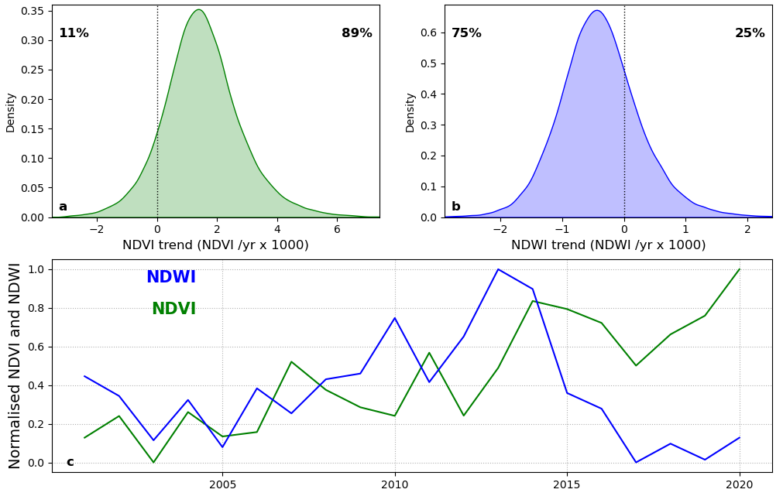
Figure 1 Frequency distribution of the NDVI and NDWI trends. Frequency distribution of NDVI (a) and NDWI (b) trends for stable European forest over 2001-2020. Numbers in (a and b) refer to the percentage of positive and negative records (on the left and right of the y-axis, respectively). (c) Time series of European averages of NDVI in green and NDWI in blue.

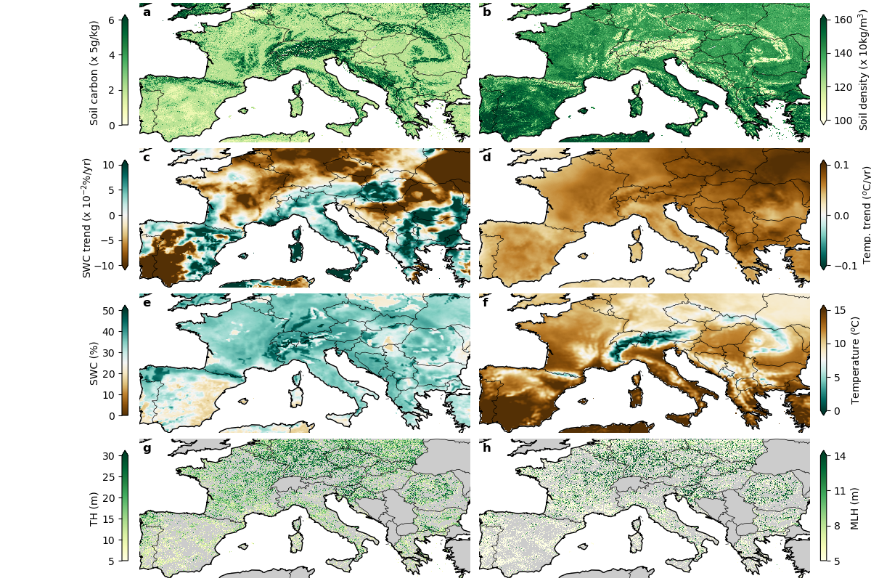
Figure 2 Observed climate means and trends over 2001-2020, tree architecture and soil characteristics. This figure shows the: soil organic carbon content (a), soil bulk density (b), mean (e) and trend (c) of soil water content SWC, mean (f) and trend (d) of surface air temperature, tree height TH (g) and median leaf height MLH (h).
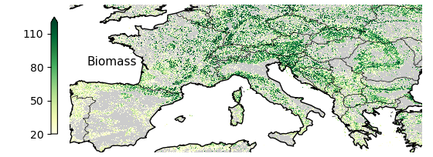
Figure 3 Spatial distribution of 2010 forest biomass in (t C/ha).

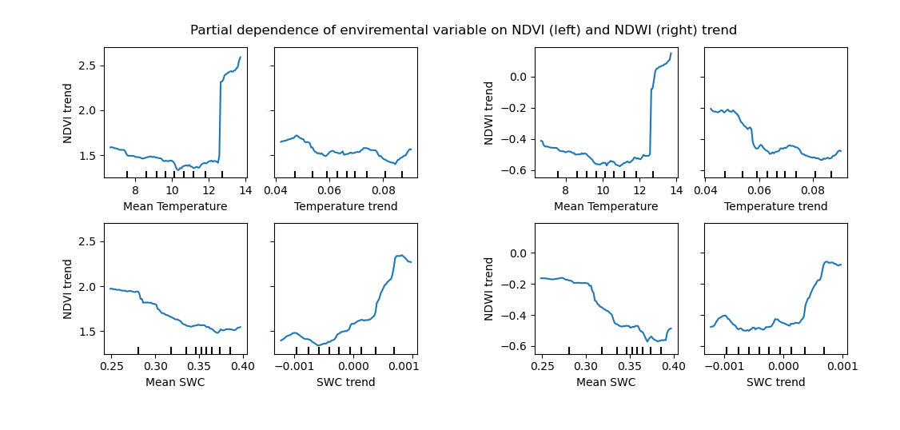
Figure 4 Results of the Random Forest regression analysis. Partial dependence plots depicting the marginal effects of the climate drivers on greenness (NDVI x1000/yr) and canopy water content (NDWI x1000/yr) trends.

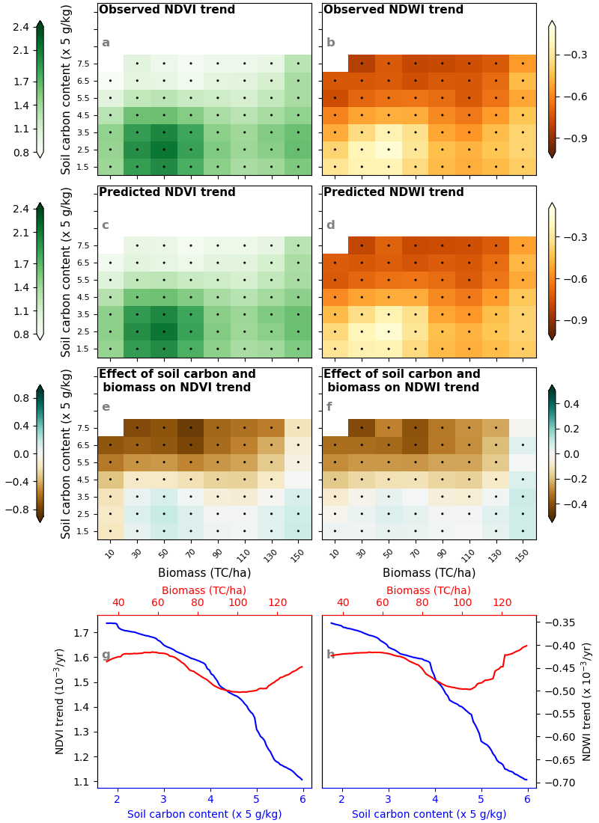
Figure 5 Dependence of greenness and water leaf content trend on biomass and soil organic carbon content. Observed (ab) and predicted (cd) greenness (NDVI) and water leaf content (NDWI) trends, with a Random Forest model, as a function biomass (x-axis) and soil organic caron content (y-axis). (ef) are similar to (cd) but the potential role of other drivers is partialled out. Bins with a minimum of 30 observations are reported. Black dots indicate bins with an average value statistically different from zero (Student’s t-test; P-value ≤ 0.05). (gh) shows the partial dependence of biomass and soil organic carbon content on greenness and water leaf content trends.

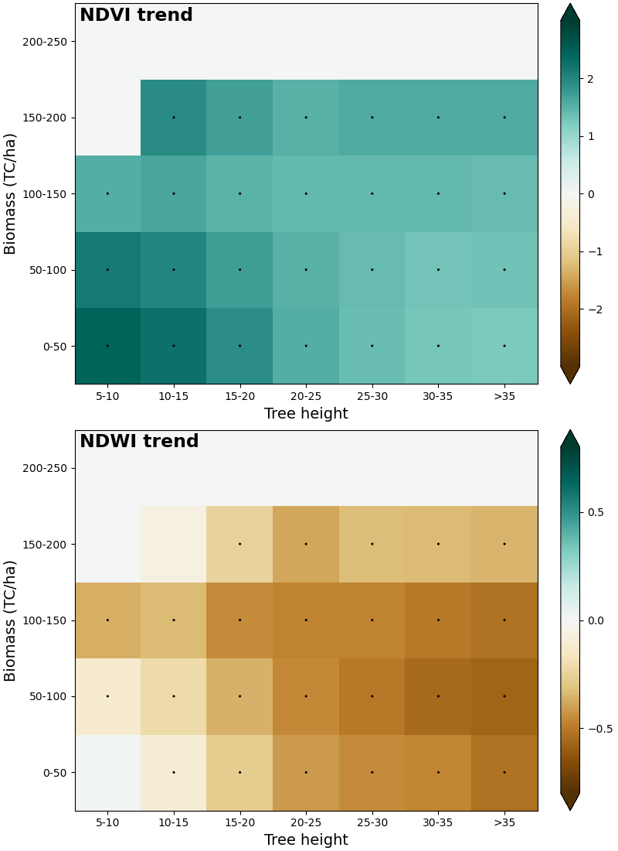
Figure 6 Dependence of greenness and canopy water content trend on tree height and biomass. Bins with a minimum of 30 observations are reported. Black dots indicate bins with an average value statistically different from zero (Student’s t-test; P-value ≤ 0.05).

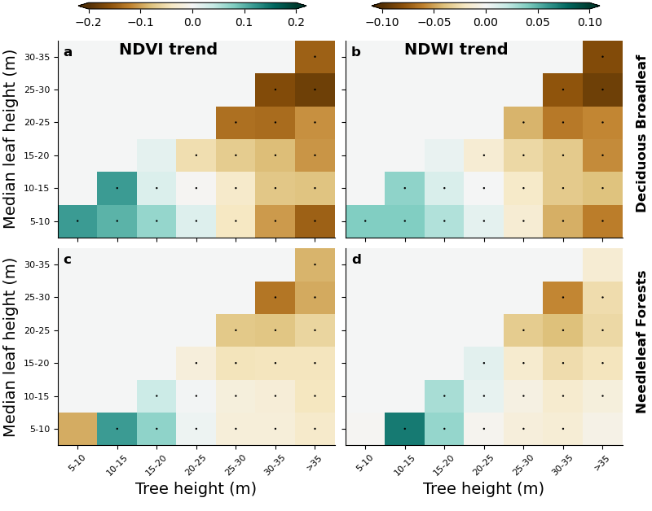

Figure 7 Dependence of greenness and canopy water content trend on tree architecture for different tree types. Deciduous (ab) and Needleleaf (cd) greenness (NDVI) and water leaf content (NDWI) trends as a function soil bulk density (x-axis) and soil organic caron content (y-axis). The potential role of other drivers is partialled using single Random Forest model for each forest type. Bins with a minimum of 30 observations are reported. Black dots indicate bins with an average value statistically different from zero (Student’s t-test; P-value ≤ 0.05).

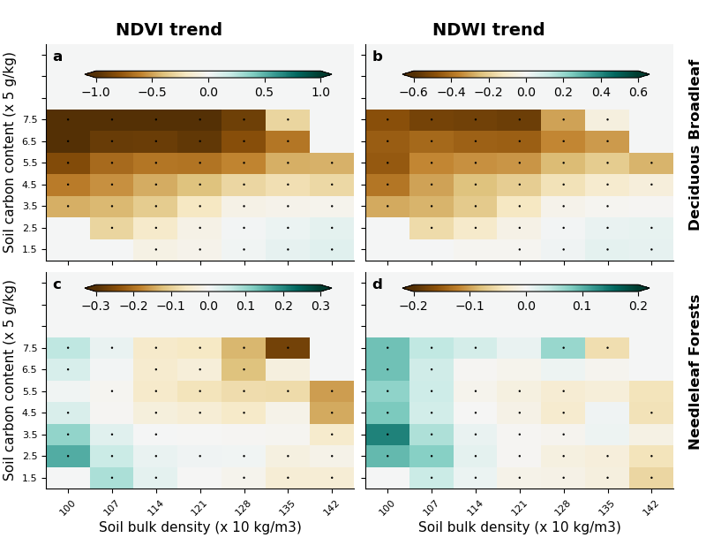
Figure 8 Dependence of greenness and water leaf content trend on soil characteristics. Deciduous (ab) and Needleleaf (cd) greenness (NDVI) and water leaf content (NDWI) trends as a function soil bulk density (x-axis) and soil organic caron content (y-axis). The potential role of other drivers is partialled using single Random Forest model for each forest type. Bins with a minimum of 30 observations are reported. Black dots indicate bins with an average value statistically different from zero (Student’s t-test; P-value ≤ 0.05).

