Supplementary information

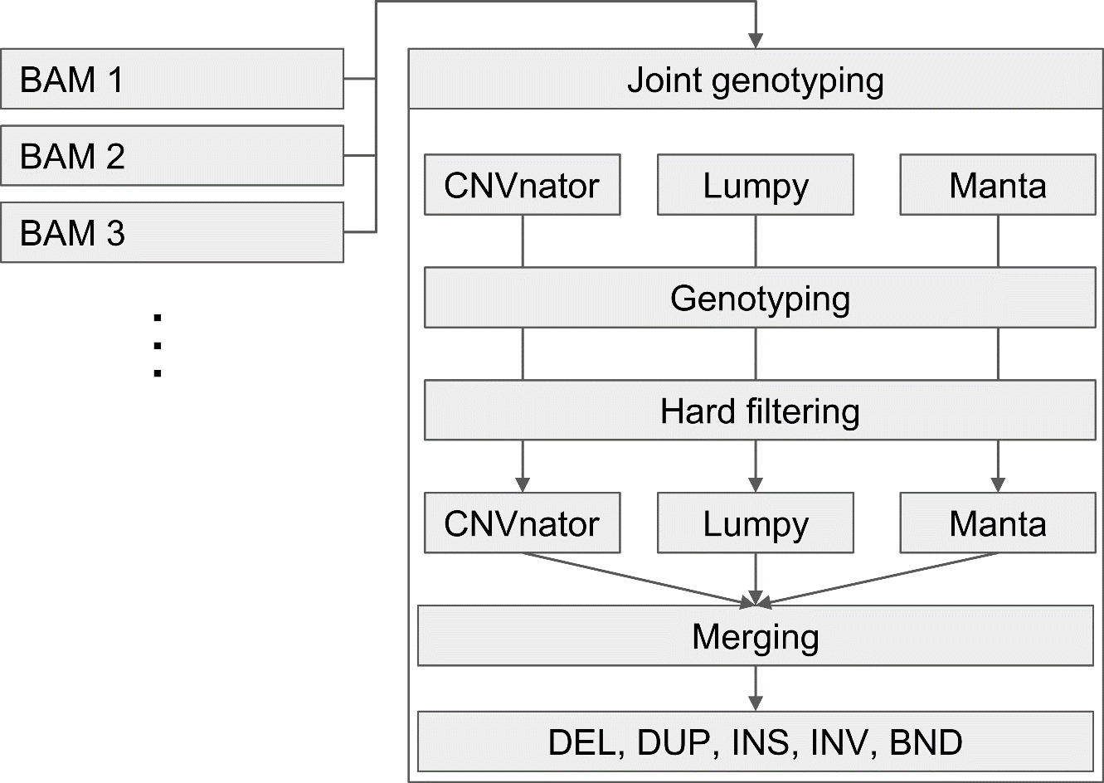
Supplementary figure 1. Structural variants detection pipeline
Supplementary figure 2. Visual representation of (A) merging two genomic intervals by % overlap and bp distance between two furthest break ends. (B) providing consensus region, based on 50% overlap and 1000 bp.
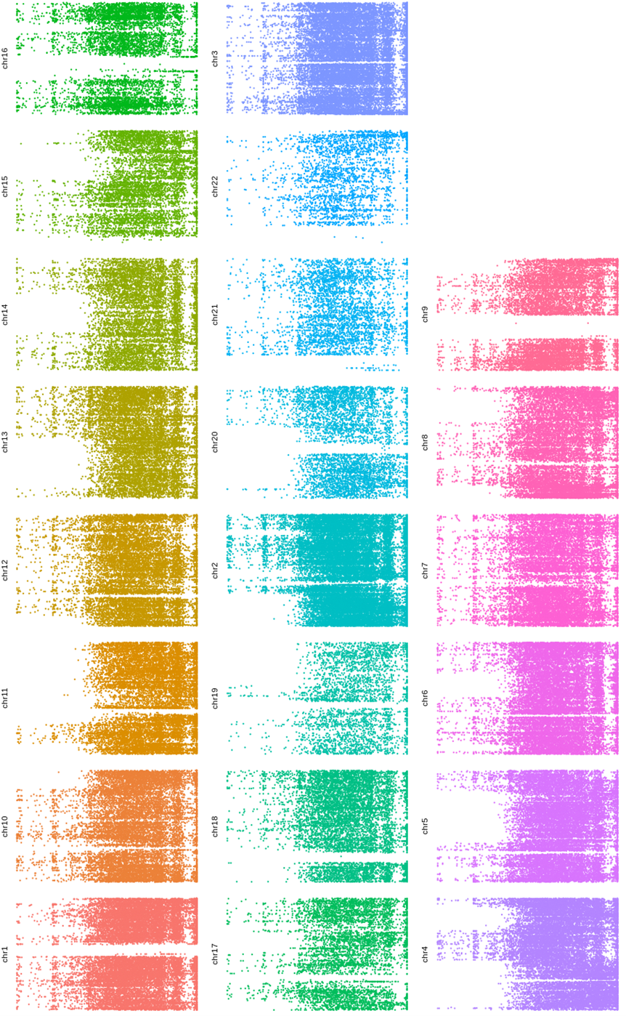
Supplementary figure 3. Complete overview on combined IBD.

