Supplementary File 1A
Standard curve of human ACE2 as analyzed using a human ACE2 ELISA Kit (ab235649; Abcam, Cambridge MA, USA; ELISA assay sensitivity is ~1052 pg/ml; range: 1.5 ng/ml - 255 ng/ml); based on the standard curve, mean ACE2 protein concentrations in the eye and brain ranged from approximately 2-16 ng/ml; ACE2 protein concentrations in the human heart and kidney have been previously reported to range between respectively, ~30 and ~100 ng/ml; https://www.abcam.com/human-ace2-elisa-kit-ab235649.html.
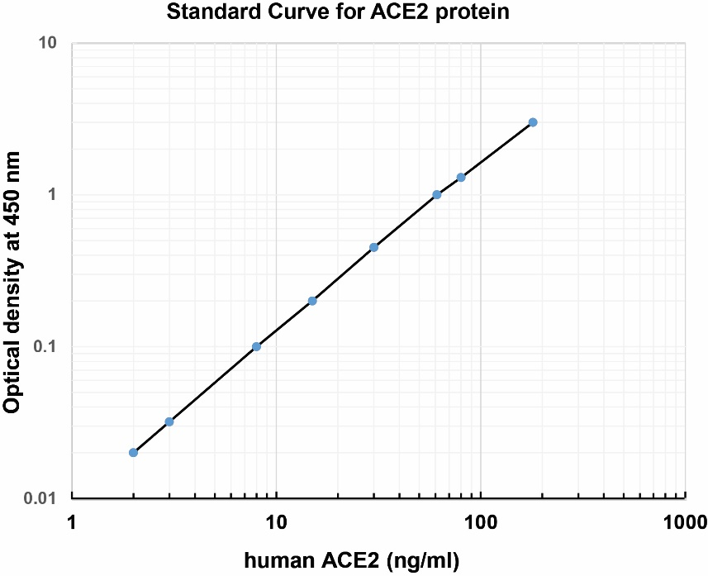

Supplementary File 1B

