Electrofluids as liquid conductors with tunable gauge factors
Dominik Sebastian Schmidt¹, Tobias Kraus^{1,2}, Lola González-García^{1,3*}
¹INM – Leibniz Institute for New Materials, Campus D2 2, 66123 Saarbrücken, Germany
²Colloid and Interface Chemistry, Saarland University, Campus D2 2, 66123 Saarbrücken, Germany
³Department of Materials Science and Engineering, Saarland University, Campus D2 2, 66123 Saarbrücken, Germany
*E-mail: lola.gonzalez-garcia@leibniz-inm.de

Table of Content
Supplementary Figure 1: | Raman spectrum of Carbon Black Powder
Supplementary Figure 2: | Fitting curves of the percolation threshold determination for the CB mixtures
Supplementary Figure 3: | Rheoelectrical graphs of 5 vol% CB in A) Hexadecane and B) Ethylene Glycol
Supplementary Figure 4: | Flow curves for 5 vol% CB in A) PDMS and B) Glycerol
Supplementary Figure 5: | Electromechanical tests with 0.9 vol% CB in glycerol
Supplementary Figure 6: | Testing protocol of uniaxial tensile tests

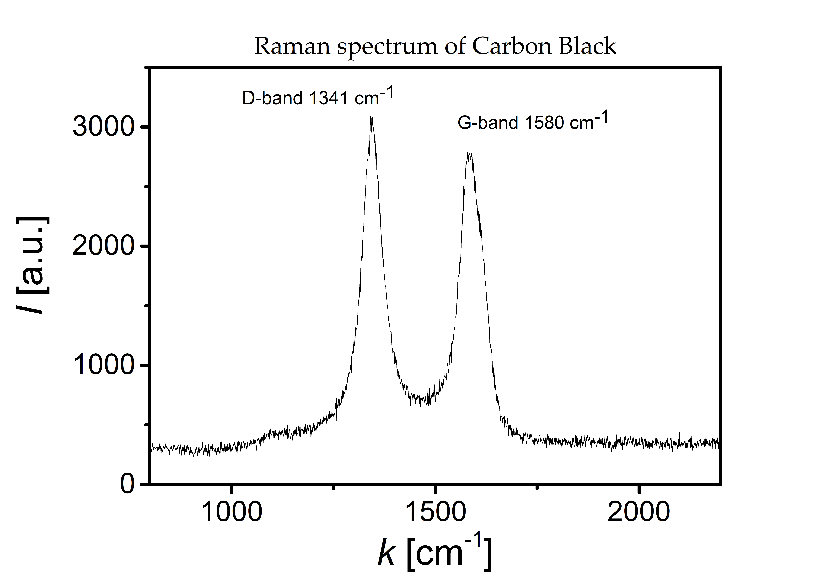
Figure S1: Raman spectrum of Carbon Black powder.
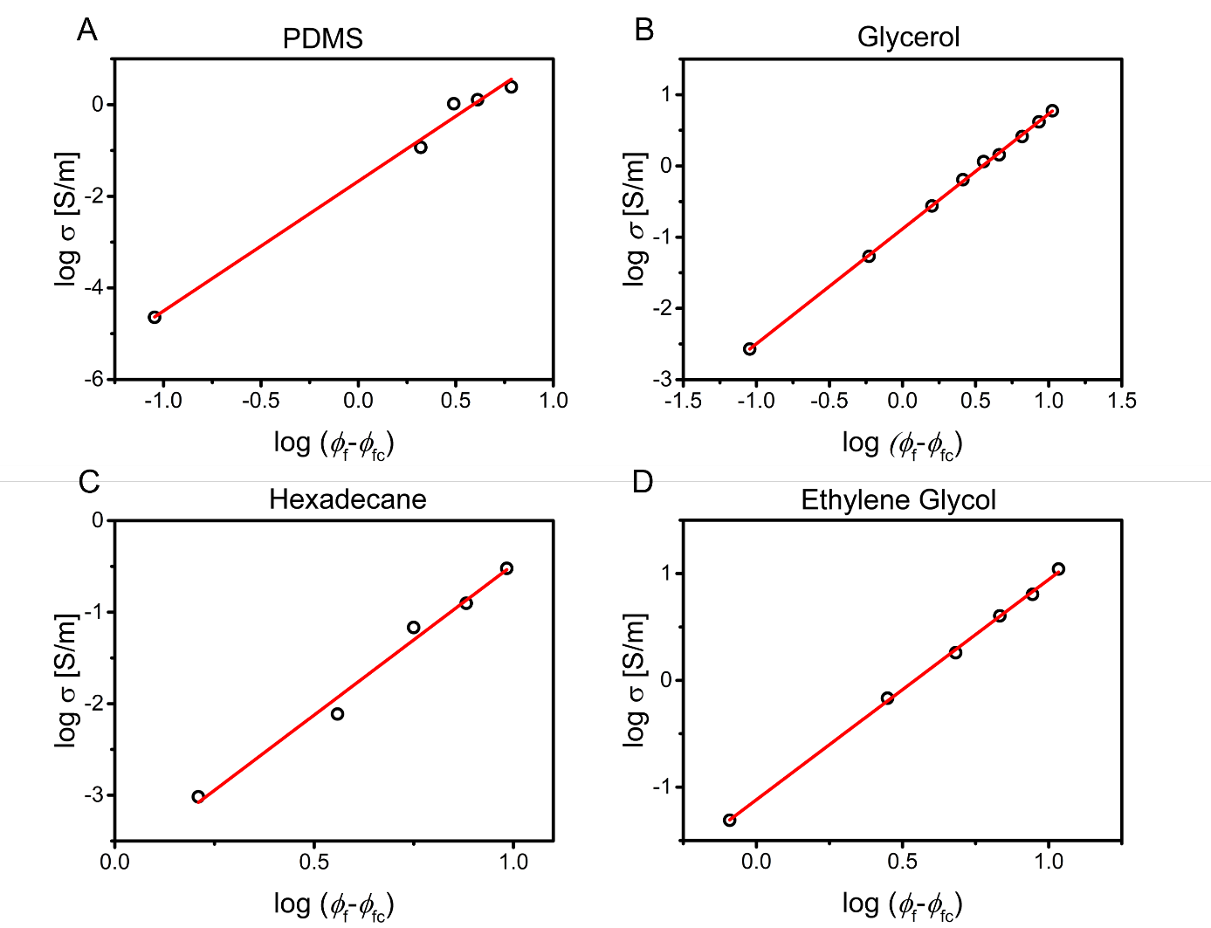
Figure S2: Fitting curves of the percolation threshold determination for the CB mixtures in PDMS (A), in glycerol (B), in hexadecane (C), and in ethylene glycol (D).

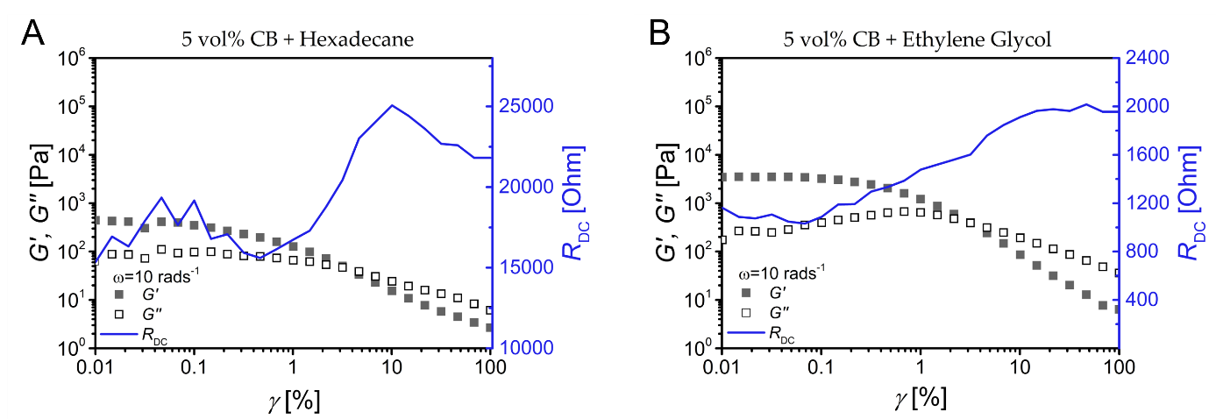
Figure S3: Rheoelectrical measurements of 5 vol% CB in A) hexadecane and B) ethylene glycol.
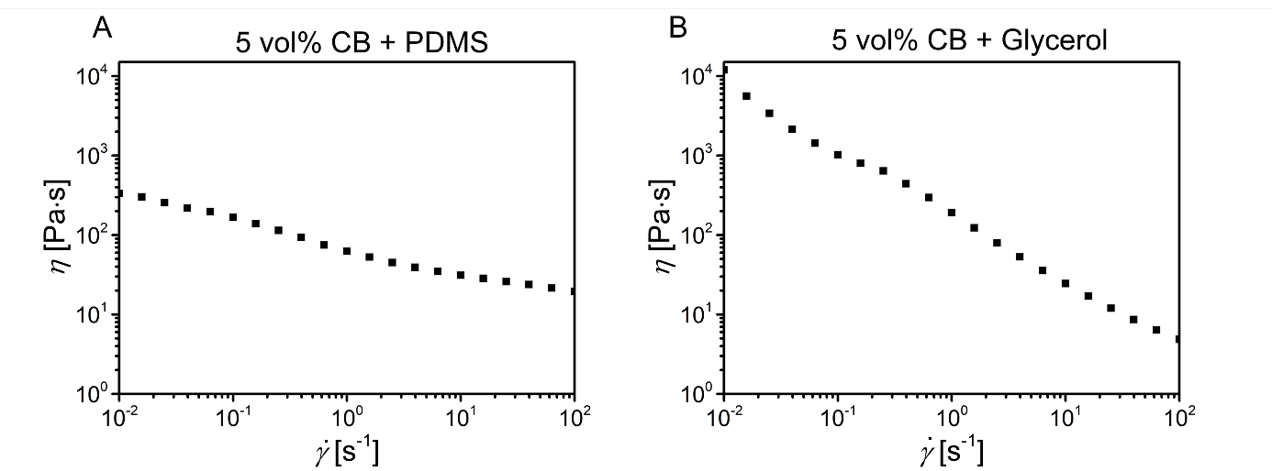
Figure S4: Flow curves of 5 vol% CB in A) PDMS and B) glycerol.

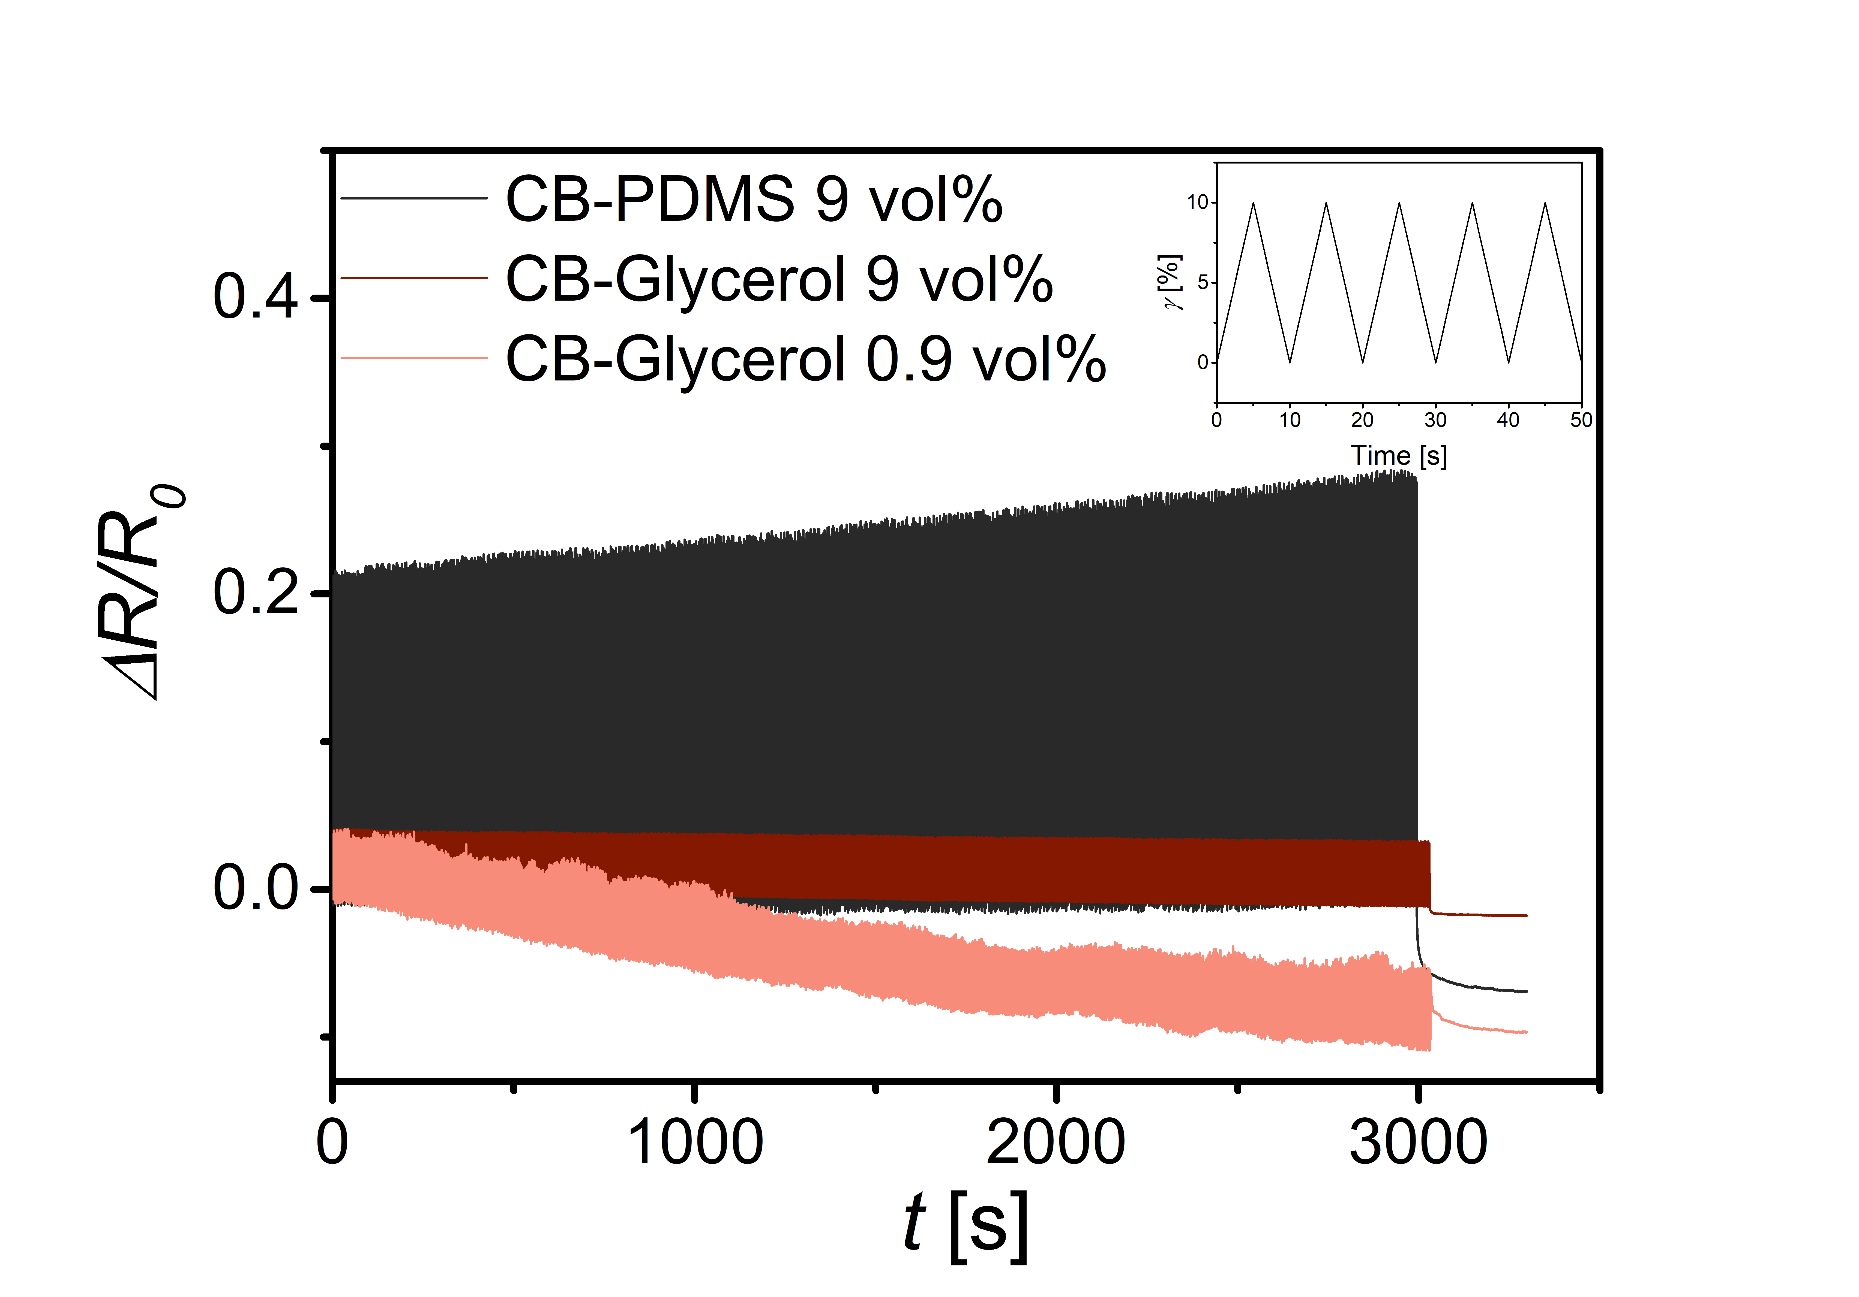
Figure S5: Resistance variation during cyclical loading between 0% and 10% strain (1000 cycles). The inset shows the strain rate. The overall decreasing trend found for the smaller concentration of 0.9 vol% CB in glycerol indicates that the equilibrium for this system was not reached within the (pre)test time.
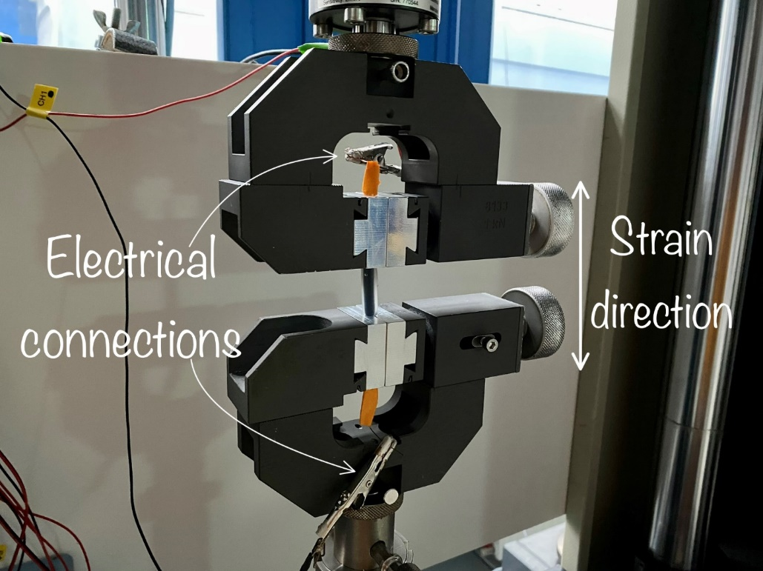
Figure S6: Image of the uniaxial tensile test set-up. The electrofluid was encapsulated in an EcoFlex® tube, clamped into the tensile machine, and electrically connected to the Keithley DAQ6510 Sourcemeter.

Videos of the demonstrators can be found as electronic supporting information.

