SUPPLEMENTARY DATA: IDENTIFICATION OF A NOVEL SEROLOGICAL PANCREATIC DUCTAL ADENOCARCINOMA AUTOANTIBODY BIOMARKER PANEL WITH DIAGNOSTIC AND THERAPEUTIC IMPLICATIONS

Metoboroghene O. Mowoe^{1*}, PhD, Hisham Ali², MBCHB, Joshua Nqada², MBCHB, Marc Bernon², MBCHB, Karan Gandhi², MBCHB, Sean Burmeister², MBCHB, Urda Kotze², MBCHB, Miriam Kahn², MBCHB, Christo Kloppers², MBCHB, Andrew Nel³, PhD, Suba Dharshan³, PhD , Zafira Azween³, MSc., Muneerah Smith³, PhD, Paul Townsend⁴, PhD, Eduard Jonas², MBCHB, Jonathan M. Blackburn^{1*}, PhD

¹Department of Integrated Biomedical Sciences, Division of Chemical and Systems Biology, University of Cape Town, Cape Town, South Africa
² Surgical gastroenterology Unit, Division of General Surgery, Groote Schuur Hospital, University of Cape Town, Cape Town, South Africa
³ Sengenics Corporation, Floor M, Block A, Plaza Zurich, Damansara Heights, Kuala Lumpur 50490, Malaysia.
⁴ Faculty of Health and Medical Sciences, University of Surrey, Guildford, Surrey, United Kingdom.

*Corresponding authors:
Metoboroghene O Mowoe
Department of Integrated Biomedical Sciences, Division of Chemical and Systems Biology, University of Cape Town, Cape Town, South Africa
Tel: +277 4431 2287
m_mowoe@yahoo.co.uk

Jonathan M Blackburn
Department of Integrated Biomedical Sciences, Division of Chemical and Systems Biology, University of Cape Town, Cape Town, South Africa
Tel: +278 2724 4835
jonathan.blackburn@uct.ac.za

Table of Contents
Supplementary Table S1a: Layout of 384-well Plate for the CT100+ Printing Design (Plate 1 of 2) 3
Supplementary Table S1b: Layout of 384-well Plate for the CT100+ Printing Design (Plate 2 of 2) 4
Supplementary Table S2: CT100+ Assay blocking buffer 5
Supplementary Table S3: Array parameters for printing CT100+ microarray 5
Supplementary Table S4: Area under the Receiver operating characteristics Curve, Cut-offs, Specificity, Sensitivity of Autoantigens Required for Pancreatic Ductal Adenocarcinoma Diagnosis against diseased controls 6
Supplementary Table S5: Results of Western blot analysis of proteins in the custom PDAC array 7
Supplementary Fig. S1: Fabrication of in-house CT100+ microarrays. a.) Flowchart detailing in-house streptavidin coating of Nexterion® H slides b.) Position of pins and corresponding microarray spots/probes on Nexterion® H slides for the CT100+ microarray design 8
Supplementary Fig. S2: CT100+ and IMMUNOME™ anti-c-Myc assay to confirm successful immobilization of in situ purification of biotinylated proteins from lysates on the arrays. 9
Supplementary Fig S3: Preparation of tumour tissue samples for western blot analysis and optimization of optimized method. 10
Supplementary Figure S4: Western blot analysis of expressed proteins for custom pancreatic ductal adenocarcinoma microarray. 11
Supplementary Figure S5: Western blot analysis of expression data of ten of the 11 autoantibodies across ten patient tumour tissue samples. 12

Supplementary Table S1a: Layout of 384-well Plate for the CT100+ Printing Design (Plate 1 of 2)
Well | Protein | Well | Protein | Well | Protein
A1-2,8-9/B1-2,8-9/  C1-2,8-9/D1-2,8-9 | Cy5-biotin-BSA  5 ng/µl | E4,11 | GAGE1 | L5,12 | MART-1/MLANA
E1-2,8-9/F1-2,8-9/  G1-2,8-9/H1-2,8-9 | Cy5-biotin-BSA 10 ng/µl | F4,11 | GAGE2A | M5,12 | MICA
I1-2,8-9/J1-2,8-9/  K1-2,8-9/L1-2,8-9 | Cy5-biotin-BSA 15 ng/µl | G4,11 | GAGE5 | N5,12 | NLRP4
M1-2,8-9/N1-2,8-9/  O1-2,8-9/P1-2,8-9 | Empty | H4,11 | GAGE6 | O5,12 | NFX2
A3,A10,D4,D11 | bHuIgG 10ng/µl | I4,11 | GAGE6 | P5,12 | NY-CO-45
B3,10 | BAGE2 | J4,11 | GAGE7 | A6,13 | NY ESO 1
C3,10 | BAGE3 | K4,11 | GRWD1 | B6,13 | OIP5
D3,10 | BAGE4 | L4,11 | HORMAD1 | C6,13 | p53
E3,10 | BAGE5 | M4,11 | LDHC | D6,13 | PBK
F3,10 | CCDC33 | N4,11 | LEMD1 | E6,13 | RELT
G3,10 | CEP290 | O4,11 | LIPI | F6,13 | ROPN1
H3,10 | COL6A1 | P4,11 | MAGEA1 | G6,13 | SGY 1
I3,10 | COX6B2 | A5,12 | MAGEA10 | H6,13 | SILV
J3,10 | CSAG2 | B5,12 | MAGEA11 | I6,13 | SPAG9*
K3,10 | CT47.11 | C5,12 | MAGEA2 | J6,13 | SPANXA1
L3,10 | CT62 | D5,12 | MAGEA3 | K6,13 | SPANXB1
M3,10 | CTAG2/NY ESO 2 | E5,12 | MAGEA4v2 | L6,13 | SPANXC
N3,10 | CXorf48.1 | F5,12 | MAGEA4v3 | M6,13 | SPANXD
O3,10 | DDX53 | G5,12 | MAGEA4v4 | N6,13 | SPO11
P3,10 | MMA1 | H5,12 | MAGEA5 | O6,13 | SSX
A4,11 | FTHL17 | I5,12 | MAGEB1 | P6,13 | SSX2a
B4,11 | Buffer | J5,12 | MAGEB5
C4,11 | anti-HuIgG | K5,12 | MAGEB6

Supplementary Table S1b: Layout of 384-well Plate for the CT100+ Printing Design (Plate 2 of 2)
Well | Protein | Well | Protein | Well | Protein
A1,8 | SSX4 | G2,9 | SRCALM1C | M3,10 | TKTL1 Isoform a
B1,8 | SYCE1 | H2,9 | CDC25A | N3,10 | SPATS1 Isoform 1
C1,8 | SYCP1 | I2,9 | CREB1 | O3,10 | DPPA2
D1,8 | THEG | J2,9 | CTNNB1 | P3,10 | SOX1
E1,8 | TPTE | K2,9 | p53 S6A | A4,11 | EMPTY
F1,8 | TSAG10 | L2,9 | EMPTY | B4,11 | EMPTY
G1,8 | TSSK6 | M2,9 | EMPTY | C4,11 | CYPR
H1,8 | TYR | N2,9 | EMPTY | D4,11 | EGFR
I1,8 | XAGE2 | O2,9 | p53Q136x | E4,11 | ROPNA1
J1,8 | XAGE3a v1 | P2,9 | EMPTY | F4,11 | CEACAM isoform 1
K1,8 | XAGE3 a v2 | A3,10 | EMPTY | G4,11 | POU5F1
L1,8 | ZNF165 | B3,10 | EMPTY | H4,11 | NANOG
M1,8 | AKT1 | C3,10 | p53M133T | I4,11 | BORIS BO
N1,8 | CDK2 | D3,10 | EMPTY | J4,11 | DPPA4
O1,8 | CDK4 | E3,10 | 5T4/TPBG | K4,11 | DPPA3
P1,8 | CDK7 | F3,10 | XAGE1B | L4,11 | GDF3
A2,9 | FES | G3,10 | SOX2 | M4,11 | CTAG2
B2,9 | FGFR2 | H3,10 | ACVR2A | N4,11 | CAMEL
C2,9 | MAPK1 | I3,10 | ACVR2B | O4,11 | NY-ESO 1/ORF2
D2,9 | MAPK3 | J3,10 | ITGB1 | P4,11 | BCCP-myc
E2,9 | PRKCZ | K3,10 | MAP9 | A5,12 | Insect cell lysate
F2,9 | RAF | L3,10 | PIM1 | B-D5,12/A-D6,13 | Control Buffer

Supplementary Table S1c: Layout of 384-well Plate for the Sengenics IMMUNOME™ Printing Design
https://sengenics.com/resources/protein-list/

Supplementary Table S2: CT100+ Assay blocking buffer
Stock | mL in 500 mL | Final concentration (mM)
1M Hepes, pH 7.5 | 12.5 | 25
Glycerol | 100 | 20%
2.5M KCL | 10 | 50
Triton X-100 | 0.5 | 0.1%
50mM biotin | 0.5 | 0.05
ddH₂O | 376.5 | -

Supplementary Table S3: Array parameters for printing CT100+ microarray
Parameter | Setting
Environmental conditions
Temperature | ~ 18 ℃
Humidity | ~45%
Print settings
Microarray pattern | 8 × 8 spots/grid
Total number of source plates | 2
Source order | By column
Spacing | 562 µm
Max. stamps per ink | 1
Stamps per spot | 1
Stamp time | 0 ms
Inking time | 500 ms
Print depth adjustment | 150 µm
Number of touch offs | 0
Pin wash setting
Water washes | 60 s
Ethanol wash | 10 s
Drying | 10 s
Pause | 1 s

Supplementary Table S4: Area under the Receiver operating characteristics Curve, Cut-offs, Specificity, Sensitivity of Autoantigens Required for Pancreatic Ductal Adenocarcinoma Diagnosis against diseased controls
Autoantigen | AUC | Cut-off (log expression) | Specificity | Sensitivity
MAGEA4 | 0.709 | 10.694 | 0.795 | 0.579
SRC | 0.704 | 9.845 | 0.800 | 0.526
5T4.TPBG | 0.675 | 9.571 | 0.800 | 0.579
SYCE1 | 0.669 | 10.475 | 0.720 | 0.631
GRWD1 | 0.667 | 11.134 | 0.820 | 0.526
CEACAM 1 | 0.654 | 9.269 | 0.700 | 0.579
XAGE 3 | 0.653 | 10.381 | 0.620 | 0.736
DPPA3 | 0.652 | 9.175 | 0.800 | 0.526
LIPI | 0.649 | 10.273 | 0.760 | 0.526
DPPA2 | 0.648 | 8.581 | 0.700 | 0.579

Supplementary Table S5: Results of Western blot analysis of proteins in the custom PDAC array
Lane | Gene Symbol | Expected MW (kDa) | Observed MW (kDa) | Uniprot
M | Biotinylated Protein Ladder | -- | -- | --
1 | CEACAM1 | 63.3 | 100 | P13688
2 | DPPA2 | 46.6 | 51.4 | Q7Z7J5
3 | DPPA3 | 32.6 | 32.3 | CT119
4 | MAGEA4 | 47.7 | 54.9 | P43358
5 | SRC | 75.8 | 65.4 | CT83
6 | TPBG | 59.0 | 67.5 | Q13641
7 | XAGE3 | 37.6 | 33.1 | CT71
8 | ALX1 | 49.7 | 52.7 | Q15699
9 | GPA33 | 48.4 | 58.2 | Q99795
10 | LIPI | 68.1 | 63.3 | Q6XZB0
11 | SUB1 | 27.1 | 30.6 | P53999

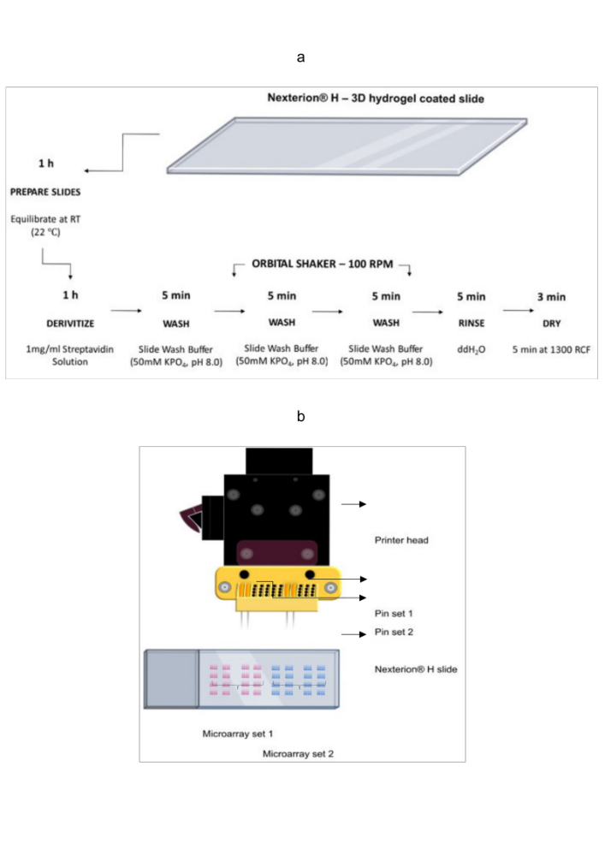Supplementary Fig. S1: Fabrication of in-house CT100+ microarrays. a.) Flowchart detailing in-house streptavidin coating of Nexterion® H slides b.) Position of pins and corresponding microarray spots/probes on Nexterion® H slides for the CT100+ microarray design

Supplementary Fig. S2: CT100+ and IMMUNOME™ anti-c-Myc assay to confirm successful immobilization of in situ purification of biotinylated proteins from lysates on the arrays. a.) JPEG image of c-Myc array to visualize proteins on the a.) CT100+ and b.) Sengenics IMMUNOME ™ arrays. Expression intensities of proteins incubated with anti-c-Myc control on the c.) CT100+ arrays and d.) Sengenics IMMUNOME ™ arrays. Each antigen expression intensity was variable because each protein was expressed at different levels within the insect cells and not pre-normalized before array fabrication. For some antigens, signal was reduced possibly because the c-Myc tag was buried within the 3D confirmation of the protein structure. This was corrected at the pre-processing stage downstream.

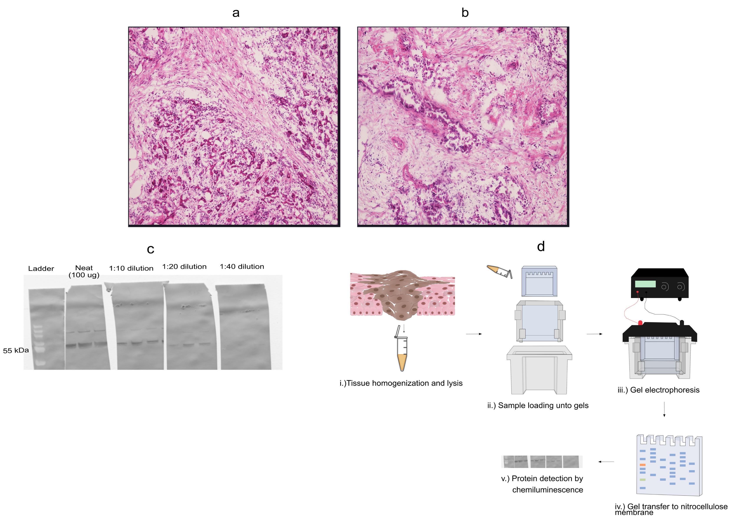
Supplementary Fig S3: Preparation of tumour tissue samples for western blot analysis and optimization of optimized method. Microscopy (H&E staining) images of histopathology of cryopreserved pancreatic cancer tissue to assess viability following: a.) snap-freezing (Patient 3) and b.) storage in buffer (90% FBS, 10% DMSO) (Patient 7). c.) Western blot analysis of autoantibodies against autoantigens (GPA33) in tissue of patient 20. Autoantigen GPA33 was randomly chosen from the list of identified diagnostic autoantibodies in PDAC. d.) Schematic of optimized western blot analysis method for this study. i.) Tissue sample is physically homogenized and chemically lysed, ii.) Lysate is loaded unto the gels and iii.) electrophoresed, iv.) gels are transferred to a nitrocellulose membrane, blocked, and incubated with antigen lysate, v.) autoantibodies are detected via chemiluminescence.

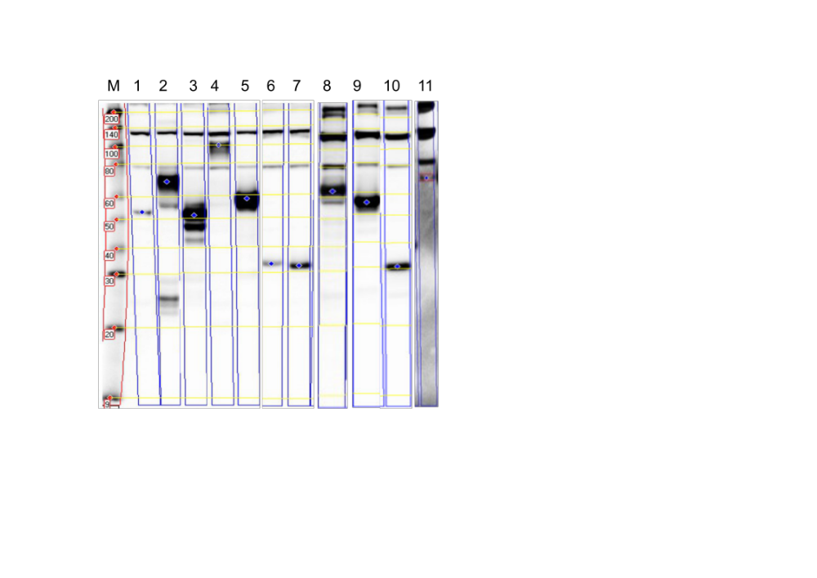

Supplementary Figure S4: Western blot analysis of expressed proteins for custom pancreatic ductal adenocarcinoma microarray. M – Protein ladder; 1 – ALX1; 2 – TPBG; 3- DPPA2; 4- CEACAM1; 5 – GPA33; 6 – XAGE3; 7 – DPPA3; 8 -LIPI; 9- MAGEA4; 10 – SUB1; 11 – SRC

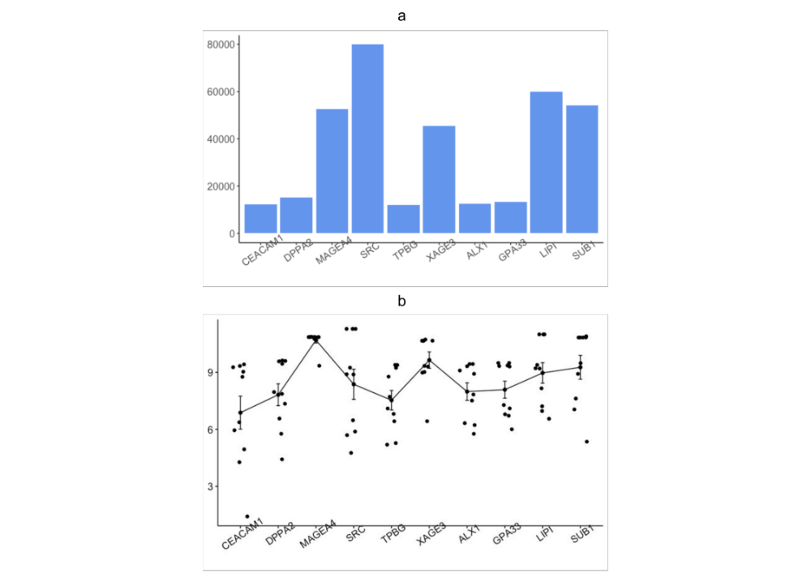
Supplementary Figure S5: Western blot analysis of expression data of ten of the 11 autoantibodies across ten patient tumour tissue samples. a.) Barplot of expression intensities of each protein biomarker identified across the ten patient tumour tissue samples, b.) Error bar of log expression intensities of each protein biomarker identified.

