Supplementary material
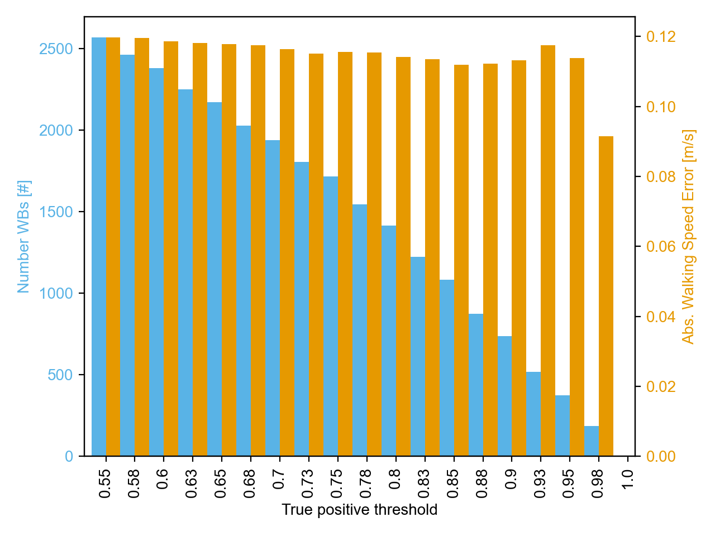
Supplementary Figure 1. Effect of selection of the threshold for identification of true-positive walking bouts (i.e. overlapping between walking bouts correctly identified by the wearable device and reference system) on the number of real-world walking bouts (WBs) detected as true-positive and included in analysis and the average absolute gait speed error across them.

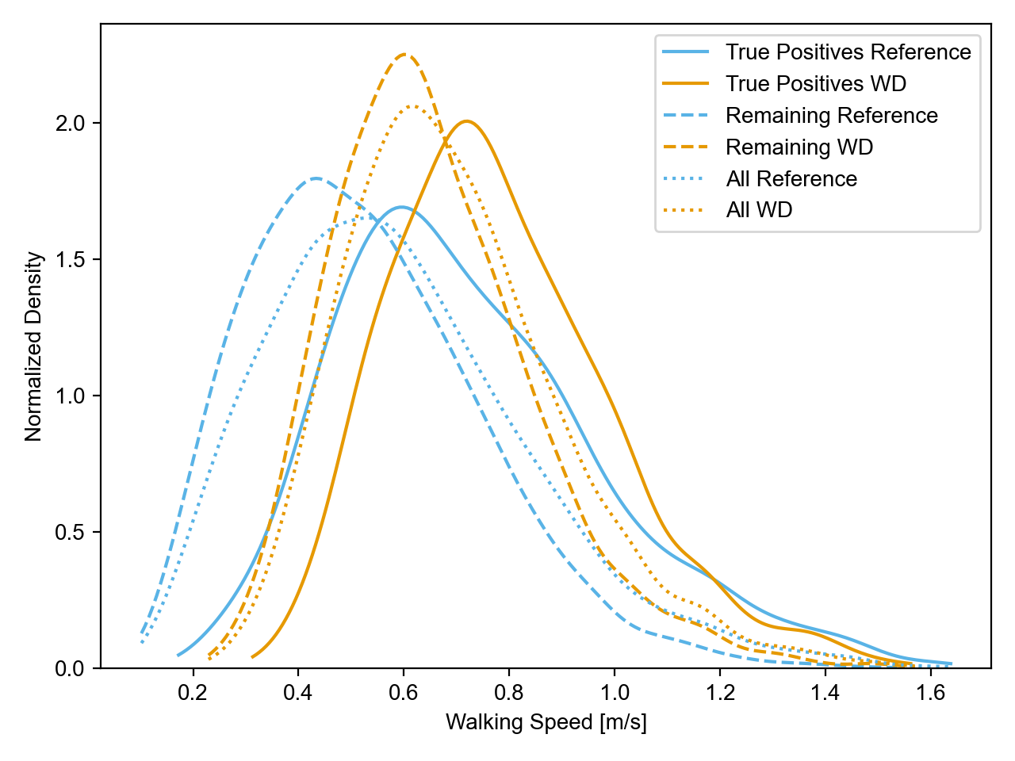
Supplementary Figure 2. Gait speed distributions overall considering all walking bouts (WBs) walking bouts, only true-positive walking bouts, and only false positive walking bouts. Comparing the reference system to the wearable device (WD). Each kernel density estimation is normalised to an area of 1 independently.

Supplementary Table 1. Results from the analysis only considering true positive walking bouts for cadence.
 | Cohort | Reference [steps/min] | Wearable device [steps/min] | Error with LOA [steps/min] | Rel. Error with LOA [%] | Abs Error [steps/min] | Rel. Abs. Error [%] | ICC
Laboratory | CHF | 99.13 [ 78.69 124.18] | 95.78 [ 77.49 120.02] | 3.35 [ -7.69 14.38] | 3.00 [ -8.14 14.14] | 4.33 [ 0.37 15.18] | 4.27 [ 0.39 13.18] | 0.82 [ 0.72 0.89]
Laboratory | COPD | 97.88 [ 75.53 116.11] | 94.94 [ 73.57 110.66] | 2.95 [ -3.57 9.46] | 2.89 [ -3.34 9.12] | 3.38 [ 0.33 9.48] | 3.38 [ 0.36 8.60] | 0.91 [ 0.87 0.94]
Laboratory | HA | 99.32 [ 74.96 117.23] | 94.81 [ 74.62 110.52] | 4.51 [ -6.59 15.60] | 4.28 [ -6.08 14.64] | 4.94 [ 0.33 14.36] | 4.77 [ 0.41 14.43] | 0.86 [ 0.80 0.90]
Laboratory | MS | 94.64 [ 66.17 116.06] | 93.86 [ 67.77 113.95] | 0.78 [-15.69 17.25] | 0.24 [-16.03 16.50] | 4.04 [ 0.14 12.68] | 4.27 [ 0.15 13.75] | 0.81 [ 0.75 0.86]
Laboratory | PD | 92.86 [ 68.62 115.40] | 92.77 [ 71.24 109.90] | 0.09 [ -9.02 9.20] | -0.22 [-10.77 10.34] | 3.38 [ 0.30 10.27] | 3.76 [ 0.34 10.13] | 0.79 [ 0.72 0.85]
Laboratory | PFF | 96.64 [ 69.81 122.09] | 95.73 [ 70.75 114.29] | 0.92 [-14.68 16.51] | 0.17 [-16.79 17.13] | 3.97 [ 0.20 10.93] | 4.08 [ 0.22 11.52] | 0.82 [ 0.75 0.87]
Laboratory | All | 96.23 [ 70.44 118.73] | 94.45 [ 71.24 113.76] | 1.78 [-11.20 14.76] | 1.39 [-11.99 14.77] | 3.96 [ 0.24 11.48] | 4.08 [ 0.24 12.70] | 0.84 [ 0.81 0.86]
Real-world | CHF | 98.76 [ 75.34 121.84] | 98.04 [ 76.99 123.03] | 0.73 [-13.99 15.44] | 0.42 [-13.64 14.48] | 4.22 [ 0.10 15.56] | 4.18 [ 0.11 17.34] | 0.82 [ 0.76 0.86]
Real-world | COPD | 87.45 [ 71.59 104.46] | 85.53 [ 72.73 99.86] | 1.92 [-10.32 14.17] | 1.82 [-11.95 15.59] | 4.32 [ 0.21 12.81] | 4.91 [ 0.27 14.40] | 0.57 [ 0.49 0.64]
Real-world | HA | 91.86 [ 71.46 114.15] | 89.97 [ 72.21 111.61] | 1.89 [-10.45 14.23] | 1.59 [-11.76 14.95] | 4.35 [ 0.22 14.39] | 4.73 [ 0.23 16.73] | 0.88 [ 0.85 0.90]
Real-world | MS | 88.29 [ 62.03 109.10] | 89.66 [ 66.78 108.42] | -1.36 [-13.91 11.18] | -2.45 [-20.68 15.77] | 4.23 [ 0.20 12.52] | 5.38 [ 0.19 19.11] | 0.63 [ 0.54 0.71]
Real-world | PD | 92.66 [ 67.85 111.56] | 93.67 [ 76.86 109.11] | -1.01 [-13.70 11.67] | -1.77 [-17.73 14.19] | 3.80 [ 0.11 16.28] | 4.56 [ 0.11 22.21] | 0.72 [ 0.64 0.78]
Real-world | PFF | 89.63 [ 64.31 113.62] | 88.59 [ 65.79 110.87] | 1.04 [-18.32 20.40] | 0.37 [-17.93 18.67] | 5.17 [ 0.14 16.74] | 5.40 [ 0.16 19.14] | 0.66 [ 0.56 0.74]
Real-world | All | 91.04 [ 69.61 113.92] | 90.22 [ 71.27 111.23] | 0.81 [-13.07 14.70] | 0.35 [-15.21 15.90] | 4.33 [ 0.14 14.93] | 4.85 [ 0.16 17.18] | 0.77 [ 0.75 0.79]

Supplementary Table 2. Results from the analysis only considering true positive walking bouts for stride length.
 | Cohort | Reference [m] | Wearable device [m] | Error with LOA [m] | Rel. Error with LOA [%] | Abs Error [m] | Rel. Abs. Error [%] | ICC
Laboratory | CHF | 1.12 [ 0.68 1.53] | 1.08 [ 0.82 1.43] | 0.03 [-0.29 0.36] | 0.34 [-33.64 34.33] | 0.12 [ 0.01 0.36] | 11.96 [ 0.85 34.36] | 0.82 [ 0.72 0.89]
Laboratory | COPD | 1.08 [ 0.82 1.30] | 1.12 [ 0.87 1.39] | -0.04 [-0.24 0.16] | -4.90 [-30.98 21.18] | 0.08 [ 0.01 0.21] | 8.50 [ 0.78 22.49] | 0.91 [ 0.87 0.94]
Laboratory | HA | 1.04 [ 0.74 1.28] | 1.07 [ 0.76 1.35] | -0.03 [-0.29 0.23] | -4.17 [-35.21 26.87] | 0.10 [ 0.01 0.25] | 10.84 [ 0.77 29.49] | 0.86 [ 0.80 0.90]
Laboratory | MS | 1.04 [ 0.70 1.36] | 1.08 [ 0.83 1.39] | -0.05 [-0.38 0.29] | -7.13 [-48.31 34.06] | 0.14 [ 0.01 0.35] | 15.11 [ 0.96 46.39] | 0.81 [ 0.75 0.86]
Laboratory | PD | 1.02 [ 0.65 1.35] | 1.06 [ 0.81 1.37] | -0.04 [-0.38 0.30] | -7.71 [-63.36 47.94] | 0.13 [ 0.01 0.32] | 16.05 [ 1.24 40.23] | 0.79 [ 0.72 0.85]
Laboratory | PFF | 0.86 [ 0.47 1.38] | 0.93 [ 0.70 1.34] | -0.06 [-0.37 0.24] | -14.70 [-78.32 48.91] | 0.13 [ 0.01 0.33] | 20.51 [ 0.90 64.43] | 0.82 [ 0.75 0.87]
Laboratory | All | 1.02 [ 0.61 1.37] | 1.06 [ 0.76 1.37] | -0.04 [-0.34 0.27] | -7.13 [-53.14 38.87] | 0.12 [ 0.01 0.33] | 14.31 [ 0.86 42.72] | 0.84 [ 0.81 0.86]
Real-world | CHF | 1.14 [ 0.65 1.67] | 1.12 [ 0.80 1.60] | 0.02 [-0.37 0.42] | -2.33 [-54.42 49.75] | 0.15 [ 0.02 0.41] | 15.91 [ 1.39 71.58] | 0.82 [ 0.76 0.86]
Real-world | COPD | 0.88 [ 0.55 1.25] | 1.05 [ 0.78 1.37] | -0.16 [-0.53 0.20] | -23.65 [-87.38 40.08] | 0.18 [ 0.01 0.54] | 25.37 [ 1.35 91.30] | 0.57 [ 0.49 0.64]
Real-world | HA | 0.92 [ 0.57 1.34] | 0.99 [ 0.68 1.37] | -0.08 [-0.38 0.22] | -11.70 [-60.71 37.30] | 0.12 [ 0.01 0.38] | 15.88 [ 1.05 56.66] | 0.88 [ 0.85 0.90]
Real-world | MS | 0.91 [ 0.58 1.33] | 1.02 [ 0.77 1.37] | -0.11 [-0.51 0.30] | -17.09 [-84.33 50.14] | 0.16 [ 0.01 0.50] | 21.59 [ 1.08 79.37] | 0.63 [ 0.54 0.71]
Real-world | PD | 0.97 [ 0.53 1.42] | 1.07 [ 0.70 1.46] | -0.09 [-0.51 0.33] | -15.57 [-85.09 53.96] | 0.16 [ 0.01 0.51] | 21.38 [ 0.76 71.32] | 0.72 [ 0.64 0.78]
Real-world | PFF | 0.88 [ 0.55 1.24] | 0.94 [ 0.72 1.19] | -0.05 [-0.44 0.33] | -11.61 [-72.96 49.74] | 0.15 [ 0.01 0.41] | 20.52 [ 1.38 70.04] | 0.66 [ 0.56 0.74]
Real-world | All | 0.94 [ 0.56 1.38] | 1.03 [ 0.73 1.41] | -0.09 [-0.47 0.30] | -14.60 [-75.84 46.65] | 0.15 [ 0.01 0.48] | 20.15 [ 1.08 75.90] | 0.77 [ 0.75 0.79]

