Additional documentation
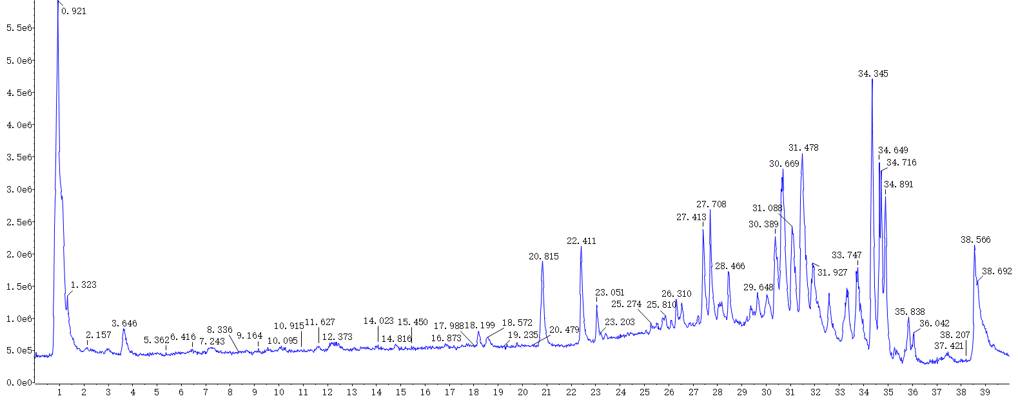
Fig1: The total ion chromatogram (TIC) of HGS extract by UHPLC-Q-TOF-MS/MS in negative ion mode.
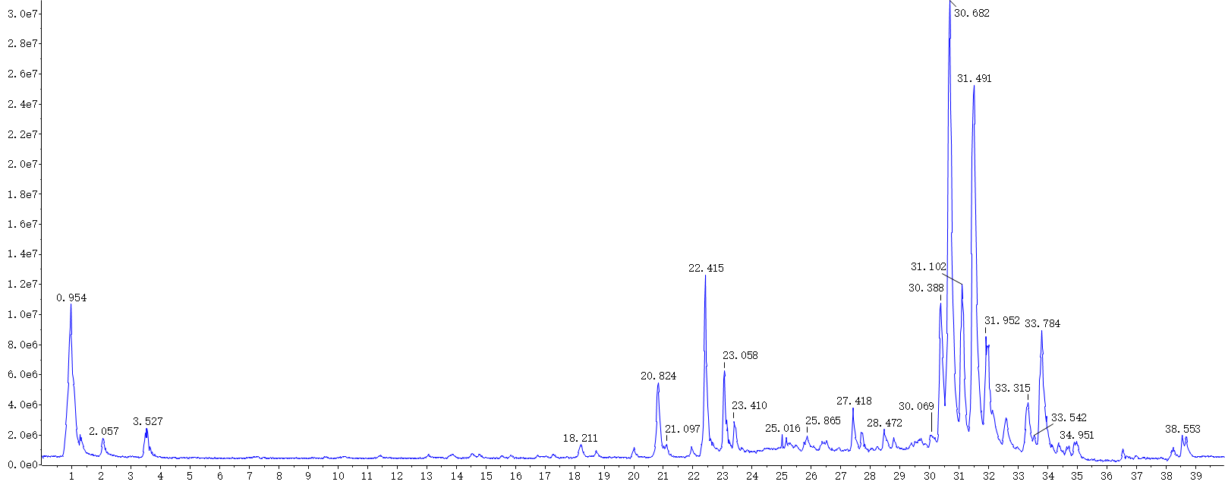
Fig2: The total ion chromatogram (TIC) of HGS extract by UHPLC-Q-TOF-MS/MS in positive ion mode.
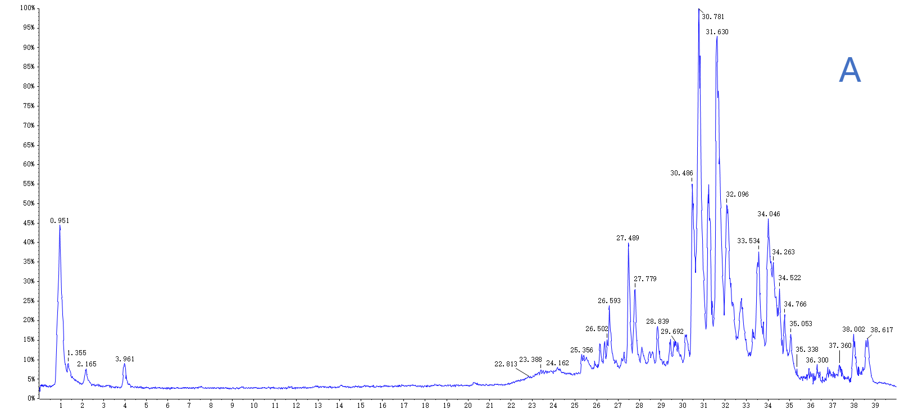
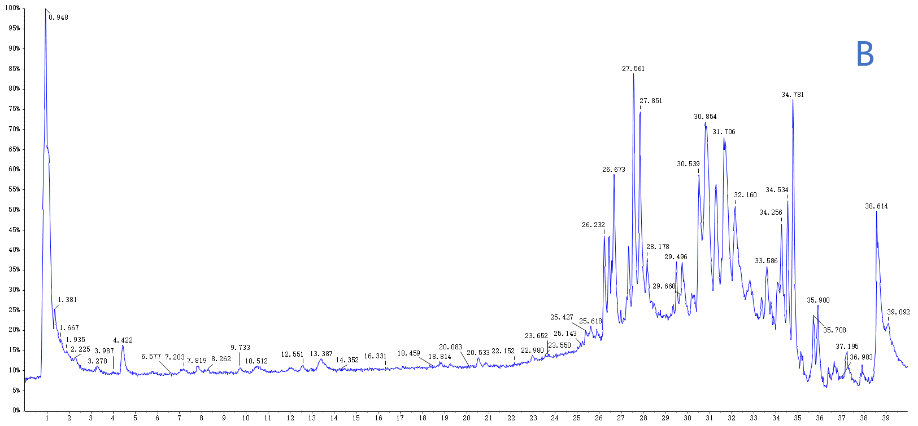
Fig3: The total ion chromatogram (TIC) of HGS at 0.25h into blood by UHPLC-Q-TOF-MS/MS. (A) TIC of HGS in positive ion mode; (B) TIC of HGS in negative ion mode.
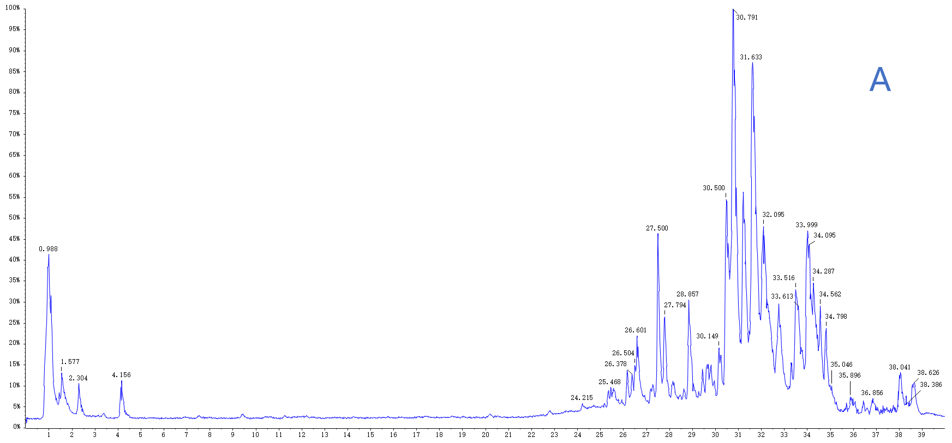
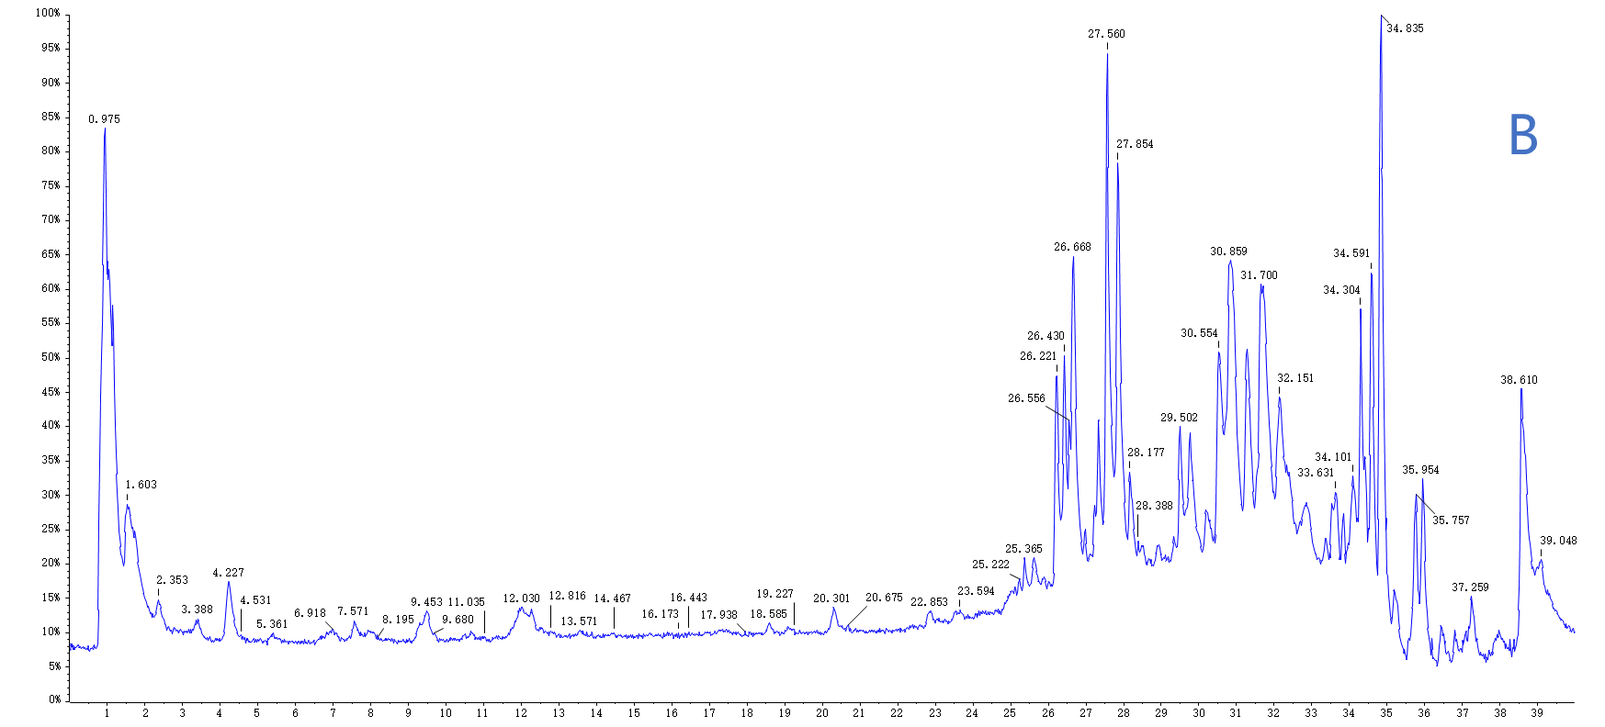
Fig4: The total ion chromatogram (TIC) of HGS at 0.5h into blood by UHPLC-Q-TOF-MS/MS. (A) TIC of HGS in positive ion mode; (B) TIC of HGS in negative ion mode.
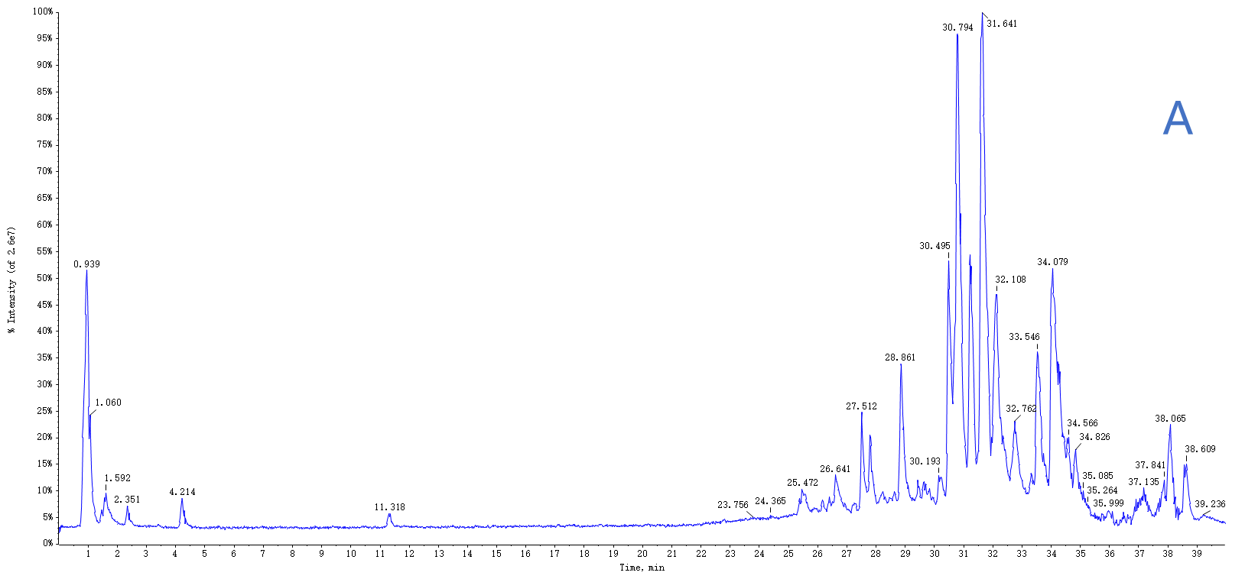
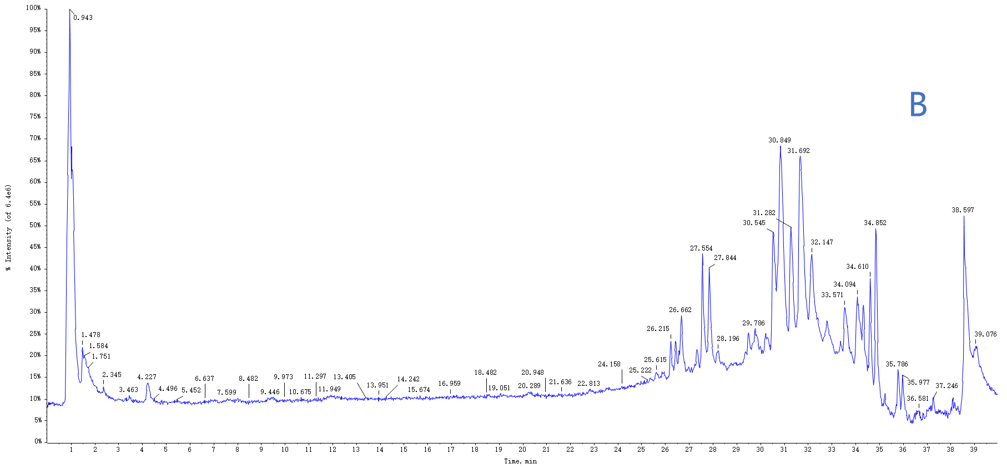
Fig5: The total ion chromatogram (TIC) of HGS at 1h into blood by UHPLC-Q-TOF-MS/MS. (A) TIC of HGS in positive ion mode; (B) TIC of HGS in negative ion mode.
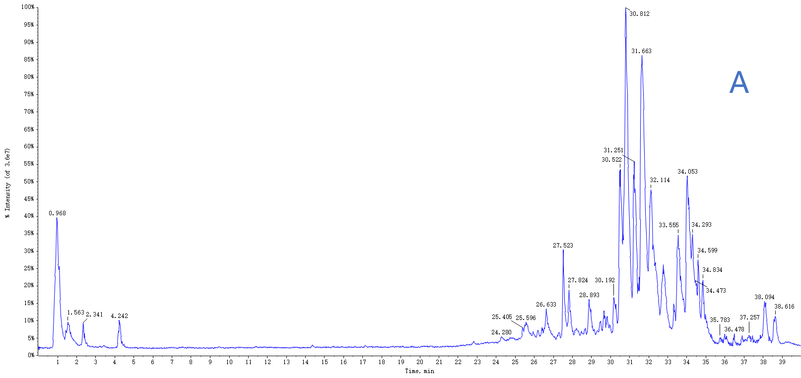
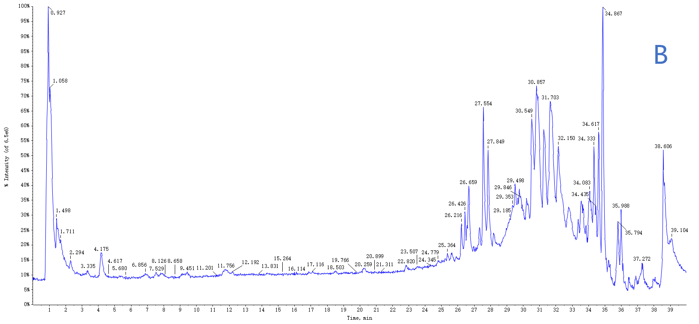
Fig6: The total ion chromatogram (TIC) of HGS at 2h into blood by UHPLC-Q-TOF-MS/MS. (A) TIC of HGS in positive ion mode; (B) TIC of HGS in negative ion mode.
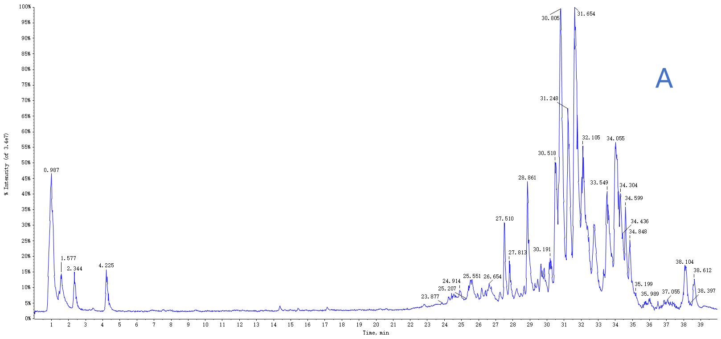
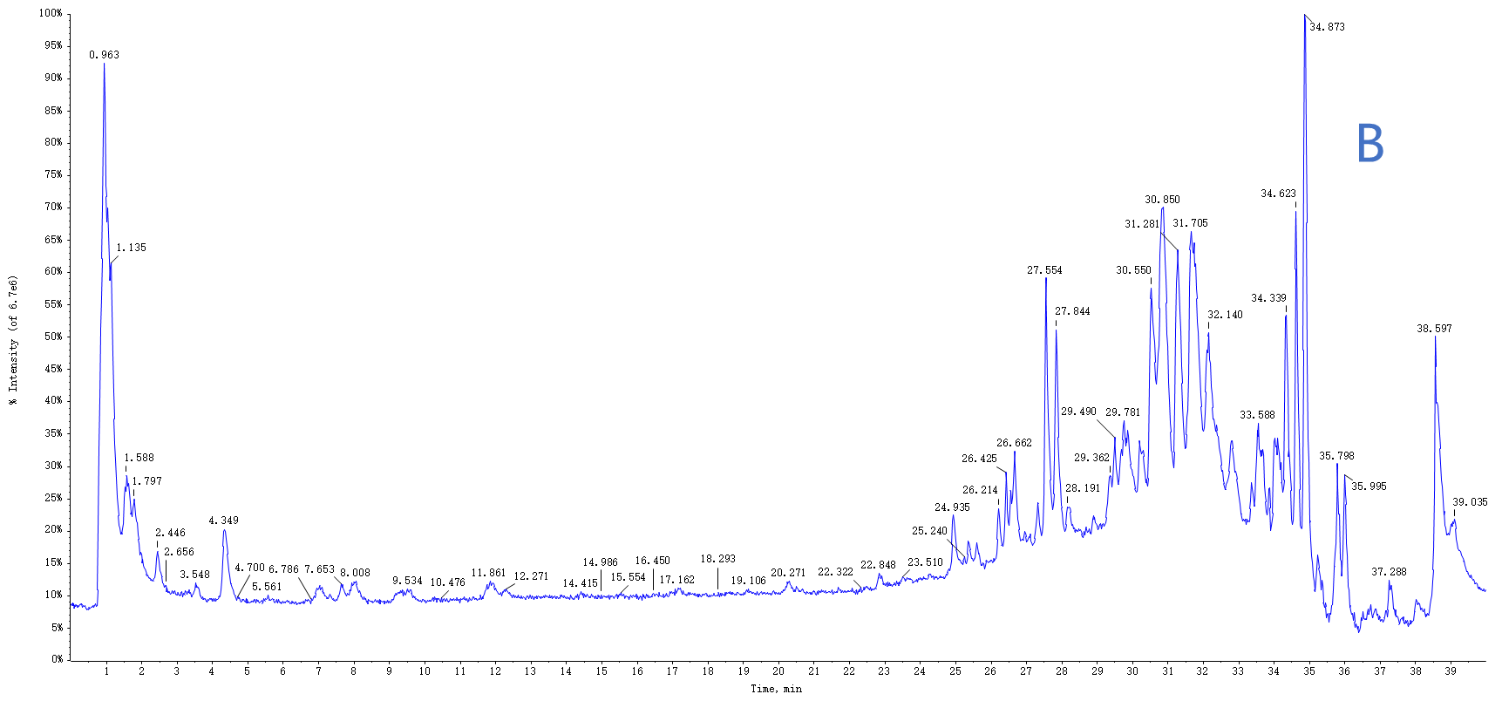
Fig7: The total ion chromatogram (TIC) of HGS at 4h into blood by UHPLC-Q-TOF-MS/MS. (A) TIC of HGS in positive ion mode; (B) TIC of HGS in negative ion mode.
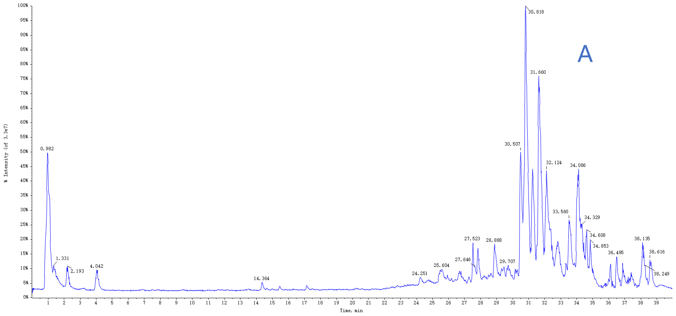
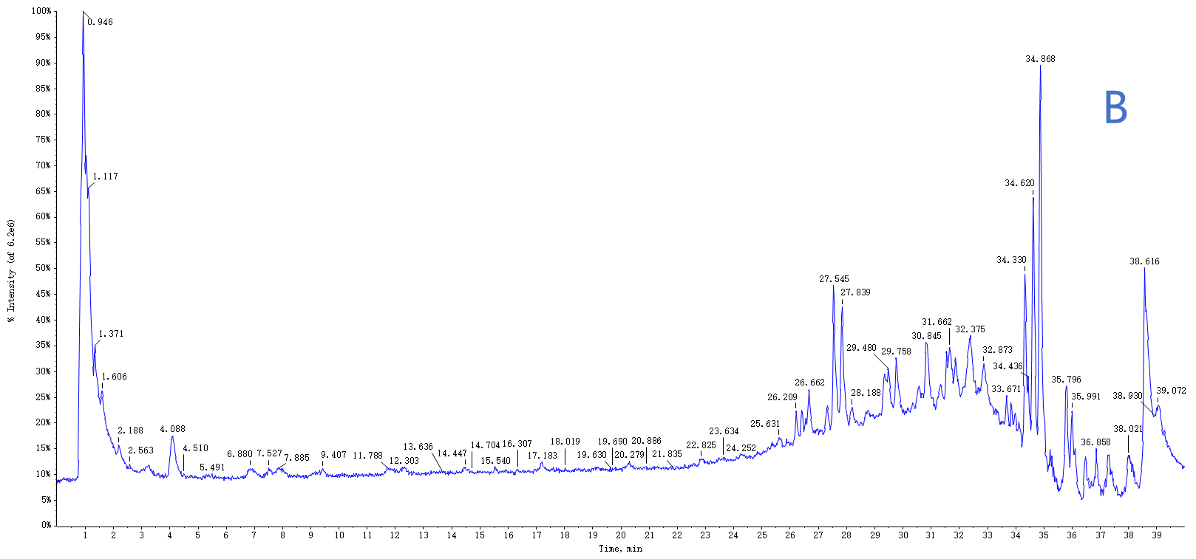
Fig8: The total ion chromatogram (TIC) of HGS at 8h into blood by UHPLC-Q-TOF-MS/MS. (A) TIC of HGS in positive ion mode; (B) TIC of HGS in negative ion mode.

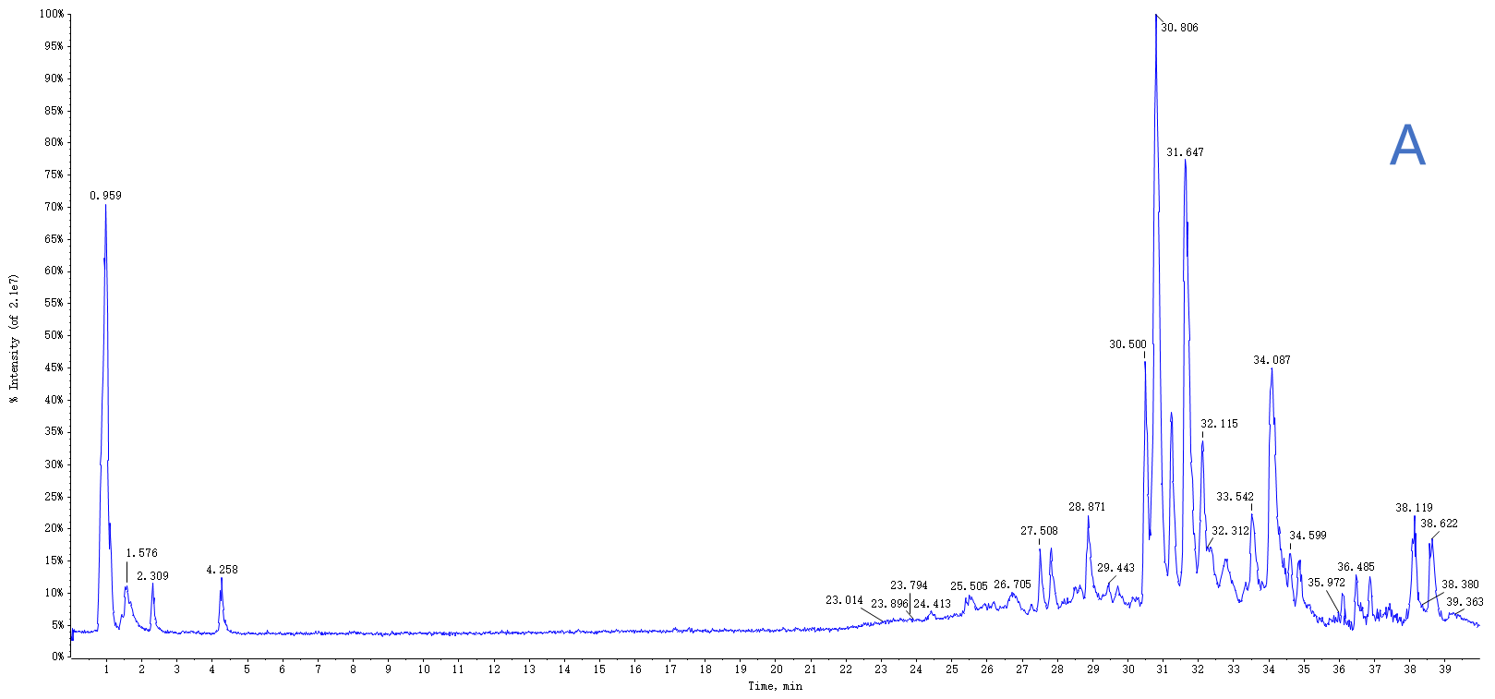
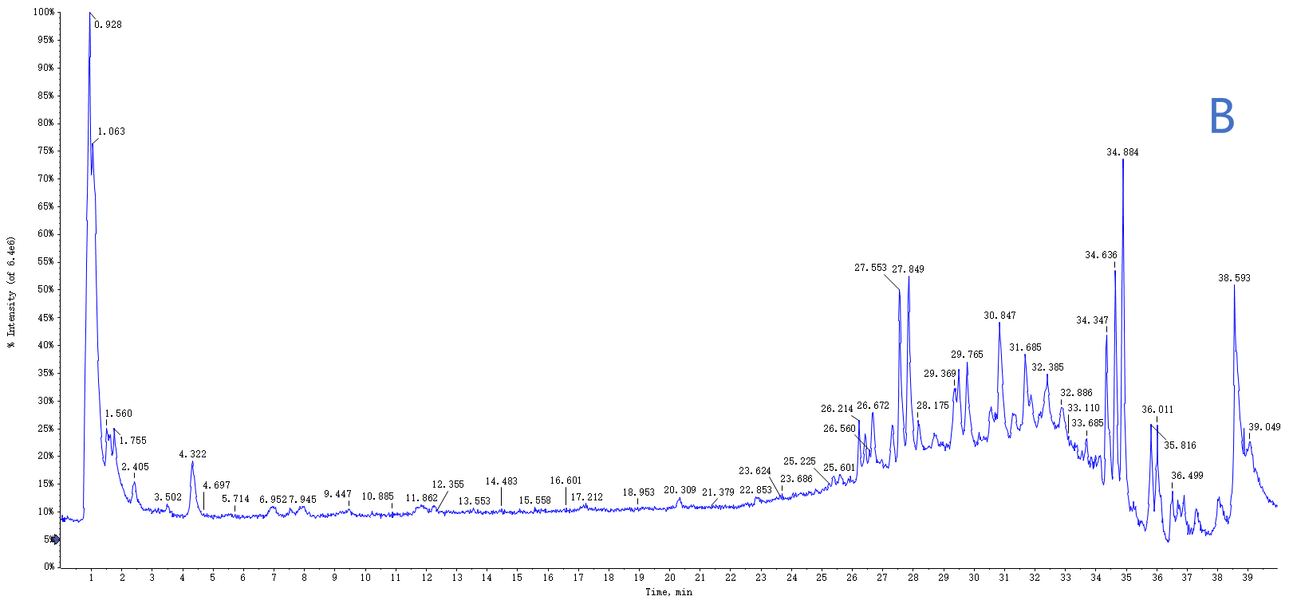
Fig9: The total ion chromatogram (TIC) of HGS at 12h into blood by UHPLC-Q-TOF-MS/MS. (A) TIC of HGS in positive ion mode; (B) TIC of HGS in negative ion mode.
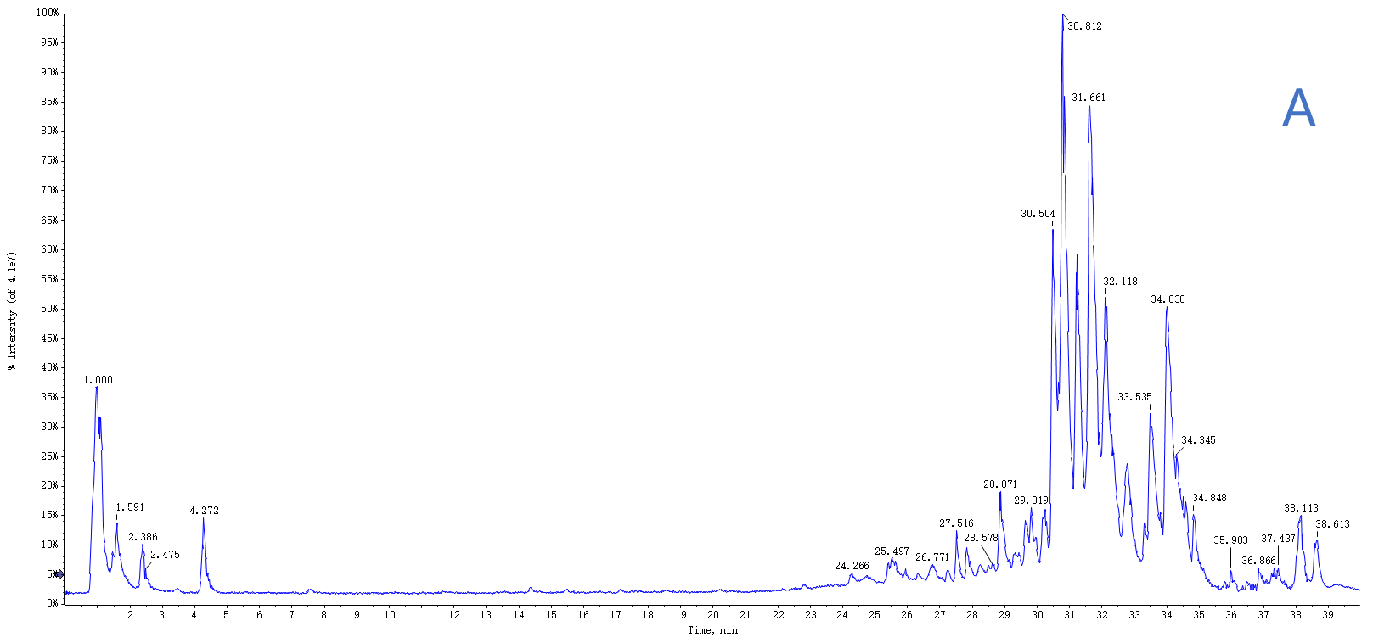
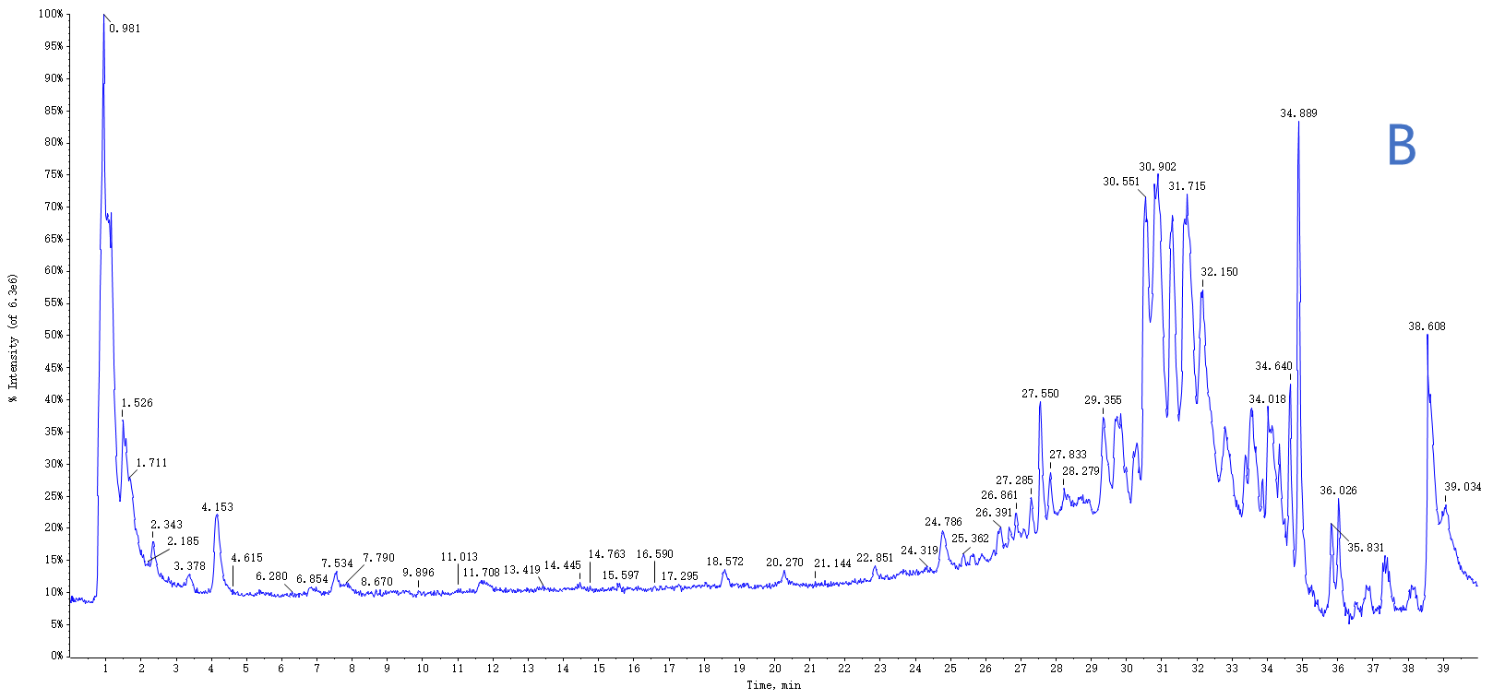
Fig10: The total ion chromatogram (TIC) of HGS at 24h into blood by UHPLC-Q-TOF-MS/MS. (A) TIC of HGS in positive ion mode; (B) TIC of HGS in negative ion mode.
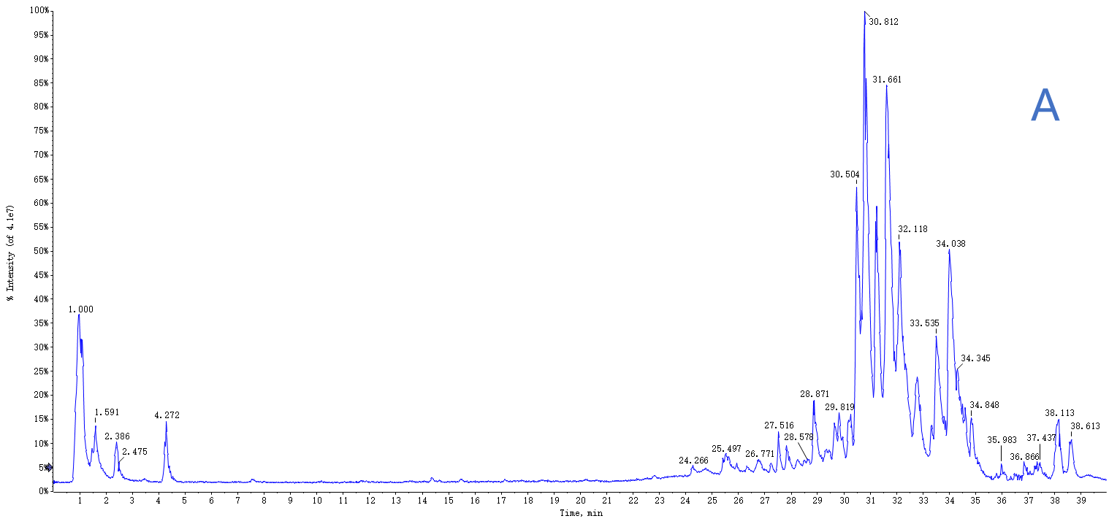
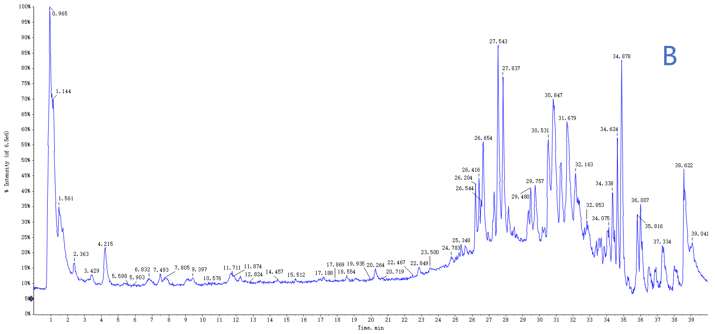
Fig11: The total ion chromatogram (TIC) of samples mixed at each time point of HGS into blood by UPLC/Q-TOF-MS/MS. (A) TIC of HGS in positive ion mode; (B) TIC of HGS in negative ion mode.

