Con | CCAE-Con
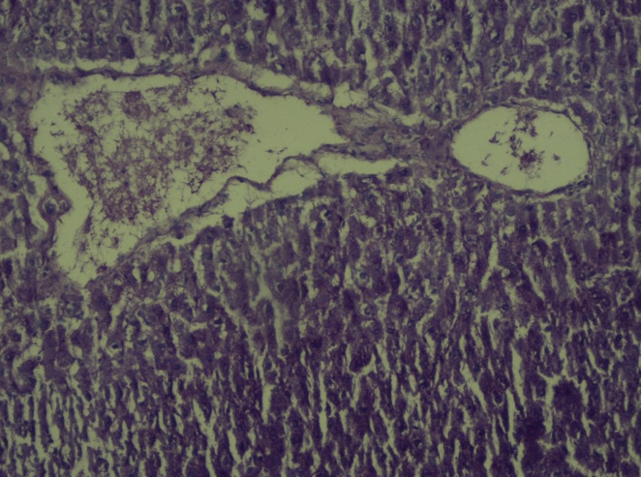 | 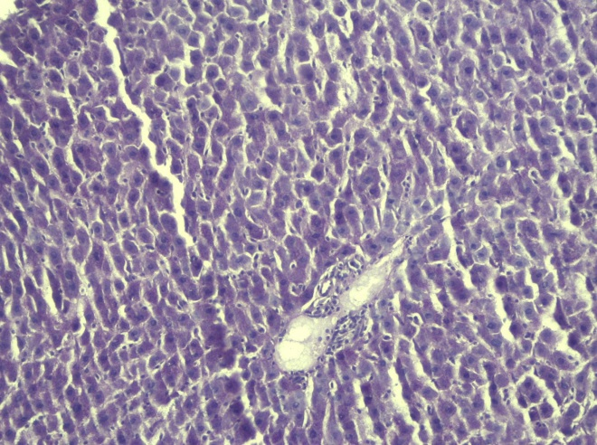
NIA/STZ | CCAE-NIA/STZ
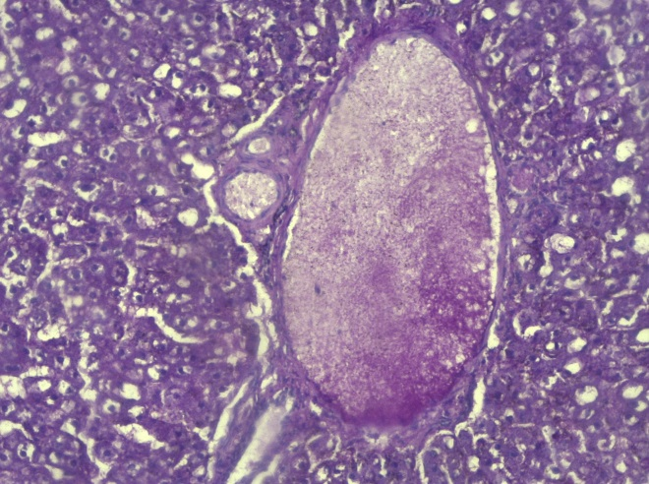 | 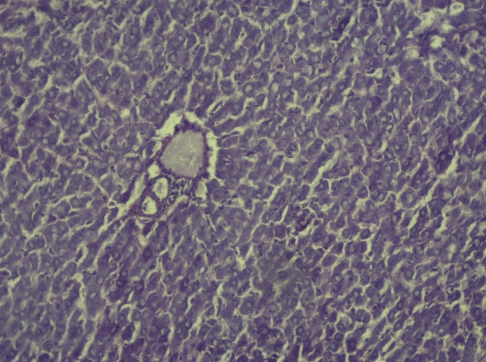
STZ | CCAE-STZ
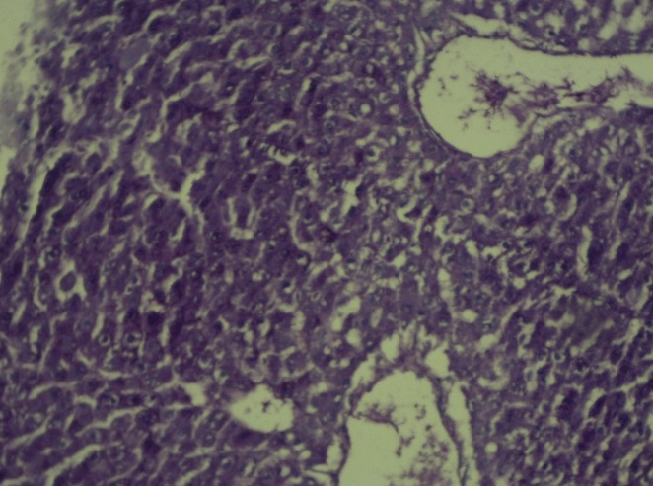 | 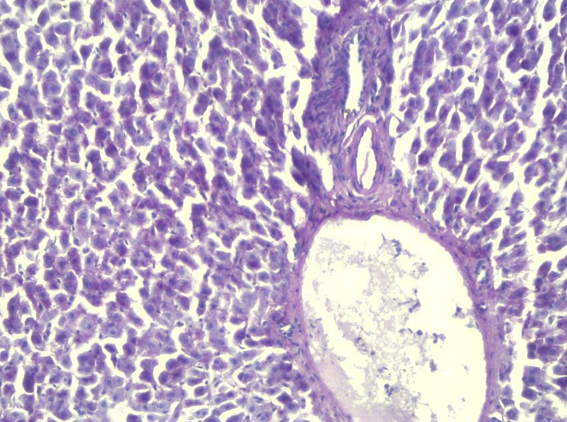

Supplement 2. Periodic acid–Schiff (PAS) was used to detect the polysaccharides glycogen in liver tissue. Except tor STZ, the liver tissues from other groups seemed to contain the same amounts of collagen.

