Con | CCAE-Con
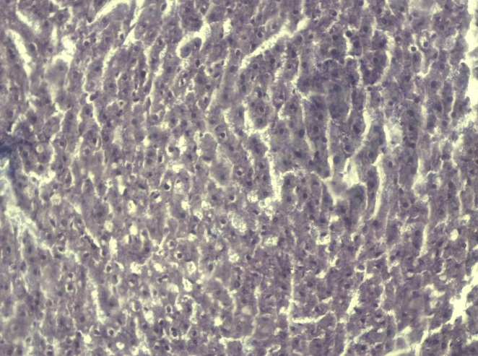 | 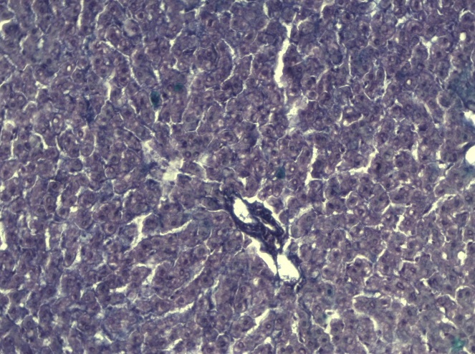
NIA/STZ | CCAE-NIA/STZ
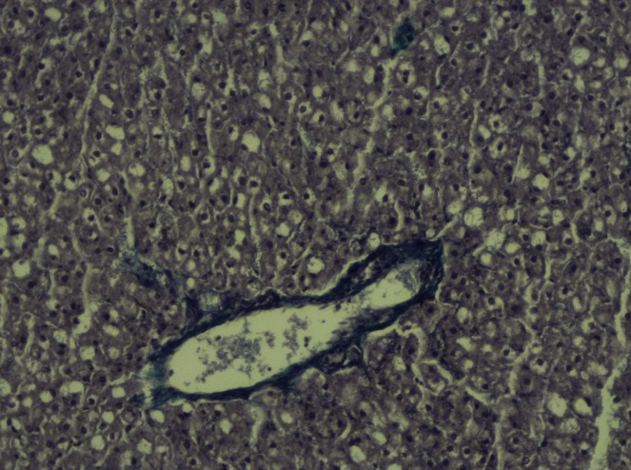 | 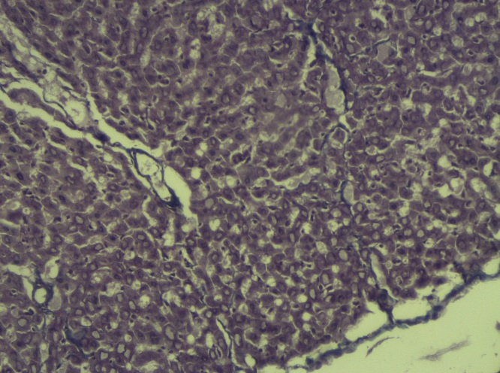
STZ | CCAE-STZ
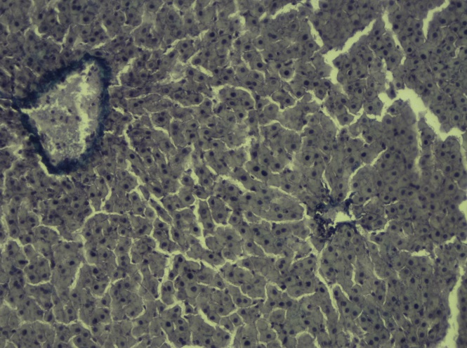 | 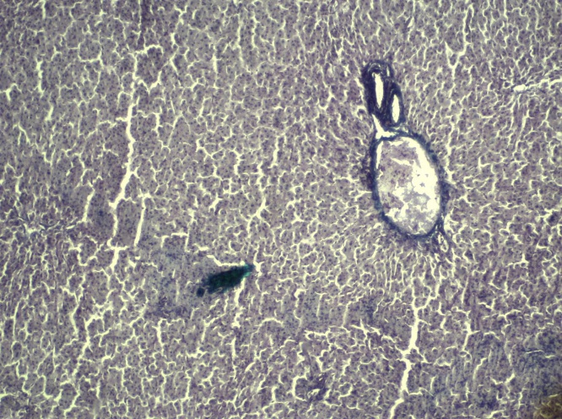

Supplement 1. Masson's Trichrome Staining for the visualization of collagen fibers in liver tissue. Collagen fibers are a sign of fibrosis which was not detected in Con, CCAE-con, NIA/STZ and CCAE-NIA/STZ. However, more collagen fibers were present in the STZ-livers which did not show improvement after CCAE treatment.

