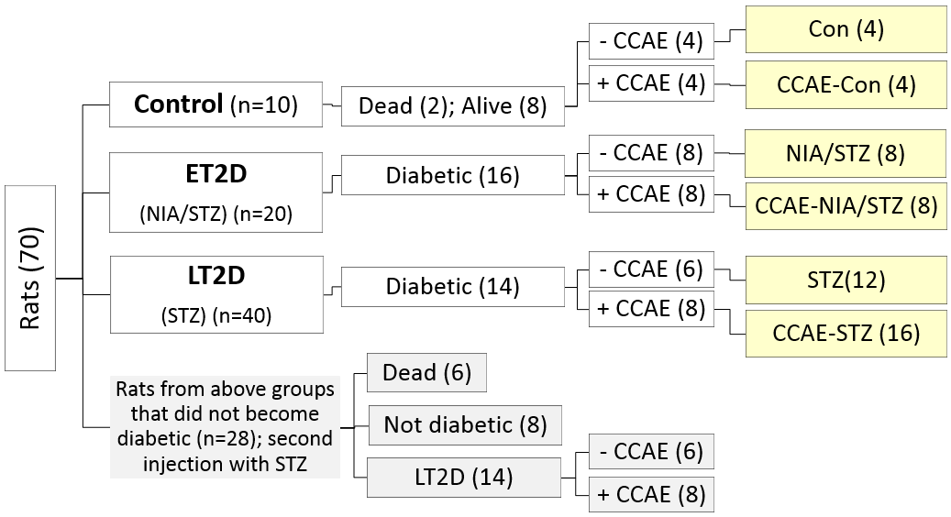
Fig. 1A. Study groups.
The groups of rats after diabetes induction and at the beginning of treatment with the aqueous seed extract of C. colocynthis (CCAE). At the end of the study, the six groups of rats included: Con (4), CCAE-Con (4), NIA/STZ (8), CCAE-NIA/STZ (8), STZ (12), CCAE-STZ (14 were alive on day 28).

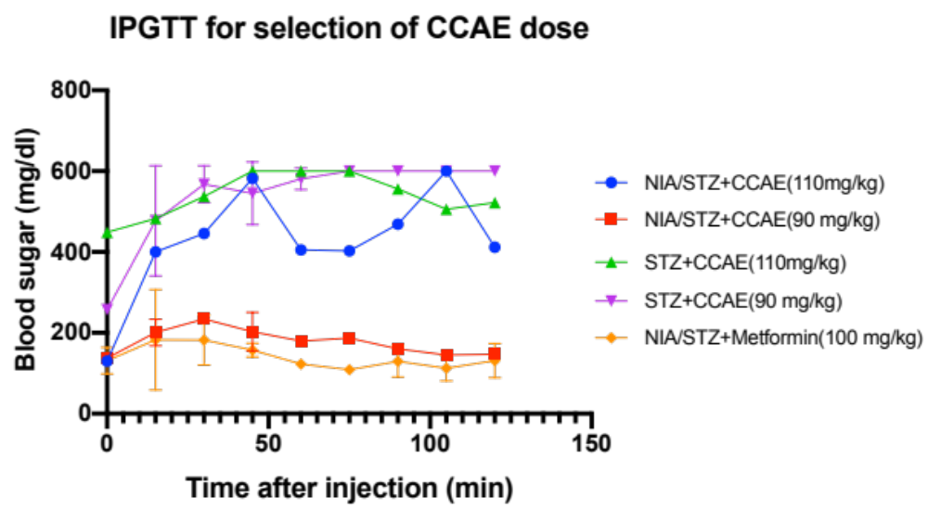
Fig. 1B. Determination of CCAE dosage.
After initial measuring of FBS in overnight starved rats, glucose (2 g/kg body weight) together with the aqueous extract CCAE (90 or 110 mg/kg body weight) or metformin (100 mg/kg), dissolved in 0.3 ml of 0.9% normal saline, were i. p. injected. Blood sugar, measured at 15 min intervals in a drop of blood from the tail by glucometer, decreased significantly in NIA/STZ+ CCAE (90 mg/kg) and NIA/STZ+ Met (100 mg/kg) groups indicating the acute or short-term hypoglycemic effect of CCAE in early stage diabetes. The two hour blood sugar did not change in the STZ groups (n=2 in each group).

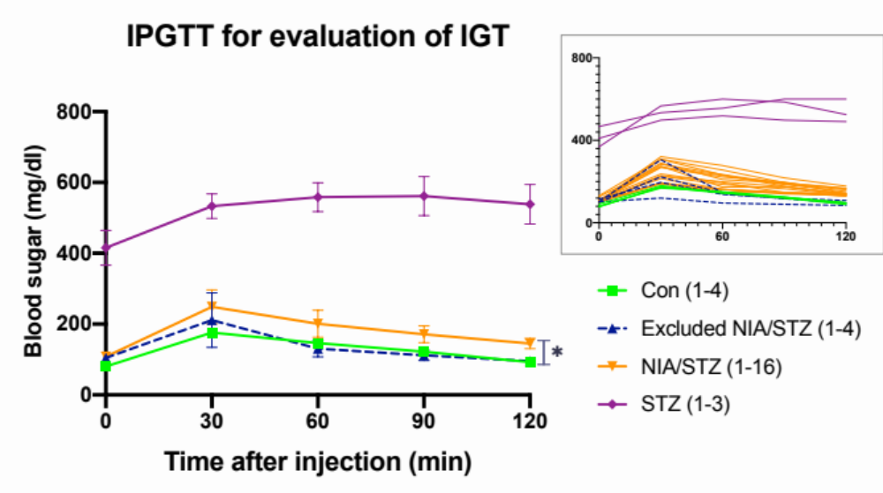
Table 1. Area under curve (AUC) for data in the above graph.
Con | Excluded NIA/STZ members | NIA/STZ | STZ
6317 ± 242.7 | 7016 ± 1740 (p=0.91) | 12820 ± 1431 (p<0.001) | 54290 ± 1974 (p<0.0001)
P values given inside the parentheses in the table are as compared to Con. The p values for the Excluded NIA/STZ members vs. NIA/STZ and the NIA/STZ vs. STZ were p<0.001 and p<0.0001, respectively.

Fig. 1C. The status of glucose tolerance in diabetic rats.
After overnight starvation, FBS was measured, and glucose (2 g/kg body weight dissolved in normal saline) was i. p. injected. Blood sugar was measured at 30 min intervals. At the end of 2h, blood sugar stayed significantly higher than normal in the NIA/STZ and STZ groups. Each line depicts the average value of blood sugar ± SD, at each time. Four members of NIA/STZ group with normal IGT were excluded from the study. The spaghetti representation in the inset is meant to display the interesting individual variations among the diabetic rats (the lines with a common color are represented by a line of the same color in the main graph). The differences among the average blood sugar values at 120 min after injection [for members of the STZ group (538.66 ± 55.77); NIA/STZ group (145.31 ± 14.84); excluded members of NIA/STZ group (95.75 ± 9.81); and Con (92.33± 4.36)] and the AUCs, given in the corresponding Table above were statistically significant; *p<0.001. AUC is a measure of insulin resistance (IR) and the data imply the existence of varying degrees of IR in ET2D and LT2D groups.

