Supplementary Files
Tailored graphene oxide-doped homogeneous braid reinforced cellulose acetate hollow fiber membranes with controllable structure
Wei Zhao¹ , Xin jin^{1*}, Kaikai Chen^{2*} ,Haoyang Ling³ ,Zuwei Fan², Changfa Xiao^{1,2,}
¹ School of Materials Science and Engineering, and State Key Laboratory of Separation Membranes and Membrane Processes, Tiangong University, Tianjin 300387, China
² Fiber Materials Research Center, School of Textiles and Fashion, Shanghai University of Engineering Science, Shanghai 201620, China
³ CAS Key Laboratory of Bio-inspired Materials and Interfacial Science, Technical Institute of Physics and Chemistry, Chinese Academy of Sciences, Beijing 100190, P. R. China.

S1 The casting solution with different GO content 2
S2 The self-made laboratory spinning spinneret 3
S3 The surface morphologies of CG hollow fiber composite membranes 4
S4 The breaking strength and elongation at break of the prepared membranes 5

S1 The casting solution with different GO content
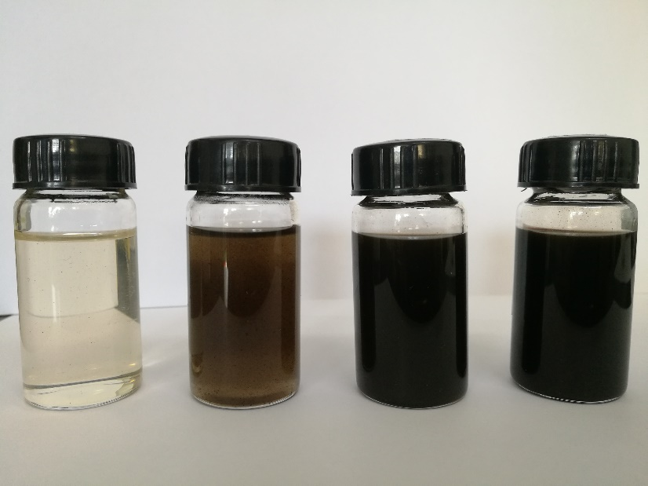
Fig S1. The casting solution with different GO content(CG-0 to -4)

S2 The self-made laboratory spinning spinneret
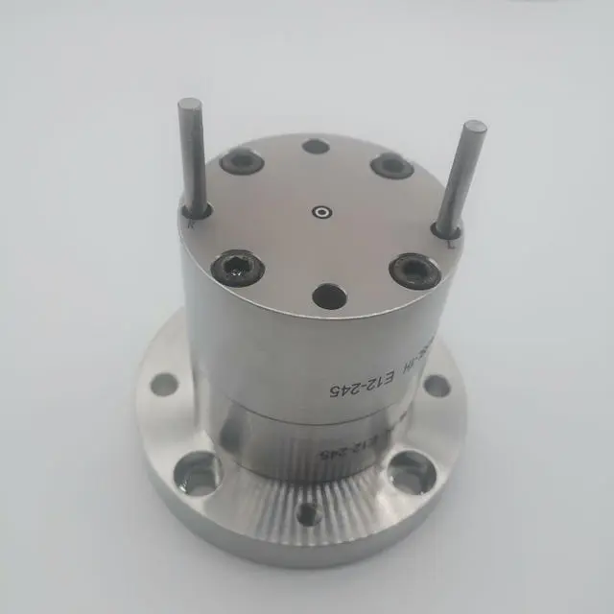
Fig S2. self-made laboratory spinning spinneret

S3 The surface morphologies of CG hollow fiber composite membranes
Figure S3. The surface morphologies of CG hollow fiber composite membranes

S4 The breaking strength and elongation at break of the prepared membranes
Table S1 The breaking strength and elongation at break of the prepared membranes
Membrane | CG-0 | CG-1 | CG-2 | CG-3
Tensile strength (MPa) | 28.2 | 31.8 | 36.1 | 33.3
Breaking elongation (%) | 14.8 | 16.2 | 16.9 | 16.0

