High dose aerosol challenge with Mycobacterium tuberculosis fails to overcome BCG vaccination-induced protection in cynomolgus macaques of Chinese origin: implications of natural resistance for TB vaccine evaluation.

Laura Sibley^{1*}, Andrew D White¹, Karen E Gooch¹, Lisa M Stevens¹, Rachel Tanner², Ashley Jacobs³, Owen Daykin-Pont¹, Fergus Gleeson⁴, Anthony McIntyre⁴, Randall Basaraba⁵, Simon Clark¹, Graham Hall¹, Geoff Pearson¹, Emma Rayner¹, Helen McShane², Ann Williams¹, Mike Dennis¹, Philip D Marsh¹, Sally Sharpe¹.

¹Public Health England, National Infection Service, Porton Down, Wiltshire, SP4 0JG, UK.
²The Jenner Institute, Nuffield Department of Medicine, University of Oxford, Oxford, UK
³University of Cape Town, Cape Town, South Africa
⁴Churchill Hospital, Headington, Oxford, UK
⁵Colorado State University, Fort Collins, Colorado, USA

*Corresponding author: Tel +441980 619864
Email: laura.sibley@phe.gov.uk

Key words
Tuberculosis, BCG, vaccine, non-human primate, aerosol challenge, Mycobacterium tuberculosis, monocyte:lymphocyte ratio
Running title, BCG protects cynomolgus macaques against aerosol M. tuberculosis challenge Supplementary data

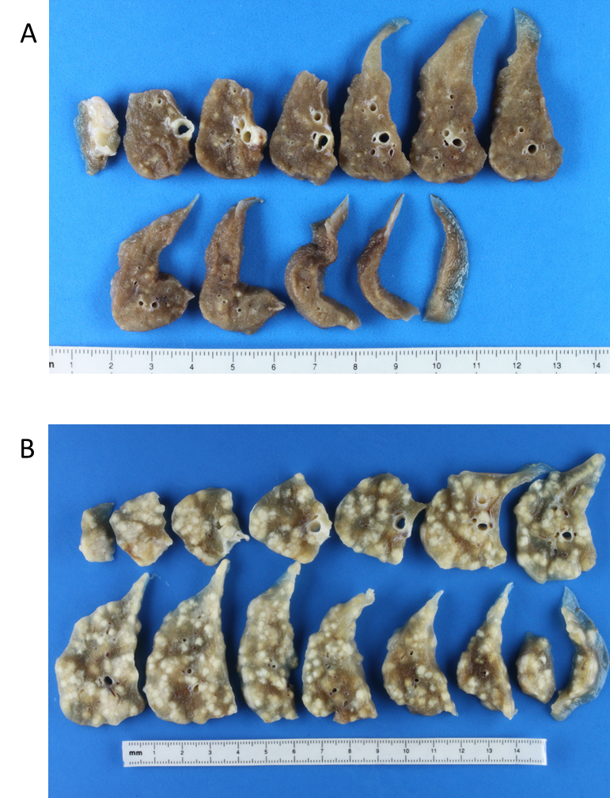

Supplementary data 1. Representative images of lung lobes of macaques after infection with M. tb. A) BCG vaccinated animal (3651) right lower lung lobe B) unvaccinated animal (1027) right lower lobe.

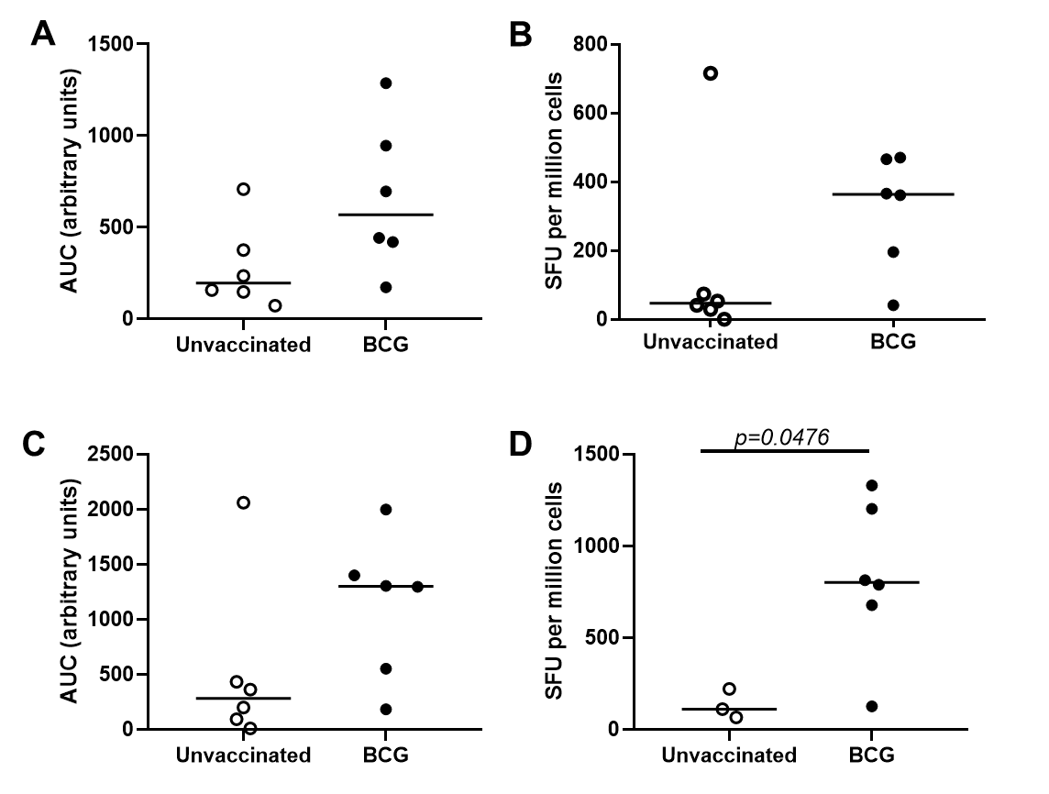

Supplementary data 2. PPD-specific ELISPOT analysis. A) AUC of the vaccination phase, B) SFU at week 2 post-infection, C) AUC week 20-25, D) SFU at week 12 post-infection (week 33).

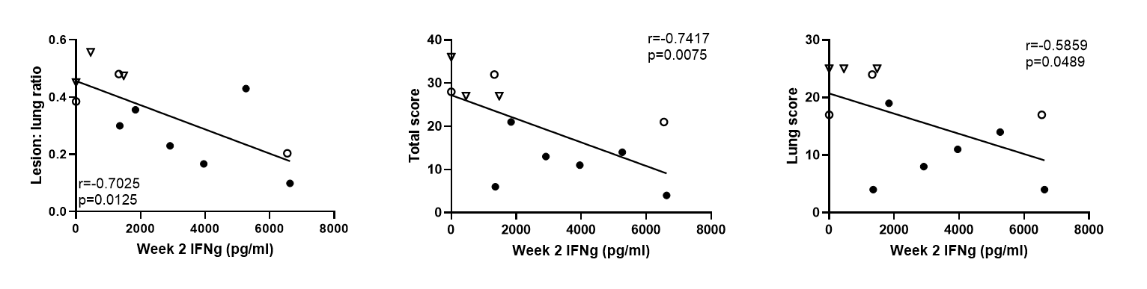

Supplementary data 3. Correlations between disease readouts with IFNγ measured in stimulated whole blood supernatants as measured by ELISA

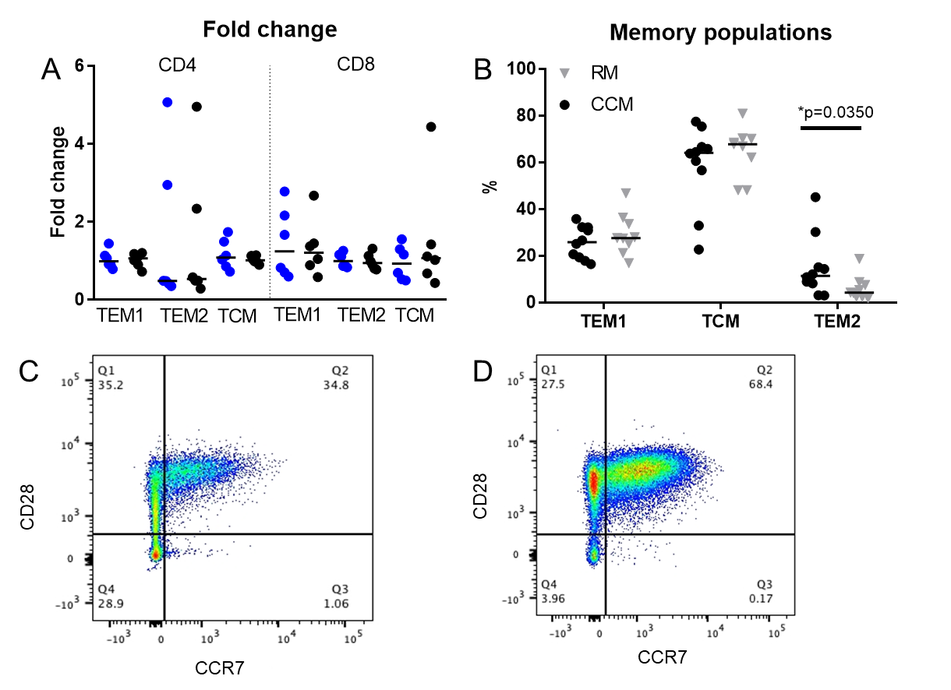
Supplementary data 4. Analysis of memory populations in CCM at week 20 post-vaccination and comparison to RM memory populations at baseline. A) Fold change in TEM1, TEM2 and TCM populations between baseline and week 20 post-vaccination in BCG vaccinated (blue) and control animals (black) in CD4+ and CD8+ T-cells. B) Comparison of TEM1, TEM2 and TCM populations in CCM (black circles) and RM (grey triangles) at baseline. Mann-whitney T-test performed p=0.05. C) Flow cytometry plot showing the staining pattern which determines TEM1 (CCR7⁻ CD28⁺), TCM (CCR7⁺ CD28⁺) and TEM2 (CCR7⁻ CD28⁻) populations in CCM. D) Flow cytometry plot showing the staining pattern which determines TEM1 (CCR7⁻ CD28⁺), TCM (CCR7⁺ CD28⁺) and TEM2 (CCR7⁻ CD28⁻) populations in RM.

Supplementary data 5: cell population data from the haematology analyser (IDEXX). Cell counts of lymphocytes, monocytes, neutrophils and eosinophils post vaccination and up to week 12 post-infection. Comparison of lymphocytes, monocytes and granulocytes at week 4 post-infection.

Supplementary data 6: correlation of M:L at baseline with total pathology score.

Supplementary data 7: Monocyte subsets defined using CD14⁺ and CD16⁺ in PBMCs at baseline. Classical monocytes (CD14⁺ CD16⁺), intermediate (CD14⁺ CD16⁺) and non-classical (CD14⁻ CD16⁺).

