Efficacy and safety of CT-P59 plus standard of care: a phase 2/3 randomized, double-blind, placebo-controlled trial in outpatients with mild-to-moderate SARS-CoV-2 infection
Michael G. Ison^{1,7}, Anca Streinu-Cercel^{2,7}, Oana Săndulescu^{2,7}, Liliana-Lucia Preotescu², Yeon-Sook Kim³, Jin Yong Kim⁴, Shin Hyea Cheon³, Young Rock Jang⁴, Sang Joon Lee⁵, Sung Hyun Kim⁵, Ilsung Chang⁵, Jee Hye Suh⁵, Seul Gi Lee⁵, Mi Rim Kim⁵, Da Rae Chung⁵, Han Na Kim⁵, Adrian Streinu-Cercel^{2,8} and Joong Sik Eom^{6,8*}
¹Divisions of Infectious Diseases and Organ Transplantation, Northwestern University Feinberg School of Medicine, Chicago, IL, USA. ²National Institute for Infectious Diseases "Prof. Dr. Matei Balș", Carol Davila University of Medicine and Pharmacy, Bucharest, Romania. ³Division of Infectious Diseases, Chungnam National University School of Medicine, Daejeon, Republic of Korea. ⁴Division of Infectious Diseases, Department of Internal Medicine, Incheon Medical Center, Republic of Korea. ⁵Celltrion, Inc., Incheon, Republic of Korea. ⁶Division of Infectious Diseases, Gil Medical Center, Gachon University College of Medicine, Incheon, Republic of Korea. ⁷These authors contributed equally: Michael G. Ison, Anca Streinu-Cercel, Oana Săndulescu. ⁸These authors contributed equally: Adrian Streinu-Cercel, Joong Sik Eom.

Supplementary Information
Contents
Supplementary methods | 3
Study design | 3
Complete eligibility criteria | 3
Study drug | 7
SARS-CoV-2 symptom checklist | 8
Anti-drug antibody, pharmacokinetic, and virology assessments | 9
Secondary efficacy endpoints | 10
Exploratory endpoints | 10
Sample size calculation | 11
Analysis populations | 11
Data presentation | 11
Supplementary Table 1. Concomitant medications (safety population) | 13
Supplementary Table 2. Summary of analysis populations | 15
Supplementary Table 3. Summary of viral serology (intent-to-treat infected population) | 16
Supplementary Fig. 1. Kaplan-Meier plot of primary endpoint ‘time to negative conversion’ with SARS-CoV-2–negative titer threshold of 3.0 log10 copies/ml (intent-to-treat infected population) | 17
Supplementary Fig. S2. Mean (standard error) change from baseline of viral load titer versus time by treatment group (intent-to-treat infected population) | 18
Supplementary Fig. 3. Mean (standard deviation) serum concentrations of CT-P59 (pharmacokinetic population) | 19

Supplementary methods
Study design. A phase 2/3, randomized, placebo-controlled, double-blind, parallel-group study (NCT04602000; EudraCT: 2020-003369-20) in outpatients with mild-to-moderate severe acute respiratory syndrome coronavirus 2 (SARS-CoV-2) infection. Part 1 of the study (reported to 28 days in the present manuscript) comprised three periods: screening (days –7 to day 1), treatment (day 1 to day 90 end-of-treatment [EOT] visit), and follow-up (EOT visit to day 180). Part 2 is ongoing and results will be reported separately. Participants completed study visits during the treatment period by visiting the study center, confinement in the study center, or via home visiting services provided by healthcare professionals (dependent on local regulations). Follow-up will be completed via biweekly telephone calls.
Complete eligibility criteria
Inclusion criteria:
- Adults aged ≥18 years
- Diagnosed with SARS-CoV-2 infection at screening using the sponsor-supplied rapid SARS-CoV-2 diagnostic test or reverse transcription polymerase chain reaction (RT-PCR)
- Oxygen saturation of >94% on room air and not requiring supplemental oxygen
- Onset of symptoms ≤7 days before study drug administration
- ≥1 of the following SARS-CoV-2 infection–associated symptoms ≤7 days before study drug administration: feeling feverish, cough, shortness of breath/difficulty breathing, sore throat, body or muscle pain, fatigue, headache, chills, loss of taste or smell, nasal congestion, nausea/vomiting, diarrhea
- ≥1 of the following SARS-CoV-2 infection–associated symptoms ≤48 hours before study drug administration: feeling feverish, cough, shortness of breath/difficulty breathing, sore throat, body or muscle pain, fatigue, headache
- Provide written, informed consent
- Patient and their partner of childbearing potential to agree to use a highly effective or medically acceptable method of contraception during the course of the study and for 6 months following discontinuation of study drug as specified below: combined estrogen and progesterone–containing, or progesterone-only, hormonal contraception associated with inhibition of ovulation; intrauterine devices; abstinence; male condom with spermicide.
Exclusion criteria:
- Serious condition, defined as: previous or current hospitalization or required hospitalization for treatment of serious SARS-CoV-2–related conditions (severe disease as defined by the World Health Organization, May 27, 2020¹⁹), respiratory distress with respiratory rate ≥30 breaths/min, required supplemental oxygen, experienced shock, complication with other organ failure, and intensive care unit (ICU) monitoring treatment needed at investigator’s discretion
- Receipt of, or planned to receive, any of the following prohibited medications or treatments: drugs with actual or possible antiviral drugs and/or possible anti–SARS-CoV-2 activity including but not limited to remdesivir, chloroquine, hydroxychloroquine, dexamethasone (alternative corticosteroids to dexamethasone), interferon beta-1b, ribavirin, and other immunomodulatory agents and human immunodeficiency virus protease inhibitors (e.g., lopinavir-ritonavir) to treat SARS-CoV-2 infection prior to study drug administration; any SARS-CoV-2 human intravenous immunoglobulin, convalescent plasma for the treatment of SARS-CoV-2 infection prior to study drug administration; any other investigational device or medical product including but not limited to any monoclonal antibody (e.g., tocilizumab, sarilumab), fusion proteins, or biologics for the treatment of SARS-CoV-2 infection prior to study drug administration; used medications that were contraindicated with standard of care; SARS-CoV-2 vaccine prior to study drug administration
- Known allergy or hypersensitivity to monoclonal antibody
- Ongoing or history of active or severe infections (any active infection other than SARS-CoV-2 requiring systemic treatment; severe infection, in the investigator’s opinion, within 30 days prior to the administration of study drug that required parenteral antibiotic use or hospitalization)
- One or more of the following conditions at screening: any uncontrolled clinically significant respiratory disease in the investigator’s opinion (e.g., chronic obstructive pulmonary disease, cystic fibrosis, bronchiectasis, asthma); abnormal liver function values including but not limited to aspartate transaminase, alanine transaminase, or alkaline phosphatase ≥5 times the upper limit of normal; renal impairment (estimated glomerular filtration rate: <30 ml/min/1.73 m²) or undergoing continuous renal replacement therapy, hemodialysis, peritoneal dialysis; history or presence of congestive heart failure with symptoms consistent with New York Heart Association class III or IV functional status within 6 months prior to study drug administration; presence of clinically significant abnormality on a 12-lead electrocardiogram at screening that could compromise the safety of the patient or affect the outcome of the study (based on the investigator's clinical judgment); uncontrolled diabetes mellitus or hypertension, at the discretion of the investigator; any active malignancy; currently immunocompromised, whether due to underlying medical condition (e.g., malignancy, transplantation) or medical therapy (e.g., medications, chemotherapy, radiation); any comorbidity that required surgery within <7 days prior to study drug administration or that was considered life threatening within 30 days prior to study drug administration; any conditions significantly affecting the nervous system (e.g., neuropathic conditions or nervous system damage); evidence of a condition (psychological, emotional problems, any disorders, or resultant therapy) that was likely to invalidate health information, consent, or limit the ability to comply with the protocol requirements in the opinion of the investigator; any medical condition that, in the opinion of the site investigator, could place the patient at an unreasonably increased risk of harm through participation in this study, including any past or concurrent conditions that could preclude randomization to one or more of the assigned treatment arms
- Anticipated transfer to another hospital that was not a study site
- Current or past history of alcohol or drug abuse within 12 months prior to study drug administration
- Treatment with any other investigational device or medical product within 4 weeks prior to study drug administration or 5 half-lives, whichever was longer
- Not likely to complete the study for any reason, in the opinion of the investigator
- Should not participate in the study, in the opinion of general practitioner or the investigator
- Female patients: pregnant, breastfeeding, or planned to become pregnant or breastfeed; male patients: planned to father a child or donate sperm throughout the study (and up to 6 months after study drug administration).
Study drug. CT-P59 was supplied as a sterile, preservative-free solution of SARS-CoV-2 receptor binding domain (RBD) binding monoclonal antibody in a 20-mL single-use vial for intravenous infusion. One vial (16 mL) delivered 960 mg of SARS-CoV-2 RBD binding monoclonal antibody, 13.12 mg of L-histidine, 15.84 mg of L-histidine monohydrochloride monohydrate, 8.0 mg of polysorbate 80, 505.584 mg of L-arginine monohydrochloride, and water for injection.
A placebo vial contained the same excipients as the CT-P59 formulation, excluding the SARS-CoV-2 RBD binding monoclonal antibody.

SARS-CoV-2 symptom checklist
Please check a matching box that describes the intensity for each of the following SARS-CoV-2 infection symptoms:
No. | Intensity (score)  Symptoms | Absent  (0) | Mildª  (1) | Moderate^{b}  (2) | Severe^{c}  (3)
1 | Feeling feverish
2 | Cough
3 | Shortness of breath or difficulty breathing
4 | Sore throat
5 | Body pain or muscle pain
6 | Fatigue
7 | Headache
ªMild: no interference with normal daily activity.
^{b}Moderate: interferes with normal daily activity.
^{c}Severe: prevents normal daily activity.

The checklist consisted of seven symptoms of SARS-CoV-2 infection (fever, cough, shortness of breath or difficulty breathing, sore throat, body pain or muscle pain, fatigue, and headache). Signs and symptoms of SARS-CoV-2 infection recorded in the diary were not reported as adverse events.
Participants completed the checklist twice daily on days 1–28. After day 28, additional completion of the checklist was required as follows: participants who achieved clinical recovery on day 28 completed the checklist until day 28 to confirm maintenance of condition for 48 hours; participants who showed deterioration or did not meet the criteria for clinical recovery completed the checklist until achievement of clinical recovery; participants with a suspicious antibody-dependent enhancement (ADE) occurrence were required to record the entire patient diary for 7 days from the day of ADE occurrence.
Self-reported rating scales for symptom intensity were as follows: absent (0), mild (1: no interference with normal daily activity), moderate (2: interference with normal daily activity), and severe (3: prevented normal daily activity).
Anti-drug antibody, pharmacokinetic, and virology assessments. Serum samples for measurement of anti-drug antibodies (ADAs) were collected at baseline (predose on day 1) and on days 7, 14, and 28. ADAs were measured using a validated electrochemiluminescence method.
For individuals participating in the pharmacokinetic substudy, blood samples for pharmacokinetic assessment were taken predose, at the end of infusion, and at 1, 24, 48, 96, 144, 216 (day 10), 312 (day 14), and 648 (day 28) hours after the start of infusion. Serum concentrations of CT-P59 were measured using a validated electrochemiluminescence method.
Serum samples for viral serology samples were collected at baseline (predose on day 1) and on days 7, 14, and 28. Viral serology with assays detecting serum antibodies (immunoglobulin [Ig] G and IgM) against SARS-CoV-2 was to be performed locally using the serum samples.
Secondary efficacy endpoints. The following endpoints were assessed up to days 7, 14, and 28:
- Proportion of patients with clinical symptoms requiring hospitalization, oxygen therapy, or experiencing mortality due to SARS-CoV-2 infection
- Proportion of patients with conversion to negative quantitative RT-PCR (RT-qPCR)
- Proportion of patients with hospital admission due to SARS-CoV-2 infection
- Proportion of patients requiring supplemental oxygen due to SARS-CoV-2 infection
- Proportion of patients with mechanical ventilation use due to SARS-CoV-2 infection
- Proportion of patients requiring rescue therapy due to SARS-CoV-2 infection
- Proportion of patients with ICU transfer due to SARS-CoV-2 infection
- Proportion of patients with all-cause mortality
- Time to conversion to negative RT-qPCR for nasopharyngeal swab specimen
- Time to clinical recovery.
Exploratory endpoints. The following endpoints were assessed:
- CT-P59 serum concentrations (predose and 1, 24, 48, 96, 144, 216, 312, and 648 hours post-dose)
- Viral shedding in nasopharyngeal swab specimens based on RT-qPCR (predose and days 2, 3, 4, 5, 6, 7, 10, 14, 17, 21, and 28)
- Viral serology for SARS-CoV-2 antibodies (predose and days 7, 14, and 28).
Sample size calculation. A sample size of 100 individuals per group provided at least 80% power at a two-sided significance level of 0.05 to detect an increase in the improvement rate ratio for the primary endpoints, based on the following assumptions:
- 10% of randomly assigned patients were assumed not to satisfy the criteria for the intent-to-treat infected population
- 80% of patients achieve an improvement
- Improvement rate ratio is greater than or equal to 1.6.
Analysis populations. The intent-to-treat population includes all randomly assigned participants. The intent-to-treat infected population includes all randomly assigned patients with a confirmed SARS-CoV-2 infection assessed by pre-infusion RT-qPCR on day 1 and receiving a partial or complete dose of study drug. If the pre-infusion result at day 1 was confirmed negative or missing, and the day 2 result was confirmed positive, the patient was considered as having confirmed SARS-CoV-2 infection. Safety analyses are based on the safety population, which includes all randomized participants who received a partial or full dose of the study drug. Pharmacokinetic analyses are based on the pharmacokinetic population, which includes all participants who provided consent to participate in the pharmacokinetic substudy, received a full dose of CT-P59, and provided ≥1 evaluable post-treatment pharmacokinetic concentration result.
Data presentation. Continuous variables are reported using descriptive statistics, including the number of observations, mean, standard deviation (SD), median, minimum and maximum, and interquartile range.
Categorical variables are summarized using frequency tables showing the number and percentage of participants within each category.
Where available, parametric variables are reported using mean and SD, and non-parametric variables using median and interquartile range.

Supplementary Table 1. Concomitant medications (safety population)
Comcomitant medication | CT-P59  40 mg/kg  n=105 | CT-P59  80 mg/kg  n=110 | CT-P59  combined  n=215 | Placebo  n=110
Patients with ≥1 concomitant medication | 90 (85.7) | 92 (83.6) | 182 (84.7) | 97 (88.2)
Agents acting on the renin-angiotensin system | 27 (25.7) | 28 (25.5) | 55 (25.6) | 41 (37.3)
Analgesics | 70 (66.7) | 72 (65.5) | 142 (66.0) | 64 (58.2)
Antibacterials for systemic use | 10 (9.5) | 18 (16.4) | 28 (13.0) | 19 (17.3)
Anti-inflammatory and antirheumatic products | 10 (9.5) | 8 (7.3) | 18 (8.4) | 10 (9.1)
Antithrombotic agents | 34 (32.4) | 38 (34.5) | 72 (33.5) | 41 (37.3)
Antivirals for systemic use | 0 | 3 (2.7) | 3 (1.4) | 6 (5.5)
Beta-blocking agents | 14 (13.3) | 12 (10.9) | 26 (12.1) | 22 (20.0)
Calcium channel blockers | 9 (8.6) | 7 (6.4) | 16 (7.4) | 8 (7.3)
Corticosteroids for systemic use | 7 (6.7) | 12 (10.9) | 19 (8.8) | 16 (14.5)
Cough and cold preparations | 19 (18.1) | 21 (19.1) | 40 (18.6) | 14 (12.7)
Diuretics | 9 (8.6) | 9 (8.2) | 18 (8.4) | 24 (21.8)
Drugs for acid-related disorders | 13 (12.4) | 14 (12.7) | 27 (12.6) | 12 (10.9)
Drugs for functional gastrointestinal disorders | 2 (1.9) | 1 (0.9) | 3 (1.4) | 9 (8.2)
Drugs for obstructive airway diseases | 6 (5.7) | 9 (8.2) | 15 (7.0) | 12 (10.9)
Drugs used in diabetes | 7 (6.7) | 11 (10) | 18 (8.4) | 11 (10)
Immunosuppressants | 0 | 3 (2.7) | 3 (1.4) | 6 (5.5)
Lipid-modifying agents | 13 (12.4) | 11 (10) | 24 (11.2) | 14 (12.7)
Psycholeptics | 3 (2.9) | 6 (5.5) | 9 (4.2) | 4 (3.6)
Sex hormones and modulators of the genital system | 6 (5.7) | 5 (4.5) | 11 (5.1) | 7 (6.4)
Vitamins | 12 (11.4) | 10 (9.1) | 22 (10.2) | 19 (17.3)
Data shown as n (%). Patients may have received more than one medication per drug class and preferred term
Supplementary Table 2. Summary of analysis populations
Analysis population, n | CT-P59  40 mg/kg | CT-P59  80 mg/kg | Placebo | Total
Intent-to-treat | 105 | 111 | 111 | 327
Intent-to-treat infected | 101 | 103 | 103 | 307
Safety | 105 | 110 | 110 | 325
Pharmacokinetic | 29 | 32 | 27 | 88

Supplementary Table 3. Summary of viral serology (intent-to-treat infected population)
 | CT-P59  40 mg/kg  n=101 | CT-P59  80 mg/kg  n=103 | CT-P59 combined  n=204 | Placebo  n=103
SARS-CoV-2 antibody, IgG positivity, n (%)
Day 1 | 0 | 6 (5.8) | 6 (2.9) | 3 (2.9)
Day 7 | 27 (26.7) | 32 (31.1) | 59 (28.9) | 32 (31.1)
Day 14 | 77 (76.2) | 82 (79.6) | 159 (77.9) | 86 (83.5)
Day 28 | 84 (83.2) | 94 (91.3) | 178 (87.3) | 91 (88.3)
SARS-CoV-2 antibody, IgM positivity,
n (%)
Day 1 | 2 (2.0) | 6 (5.8) | 8 (3.9) | 4 (3.9)
Day 7 | 38 (37.6) | 43 (41.7) | 81 (39.7) | 49 (47.6)
Day 14 | 78 (77.2) | 82 (79.6) | 160 (78.4) | 87 (84.5)
Day 28 | 59 (58.4) | 77 (74.8) | 136 (66.7) | 65 (63.1)
Ig, immunoglobulin; SARS-CoV-2, severe acute respiratory syndrome coronavirus 2.

Supplementary Fig. 1. Kaplan-Meier plot of primary endpoint ‘time to negative conversion’ with SARS-CoV-2–negative titer threshold of 3.0 log₁₀ copies/ml (intent-to-treat infected population) up to Day 28. SARS-CoV-2, severe acute respiratory syndrome coronavirus 2.
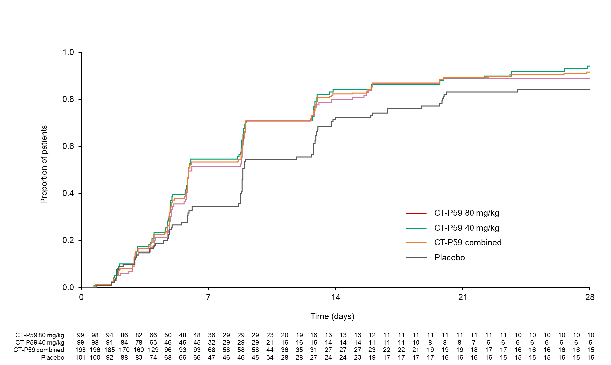

Supplementary Fig. S2. Mean (standard error) change from baseline of viral load titer versus time by treatment group (intent-to-treat infected population).
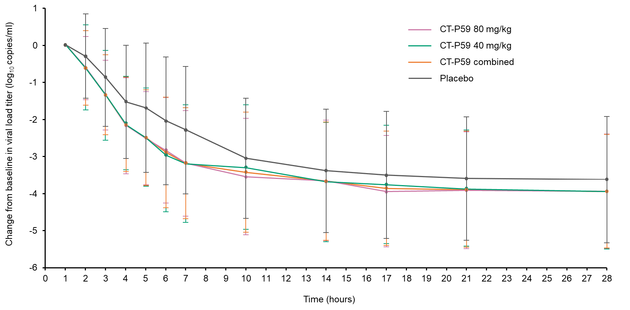

Supplementary Fig. 3. Mean (standard deviation) serum concentrations of CT-P59 (pharmacokinetic population).
