Low-Temperature Catalytic Oxidation of Glycerol to Glyceric Acid over Zr@MCM-41 Supported Pt Catalyst

Yi-Hu Ke*, Huanhuan Xu, Hongyu Qin, Xue Wang, Hai Liu, Hong Yuan
（Key Laboratory of Chemical Engineering and Technology, State Ethnic Affairs Commission, Ningxia Key Laboratory of Solar Chemical Conversion Technology, North Minzu University, Yinchuan, 750021, China）
* To whom correspondence should be addressed. E-mail: keyihu123@nmu.edu.cn
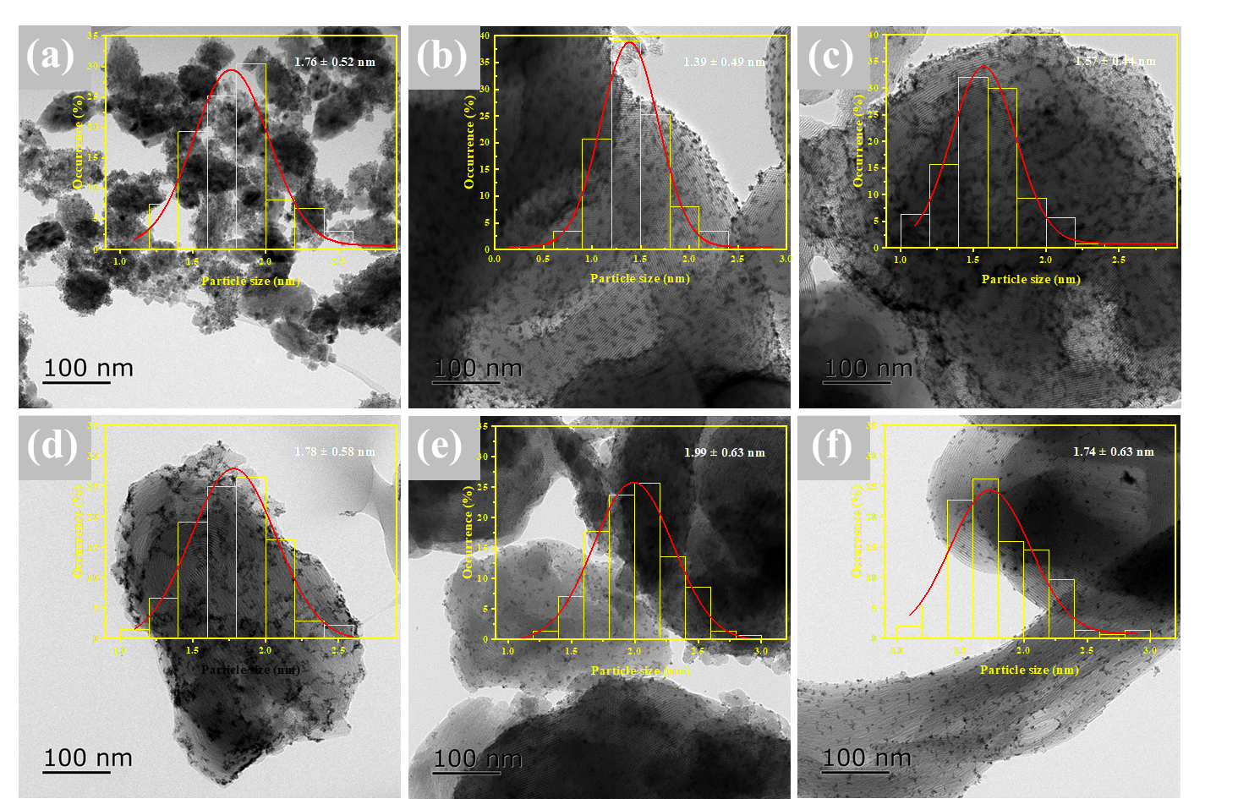
Fig. S1 TEM images and Pt nanoparticles distribution of Pt/Zr@MCM-41-x catalysts. (a) Pt/Zr@MCM-41-30, (b) Pt/Zr@MCM-41-100, (c) Pt/Zr@MCM-41-200, (d) Pt/Zr@MCM-41-300, (e) Pt/Zr@MCM-41-500, (f) Pt/Zr@MCM-41

