Supporting Information for
Estimating frequency-dependent shear wave velocity in near-surface sediment based on seismic interferometry
Hao Zhang¹, Yang Shi¹, Hongjun He¹, Hanwen Ji¹, Yu Miao^{1,2*}
¹School of Civil and Hydraulic Engineering, Huazhong University of Science and Technology. Wuhan 430074, China
²National Center of Technology Innovation for Digital Construction. Wuhan 430074, China

Contents of this file

Text S1
Figures S1 to S6

Introduction
The supplementary materials primarily provide additional details for the data, methods, and results.

Text S1.
We have also considered that whether the dispersion phenomenon is determined by the path effects, such as that the finite-frequency theory indicates that different incident angles may cause the observed phase velocity varies with frequency (Park et al., 2019). However, the observation results rejected this conjecture.
First, only a few seismic signals recorded by KiK-net network meet the requirement of "tele-seismic" in the finite-frequency tomography (Miao et al., 2018). Previous studies have also shown that the incident angle of the near-surface shear wave is close to 90 degrees, which means the shear wave is almost perpendicular to the surface (Nakata & Snieder, 2012). Besides, after the first arrival of the wave, the wave field will be fully diffused under the effect of refraction and reflection, and this is the most of the seismic signals. In this case, the seismic interferometry calculates the transfer function of the sediment between the two sensors. We have compared the results from different parts of the seismic signals, and compared the results from different seismic source mechanisms. The results indicate that the dispersion phenomenon is solely determined by the site sediment.
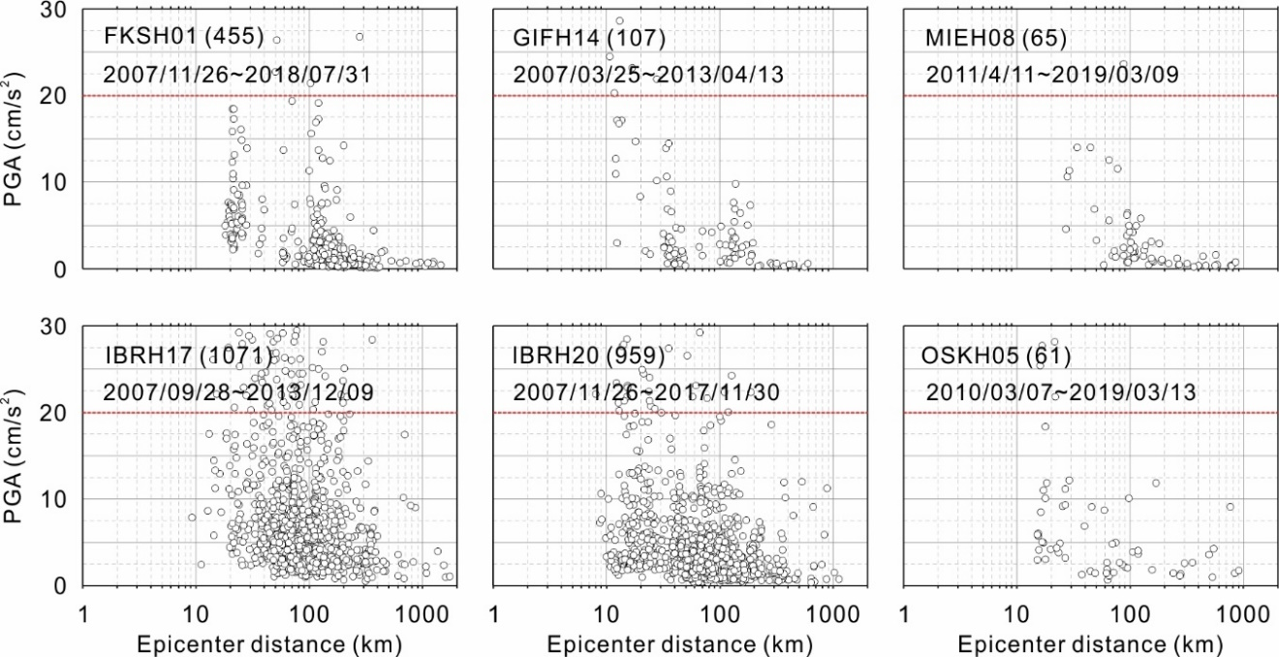

Figure S1. Information of the Seismic signals collected at the six stations.
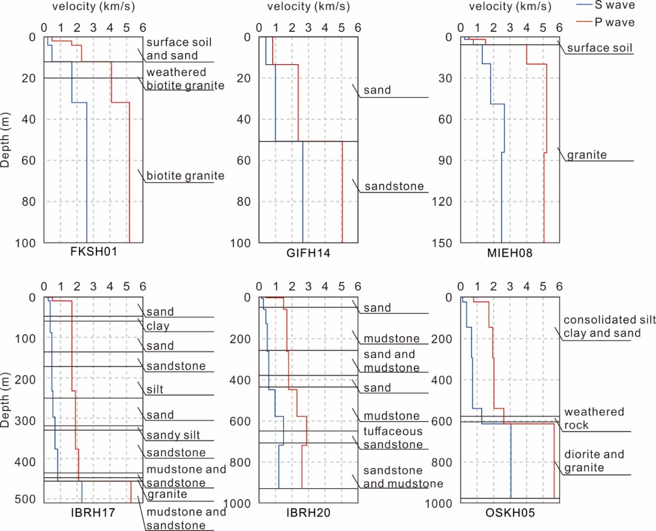

Figure S2. Geological profiles of the six stations.

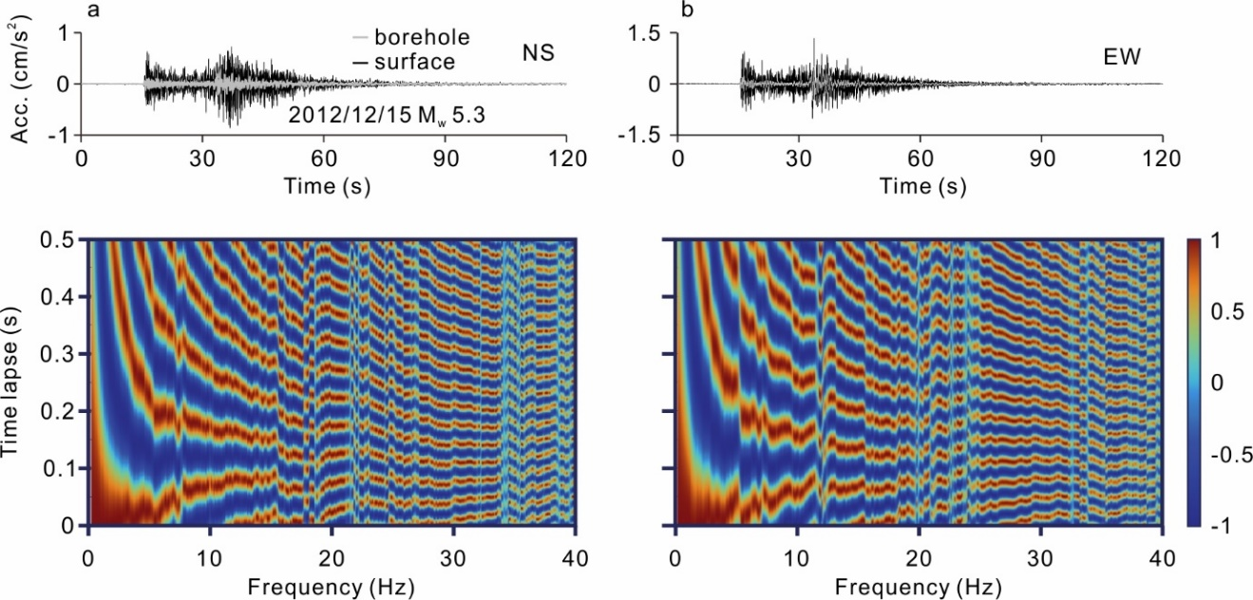

Figure S3. Comparison of the deconvolution waveforms of the seismic signals recoded at the direction of east-west and north-south. The similar results imply that the dispersion phenomenon is not strongly influenced by the sediment anisotropy.

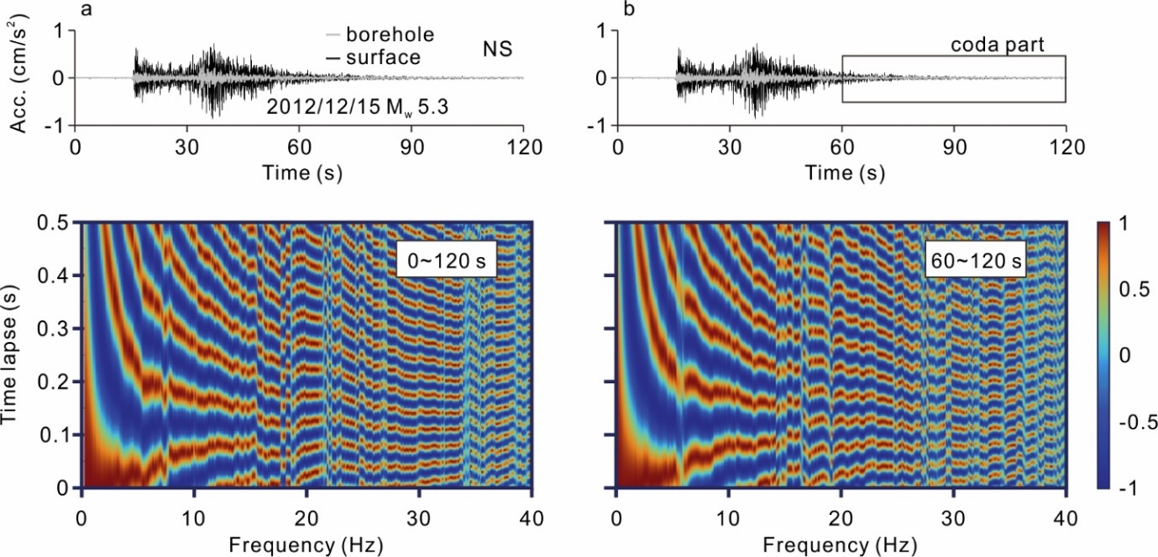

Figure S4. Comparison of the deconvolution waveforms calculated by the full wavefield and coda part of the wavefield. The coda part of the seismic signal is generally believed fully diffused (Takagi & Okada, 2012; Nagaoka et al., 2010), and the similar results imply that the dispersion phenomenon is not strongly influenced by the phase of the first arrival wave.

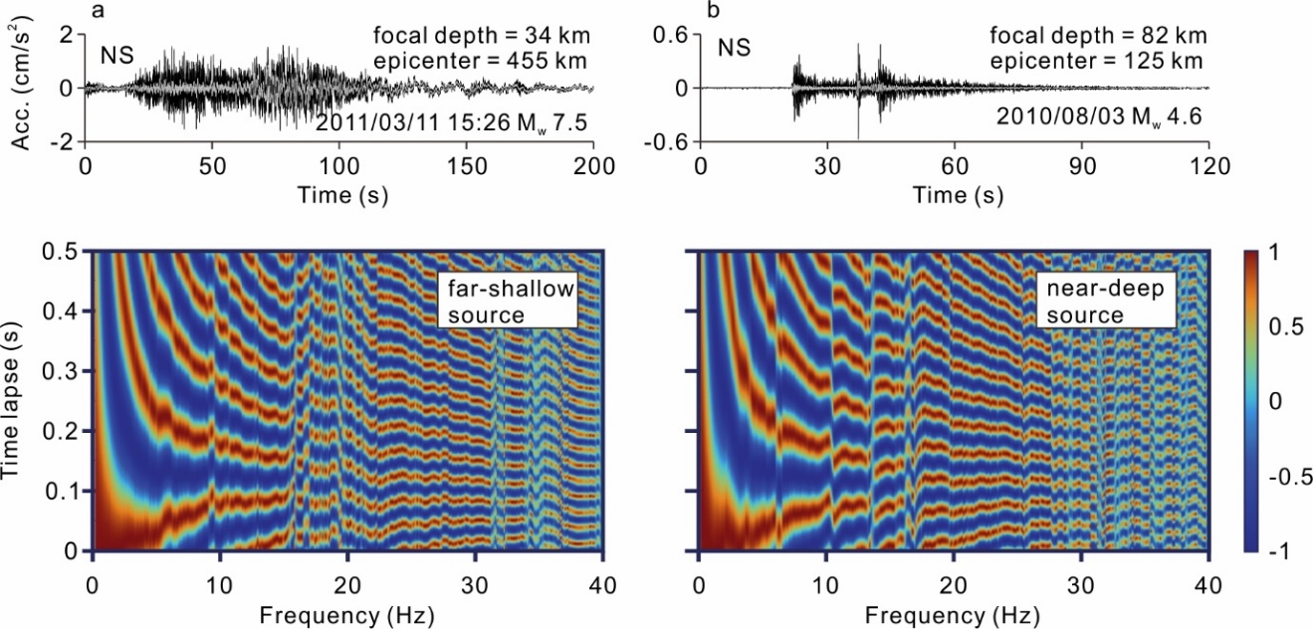

Figure S5. Comparison of the deconvolution waveforms calculated by the far-shallow earthquake and near-deep earthquake. The similar results imply that the dispersion phenomenon is unrelated to the source and path effects.
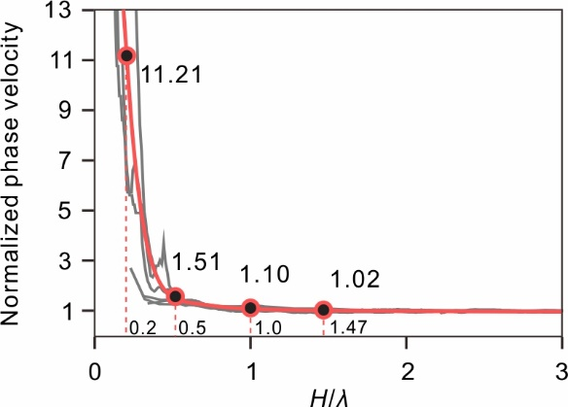

Figure S6. Normalized phase velocity and normalized frequency of the six stations. H is the borehole depth and λ is the wavelength.

Reference:
Park, S., Tsai, V. C., & Ishii, M. (2019). Frequency-dependent P wave polarization and its subwavelength near-surface depth sensitivity. Geophysical Research Letters, 46(24), 14377-14384.
Miao, Y., Shi, Y., & Wang, S. Y. (2018). Estimating near-surface shear wave velocity using the P-wave seismograms method in Japan. Earthquake Spectra, 34(4), 1955-1971.
Nakata, N., & Snieder, R. (2012) Estimating near‐surface shear wave velocities in Japan by applying seismic interferometry to KiK‐net data. Journal of Geophysical Research: Solid Earth; 117(B1).
Takagi, R., & Okada, T. (2012). Temporal change in shear velocity and polarization anisotropy related to the 2011 M9. 0 Tohoku‐Oki earthquake examined using KiK‐net vertical array data. Geophysical Research Letters, 39(9).
Nagaoka, Y., Nishida, K., Aoki, Y., & Takeo, M. (2010). Temporal change of phase velocity beneath Mt. Asama, Japan, inferred from coda wave interferometry. Geophysical Research Letters, 37(22).

