Residue monitoring and dietary risk evaluation of fungicide propiconazole in leafy vegetables under greenhouse conditions.
Lawal Abdulkareem¹, Se-Yeon Kwak¹, Sang-Hyeob Lee¹, Jae-Won Choi¹, Ji-Eun Oh¹, Aniruddha Sarker^{2,} Kee Sung Kyung³, Tae Hwa Kim⁴ and Jang-Eok Kim¹*
¹School of Applied Biosciences, College of Agriculture and Life Sciences, Kyungpook National University, Daegu, 41566, Republic of Korea
²Department of Agro-Food Safety and Crop Protection, National Institute of Agricultural Sciences, Rural Development Administration, Wanju, Jeollabuk-Do, 55365, Republic of Korea
³Department of Environmental and Biological Chemistry, College of Agriculture, Life and Environment Science, Chungbuk National University, Cheongju, Republic of Korea
⁴Analysis Technology and Tomorrow, Ltd., Daegu 42703, Republic of Korea

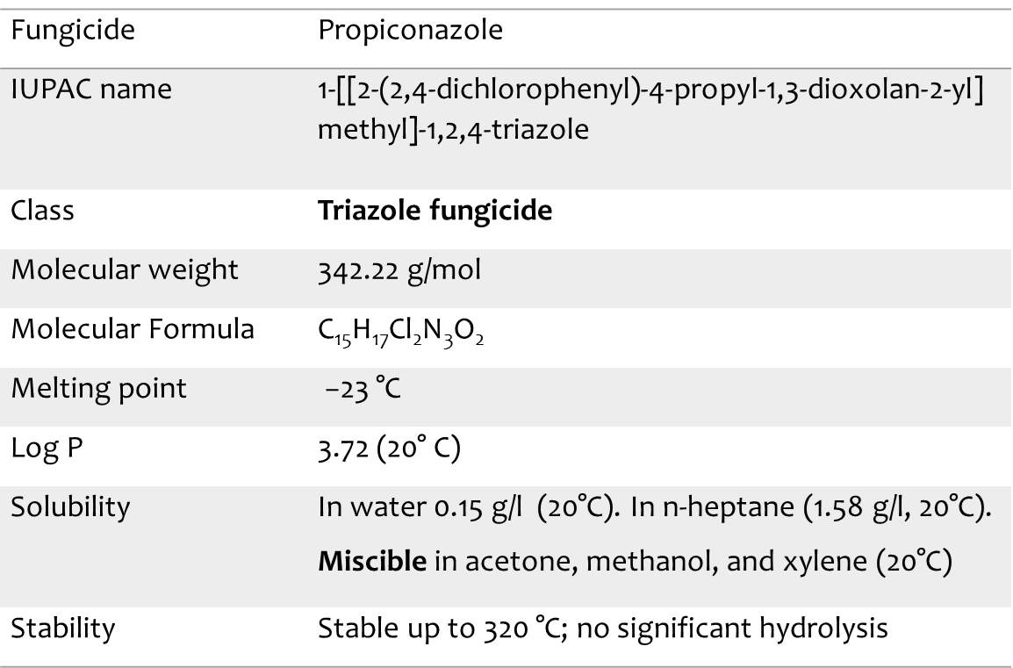
Figure S1: Physiochemical properties of propiconazole

Section S1: Preparation of standard and working solutions.
The standard solution propiconazole (99.7%) obtained from NongHyup Co., Ltd., was dissolved in acetone to make a 400 mg/L stock solution for each. Propiconazole was used after diluting into 10 mg/L mixture working solution for simultaneous analysis.

¹⁾PHI- pre harvest interval

Figure S2: Dosage of propiconazole applied to cabbage during foliar application experiment.

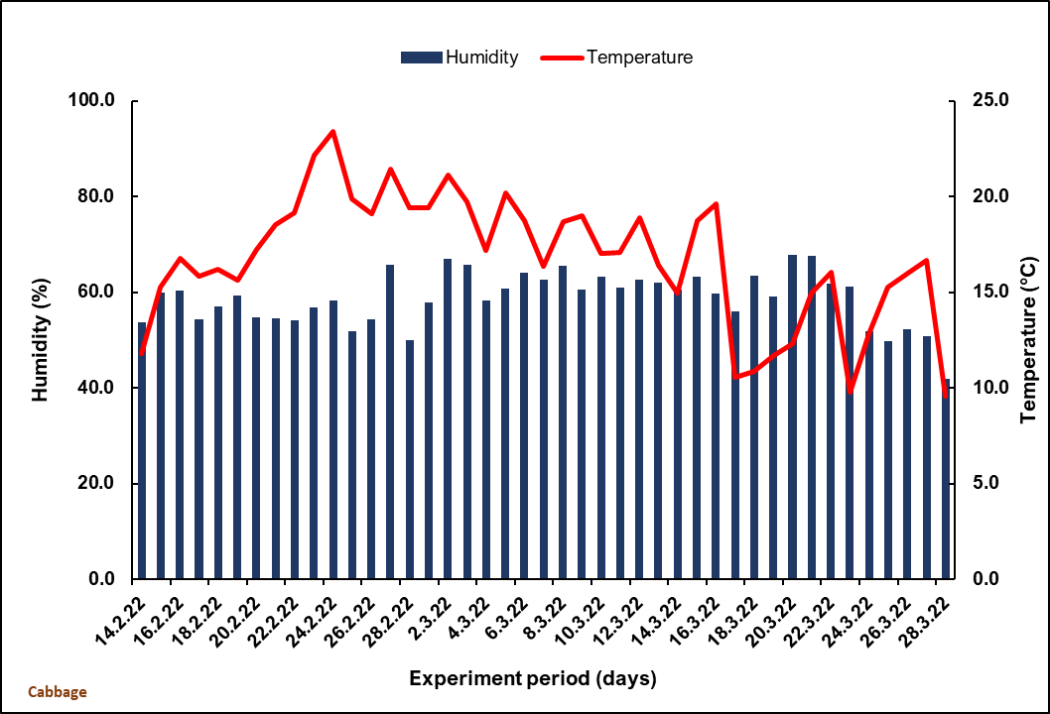

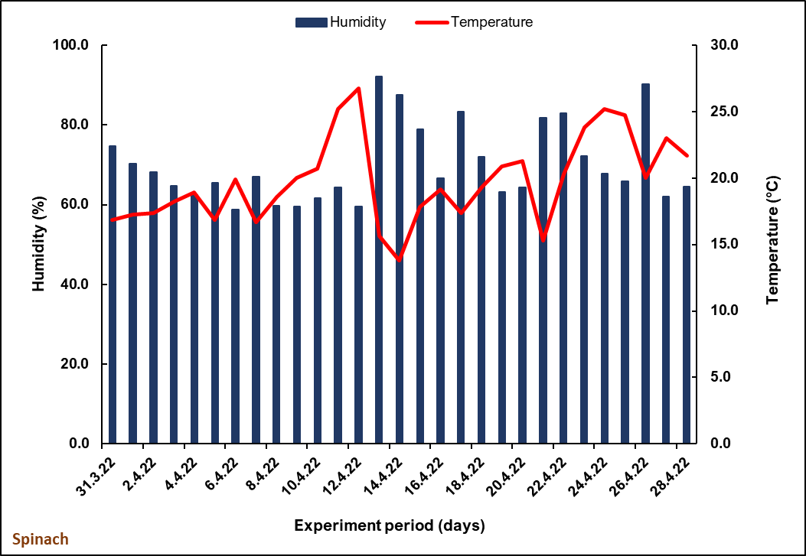

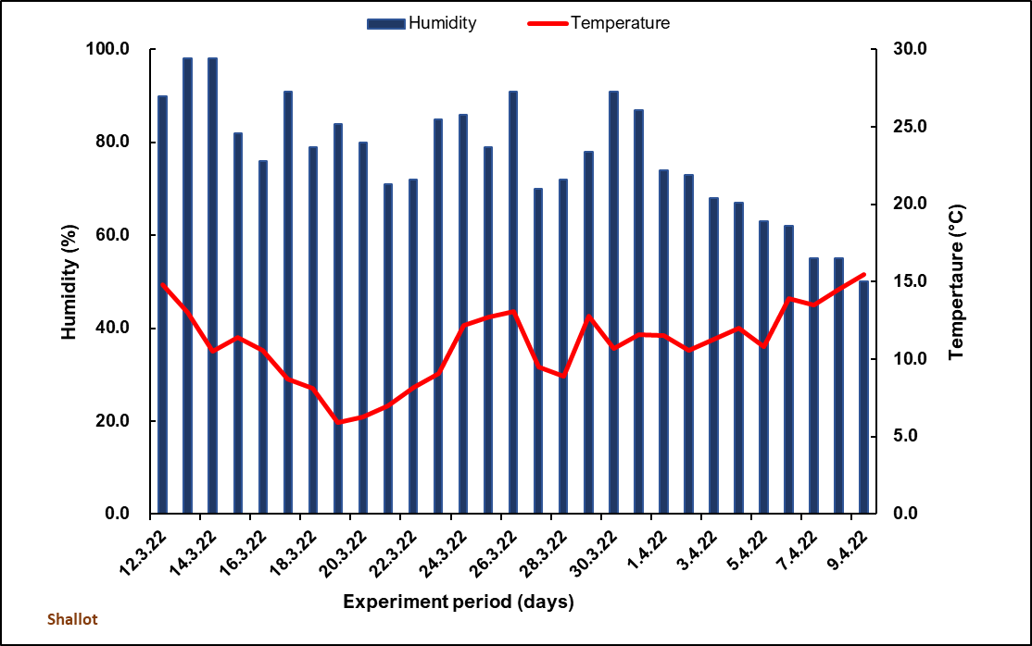

Figure S3: The climatic conditions in the greenhouse during the overall experimental period.

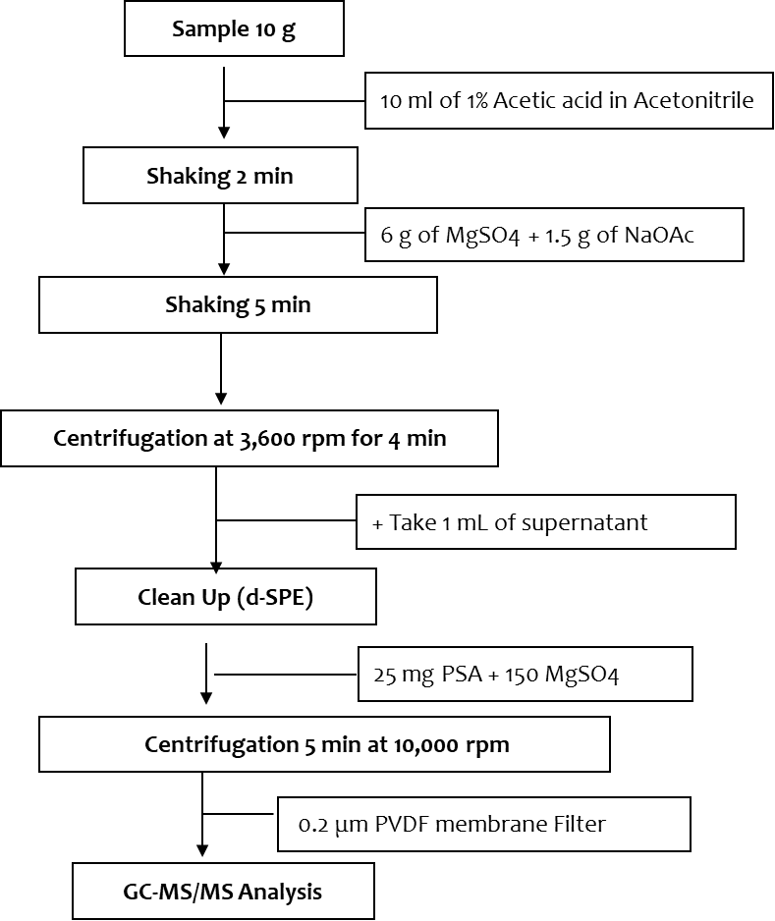

Figure S4: Flow chart for analytical method of propiconazole in leafy vegetables.

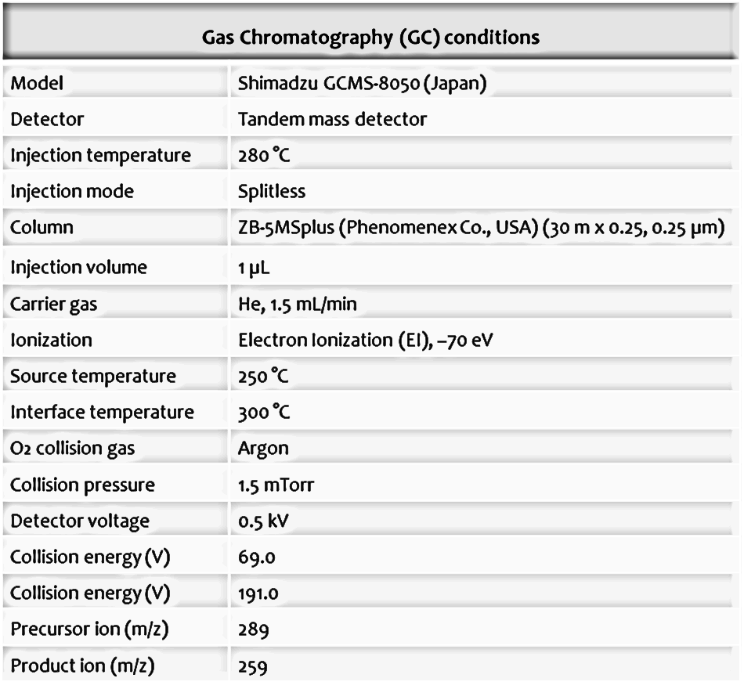
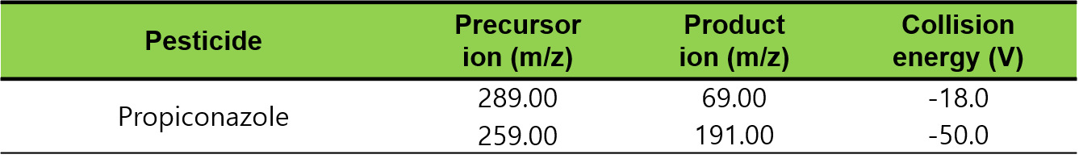
<MRM transition>

Figure S5: GC-MS/MS conditions including Multiple Reaction Monitoring (MRM) parameters for the analyses of propiconazole in leafy greens samples.

Figure S6: The method quantification limit (MQL) was calculated from the minimum detectable amount (MDA) obtained by injecting standard solution of propiconazole.

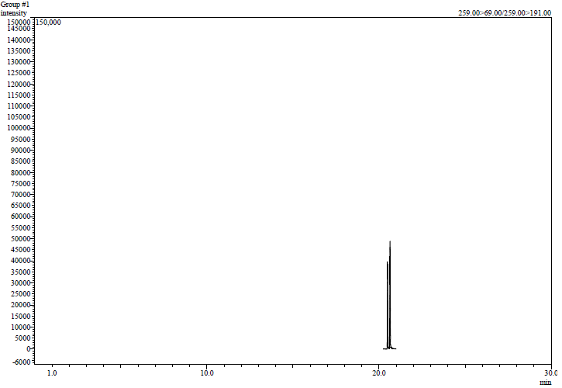
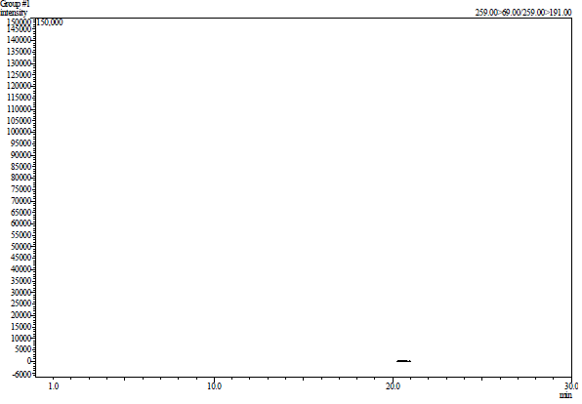
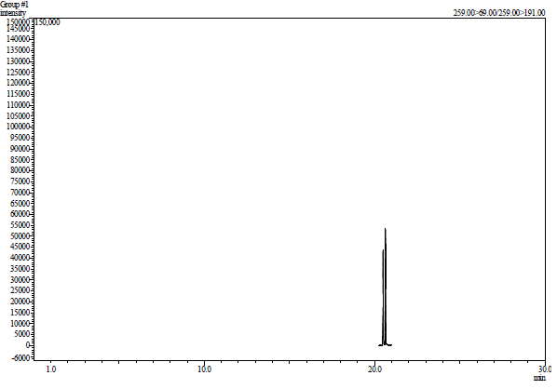
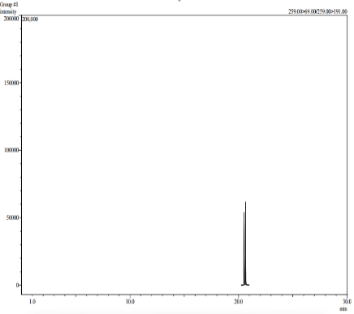
Propiconazole Representative Chromatograms
< PCZ M.M STD 0.1 mg/kg Cabbage>
< PCZ fortified at 0.1 mg/kg in Cabbage>
< Shallot control Sample- No peak>
< PCZ MM STD 0.1 mg/kg Spinach >

Figure S7. Representative matrix-matched standard, control, and fortified levels chromatograms of propiconazole (PCZ) in leafy greens

Table 1. Residue equations, half-life, and correlation coefficient of propiconazole in leafy vegetables
Pesticide | Matrix | Calibration curve |  | MDA^{b)}  (ng) | MQL^{a)}  (mg/kg)
Pesticide | Matrix | Equation | R^{2c)} | MDA^{b)}  (ng) | MQL^{a)}  (mg/kg)
Propiconazole | Cabbage | 896,684.4637x + 1,256.9969 | 0.9995 | 0.1 | 0.01
Propiconazole | Shallot | 893,491.2903 x + 1,955.7255 | 0.9998 | 0.1 | 0.01
Propiconazole | Spinach | 1,179,900.4708 x + 2,029.1365 | 0.9996 | 0.1 | 0.01
- MQL, Method quantification limit, ^{b)} MDA, minimum detectable amount, ^{c)} R², Correlation coefficient

