Insight into the metabolic pathways of Paracoccus sp. strain DMF: a non-marine halotolerant methylotroph capable of degrading aliphatic amines/ amides
Chetan Kumar Arya¹, Shiwangi Maurya¹, and Gurunath Ramanathan¹
^{1.} Department of Chemistry, Indian Institute of Technology, Kanpur-208016, India.
Corresponding author: Gurunath Ramanathan, Department of Chemistry, Indian Institute of Technology, Kanpur - 208016, India; Phone: +91-512-2597417 (office) 2596039 (lab); Email: gurunath@iitk.ac.in

SUPPLEMENTARY INFORMATION:

Figure S1: Temperature-dependent microbial growth to show P. DMF is mesophilic in nature
Figure S2: BLAST-based protein homology of betaine-specific methyltransferase mtgB (A) and mtgC (B) and structural comparison with the predicted structures (by AlphaFold) for mtgB (C) and mtgC (D) with structures reported in the PDB database (2QNE and 1Y80 respectively).

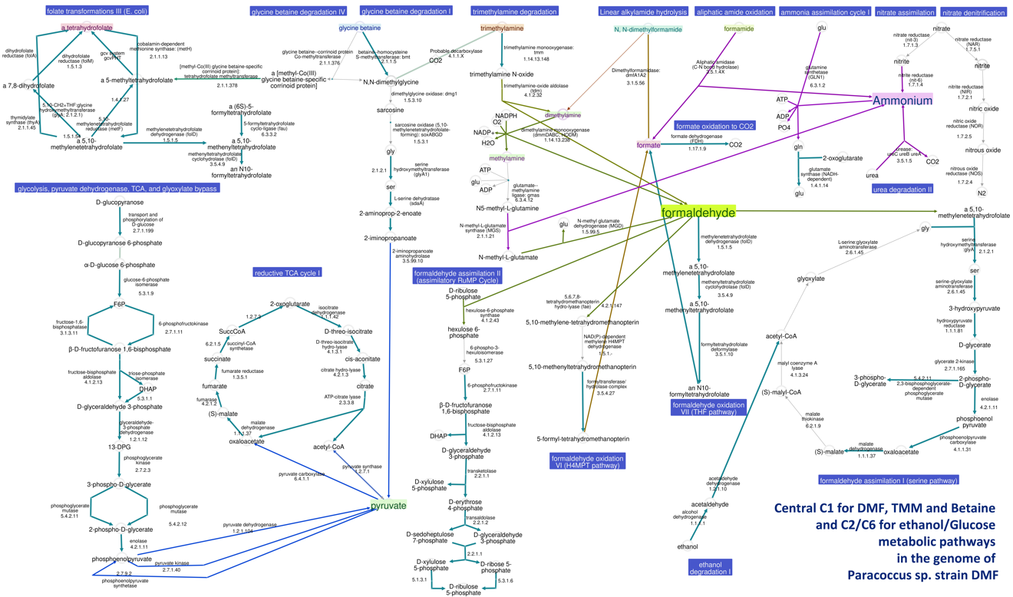
Figure S3: Predicted central C₁ and C₂/C₆ metabolic pathways of Paracoccus sp. strain DMF. Key operons and related genes are mentioned in the lower part of the pictorial representation. Each node is pathways annotated in the present study, and listed enzymes (E.C. number format) are provided in supplementary table ST1.
Figure S4: One carbon pool by folates in P. DMF by KEGG pathway map.

Figure S5: Annotated two linear aliphatic amidases within the P. DMF genome and a BLAST-based survey with homologous proteins from Protein Data Base (PDB). (A) The aliphatic amidase (AmiE; EC 3.5.1.4; NCBI Reference Sequence: WP_263567463.1) sequence/secondary structure alignment with enzymes yNit2 (PDB code: 4HG3). The catalytic triad Cys-Lys-Glu was annotated as (★). (B) The enzyme formamidase (FmdA; EC 3.5.1.49; NCBI Reference Sequence: WP_263566961.1) has homology with Acetamidase (PDB code: 2II1) from Bacillus Halodurans. The conserved residues for the catalytically important metal-binding site for Ca²⁺/Zn²⁺ were marked with (▲).

Table ST1: List of key enzymes annotated for the C1-based methylotrophic activity in P. DMF

EC Number | Name
Methylated amine/amide (C1)
1.14.13.148 | trimethylamine monooxygenase; flavin-containing monooxygenase 3; FMO3; tmm
4.1.2.32 | trimethylamine-oxide aldolase; trimethylamine N-oxide formaldehyde-lyase; trimethylamine N-oxide aldolase; trimethylamine N-oxide demethylase; trimethylamine-N-oxide formaldehyde-lyase
3.5.1.56 | N, N-dimethylformamidase; dimethylformamidase; DMFase (dmfA1A2)
1.14.13.238 | dimethylamine monooxygenase; dmmDABC
6.3.4.12 | glutamate-methylamine ligase; gamma-glutamylmethylamide synthetase
2.1.1.21 | methylamine-glutamate N-methyltransferase; N-methylglutamate synthase; methylamine-glutamate methyltransferase
1.5.99.5 | methylglutamate dehydrogenase; N-methylglutamate dehydrogenase; N-methyl-L-glutamate:(acceptor) oxidoreductase (demethylating)
1.4.9.1 | methylamine dehydrogenase (amicyanin); amine dehydrogenase; primary-amine dehydrogenase
1.1.2.7 | methanol dehydrogenase (cytochrome c); methanol dehydrogenase; MDH (ambiguous)
3.5.1.49 | formamidase
3.5.4.9 | methenyltetrahydrofolate cyclohydrolase; Citrovorum factor cyclodehydrase; cyclohydrolase; formyl-methenyl-methylenetetrahydrofolate synthetase (combined); 5,10-methenyltetrahydrofolate 5-hydrolase (decyclizing)
3.5.1.10 | formyltetrahydrofolate deformylase
1.5.1.5 | methylenetetrahydrofolate dehydrogenase (NADP+); N⁵,N¹⁰-methylenetetrahydrofolate dehydrogenase; 5,10-methylenetetrahydrofolate:NADP oxidoreductase; 5,10-methylenetetrahydrofolate dehydrogenase; methylenetetrahydrofolate dehydrogenase
4.4.1.22 | S-(hydroxymethyl)glutathione synthase; glutathione-dependent formaldehyde-activating enzyme; Gfa; S-(hydroxymethyl)glutathione formaldehyde-lyase
1.1.1.284 | S-(hydroxymethyl)glutathione dehydrogenase; NAD-linked formaldehyde dehydrogenase
1.17.1.9 | formate dehydrogenase; formate-NAD⁺ oxidoreductase; FDH I; FDH II; N-FDH
6.3.4.3 | formate-tetrahydrofolate ligase; formyltetrahydrofolate synthetase; 10-formyltetrahydrofolate synthetase; tetrahydrofolic formylase; tetrahydrofolate formylase
Formaldehyde assimilation (Serine Pathway)
2.1.2.1 | glycine hydroxymethyltransferase; serine aldolase; threonine aldolase; serine hydroxymethylase
2.6.1.45 | serine-glyoxylate transaminase
4.1.3.24 | malyl-CoA lyase; malyl-coenzyme A lyase; (3S)-3-carboxy-3-hydroxypropanoyl-CoA glyoxylate-lyase; mclA (gene name); mcl1 (gene name); (3S)-3-carboxy-3-hydroxypropanoyl-CoA glyoxylate-lyase (acetyl-CoA-forming); L-malyl-CoA lyase
6.2.1.9 | malate-CoA ligase; malyl-CoA synthetase; malyl coenzyme A synthetase; malate thiokinase
1.1.1.37 | malate dehydrogenase; malic dehydrogenase; L-malate dehydrogenase; NAD-L-malate dehydrogenase; malic acid dehydrogenase; NAD-dependent malic dehydrogenase
4.1.1.31 | phosphoenolpyruvate carboxylase
4.2.1.11 | phosphopyruvate hydratase; enolase; 2-phosphoglycerate dehydratase
2.7.1.165 | glycerate 2-kinase; D-glycerate-2-kinase; glycerate kinase (2-phosphoglycerate forming); ATP:(R)-glycerate 2-phosphotransferase
1.1.1.181 | cholest-5-ene-3beta,7alpha-diol 3beta-dehydrogenase; 3beta-hydroxy-Delta5-C27-steroid oxidoreductase
5.4.2.11 | phosphoglycerate mutase (2,3-diphosphoglycerate-dependent); glycerate phosphomutase (diphosphoglycerate cofactor)
Formaldehyde Oxidation I
1.1.1.49 | glucose-6-phosphate dehydrogenase (NADP⁺); NADP-glucose-6-phosphate dehydrogenase
5.3.1.9 | glucose-6-phosphate isomerase; phosphohexose isomerase; phosphohexomutase; oxoisomerase; hexosephosphate isomerase
5.3.1.27 | 6-phospho-3-hexuloisomerase; 3-hexulose-6-phosphate isomerase; phospho-3-hexuloisomerase; PHI; 6-phospho-3-hexulose isomerase; YckF
1.1.1.343 | phosphogluconate dehydrogenase (NAD⁺-dependent, decarboxylating); 6-PGDH (ambiguous); gntZ (gene name); GNDl
3.1.1.31 | 6-phosphogluconolactonase; phosphogluconolactonase; 6-PGL
Ethanol Degradation
1.1.1.1 | alcohol dehydrogenase; aldehyde reductase; ADH; alcohol dehydrogenase (NAD)
1.2.1.10 | acetaldehyde dehydrogenase (acetylating)
Prokaryote TCA cycle
1.1.5.4 | malate dehydrogenase (quinone); FAD-dependent malate-vitamin K reductase; malate-vitamin K reductase; (S)-malate:(acceptor) oxidoreductase
1.1.1.37 | malate dehydrogenase; malic dehydrogenase; L-malate dehydrogenase; NAD-L-malate dehydrogenase; malic acid dehydrogenase
4.2.1.2 | fumarate hydratase; fumarase; L-malate hydro-lyase; (S)-malate hydro-lyase
1.3.5.1 | succinate dehydrogenase; succinate dehydrogenase (quinone); succinate dehydrogenase (ubiquinone); succinic dehydrogenase; complex II
6.2.1.5 | succinate-CoA ligase (ADP-forming); succinyl-CoA synthetase (ADP-forming); succinic thiokinase
1.2.1.9 | glyceraldehyde-3-phosphate dehydrogenase (NADP⁺); triosephosphate dehydrogenase; glyceraldehyde phosphate dehydrogenase (nicotinamide adenine dinucleotide phosphate); glyceraldehyde phosphate dehydrogenase (NADP⁺)
1.1.1.42 | isocitrate dehydrogenase (NADP⁺); oxalosuccinate decarboxylase; oxalsuccinic decarboxylase; isocitrate (NADP) dehydrogenase
2.3.3.1 | citrate (Si)-synthase; (R)-citric synthase; citrate oxaloacetate-lyase
RuMP Cycle
5.3.1.27 | 6-phospho-3-hexuloisomerase; 3-hexulose-6-phosphate isomerase; phospho-3-hexuloisomerase; PHI; 6-phospho-3-hexulose isomerase; YckF
2.7.1.11 | 6-phosphofructokinase; phosphohexokinase; phosphofructokinase I; phosphofructokinase (phosphorylating); 6-phosphofructose 1-kinase
4.1.2.13 | fructose-bisphosphate aldolase; aldolase; fructose-1,6-bisphosphate triosephosphate-lyase; fructose diphosphate aldolase
4.1.2.43 | 3-hexulose-6-phosphate synthase; D-arabino-3-hexulose 6-phosphate formaldehyde-lyase; 3-hexulosephosphate synthase; 3-hexulose phosphate synthase; HPS
2.2.1.1 | transketolase; glycolaldehydetransferase
2.2.1.2 | transaldolase; dihydroxyacetonetransferase
5.3.1.3 | D-arabinose isomerase; D-arabinose(L-fucose) isomerase
5.3.1.6 | ribose-5-phosphate isomerase; phosphopentosisomerase
Calvin cycle
- | Cbbr, Calvin cycle transcriptional regulator
3.1.3.11 | Fbp, fructose-bisphosphatase
2.7.1.19 | Prk, phosphoribulokinase
- | cbbLS, Large and small subunits of RuBisCO activating protein
- | rbcL, large and small subunits of RuBisCO
5.1.3.1 | Rpe, ribulose-phosphate 3-epimerase
Glycolysis I
5.3.1.9 | glucose-6-phosphate isomerase; phosphohexose isomerase; phosphohexomutase; oxoisomerase; hexosephosphate isomerase
3.1.3.11 | fructose-bisphosphatase; hexose diphosphatase; FBPase; fructose 1,6-diphosphatase; fructose 1,6-diphosphate phosphatase
2.7.1.11 | 6-phosphofructokinase; phosphohexokinase; phosphofructokinase I
4.1.2.13 | fructose-bisphosphate aldolase; aldolase; fructose-1,6-bisphosphate triosephosphate-lyase
5.3.1.1 | triose-phosphate isomerase; phosphotriose isomerase; triose phosphoisomerase; triose phosphate mutase; D-glyceraldehyde-3-phosphate ketol-isomerase
1.2.1.12 | glyceraldehyde-3-phosphate dehydrogenase (phosphorylating); triosephosphate dehydrogenase
2.7.2.3 | phosphoglycerate kinase; PGK; 3-PGK; ATP-3-phospho-D-glycerate-1-phosphotransferase; ATP:D-3-phosphoglycerate 1-phosphotransferase;
5.4.2.12 | phosphoglycerate mutase (2,3-diphosphoglycerate-independent); cofactor independent phosphoglycerate mutase
4.2.1.11 | phosphopyruvate hydratase; enolase; 2-phosphoglycerate dehydratase
2.7.9.2 | pyruvate, water dikinase; phosphoenolpyruvate synthase; pyruvate-water dikinase (phosphorylating); PEP synthetase
2.7.1.40 | pyruvate kinase; phosphoenolpyruvate kinase; phosphoenol transphosphorylase

