Phyllostachys edulis (moso bamboo) ages significantly affect soil nitrogen transformation and endophytic microbes but niche differentiations outweigh ages in shaping microbial communities of moso bamboo-soil system
Manyun Zhang ^{a, b}, Weijin Wang ^{b}, Shahla Hosseini Bai ^{b}, Zhihong Xu ^{b}, Zhe Yun ^{c}, Wenyuan Zhang ^{b, c∗}
ª College of Resources and Environment, Hunan Agriculture University, Changsha 410128, China
^{b} Environmental Futures Research Institute, School of Environment and Science, Griffith University, Brisbane, Queensland 4111, Australia
^{c} College of Forestry, Jiangxi Agricultural University, Nanchang 330045, China

Table S1 Primers used for qPCR and amplification efficiencies of functional genes.
Table S2 Basic information of effective sequences of different samples.
Fig. S1. Rarefaction curves for (a) bacterial and (b) fungal OTUs in the 48 samples. A0.5y, 0.5-year above-ground tissues; A2.5y, 2.5-year above-ground tissues; A4.5y, 4.5-year above-ground tissues; A6.5y, 6.5-year above-ground tissues; R0.5y, 0.5-year roots; R2.5y, 2.5-year roots; R4.5y, 4.5-year roots; R6.5y, 6.5 roots; S0.5y, rhizospheric soils of 0.5-year bamboos; S2.5y, rhizospheric soils of 2.5-year bamboos; S4.5y, rhizospheric soils of 4.5-year bamboos; and S6.5y, rhizospheric soils of 6.5-year bamboos.
Fig. S2. Venn diagram revealing the shared and unique OTUs of bacterial communities in (a) above-ground tissues, (b) roots and (c) rhizospheric soils and fungal communities in (d) above-ground tissues, (e) roots and (f) rhizospheric soils. A0.5y, 0.5-year above-ground tissues; A2.5y, 2.5-year above-ground tissues; A4.5y, 4.5-year above-ground tissues; A6.5y, 6.5-year above-ground tissues; R0.5y, 0.5-year roots; R2.5y, 2.5-year roots; R4.5y, 4.5-year roots; R6.5y, 6.5 roots; S0.5y, rhizospheric soils of 0.5-year bamboos; S2.5y, rhizospheric soils of 2.5-year bamboos; S4.5y, rhizospheric soils of 4.5-year bamboos; and S6.5y, rhizospheric soils of 6.5-year bamboos.
Fig. S3. The relative abundances of bacterial distribution at: (a) predominant phyla; (b) predominant genera and (c) predicted function analyses of bacteria with PICRUSt. A0.5y, 0.5-year above-ground tissues; A2.5y, 2.5-year above-ground tissues; A4.5y, 4.5-year above-ground tissues; A6.5y, 6.5-year above-ground tissues; R0.5y, 0.5-year roots; R2.5y, 2.5-year roots; R4.5y, 4.5-year roots; R6.5y, 6.5 roots; S0.5y, rhizospheric soils of 0.5-year bamboos; S2.5y, rhizospheric soils of 2.5-year bamboos; S4.5y, rhizospheric soils of 4.5-year bamboos; and S6.5y, rhizospheric soils of 6.5-year bamboos.
Fig. S4. The relative abundances of bacterial phyla with significant differences among different groups: (a) Acidobacteria, (b) Actinobacteria, (c) Bacteroidetes, (d) Chloroflexi, (e) Dependentiae, (f) Elusimicrobia, (g) Firmicutes, (h) Gemmatimonadetes, (i) Latescibacteria, (j) Nitrospirae, (k) Planctomycetes, (l) Proteobacteria and (m) Verrucomicrobia. Vertical bars indicate the maximum and minimum values. Lowercase letters show significant differences among the same samples of different ages, and capital letters show significant differences among different niches of the same age.
Fig. S5. The relative abundances of fungal distribution at: (a) predominant phyla; (b) predominant genera and (c) predicted function analyses of fungi with Fungi Functional Guild. A0.5y, 0.5-year above-ground tissues; A2.5y, 2.5-year above-ground tissues; A4.5y, 4.5-year above-ground tissues; A6.5y, 6.5-year above-ground tissues; R0.5y, 0.5-year roots; R2.5y, 2.5-year roots; R4.5y, 4.5-year roots; R6.5y, 6.5 roots; S0.5y, rhizospheric soils of 0.5-year bamboos; S2.5y, rhizospheric soils of 2.5-year bamboos; S4.5y, rhizospheric soils of 4.5-year bamboos; and S6.5y, rhizospheric soils of 6.5-year bamboos.
Fig. S6. The relative abundances of fungal phyla with significant differences among different groups: (a) Ascomycota, (b) Basidiomycota, (c) Chytridiomycota, (d) Glomeromycota and (e) Mortierellomycota. Vertical bars indicate the maximum and minimum values. Lowercase letters show significant differences among the same samples of different ages, and capital letters show significant differences among different niches of the same age.
Table S3 The linear correlations between bamboo biomass and soil nutrient contents and microbial relative abundances in above-ground tissues, roots and rhizospheric soils.

Table S1 Primers used for qPCR and amplification efficiencies of functional genes.
Functional genes | Primers | Sequence 5’-3’ | References | Amplification efficiency | R²
nprA gene | FP npr I  RP npr II | GTDGAYGCHCAYTAYTAYGC  ACMGCATGBGTYADYTCATG | Bach et al. [1] | 85.0% | ≥ 0.99
chiA gene | chif2  chir | GACGGCATCGACATCGATTGG  CSGTCCAGCCGCGSCCRTA | Xiao et al. [2] | 90.5% | ≥ 0.99
AOA amoA gene | amoAF  amoAR | STAATGGTCTGGCTTAGACG  GCGGCCATCCATCTGTATGT | Francis et al. [3] | 83.5% | ≥ 0.99
AOB amoA gene | amoA-1F  amoA-2R | GGGGTTTCTACTGGTGGT  CCCCTCKGSAAAGCCTTCTTC | Rotthauwe et al. [4] | 84.5% | ≥ 0.99

Samples | Bacterial communities |  |  |  | Fungal communities
Samples | Average sequence number | Sequence number range | Average sequence length | Sequence length range | Average sequence number | Sequence number range | Average sequence length | Sequence length range
0.5 y above-ground tissues | 20703 | 16600 - 23299 | 376.4 | 375.2 - 377.3 | 67652 | 59258 - 72000 | 231.1 | 228.5 - 234.5
2.5 y above-ground tissues | 18126 | 11873 - 24139 | 376.9 | 376.3 - 377.2 | 69624 | 59206 - 73997 | 231.0 | 227.7 - 233.2
4.5 y above-ground tissues | 18839 | 11654 - 24924 | 377.3 | 377.1 - 377.6 | 70630 | 67490 - 74723 | 238.2 | 221.4 - 253.5
6.5 y above-ground tissues | 23990 | 22848 - 24793 | 376.4 | 375.1 - 377.7 | 62141 | 47634 - 74347 | 246.2 | 225.7 - 268.6
0.5 y roots | 19402 | 13468 - 24413 | 376.3 | 375.1 - 378 | 56793 | 50263 - 67320 | 239.3 | 229.0 - 249.6
2.5 y roots | 23359 | 21240 - 24505 | 376.4 | 374.9 - 377.2 | 53024 | 47711 - 56359 | 243.1 | 228.5 - 268.9
4.5 y roots | 22088 | 20979 - 23590 | 377.0 | 374.9 - 378 | 52928 | 47587 - 58556 | 255.6 | 229.4 – 282.0
6.5 y roots | 23107 | 19895 - 24723 | 376.9 | 376.2 - 377.5 | 55213 | 45603 - 70614 | 251.5 | 241.7 - 259.7
rhizospheric soils of 0.5 y bamboos | 18052 | 10034 - 23467 | 375.4 | 373.9 - 376.6 | 66855 | 60905 - 72268 | 229.3 | 226.5 - 233.5
rhizospheric soils of 2.5 y bamboos | 22219 | 17109 - 24426 | 374.7 | 374 - 375.5 | 52757 | 33045 - 67462 | 235.3 | 233.2 - 239.8
rhizospheric soils of 4.5 y bamboos | 22791 | 20639 - 24941 | 376.3 | 375.9 - 376.5 | 63636 | 57715 - 69010 | 237.4 | 229.9 - 253.9
rhizospheric soils of 6.5 y bamboos | 21382 | 13062 - 24593 | 373.9 | 370.5 - 375.6 | 60991 | 48871 - 70167 | 270.1 | 237.6 - 317.3
Table S2 Basic information of effective sequences of different samples.

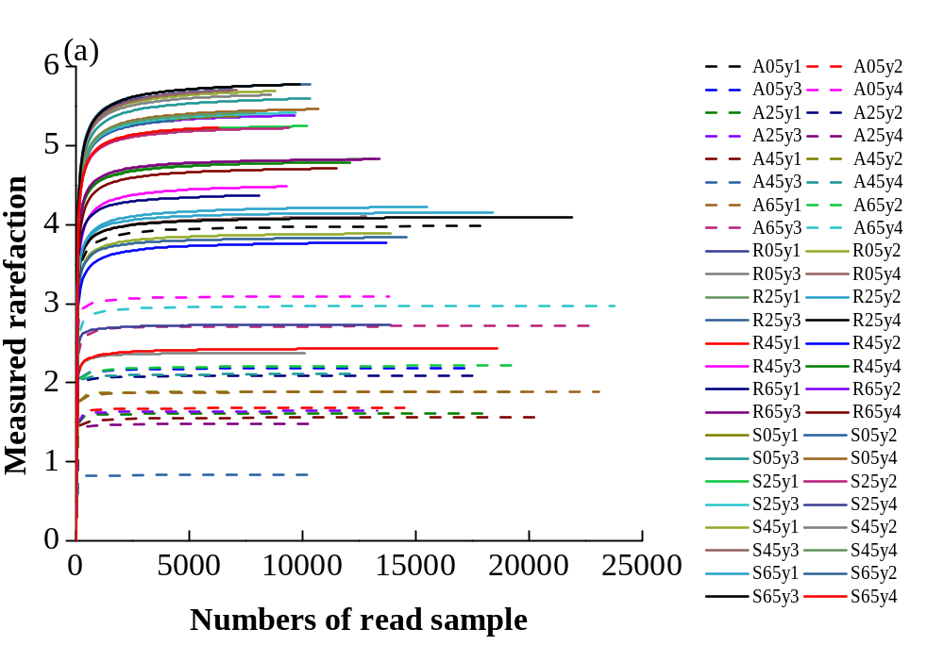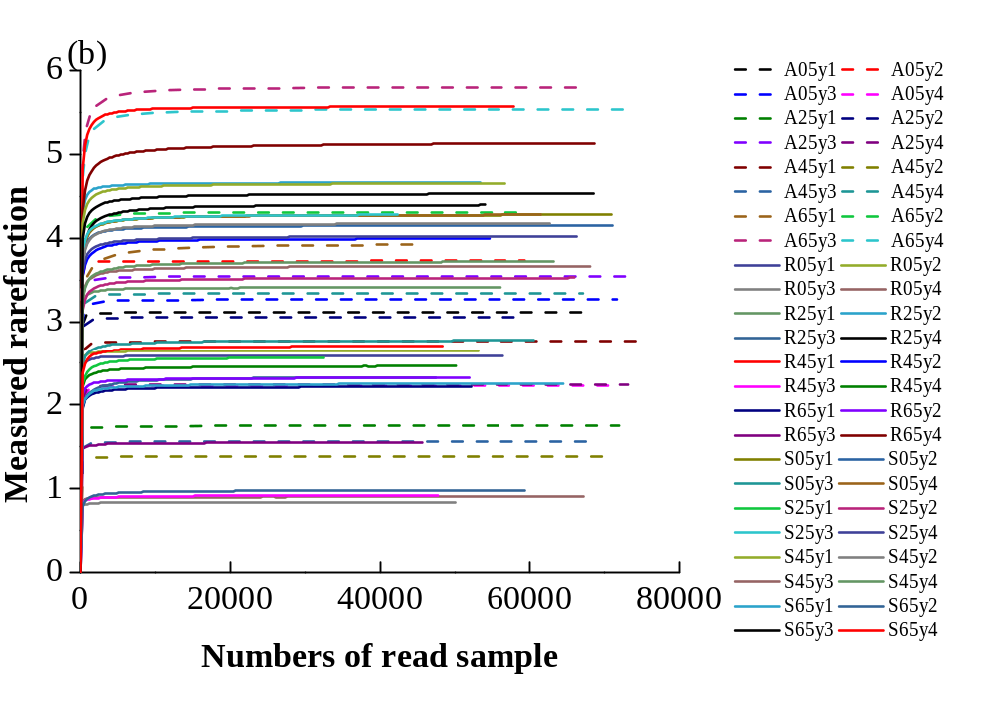
Fig. S1. Rarefaction curves for (a) bacterial and (b) fungal OTUs in the 48 samples. A0.5y, 0.5-year above-ground tissues; A2.5y, 2.5-year above-ground tissues; A4.5y, 4.5-year above-ground tissues; A6.5y, 6.5-year above-ground tissues; R0.5y, 0.5-year roots; R2.5y, 2.5-year roots; R4.5y, 4.5-year roots; R6.5y, 6.5 roots; S0.5y, rhizospheric soils of 0.5-year bamboos; S2.5y, rhizospheric soils of 2.5-year bamboos; S4.5y, rhizospheric soils of 4.5-year bamboos; and S6.5y, rhizospheric soils of 6.5-year bamboos.
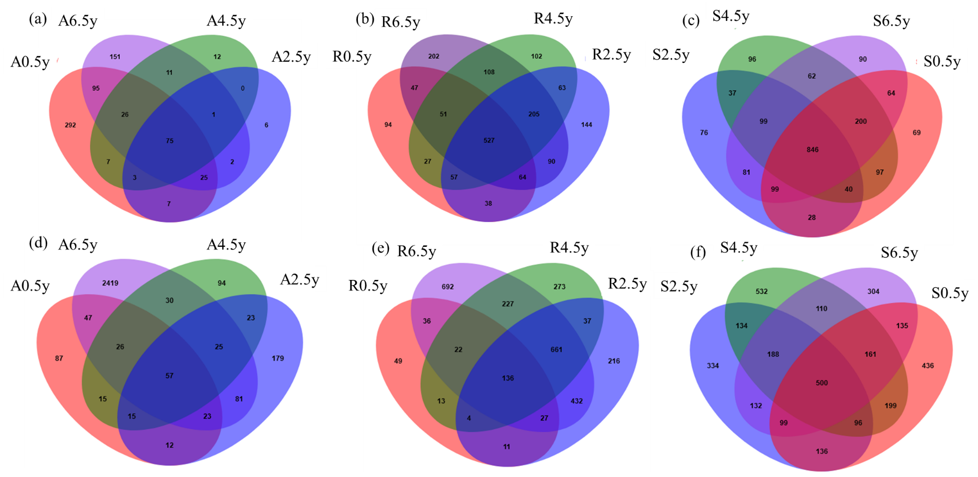
Fig. S2. Venn diagram revealing the shared and unique OTUs of bacterial communities in (a) above-ground tissues, (b) roots and (c) rhizospheric soils and fungal communities in (d) above-ground tissues, (e) roots and (f) rhizospheric soils. A0.5y, 0.5-year above-ground tissues; A2.5y, 2.5-year above-ground tissues; A4.5y, 4.5-year above-ground tissues; A6.5y, 6.5-year above-ground tissues; R0.5y, 0.5-year roots; R2.5y, 2.5-year roots; R4.5y, 4.5-year roots; R6.5y, 6.5 roots; S0.5y, rhizospheric soils of 0.5-year bamboos; S2.5y, rhizospheric soils of 2.5-year bamboos; S4.5y, rhizospheric soils of 4.5-year bamboos; and S6.5y, rhizospheric soils of 6.5-year bamboos.
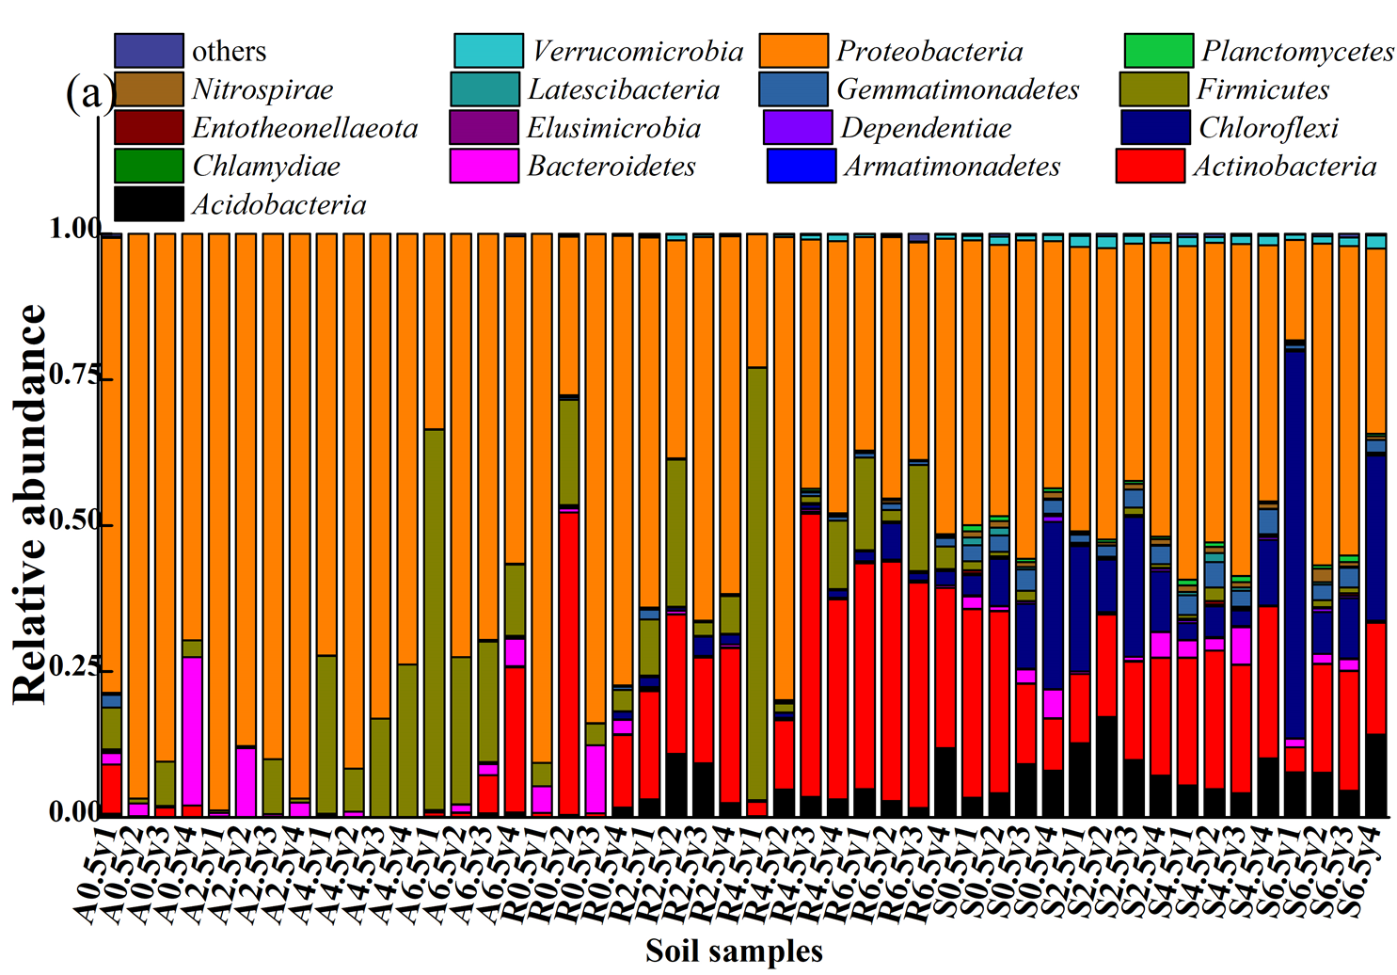
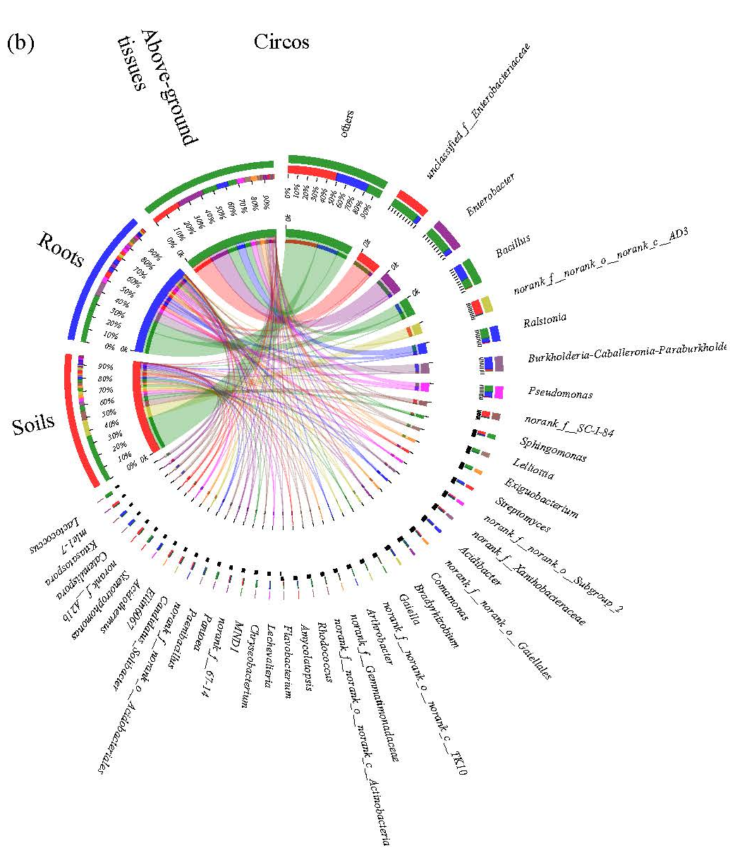
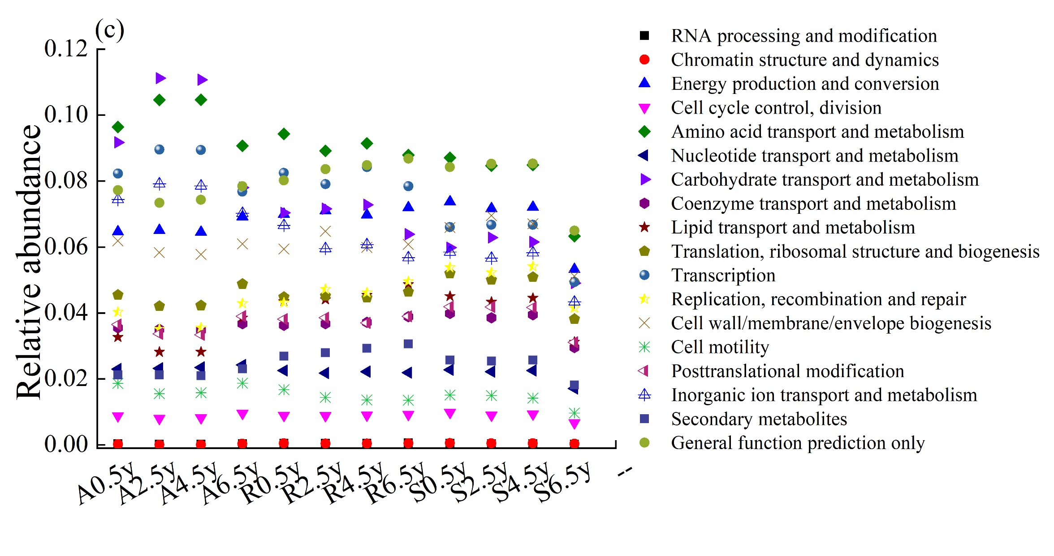
Fig. S3. The relative abundances of bacterial distribution at: (a) predominant phyla; (b) predominant genera and (c) predicted function analyses of bacteria with PICRUSt. A0.5y, 0.5-year above-ground tissues; A2.5y, 2.5-year above-ground tissues; A4.5y, 4.5-year above-ground tissues; A6.5y, 6.5-year above-ground tissues; R0.5y, 0.5-year roots; R2.5y, 2.5-year roots; R4.5y, 4.5-year roots; R6.5y, 6.5 roots; S0.5y, rhizospheric soils of 0.5-year bamboos; S2.5y, rhizospheric soils of 2.5-year bamboos; S4.5y, rhizospheric soils of 4.5-year bamboos; and S6.5y, rhizospheric soils of 6.5-year bamboos.
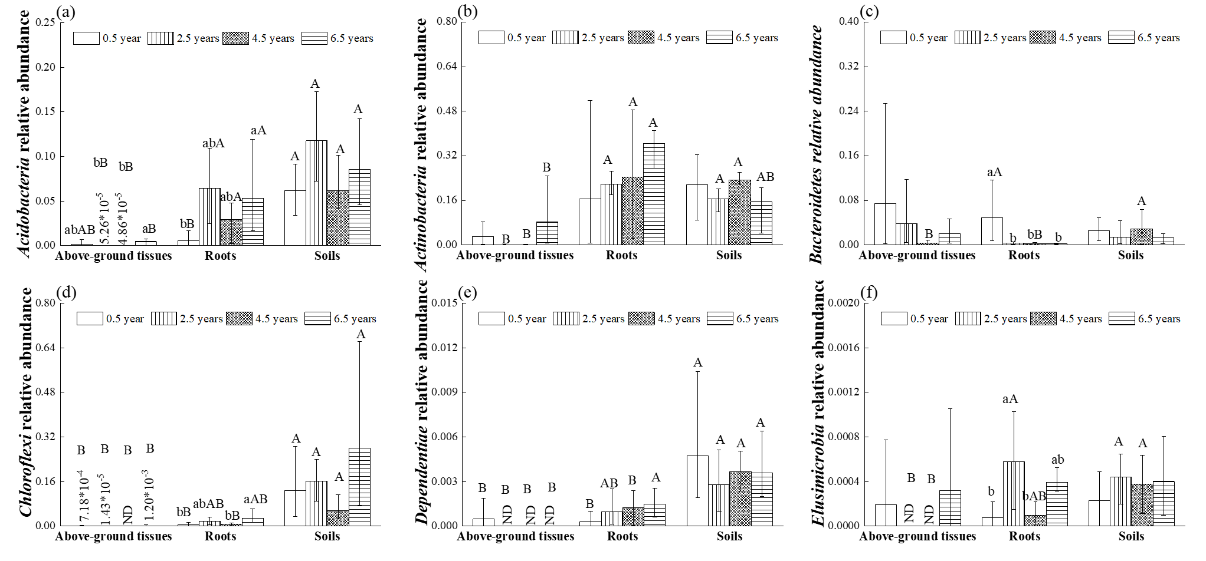

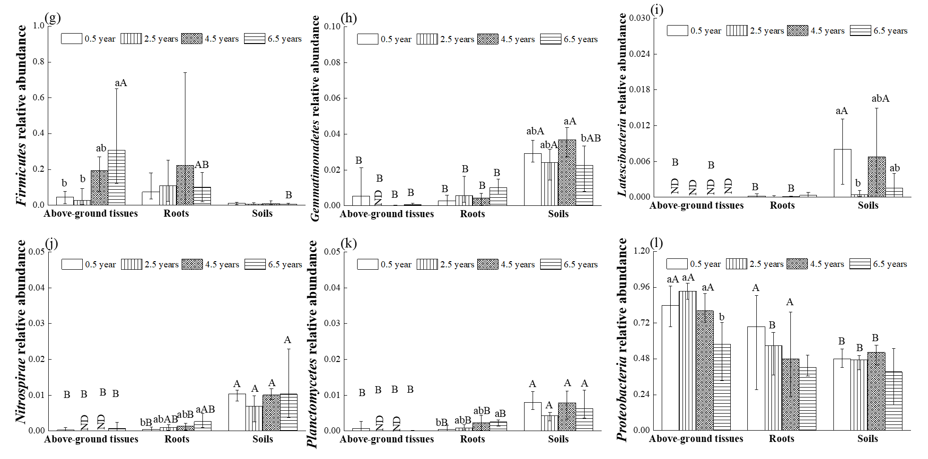

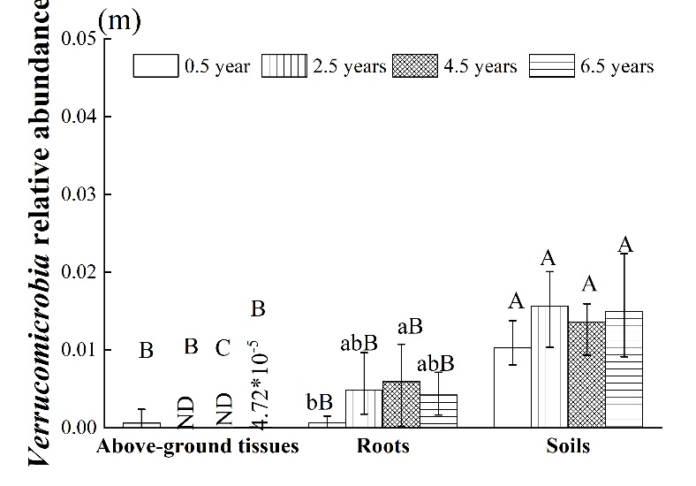
Fig. S4. The relative abundances of bacterial phyla with significant differences among different groups: (a) Acidobacteria, (b) Actinobacteria, (c) Bacteroidetes, (d) Chloroflexi, (e) Dependentiae, (f) Elusimicrobia, (g) Firmicutes, (h) Gemmatimonadetes, (i) Latescibacteria, (j) Nitrospirae, (k) Planctomycetes, (l) Proteobacteria and (m) Verrucomicrobia. Vertical bars indicate the maximum and minimum values. Lowercase letters show significant differences among the same samples of different ages, and capital letters show significant differences among different niches of the same age.
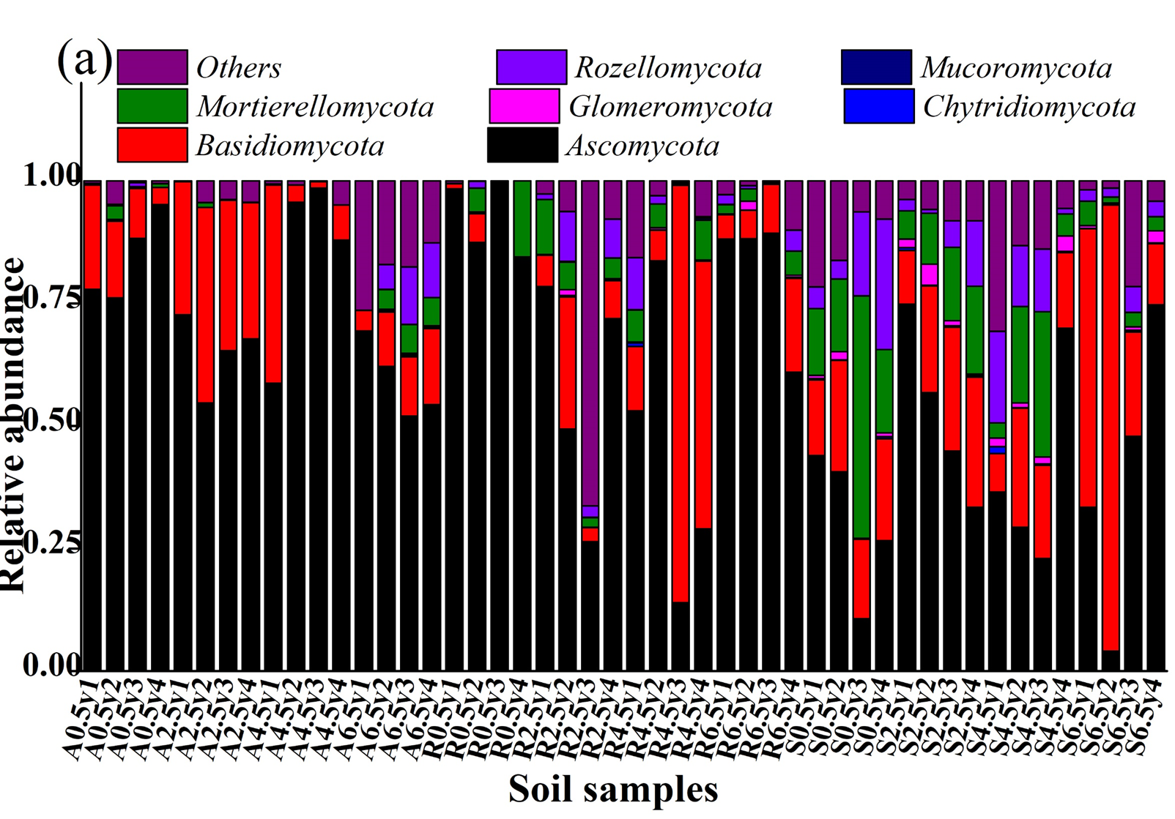
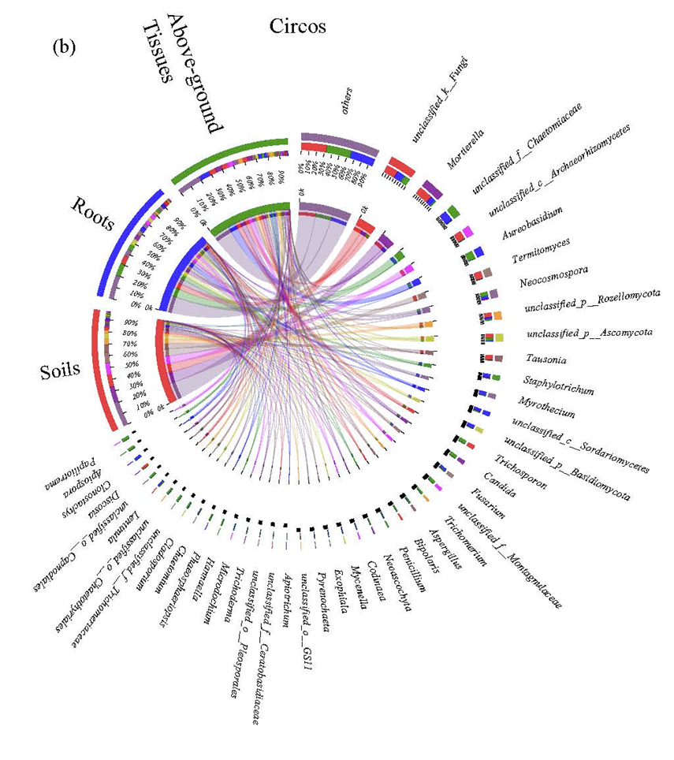
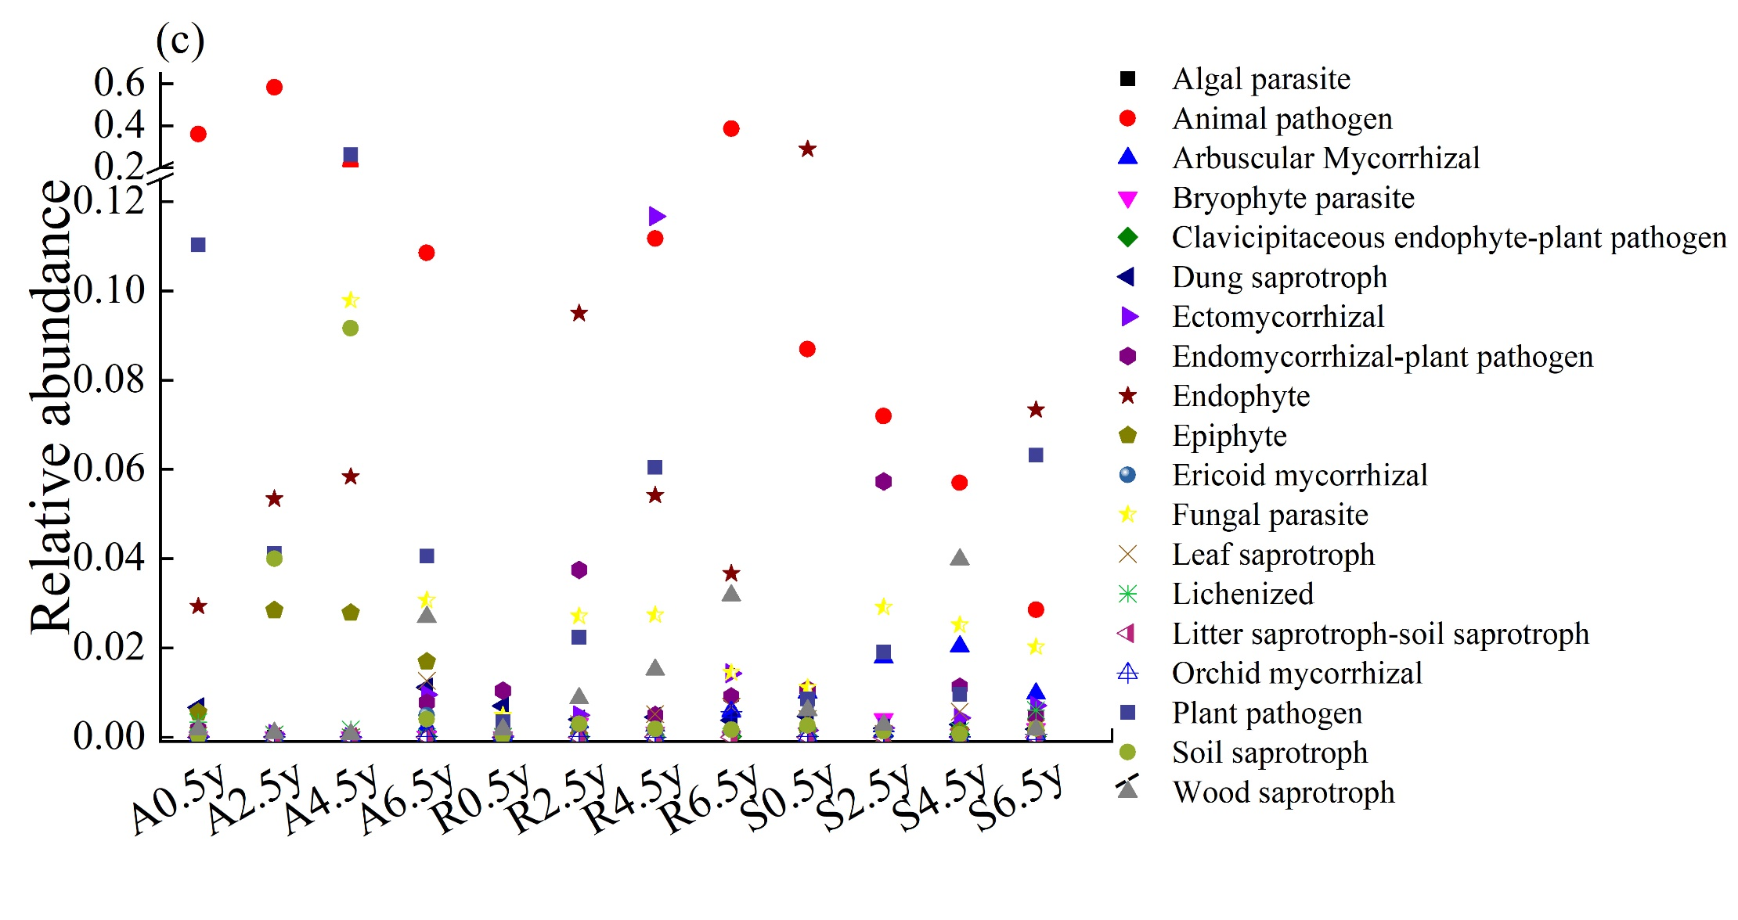
Fig. S5. The relative abundances of fungal distribution at: (a) predominant phyla; (b) predominant genera and (c) predicted function analyses of fungi with Fungi Functional Guild. A0.5y, 0.5-year above-ground tissues; A2.5y, 2.5-year above-ground tissues; A4.5y, 4.5-year above-ground tissues; A6.5y, 6.5-year above-ground tissues; R0.5y, 0.5-year roots; R2.5y, 2.5-year roots; R4.5y, 4.5-year roots; R6.5y, 6.5 roots; S0.5y, rhizospheric soils of 0.5-year bamboos; S2.5y, rhizospheric soils of 2.5-year bamboos; S4.5y, rhizospheric soils of 4.5-year bamboos; and S6.5y, rhizospheric soils of 6.5-year bamboos.
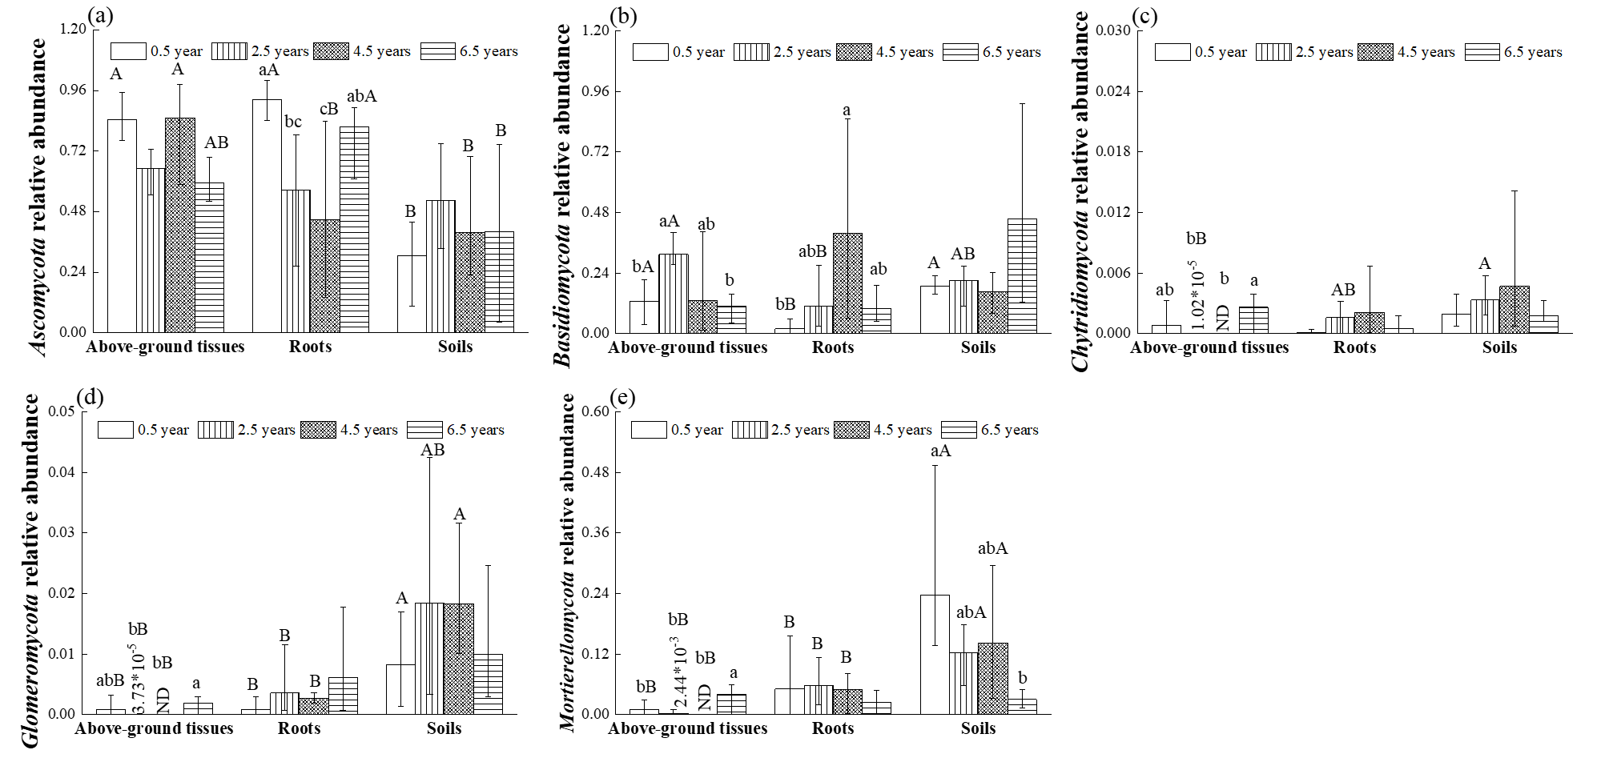
Fig. S6. The relative abundances of fungal phyla with significant differences among different groups: (a) Ascomycota, (b) Basidiomycota, (c) Chytridiomycota, (d) Glomeromycota and (e) Mortierellomycota. Vertical bars indicate the maximum and minimum values. Lowercase letters show significant differences among the same samples of different ages, and capital letters show significant differences among different niches of the same age.
Table S3 The linear correlations between bamboo biomass and soil nutrient contents and microbial relative abundances in above-ground tissues, roots and rhizospheric soils.
Soil nutrients |  | Bacterial community |  |  |  | Fungal community
 |  | Bacterial phyla | Above-ground tissues | Roots | Rhizospheric soil | Fungal phyla | Above-ground tissues | Roots | Rhizospheric soil
Soil organic matter | -0.012 | Acidobacteria | -0.130 | -0.075 | 0.476 | Ascomycota | -0.451 | 0.276 | 0.237
Total N | 0.191 | Actinobacteria | -0.137 | -0.224 | -0.226 | Basidiomycota | 0.589* | -0.444 | 0.099
NH₄⁺-N | 0.370 | Armatimonadetes | -0.139 | -0.157 | 0.314 | Chytridiomycota | 0.031 | 0.069 | 0.245
NO₃⁻-N | 0.256 | Bacteroidetes | 0.046 | 0.165 | -0.484 | Glomeromycota | -0.025 | 0.176 | 0.128
 |  | Chlamydiae | -0.113 | -0.037 | -0.598* | Mortierellomycota | -0.042 | 0.255 | -0.238
 |  | Chloroflexi | -0.022 | 0.171 | 0.083 | Mucoromycota | -0.057 | 0.026 | -0.072
 |  | Dependentiae | 0.087 | -0.062 | 0.052 | Rozellomycota | -0.121 | 0.213 | -0.301
 |  | Elusimicrobia | -0.077 | -0.011 | -0.214
 |  | Entotheonellaeota | -0.030 | -0.057 | -0.329
 |  | Firmicutes | -0.142 | 0.224 | -0.209
 |  | Gemmatimonadetes | 0.079 | 0.165 | -0.403
 |  | Latescibacteria | 0.000 | 0.221 | -0.365
 |  | Nitrospirae | -0.082 | -0.017 | -0.074
 |  | Planctomycetes | 0.093 | -0.318 | -0.437
 |  | Proteobacteria | 0.173 | -0.034 | 0.021
 |  | Verrucomicrobia | 0.096 | -0.212 | 0.242
Pearson’s correlation coefficients (r values) and P level (* P < 0.05) were in each cell.

References
- Bach HJ, Hartmann A, Schloter M, Munch J. PCR primers and functional probes for amplification and detection of bacterial genes for extracellular peptidases in single strains and in soil. J Microbiol Meth. 2001;44:173-182
- Xiao X, Yin X, Lin J, Sun L, You Z, Wang P, Wang F. Chitinase genes in lake sediments of Ardley Island, Antarctica. Appl Environ Microb 2005;71:7904-7909
- Francis CA, Roberts KJ, Beman JM, Santoro AE, Oakley BB. Ubiquity and diversity of ammonia-oxidizing archaea in water columns and sediments of the ocean. P Natl Acad Sci USA. 2005;102: 14683-14688.
- Rotthauwe JH, Witzel KP, Liesack W.The ammonia monooxygenase structural gene amoA as a functional marker molecular fine-scale analysis of natural ammonia-oxidizing populations. Appl Environ Microb 1997;63: 4704-4712

∗ Corresponding author, E-mail: zhangwenyuan@jxau.edu.cn

