Supplementary figures online

Supplementary Fig 1 – Treatment with 6-OHDA (a) and rotenone (b) for 24h and 96 h causes different decreases of ATP levels.
Differentiated SH-SY5Y cells were treated with 6-OHDA (a) or rotenone (b) for 24 and 96 h. Data are presented as boxplots, in which each dot represents an independent cell population (n=4), in duplicate. Kruskal-Wallis test (one-way ANOVA on ranks) pairwise (control vs 6-OHDA or control vs rotenone) was used to assess statistical significance, (*) p< 0.05.

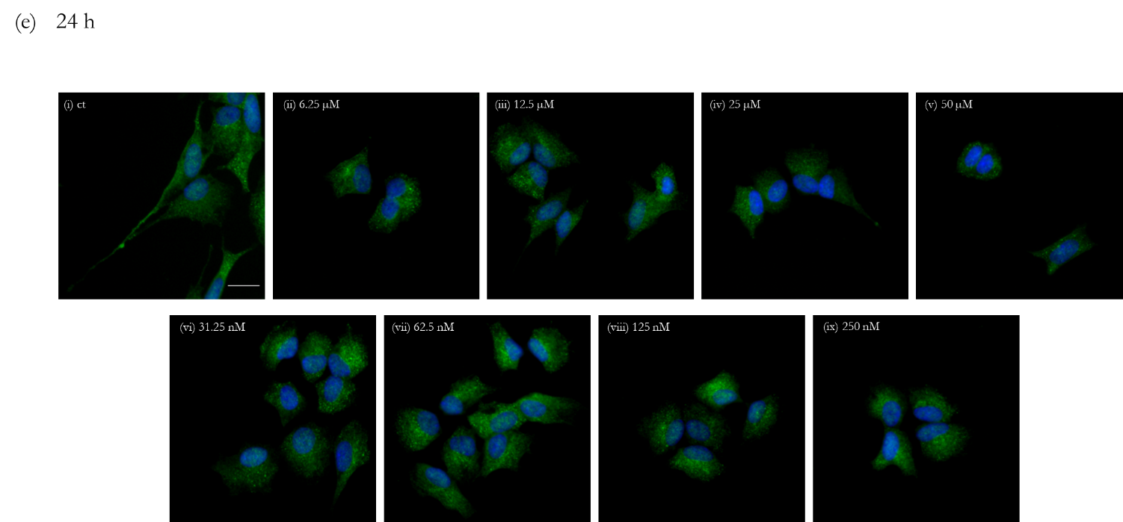

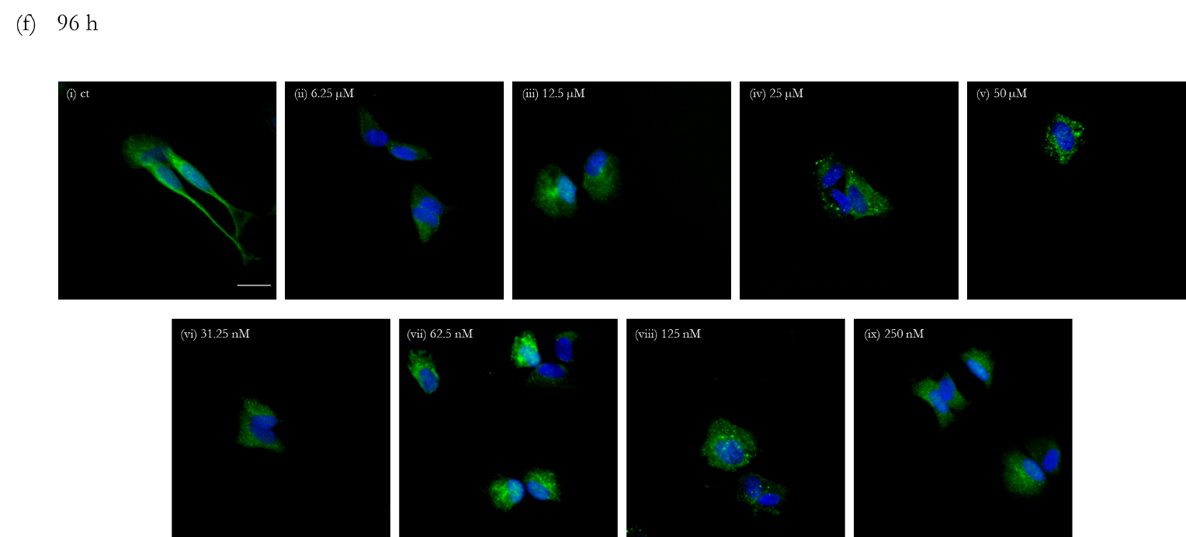

Supplementary Fig 2 – Incubations with 6-OHDA and rotenone decreases the level of βIII tubulin in a dose-dependent manner.
Incubations with 6-OHDA for 24 h (a) and 96 h (b) or rotenone for 24 h (c) and 96 h (d) induced a significant decrease in βIII tubulin level. Data are presented as boxplots, in which each dot represents an independent cell population (n=4) in duplicate. Kruskal-Wallis test (one-way ANOVA on ranks) pair-wise (control vs 6-OHDA or control vs rotenone) was used to assess statistical significance, (*) p< 0.05. Immunofluorescence images of βIII tubulin in differentiated SH-SY5Y cells were acquired using a 20x objective and the IN Cell Analyzer 2200. Scale bar = 20 µm. Nuclei staining is presented in blue and βIII tubulin is presented in green (e and f). Cells were treated for 24 h (e) or 96 h (f) with 6.25 (ii), 12.5 (iii), 25 (iv) and 50 µM (v) of 6-OHDA or with 31.25 (vi), 62.5 (vii), 125 (viii) and 250 nM (ix) rotenone. Non-treated cells are presented in part (i) of both (e) and (f) panels.

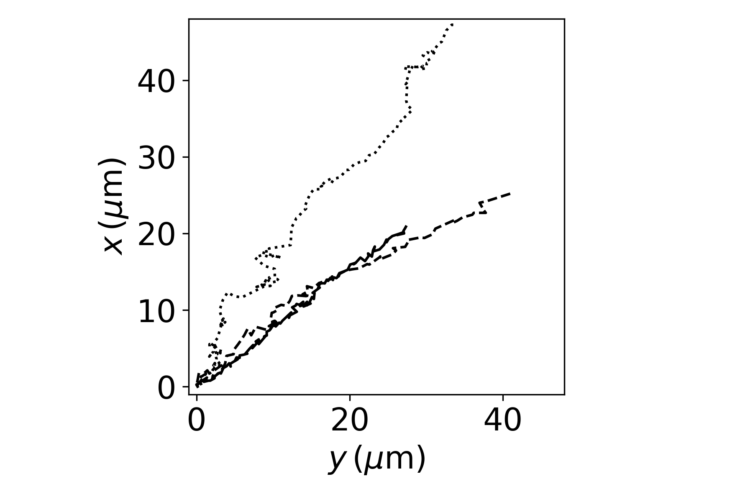
Supplementary Fig. 3 - A subset of 3 trajectories obtained from the control group.

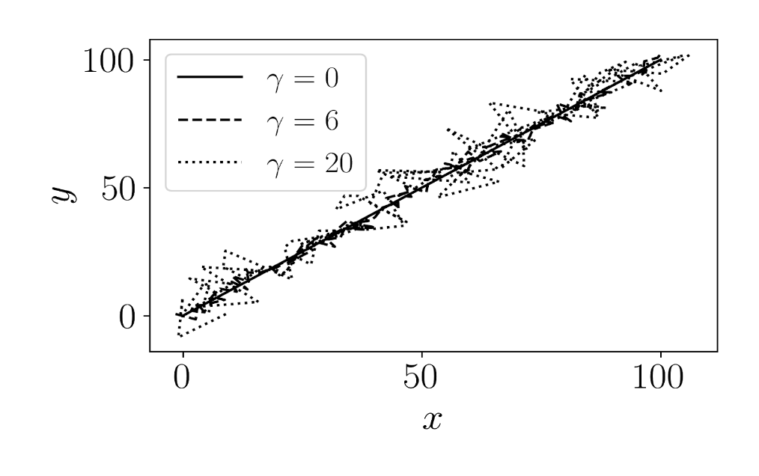
Supplementary Fig. 4 - Three trajectories with different stochastic noise strength 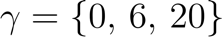 . This example is a linear trajectory under the influence of a random noise with 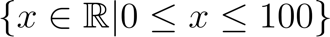 and is the parameter that controls the stochastic strength. It is shown the trajectories for (without noise), 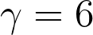 (weak noise) and (high noise), presenting lower to higher tortuosity, respectively.

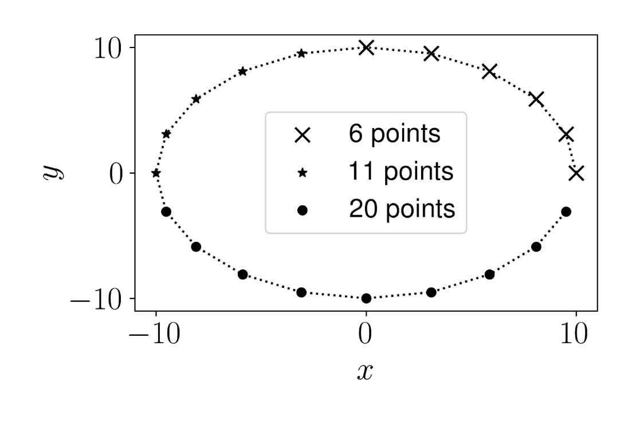
Supplementary Fig.5 - Circular trajectory to observe the effect of symmetry in the features by considering subsets of the circle, as exemplified with 6, 11 and 20 points. We calculated the anisotropy, kurtosis, straightness and efficiency attributes for incomplete circles from 3 to 20 points (complete circle), counterclockwise, and determined the dependency as a function of the number of points considered.

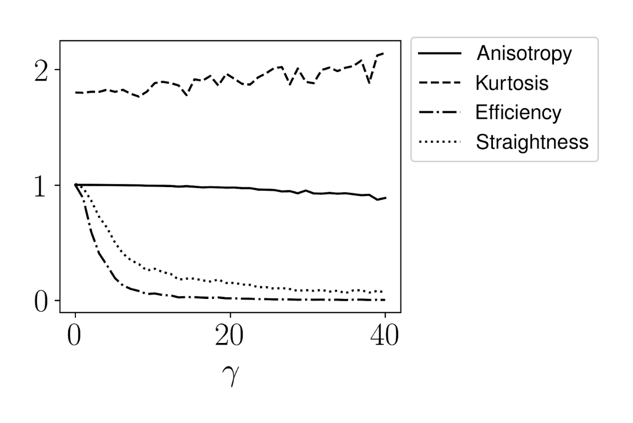
Supplementary Fig. 6 - The effect of stochasticity on each of the features is depicted. We can observe that anisotropy and kurtosis are resilient to the introduction of stochastic noise in the trajectory. The anisotropy shows a tendency to decrease as the noise influence increases, while the kurtosis goes in the opposite direction and increases with . In contrast, efficiency and straightness are strongly affected by stochasticity, decreasing rapidly.

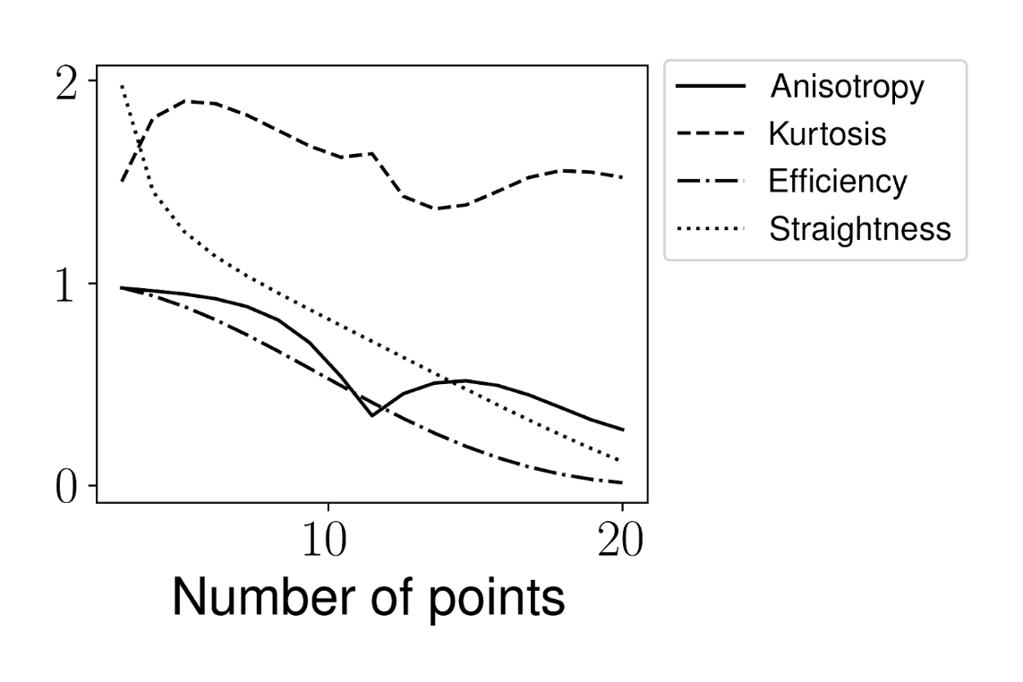

Supplementary Fig. 7 - Anisotropy, kurtosis, efficiency and straightness measured for the circular trajectory with different subsets. We can see that the anisotropy and the kurtosis present a non-monotonic behavior. As we consider more points in the circle, the anisotropy decreases due to the symmetry of the circle. With 11 points we have the semi-circle, which coincides with a local minimum in anisotropy and a local maximum in kurtosis. Efficiency and straightness decrease monotonically as we vary the number of points. The examples explored here highlight the difficulties faced in the analysis of some features, presenting often a non-intuitive behavior.

