Chinese Empirical Dietary Inflammatory index Is Associated with High Risk of Systematic Inflammation and Aging in Rural China
Lu Lyu^{1，2}, Jie Yu¹, Yiwen Liu¹, Shuli He³, Mengya Qi¹, Na Yang¹, Liyun He¹, Jialu Wang¹,Fan Ping¹, Lingling Xu¹, Wei Li¹, Huabing Zhang^{1*}, Yuxiu Li^{1*}

Contents

Supplementary Table 1 The association between the first dietary pattern score and food groups was assessed using the stepwise liner regression 2
Supplementary Table 2 Macronutrient intakes across CEDII subgroups 3
Supplementary Figure 1 Factor loadings of 27 food groups with the RRR-derived dietary pattern in the study population 4
Supplementary Figure 2 Radar charts for daily intake of food items across CEDII tertiles 5
Supplementary Figure 3 Flowchart of subjects included 6

Supplementary Table 1 The association between the first dietary pattern score and food groups was assessed using the stepwise liner regression
food groups | β-coefficients | p-value | food groups | β-coefficients | p-value
rice and rice products | 0.05400 | 0.244 | eggs | 0.00493 | 0.001
millet and millet products | 0.02300 | 0.628 | red meat | -0.02000 | 0.671
wheat and wheat products | -0.00200 | 0.970 | poultry meat | -0.02700 | 0.563
coarse grain | -0.00344 | 0.002 | sea foods | 0.01300 | 0.772
turbers | -0.00600 | 0.905 | fruits | -0.04000 | 0.415
starch products | 0.00454 | 0.097 | snacks | 0.07000 | 0.127
green leafy vegetables | 0.06900 | 0.132 | oil and fats | -0.00509 | 0.004
scallion, ginger and galic | 0.00100 | 0.986 | white/red wine | 0.05700 | 0.215
yellow vegetables | -0.03200 | 0.532 | beer | 0.07200 | 0.121
other vegetables | 0.00236 | 0.003 | tea/coffee | 0.05700 | 0.223
beans | 0.05500 | 0.232 | beverages | 0.07400 | 0.107
nuts | 0.04900 | 0.281 | sugar | -0.01100 | 0.818
low fat diary | -0.00900 | 0.839 | condiment | 0.01079 | 0.057
high fat diary | -0.04100 | 0.369

Supplementary Table 2 Macronutrient intakes across CEDII subgroups
 | Low CEDII (n=126) | Moderate CEDII (n=130) | High CEDII (n=132) | Total(n=388) | p-value
Energy intake(kcal/day) | 1598.36(1240.88,1939.63) | 1442.42(1091.92,1909.94) | 1446.78(1035.96,2075.14) | 1519.66(1119.47,1970.55) | 0.129
Daily macronutrient intake(g/day)
Carbohydrate intake | 212.22(156.16,306.53)^{b,c} | 254.29(189,335.95)ª | 242.39(186.88,323.04)ª | 239.4(172.1,321.29) | <0.001**
Protein intake | 34.26(24.4,46.28)^{b,c} | 42.31(30.58,52.12)ª | 44.72(33.44,61.32)ª | 41.27(29.79,52.18) | <0.001**
Fat intake | 64.66(43.5,87.12)^{b,c} | 22.65(9.53,49.26)ª | 27.55(12.87,51.65)ª | 38.61(16.89,66.44) | 0.005**
Protein/Fat intake | 0.16(0.13,0.20)^{c} | 0.15(0.13,0.19)^{c} | 0.17(0.14,0.21)^{a,b} | 0.16(0.13,0.20) | 0.020*
Proportion of energy from macronutrient (%)
Carbohydrate intake | 52.81(42.75,65.81)^{b,c} | 72.20(62.52,83.59)ª | 71.73(60.27,78.57)ª | 66.89(53.39,76.94) | <0.001**
Protein intake | 8.58(7.31,9.91)^{b,c} | 11.45(9.85,12.75)ª | 12.26(10.18,14.72)ª | 10.75(8.83,12.71) | <0.001**
Fat intake | 39.75(23.99,49.66)^{b,c} | 15.66(4.78,24.62)ª | 15.13(7.58,27.93)ª | 21.52(10.20,34.59) | <0.001**
*: p＜0.05, ** p<0.01; ª, a significant difference with the low CEDII; ^{b}, a significant difference with the moderate CEDII; ^{c}, a significant difference with the high CEDII;
Differences among the three clusters were performed by either ANOVA or Kruskal-Wallis tests

Supplementary Figure 1 Factor loadings of 27 food groups with the RRR-derived dietary pattern in the study population
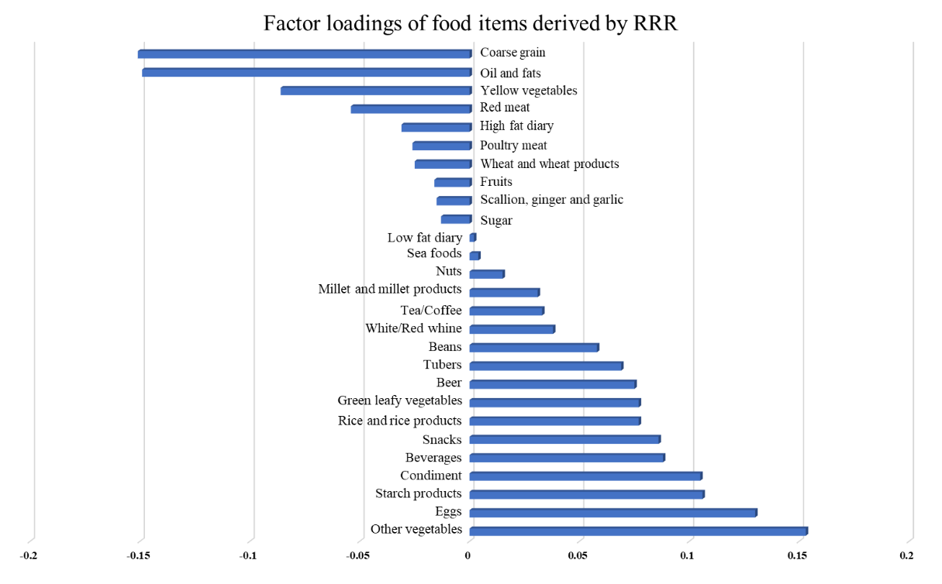
RRR, Reduced-Rank Regression

Supplementary Figure 2 Radar charts for daily intake of food items across CEDII tertiles
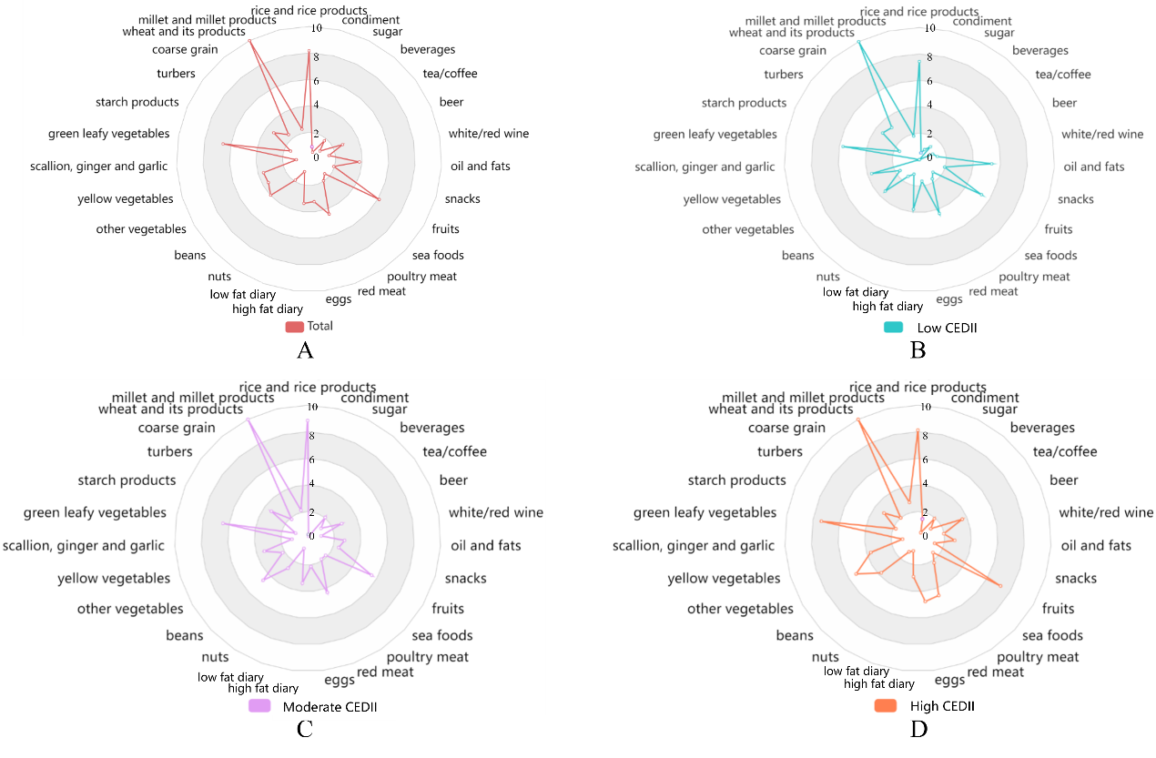
Daily average intakes of all food items were transformed by square and presented in radar charts
CEDII, Chinese empirical dietary inflammatory index
Daily average intakes of all food items (A) in total subjects, (B) in the Low CEDII group, (C) in the Moderate CEDII group, (D) in the High CEDII group

Supplementary Figure 3 Flowchart of subjects included
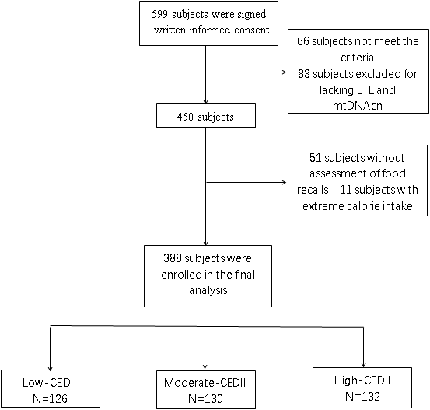
LTL, leukocyte telomere length; mtDNAcn, mitochondrial DNA copy number; CEDII, Chinese empirical dietary inflammatory index

