Supplementary material
Demethylation in promoter region of severely damaged hepatocytes enhances chemokine receptor CXCR4 gene expression

Chihiro Ito^{1,2}, Ryuma Haraguchi¹, Kohei Ogawa², Miku Iwata^{1,2}, Riko Kitazawa³, Yasutsugu Takada² and Sohei Kitazawa^{1*}

1 Department of Molecular Pathology, Ehime University Graduate School of Medicine, Shitsukawa 454, Toon city, Ehime, 791-0295, Japan.
2 Department of Hepato-Biliary-Pancreatic and Breast Surgery, Ehime University Graduate School of Medicine, Shitsukawa 454, Toon city, Ehime, 791-0295, Japan.
3 Division of Diagnostic Pathology, Ehime University Hospital, Shitsukawa 454, Toon city, Ehime, 791-0295, Japan

*Correspondence: Kitazawa@m.ehime-u.ac.jp

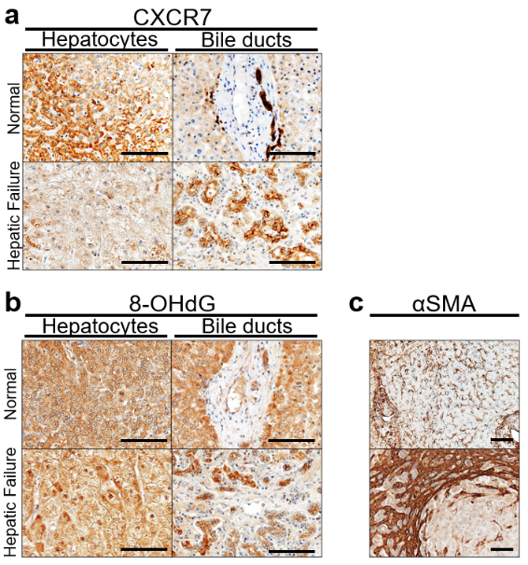
Supplementary Figure 1:
- CXCR7 is strongly positive in normal hepatocytes and intrahepatic cholangiocytes, while it shows weak staining in damaged hepatocytes and pseudoducts.
- 8-OHdG is exclusively stained in the nuclei of injured hepatocytes.
- Although αSMA is positive in a few liver sinusoidal endothelial cells in the normal case, it is strongly positive in stroma around pseudoducts in the hepatic failure case.
Scale bars indicate 50μm (a, b) and 100μm (c).

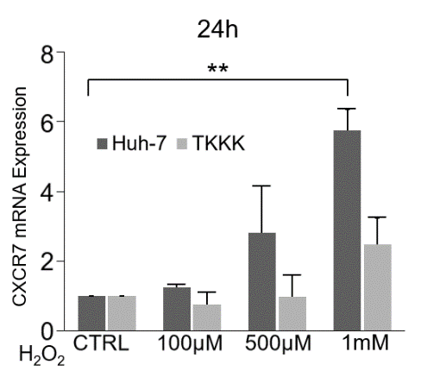
Supplementary Figure 2:
H₂O₂ increased CXCR7 mRNA dose-dependently in Huh-7 and TKKK cells (**p<0.01, n=3).

Supplementary Table 1: Oligonucleotide primers for nested PCR

 | Forward primer (5'-3') | Reverse primer (5'-3')
1st | GGGTTTTTTGGGTTTTTTAAG | CTACTAAAACACTCAAACCCTC
2nd U | GTTTTAGTGGTGTATGTGTTGT | GTTTTAGCGGCGTATGCGTCGC
2nd M | CACTTTACTACCTACTACCA | CACTTTACTACCTACTACCG

U= unmethylated CpG primer
M=methylated CpG primer

Supplementary Table 2: Oligonucleotide probes for Electrophoretic Mobility Shift Assay (EMSA)

 | Sense probe (5'-3') | Antisense probe (5'-3')
U | GCTCGGAGCGTGTTTTTATAAAAGTCCGGCCGCGGCCAGA | TCTGGCCGCGGCGGACTTTTATAAAAACACGCTCCGAGC
M | GCTCGGAGC*GTGTTTTTATAAAAGTCCGGCCGCGGCCAGA | TCTGGCCGCGGCCGGACTTTTATAAAAACAC*GCTCCGAGC

U=unmethylated probe
M=methylated probe
C*=5-methylcytosine

