Novel Biphenylidene-Thiobarbituric Acid Derivatives as Corrosion Inhibitors for Carbon-Steel in Oilfield Produced Water

Hajar A. Aliª, Mahmoud M. Shaban^{b, *}, Ashraf S. Abousalem^{a,c, **}, Eslam A. Ghaithª, Abdelaziz S. Foudaª, Mohamed A. Ismail^{a, ***}

ª Chemistry Departments, Faculty of Science Mansoura University, Mansoura 35516, Egypt
^{b} Egyptian Petroleum Research Institute, Nasr City 11727, Cairo, Egypt
^{c} Quality Control Laboratory, Operations Department, Jotun, Egypt

Supplementary Material
I. Figures
1.1. Figures S1: IR Spectra of the new biphenyl-pyrimidines 5a-c.
1.2. Figures S2: NMR Spectra of the new biphenyl-pyrimidines 5a-c.
1.3. Figures S3: Mass Spectra of the new biphenyl-pyrimidines 5a-c.

1.1. Figures S1: IR Spectra of the new biphenyl-pyrimidines 5a-c
Compound HM-1228 IR Spectrum

Compound HM-1227 IR Spectrum

Compound HM-1226 IR Spectrum

1.2. Figures S2: NMR Spectra of the new biphenyl-pyrimidines 5a-c
Compound HM-1228 ¹H-NMR/JEOL 500 MHz (DMSO-d₆)

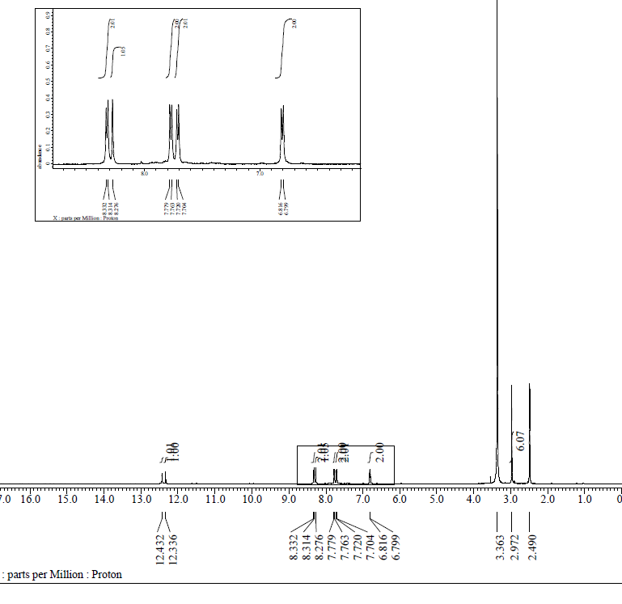
Compound HM-1227 ¹H-NMR/JEOL 500 MHz (DMSO-d₆)

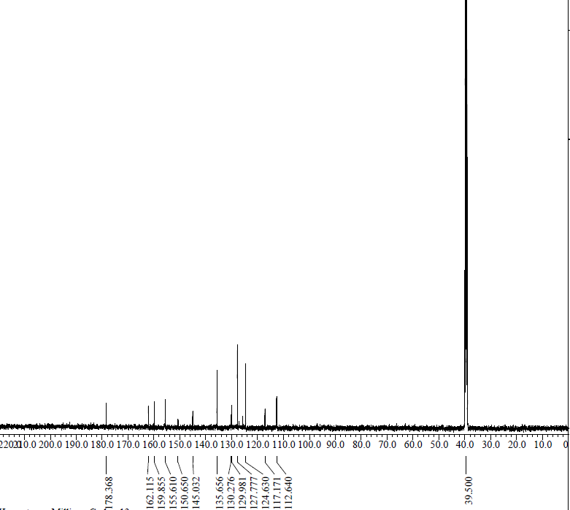
Compound HM-1227 ¹³C-NMR/JEOL 125 MHz (DMSO-d₆)

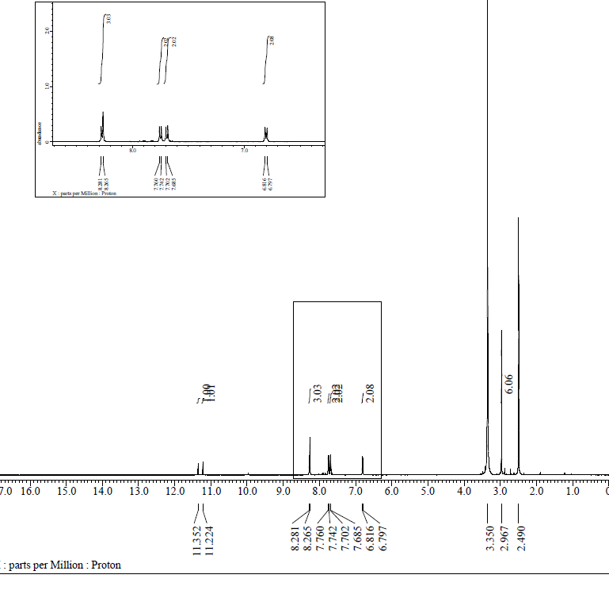
Compound HM-1226 ¹H-NMR/JEOL 500 MHz (DMSO-d₆)

1.3. Figures S3: Mass Spectra of the new biphenyl-pyrimidines 5a-c

Compound HM-1228 ¹H-NMR/JEOL 500 MHz (DMSO-d₆)

Compound HM-1227 ¹H-NMR/JEOL 500 MHz (DMSO-d₆)

Compound HM-1226 ¹H-NMR/JEOL 500 MHz (DMSO-d₆)

