Deubiquitinase USP7 stabilizes KDM5B and promotes tumor progression and cisplatin resistance in nasopharyngeal carcinoma through the ZBTB16/TOP2A axis

Bin Zhang, Jie Li, Yijun Wang, Xixi Liu, Xiao Yang, Zhiyun Liao, Suke Deng, Yue Deng, Zhiyuan Zhou, Yu Tian, Wenwen Wei, Jingshu Meng, Yan Hu, Chao Wan, Zhanjie Zhang, Fang Huang, Lu Wen, Bian Wu, Yajie Sun, Yan Li, Kunyu Yang

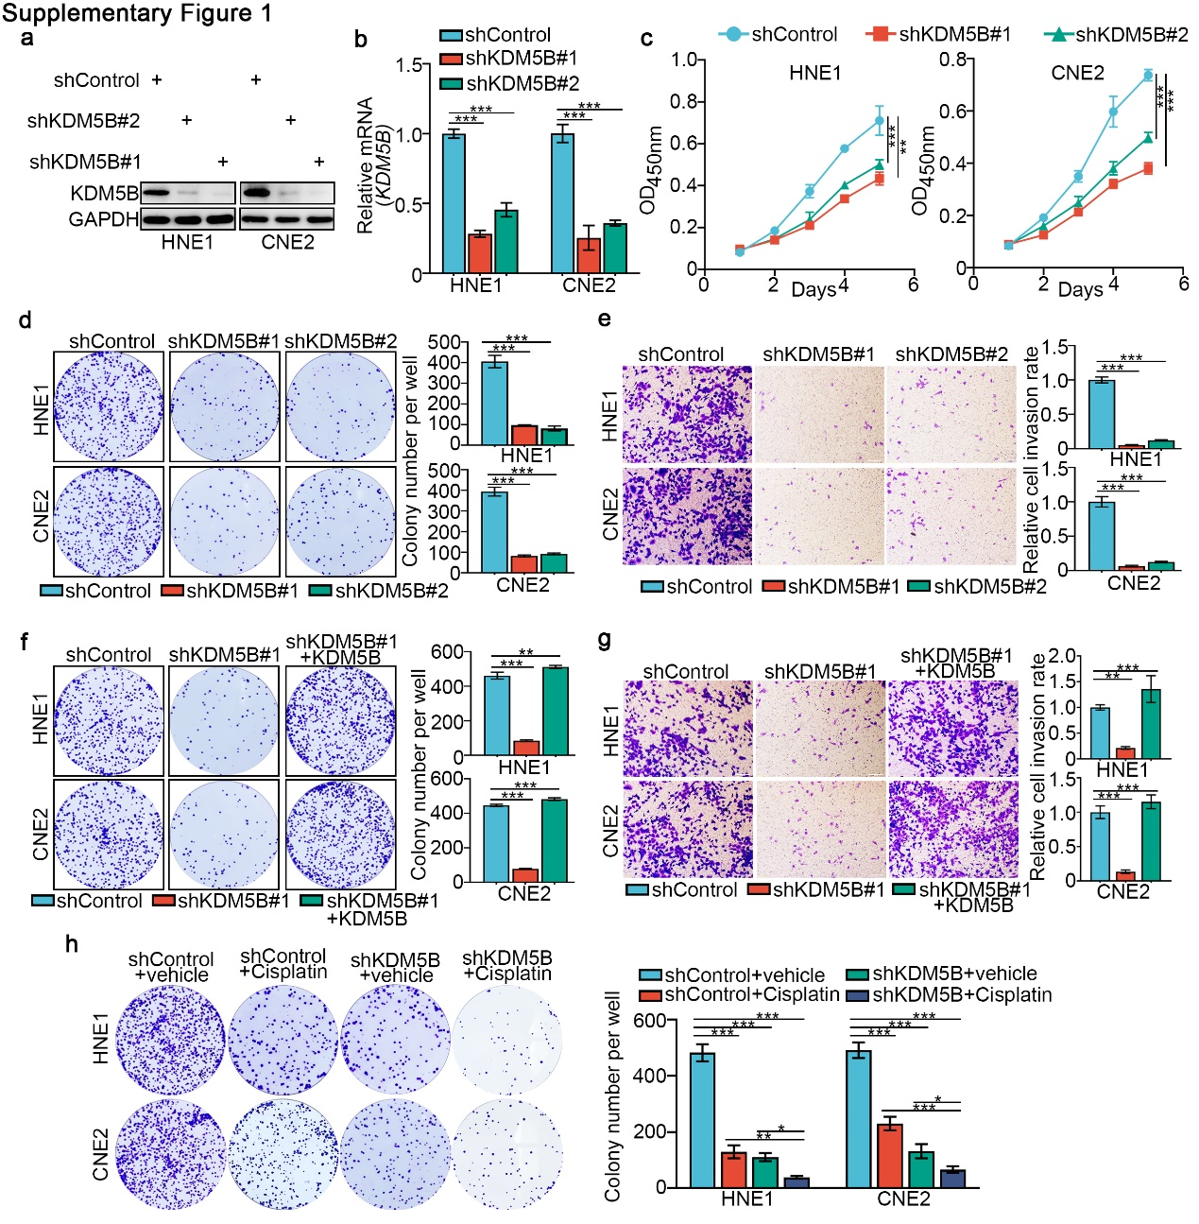
Supplementary figure 1. KDM5B promotes NPC cell proliferation and resistance to cisplatin, related to Figure 1.
a-e HNE1 and CNE2 cells infected with shControl, shKDM5B #1 or shKDM5B #2 for 48 h. Cells were harvested for Western blotting analysis (a), RT-qPCR analysis (b), CCK-8 assay (c), colony formation assay (d) and transwell assay (e). f and g HNE1 and CNE2 cells infected with shControl, shKDM5B or shKDM5B+myc-KDM5B for 48 h. Cells were harvested for colony formation assay (f) and transwell assay (e). h HNE1 and CNE2 cells were infected with shControl or shKDM5B plasmid for 48 hours. Then cells were treated with or without cisplatin (4 μg/ml) for another 48 hours. Cells were collected for colony formation assay. Statistical significance was determined by one-way ANOVA followed by Tukey’s multiple comparisons test. Data presented as Mean ±SD with three replicates. *P<0.05; **P<0.01; ***P<0.001.

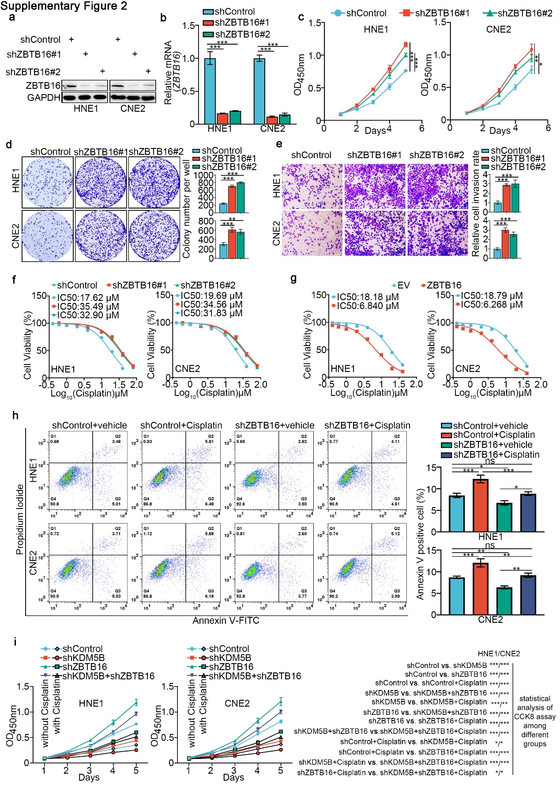
Supplementary figure 2. ZBTB16 inhibits the progression and cisplatin resistance of NPC, related to Figure 3.
a-e HNE1 and CNE2 cells infected with shControl, shZBTB16 #1 or shZBTB16 #2 for 48 h. Cells were harvested for Western blotting analysis (a), RT-qPCR analysis (b), CCK-8 assay (c), colony formation assay (d) and transwell assay (e). Statistical significance was determined by one-way ANOVA followed by Tukey’s multiple comparisons test. Data presented as Mean ±SD with three replicates. *P<0.05; **P<0.01; ***P<0.001. f and g HNE1 and CNE2 cells infected with shZBTB16 #1, shZBTB16 #2 or ZBTB16 plasmids for 72 h. Cells were treated with a serial dose of cisplatin. Then, these cells were collected for CCK-8 assay and subjected to measure the IC50 values of cisplatin. h HNE1 and CNE2 cells were infected with shControl or shZBTB16 plasmid for 48 hours. then cells were treated with or without cisplatin (4 μg/ml) for another 48 hours. Cells were collected for fluorescein isothiocyanate (FITC)/PI flow cytometry. Statistical significance was determined by one-way ANOVA followed by Tukey’s multiple comparisons test. Data presented as Mean ±SD with three replicates. NS not significant; *P<0.05; **P<0.01; ***P<0.001. i HNE1 and CNE2 cells were infected with shControl, shKDM5B or shZBTB16 plasmid for 48 hours. Then cells were treated with or without cisplatin (4 μg/ml) for another 48 hours. Cells were collected for colony formation assay. Statistical significance was determined by one-way ANOVA followed by Tukey’s multiple comparisons test. Data presented as Mean ±SD with three replicates. *P<0.05; ***P<0.001.

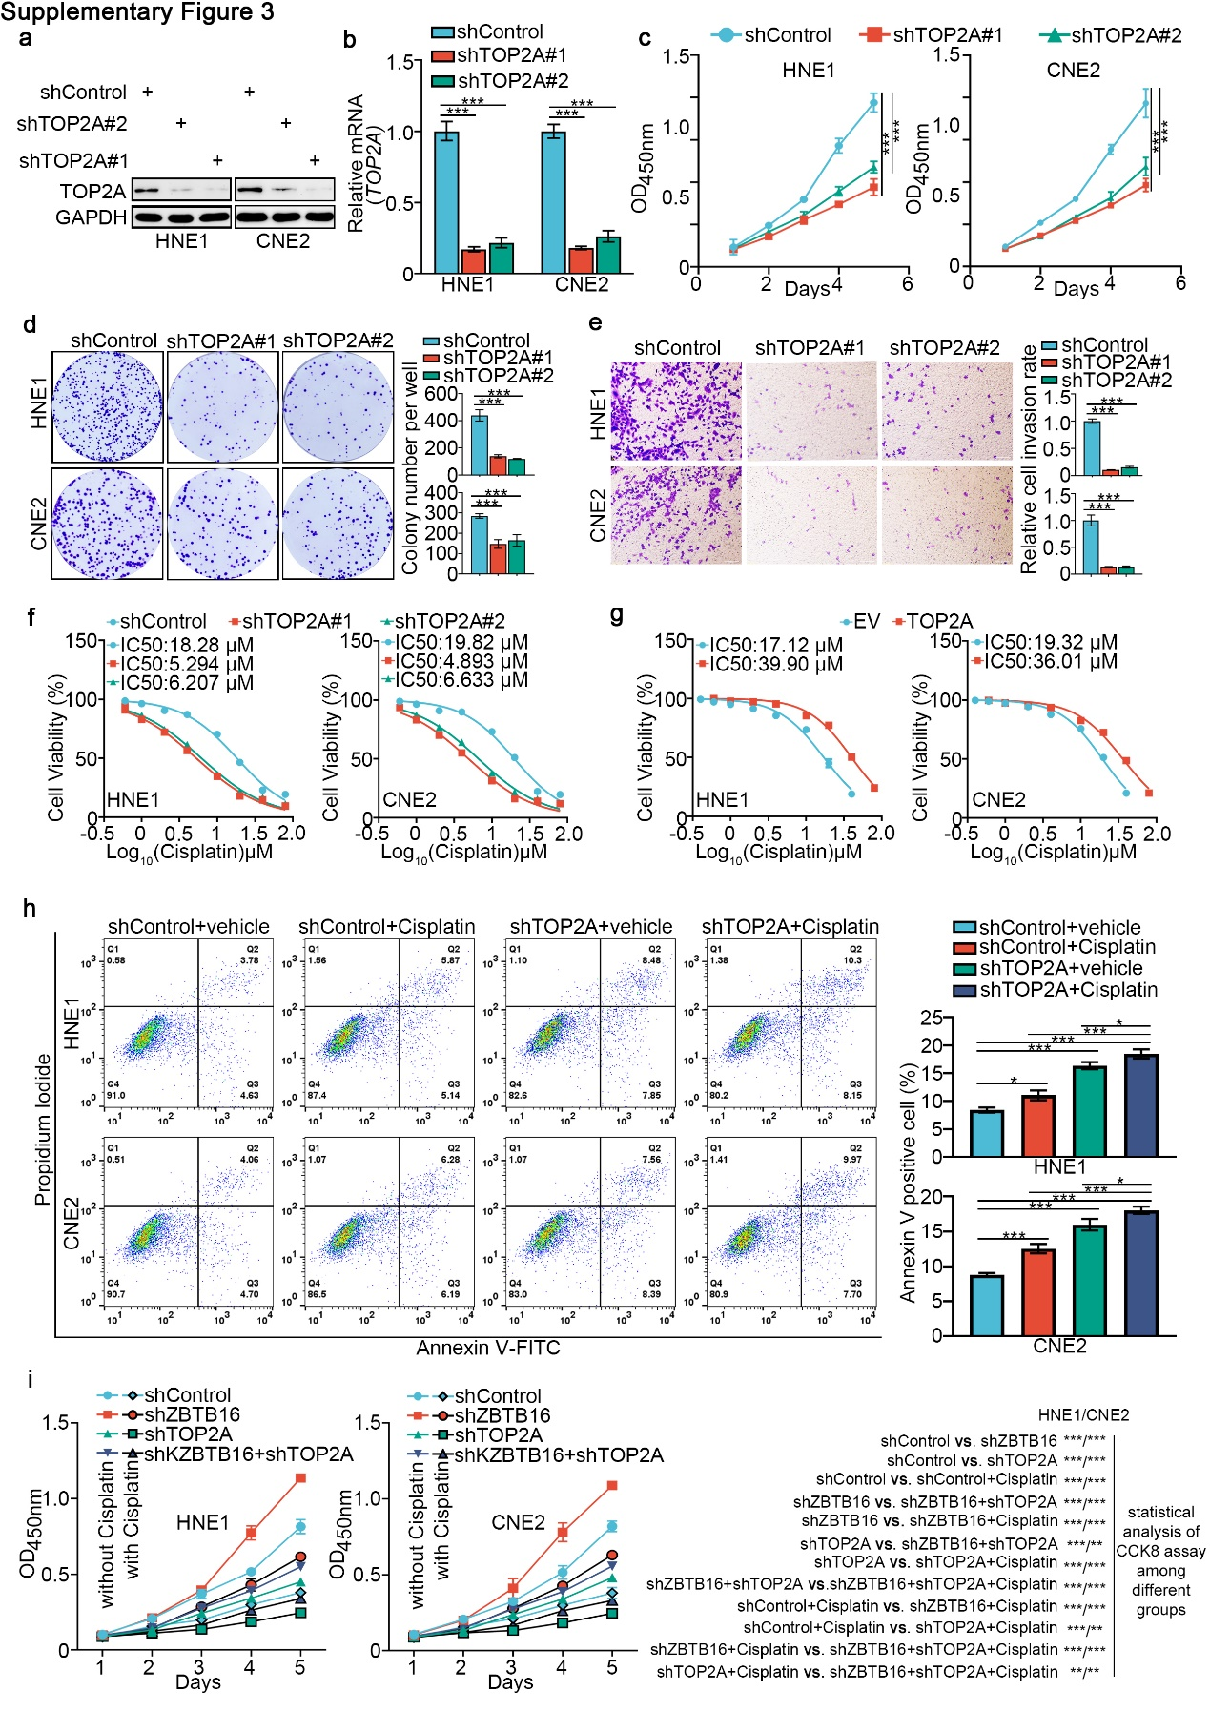
Supplementary figure 3. TOP2A promotes the progression and cisplatin resistance of NPC, related to Figure 5.
a-e HNE1 and CNE2 cells infected with shControl, shTOP2A #1 or shTOP2A #2 for 48 h. Cells were harvested for Western blotting analysis (a), RT-qPCR analysis (b), CCK-8 assay (c), colony formation assay (d) and transwell assay (e). Statistical significance was determined by one-way ANOVA followed by Tukey’s multiple comparisons test. Data presented as Mean ±SD with three replicates. ***P<0.001. f and g HNE1 and CNE2 cells infected with shTOP2A #1, shTOP2A #2 or TOP2A plasmids for 72 h. Cells were treated with a serial dose of cisplatin. Then, these cells were collected for CCK-8 assay and subjected to measure the IC50 values of cisplatin. h HNE1 and CNE2 cells were infected with shControl or shTOP2A plasmid for 48 hours. Then cells were treated with or without cisplatin (4 μg/ml) for another 48 hours. Cells were collected for fluorescein isothiocyanate (FITC)/PI flow cytometry. Statistical significance was determined by one-way ANOVA followed by Tukey’s multiple comparisons test. Data presented as Mean ±SD with three replicates. NS not significant; *P<0.05; ***P<0.001. i HNE1 and CNE2 cells were infected with shControl, shZBTB16 or shTOP2A plasmid for 48 hours. Then cells were treated with or without cisplatin (4 μg/ml) for another 48 hours. Cells were collected for colony formation assay. Statistical significance was determined by one-way ANOVA followed by Tukey’s multiple comparisons test. Data presented as Mean ±SD with three replicates. **P<0.01; ***P<0.001.

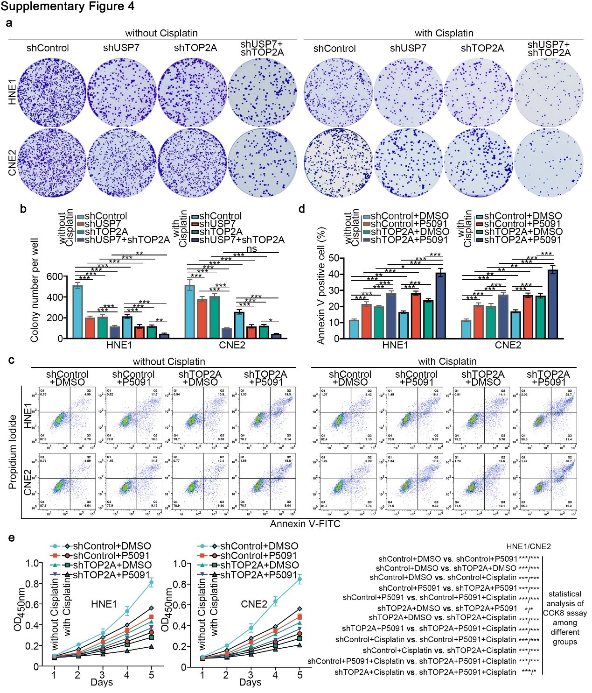
Supplementary figure 4. Targeting USP7 and/or TOP2A can enhance the sensitivity of NPC cells to cisplatin, related to Figure 7.
a and b HNE1 and CNE2 cells were infected with shUSP7 or shTOP2A plasmid for 48 hours. Then cells were treated with USP7 inhibitors P5091 (10 μM) for colony formation assay in the presence or absence of cisplatin. c-e HNE1 and CNE2 cells were infected with shControl or shTOP2A plasmid for 48 hours. Then cells were treated with USP7 inhibitors P5091 (10 μM) for fluorescein isothiocyanate (FITC)/PI flow cytometry (c and d) and CCK-8 assay (e) in the presence or absence of cisplatin. Statistical significance was determined by one-way ANOVA followed by Tukey’s multiple comparisons test. Data presented as Mean ±SD with three replicates. *P<0.05; **P<0.01; ***P<0.001.

Table S1. Sequences for shRNAs and siRNAs
Sequences for shRNAs:
shUSP7-1 | 5’-CCGGCCTGGATTTGTGGTTACGTTACTCGAGTAACGTAACCACAAATCCAGGTTTTTG-3’
shUSP7-2 | 5’-CCGGCCAGCTAAGTATCAAAGGAAACTCGAGTTTCCTTTGATACTTAGCTGGTTTTTG-3’
shKDM5B-1 | 5′-CCGGGCTCCCTTACTTTAGATGATACTCGAGTATCATCTAAAGTAAGGGAGCTTTTTG-3′
shKDM5B-2 | 5’-CCGGCCTGAGGAAGAGGAGTATCTTCTCGAGAAGATACTCCTCTTCCTCAGGTTTTTG-3’
shZBTB16-1 | 5’-CCGGGAATGCACTTACTGGCTCATTCTCGAGAATGAGCCAGTAAGTGCATTCTTTTTG-3’
shZBTB16-2 | 5’-CCGGGTGGACAGTTTGATGACCATACTCGAGTATGGTCATCAAACTGTCCACTTTTTG-3’
shTOP2A-1 | 5’-CCGGGCCTGATTTGTCTAAGTTTAACTCGAGTTAAACTTAGACAAATCAGGCTTTTTG-3’
shTOP2A-2 | 5’-CCGGGCTCCAAATCAATATGTGATTCTCGAGAATCACATATTGATTTGGAGCTTTTTG-3’
Sequences for siRNAs:
siKDM5B#1 | 5’-GGAAGATCTTGGACTTATT-3’
siKDM5B#2 | 5’-GCAGAATCTTACAACGAAT-3’

Table S2. Sequences for primers used for RT-qPCR
Species | Gene | Forward (5’-3’) | Reverse (5’-3’)
Human | GAPDH | CCAGAACATCATCCCTGCCT | CCTGCTTCACCACCTTCTTG
Human | KDM5B | AGTGGGCTCACATATCAGAGG | CAAACACCTTAGGCTGTCTCC
Human | USP7 | GGAAGCGGGAGATACAGATGA | AAGGACCGACTCACTCAGTCT
Human | ZBTB16 | CCTCAGACGACAATGACACGG | CTCGCTGGAATGCTTCGAGAT
Human | TOP2A | ACCATTGCAGCCTGTAAATGA | GGGCGGAGCAAAATATGTTCC

Table S3. Sequences of ChIP-qPCR primers
Species | Gene | Forward (5’-3’) | Reverse (5’-3’)
Human | ZBTB16 (Primer I) | CCGCCAGCACTAAAGATGGA | TTCGCAGTACCCGCTCTCAT
Human | ZBTB16 (Primer O) | ATTGCTAAAACCGCGTGACC | CTGGAGCTGAGCGAAGGTAG
Human | TOP2A  (Primer I) | TGACACTTCCATGGTGACGG | GAGTCAGGGATTGGCTGGTC
Human | TOP2A  (Primer O) | TTCAGGTCCCCAGTAGAGCA | TCACGGAGGTGAGCAAAAGT

Table S4. RNA-seq of siKDM5B vs. siControl
gene_id | si_KDM5B | si_Control | log2FC | pvalue | padj | gene_name | gene_biotype
ENSG00000058085 | 2679.55434 | 9772.149045 | -1.866737584 | 1.19E-307 | 1.96E-303 | LAMC2 | protein_coding
ENSG00000167601 | 681.2737036 | 4129.127151 | -2.599128127 | 2.56E-273 | 2.10E-269 | AXL | protein_coding
ENSG00000106366 | 6983.17104 | 21016.13117 | -1.589521466 | 9.96E-243 | 5.45E-239 | SERPINE1 | protein_coding
ENSG00000096060 | 7470.809034 | 2640.028489 | 1.500693089 | 6.88E-168 | 2.83E-164 | FKBP5 | protein_coding
ENSG00000163283 | 6800.931609 | 2143.946576 | 1.665220323 | 4.62E-160 | 1.52E-156 | ALPP | protein_coding
ENSG00000117139 | 411.6851235 | 2059.944744 | -2.323656446 | 7.72E-160 | 2.11E-156 | KDM5B | protein_coding
ENSG00000180447 | 1403.320653 | 198.23233 | 2.822257218 | 1.22E-154 | 2.85E-151 | GAS1 | protein_coding
ENSG00000089597 | 13588.63246 | 5075.218323 | 1.420730353 | 3.64E-147 | 7.47E-144 | GANAB | protein_coding
ENSG00000214049 | 2004.807653 | 5596.389585 | -1.48130113 | 2.25E-145 | 4.11E-142 | UCA1 | lincRNA
ENSG00000166741 | 2261.14142 | 553.7556844 | 2.029594898 | 1.49E-144 | 2.45E-141 | NNMT | protein_coding
ENSG00000189221 | 2649.238184 | 715.2175459 | 1.889673305 | 5.78E-140 | 8.63E-137 | MAOA | protein_coding
ENSG00000197632 | 1036.362619 | 3160.38622 | -1.608969939 | 9.16E-132 | 1.25E-128 | SERPINB2 | protein_coding
ENSG00000167460 | 10318.22087 | 4648.114179 | 1.150444872 | 1.59E-125 | 2.01E-122 | TPM4 | protein_coding
ENSG00000186081 | 13231.24987 | 4161.946341 | 1.66844889 | 1.54E-119 | 1.80E-116 | KRT5 | protein_coding
ENSG00000111335 | 5708.492306 | 2276.43418 | 1.326408069 | 2.41E-116 | 2.64E-113 | OAS2 | protein_coding
ENSG00000117525 | 3520.237115 | 8482.858138 | -1.268931703 | 6.54E-116 | 6.71E-113 | F3 | protein_coding
ENSG00000138757 | 570.5225915 | 1922.251969 | -1.753129975 | 4.40E-109 | 4.25E-106 | G3BP2 | protein_coding
ENSG00000152377 | 256.5365797 | 1195.058724 | -2.219733763 | 1.57E-103 | 1.44E-100 | SPOCK1 | protein_coding
ENSG00000125538 | 723.2887286 | 2247.501751 | -1.635423418 | 1.06E-102 | 9.15E-100 | IL1B | protein_coding
ENSG00000139289 | 1420.785198 | 3523.457283 | -1.31040219 | 2.17E-101 | 1.78E-98 | PHLDA1 | protein_coding
ENSG00000139211 | 4680.897277 | 9760.010386 | -1.060016731 | 7.63E-96 | 5.97E-93 | AMIGO2 | protein_coding
ENSG00000100605 | 962.3860155 | 2621.758556 | -1.446115395 | 6.15E-94 | 4.59E-91 | ITPK1 | protein_coding
ENSG00000104327 | 349.6041352 | 1290.086694 | -1.883764699 | 1.75E-91 | 1.25E-88 | CALB1 | protein_coding
ENSG00000130589 | 10640.38722 | 4370.958546 | 1.283399868 | 2.38E-90 | 1.63E-87 | HELZ2 | protein_coding
ENSG00000131238 | 1392.041218 | 3436.231566 | -1.303561848 | 2.32E-86 | 1.53E-83 | PPT1 | protein_coding
ENSG00000114942 | 2201.639865 | 4829.608231 | -1.133444204 | 2.95E-85 | 1.87E-82 | EEF1B2 | protein_coding
ENSG00000183486 | 2530.817142 | 1002.410905 | 1.336373901 | 8.26E-85 | 5.02E-82 | MX2 | protein_coding
ENSG00000113083 | 5771.99352 | 2752.720833 | 1.068315747 | 1.96E-84 | 1.15E-81 | LOX | protein_coding
ENSG00000111319 | 6494.626549 | 3241.396524 | 1.002617053 | 1.56E-81 | 8.54E-79 | SCNN1A | protein_coding
ENSG00000185745 | 2654.080041 | 1096.187156 | 1.27567072 | 9.56E-80 | 5.07E-77 | IFIT1 | protein_coding
ENSG00000204103 | 872.4322755 | 183.0472189 | 2.252530188 | 1.56E-78 | 8.00E-76 | MAFB | protein_coding
ENSG00000149948 | 1576.506613 | 3784.014091 | -1.263416369 | 2.60E-78 | 1.30E-75 | HMGA2 | protein_coding
ENSG00000130635 | 17505.4063 | 8362.601741 | 1.065714329 | 1.03E-76 | 5.00E-74 | COL5A1 | protein_coding
ENSG00000185499 | 1833.741768 | 627.7411155 | 1.545992479 | 1.25E-76 | 5.88E-74 | MUC1 | protein_coding
ENSG00000173210 | 2826.26145 | 1271.657031 | 1.152395384 | 4.88E-74 | 2.23E-71 | ABLIM3 | protein_coding
ENSG00000137959 | 4064.875443 | 1824.778271 | 1.155765272 | 2.18E-68 | 9.42E-66 | IFI44L | protein_coding
ENSG00000090054 | 947.2518678 | 2316.269044 | -1.289668964 | 3.58E-68 | 1.51E-65 | SPTLC1 | protein_coding
ENSG00000078018 | 1447.815711 | 402.0672621 | 1.849024431 | 4.49E-68 | 1.84E-65 | MAP2 | protein_coding
ENSG00000165949 | 9788.917494 | 4536.916904 | 1.109292747 | 6.06E-64 | 2.26E-61 | IFI27 | protein_coding
ENSG00000091409 | 2334.386296 | 4740.498118 | -1.021911013 | 2.71E-63 | 9.90E-61 | ITGA6 | protein_coding
ENSG00000111913 | 443.531722 | 57.59083617 | 2.942751478 | 1.14E-62 | 4.07E-60 | RIPOR2 | protein_coding
ENSG00000130303 | 5603.366743 | 2498.782206 | 1.164857664 | 4.27E-62 | 1.46E-59 | BST2 | protein_coding
ENSG00000132274 | 1907.382564 | 752.5714618 | 1.341818249 | 2.79E-60 | 9.36E-58 | TRIM22 | protein_coding
ENSG00000138772 | 1369.236227 | 2991.230509 | -1.127407221 | 4.04E-58 | 1.25E-55 | ANXA3 | protein_coding
ENSG00000153815 | 910.0946063 | 1994.871374 | -1.132222572 | 1.26E-57 | 3.84E-55 | CMIP | protein_coding
ENSG00000143537 | 4783.024834 | 2248.1071 | 1.088984722 | 1.75E-56 | 5.22E-54 | ADAM15 | protein_coding
ENSG00000158417 | 1305.709778 | 2674.495195 | -1.03453045 | 1.13E-53 | 3.27E-51 | EIF5B | protein_coding
ENSG00000273749 | 974.3228056 | 2101.669977 | -1.108453603 | 8.51E-50 | 2.37E-47 | CYFIP1 | protein_coding
ENSG00000118985 | 1147.777972 | 2478.257675 | -1.110149824 | 1.85E-49 | 5.06E-47 | ELL2 | protein_coding
ENSG00000094975 | 564.5550005 | 1414.859575 | -1.324825826 | 4.64E-49 | 1.25E-46 | SUCO | protein_coding
ENSG00000089127 | 2329.941322 | 1128.774528 | 1.045290757 | 1.32E-48 | 3.50E-46 | OAS1 | protein_coding
ENSG00000261780 | 347.7475716 | 954.4389765 | -1.456442199 | 7.21E-48 | 1.82E-45 | LINC02582 | processed_transcript
ENSG00000196611 | 49.7537855 | 323.5479884 | -2.699594617 | 1.48E-47 | 3.58E-45 | MMP1 | protein_coding
ENSG00000175348 | 911.5138304 | 1992.603316 | -1.128058732 | 6.03E-46 | 1.44E-43 | TMEM9B | protein_coding
ENSG00000154188 | 345.0740905 | 49.39731445 | 2.8015353 | 4.91E-45 | 1.15E-42 | ANGPT1 | protein_coding
ENSG00000049192 | 47.57795902 | 346.7447107 | -2.870065665 | 2.28E-44 | 5.13E-42 | ADAMTS6 | protein_coding
ENSG00000070950 | 448.5692384 | 1250.319216 | -1.479175179 | 5.85E-44 | 1.26E-41 | RAD18 | protein_coding
ENSG00000151414 | 801.0698505 | 1727.126483 | -1.108605933 | 1.81E-43 | 3.77E-41 | NEK7 | protein_coding
ENSG00000134954 | 1684.375203 | 3473.943079 | -1.044063459 | 2.27E-43 | 4.63E-41 | ETS1 | protein_coding
ENSG00000102996 | 865.9845418 | 334.9119672 | 1.370654235 | 1.70E-42 | 3.40E-40 | MMP15 | protein_coding
ENSG00000164171 | 1156.503389 | 2552.908978 | -1.142238292 | 1.32E-41 | 2.61E-39 | ITGA2 | protein_coding
ENSG00000058091 | 1010.206703 | 429.7641582 | 1.232696125 | 2.75E-40 | 5.13E-38 | CDK14 | protein_coding
ENSG00000196072 | 284.7206144 | 738.4655161 | -1.375508768 | 5.84E-40 | 1.07E-37 | BLOC1S2 | protein_coding
ENSG00000157693 | 529.5646824 | 1209.423642 | -1.190326278 | 1.37E-39 | 2.42E-37 | TMEM268 | protein_coding
ENSG00000165806 | 936.3724954 | 368.006959 | 1.346871446 | 2.00E-39 | 3.45E-37 | CASP7 | protein_coding
ENSG00000150630 | 599.7218874 | 1268.112203 | -1.079891369 | 4.17E-39 | 7.13E-37 | VEGFC | protein_coding
ENSG00000126709 | 9399.345599 | 4441.535158 | 1.081387785 | 9.69E-39 | 1.64E-36 | IFI6 | protein_coding
ENSG00000123689 | 1197.471882 | 2738.670093 | -1.193755841 | 1.59E-38 | 2.63E-36 | G0S2 | protein_coding
ENSG00000180776 | 562.3908994 | 1255.760172 | -1.159229195 | 2.02E-38 | 3.31E-36 | ZDHHC20 | protein_coding
ENSG00000187908 | 263.946073 | 41.61958694 | 2.662633323 | 1.62E-37 | 2.57E-35 | DMBT1 | protein_coding
ENSG00000134326 | 688.5327266 | 265.0963276 | 1.377114802 | 2.81E-37 | 4.39E-35 | CMPK2 | protein_coding
ENSG00000166736 | 392.4480573 | 91.3716507 | 2.105908906 | 7.74E-36 | 1.14E-33 | HTR3A | protein_coding
ENSG00000068078 | 829.557161 | 341.381484 | 1.280266494 | 1.49E-35 | 2.12E-33 | FGFR3 | protein_coding
ENSG00000155893 | 480.5019033 | 150.986912 | 1.671167213 | 5.27E-35 | 7.22E-33 | PXYLP1 | protein_coding
ENSG00000064652 | 184.9013477 | 580.0591918 | -1.648696571 | 2.08E-34 | 2.80E-32 | SNX24 | protein_coding
ENSG00000104756 | 330.1802777 | 785.4375354 | -1.2506862 | 3.60E-34 | 4.80E-32 | KCTD9 | protein_coding
ENSG00000039987 | 255.4207334 | 37.34736855 | 2.768552408 | 1.77E-33 | 2.33E-31 | BEST2 | protein_coding
ENSG00000174804 | 1047.633366 | 494.2676813 | 1.083715533 | 7.92E-33 | 1.01E-30 | FZD4 | protein_coding
ENSG00000031691 | 259.6444199 | 688.1971054 | -1.406301383 | 1.10E-32 | 1.39E-30 | CENPQ | protein_coding
ENSG00000049249 | 360.601148 | 817.8374543 | -1.181488976 | 5.34E-32 | 6.63E-30 | TNFRSF9 | protein_coding
ENSG00000060491 | 1843.07617 | 822.4932112 | 1.163596253 | 5.42E-32 | 6.65E-30 | OGFR | protein_coding
ENSG00000244398 | 880.3705795 | 1897.513926 | -1.107931959 | 6.04E-32 | 7.35E-30 | AC116533.1 | processed_pseudogene
ENSG00000128923 | 294.417045 | 764.8556457 | -1.377291458 | 1.43E-31 | 1.71E-29 | MINDY2 | protein_coding
ENSG00000204767 | 119.9165823 | 393.6099704 | -1.714562171 | 6.14E-31 | 7.10E-29 | INSYN2B | protein_coding
ENSG00000168453 | 1564.491881 | 730.7817939 | 1.097537033 | 7.82E-31 | 8.93E-29 | HR | protein_coding
ENSG00000173432 | 3267.278534 | 1466.791489 | 1.155021393 | 1.57E-30 | 1.77E-28 | SAA1 | protein_coding
ENSG00000178150 | 201.3186224 | 533.5738188 | -1.406598265 | 2.10E-30 | 2.34E-28 | ZNF114 | protein_coding
ENSG00000187193 | 788.5398913 | 335.792152 | 1.230674285 | 2.60E-30 | 2.87E-28 | MT1X | protein_coding
ENSG00000221869 | 2737.70214 | 1253.852434 | 1.126277583 | 6.31E-30 | 6.77E-28 | CEBPD | protein_coding
ENSG00000141959 | 1519.242518 | 720.0140926 | 1.076670147 | 2.60E-29 | 2.69E-27 | PFKL | protein_coding
ENSG00000143845 | 424.9047952 | 144.7084801 | 1.554342437 | 2.74E-29 | 2.81E-27 | ETNK2 | protein_coding
ENSG00000109906 | 220.2232683 | 36.76680967 | 2.586348703 | 2.22E-28 | 2.19E-26 | ZBTB16 | protein_coding
ENSG00000231412 | 165.6728084 | 475.4886403 | -1.520188158 | 3.34E-28 | 3.27E-26 | AC005392.2 | lincRNA
ENSG00000226380 | 46.35839467 | 244.6055203 | -2.405738463 | 3.79E-28 | 3.68E-26 | LINC-PINT | lincRNA
ENSG00000076554 | 289.4161822 | 665.8459946 | -1.202622056 | 4.10E-28 | 3.94E-26 | TPD52 | protein_coding
ENSG00000157450 | 596.0780601 | 1290.635847 | -1.114670434 | 4.63E-28 | 4.42E-26 | RNF111 | protein_coding
ENSG00000110446 | 662.24353 | 250.6272282 | 1.401048402 | 6.75E-28 | 6.33E-26 | SLC15A3 | protein_coding
ENSG00000133106 | 967.6647408 | 447.7963144 | 1.112543579 | 2.26E-27 | 2.07E-25 | EPSTI1 | protein_coding
ENSG00000158292 | 1122.605756 | 560.3380167 | 1.002702314 | 2.69E-27 | 2.44E-25 | GPR153 | protein_coding
ENSG00000116701 | 417.7903963 | 859.7121937 | -1.041193686 | 6.85E-27 | 6.02E-25 | NCF2 | protein_coding
ENSG00000111077 | 832.5091933 | 409.827868 | 1.021996537 | 3.42E-25 | 2.83E-23 | TNS2 | protein_coding
ENSG00000157168 | 349.4883447 | 737.0579115 | -1.07642869 | 2.89E-24 | 2.28E-22 | NRG1 | protein_coding
ENSG00000100767 | 415.5769331 | 150.1584564 | 1.468159424 | 3.25E-24 | 2.56E-22 | PAPLN | protein_coding
ENSG00000181333 | 232.5372774 | 578.2160753 | -1.314606716 | 1.60E-23 | 1.22E-21 | HEPHL1 | protein_coding
ENSG00000170989 | 103.2395638 | 317.026481 | -1.618875948 | 3.81E-23 | 2.86E-21 | S1PR1 | protein_coding
ENSG00000141384 | 84.33555397 | 287.837631 | -1.771339689 | 4.82E-23 | 3.58E-21 | TAF4B | protein_coding
ENSG00000167191 | 126.320993 | 352.767213 | -1.483174937 | 6.23E-23 | 4.61E-21 | GPRC5B | protein_coding
ENSG00000205426 | 83.00607998 | 279.5406954 | -1.750433435 | 6.81E-23 | 5.00E-21 | KRT81 | protein_coding
ENSG00000172667 | 265.1289475 | 566.2572048 | -1.094640306 | 1.03E-22 | 7.40E-21 | ZMAT3 | protein_coding
ENSG00000144228 | 152.7648197 | 409.8575067 | -1.423483237 | 1.04E-22 | 7.48E-21 | SPOPL | protein_coding
ENSG00000129480 | 154.6795502 | 404.3725445 | -1.385096263 | 1.07E-22 | 7.62E-21 | DTD2 | protein_coding
ENSG00000197766 | 975.4912851 | 436.202819 | 1.160332752 | 1.11E-22 | 7.84E-21 | CFD | protein_coding
ENSG00000166147 | 890.8893088 | 441.2200206 | 1.014062813 | 6.77E-22 | 4.56E-20 | FBN1 | protein_coding
ENSG00000067798 | 149.8890675 | 420.5049753 | -1.488843471 | 1.06E-21 | 7.08E-20 | NAV3 | protein_coding
ENSG00000260604 | 603.8031198 | 274.4883017 | 1.137027905 | 1.65E-21 | 1.08E-19 | AL590004.3 | lincRNA
ENSG00000003989 | 422.2049976 | 176.2856104 | 1.260566413 | 8.50E-21 | 5.29E-19 | SLC7A2 | protein_coding
ENSG00000186847 | 306.6851341 | 715.7859865 | -1.223292267 | 1.64E-20 | 9.98E-19 | KRT14 | protein_coding
ENSG00000105855 | 669.2957531 | 316.7428452 | 1.080213386 | 1.88E-20 | 1.14E-18 | ITGB8 | protein_coding
ENSG00000091592 | 283.3229691 | 612.6208836 | -1.113706382 | 2.17E-20 | 1.31E-18 | NLRP1 | protein_coding
ENSG00000109452 | 508.6149462 | 1072.980547 | -1.077087547 | 7.93E-20 | 4.59E-18 | INPP4B | protein_coding
ENSG00000185947 | 456.7926469 | 200.9854042 | 1.185160379 | 1.42E-19 | 8.07E-18 | ZNF267 | protein_coding
ENSG00000187134 | 194.953513 | 448.2174558 | -1.199885898 | 2.10E-19 | 1.19E-17 | AKR1C1 | protein_coding
ENSG00000136286 | 579.3181789 | 257.5932744 | 1.169015663 | 2.81E-19 | 1.55E-17 | MYO1G | protein_coding
ENSG00000149968 | 14.11166797 | 110.0267691 | -2.960231637 | 3.41E-19 | 1.87E-17 | MMP3 | protein_coding
ENSG00000100292 | 316.1923364 | 671.9813397 | -1.088031315 | 4.02E-19 | 2.18E-17 | HMOX1 | protein_coding
ENSG00000226145 | 57.86509993 | 245.8184842 | -2.081460918 | 6.57E-19 | 3.50E-17 | KRT16P6 | transcribed_unprocessed_pseudogene
ENSG00000170571 | 356.7333561 | 736.9462688 | -1.045730323 | 2.80E-18 | 1.44E-16 | EMB | protein_coding
ENSG00000149596 | 569.9589501 | 245.1213514 | 1.215578841 | 1.23E-17 | 6.06E-16 | JPH2 | protein_coding
ENSG00000164400 | 68.34590348 | 213.9736568 | -1.648495067 | 1.36E-17 | 6.70E-16 | CSF2 | protein_coding
ENSG00000144815 | 202.2800712 | 446.3666639 | -1.141584349 | 2.48E-17 | 1.19E-15 | NXPE3 | protein_coding
ENSG00000164283 | 5.171145563 | 79.20753796 | -3.94349557 | 2.72E-17 | 1.30E-15 | ESM1 | protein_coding
ENSG00000087303 | 307.2636556 | 125.7451285 | 1.28894404 | 6.81E-17 | 3.19E-15 | NID2 | protein_coding
ENSG00000184792 | 355.7455907 | 149.3810698 | 1.250519952 | 7.27E-17 | 3.38E-15 | OSBP2 | protein_coding
ENSG00000113657 | 145.7741474 | 337.1419717 | -1.208736781 | 3.77E-16 | 1.64E-14 | DPYSL3 | protein_coding
ENSG00000264112 | 118.7463236 | 297.4719206 | -1.324719384 | 6.27E-16 | 2.68E-14 | AC015813.1 | lincRNA
ENSG00000204611 | 272.0666976 | 108.3512061 | 1.32756479 | 2.30E-15 | 9.41E-14 | ZNF616 | protein_coding
ENSG00000254726 | 406.4431025 | 195.335973 | 1.056123988 | 5.73E-15 | 2.27E-13 | MEX3A | protein_coding
ENSG00000120910 | 181.4567094 | 403.6948475 | -1.153974356 | 8.22E-15 | 3.22E-13 | PPP3CC | protein_coding
ENSG00000277758 | 507.2517991 | 246.2378444 | 1.042129231 | 1.05E-14 | 4.05E-13 | FO681492.1 | protein_coding
ENSG00000197142 | 395.0644927 | 195.8236165 | 1.012497475 | 1.28E-14 | 4.87E-13 | ACSL5 | protein_coding
ENSG00000075213 | 171.7181351 | 376.9960032 | -1.13366145 | 1.75E-14 | 6.56E-13 | SEMA3A | protein_coding
ENSG00000147100 | 31.34429895 | 141.9077997 | -2.174942258 | 2.46E-14 | 9.09E-13 | SLC16A2 | protein_coding
ENSG00000134996 | 197.7581136 | 411.9981276 | -1.058835494 | 4.04E-14 | 1.47E-12 | OSTF1 | protein_coding
ENSG00000119979 | 192.2537154 | 399.2771146 | -1.053042747 | 1.03E-13 | 3.63E-12 | FAM45A | protein_coding
ENSG00000124641 | 160.5709991 | 347.6163812 | -1.116102151 | 2.18E-13 | 7.36E-12 | MED20 | protein_coding
ENSG00000107159 | 158.5597489 | 39.10936821 | 2.016993076 | 5.71E-13 | 1.84E-11 | CA9 | protein_coding
ENSG00000120833 | 172.6671771 | 352.6991323 | -1.031381097 | 6.74E-13 | 2.15E-11 | SOCS2 | protein_coding
ENSG00000132530 | 112.813389 | 29.02337688 | 1.95764878 | 1.19E-12 | 3.73E-11 | XAF1 | protein_coding
ENSG00000144810 | 205.430562 | 74.89561911 | 1.454984073 | 1.71E-12 | 5.27E-11 | COL8A1 | protein_coding
ENSG00000136378 | 93.90390358 | 18.40300576 | 2.350287465 | 1.84E-12 | 5.67E-11 | ADAMTS7 | protein_coding
ENSG00000137745 | 144.4832006 | 44.67806424 | 1.692535223 | 2.15E-12 | 6.58E-11 | MMP13 | protein_coding
ENSG00000005469 | 115.0458341 | 260.3636387 | -1.176919697 | 2.18E-12 | 6.63E-11 | CROT | protein_coding
ENSG00000047936 | 289.4090783 | 124.9234886 | 1.212447055 | 3.85E-12 | 1.14E-10 | ROS1 | protein_coding
ENSG00000146700 | 34.80106792 | 128.7788571 | -1.884484034 | 6.10E-12 | 1.76E-10 | SSC4D | protein_coding
ENSG00000165124 | 278.7905802 | 127.1009282 | 1.134137804 | 8.51E-12 | 2.43E-10 | SVEP1 | protein_coding
ENSG00000137573 | 207.7355908 | 86.10778351 | 1.26952316 | 9.56E-12 | 2.71E-10 | SULF1 | protein_coding
ENSG00000173702 | 300.9006944 | 140.3324663 | 1.100947368 | 1.03E-11 | 2.91E-10 | MUC13 | protein_coding
ENSG00000182795 | 66.91007821 | 177.838898 | -1.410655546 | 1.13E-11 | 3.20E-10 | C1orf116 | protein_coding
ENSG00000157601 | 215.336693 | 86.57338121 | 1.313673821 | 1.33E-11 | 3.70E-10 | MX1 | protein_coding
ENSG00000153071 | 139.483828 | 294.0420194 | -1.074388001 | 1.36E-11 | 3.78E-10 | DAB2 | protein_coding
ENSG00000184497 | 70.29320033 | 180.9345827 | -1.363668088 | 2.68E-11 | 7.13E-10 | TMEM255B | protein_coding
ENSG00000174206 | 113.5028833 | 249.4107671 | -1.1358034 | 3.11E-11 | 8.19E-10 | C12orf66 | protein_coding
ENSG00000239620 | 145.3375239 | 50.96389632 | 1.51197208 | 4.78E-11 | 1.24E-09 | PRR20G | protein_coding
ENSG00000185885 | 2222.444682 | 906.9852765 | 1.292751793 | 5.55E-11 | 1.42E-09 | IFITM1 | protein_coding
ENSG00000138061 | 235.0382695 | 105.5641844 | 1.156016991 | 5.61E-11 | 1.43E-09 | CYP1B1 | protein_coding
ENSG00000161896 | 183.3172947 | 67.47308103 | 1.444035969 | 9.91E-11 | 2.43E-09 | IP6K3 | protein_coding
ENSG00000182585 | 170.2265582 | 64.84875396 | 1.393502913 | 1.81E-10 | 4.26E-09 | EPGN | protein_coding
ENSG00000141664 | 364.2796189 | 179.1725831 | 1.02366285 | 3.68E-10 | 8.24E-09 | ZCCHC2 | protein_coding
ENSG00000129521 | 244.4729462 | 116.6029185 | 1.069072734 | 3.80E-10 | 8.51E-09 | EGLN3 | protein_coding
ENSG00000111863 | 33.22526187 | 109.1739774 | -1.712006328 | 4.44E-10 | 9.85E-09 | ADTRP | protein_coding
ENSG00000138615 | 88.96641616 | 20.01362095 | 2.158019789 | 4.93E-10 | 1.09E-08 | CILP | protein_coding
ENSG00000059804 | 18.23771358 | 79.03268047 | -2.11194013 | 5.09E-10 | 1.12E-08 | SLC2A3 | protein_coding
ENSG00000171033 | 45.45995234 | 138.3863691 | -1.611771183 | 5.36E-10 | 1.17E-08 | PKIA | protein_coding
ENSG00000181634 | 133.7397746 | 267.5467944 | -1.001451566 | 6.06E-10 | 1.31E-08 | TNFSF15 | protein_coding
ENSG00000182263 | 133.392336 | 276.8413003 | -1.054984789 | 6.98E-10 | 1.49E-08 | FIGN | protein_coding
ENSG00000232472 | 107.8833307 | 223.9093366 | -1.053446997 | 1.32E-09 | 2.70E-08 | EEF1B2P3 | processed_pseudogene
ENSG00000146147 | 36.1865244 | 0 | 7.581845052 | 2.08E-09 | 4.13E-08 | MLIP | protein_coding
ENSG00000230882 | 100.5111634 | 213.808758 | -1.088327144 | 2.33E-09 | 4.62E-08 | AC005077.4 | processed_pseudogene
ENSG00000168952 | 85.63919656 | 195.6511077 | -1.192654284 | 3.20E-09 | 6.27E-08 | STXBP6 | protein_coding
ENSG00000248607 | 133.6820129 | 50.77865724 | 1.394532917 | 3.34E-09 | 6.52E-08 | AC117422.1 | antisense
ENSG00000065325 | 58.22767138 | 10.89240106 | 2.414326162 | 3.70E-09 | 7.16E-08 | GLP2R | protein_coding
ENSG00000117594 | 95.15086949 | 205.7952795 | -1.112472014 | 5.02E-09 | 9.51E-08 | HSD11B1 | protein_coding
ENSG00000128512 | 104.2228585 | 214.7355347 | -1.041641681 | 6.12E-09 | 1.14E-07 | DOCK4 | protein_coding
ENSG00000144893 | 43.13382992 | 123.3388394 | -1.512578138 | 6.56E-09 | 1.22E-07 | MED12L | protein_coding
ENSG00000104892 | 33.13891926 | 100.7337488 | -1.603930039 | 1.07E-08 | 1.93E-07 | KLC3 | protein_coding
ENSG00000143369 | 90.74520942 | 190.8755169 | -1.07316554 | 1.35E-08 | 2.40E-07 | ECM1 | protein_coding
ENSG00000011465 | 46.71214116 | 6.869372368 | 2.770949688 | 1.45E-08 | 2.55E-07 | DCN | protein_coding
ENSG00000198074 | 87.88611655 | 27.62787674 | 1.668460784 | 1.86E-08 | 3.21E-07 | AKR1B10 | protein_coding
ENSG00000157343 | 43.00981429 | 5.510649758 | 2.971558681 | 3.32E-08 | 5.53E-07 | ARMC12 | protein_coding
ENSG00000166510 | 79.60919895 | 171.2150153 | -1.105784709 | 3.54E-08 | 5.86E-07 | CCDC68 | protein_coding
ENSG00000285106 | 28.701467 | 91.51022927 | -1.667201071 | 3.70E-08 | 6.11E-07 | AC016831.6 | lincRNA
ENSG00000053918 | 101.2815466 | 35.71419167 | 1.506518764 | 5.10E-08 | 8.15E-07 | KCNQ1 | protein_coding
ENSG00000166922 | 19.03874583 | 71.86147787 | -1.919999216 | 7.30E-08 | 1.14E-06 | SCG5 | protein_coding
ENSG00000225886 | 78.05970948 | 24.62389001 | 1.664882759 | 7.97E-08 | 1.23E-06 | AL445490.1 | antisense
ENSG00000117151 | 54.00946045 | 129.2866965 | -1.259241552 | 8.30E-08 | 1.27E-06 | CTBS | protein_coding
ENSG00000117407 | 90.48595074 | 183.8778203 | -1.022828716 | 1.04E-07 | 1.56E-06 | ARTN | protein_coding
ENSG00000168961 | 171.6859159 | 79.68927721 | 1.108491614 | 1.18E-07 | 1.76E-06 | LGALS9 | protein_coding
ENSG00000119698 | 89.44710056 | 185.5547933 | -1.0522716 | 1.47E-07 | 2.16E-06 | PPP4R4 | protein_coding
ENSG00000133069 | 63.69878717 | 142.2993438 | -1.15719439 | 1.99E-07 | 2.87E-06 | TMCC2 | protein_coding
ENSG00000144063 | 67.94368362 | 154.401576 | -1.184813137 | 2.20E-07 | 3.15E-06 | MALL | protein_coding
ENSG00000057657 | 61.68635761 | 138.1412337 | -1.163659809 | 2.26E-07 | 3.22E-06 | PRDM1 | protein_coding
ENSG00000135119 | 47.98981427 | 118.3822082 | -1.300792466 | 3.06E-07 | 4.26E-06 | RNFT2 | protein_coding
ENSG00000127129 | 51.61290244 | 10.91466702 | 2.238593303 | 3.37E-07 | 4.66E-06 | EDN2 | protein_coding
ENSG00000220517 | 38.72157298 | 6.126913268 | 2.657192751 | 6.62E-07 | 8.71E-06 | ASS1P1 | processed_pseudogene
ENSG00000105550 | 170.6656423 | 79.90916523 | 1.095616874 | 6.92E-07 | 9.06E-06 | FGF21 | protein_coding
ENSG00000181773 | 163.6234001 | 78.74080889 | 1.054692516 | 7.71E-07 | 1.00E-05 | GPR3 | protein_coding
ENSG00000256393 | 32.21089097 | 100.383408 | -1.641815045 | 9.95E-07 | 1.26E-05 | RPL41P5 | processed_pseudogene
ENSG00000246985 | 11.16963995 | 48.07031785 | -2.101138564 | 1.03E-06 | 1.30E-05 | SOCS2-AS1 | processed_transcript
ENSG00000169306 | 11.9040493 | 49.2314184 | -2.048776346 | 1.07E-06 | 1.33E-05 | IL1RAPL1 | protein_coding
ENSG00000166394 | 7.190251962 | 42.51968909 | -2.577796906 | 1.15E-06 | 1.43E-05 | CYB5R2 | protein_coding
ENSG00000132932 | 43.82085088 | 105.6050163 | -1.269426301 | 1.32E-06 | 1.62E-05 | ATP8A2 | protein_coding
ENSG00000257219 | 60.65679574 | 133.4828014 | -1.136798727 | 1.37E-06 | 1.68E-05 | LINC02407 | lincRNA
ENSG00000274943 | 18.04771111 | 59.41678645 | -1.72130514 | 1.51E-06 | 1.83E-05 | AC079684.1 | sense_intronic
ENSG00000214357 | 147.1785276 | 70.85132168 | 1.056645497 | 1.61E-06 | 1.94E-05 | NEURL1B | protein_coding
ENSG00000232909 | 35.92803988 | 4.449424531 | 3.016479513 | 1.66E-06 | 2.00E-05 | AL157823.2 | antisense
ENSG00000079263 | 28.9862681 | 79.19757931 | -1.451808448 | 1.91E-06 | 2.26E-05 | SP140 | protein_coding
ENSG00000103313 | 61.85890474 | 19.12910325 | 1.693416857 | 2.07E-06 | 2.45E-05 | MEFV | protein_coding
ENSG00000225383 | 47.60576579 | 111.1601979 | -1.222757373 | 2.20E-06 | 2.59E-05 | SFTA1P | lincRNA
ENSG00000067715 | 52.95690949 | 122.6536323 | -1.209578241 | 2.44E-06 | 2.83E-05 | SYT1 | protein_coding
ENSG00000164120 | 130.4217852 | 60.06420169 | 1.119402574 | 3.10E-06 | 3.51E-05 | HPGD | protein_coding
ENSG00000174640 | 131.5928762 | 64.50879476 | 1.027977448 | 3.18E-06 | 3.59E-05 | SLCO2A1 | protein_coding
ENSG00000153233 | 37.93530465 | 91.0947893 | -1.263354943 | 3.27E-06 | 3.67E-05 | PTPRR | protein_coding
ENSG00000248588 | 19.22172436 | 60.56337543 | -1.653212589 | 3.42E-06 | 3.82E-05 | AC008517.1 | lincRNA
ENSG00000278619 | 153.3825844 | 75.21510391 | 1.025580016 | 3.51E-06 | 3.89E-05 | MRM1 | protein_coding
ENSG00000250771 | 24.0476957 | 1.365978394 | 4.137080785 | 3.55E-06 | 3.94E-05 | AC106865.1 | transcribed_unprocessed_pseudogene
ENSG00000188856 | 107.6884306 | 220.0988473 | -1.03051345 | 4.25E-06 | 4.64E-05 | RPSAP47 | processed_pseudogene
ENSG00000137198 | 130.9625537 | 64.30206687 | 1.026882178 | 4.29E-06 | 4.68E-05 | GMPR | protein_coding
ENSG00000196196 | 113.6714669 | 53.243137 | 1.092570401 | 7.28E-06 | 7.57E-05 | HRCT1 | protein_coding
ENSG00000277196 | 41.18099933 | 9.908785192 | 2.05435295 | 7.46E-06 | 7.73E-05 | AC007325.2 | protein_coding
ENSG00000064205 | 31.38644257 | 4.440318704 | 2.821392159 | 7.51E-06 | 7.76E-05 | WISP2 | protein_coding
ENSG00000167656 | 30.89724404 | 4.40218974 | 2.802525475 | 8.39E-06 | 8.58E-05 | LY6D | protein_coding
ENSG00000197405 | 93.84530962 | 41.42516635 | 1.180600076 | 9.90E-06 | 9.99E-05 | C5AR1 | protein_coding
ENSG00000204616 | 62.91919568 | 21.61805323 | 1.542480319 | 1.10E-05 | 0.000109287 | TRIM31 | protein_coding
ENSG00000204176 | 130.1911874 | 62.74779231 | 1.05162577 | 1.19E-05 | 0.00011707 | SYT15 | protein_coding
ENSG00000210144 | 128.5886377 | 58.08140269 | 1.142925776 | 1.53E-05 | 0.000145046 | MT-TY | Mt_tRNA
ENSG00000141744 | 58.63095437 | 19.81757038 | 1.563715619 | 1.69E-05 | 0.000158643 | PNMT | protein_coding
ENSG00000179869 | 43.11347415 | 94.7408612 | -1.1362753 | 1.90E-05 | 0.000175532 | ABCA13 | protein_coding
ENSG00000187689 | 38.47154448 | 87.16950734 | -1.178636436 | 2.06E-05 | 0.000189716 | AMTN | protein_coding
ENSG00000008118 | 28.91772793 | 73.47835162 | -1.345301414 | 2.24E-05 | 0.000204145 | CAMK1G | protein_coding
ENSG00000162520 | 61.20481908 | 21.1685386 | 1.530178816 | 2.60E-05 | 0.000231041 | SYNC | protein_coding
ENSG00000117245 | 33.97776263 | 80.49455556 | -1.243583337 | 2.78E-05 | 0.000244758 | KIF17 | protein_coding
ENSG00000131386 | 41.72021956 | 10.68161886 | 1.971501981 | 3.06E-05 | 0.000266676 | GALNT15 | protein_coding
ENSG00000182866 | 7.390258772 | 33.03729974 | -2.161316072 | 3.25E-05 | 0.000281886 | LCK | protein_coding
ENSG00000154556 | 36.37354647 | 8.596798767 | 2.084988672 | 3.28E-05 | 0.000283773 | SORBS2 | protein_coding
ENSG00000242779 | 77.12494623 | 32.79614297 | 1.231861599 | 3.52E-05 | 0.000301518 | ZNF702P | transcribed_processed_pseudogene
ENSG00000004799 | 138.7512197 | 59.40283197 | 1.22650882 | 3.64E-05 | 0.000310519 | PDK4 | protein_coding
ENSG00000134539 | 30.37356188 | 5.412624477 | 2.47850143 | 3.93E-05 | 0.000332959 | KLRD1 | protein_coding
ENSG00000269896 | 51.08113321 | 15.77953152 | 1.695324172 | 4.33E-05 | 0.000362879 | AL513477.1 | transcribed_processed_pseudogene
ENSG00000162006 | 117.7990608 | 57.63486948 | 1.031196241 | 4.52E-05 | 0.000376491 | MSLNL | protein_coding
ENSG00000163751 | 4.214167394 | 26.08248794 | -2.635740627 | 4.90E-05 | 0.000405233 | CPA3 | protein_coding
ENSG00000224858 | 28.27668513 | 82.46378171 | -1.539906411 | 5.10E-05 | 0.000419066 | RPL29P11 | processed_pseudogene
ENSG00000224389 | 34.60851211 | 7.124187872 | 2.275317032 | 5.52E-05 | 0.000450155 | C4B | protein_coding
ENSG00000241494 | 30.18837711 | 84.79671862 | -1.488897631 | 5.57E-05 | 0.000453596 | AL355032.1 | processed_pseudogene
ENSG00000144583 | 28.90368005 | 69.2724325 | -1.261168036 | 6.02E-05 | 0.000486515 | 4-Mar | protein_coding
ENSG00000249364 | 22.60960606 | 3.092053357 | 2.873462742 | 6.15E-05 | 0.000495228 | AC112206.2 | lincRNA
ENSG00000169213 | 39.7566686 | 87.53443537 | -1.135980435 | 6.15E-05 | 0.000495228 | RAB3B | protein_coding
ENSG00000168874 | 34.69847119 | 8.166348618 | 2.086102988 | 7.39E-05 | 0.000581895 | ATOH8 | protein_coding
ENSG00000245648 | 94.74119862 | 45.65925578 | 1.055634216 | 8.28E-05 | 0.000643615 | AC022075.1 | antisense
ENSG00000185565 | 11.27628022 | 41.80247736 | -1.891259931 | 8.39E-05 | 0.000651145 | LSAMP | protein_coding
ENSG00000179583 | 77.38681637 | 33.97310653 | 1.190163815 | 8.44E-05 | 0.000654792 | CIITA | protein_coding
ENSG00000135678 | 82.2960918 | 37.16745953 | 1.143955482 | 8.59E-05 | 0.000664725 | CPM | protein_coding
ENSG00000182261 | 31.98568884 | 72.50569163 | -1.177728799 | 9.88E-05 | 0.000750036 | NLRP10 | protein_coding
ENSG00000165548 | 39.92886863 | 11.23528319 | 1.82592565 | 9.92E-05 | 0.000752842 | TMEM63C | protein_coding
ENSG00000144821 | 16.22116051 | 48.64012372 | -1.577255736 | 0.000101229 | 0.000766094 | MYH15 | protein_coding
ENSG00000011201 | 55.03234548 | 110.5711075 | -1.003090315 | 0.000101879 | 0.000769598 | ANOS1 | protein_coding
ENSG00000104760 | 42.88898805 | 12.70654265 | 1.757022946 | 0.000104892 | 0.000789095 | FGL1 | protein_coding
ENSG00000197467 | 14.70644363 | 44.66220124 | -1.600086015 | 0.000106818 | 0.000801377 | COL13A1 | protein_coding
ENSG00000137878 | 47.78797017 | 96.41984576 | -1.01507435 | 0.000120988 | 0.000899472 | GCOM1 | protein_coding
ENSG00000268350 | 53.34111792 | 11.60989132 | 2.198606631 | 0.000125786 | 0.000931234 | FAM156A | protein_coding
ENSG00000116678 | 62.40480182 | 26.09970238 | 1.260114367 | 0.000145135 | 0.001058394 | LEPR | protein_coding
ENSG00000133328 | 68.05889614 | 27.14911891 | 1.330229007 | 0.000152097 | 0.001105732 | HRASLS2 | protein_coding
ENSG00000226237 | 26.27305869 | 5.124232922 | 2.355002978 | 0.00015236 | 0.001106665 | GAS1RR | lincRNA
ENSG00000174125 | 4.800428921 | 25.53017505 | -2.405115109 | 0.00016067 | 0.001160862 | TLR1 | protein_coding
ENSG00000187151 | 42.61610856 | 14.04299929 | 1.603726582 | 0.000161396 | 0.001165089 | ANGPTL5 | protein_coding
ENSG00000066056 | 1.588790789 | 17.03112302 | -3.411523108 | 0.000166699 | 0.001200206 | TIE1 | protein_coding
ENSG00000164744 | 27.73520053 | 63.54239333 | -1.198288712 | 0.000212663 | 0.001487465 | SUN3 | protein_coding
ENSG00000186567 | 66.98045567 | 28.91169285 | 1.209955168 | 0.000221072 | 0.001542344 | CEACAM19 | protein_coding
ENSG00000137501 | 17.11555931 | 48.84770444 | -1.505084611 | 0.00022956 | 0.001595459 | SYTL2 | protein_coding
ENSG00000155816 | 46.93436289 | 17.13099834 | 1.455350085 | 0.000237684 | 0.00164566 | FMN2 | protein_coding
ENSG00000102445 | 15.12569177 | 43.78571648 | -1.534017588 | 0.000279133 | 0.001887307 | RUBCNL | protein_coding
ENSG00000155093 | 75.78177147 | 35.17796185 | 1.108186115 | 0.000284923 | 0.001920923 | PTPRN2 | protein_coding
ENSG00000229953 | 95.94224449 | 46.85927964 | 1.030902611 | 0.000309741 | 0.002067875 | AL590666.2 | antisense
ENSG00000242960 | 235.3411982 | 501.8957918 | -1.092070279 | 0.000313062 | 0.002087506 | FTH1P23 | processed_pseudogene
ENSG00000184838 | 36.10648969 | 76.44975952 | -1.084459934 | 0.000335027 | 0.00220968 | PRR16 | protein_coding
ENSG00000285294 | 39.88587087 | 81.81677918 | -1.036537313 | 0.000344542 | 0.002261614 | LINC00842 | lincRNA
ENSG00000197301 | 38.59337572 | 80.7727684 | -1.069716085 | 0.000348072 | 0.002282961 | AC090673.1 | antisense
ENSG00000166262 | 18.22140134 | 52.28747138 | -1.525513376 | 0.000358935 | 0.002343918 | FAM227B | protein_coding
ENSG00000143434 | 85.21816925 | 42.08951748 | 1.01918558 | 0.000362535 | 0.002366486 | SEMA6C | protein_coding
ENSG00000241935 | 80.79023615 | 37.85777671 | 1.091851462 | 0.000369092 | 0.002401653 | HOGA1 | protein_coding
ENSG00000248213 | 48.6957008 | 17.62697061 | 1.461749487 | 0.000381304 | 0.002466465 | CICP16 | processed_pseudogene
ENSG00000166482 | 63.6892099 | 28.31449383 | 1.169560824 | 0.000382786 | 0.00247508 | MFAP4 | protein_coding
ENSG00000153294 | 27.14822297 | 61.54108695 | -1.177094375 | 0.000387995 | 0.002505801 | ADGRF4 | protein_coding
ENSG00000277142 | 48.94977284 | 19.49375274 | 1.329988283 | 0.000392237 | 0.002526345 | LINC00235 | lincRNA
ENSG00000256542 | 40.62177042 | 14.41355313 | 1.496358184 | 0.000402128 | 0.002582866 | AC148477.2 | antisense
ENSG00000169760 | 48.48236216 | 18.75719799 | 1.366661515 | 0.0004091 | 0.002622517 | NLGN1 | protein_coding
ENSG00000251169 | 34.12109275 | 8.83525266 | 1.943001395 | 0.000454377 | 0.002880176 | LINC01843 | lincRNA
ENSG00000223764 | 63.92654263 | 29.29675826 | 1.123680212 | 0.000518244 | 0.003226504 | LINC02593 | lincRNA
ENSG00000172967 | 66.8419651 | 28.25807753 | 1.246132861 | 0.000523828 | 0.003255101 | XKR3 | protein_coding
ENSG00000224260 | 28.4525816 | 7.844381012 | 1.855194606 | 0.000549553 | 0.003394421 | AL023754.1 | lincRNA
ENSG00000105696 | 36.83571239 | 76.48198413 | -1.05274859 | 0.000570633 | 0.003508794 | TMEM59L | protein_coding
ENSG00000133519 | 25.48833867 | 59.90948157 | -1.227944747 | 0.000595431 | 0.003644907 | ZDHHC8P1 | transcribed_unprocessed_pseudogene
ENSG00000241749 | 39.20113613 | 81.69613372 | -1.063081044 | 0.000653607 | 0.003946482 | RPSAP52 | transcribed_processed_pseudogene
ENSG00000244731 | 39.41447477 | 12.56988979 | 1.645718942 | 0.000663588 | 0.003996607 | C4A | protein_coding
ENSG00000232316 | 15.1737962 | 1.699754697 | 3.151334007 | 0.000675196 | 0.004056112 | LINC02518 | lincRNA
ENSG00000280587 | 42.33351371 | 16.42076386 | 1.367359656 | 0.000713526 | 0.004266094 | LINC01348 | lincRNA
ENSG00000125798 | 16.12375043 | 41.42381492 | -1.36290099 | 0.000742512 | 0.004418497 | FOXA2 | protein_coding
ENSG00000162894 | 76.31382967 | 36.00983901 | 1.085687134 | 0.000746776 | 0.004437445 | FCMR | protein_coding
ENSG00000277400 | 35.3029041 | 11.54544209 | 1.608386924 | 0.000760215 | 0.004507521 | AC145212.1 | protein_coding
ENSG00000110427 | 37.06793846 | 13.38590395 | 1.4711234 | 0.000827601 | 0.004861375 | KIAA1549L | protein_coding
ENSG00000205670 | 85.95419782 | 9.929201109 | 3.114268087 | 0.000869518 | 0.005064227 | SMIM11A | protein_coding
ENSG00000127863 | 5.496311112 | 23.82906892 | -2.117454023 | 0.000978527 | 0.005603766 | TNFRSF19 | protein_coding
ENSG00000234432 | 48.43758522 | 20.78937755 | 1.218925621 | 0.000979696 | 0.005608504 | AC092171.3 | lincRNA
ENSG00000117707 | 6.758446152 | 24.66066754 | -1.867786305 | 0.001005162 | 0.005730328 | PROX1 | protein_coding
ENSG00000163395 | 10.7733809 | 35.1685018 | -1.69900469 | 0.001041839 | 0.005902558 | IGFN1 | protein_coding
ENSG00000115705 | 15.03309938 | 2.020370867 | 2.882537433 | 0.001155708 | 0.006465199 | TPO | protein_coding
ENSG00000248187 | 14.55496832 | 2.052595483 | 2.824710654 | 0.001181063 | 0.006577923 | AC078850.1 | lincRNA
ENSG00000260302 | 61.29116169 | 28.92485299 | 1.081178955 | 0.001201383 | 0.006682033 | AP005482.1 | lincRNA
ENSG00000102931 | 60.18313527 | 26.48263919 | 1.180340646 | 0.001233326 | 0.006838861 | ARL2BP | protein_coding
ENSG00000177494 | 6.136637871 | 23.29333771 | -1.927208932 | 0.001364404 | 0.007479867 | ZBED2 | protein_coding
ENSG00000224081 | 20.32791349 | 47.0789476 | -1.214640354 | 0.001407566 | 0.00768061 | SLC44A3-AS1 | transcribed_processed_pseudogene
ENSG00000137673 | 16.06415146 | 2.758277054 | 2.549478118 | 0.001454767 | 0.007890992 | MMP7 | protein_coding
ENSG00000272872 | 42.29945715 | 16.28460962 | 1.373386156 | 0.001540126 | 0.00827091 | AP000525.1 | sense_intronic
ENSG00000253313 | 7.995038777 | 26.36632658 | -1.717561869 | 0.001556257 | 0.008350522 | C1orf210 | protein_coding
ENSG00000125872 | 15.22935163 | 39.0637634 | -1.363084288 | 0.001587038 | 0.008493497 | LRRN4 | protein_coding
ENSG00000269376 | 61.55233764 | 28.36443149 | 1.116786357 | 0.001600094 | 0.008549443 | AL356740.3 | sense_intronic
ENSG00000188897 | 46.73690941 | 20.20078574 | 1.210085047 | 0.001615168 | 0.008615979 | AC099489.1 | protein_coding
ENSG00000273472 | 62.40408578 | 30.67589678 | 1.024198609 | 0.001634607 | 0.008708366 | AC096733.2 | lincRNA
ENSG00000160868 | 2.869444307 | 15.76501995 | -2.450303618 | 0.001639849 | 0.008733457 | CYP3A4 | protein_coding
ENSG00000228437 | 16.30119523 | 45.06660967 | -1.462783239 | 0.001678099 | 0.008925595 | LINC02474 | lincRNA
ENSG00000181781 | 17.03666771 | 2.68927491 | 2.649600427 | 0.001694753 | 0.009002521 | ODF3L2 | protein_coding
ENSG00000272221 | 56.20409438 | 26.52987398 | 1.080269544 | 0.001764181 | 0.009323091 | AL645933.2 | lincRNA
ENSG00000226472 | 59.93459697 | 28.84161782 | 1.056828021 | 0.001766508 | 0.009332387 | AC008013.1 | transcribed_unprocessed_pseudogene
ENSG00000234290 | 69.60577416 | 34.40512817 | 1.012543157 | 0.001773424 | 0.009362904 | AC116366.1 | antisense
ENSG00000229619 | 26.10234885 | 6.513330104 | 2.003869807 | 0.001794947 | 0.009461336 | MBNL1-AS1 | antisense
ENSG00000226007 | 15.77453267 | 2.718796654 | 2.530871465 | 0.001835727 | 0.009648433 | BX005266.2 | lincRNA
ENSG00000233328 | 36.73425877 | 73.56499114 | -1.00146245 | 0.001837617 | 0.009652191 | PFN1P1 | processed_pseudogene
ENSG00000065413 | 32.45155121 | 67.75229108 | -1.060164536 | 0.001856606 | 0.009733479 | ANKRD44 | protein_coding
ENSG00000180264 | 53.77021044 | 25.60615444 | 1.070905655 | 0.001908612 | 0.009974077 | ADGRD2 | protein_coding
ENSG00000273045 | 17.00963509 | 40.85428759 | -1.261783717 | 0.00205787 | 0.010642368 | C2orf15 | protein_coding
ENSG00000008323 | 54.96976611 | 26.36177367 | 1.062843113 | 0.002144243 | 0.011005907 | PLEKHG6 | protein_coding
ENSG00000086717 | 23.16883498 | 6.105145915 | 1.918026186 | 0.002151146 | 0.01103789 | PPEF1 | protein_coding
ENSG00000223459 | 22.52446468 | 50.07702998 | -1.154389395 | 0.002227477 | 0.011404629 | TCAF1P1 | unprocessed_pseudogene
ENSG00000005001 | 9.985622359 | 30.69545987 | -1.622184185 | 0.002309301 | 0.011772206 | PRSS22 | protein_coding
ENSG00000205809 | 56.51819245 | 27.67326149 | 1.03011479 | 0.00232191 | 0.011825474 | KLRC2 | protein_coding
ENSG00000127774 | 40.15143745 | 16.65921775 | 1.265817974 | 0.00234291 | 0.011917652 | EMC6 | protein_coding
ENSG00000268713 | 30.91129191 | 11.26430632 | 1.454648204 | 0.002354515 | 0.01196557 | AC005261.3 | lincRNA
ENSG00000130052 | 46.50135585 | 20.50233743 | 1.179655149 | 0.002413359 | 0.012219257 | STARD8 | protein_coding
ENSG00000284883 | 7.34619788 | 24.26969779 | -1.719851468 | 0.002577737 | 0.012935924 | AC021066.2 | unprocessed_pseudogene
ENSG00000179593 | 24.33433409 | 7.544180759 | 1.692878743 | 0.002602877 | 0.01303819 | ALOX15B | protein_coding
ENSG00000256083 | 9.356790141 | 29.12382648 | -1.643003964 | 0.0028584 | 0.014083492 | AC090673.2 | antisense
ENSG00000217236 | 3.248675087 | 15.65063306 | -2.278225469 | 0.002969874 | 0.014578738 | SP9 | protein_coding
ENSG00000151846 | 25.85203137 | 54.45147234 | -1.070502834 | 0.0029752 | 0.014600519 | PABPC3 | protein_coding
ENSG00000160870 | 10.64042406 | 29.67591931 | -1.48240947 | 0.002985866 | 0.014631013 | CYP3A7 | protein_coding
ENSG00000267780 | 15.01607111 | 2.355498606 | 2.660815008 | 0.003051904 | 0.014919007 | AC021594.2 | lincRNA
ENSG00000177989 | 66.03092851 | 31.33398934 | 1.074296483 | 0.003095363 | 0.015100004 | ODF3B | protein_coding
ENSG00000253406 | 35.40358356 | 14.04299929 | 1.33472019 | 0.003124077 | 0.015212975 | AC012613.2 | antisense
ENSG00000254602 | 17.8540122 | 4.13741558 | 2.118132841 | 0.003189223 | 0.015502645 | AP000662.1 | sense_overlapping
ENSG00000019186 | 16.13077437 | 39.45125313 | -1.2939804 | 0.003243181 | 0.015746298 | CYP24A1 | protein_coding
ENSG00000272430 | 14.58349114 | 2.72014809 | 2.415597103 | 0.003353994 | 0.016215462 | AL356056.3 | lincRNA
ENSG00000169403 | 20.71941297 | 46.28597655 | -1.154173635 | 0.003359569 | 0.016234623 | PTAFR | protein_coding
ENSG00000248569 | 26.9504224 | 59.62542286 | -1.148004422 | 0.003373226 | 0.016281462 | CRSP8P | processed_pseudogene
ENSG00000283689 | 17.9736372 | 4.446223053 | 2.015936046 | 0.003470968 | 0.016665111 | AC018553.2 | antisense
ENSG00000275038 | 13.00172428 | 2.058499831 | 2.658969956 | 0.003634794 | 0.01730503 | AC091980.2 | antisense
ENSG00000260088 | 12.41474672 | 32.57540213 | -1.385052137 | 0.003641295 | 0.017330962 | AL445483.1 | lincRNA
ENSG00000178342 | 34.76772741 | 13.92000518 | 1.315701604 | 0.00368171 | 0.017503036 | KCNG2 | protein_coding
ENSG00000260997 | 45.61446617 | 20.58905262 | 1.151967631 | 0.003796166 | 0.01794849 | AC004847.1 | sense_overlapping
ENSG00000223829 | 48.72124322 | 23.54175025 | 1.048996282 | 0.003845009 | 0.01812726 | AC004870.2 | processed_transcript
ENSG00000175899 | 3.824932275 | 16.49111744 | -2.100425474 | 0.003985089 | 0.018685793 | A2M | protein_coding
ENSG00000255642 | 15.4193541 | 37.90749431 | -1.295053105 | 0.004117679 | 0.019159861 | PABPC1P4 | processed_pseudogene
ENSG00000132718 | 5.159651023 | 19.12049603 | -1.892611342 | 0.004304015 | 0.019874409 | SYT11 | protein_coding
ENSG00000266924 | 17.22816038 | 4.07296635 | 2.077189538 | 0.00468963 | 0.02143272 | AC021594.1 | lincRNA
ENSG00000167083 | 6.480321897 | 21.13496255 | -1.711756179 | 0.005053397 | 0.022828517 | GNGT2 | protein_coding
ENSG00000220685 | 3.238670748 | 14.63884689 | -2.183604138 | 0.005147074 | 0.023175233 | AL139094.1 | processed_pseudogene
ENSG00000111325 | 40.49107794 | 18.39845285 | 1.136024448 | 0.00525301 | 0.023573069 | OGFOD2 | protein_coding
ENSG00000244734 | 35.17029436 | 14.64204836 | 1.263370947 | 0.005287563 | 0.023710335 | HBB | protein_coding
ENSG00000229951 | 12.90508836 | 2.411340617 | 2.425343978 | 0.005351558 | 0.023951538 | FLJ31356 | antisense
ENSG00000230291 | 3.735320289 | 17.15731861 | -2.176861849 | 0.005581692 | 0.024779033 | AC078817.1 | processed_pseudogene
ENSG00000183484 | 16.27671595 | 36.83233179 | -1.174945601 | 0.005629831 | 0.024932109 | GPR132 | protein_coding
ENSG00000139187 | 9.941561467 | 27.14641604 | -1.446284596 | 0.005982224 | 0.026259133 | KLRG1 | protein_coding
ENSG00000198732 | 25.30834054 | 9.191294923 | 1.459379006 | 0.006110659 | 0.026744306 | SMOC1 | protein_coding
ENSG00000179954 | 16.80260435 | 4.43306292 | 1.918699435 | 0.006129131 | 0.026791021 | SSC5D | protein_coding
ENSG00000188488 | 22.88368678 | 7.82531653 | 1.543773602 | 0.006152328 | 0.026869417 | SERPINA5 | protein_coding
ENSG00000168517 | 30.18135317 | 12.26563523 | 1.297127843 | 0.006193934 | 0.027029572 | HEXIM2 | protein_coding
ENSG00000257718 | 16.37079853 | 3.702412518 | 2.133517366 | 0.006272328 | 0.027323199 | CPNE8-AS1 | antisense
ENSG00000258824 | 22.2666962 | 7.191339973 | 1.634699566 | 0.006272861 | 0.027323199 | AL122035.1 | antisense
ENSG00000249839 | 5.811472322 | 24.43289096 | -2.075359231 | 0.006427354 | 0.027892611 | AC011330.1 | unprocessed_pseudogene
ENSG00000261499 | 9.710478506 | 26.0806379 | -1.428429246 | 0.006486806 | 0.02810607 | AC233699.1 | unprocessed_pseudogene
ENSG00000250920 | 12.66251086 | 31.53274277 | -1.321155348 | 0.00656416 | 0.028381357 | AC105460.1 | lincRNA
ENSG00000152463 | 15.21934729 | 3.386349261 | 2.158716136 | 0.006700245 | 0.028870973 | OLAH | protein_coding
ENSG00000186340 | 36.56128458 | 16.39579503 | 1.154205808 | 0.006897769 | 0.029628849 | THBS2 | protein_coding
ENSG00000260325 | 14.14721472 | 3.034859911 | 2.209784993 | 0.006962571 | 0.029868156 | HSPB9 | protein_coding
ENSG00000227199 | 29.44141009 | 12.01992556 | 1.296686514 | 0.007127788 | 0.030481405 | ST7-AS1 | antisense
ENSG00000267076 | 7.364716357 | 22.228911 | -1.591195799 | 0.00741594 | 0.03149235 | CCDC58P3 | processed_pseudogene
ENSG00000165995 | 8.276143434 | 25.3422331 | -1.608575554 | 0.007646209 | 0.032319839 | CACNB2 | protein_coding
ENSG00000228137 | 13.86837443 | 2.758277054 | 2.341175802 | 0.007727971 | 0.032589979 | AP001469.2 | antisense
ENSG00000239405 | 4.438226417 | 17.15461574 | -1.940427016 | 0.008006612 | 0.033519353 | TMED10P2 | processed_pseudogene
ENSG00000237975 | 26.78346713 | 9.960074289 | 1.432193331 | 0.008126409 | 0.033912169 | FLG-AS1 | antisense
ENSG00000176659 | 5.152627086 | 17.38126094 | -1.756564717 | 0.00828406 | 0.034440057 | C20orf197 | lincRNA
ENSG00000204745 | 66.85801022 | 29.52282917 | 1.179891952 | 0.008499192 | 0.03516538 | AC083899.1 | unprocessed_pseudogene
ENSG00000279569 | 22.72702483 | 8.223542064 | 1.469366146 | 0.00872391 | 0.035932276 | AC020763.4 | TEC
ENSG00000273143 | 5.035982485 | 18.75449511 | -1.884529186 | 0.008954934 | 0.036699817 | AL355512.1 | lincRNA
ENSG00000135519 | 12.9121123 | 29.99383261 | -1.219668148 | 0.008999352 | 0.036835911 | KCNH3 | protein_coding
ENSG00000230513 | 32.36790003 | 14.36951981 | 1.172991256 | 0.00903307 | 0.036955512 | THAP7-AS1 | antisense
ENSG00000232838 | 41.23804496 | 20.44834546 | 1.009254797 | 0.009482857 | 0.038536568 | PET117 | protein_coding
ENSG00000267281 | 13.32688983 | 3.078893224 | 2.110967522 | 0.009715586 | 0.039239694 | AC023509.3 | protein_coding
ENSG00000213760 | 2.65240922 | 12.94499654 | -2.310610571 | 0.009874759 | 0.03973605 | ATP6V1G2 | protein_coding
ENSG00000179344 | 16.59485756 | 36.04206362 | -1.113600918 | 0.010184742 | 0.04071419 | HLA-DQB1 | protein_coding
ENSG00000173261 | 13.15064626 | 2.693827823 | 2.276467717 | 0.011111642 | 0.043654778 | PLAC8L1 | protein_coding
ENSG00000269720 | 38.67857522 | 18.74268642 | 1.045079317 | 0.011341377 | 0.044429857 | CCDC194 | protein_coding
ENSG00000244480 | 15.58005959 | 3.715572651 | 2.057411389 | 0.011445558 | 0.044805937 | AC005154.2 | transcribed_processed_pseudogene
ENSG00000258654 | 16.68446954 | 4.739167521 | 1.809279536 | 0.011534758 | 0.045047796 | AC026495.1 | lincRNA
ENSG00000165887 | 26.61900707 | 10.86608079 | 1.289000039 | 0.011559715 | 0.04509167 | ANKRD2 | protein_coding
ENSG00000255031 | 36.61463377 | 17.37941089 | 1.073353605 | 0.011569495 | 0.04510094 | AP002807.1 | antisense
ENSG00000215861 | 6.739927674 | 19.91964997 | -1.561010097 | 0.012022735 | 0.046534537 | AC245297.1 | unprocessed_pseudogene
ENSG00000144837 | 15.48342367 | 4.412647002 | 1.804511459 | 0.012023074 | 0.046534537 | PLA1A | protein_coding
ENSG00000039139 | 10.14305848 | 26.02344445 | -1.35078498 | 0.012104872 | 0.046763002 | DNAH5 | protein_coding
ENSG00000258727 | 14.75901866 | 3.783223359 | 1.968521854 | 0.012198908 | 0.047059887 | AL135999.1 | antisense
ENSG00000180878 | 20.3579265 | 7.153211009 | 1.504736773 | 0.012312168 | 0.047429994 | C11orf42 | protein_coding
ENSG00000165874 | 40.49881792 | 18.27118437 | 1.150350483 | 0.012353243 | 0.047565919 | SHLD2P1 | transcribed_unprocessed_pseudogene
ENSG00000101280 | 14.86161539 | 32.21665699 | -1.118314129 | 0.012543364 | 0.048207594 | ANGPT4 | protein_coding
ENSG00000115155 | 15.78453701 | 4.496160715 | 1.819259507 | 0.01277395 | 0.0490021 | OTOF | protein_coding
ENSG00000134259 | 11.2537182 | 26.90448212 | -1.258946424 | 0.01278092 | 0.04900916 | NGF | protein_coding
ENSG00000112902 | 16.36781813 | 5.150553188 | 1.671658117 | 0.01287825 | 0.049272166 | SEMA5A | protein_coding
ENSG00000182459 | 15.7074827 | 4.077519263 | 1.942013809 | 0.012979775 | 0.049594816 | TEX19 | protein_coding
ENSG00000110944 | 18.95062405 | 38.45582856 | -1.022184443 | 0.012985952 | 0.049606878 | IL23A | protein_coding

