Supplementary Information
[(EtO)₃Si(CH₂)₃N⁺H₃][CH₃COO⁻] as basic ionic liquid catalyst promoted green synthesis of benzo[a]pyrano[2,3-c]phenazine derivatives
Farhad Shirzaei, Hamid Reza Shaterian*
Department of Chemistry, Faculty of Science, University of Sistan and Baluchestan, PO Box: 987-98155, Postal Code: 98197-45845, Zahedan, Iran, Tel: 0098-54-33447010, Fax: 0098-54-33431067, E-mail: hrshaterian@chem.usb.ac.ir

Title Page.................................................................................................................................S1
Preparation and characterization of ionic liquid [(EtO)₃Si(CH₂)₃N⁺H₃][CH₃COO⁻]..............S2
General Experimental Details..................................................................................................S5
FT-IR, ¹HNMR and ¹³CNMR spectra of compounds 5E.........................................................S5
FT-IR, ¹HNMR and ¹³CNMR spectra of compounds 5H........................................................S7
FT-IR, ¹HNMR and ¹³CNMR spectra of compounds 5L.........................................................S9

Preparation of ionic liquid [(EtO)₃Si(CH₂)₃N⁺H₃][CH₃COO⁻]
APTES ((3-aminopropyl) triethoxy silane) (10 mmol) was placed in a two necked flask equipped with a reflux condenser and a dropping funnel. The flask was placed in an ice bath. Under vigorous stirring with a magnetic stirring bar, acetic acid (10 mmol) was added dropwise to the flask in about 60 min. stirring was continued for 24 h at room temperature, to obtain a viscous yellow liquid. The ionic liquid was prepared. The stable ionic liquid sample could be stored at room temperature for over 6 month.

[(EtO)₃Si(CH₂)₃N⁺H₃][CH₃COO⁻]: Yellow oil; IR (KBr) (νmax/cm⁻¹): 2974, 2920, 2174, 1888, 1710, 1617, 1569, 1403, 1334, 1295, 1225, 1166, 1079, 1007, 964, 885, 774, 650, 617, 498; ¹HNMR (300 MHz, DMSO-d₆): δ_{H} (ppm) 1.06 (9H, t, J = 6.9 Hz, 3CH₃), 1.75 (3H, s, CH₃), 1.79 (2H, s, CH₂), 2.73 (2H, s, CH₂), 3.45 (6H, q, J = 7.2 Hz, 3CH₂), 3.75 (2H, t, J = 3.6 Hz, CH₂), 7.26 (3H, s, NH₃), ¹³CNMR (75 MHz, DMSO-d₆): δ_{C} (ppm) 18.3, 18.4, 18.8, 24.2, 41.7, 56.4, 175.5.

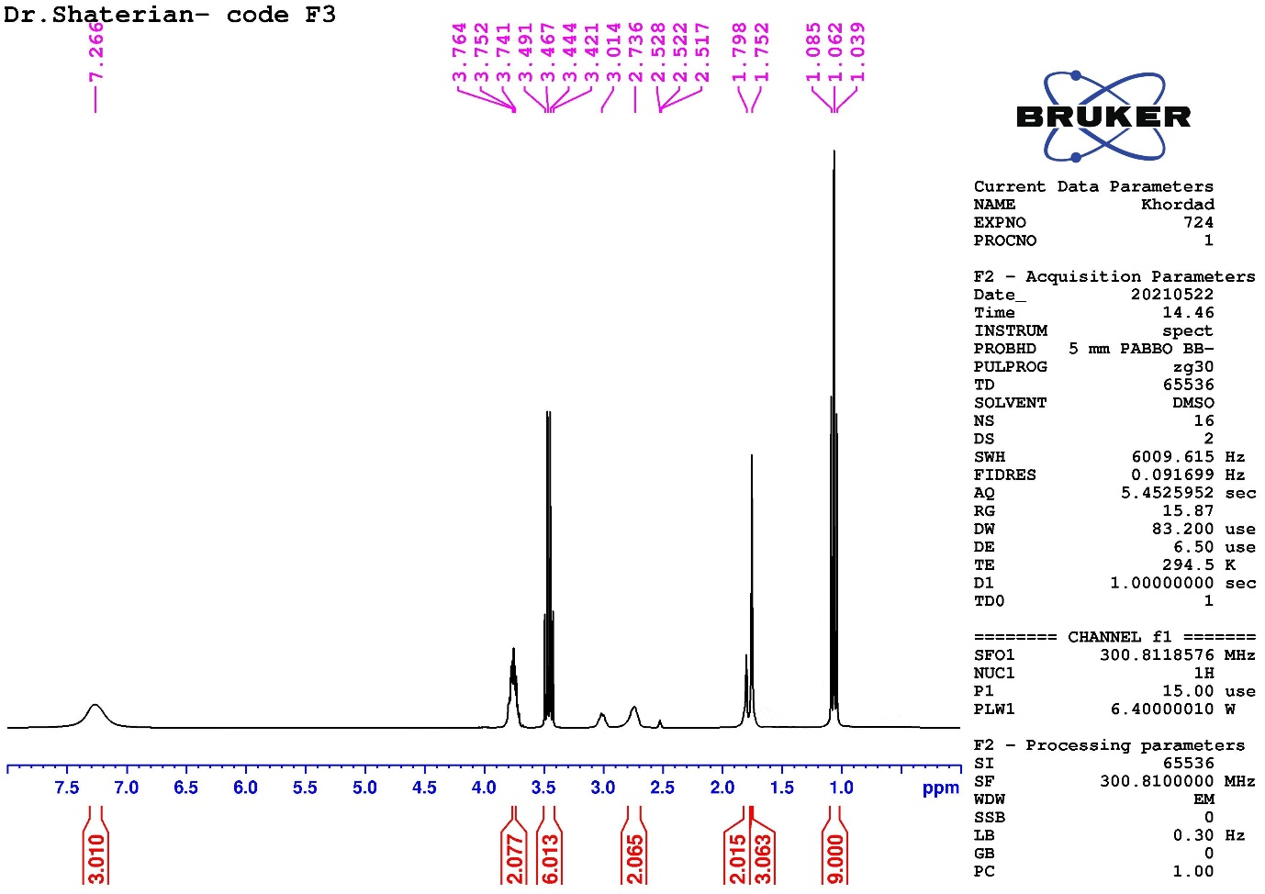
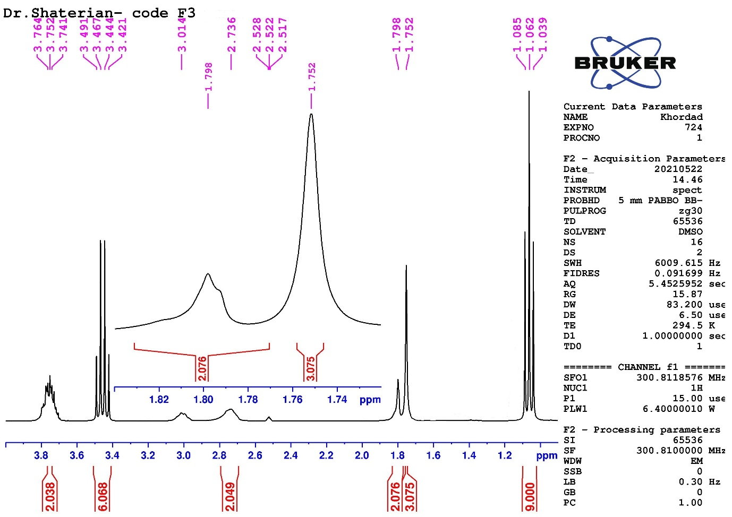
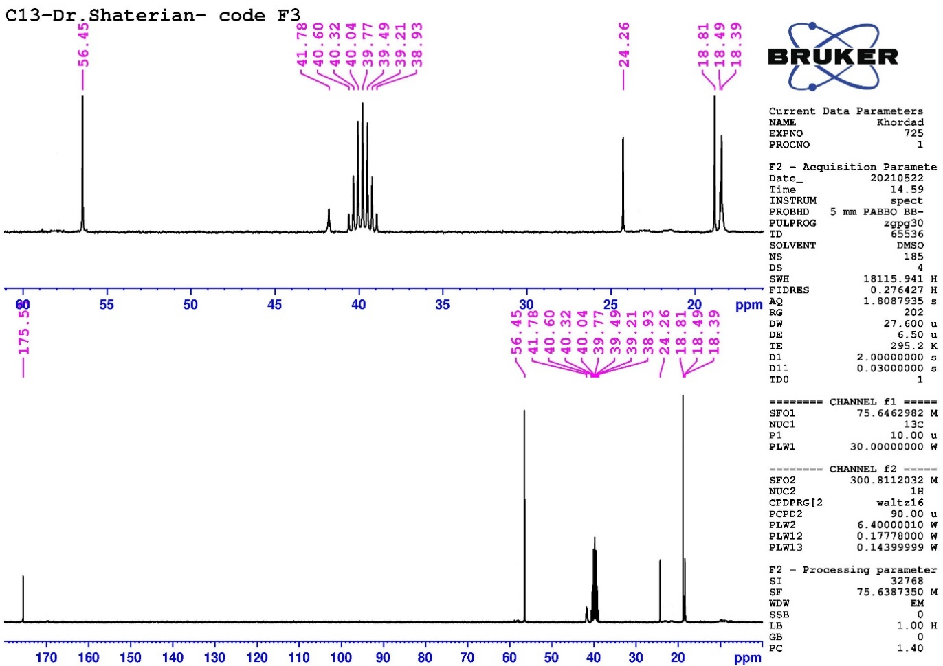
General procedure for the direct synthesis of benzo[a]pyrano[2,3-c]phenazine (5A–O) derivatives using [(EtO)₃Si(CH₂)₃N⁺H₃][CH₃COO⁻] as basic ionic liquid catalyst
[(EtO)₃Si(CH₂)₃N⁺H₃][CH₃COO⁻] (30 mol ٪) was added to a mixture of 2-hydroxynaphthalene-1,4-dione (1 mmol) and benzene-1,2-diamine (1 mmol) at 90 °C. After 5 minutes an orange solid of benzo[a]phenazine was formed. Then, aryl aldehydes (1 mmol), and malononitrile (1 mmol), were added to this obtained mixture. The progress of the reaction was monitored by TLC (petroleum benzene / ethyl acetate: 1 / 3). After completion of the reaction, ethanol (3 mL) was added to the reaction mixture and warmed mixture. Then, mixture was cooled, the ionic liquid as catalyst is dissolved in ethanol. The ethanol containing the catalyst is separated and then the resulting solid product was subsequently recrystallized from hot ethanol to give the pure solid. The known pure products were characterized and their physical data compared with those of known to litreature compounds. The new products were identified by FT-IR, ¹HNMR and ¹³CNMR spectra. The new unknown products are characterized as follows:
3-amino-1-(2-hydroxy-3-methoxyphenyl)-1H-benzo[a]pyrano[2,3-c]phenazine-2-carbonitrile (5E): Time: 55 min, Yield (%): 89 %, M.p. (°C) (Observed): 267-269; IR (KBr) (ν_{max}/cm⁻¹): 3440, 3374, 3316, 3199, 3069, 2169, 1663, 1630, 1594, 1513, 1461, 1386, 1346, 1293, 1248, 1221, 1174, 1159, 1140, 1110, 1052, 953, 855, 826, 794, 771, 749, 735, 724, 656, 640, 621, 583, 554, 527, 476, 448, 413; ¹HNMR (300 MHz, DMSO-d₆): δ_{H} (ppm) 3.69 (3H, s, CH₃), 5.69 (1H, s, CH), 6.62 (1H, t, J = 7.2 Hz, Ar-H), 6.69 (1H, d, J = 6.3 Hz, Ar-H), 6.80 (1H, d, J = 6.3 Hz, Ar-H), 7.22 (2H, s, NH₂), 7.87-7.98 (4H, m, Ar-H), 8.04-8.07 (1H, m, Ar-H), 8.18-8.21 (1H, m, Ar-H), 8.40 (1H, d, J = 7.8 Hz, Ar-H), 8.88 (1H, s, OH), 9.13 (1H, d, J = 7.5 Hz, Ar-H), ¹³CNMR (75 MHz, DMSO-d₆): δ_{C} (ppm) 33.0, 56.0, 57.5, 110.4, 113.8, 119.0, 120.9, 121.9, 122.5, 125.2, 126.1, 128.9, 129.2, 130.1, 130.4, 130.8, 131.1, 131.7, 140.1, 140.3, 141.3, 141.6, 144.5, 147.1, 148.2, 160.6.
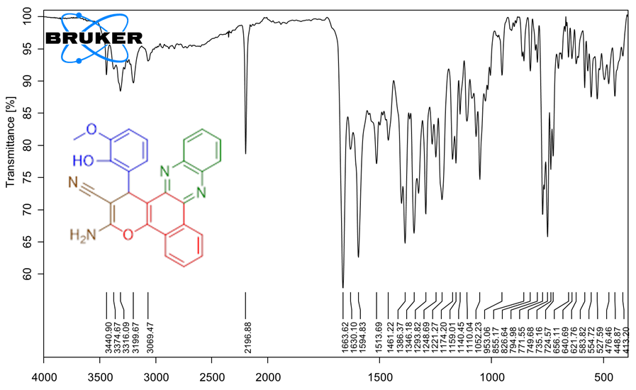

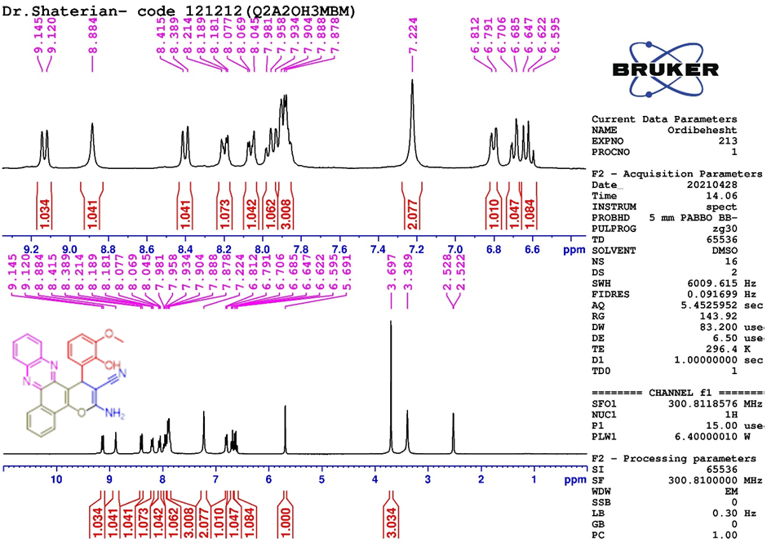
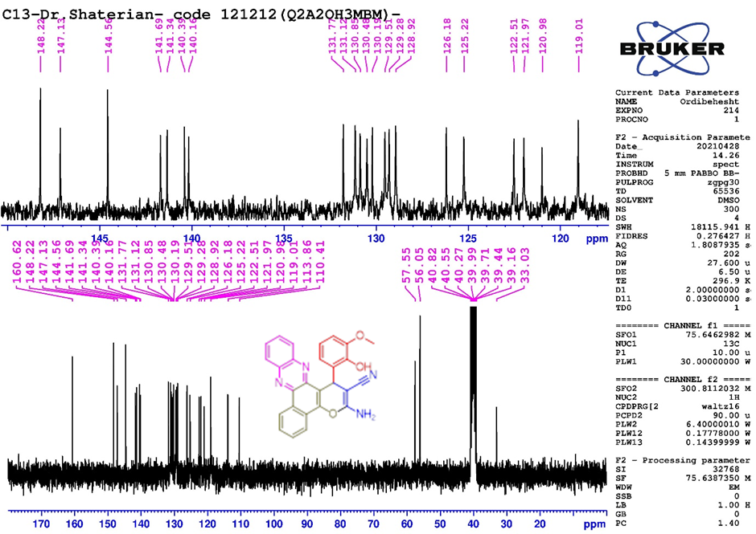
3-amino-1-(2,5-dihydroxyphenyl)-1H-benzo[a]pyrano[2,3-c]phenazine-2-carbonitrile (5H): Time: 95 min, Yield (%): 92 %, M.p. (°C) (Observed): >280; IR (KBr) (ν_{max}/cm⁻¹): 3425, 3338, 3059, 2940, 2821, 2750, 2719, 2598, 2191, 1662, 1631, 1594, 1526, 1484, 1461, 1404, 1348, 1325, 1292, 1222, 1139, 1084, 1052, 1004, 916, 854, 762, 723, 698, 641, 618, 583, 554, 528, 503, 450; ¹HNMR (300 MHz, DMSO-d₆): δ_{H} (ppm) 6.07 (1H, s, CH), 6.37 (1H, s, Ar-H), 7.22 (2H, s, NH₂), 7.37 (1H, d, J = 6.6 Hz, Ar-H), 8.16 (3H, s, Ar-H), 8.33 (6H, s, Ar-H), 8.87 (1H, s, OH), 9.08 (1H, s, OH); ¹³CNMR (75 MHz, DMSO-d₆): δ_{C} (ppm) 33.0, 57.5, 110.4, 113.8, 119.0, 120.9, 121.9, 122.5, 125.2, 126.1, 128.9, 129.5, 129.2, 130.1, 130.4, 130.8, 131.1, 131.7, 140.1, 140.3, 141.3, 141.6, 144.5, 147.1, 148.2, 160.6.

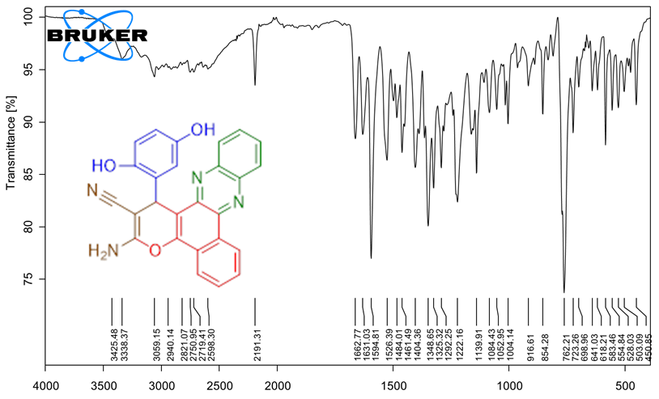
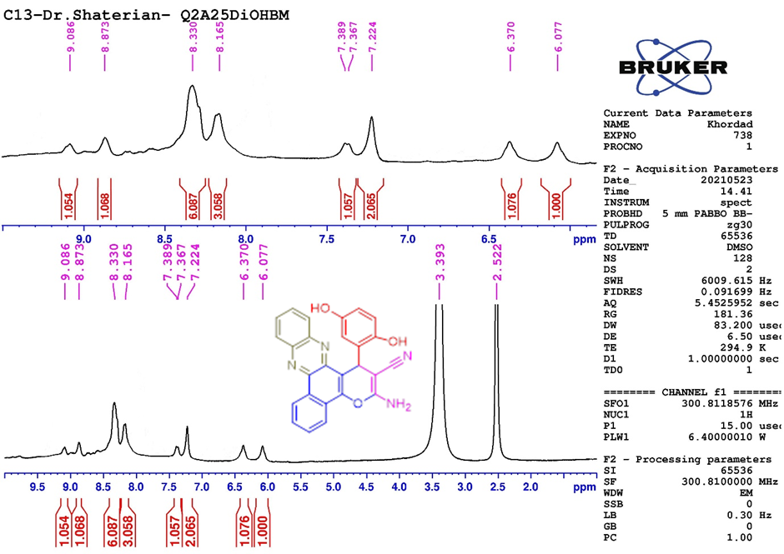
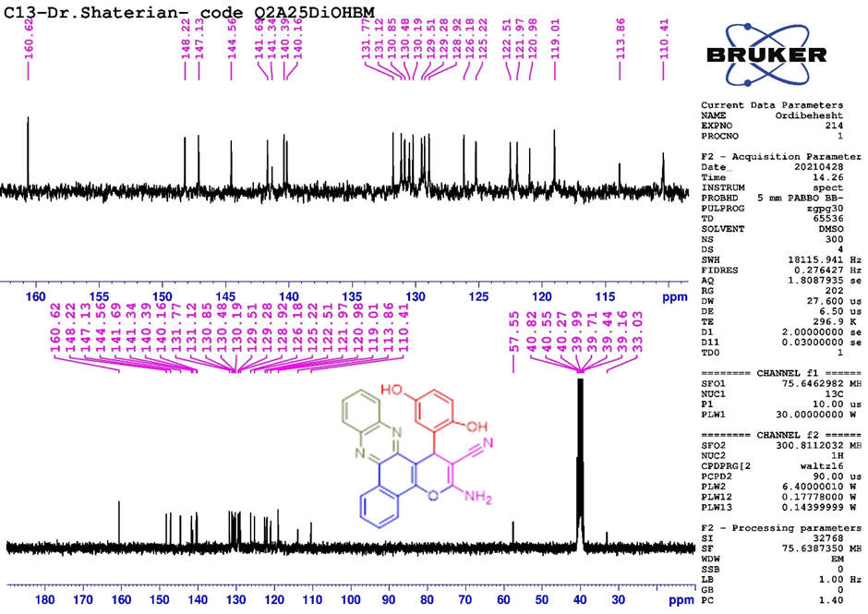
3-amino-1-(naphthalen-1-yl)-1H-benzo[a]pyrano[2,3-c]phenazine-2-carbonitrile (5L): Time: 35 min, Yield (%): 95 %, M.p. (°C) (Observed): >280; IR (KBr) (ν_{max}/cm⁻¹): 3465, 3356, 3171, 3087, 3054, 3039, 2184, 1659, 1621, 1590, 1495, 1471, 1398, 1383, 1328, 1291, 1262, 1222, 1162, 1106, 1053, 1022, 950, 860, 779, 754, 667, 637, 610, 545, 449, 424, 404; ¹HNMR (300 MHz, DMSO-d₆): δ_{H} (ppm) 6.33 (1H, s, CH), 7.22-7.30 (2H, t, m, Ar-H), 7.34 (2H, s, NH₂), 7.55-7.69 (3H, m, Ar-H), 7.77-7.83 (2H, s, Ar-H), 7.85-7.95 (2H, m, Ar-H), 7.97-8.02 (1H, m, Ar-H), 8.05-8.07 (1H, m, Ar-H), 8.22 (1H, d, J = 8.1 Hz, Ar-H), 8.49 (1H, d, J = 7.2, Ar-H), 8.89 (1H, d, J = 8.84 Hz, Ar-H), 9.22 (1H, d, J = 7.8 Hz, Ar-H); ¹³CNMR (75 MHz, DMSO-d₆): δ_{C} (ppm) 35.6, 55.9, 82.8, 112.1, 114.5, 122.5, 122.7, 125.2, 125.4, 126.1, 126.2, 128.9, 129.0, 129.2, 129.5, 130.2, 130.4, 130.9, 131.0, 132.3, 136.1, 140.1, 140.2, 141.4, 142.0, 144.0, 146.6, 148.2, 152.6, 158.1.
