Supplementary materials

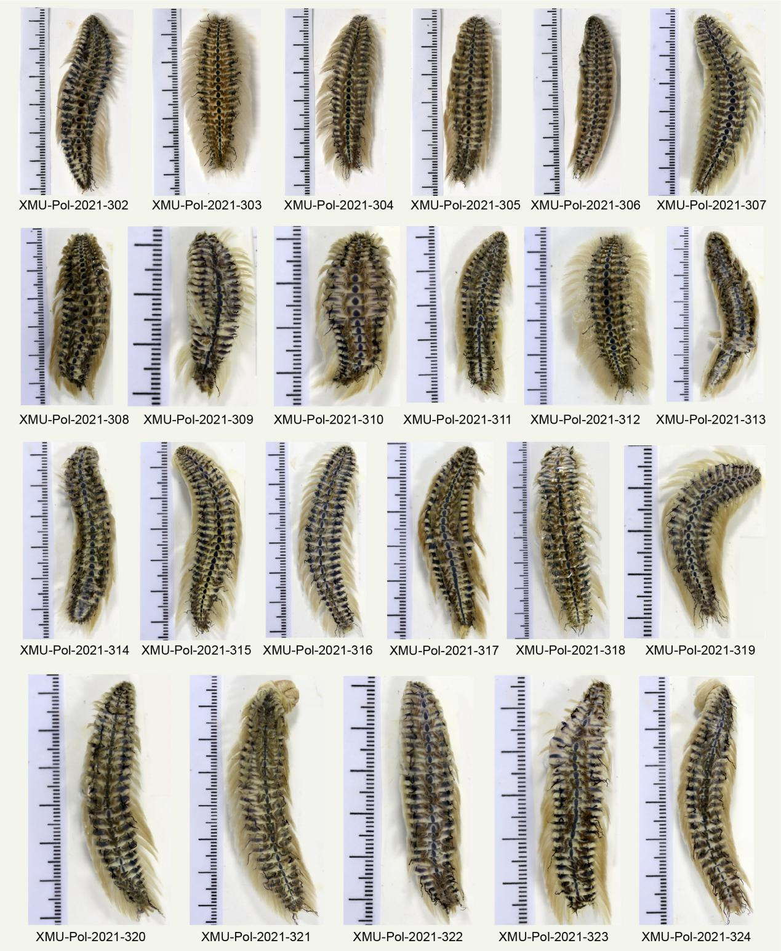
Supplementary Figure 1. Twenty-three Chloeia flava specimens used for morphological and phylogenetic analysis (as listed in Table 1 and Table 2), with their vouchers labelled below each specimen. The division value of the scale next to each specimen is 1 mm.

References for images, videos and sampling sites of Chloeia flava and C. pulchella from the Internet
Chloeia flava from Thailand
Chaloklum Diving School (2003) Fireworms; Chloeia species. Available from: https://www.chaloklum-diving.com/marine-life-guide-koh-phangan/annelid-worms-annelida/fireworms-amphinomidae/ (accessed 16 May 2023, as Chloeia flava from Koh Phangan, Thailand)
Chloeia flava from Singapore
Wildfactsheets (2022) Beautiful fireworm Chloeia sp. Family Amphinomidae. Available from: http://www.wildsingapore.com/wildfacts/worm/polychaeta/chloeia.htm (accessed 16 May 2023, as Chloeia flava from Singapore)
Chloeia flava from Japan
Marine Biological Station, Sado Island Center for Ecological Sustainability, Niigata University (2023) Available from: https://www.sc.niigata-u.ac.jp/sc/sadomarine/english/marinelife/umikemushi.html (accessed 16 May 2023, as Chloeia flava from Sado Island, Japan)
Japan Marine Club (2018) Available from: https://www.youtube.com/watch?v=90ZHhL4q9sc (accessed 16 May 2023, as Chloeia flava (“ウミケムシ” in Japanese) from Omi Island, Japan)
Japan Marine Club (2012) Available from: https://www.youtube.com/watch?v=3Or4PqgBVYE (accessed 16 May 2023, as Chloeia flava from Omi Island, Japan)
Iromongara (2009) Available from: https://www.youtube.com/watch?v=PGLLgLJJG-Y (accessed 16 May 2023, as Chloeia flava from Goshoura Island, Kumamoto, Japan)
Chloeia flava from China
a. Chen ZL, Li CH, Xiao YY, Liu Y, Lin L, Wang JJ, Quan QM (2020) Distribution of structure of macrobenthic communities in coastal waters of Jiangmen, Guangdong. SCSF 16(4):18–27. https://doi.org/10.12131/20190248
b. Shu LM, Chen PM, Li XG, Yu J, Feng X (2015) Species composition and seasonal variation of macrobenthic fauna in Zhelin Bay and adjacent waters. J Appl Oceanogr 34(1):124–132. https://doi.org/10.3969/J.ISSN.2095-4972.2015.01.016
c. Zhou H (2021) Community characteristics of macrobenthos and evaluation of benthic ecosystem in Jiuzhen Bay intertidal zone, Fujian. Master Thesis. Fujian Normal University, Fuzhou. pp123.
d. Monro CCA (1934) On a collection of Polychæta from the coast of China. Ann Mag Nat Hist 13(75):353–380. https://doi.org/10.1080/00222933408654824
e. Wu BL (1962) The characteristics of polychaeta fauna in Fujian coast. Oceanol Limnol Sin 4(1-2):87–96. [in Chinese]
I. Kwong (2018) Available from: https://www.sohu.com/a/239243844_400492 (accessed 16 May 2023, as Chloeia from Hong Kong, China)
II, V. Fisheries Research Institute,Council of Agriculture (2023) Available from: https://www.tfrin.gov.tw/News_Content.aspx?n=4088&s=236594 (accessed 16 May 2023, as Chloeia flava from Penghu and northeast of Taiwan, China)
III, IV. Biodiversity Research Center, Academia Sinica (2023) Available from: http://digimuse.nmns.edu.tw/Demo_2011/NewModule.aspx?ObjectId=0b00000181f0703f&ParentID=0b00000181f07039&Type=mollusca&Part=2-1&Domain=az&Field=an (accessed 16 May 2023, as Chloeia flava from Zhongyun, Mituo, Mashagou, and Taizhong, Taiwan, China)
Chloeia pulchella from Australia
GMT (2021) Available from: https://www.youtube.com/watch?v=5qQgwHeHUc8 (accessed 16 May 2023, as Chloeia flava from Inskip Point, Queensland, Australia)
Senja (2021) Available from: https://www.youtube.com/watch?v=m3I3CiWB1Wo&t=44s (accessed 16 May 2023, as Chloeia flava from unknown locality (0:28) and from Malaysia (1:27))

