Extended Data Figures and Table

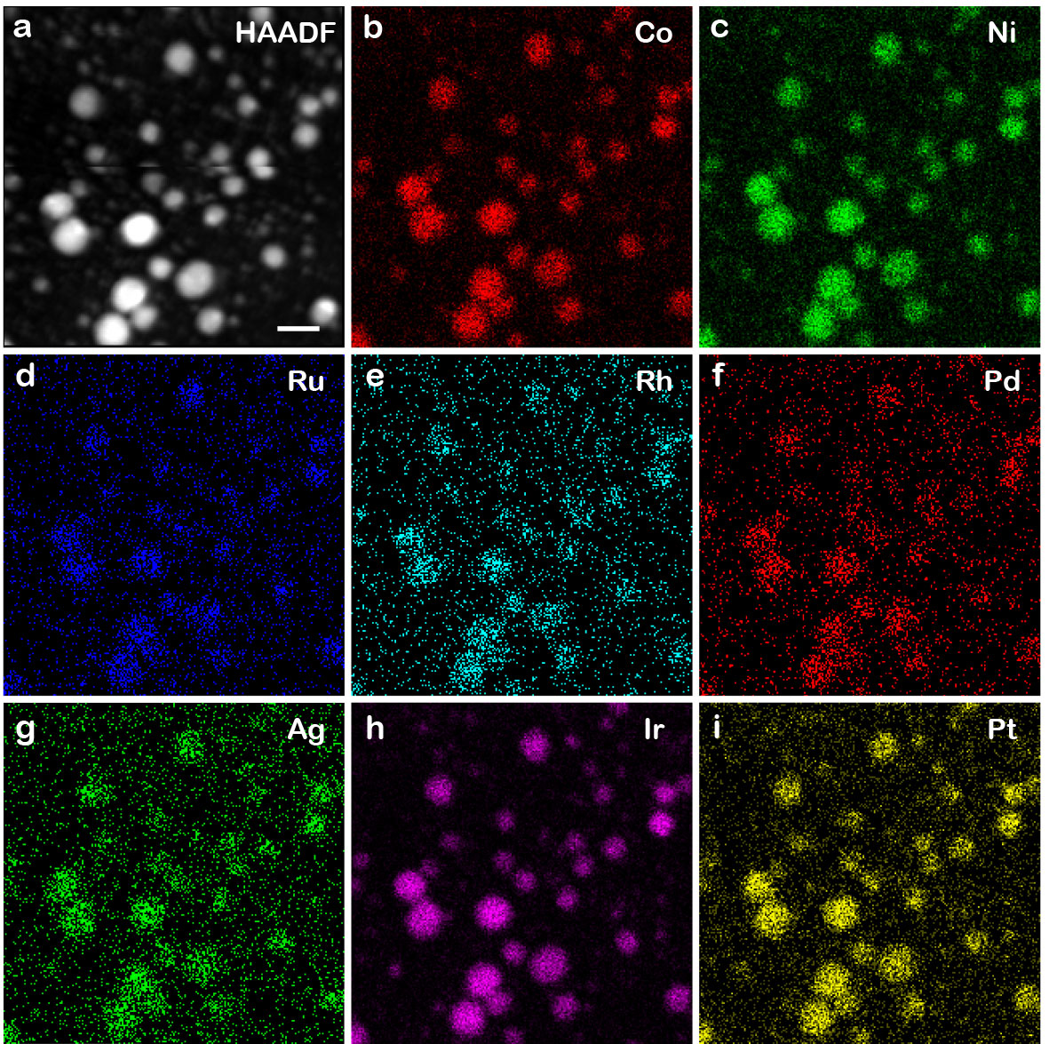

Extended Data Fig. 1 | EDS maps of the HEA nanocrystals. a, Low-resolution ADF-STEM image of the nanocrystals. b-i, EDS maps showing the distribution of Co (b), Ni (c), Ru (d), Rh (e), Pd (f), Ag (g), Ir (h) and Pt (i) in the nanocrystals. Scale bars, 20 nm.

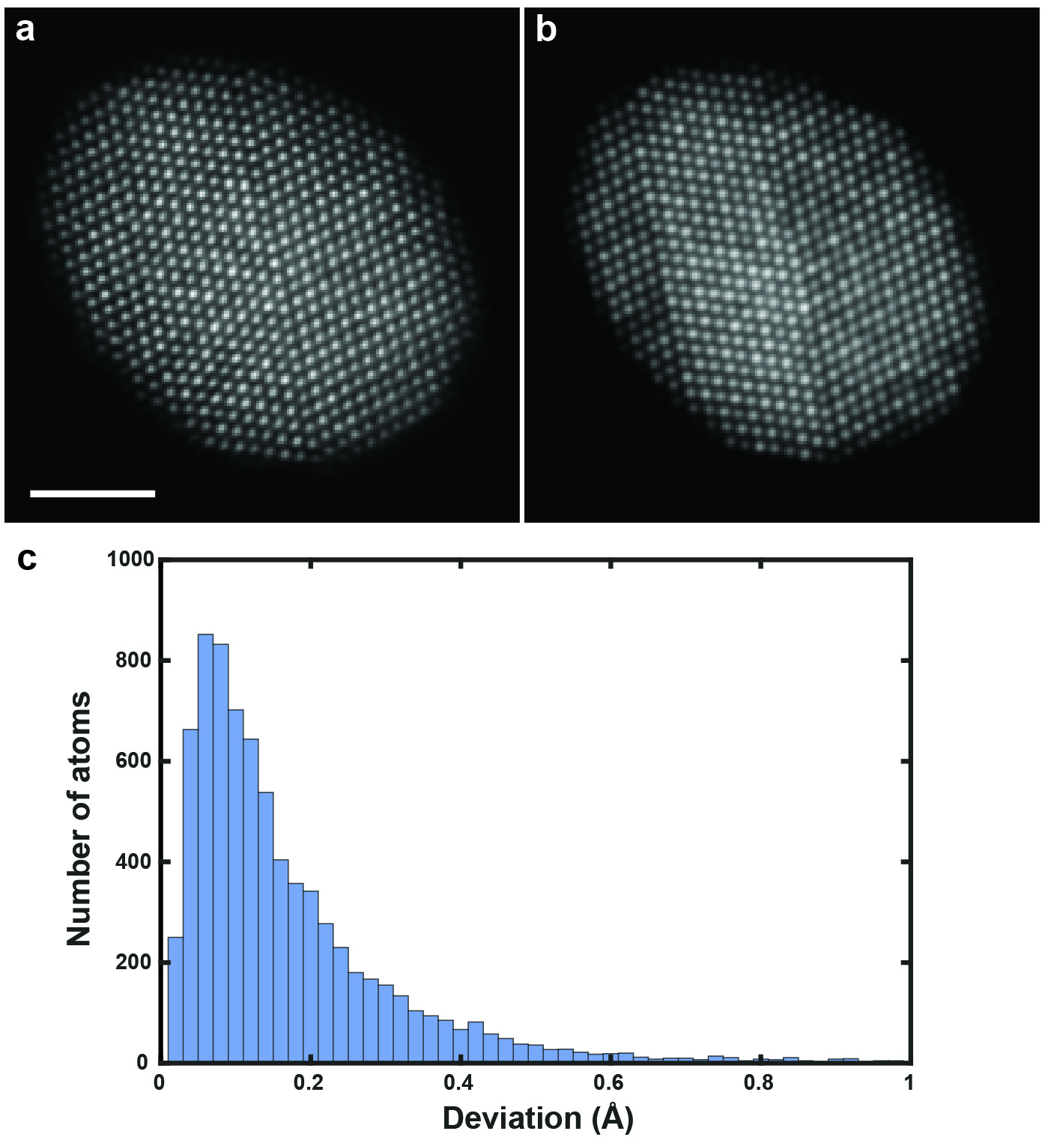
Extended Data Fig. 2 | 3D precision estimation. a, b, Comparison between a representative experimental (after denoising) (a) and a multi-slice calculated image (b) of MEA-3. The multi-slice images were convolved with a Gaussian function to match the incoherence effects in the experimental images. c, Histogram of the deviation of the 3D atomic positions between the experimental atomic model and that obtained from 55 multi-slice images. The root-mean-square deviation of the histogram is 19.5 pm. Scale bar, 2 nm.

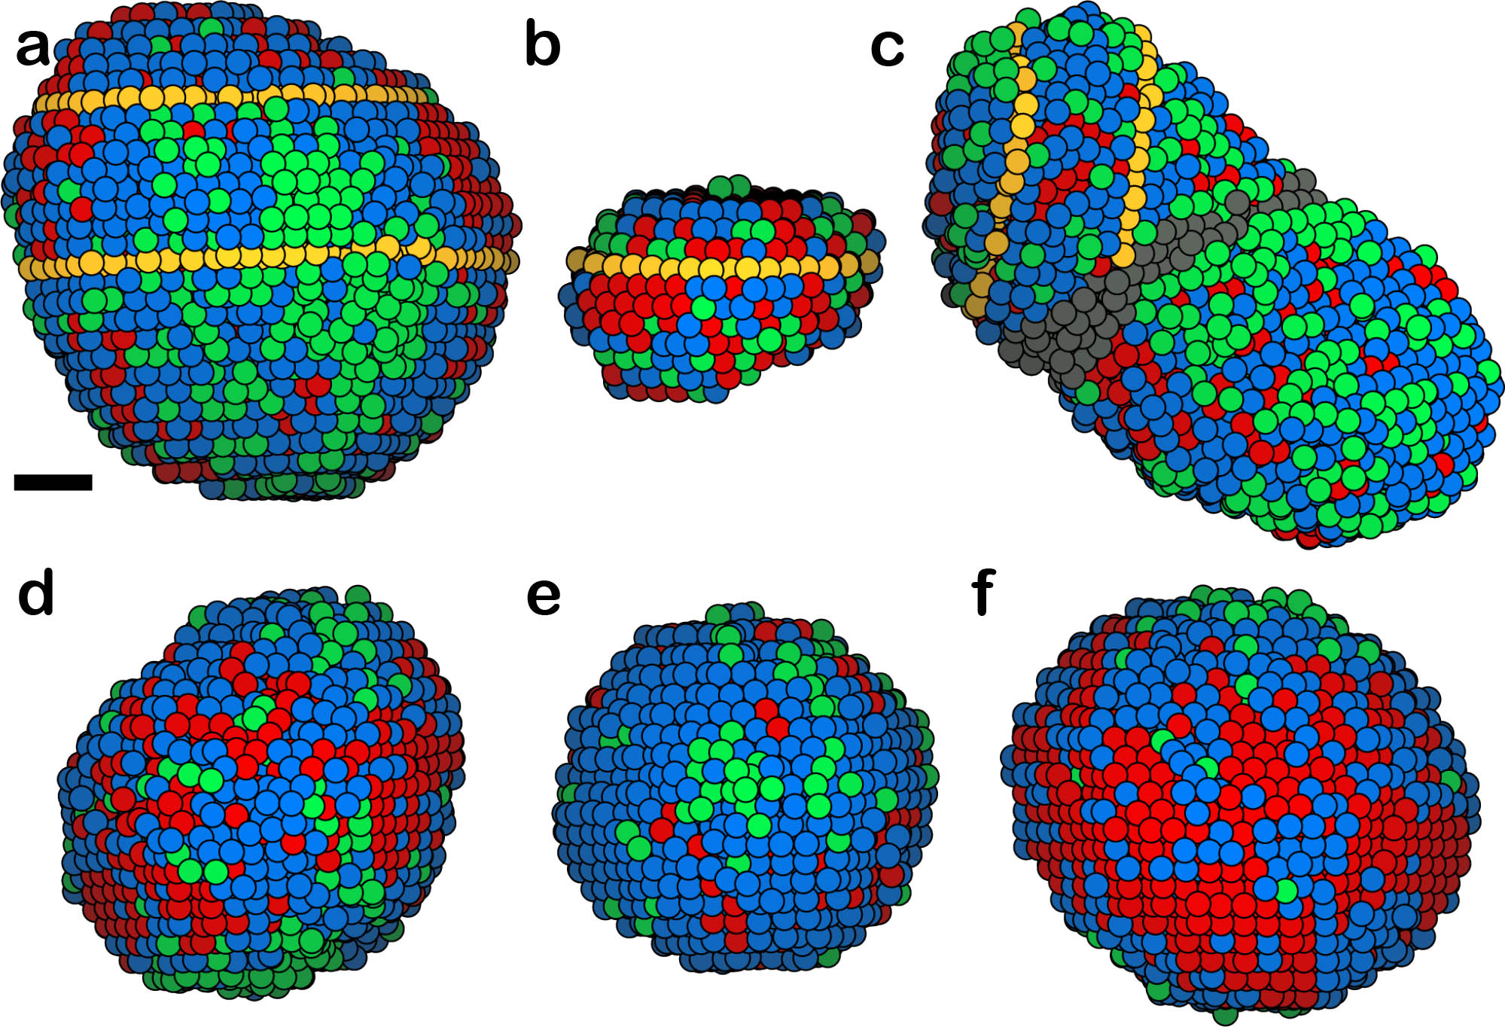
Extended Data Fig. 3 | Experimental 3D atomic models of the other six M/HEA nanocrystals. a-f, Experimental atomic models of four MEAs and two HEAs, named MEA-3 (a), MEA-4 (b), MEA-5 (c), MEA-6 (d), HEA-3 (e) and HEA-4 (f), in which the yellow circles represent the twin boundaries in (a-c) and grey circles indicate a grain boundary in (c). Scale bar, 1 nm.

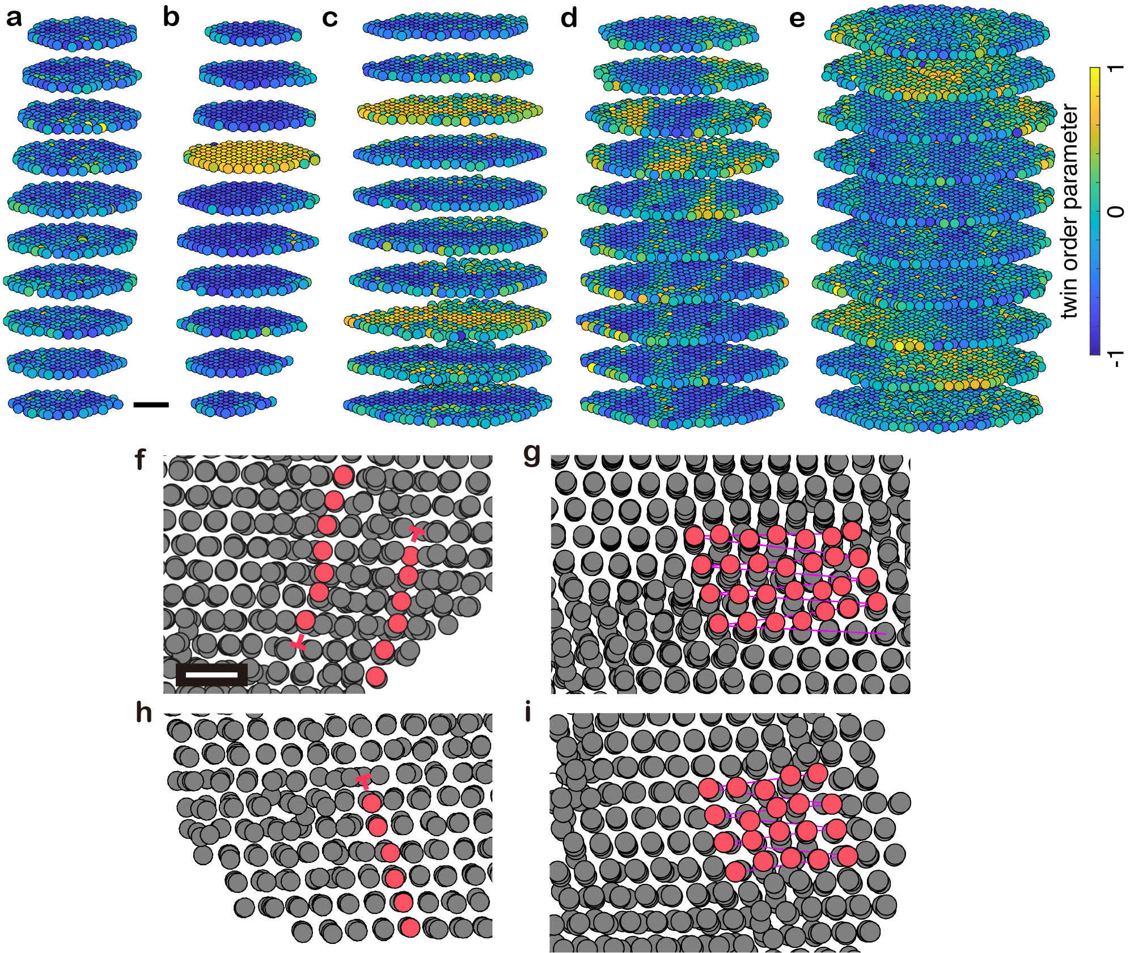
Extended Data Fig. 4 | Twin boundaries and dislocations in the M/HEAs. a-e, The twin boundaries of three representative MEAs (a, twin-free; b, single twin; c, double twins) and two HEAs (d, single twin; e, double twins), showing more diffuse twin boundaries in the HEAs with each boundary spreading to the neighbouring atomic layers. The twin order parameter of 1 and -1 represents a hcp (i.e., twinning) and fcc structure, respectively. f, Two Shockley partial dislocations in MEA-5 with opposite Burgers vectors $\frac{a}{6}\left[121\right]$ and $\frac{a}{6}[\overline{1}\overline{2}\overline{1}]$, as the gliding process was frozen near the boundary during the rapid cooling process of the nanocrystal. g, A screw dislocation in MEA-2 with the Burgers vector $\frac{a}{2}[110]$. h, A Shockley partial dislocation in HEA-4 with the Burgers vector $\frac{a}{6}\left[121\right]$, which exists near the boundary of the nanocrystal. i, A screw dislocation in HEA-3 with the Burgers vector $\frac{a}{2}[110]$. Scale bars, 1 nm (a); and 5 Å (f).

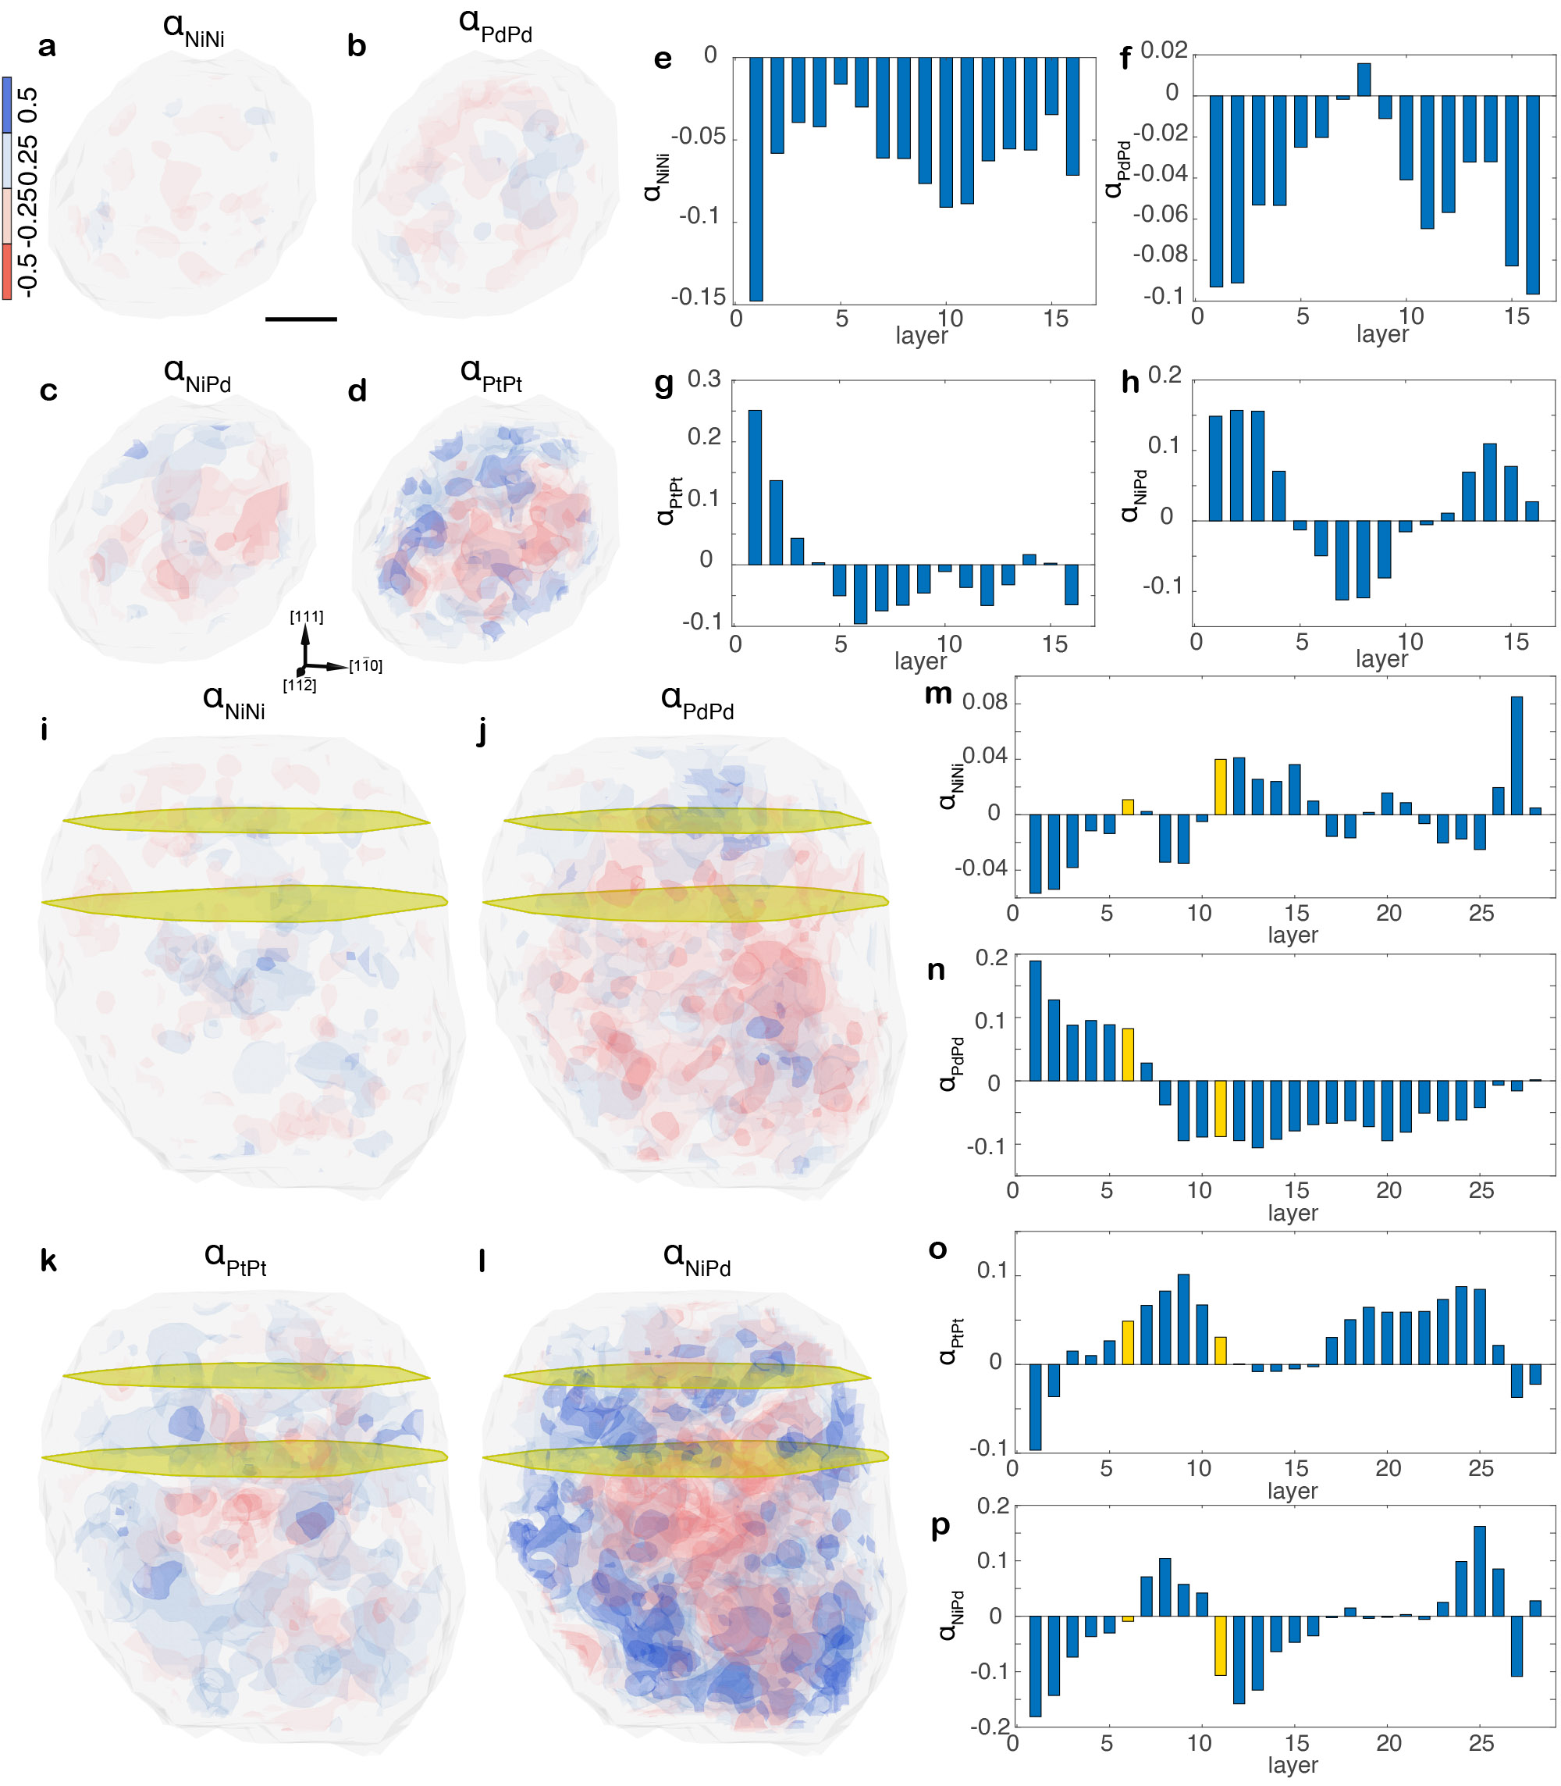
Extended Data Fig. 5 | 3D distribution of the other four CSRO parameters of the twin-free MEA-1 and double-twinned MEA-2. a-d, 3D distribution of $α_{NiNi}$, $α_{PdPd}$, $α_{PtPt}$, and $α_{NiPd}$ in MEA-1, showing the formation of local chemical-order pockets. e-h, Histogram of the average $α_{NiNi}$, $α_{PdPd}$, $α_{PtPt}$, and $α_{NiPd}$ for each atomic layer along the [111] direction in MEA-1. i-l, 3D distribution of $α_{NiNi}$, $α_{PdPd}$, $α_{PtPt}$, and $α_{NiPd}$ in MEA-2 (the twins labelled as yellow planes), exhibiting more heterogeneous CSRO than the twin-free MEA-1 (a-d). m-p, Histogram of the average $α_{NiNi}$, $α_{PdPd}$, $α_{PtPt}$, and $α_{NiPd}$ for each atomic layer along the [111] direction in MEA-2. Scale bar, 1 nm.
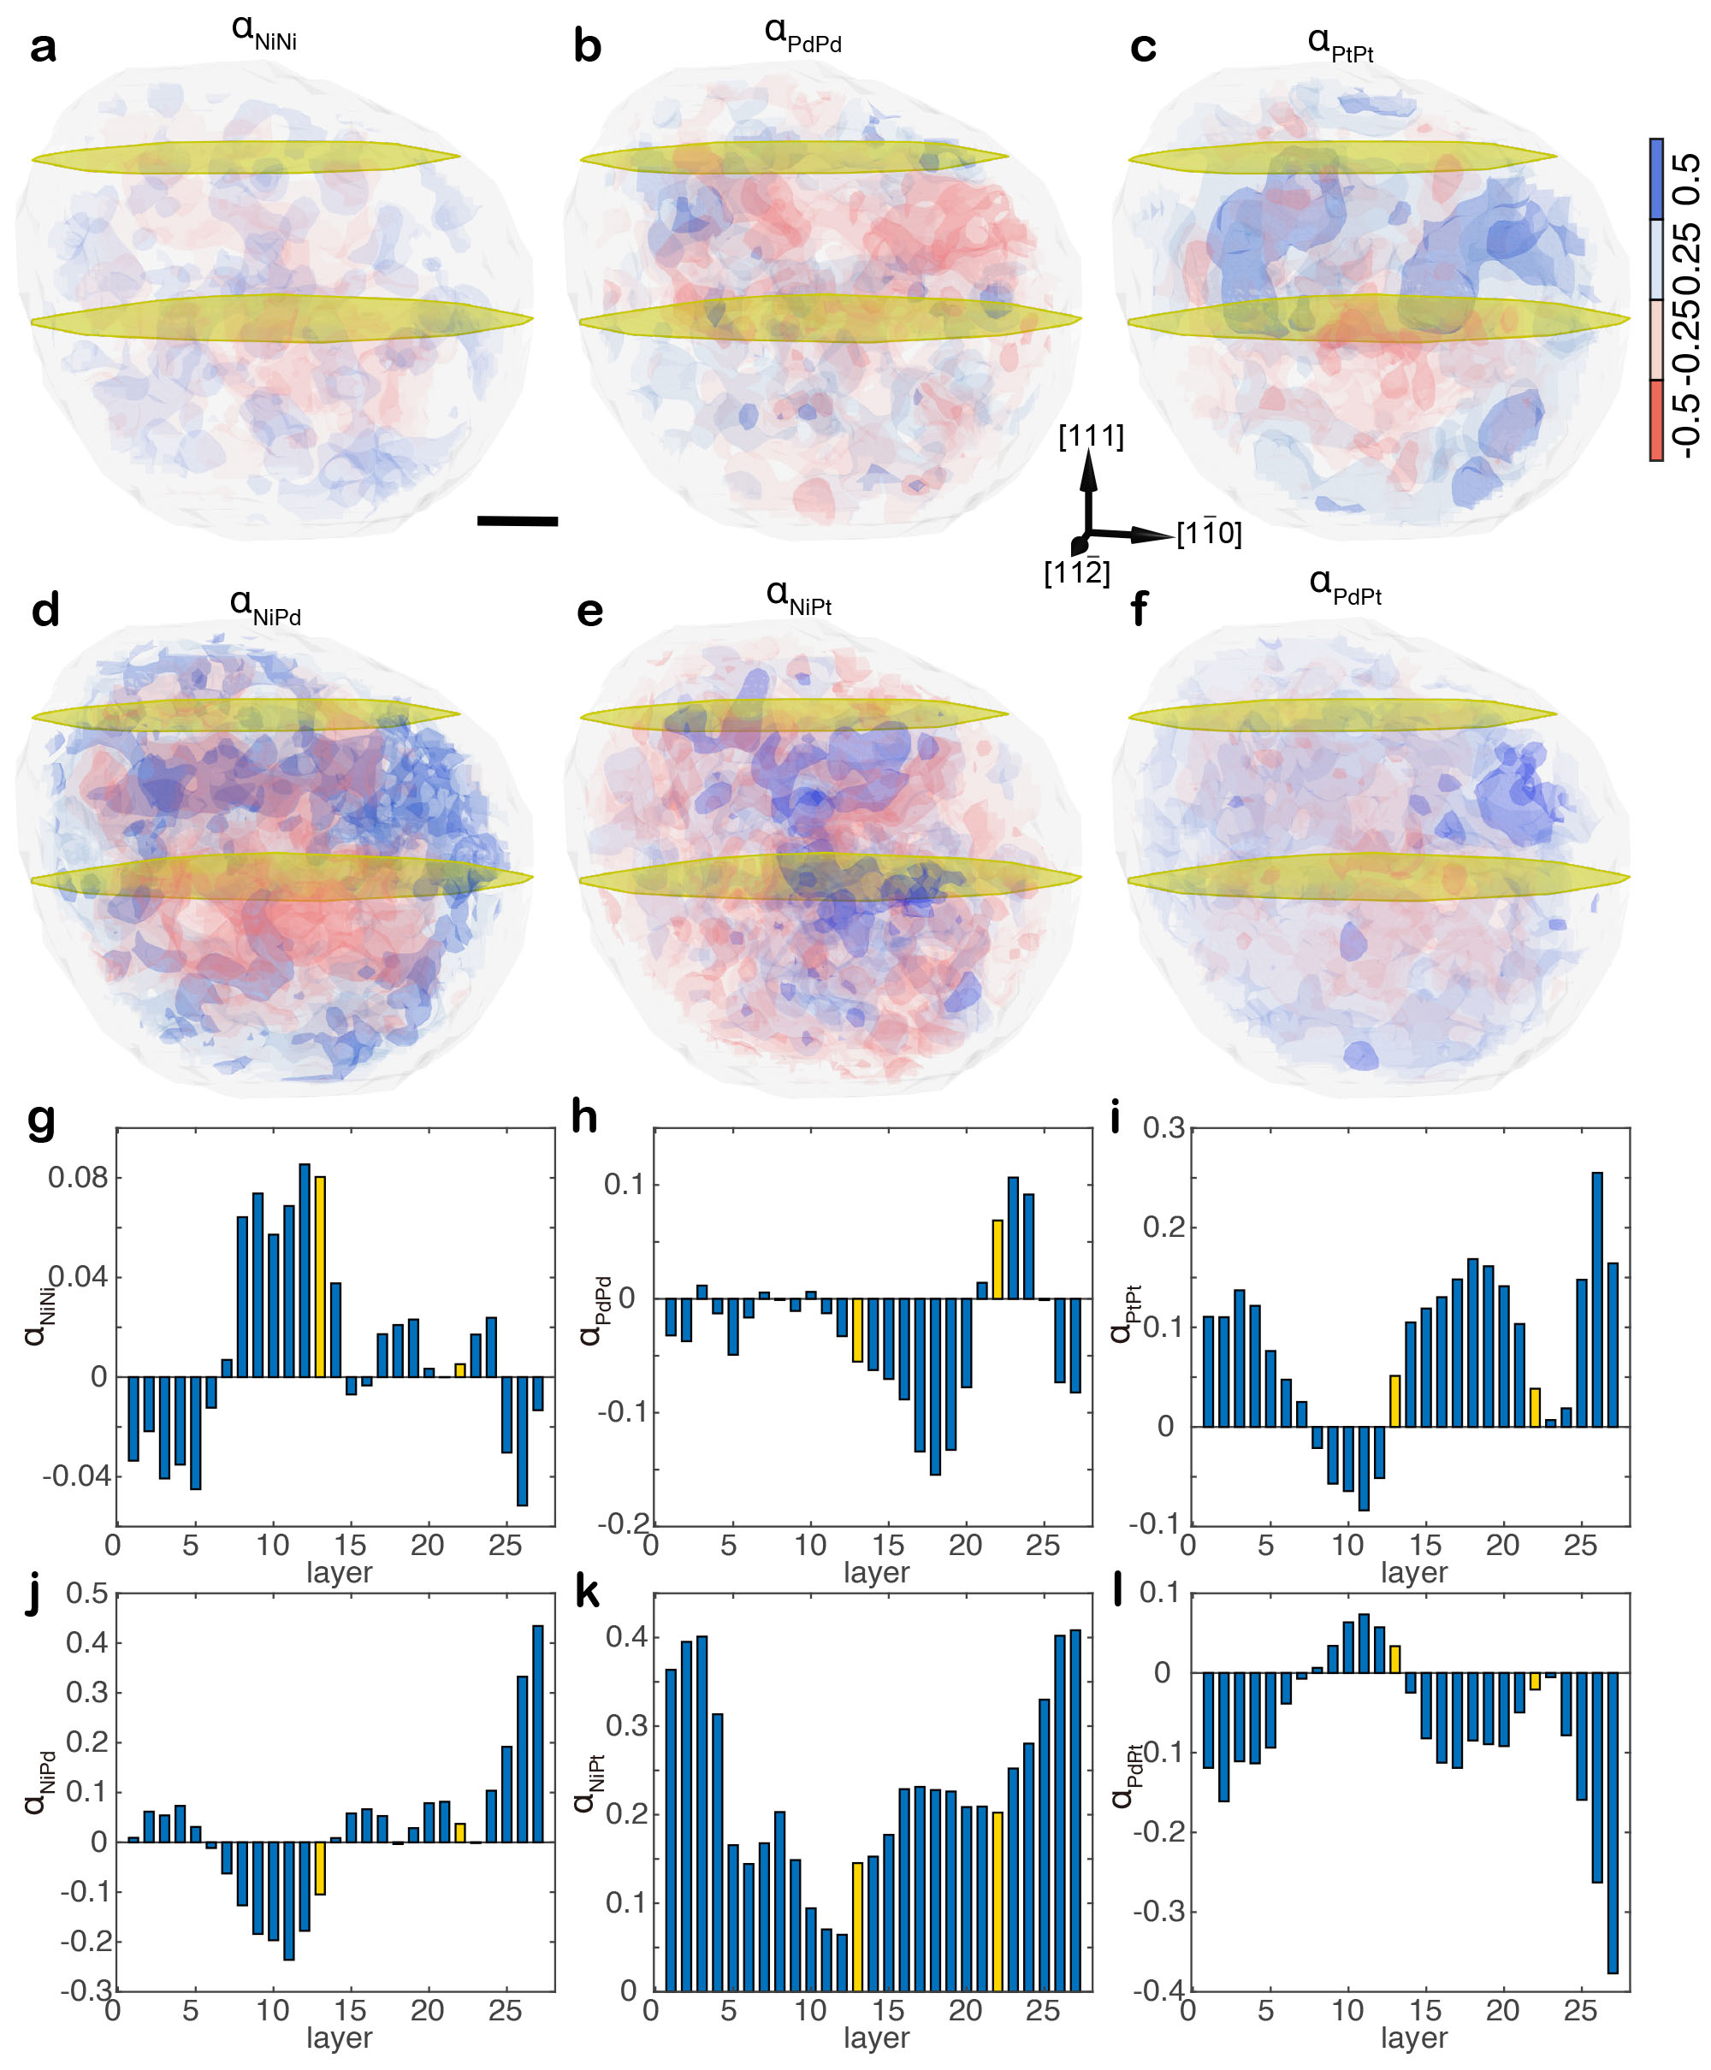
Extended Data Fig. 6 | 3D distribution of the six CSRO parameters in the double-twinned MEA-3. a-f, 3D distribution of $α_{NiNi}$, $α_{PdPd}$, $α_{PtPt}$, $α_{NiPd}$, $α_{NiPt}$, and $α_{PdPt}$, where the twins are labelled as yellow planes. g-l, Histogram of the average $α_{NiNi}$, $α_{PdPd}$, $α_{PtPt}$, $α_{NiPd}$, $α_{NiPt}$, and $α_{PdPt}$ values for each atomic layer along the [111] direction, where the yellow bars indicate the twin positions. Scale bar, 1 nm.

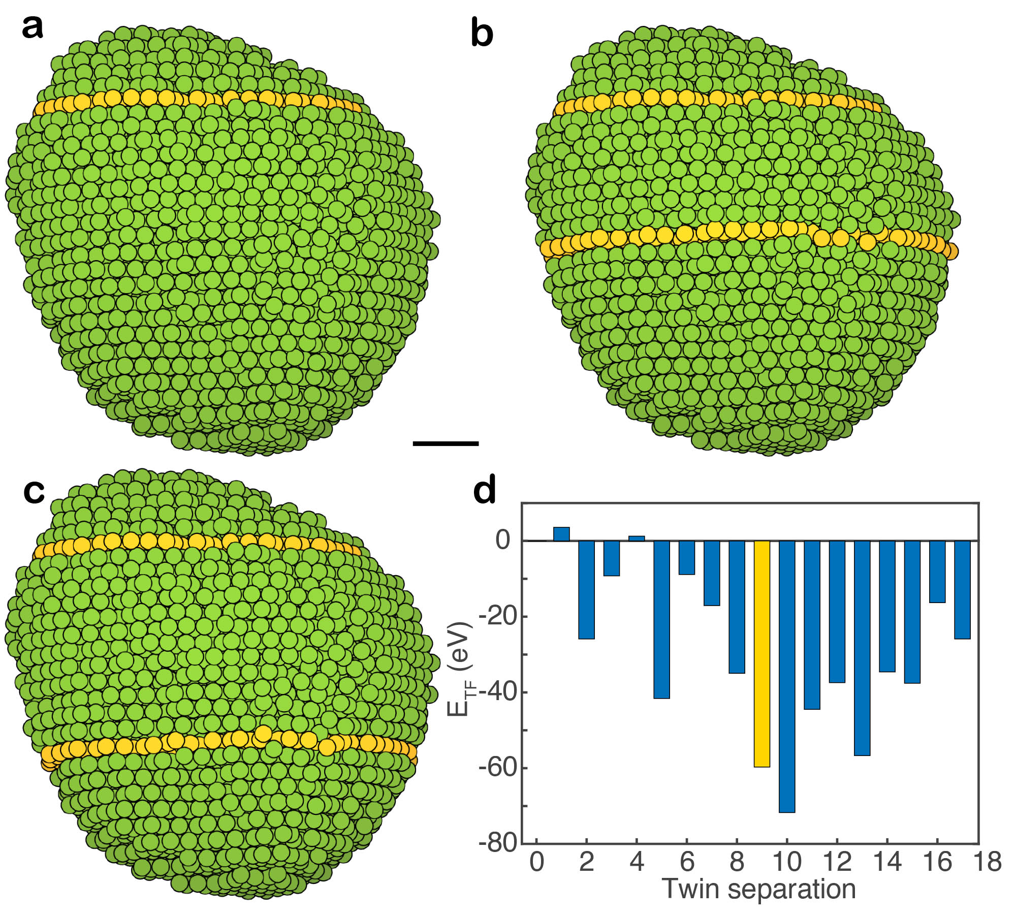
Extended Data Fig. 7 | Twin formation energy (E_{TF}) calculated from experimental 3D atomic coordinates of the double-twinned MEA-3. a-c, Calculation of E_{TF} of the double-twinned MEA by fixing one twin (top yellow circles) and moving the other twin from the 0th to the 14th atomic layer along the [111] direction, where three representative atomic configurations show a twin separation by 0 (i.e., a single twin) (a), 9 (b), and 13 atomic layers (c). d, Histogram of E_{TF} as a function of the twin separation. The experimentally determined twin separation is 9 atomic layers (yellow bar), which is next to the minimum E_{TF} with a twin separation of 10 layers. Scale bar, 1 nm.

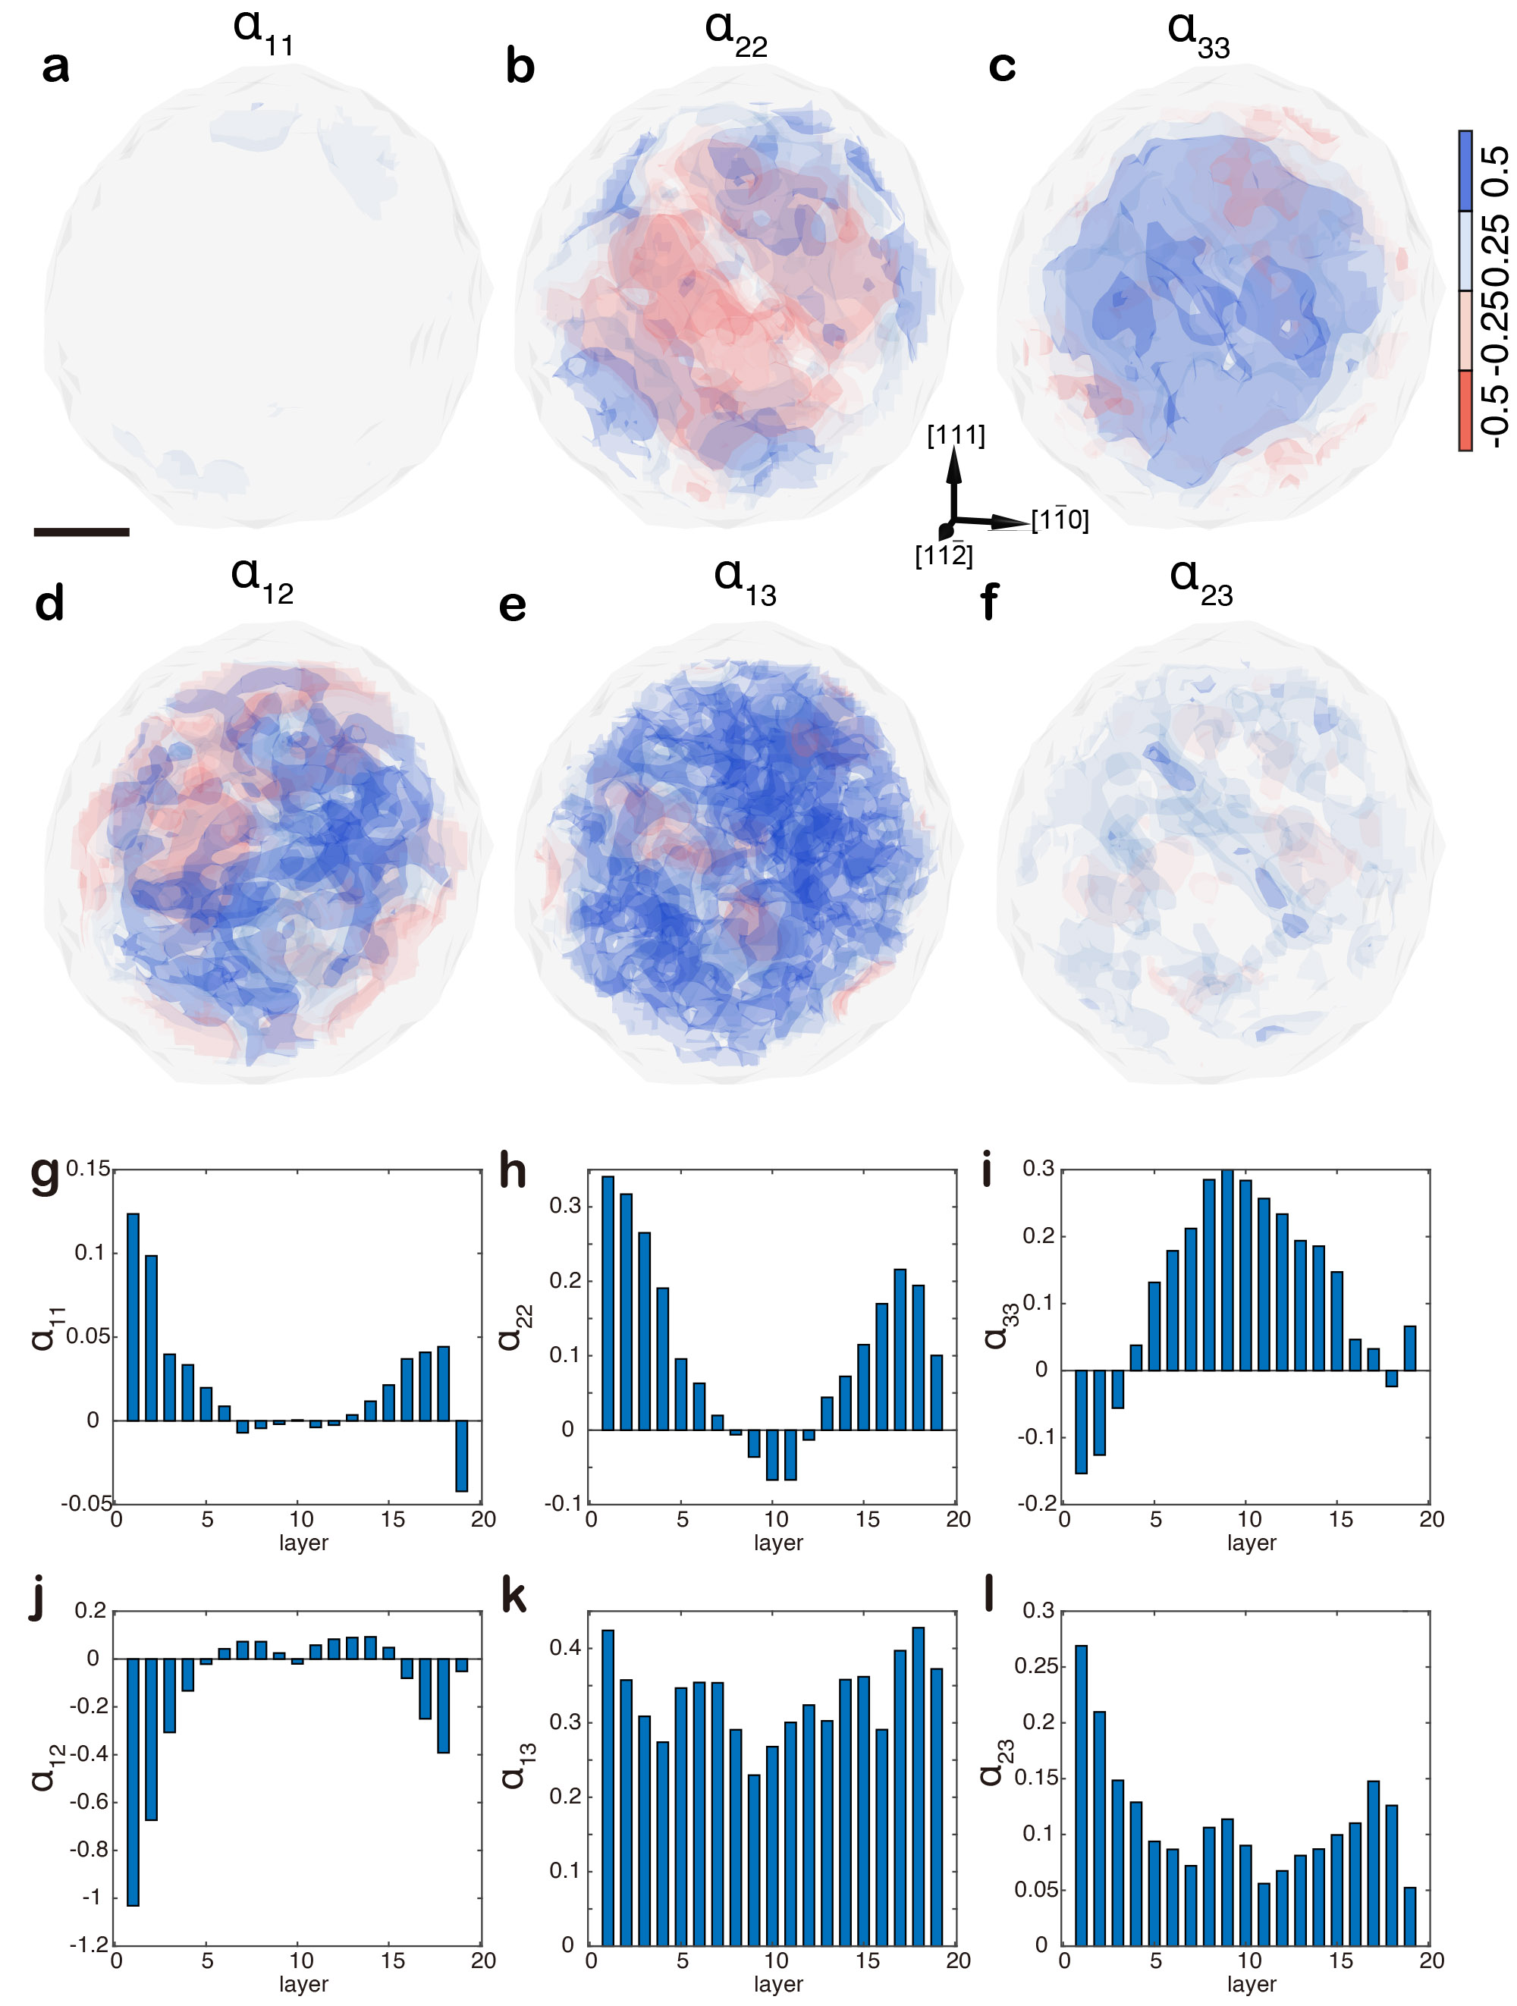
Extended Data Fig. 8 | 3D distribution of the six CSRO parameters in the twin-free HEA-1. a-f, 3D distribution of $α_{11}$, $α_{22}$, $α_{33}$, $α_{12}$, $α_{13}$, and $α_{23}$, which are more heterogeneous than those of the twin-free MEAs (Fig. 3a, b, Extended Data Fig. 5a-d). g-l, Histograms of the average $α_{11}$, $α_{22}$, $α_{33}$, $α_{12}$, $α_{13}$, and $α_{23}$ values for the atomic layer along the [111] direction. Scale bar, 1 nm.
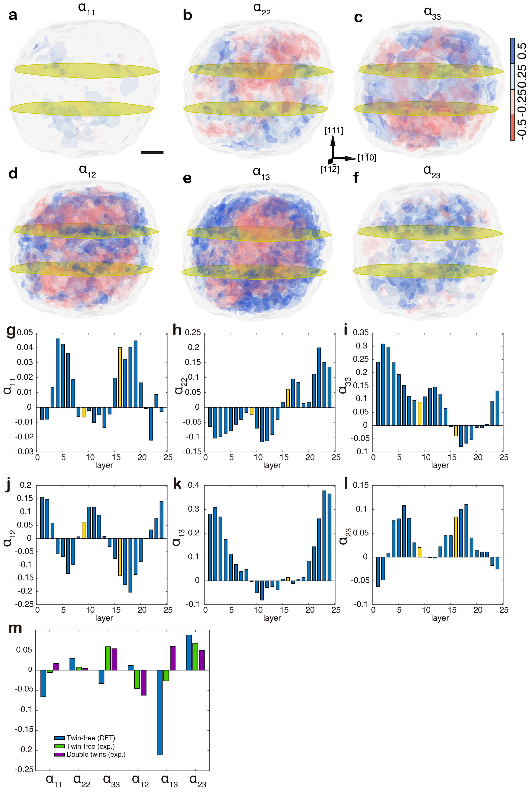
Extended Data Fig. 9 | 3D distribution of the six CSRO parameters in the double-twinned HEA-2. a-f, 3D distribution of $α_{11}$, $α_{22}$, $α_{33}$, $α_{12}$, $α_{13}$, and $α_{23}$, exhibiting greater local chemical fluctuations than the double-twinned MEA (Fig. 3e, f, Extended Data Fig. 5i-l and 6a-f)). g-l, Histograms of the average $α_{11}$, $α_{22}$, $α_{33}$, $α_{12}$, $α_{13}$, and $α_{23}$ values of the atomic layer along the [111] direction. m, Histogram of the six average CSRO parameters of a DFT-calculated bulk HEA, the twin-free HEA-1, and the double-twinned HEA-2. Scale bar, 1 nm.

Extended Table 1 | AET data collection, processing, reconstruction, refinement and statistics of M/HEAs.
 | MEA-1ª | MEA-2 | MEA3 | MEA-4 | MEA5 | MEA-6 | HEA-1 | HEA-2 | HEA-3 | HEA-4
Data collection and processing
Voltage (kV) | 200 | 300 | 300 | 200 | 300 | 200 | 200 | 200 | 200 | 200
Convergence semi-angle (mrad) | 25 | 30 | 30 | 25 | 30 | 25 | 25 | 25 | 25 | 25
Probe size (Å) | 0.8 | 0.8 | 0.8 | 0.8 | 0.8 | 0.8 | 0.8 | 0.8 | 0.8 | 0.8
Detector inner angle (mrad) | 38 | 38 | 38 | 38 | 38 | 38 | 38 | 38 | 38 | 38
Detector outer angle (mrad) | 190 | 190 | 190 | 190 | 190 | 190 | 190 | 190 | 190 | 190
Depth of focus (nm) | 14 | 14 | 14 | 14 | 14 | 14 | 14 | 14 | 14 | 14
Pixel size (Å) | 0.347 | 0.434 | 0.434 | 0.347 | 0.306 | 0.347 | 0.347 | 0.347 | 0.347 | 0.347
# of images | 57 | 53 | 54 | 56 | 59 | 55 | 56 | 61 | 54 | 57
# of frames/angle | 3 | 3 | 3 | 3 | 3 | 4 | 4 | 3 | 3 | 3
Tilt range (°) | -74.3° | -72.6° | -74.3° | -72.0° | -72.6° | -72.6° | -74.3° | -73.6° | -74.3° | -72.6°
 | 66.4° | 69.4° | 66.4° | 69.4° | 66.4° | 69.4° | 63.4° | 66.4° | 66.4° | 66.4°
Total electron dose (10⁵ e/Å²) | 7.9 | 7.4 | 7.5 | 7.8 | 8.2 | 7.7 | 7.8 | 8.5 | 7.5 | 7.9
Reconstruction
Algorithm | RESIRE | RESIRE | RESIRE | RESIRE | RESIRE | RESIRE | RESIRE | RESIRE | RESIRE | RESIRE
Oversampling ratio | 4 | 4 | 4 | 4 | 4 | 4 | 4 | 4 | 4 | 4
Number of iterations | 200 | 200 | 200 | 200 | 200 | 200 | 200 | 200 | 200 | 200
Refinement
R₁ (%)^{b} | 10.10 | 10.29 | 13.68 | 12.00 | 11.43 | 10.03 | 7.90 | 8.46 | 9.95 | 8.21
R (%)^{c} | 8.38 | 6.89 | 10.17 | 10.23 | 9.05 | 7.05 | 5.60 | 5.89 | 6.48 | 5.84
B’ factors (Å²)
Ni / Type 1 | 42.30 | 38.82 | 33.11 | 29.04 | 54.51 | 42.34 | 41.63 | 45.77 | 33.95 | 35.5
Pd / Type 2 | 37.95 | 28.47 | 25.68 | 29.74 | 37.46 | 37.87 | 37.62 | 46.41 | 32.81 | 34.5
Pt / Type 3 | 29.95 | 22.88 | 24.55 | 25.29 | 30.65 | 26.97 | 36.33 | 40.92 | 29.86 | 34.6
Statistics
# of atoms
Total | 2436 | 8349 | 8141 | 1794 | 5099 | 5323 | 5672 | 10053 | 3696 | 6037
Ni / Type 1 | 989 | 2522 | 2399 | 545 | 1741 | 1514 | 1124 | 2638 | 872 | 1446
Pd / Type 2 | 597 | 3247 | 3476 | 430 | 2010 | 1799 | 2356 | 3830 | 1735 | 2045
Pt / Type 3 | 850 | 2580 | 2266 | 819 | 1348 | 2010 | 2192 | 3585 | 1089 | 2546
ª MEA-1, MEA-2, HEA-1 and HEA-2 are the four nanocrystals shown in main text figures.
^{b} The R₁-factor is defined as equation 5 in ref. 63.
^{c} The R-factor is defined in equation 4 in ref. 58.

