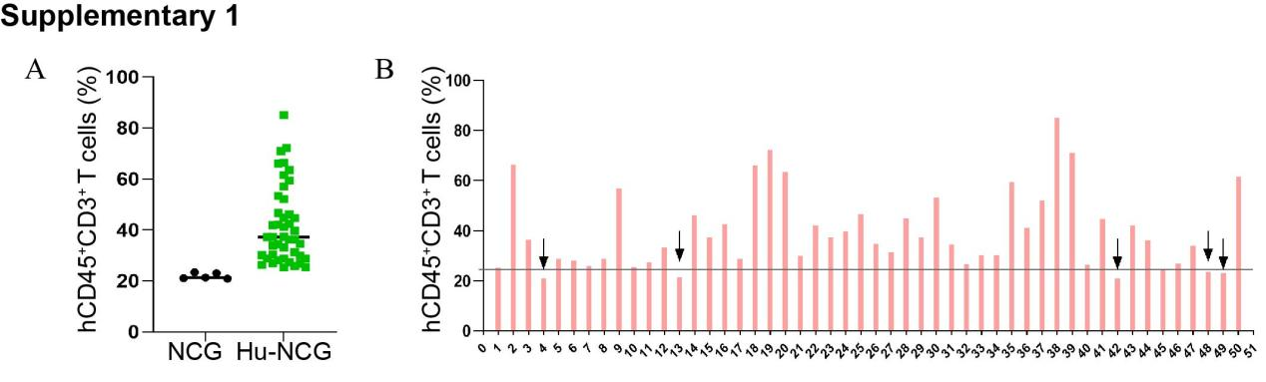

Supplementary 1 The construction and detection of humanized mice. (A-B) Peripheral blood samples from 50 mice were analyzed by flow cytometry to determine the percentage of hCD45⁺CD3⁺T cells. Mice with levels exceeding 25% were identified as humanized and selected for subsequent study.

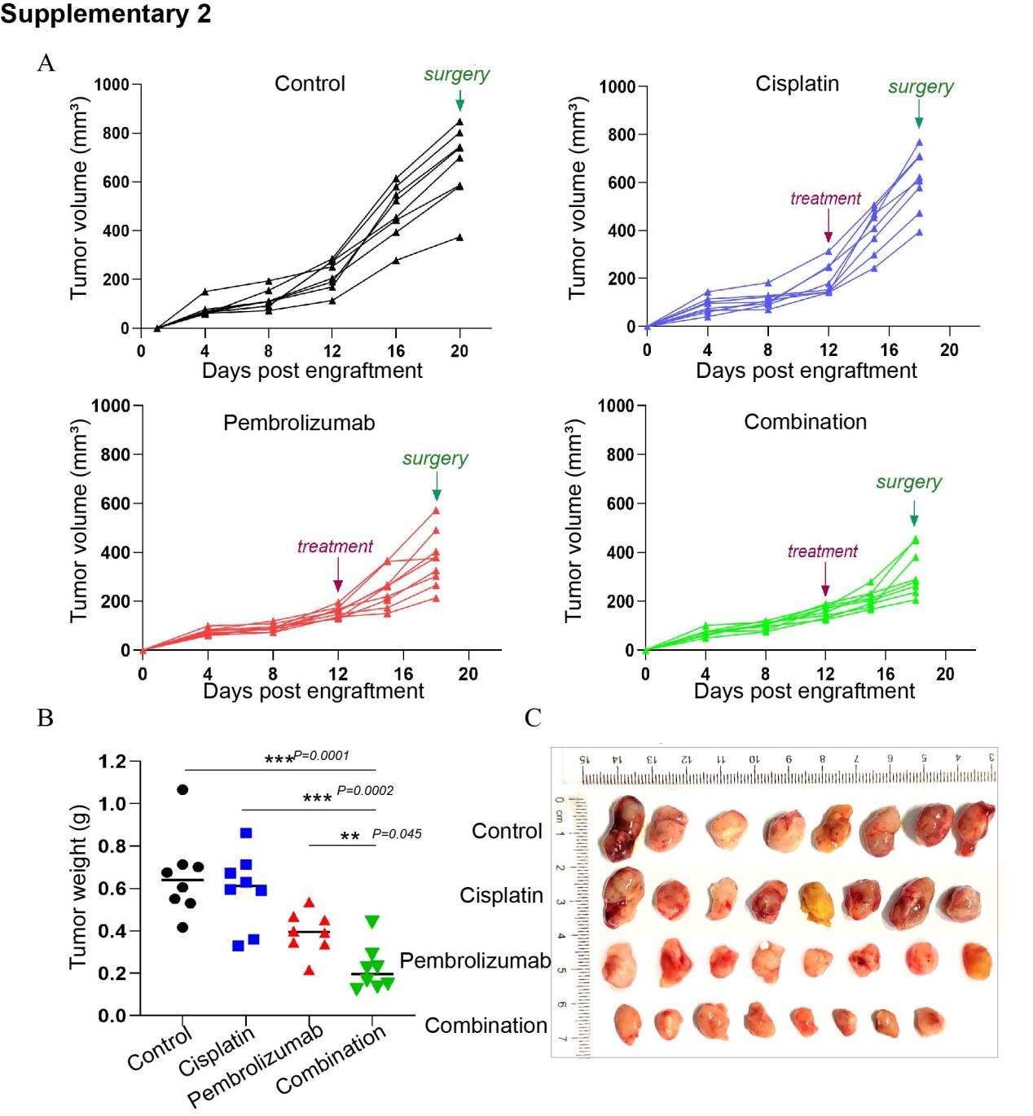

Supplementary 2 Measurement and comparison of tumor volume in four groups after treatment. (A) Tumor growth curves of each humanized mice in the four groups. Purple arrow indicates the start of treatment, while the green arrow indicates tumor surgery (n = 8 per group). (B-C) The tumors were weighed and photographed following resection in each group, as part of the experimental protocol. **P < 0.01, ***P < 0.001

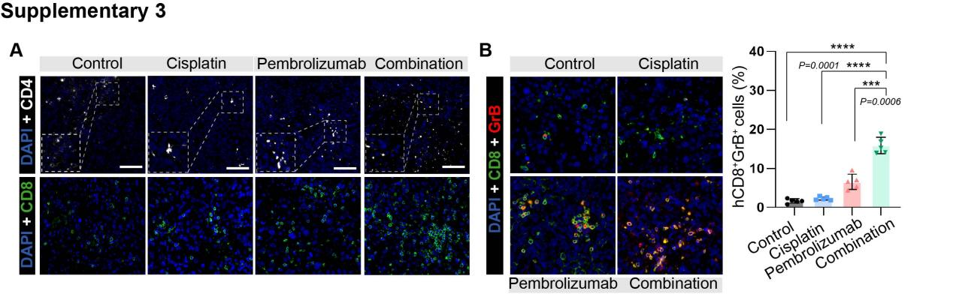

Supplementary 3 Reprogramming of immunity in tumor after neoadjuvant therapy. (A) The infiltration of human CD8⁺ and CD4⁺ T cells in tumors of each group. (B-C) Immunofluorescence was used to analyze the expression of CD8⁺GrB⁺ T cells in four groups. n=5 for each group. ***P < 0.001

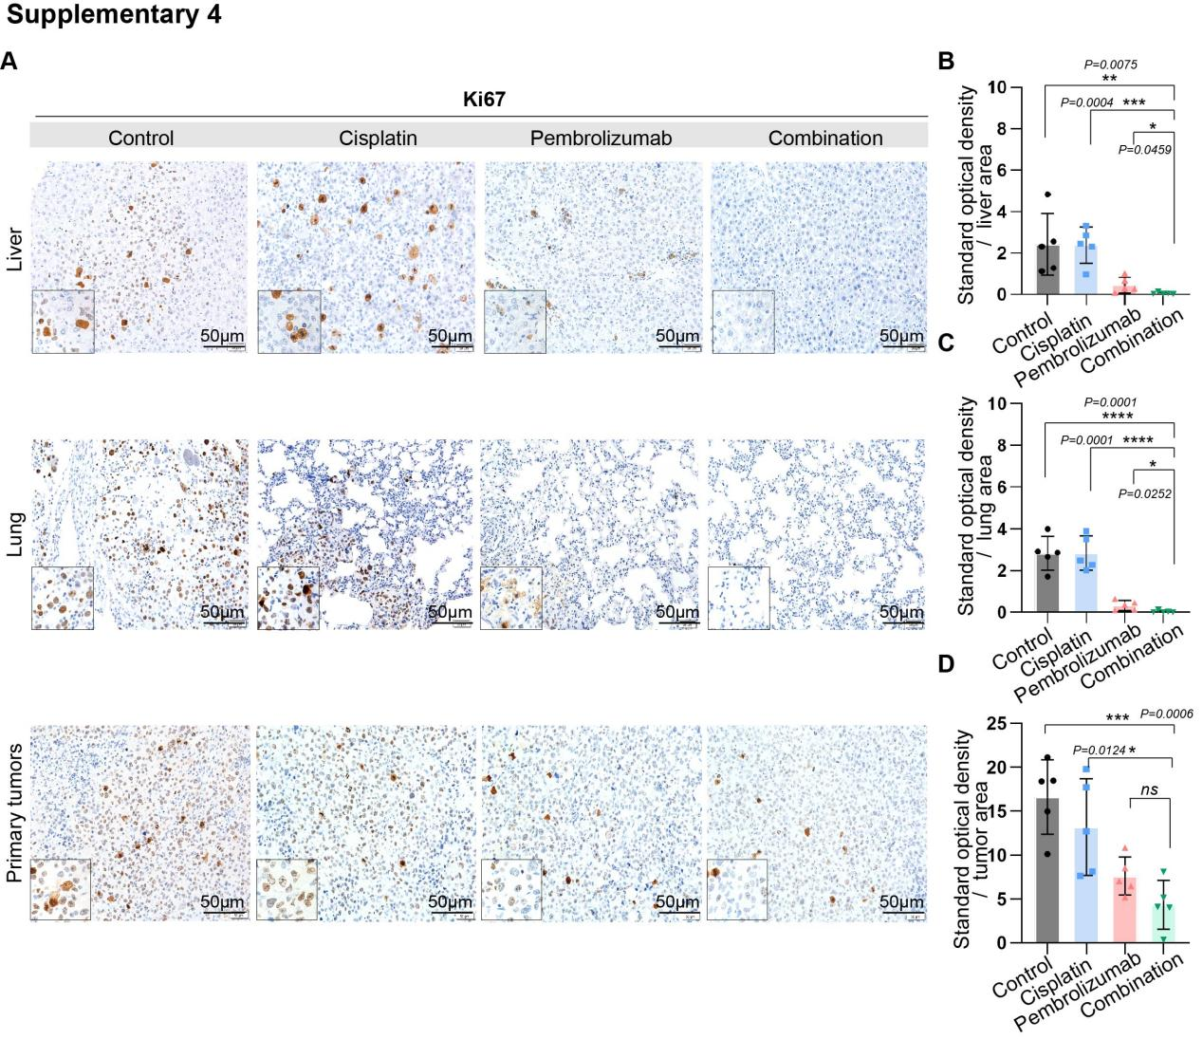
Supplementary 4 Comparison of the proliferative activity between primary tumors and organ metastases following neoadjuvant therapy. (A-D) The proliferative capacity of the primary tumor and organ metastases was measured and recorded using immunohistochemistry. n.s, not significant; *P < 0.05, **P < 0.01, ***P < 0.001

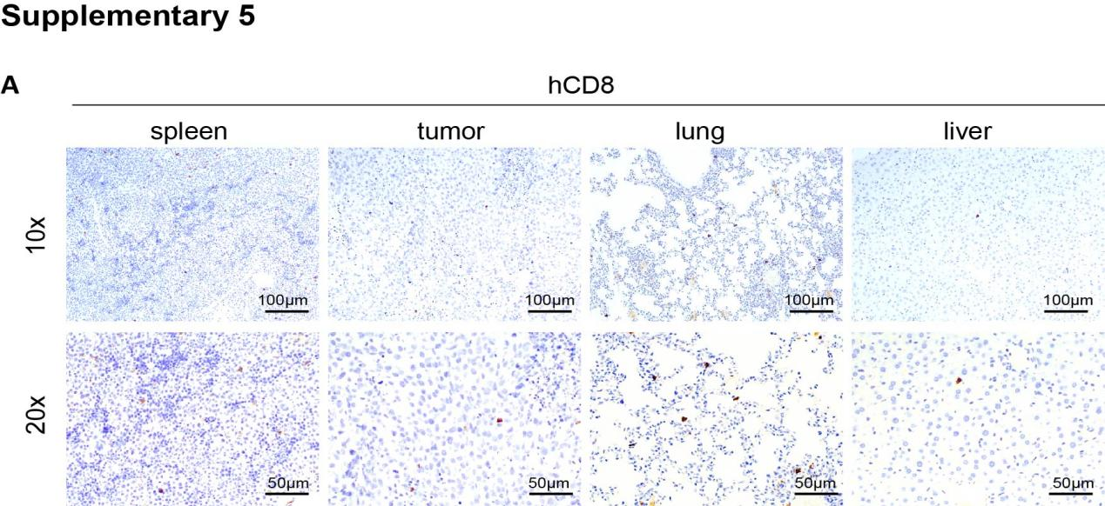

Supplementary 5 Comparison of the infiltration of CD8⁺ T cells in primary tumor, spleen and organ metastasis after neoadjuvant therapy.

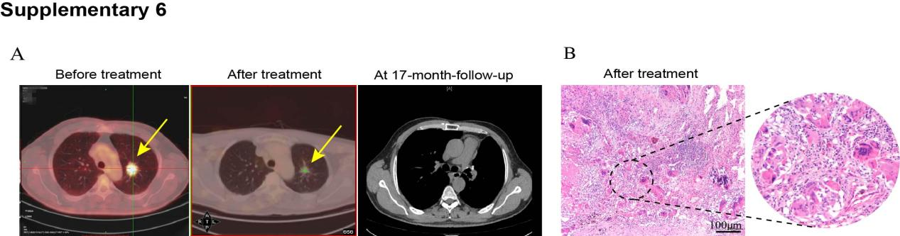

Supplementary 6 Comparison of patients before and after treatment. (A) Pre- and post-neoadjuvant therapy imaging data were acquired and compared. (B) A pathological analysis was conducted on the tumor tissue excised post neoadjuvant therapy

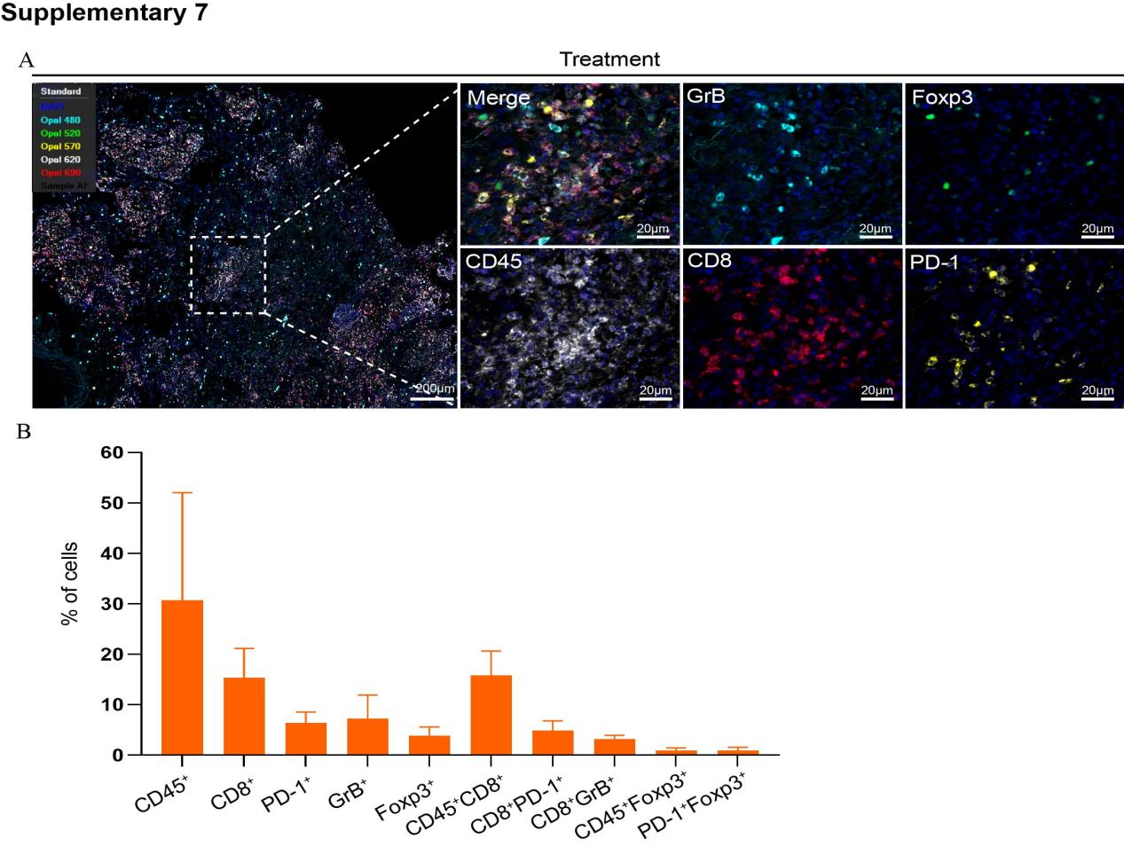

Supplementary 7 Analysis of surgical specimens with multiplex fluorescence. (A) After neoadjuvant therapy, immune microenvironment analysis was performed on surgical specimens using multiplex fluorescence. (B) Quantification and comparison of the mentioned single-staining indicators and CD45⁺CD8⁺, CD8⁺PD-1⁺, CD8⁺GrB⁺, CD45⁺Foxp⁺, and Foxp⁺PD-1⁺. Bar = mean ± SEM.

