Fabrication of Highly Porous MOF/Cellulose Beads for Sustained Degradation of Dye
Yuhang Wu^{ab*}, Yuwen Li^{c}, Yanchun Zhengª, Juming Yao^{b}, Junkuo Gao^{b*}
ªDepartment of Industrial Design, School of Art and Archaeology, Hangzhou City University, Hangzhou, Zhejiang, China
^{b}School of Materials Science and Engineering, Zhejiang Sci-Tech University, Hangzhou Zhejiang, China
^{c}State Key Laboratory of Silicon Materials, School of Materials Science and Engineering, Zhejiang University, Hangzhou, Zhejiang, China

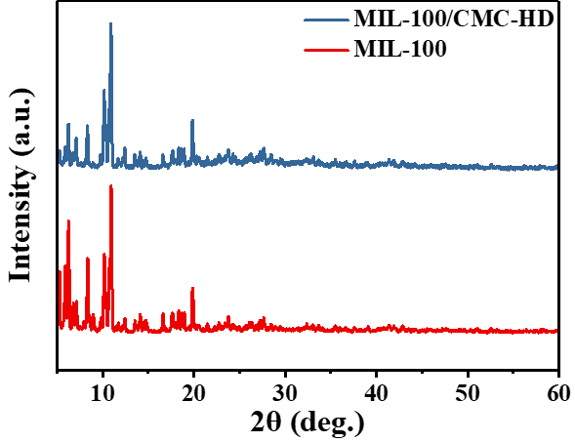
Figure S1 XRD patterns of powdered MIL-100 and MIL-100/CMC-HD
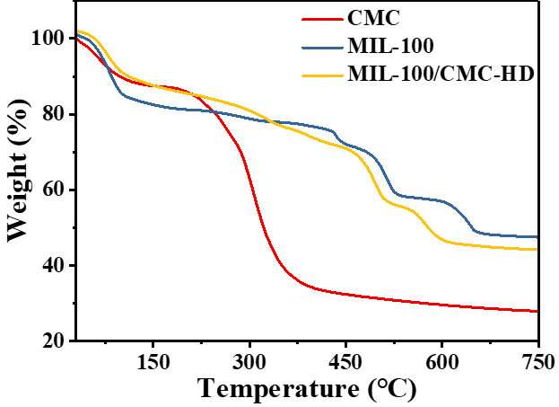
Figure S2 TG plots of CMC, MIL-100, and MIL-100/CMC-HD
Table S1 Porosity and pore structure properties of MIL-100/CMC-FD and MIL-100/CMC-HD
Samples | Porosity（%） | Total pore volume  （mL g⁻¹） | Total pore area  （m² g⁻¹） | Average pore size  （nm）
MIL-100/CMC-FD | 64.4 | 1.8 | 8.2 | 896.5
MIL-100/CMC-HD | 62.5 | 1.6 | 6.1 | 1061.0

Table S2 Ash content of different samples after pyrolysis
 | MIL-100/CMC-HD
MIL-100 ash | 27%
CMC ash | 46%
MIL-100/CMC-HD ash | 42%
MIL-100 Loading content | 79%

Equation S1 $\text{MIL-100 Loading}（\text{wt\%}）\text{ = }\frac{MIL-100/CMC-HD ash \text{-CMC ash}}{\text{MIL-100 ash-CMC ash}}$

