Supplementary Information
Uranyl-catalyzed C-H Alkynylation and Olefination
Mao et al.

Supplementary Methods
General Methods. All reactions were performed in flame-dried glassware with magnetic stirring bar and sealed with a rubber septum. The solvents were distilled by standard methods. Reagents were obtained from commercial suppliers and used without further purification unless otherwise noted. Silica gel column chromatography was carried out using silica Gel 60 (230–400 mesh). Analytical thin layer chromatography (TLC) was done using silica Gel (silica gel 60 F254). TLC was performed on pre-coated silica gel plated, using short-wave UV light as the visualizing agent, and phosphomolybdic acid, p-anisaldehyde, or KMnO₄ and heat as developing agents. NMR experiments were measured on a Bruker AVANCE III-400 or 500 spectrometer and carried out indeuterochloroform (CDCl₃) ¹H NMR and ¹³C NMR spectra were recorded at 400 MHz or 500 MHz and 100 MHz or 125 MHz spectrometers respectively. 19F NMR spectra were recorded at 376 MHz or 470 MHz spectrometers. Chemical shifts are reported as δ valuesrelative to internal TMS (δ 0.00 for ¹H NMR), chloroform (δ 7.26 for ¹H NMR), chloroform (δ 77.00 for ¹³C NMR). The following abbreviations are used for the multiplicities: s: singlet, d: doublet, dd:doublet of doublet, t: triplet, q: quadruplet, m: multiplet, br: broad signal for proton spectra; Coupling constants (J) are reported in Hertz (Hz). Melting points were uncorrected. HRMS were recorded on a Bruker microTOF-Q111. GC-MS spectra were performed on Shimadzu QP2010 (EI Source). A borosilicate glass tube was used as a reaction tube. The reaction mixture was irradiated with two Kessil LEDs (Saltwater Aquarium Light A360WE Series Tuna Blue; Rating: 19VDC 90W Max http://www.kessil.com/products/saltwater_A360.php) from 10 cm away. The emission spectrum of the lamp is shown below:
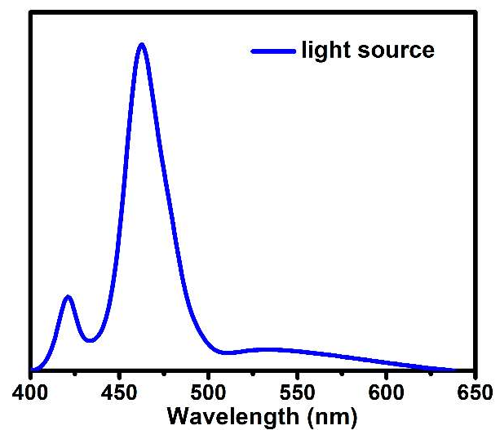
Supplementary Figure 1. Emission spectrum of the lamp
We have not used any filters. Unless otherwise noted, all reagents were weighed and handled in air, and all reactions were underargon.
Medium-sized screw-cap test tubes (8 mL) were used for all 0.20 mmol scale reactions: Fisher 13 x 100 mm tubes (Cat. No.1495935C), Cap with Septa: Thermo Scientific ASM PHN CAP w/PTFE/SIL (Cat. No.03378316)
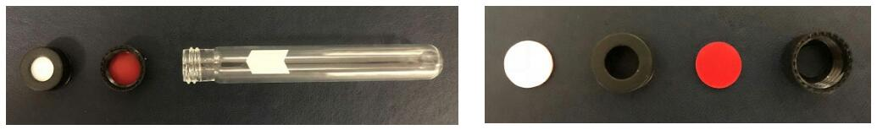
Reactor setup:
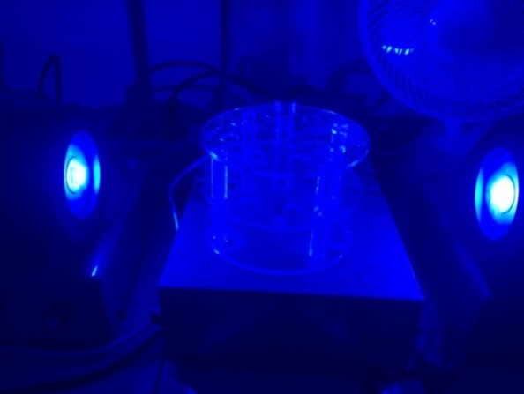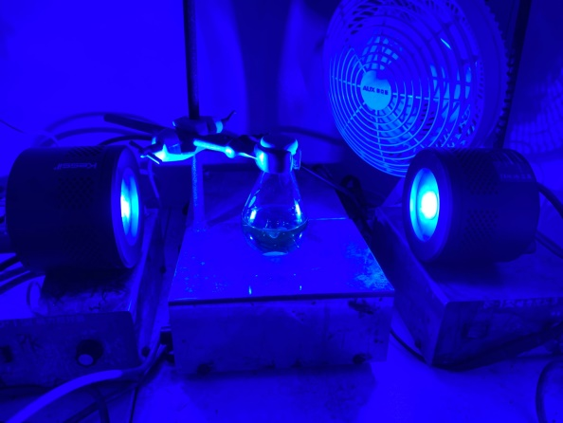
(left) 0.20 mmol scale reactions (right) gram scale reactions

Synthesis of Starting Materials.
Synthesis of Alkynyl Bromides (Procedure A)
Alkynyl bromides were prepared according to a previously reported procedure¹. Terminal alkynes (5.00 mmol, 1.00 equiv) was dissolved in acetone (30 mL). N-bromosuccinimide (5.80 mmol, 1.16 equiv) was added, followed by silver nitrate (0.50 mmol, 0.1 equiv). The resulting mixture was stirred at room temperature for 3 h and it was then poured onto ice. After ice being allowed to melt, the aqueous layer was extracted with pentane (3 x 30 mL, ethyl acetate instead of pentane if precipitate). The combined organic layers were dried over MgSO₄ , filtered and concentrated in vacuo to afford bromoalkynes. If necessary, the product could be purified by column chromatography or recrystallization.
The bromoalkynes shown below were prepared according to Procedure A.
Synthesis of Alkenyl Bromides
Method A (Procedure B)
Alkenyl bromides were prepared according to a previously reported procedure². A round-bottomed flask was charged with cinnamic acid (1.00 mmol, 1.00 equiv), N-bromosuccinimide (1.05 mmol, 1.05 equiv), Manganese(II) acetate tetrahydrate (0.20 mmol, 0.20 equiv), 2 mL of water and 2 mL of acetonitrile. The reaction mixture was stirred at room temperature and monitored by TLC analysis. After total conversion of substrates, acetonitrile was evaporated. The mixture was extracted by diethyl ether (2 mL x 3). The combined organic extracts were washed with brine, dried over anhydrous Na₂SO₄. After evaporation of the solvent, the residue was purified by column chromatography to give the product.
The bromoalkynes shown below were prepared according to Procedure B.
Method B (Procedure C)
(2-bromoethene-1,1-diyl)dibenzene was prepared according to a previously reported procedure³. To a suspension of 1, 1-diphenylethene (2.00 mmol, 1.00 equiv) in AcOH (2 mL) was added N-bromosuccinimide (2.00 mmol, 1.00 equiv). The resulting mixture was stirred at 70 °C for 4 h. After cooling down to room temperature naturally, the reaction was neutralized by slowly adding NaOH/NaHCO₃ (1:1) and extracted with ethyl acetate (3 x 10 mL). The combined organic layers were dried over MgSO₄ and concentrated under reduced pressure. The residue was purified by silica gel flash chromatography (petroleum ether / ethyl acetate 100:1) to afford 2,2-diarylvinyl bromides. (97%, 0.52 g).
Synthesis of Allyl Bromides
Method A (Procedure D)
Allyl bromides were prepared according to a previously reported procedure⁴. In an oven dried flask 1-methylethylenebenzene (5.00 mmol, 1.00 equiv.) was taken and to this dry tetrahydrofuran (15 mL) was added. To the resulting solution N-bromosuccinimide (5.25 mmol, 1.05 equiv.) and p-toluenesulfonic acid (0.50 mmol, 0.10 equiv.) was added and the solution was refluxed at 100 °C for 4 h. Reaction mixture was cooled to rt and the reaction mixture was taken in petroleum ether (15 mL/mmol), washed with water (15 mL x 3). Organic phase was dried over Na₂SO₄, concentrated under reduced pressure to obtain a yellow oil. Purification by column chromatography using petroleum ether as eluent afforded the product.
The allyl bromides shown below were prepared according to Procedure D.
Method B (Procedure E)
Bromo carvone was prepared according to a previously reported procedure⁵. A solution of (S)-carvone (30.0 mmol, 1.00 equiv.) and sodium acetate (22.0 mmol, 0.73 equiv.) in 45 mL of a mixture of CH₂Cl₂ and acetic acid (40 mL, 3 : 2) was cooled in an ice bath. To the magnetically stirring solution was added N-bromosuccinimide (36.0 mmol, 1.20 equiv.) in small portions over a period of 90 min. The reaction mixture was stirred at room temperature for 5 h, diluted with 50 mL of CH₂Cl₂, washed successively with water (3 x 30 mL), aqueous NaHCO₃ (3 x 30 mL), and brine, and dried over anhydrous Na₂SO₄. Evaporation of the solvent and purification of the residue on silica gel with 1:3 ethyl acetate-hexane as eluent furnished allyl bromide (1.25 g, 40% ) as an oil.
Synthesis of Amide
Synthesis of 2,2-dimethyl-1-(piperidin-1-yl)propan-1-one (Procedure F)
2,2-dimethyl-1-(piperidin-1-yl)propan-1-one was prepared according to a previously reported procedure⁶. To a 100 ml flask charged with a magnetic stirring bar and piperidine (0.92 mL, 1.0 equiv., 10 mmol) was added. Dichloromethane (50 ml, 0.2 M) was added and the mixture was cooled to 0°C with an ice bath. Triethylamine (2.80 ml, 2.0 equiv., 20 mmol) was added in one portion. Pivaloyl chloride (1.35 ml, 1.1 equiv., 11 mmol) was then added dropwise and the reaction was stirred for 2 h before quenching with sat. NaHCO₃. The organic layer was separated, washed with brine, dried over anhydrous magnesium sulfate, and filtered to a yellowish oil (1.6 g, 95%), which was used without further purification.
Synthesis of Methyl acetyl-L-prolinate (Procedure G)
Methyl acetyl-L-prolinate was prepared according to a previously reported procedure⁷. Into a flask were added methyl L-prolinate hydrochloride (490 mg, 2.96 mmol, 1.0 equiv), dichloromethane (30 mL, 0.1 M), and 4-(dimethylamino)pyridine (90 mg, 0.74 mmol, 0.25 equiv). The flask was capped with a rubber septum and maintained under a nitrogen atmosphere. To the flask were added triethylamine (1.64 mL, 11.86 mmol, 4.0 equiv) and acetic anhydride (0.56 mL, 5.92 mmol, 2.0 equiv). The mixture was stirred (2.5 h), diluted with dichloromethane (80 mL), washed with sodium carbonate (10% aqueous, 80 mL) and citric acid (10% aqueous, 80 mL), and dried with sodium sulfate. Volatiles were removed under reduced pressure, and the crude material was purified by column chromatography (silica gel, EtOAc) to yield acetamide (313 mg, 62%).

Optimization Tables
Supplementary Table 1. Optimization of Solvent
Entry | Solvent | Yieldª (%)
1 | acetonitrile | 23
2 | acetone | 26
3 | benzene | 28
4 | methanol | 0
5 | dimethyl sulfoxide | 0
ª Yields were determined by GC-FID using cyclododecane as internal standard.
Supplementary Table 2. Optimization of Base
Entry | Base | Yieldª (%)
1 | K₂CO₃ | 8
2 | K₃PO₄ | 0
3 | Et₃N | 0
4 | LiOH·H₂O | 0
ª Yields were determined by GC-FID using cyclododecane as internal standard.
Supplementary Table 3. Optimization of Material Ratio
Entry | Material Ratio | Yield(%)
1 | x = 5 | 23
2 | x = 10 | 31
3 | x = 20 | 49
4 | DMAc as solvent | 73
ª Yields were determined by GC-FID using cyclododecane as internal standard.
Supplementary Table 4. Optimization of Light Sources
Entry | Light sources | Yield(%)
1 | 30 W blue LEDs | 59
2 | 90 W blue LEDs | 72
3 | in darkness | 0
ª Yields were determined by GC-FID using cyclododecane as internal standard.
Supplementary Table 5. Optimization of Ligands
Entry | Ligands | Yield(%)
1 | L1 | 7
2 | L2 | 74
3 | L3 | 98
4 | L4 | 81
5 | L5 | 86
ª Yields were determined by GC-FID using cyclododecane as internal standard.
Supplementary Table 5. Optimization of Catalylst Quantity
Entry | Catalylst Quantity | Yield(%)
1 | [UO₂] (8 mol%) & pbi (10 mol%) | 98
2 | [UO₂] (4 mol%) & pbi (5 mol%) | 51
ª Yields were determined by GC-FID using cyclododecane as internal standard.

General Procedure
Procedure for C-H Alkynylation, Alkenylation and Allylation
Method A (Procedure H)
Uranyl nitrate hexahydrate (8.0 mg, 8 mol%), 2-(2-pyridyl)benzimidazole (pbi) (3.9 mg, 10 mol%) and the bromide (if solid, 0.2 mmol, 1.0 equiv.) were added into a screw-cap test tube with stirring bar. The alkyl source (2 mL, 0.1 M) was injected into the tube, followed with the bromide (if liquid, 0.2 mmol, 1.0 equiv.). Afterwards, the tube was set between two lamps (10 cm away from the lamp, 60 W each) and stirred at room temperature (with a fan to cool down the reaction) for 24 h. The mixture was diluted with ethyl acetate and washed with saturated NaHCO₃ (10 mL), water (10 mL x 3) and brine (10 mL). The organic layer was dried over anhydrous Na₂SO₄, and concentrated under reduced pressure. The crude material was purified by column chromatography to afford the corresponding product.
Method B (Procedure I)
Uranyl nitrate hexahydrate (8.0 mg, 8 mol%) and 2-(2-pyridyl)benzimidazole (3.9 mg, 10 mol%) were added into a screw-cap test tube with stirring bar. The bromide (0.2 mmol, 1.0 equiv.) and the alkyl source (1 mmol, 5.0 equiv.) were dissolved in benzene (1 mL, 0.2 M) and the solution was injected into the tube. Afterwards, the tube was set between two lamps (10 cm away from the lamp, 60 W each) and stirred at room temperature (with a fan to cool down the reaction) for 24-96 h. The mixture was diluted with ethyl acetate and washed with saturated NaHCO₃ (10 mL), water (10 mL x 3) and brine (10 mL). The organic layer was dried over anhydrous Na₂SO₄, and concentrated under reduced pressure. The crude material was purified by column chromatography to afford the corresponding product.

Procedure for One-pot Alkynylation with Terminal Alkynes (Procedure J)
In a screw-cap test tube, silver nitrate (3.4 mg, 10 mol%), N-bromosuccinimide (41.3 mg, 1.16 equiv.) and phenylacetylene (22 μL, 1.0 equiv.) were dissolved in N,N-dimethylacetamide (2 mL, 0.1 M). The mixture was stirred for 1 h and then uranyl nitrate hexahydrate (8.0 mg, 8 mol%) and 2-(2-pyridyl)benzimidazole (3.9 mg, 10 mol%) were added. Afterwards, the tube was set between two lamps (10 cm away from the lamp, 60 W each) and stirred at room temperature (with a fan to cool down the reaction) for 24 h. The mixture was diluted with ethyl acetate and washed with saturated NaHCO₃ (10 mL), water (10 mL x 3) and brine (10 mL). The organic layer was dried over anhydrous Na₂SO₄, and concentrated under reduced pressure. The crude material was purified by column chromatography (silica, 50% ethyl acetate / petroleum ether) to afford the propargyl amide (colorless oil, 25.1 mg, 67%).

Procedure for Alkynylation with Aldehyde (Dibromoethene)
Synthesis of dibromoethene (Procedure K)
Dibromoethene was prepared according to a previously reported procedure⁸. Carbon tetrabromide (1.33 g, 4.0 mmol), 4-benzyloxybenzaldehyde (424 mg, 2.0 mmol) and triphenylphosphine (2.10 g, 8.0 mmol) was stirred at 0 ºC in dichloromethane (6 mL). The ice bath was removed, and the reaction mixture was stirred at room temperature overnight. The reaction mixture was quenched with pentane (30 mL) and filtered through a silica plug (Et₂O). The solvent was removed under reduced pressure and the corresponding dibromoethene was isolated by flash column chromatography (5% ethyl acetate / petroleum ether) as a white solid (0.67 g, 91%).
Alkynylation with dibromoethene (Procedure L)
Uranyl nitrate hexahydrate (8.0 mg, 8 mol%), 2-(2-pyridyl)benzimidazole (pbi) (3.9 mg, 10 mol%) and the dibromoethene (58.7 mg, 0.2 mmol, 1.0 equiv.) were added into a screw-cap test tube with a stirring bar. 2-(tert-butyl)-1,1,3,3- tetramethylguanidine (40 μL, 1.0 equiv.) were dissolved in N,N-dimethylacetamide (2 mL, 0.1 M) and the solution was injected into the tube. Afterwards, the tube was set between two lamps (10 cm away from the lamp, 60 W each) and stirred at room temperature (with a fan to cool down the reaction) for 24 h. The mixture was diluted with ethyl acetate and washed with water (10 mL x 3) and brine (10 mL). The organic layer was dried over anhydrous Na₂SO₄, and concentrated under reduced pressure. The crude material was purified by column chromatography to afford the corresponding propargyl amide.

Flowing Reaction
Flowing reaction is carried out with a homemade setup consisting of peristaltic pump (CM1000; purchased from Baoding Chuang Rui Precision Pump Co., Ltd), annular capillary tube (PTEF, ID 0.8 mm, ED 1.6 mm, length 40 m, volume 20 mL) and two Kessil LEDs (Saltwater Aquarium Light A360WE Series Tuna Blue; Rating: 19VDC 90W Max).
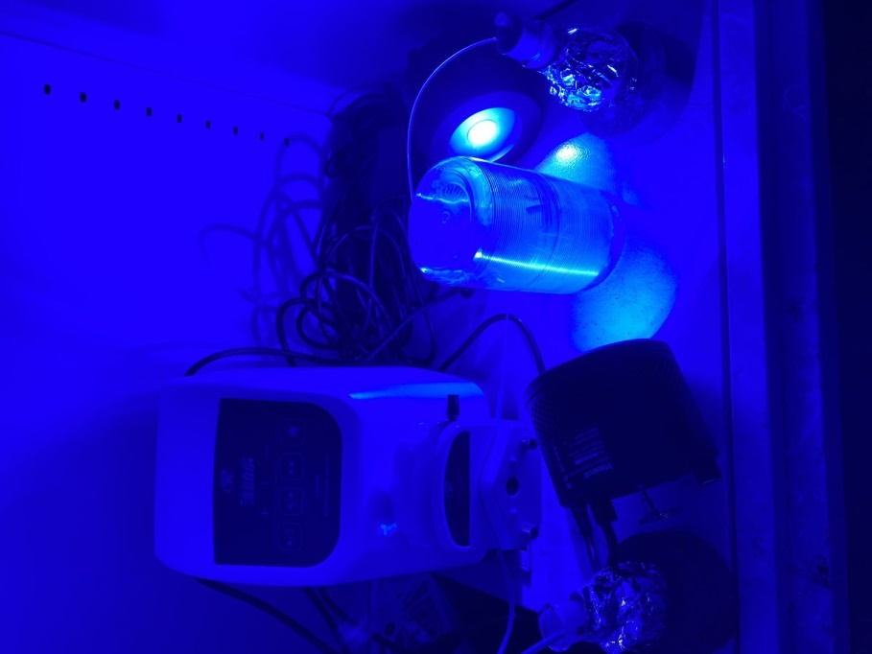
peristaltic pump
lamp
capillary tube
sample mixture
reservoir bottle
Supplementary Figure 2. Setting method of reactor
We selected (bromoethynyl)benzene to react in continuous flow in 2.0 mmol scale. Uranyl nitrate hexahydrate (80.3 mg, 8 mol%), 2-(2-pyridyl)benzimidazole (pbi) (39.0 mg, 10 mol%), (bromoethynyl)benzene (362 mg, 2.0 mmol, 1.0 equiv.) and cyclododecane (84.2 mg, 0.25 equiv., internal standard) were dissolved in N,N-dimethylacetamide (20 mL). The yellow mixture was then transferred into a sample bottle (wrapped in aluminum foil). Next, the reaction mixture was flowing under the irradiation of two 60 W blue LEDs (distance app. 10.0 cm) in the mode of extraction at the speed of 0.33 mL/min. After 1 h, the sample would be completely transferred to the reservoir bottle (wrapped in aluminum foil). The position of two bottles could be exchanged so the reaction time could be extended. The products and the crude yields were monitored by GC-FID and GC-MS. The comparison of reaction rate with conventional reaction was shown below.
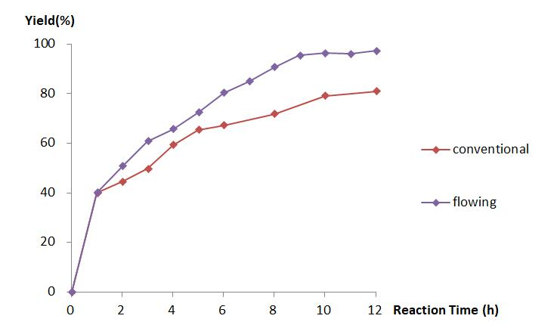
Supplementary Figure 3. Comparison between conventional and flowing reactor

Synthesis of the Uranyl Nitrate Peroxide Complex
Uranyl nitrate hexahydrate (25.1 mg, 0.05 mmol, 1.0 equiv.) and 2-(2-pyridyl)benzimidazole (pbi) (9.8 mg, 1.0 equiv.) were dissolved in acetone (2 mL, 0.1 M) in a screw-cap test tube with a stirring bar. The tube was set between two lamps (10 cm away from the lamp, 60 W each) and stirred under ambient conditions. The tube was pierced by a syringe needle and the solvent volatilized slowly for 1-2 weeks. The orange supernatant was decanted and the yellow crystals were harvested and dried under vacuum. Single crystals for structure determination were isolated manually from the initial crude precipitate. (10.5 mg, 35% based on U).

X-ray crystallography data for Uranyl Nitrate Peroxide
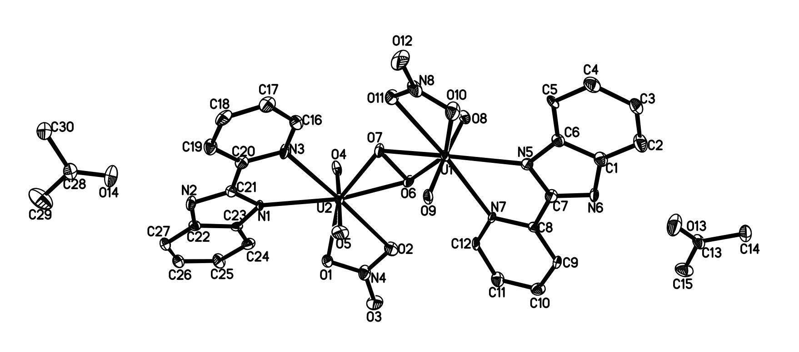
Supplementary Figure 4. X-ray structure of uranyl nitrate peroxide

Supplementary Table 6 Crystal data and structure refinement
Identification code | Compound 52
Empirical formula | C₃₀H₃₀N₈O₁₄U₂
Formula weight | 1202.68
Temperature/K | 193
Crystal system | orthorhombic
Space group | Pca2₁
a/Å | 14.6321(10)
b/Å | 15.2595(7)
c/Å | 16.1553(9)
α/ | 90
β/ | 90
γ/ | 90
Volume/Å³ | 3607.1(4)
Z | 4
ρ_{calc}g/cm³ | 2.215
μ/mm⁻¹ | 9.046
F(000) | 2248.0
Crystal size/mm³ | 0.15 × 0.12 × 0.1
Radiation | MoKα (λ = 0.71073)
2Θ range for data collection/ | 4.608 to 58.134
Index ranges | -18 ≤ h ≤ 17, -15 ≤ k ≤ 20, -19 ≤ l ≤ 19
Reflections collected | 22885
Independent reflections | 8231 [R_{int}= 0.0743, R_{sigma}= 0.0846]
Data/restraints/parameters | 8231/253/491
Goodness-of-fit on F² | 1.007
Final R indexes [I>=2σ (I)] | R₁= 0.0572, wR₂= 0.1347
Final R indexes [all data] | R₁= 0.0721, wR₂= 0.1456
Largest diff. peak/hole / e Å⁻³  Flack parameter | 5.90/-3.33  0.038(10)

Characterization Data for Products
General Information
NMR experiments were measured at room temperature. All the asymmetric tertiary amide derivatives are mixtures of two conformational products, giving a splitting of the signal in both ¹H NMR and ¹³C NMR spectra.

Compound 3
Following Procedure H on 0.20 mmol scale. Purification by column chromatography (petroleum ether/ethyl acetate = 1:1) afforded 36.0 mg (96%).
Physical State: colorless oil.
R_{f}= 0.40 (petroleum ether/ethyl acetate = 1:1).
¹H NMR (400 MHz, CDCl₃): δ 7.46 – 7.36 (m, 2H), 7.36 – 7.24 (m, 3H), 4.44/4.24 (s, 2H), 3.11/3.03 (s, 3H), 2.20/2.11 (s, 3H) ppm.
¹³C NMR (101 MHz, CDCl₃): δ 170.6, 170.4, 131.8, 131.8, 128.7, 128.4, 128.4, 128.3, 122.8, 122.3, 84.6, 84.3, 83.7, 83.2, 41.2, 36.8, 35.2, 33.4, 21.8, 21.6 ppm.
This compound was previously reported⁹.

Compound 4
Following Procedure H on 0.20 mmol scale. Purification by column chromatography (petroleum ether/ethyl acetate = 2:1) afforded 19.1 mg (52%).
Physical State: colorless oil.
R_{f}= 0.26 (petroleum ether/ethyl acetate = 2:1).
¹H NMR (400 MHz, CDCl₃): δ 8.23 – 8.02 (m, 1H), 7.50 – 7.37 (m, 3H), 7.41 – 7.25 (m, 2H), 4.50 – 4.17 (m, 2H), 3.18 – 2.97 (m, 3H) ppm.
¹³C NMR (126 MHz, CDCl₃):δ 162.4, 162.2, 131.9, 131.8, 128.9, 128.6, 128.5, 128.4, 122.5, 122.1, 85.5, 84.2, 82.9, 82.6, 40.1, 34.0, 34.0, 29.6 ppm.
This compound was previously reported¹¹.

Compound 5
Following Procedure H on 0.20 mmol scale. Purification by column chromatography (petroleum ether/ethyl acetate = 2:1) afforded 10.5 mg (29%).
Physical State: colorless oil.
R_{f}= 0.34 (petroleum ether/ethyl acetate = 2:1).
¹H NMR (400 MHz, CDCl₃): δ 7.57 – 7.52 (m, 2H), 7.43 – 7.33 (m, 3H), 3.29 (s, 3H), 3.03 (s, 3H) ppm.
¹³C NMR (126 MHz, CDCl₃): δ 149.2, 132.3, 130.0, 128.5, 121.6, 90.2, 81.6, 38.4, 34.2. ppm.
This compound was previously reported¹¹.

Compound 6
Following Procedure H on 0.20 mmol scale. Purification by column chromatography (petroleum ether/ethyl acetate = 1:1) afforded 21.1 mg (49%).
Physical State: colorless oil.
R_{f}= 0.35 (petroleum ether/ethyl acetate = 1:1).
¹H NMR (400 MHz, CDCl₃): δ 7.44 – 7.39 (m, 2H), 7.34 – 7.27 (m, 3H), 4.72 (s, 2H), 2.54 (s, 6H) ppm.
¹³C NMR (101 MHz, CDCl₃): δ 172.5, 131.8, 128.7, 128.3, 122.1, 83.8, 83.5, 34.6, 26.4 ppm.
HRMS (ESI-TOF): calculated for C₁₃H₁₃NO₂ [M+Na]⁺: 238.0839, found: 238.0840.

Compound 7
Following Procedure H on 0.20 mmol scale. Purification by column chromatography (petroleum ether/ethyl acetate = 1:1) afforded 34.9 mg (81%).
Physical State: colorless oil.
R_{f}= 0.44 (petroleum ether/ethyl acetate = 1:1).
¹H NMR (400 MHz, CDCl₃): δ 7.47 – 7.37 (m, 2H), 7.37 – 7.28 (m, 3H), 5.74/4.84 (q, J = 6.9 Hz, 1H), 3.69 – 3.34 (m, 2H), 2.18/2.14 (s, 3H), 1.55/1.43 (d, J = 7.0 Hz, 3H), 1.35/1.26 (t, J = 7.1 Hz, 3H) ppm.
¹³C NMR (101 MHz, CDCl₃): δ 169.9, 169.5, 131.7, 131.7, 128.7, 128.5, 128.4, 128.4, 123.0, 122.5, 89.0, 83.7, 46.6, 42.0, 39.9, 38.1, 29.8, 21.9, 21.8, 21.1, 16.3, 14.7 ppm.
HRMS (ESI-TOF): calculated for C₁₄H₁₇NO [M+Na]⁺: 238.1203, found: 238.1201.

Compound 8
Following Procedure I on 0.20 mmol scale. Purification by column chromatography (petroleum ether/ethyl acetate = 1:1) afforded 14.6 mg (42%).
Physical State: colorless oil.
R_{f}= 0.45 (petroleum ether/ethyl acetate = 1:1).
¹H NMR (400 MHz, CDCl₃): δ 7.47 – 7.37 (m, 2H), 7.33 – 7.26 (m, 3H), 6.11 (s, 1H), 4.25 (d, J = 5.2 Hz, 2H), 2.02 (s, 3H) ppm.
¹³C NMR (101 MHz, CDCl₃): δ 170.0, 131.8, 128.5, 128.4, 122.6, 84.9, 83.4, 30.2, 23.1 ppm.
This compound was previously reported⁹.

Compound 9
Following Procedure H on 0.20 mmol scale. Purification by column chromatography (petroleum ether/ethyl acetate = 1:1) afforded 27.4 mg (69%).
Physical State: colorless oil.
R_{f}= 0.35 (petroleum ether/ethyl acetate = 1:1).
¹H NMR (400 MHz, CDCl₃): δ 7.45 – 7.39 (m, 2H), 7.36 – 7.30 (m, 3H), 4.62 – 4.33 (m, 1H), 2.94 (s, 3H), 2.63 – 2.51 (m, 1H), 2.48 – 2.36 (m, 2H), 2.25 – 2.15 (m, 1H) ppm.
¹³C NMR (126 MHz, CDCl₃):δ 174.5, 131.8, 128.8, 128.5, 122.2, 86.5, 85.5, 52.0, 29.9, 28.2, 26.3 ppm.
This compound was previously reported¹¹.

Compound 10
Following Procedure I on 0.20 mmol scale. Purification by column chromatography (petroleum ether/ethyl acetate = 5:1) afforded 25.9 mg (48%).
Physical State: colorless oil.
R_{f}= 0.30 (petroleum ether/ethyl acetate = 5:1).
¹H NMR (400 MHz, CDCl₃): δ 7.48 – 7.38 (m, 2H), 7.36 – 7.26 (m, 3H), 5.72 (s, 1H), 4.21 (d, J = 13.4 Hz, 1H), 3.35 (s, 1H), 2.02 – 1.85 (m, 2H), 1.78 – 1.66 (m, 3H), 1.44 (qt, J = 13.2, 4.1 Hz, 1H), 1.31 (s, 9H) ppm.
¹³C NMR (101 MHz, CDCl₃): δ 176.2, 131.9, 128.4, 128.3, 123.1, 87.7, 84.7, 77.5, 77.2, 76.8, 45.0, 42.4, 39.0, 31.1, 28.5, 26.1, 20.6 ppm.
HRMS (ESI-TOF): calculated for C₁₈H₂₃NO [M+Na]⁺: 292.1672, found: 292.1672.

Compound 11
Following Procedure H on 0.20 mmol scale. Purification by column chromatography (ethyl acetate) afforded 38.1 mg (88%).
Physical State: colorless oil.
R_{f}= 0.45 (ethyl acetate).
¹H NMR (400 MHz, CDCl₃): δ 7.49 – 7.39 (m, 2H), 7.34 – 7.27 (m, 3H), 4.12 (s, 2H), 2.93 (s, 3H), 2.86 (s, 6H) ppm.
¹³C NMR (101 MHz, CDCl₃): δ 164.9, 131.8, 128.4, 128.3, 123.0, 85.2, 84.0, 41.1, 38.7, 36.4 ppm.
HRMS (ESI-TOF): calculated for C₁₃H₁₆N₂O [M+Na]⁺: 239.1155, found: 239.1154.

Compound 12
Following Procedure H on 0.20 mmol scale. Purification by column chromatography (dichloromethane/methanol = 10:1) afforded 40.8 mg (73%).
Physical State: colorless oil.
R_{f}= 0.56 (dichloromethane/methanol = 10:1).
¹H NMR (400 MHz, CDCl₃): δ 7.43 – 7.36 (m, 2H), 7.33 – 7.27 (m, 3H), 4.01 (d, J = 9.7 Hz, 2H), 2.78 (d, J = 8.9 Hz, 3H), 2.69 (d, J = 9.6 Hz, 12H) ppm.
¹³C NMR (101 MHz, CDCl₃): δ 131.7, 128.4, 128.3, 123.2, 86.2, 86.2, 83.9, 39.8, 39.7, 37.0, 37.0, 34.2, 34.2 ppm.
³¹P NMR (162 MHz, CDCl₃): δ 25.0.
HRMS (ESI-TOF): calculated for C₁₄H₂₂N₃OP [M+Na]⁺: 302.1393, found: 302.1395.

Compound 13
Following Procedure I on 0.20 mmol scale. Purification by column chromatography (petroleum ether/ethyl acetate = 2:1) afforded 34.5 mg (49%).
Physical State: colorless oil.
R_{f}= 0.40 (petroleum ether/ethyl acetate = 2:1).
¹H NMR (400 MHz, CDCl₃): δ 7.48 – 7.40 (m, 2H), 7.26 – 7.22 (m, 2H), 4.90 – 4.83 (m, 1H), 4.63 – 4.57 (m, 1H), 3.72 (s, 3H), 2.53 – 2.38 (m, 2H), 2.28 (s, 3H), 2.25 – 2.15 (m, 1H), 2.13 – 2.02 (m, 1H) ppm.
¹³C NMR (101 MHz, CDCl₃): δ 172.4, 170.0, 133.1, 131.7, 123.0, 121.0, 88.8, 82.9, 58.6, 52.4, 50.3, 32.6, 28.1, 22.4 ppm.
HRMS (ESI-TOF): calculated for C₁₆H₁₆BrNO₃ [M+Na]⁺: 372.0206, found: 372.0202.

Compound 14
Following Procedure H on 0.20 mmol scale. Purification by column chromatography (petroleum ether/ethyl acetate = 20:1) afforded 18.4 mg (49%).
Physical State: colorless oil.
R_{f}= 0.32 (petroleum ether/ethyl acetate = 20:1).
¹H NMR (400 MHz, CDCl₃): δ 7.47 – 7.41 (m, 2H), 7.34 – 7.27 (m, 3H), 4.32 (s, 2H), 1.29 (s, 9H) ppm.
¹³C NMR (126 MHz, CDCl₃): δ 131.9, 128.3, 128.3, 123.2, 87.2, 84.9, 51.3, 29.9, 27.7 ppm.
This compound was previously reported¹³.

Compound 15
Following Procedure H on 0.20 mmol scale. Purification by column chromatography (petroleum ether/ethyl acetate = 20:1) afforded 17.9 mg (52%).
Physical State: colorless oil.
R_{f}= 0.42 (petroleum ether/ethyl acetate = 20:1).
¹H NMR (500 MHz, CDCl₃): δ 7.47 – 7.39 (m, 2H), 7.35 – 7.27 (m, 3H), 4.81 (dd, J = 7.2, 4.9 Hz, 1H), 4.06 – 3.98 (m, 1H), 3.86 (td, J = 7.9, 5.4 Hz, 1H), 2.28 – 2.18 (m, 1H), 2.15 – 2.04 (m, 2H), 2.00 – 1.90 (m, 1H) ppm.
¹³C NMR (126 MHz, CDCl₃): δ 131.8, 128.4, 128.3, 122.9, 89.2, 84.6, 68.7, 68.1, 33.5, 25.6 ppm.
This compound was previously reported⁹.

Compound 16
Following Procedure H on 0.20 mmol scale. Purification by column chromatography (petroleum ether/ethyl acetate = 20:1) afforded 23.6 mg (63%).
Physical State: colorless oil.
R_{f}= 0.33 (petroleum ether/ethyl acetate = 20:1).
¹H NMR (500 MHz, CDCl₃): δ 7.48 – 7.43 (m, 2H), 7.35 – 7.28 (m, 3H), 4.57 (dd, J = 8.5, 2.9 Hz, 1H), 3.94 (ddd, J = 11.5, 5.5, 2.4 Hz, 2H), 3.79 – 3.66 (m, 4H) ppm.
¹³C NMR (126 MHz, CDCl₃): δ 132.0, 128.8, 128.4, 122.1, 86.7, 84.4, 70.5, 66.6, 66.5, 65.9 ppm.
This compound was previously reported¹⁰.

Compound 17
Following Procedure H on 0.20 mmol scale. Purification by column chromatography (petroleum ether/ethyl acetate = 20:1) afforded 18.9 mg (51%).
Physical State: colorless oil.
R_{f}= 0.40 (petroleum ether/ethyl acetate = 20:1).
¹H NMR (400 MHz, CDCl₃): δ 7.50 – 7.40 (m, 2H), 7.36 – 7.23 (m, 3H), 4.51 (dd, J = 7.9, 2.9 Hz, 1H), 4.16 – 3.97 (m, 1H), 3.59 (ddd, J = 11.7, 8.3, 3.3 Hz, 1H), 1.99 – 1.83 (m, 2H), 1.85 – 1.72 (m, 1H), 1.70 – 1.53 (m, 3H) ppm.
¹³C NMR (101 MHz, CDCl₃): δ 131.9, 128.4, 128.3, 122.9, 88.2, 85.3, 67.6, 66.8, 32.3, 25.8, 22.0 ppm.
This compound was previously reported¹³.

Compound 18
Following Procedure H on 0.20 mmol scale. Purification by column chromatography (petroleum ether/ethyl acetate = 20:1) afforded 19.3 mg (51%).
Physical State: colorless oil.
R_{f}= 0.35 (petroleum ether/ethyl acetate = 20:1).
¹H NMR (400 MHz, CDCl₃): δ 7.47 – 7.42 (m, 2H), 7.31 (dd, J = 5.2, 2.1 Hz, 3H), 4.41 (dd, J = 7.3, 4.0 Hz, 1H), 3.73 – 3.60 (m, 2H), 3.53 (s, 3H), 3.45 (s, 3H) ppm.
¹³C NMR (101 MHz, CDCl₃): δ 132.0, 128.7, 128.4, 122.5, 87.0, 85.0, 75.1, 71.2, 59.5, 57.0 ppm.
This compound was previously reported¹⁰.

Compound 19
Following Procedure I on 0.20 mmol scale, using 40 equiv. of cyclooctane, reaction for 96 h. Purification by column chromatography (petroleum ether) afforded 23.4 mg (55%).
Physical State: colorless oil.
R_{f}= 0.65 (petroleum ether).
¹H NMR (400 MHz, CDCl₃): δ 7.43 – 7.35 (m, 2H), 7.32 – 7.21 (m, 3H), 2.79 (tt, J = 8.2, 4.1 Hz, 1H), 2.00 – 1.89 (m, 2H), 1.84 – 1.71 (m, 4H), 1.65 – 1.49 (m, 8H) ppm.
¹³C NMR (101 MHz, CDCl₃): δ 131.7, 128.3, 127.5, 124.4, 95.6, 80.6, 31.8, 30.9, 27.6, 25.6, 24.7 ppm.
This compound was previously reported¹⁴.

Compound 20
Following Procedure H on 0.20 mmol scale. Purification by column chromatography (petroleum ether/ethyl acetate = 1:1) afforded 33.1 mg (82%).
Physical State: colorless oil.
R_{f}= 0.40 (petroleum ether/ethyl acetate = 1:1).
¹H NMR (400 MHz, CDCl₃): δ 7.33 – 7.28 (m, 2H), 7.13 – 7.07 (m, 2H), 4.43/4.23 (s, 2H), 3.11/3.03 (s, 3H), 2.34/2.33 (s, 3H), 2.20/2.11 (s, 3H) ppm.
¹³C NMR (126 MHz, CDCl₃): δ 170.7, 170.4, 138.9, 138.5, 131.7, 131.7, 129.2, 129.1, 119.7, 119.2, 84.7, 83.8, 83.5, 82.5, 41.2, 36.8, 35.2, 33.4, 21.8, 21.5 ppm.
HRMS (ESI-TOF): calculated for C₁₃H₁₅NO [M+Na]⁺: 224.1046, found: 224.1045.

Compound 21
Following Procedure H on 0.20 mmol scale. Purification by column chromatography (petroleum ether/ethyl acetate = 1:1) afforded 37.6 mg (77%).
Physical State: colorless oil.
R_{f}= 0.45 (petroleum ether/ethyl acetate = 1:1).
¹H NMR (400 MHz, CDCl₃): δ 7.39 – 7.29 (m, 4H), 4.44/4.23 (s, 2H), 3.11/3.03 (s, 3H), 2.20/2.11 (s, 3H), 1.30/1.29 (s, 9H) ppm.
¹³C NMR (126 MHz, CDCl₃): δ 170.7, 170.3, 152.0, 151.7, 131.6, 131.5, 125.4, 125.3, 119.8, 119.3, 84.7, 83.8, 83.5, 82.5, 52.9, 49.1, 41.2, 36.8, 35.2, 33.4, 31.2, 31.2, 21.8, 21.6 ppm.
HRMS (ESI-TOF): calculated for C₁₆H₂₁NO [M+Na]⁺: 266.1516, found: 266.1512.

Compound 22
Following Procedure H on 0.20 mmol scale. Purification by column chromatography (petroleum ether/ethyl acetate = 1:1) afforded 38.1 mg (86%).
Physical State: colorless oil.
R_{f}= 0.39 (petroleum ether/ethyl acetate = 1:1).
¹H NMR (400 MHz, CDCl₃): δ 7.44 (dt, J = 7.5, 2.3 Hz, 1H), 7.41 – 7.35 (m, 1H), 7.29 – 7.15 (m, 2H), 4.51/4.30 (s, 2H), 3.16/3.06 (s, 3H), 2.22/2.13 (m, 3H) ppm.
¹³C NMR (126 MHz, CDCl₃): δ 170.8, 170.5, 136.2, 136.1, 133.5, 133.5, 129.8, 129.5, 129.4, 129.3, 126.6, 126.5, 122.7, 122.3, 89.7, 88.6, 81.5, 80.7, 41.3, 36.8, 35.3, 33.5, 21.8, 21.6 ppm.
HRMS (ESI-TOF): calculated for C₁₂H₁₂ClNO [M+Na]⁺: 244.0500, found: 244.0501.

Compound 23
Following Procedure H on 0.20 mmol scale. Purification by column chromatography (petroleum ether/ethyl acetate = 1:1) afforded 41.9 mg (79%).
Physical State: colorless oil.
R_{f}= 0.45 (petroleum ether/ethyl acetate = 1:1).
¹H NMR (400 MHz, CDCl₃): δ 7.48 – 7.40 (m, 2H), 7.30 – 7.24 (m, 2H), 4.43/4.24 (s, 2H), 3.12/3.04 (s, 3H), 2.20/2.13 (s, 3H) ppm.
¹³C NMR (101 MHz, CDCl₃): δ 170.6, 170.5, 133.3, 133.2, 131.8, 131.6, 123.0, 122.7, 121.8, 121.2, 85.5, 84.4, 83.6, 82.6, 41.2, 36.8, 35.4, 33.5, 21.8, 21.6 ppm.
HRMS (ESI-TOF): calculated for C₁₂H₁₂BrNO [M+Na]⁺: 287.9995, found: 287.9991.

Compound 24
Following Procedure H on 0.20 mmol scale. Purification by column chromatography (petroleum ether/ethyl acetate = 1:1) afforded 41.2 mg (98%).
Physical State: colorless oil.
R_{f}= 0.40 (petroleum ether/ethyl acetate = 1:1).
¹H NMR (400 MHz, CDCl₃): δ 7.44 – 7.33 (m, 2H), 7.04 – 6.91 (m, 2H), 4.41/4.22 (s, 2H), 3.10/3.02 (s, 3H), 2.18/2.10 (s, 3H) ppm.
¹³C NMR (126 MHz, CDCl₃): δ 170.6, 170.4, 163.7, 163.5, 161.7, 161.5, 133.8, 133.7, 133.7, 133.6, 118.9, 118.8, 118.4, 118.3, 115.8, 115.7, 115.6, 115.5, 84.0, 84.0, 83.5, 82.9, 82.5, 41.1, 36.7, 35.3, 33.4, 21.7, 21.5 ppm.
¹⁹F NMR (471 MHz, CDCl₃): δ -110.3, -110.9 ppm.
HRMS (ESI-TOF): calculated for C₁₂H₁₂FNO [M+Na]⁺: 228.0796, found: 228.0794.

Compound 25
Following Procedure H on 0.20 mmol scale. Purification by column chromatography (petroleum ether/ethyl acetate = 1:1) afforded 16.7 mg (34%).
Physical State: colorless oil.
R_{f}= 0.25 (petroleum ether/ethyl acetate = 1:1).
¹H NMR (400 MHz, CDCl₃): δ 8.08 – 7.81 (m, 2H), 7.57 – 7.34 (m, 2H), 4.44/4.25 (s, 2H), 3.89/3.88 (s, 3H), 3.11/3.02 (s, 3H), 2.19/2.11 (s, 3H) ppm.
¹³C NMR (126 MHz, CDCl₃): δ 170.6, 170.4, 166.5, 166.4, 131.8, 131.7, 130.0, 129.7, 129.6, 129.5, 127.5, 126.9, 87.4, 86.2, 83.9, 82.9, 52.3, 52.3, 41.2, 36.8, 35.4, 33.4, 21.7, 21.6 ppm.
HRMS (ESI-TOF): calculated for C₁₄H₁₅NO₃ [M+Na]⁺: 268.0945, found: 268.0942.

Compound 26
Following Procedure H on 0.20 mmol scale. Purification by column chromatography (dichloromethane/acetone = 10:1) afforded 30.3 mg (52%).
Physical State: colorless oil.
R_{f}= 0.60 (dichloromethane/acetone = 10:1).
¹H NMR (400 MHz, CDCl₃): δ 7.58 – 7.18 (m, 4H), 4.42/4.23 (s, 2H), 3.10/3.02 (s, 3H), 2.18/2.10 (s, 3H) ppm.
¹³C NMR (126 MHz, CDCl₃): δ 170.6, 170.5, 136.1, 136.0, 135.3, 135.2, 132.2, 132.0, 131.9, 131.9, 128.5, 128.4, 123.2, 123.2, 85.2, 85.0, 83.1, 82.7, 79.3, 79.1, 51.1, 50.8, 41.2, 36.8, 35.3, 33.5, 21.8, 21.6 ppm.
HRMS (ESI-TOF): calculated for C₁₄H₁₂BrNO [M+Na]⁺: 311.9995, found: 311.9991.

Compound 27
Following Procedure H on 0.20 mmol scale. Purification by column chromatography (dichloromethane/acetone = 5:1) afforded 26.8 mg (45%).
Physical State: colorless oil.
R_{f}= 0.42 (dichloromethane/acetone = 5:1).
¹H NMR (400 MHz, CDCl₃): δ 7.49 – 7.45 (m, 1H), 7.40 – 7.31 (m, 2H), 7.25 – 7.19 (m, 1H), 4.43/4.23 (s, 4H), 3.11/3.03 (s, 6H), 2.19/2.12 (d, 6H) ppm.
¹³C NMR (126 MHz, CDCl₃): δ 170.6, 170.4, 135.1, 135.0, 131.9, 131.8, 131.6, 131.5, 128.5, 128.4, 123.3, 123.1, 122.7, 122.6, 85.2, 85.0, 84.1, 83.9, 83.7, 83.6, 82.8, 82.6, 41.2, 36.8, 35.3, 33.4, 21.8, 21.6 ppm.
HRMS (ESI-TOF): calculated for C₁₈H₂₀N₂O₂ [M+Na]⁺: 319.1417, found: 319.1419.

Compound 28
Following Procedure H on 0.20 mmol scale. Purification by column chromatography (petroleum ether/ethyl acetate = 2:1) afforded 35.8 mg (67%).
Physical State: colorless oil.
R_{f}= 0.30 (petroleum ether/ethyl acetate = 2:1).
¹H NMR (400 MHz, CDCl₃): δ 4.28/4.05 (s, 2H), 3.06/2.98 (s, 3H), 2.15/2.08 (s, 3H), 1.04 (s, 21H) ppm.
¹³C NMR (126 MHz, CDCl₃): δ 170.7, 170.3, 102.4, 101.4, 86.2, 85.1, 41.5, 36.9, 34.9, 33.3, 21.9, 21.5, 18.7, 18.7, 11.3, 11.2 ppm.
HRMS (ESI-TOF): calculated for C₁₅H₂₉NOSi [M+Na]⁺: 290.1911, found: 290.1912.

Compound 29
Following Procedure H on 0.20 mmol scale. Purification by column chromatography (petroleum ether/ethyl acetate = 2:1) afforded 23.7 mg (50%).
Physical State: colorless oil.
R_{f}= 0.42 (petroleum ether/ethyl acetate = 2:1).
¹H NMR (400 MHz, CDCl₃): δ 4.17/3.96 (t, J = 2.2 Hz, 2H), 3.02/2.94 (s, 3H), 2.17 – 2.11 (m, 2H), 2.12/2.06 (s, 3H), 1.50 – 1.41 (m, 2H), 1.24 (s, 12H), 0.89 – 0.83 (m, 3H) ppm.
¹³C NMR (126 MHz, CDCl₃): 170.8, 170.4, 85.4, 84.4, 74.7, 74.0, 53.7, 51.9, 48.2, 41.7, 41.6, 40.8, 36.4, 35.0, 33.2, 32.0, 29.8, 29.6, 29.5, 29.4, 29.3, 29.2, 29.2, 29.0, 28.9, 28.8, 28.7, 28.5, 28.0, 22.8, 21.8, 21.5, 18.8, 18.7, 14.2 ppm.
HRMS (ESI-TOF): calculated for C₁₅H₂₇NO [M+Na]⁺: 260.1985, found: 260.1983.

Compound 30
Following Procedure H on 0.20 mmol scale. Purification by column chromatography (ethyl acetate) afforded 48.5 mg (61%).
Physical State: white solid.
R_{f}= 0.55 (ethyl acetate).
¹H NMR (500 MHz, CDCl₃): δ 5.72 (s, 1H), 4.25/4.07 (d/s, J = 5.0 Hz, 2H), 3.04/2.95 (s, 3H), 2.47 – 2.18 (m, 6H), 2.13/2.08 (s, 3H), 2.05 – 1.48 (m, 8H), 1.48 – 1.21 (m, 4H), 1.18 (s, 3H), 1.08 – 0.89 (m, 2H), 0.87/0.86 (s, 3H) ppm.
¹³C NMR (126 MHz, CDCl₃): δ 199.7, 199.6, 171.3, 171.1, 170.6, 170.5, 124.0, 124.0, 88.3, 87.2, 80.9, 80.0, 79.8, 79.7, 53.7, 53.6, 50.3, 50.1, 47.0, 46.9, 40.7, 39.1, 39.0, 38.7, 38.7, 36.4, 36.3, 36.3, 35.8, 35.3, 34.1, 34.0, 33.4, 32.9, 32.8, 32.8, 31.6, 31.6, 29.8, 23.2, 21.8, 21.6, 20.8, 20.8, 17.5, 12.9 ppm.
HRMS (ESI-TOF): calculated for C₂₅H₃₅NO₃ [M+Na]⁺: 420.2510, found: 420.2511.

Compound 31
Following Procedure H on 0.20 mmol scale. Purification by column chromatography (ethyl acetate) afforded 42.9 mg (49%).
Physical State: colorless oil.
R_{f}= 0.41 (ethyl acetate).
¹H NMR (400 MHz, CDCl₃): δ 7.85/7.85 (s 1H), 7.50/7.47 (d, J = 2.2 Hz, 1H), 7.11 – 7.02 (m, 2H), 6.96 – 6.85 (m, 2H), 4.82 – 4.70 (m, 3H), 4.27 – 4.02 (m, 2H), 3.01/2.94 (s, 3H), 2.12/2.08 (s, 3H), 1.63 (d, J = 6.8 Hz, 3H) ppm.
¹³C NMR (101 MHz, CDCl₃): δ 171.5, 171.4, 170.6, 170.5, 154.9, 151.4, 151.3, 148.4, 147.3, 147.3, 145.8, 140.3, 140.2, 129.8, 128.8, 125.2, 125.0, 122.5, 122.4, 122.4, 116.3, 116.2, 116.2, 82.7, 81.6, 78.1, 77.0, 73.1, 53.2, 52.9, 40.6, 36.3, 35.3, 33.4, 21.7, 21.5, 18.8, 18.6 ppm.
¹⁹F NMR (471 MHz, CDCl₃): δ -134.3 ppm.
HRMS (ESI-TOF): calculated for C₂₁H₂₀ClFN₂O₅ [M+Na]⁺: 457.0937, found: 457.0938.

Compound 32
Following Procedure H on 0.20 mmol scale. Purification by column chromatography (petroleum ether/ethyl acetate = 1:1) afforded 24.6 mg (65%).
Physical State: colorless oil.
R_{f}= 0.45 (petroleum ether/ethyl acetate = 1:1).
¹H NMR (400 MHz, CDCl₃): δ 7.44 – 7.17 (m, 5H), 6.56 – 6.40 (m, 1H), 6.21 – 6.07 (m, 1H), 4.06/4.15 (dd, J = 6.0, 1.5 Hz, 2H), 2.99/2.98 (s, 3H), 2.14/2.13 (s, 3H) ppm.
¹³C NMR (126 MHz, CDCl₃): δ 171.0, 170.7, 136.7, 136.2, 132.9, 131.9, 128.8, 128.7, 128.1, 127.8, 126.5, 126.5, 124.7, 123.8, 52.8, 49.4, 35.6, 33.7, 22.0, 21.5 ppm.
This compound was previously reported⁹.

Compound 33
Following Procedure H on 0.20 mmol scale. Purification by column chromatography (petroleum ether/ethyl acetate = 1:1) afforded 33.2 mg (62%).
Physical State: colorless oil.
R_{f}= 0.50 (petroleum ether/ethyl acetate = 1:1).
¹H NMR (400 MHz, CDCl₃): δ 7.46 – 7.39 (m, 2H), 7.25 – 7.18 (m, 2H), 6.44 – 6.36 (m, 1H), 6.17 – 6.07 (m, 1H), 4.12/4.03 (dd, J = 5.8, 1.6 Hz, 2H), 2.98/2.96 (s, 3H), 2.12/2.12 (s, 3H) ppm.
¹³C NMR (101 MHz, CDCl₃): δ 170.9, 170.6, 135.6, 135.2, 131.9, 131.8, 131.5, 130.6, 128.0, 128.0, 125.6, 124.7, 121.5, 52.6, 49.4, 35.7, 33.6, 21.9, 21.4 ppm.
HRMS (ESI-TOF): calculated for C₁₂H₁₄BrNO [M+Na]⁺: 290.0151, found: 290.0151.

Compound 34
Following Procedure H on 0.20 mmol scale. Purification by column chromatography (petroleum ether/ethyl acetate = 1:1) afforded 32.5 mg (59%).
Physical State: colorless oil.
R_{f}= 0.41 (petroleum ether/ethyl acetate = 1:1).
¹H NMR (400 MHz, CDCl₃): δ7.43 – 7.32 (m, 2H), 7.21 – 7.10 (m, 2H), 6.53 – 6.40 (m, 1H), 6.20 – 6.05 (m, 1H), 4.13/4.05 (dd, J = 5.9, 1.7 Hz, 2H), 2.98/2.97 (s, 3H), 2.13/2.12 (s, 3H) ppm.
¹³C NMR (101 MHz, CDCl₃): δ 170.9, 170.6, 148.9, 148.7, 135.5, 135.0, 131.3, 130.3, 127.8, 127.7, 125.9, 125.0, 121.3, 121.2, 52.6, 49.4, 35.7, 33.6, 21.9, 21.4 ppm.
¹⁹F NMR (376 MHz, CDCl₃): δ -57.9 ppm.
HRMS (ESI-TOF): calculated for C₁₃H₁₄F₃NO₂ [M+Na]⁺: 296.0869, found: 296.0870.

Compound 35
Following Procedure H on 0.20 mmol scale. Purification by column chromatography (petroleum ether/ethyl acetate = 1:1) afforded 43.9 mg (88%).
Physical State: colorless oil.
R_{f}= 0.33 (petroleum ether/ethyl acetate = 1:1).
¹H NMR (400 MHz, CDCl₃): δ 6.95 – 6.77 (m, 3H), 6.49 – 6.34 (m, 1H), 6.07 – 5.92 (m, 1H), 4.11/4.03 (dd, J = 6.1, 1.5 Hz, 2H), 3.95 – 3.80 (m, 6H), 2.98/2.96 (s, 3H), 2.13/2.11 (s, 3H) ppm.
¹³C NMR (101 MHz, CDCl₃): δ 170.9, 170.6, 149.2, 149.2, 149.2, 149.0, 132.7, 131.6, 129.8, 129.3, 122.7, 121.7, 119.8, 119.6, 111.3, 111.2, 109.0, 108.8, 56.1, 56.0, 56.0, 55.9, 52.7, 49.5, 35.6, 33.6, 22.0, 21.4 ppm.
This compound was previously reported¹⁶.

Compound 36
Following Procedure H on 0.20 mmol scale. Purification by column chromatography (ethyl acetate) afforded 54.6 mg (98%).
Physical State: colorless oil.
R_{f}= 0.61 (ethyl acetate).
¹H NMR (400 MHz, CDCl₃): δ 7.01 – 6.88 (m, 3H), 6.49 – 6.37 (m, 1H), 6.13 – 6.02 (m, 1H), 4.12/4.04 (dd, J = 5.9, 1.5 Hz, 2H), 3.84/3.82 (s, 3H), 2.97/2.96 (s, 3H), 2.29/2.29 (s, 3H), 2.12/2.11 (s, 3H) ppm.
¹³C NMR (101 MHz, CDCl₃): δ 170.9, 170.6, 169.1, 169.1, 151.3, 151.2, 139.6, 139.4, 135.7, 135.3, 132.3, 131.1, 125.0, 124.1, 123.0, 122.9, 119.3, 119.0, 110.4, 110.0, 56.0, 55.9, 52.6, 49.4, 35.6, 33.6, 21.9, 21.4, 20.7 ppm.
HRMS (ESI-TOF): calculated for C₁₅H₁₉NO₄ [M+Na]⁺: 300.1207, found: 300.1206.

Compound 37
Following Procedure H on 0.20 mmol scale. Purification by column chromatography (petroleum ether/ethyl acetate = 1:1) afforded 24.5 mg (63%).
Physical State: colorless oil.
R_{f}= 0.56 (petroleum ether/ethyl acetate = 1:1).
¹H NMR (400 MHz, CDCl₃): δ 7.20 – 7.08 (m, 1H), 7.01 – 6.88 (m, 2H), 6.64 – 6.54 (m, 1H), 6.02 – 5.90 (m, 1H), 4.10/4.01 (dd, J = 6.0, 1.6 Hz, 2H), 2.97/2.96 (s, 3H), 2.12/2.11 (s, 3H) ppm.
¹³C NMR (101 MHz, CDCl₃): δ 170.9, 170.6, 141.8, 141.2, 127.6, 127.4, 126.2, 126.0, 125.7, 125.0, 124.7, 124.4, 124.3, 123.4, 52.4, 49.1, 35.6, 33.6, 21.9, 21.4 ppm.
This compound was previously reported¹⁶.

Compound 38
Following Procedure H on 0.20 mmol scale. Purification by column chromatography (petroleum ether/ethyl acetate = 1:1) afforded 39.8 mg (75%).
Physical State: colorless oil.
R_{f}= 0.43 (petroleum ether/ethyl acetate = 1:1).
¹H NMR (400 MHz, CDCl₃): δ 7.44 – 7.13 (m, 10H), 6.04/6.01 (t, J = 6.7 Hz, 1H), 4.08/3.95 (d, J = 6.7 Hz, 2H), 2.91/2.87 (s, 3H), 2.08/1.97 (s, 3H) ppm.
¹³C NMR (101 MHz, CDCl₃): δ 170.6, 170.5, 145.4, 144.9, 141.6, 141.2, 139.1, 138.7, 129.8, 129.7, 128.6, 128.4, 128.4, 128.3, 127.9, 127.6, 127.5, 127.4, 127.3, 124.4, 123.3, 49.9, 46.2, 35.6, 33.3, 21.9, 21.4 ppm.
This compound was previously reported¹⁵.

Compound 39
Following Procedure H on 0.20 mmol scale. Purification by column chromatography (petroleum ether/ethyl acetate = 1:1) afforded 32.8 mg (81%).
Physical State: colorless oil.
R_{f}= 0.47 (petroleum ether/ethyl acetate = 1:1).
¹H NMR (400 MHz, CDCl₃): δ 7.48 – 7.24 (m, 5H), 5.37 (dd, J = 7.3, 1.3 Hz, 1H), 5.12 (t, J = 1.2 Hz, 1H), 3.51 – 3.33 (m, 2H), 2.91 (s, 3H), 2.81 – 2.73 (m, 2H), 2.02/1.91 (s, 3H) ppm.
¹³C NMR (101 MHz, CDCl₃): δ 170.5, 170.5, 145.8, 144.8, 140.5, 140.0, 128.7, 128.5, 128.0, 127.6, 126.1, 126.0, 115.0, 114.0, 49.8, 47.8, 37.0, 34.4, 33.2, 33.1, 22.0, 21.1 ppm.
HRMS (ESI-TOF): calculated for C₁₃H₁₇NO [M+Na]⁺: 226.1203, found: 226.1202.

Compound 40
Following Procedure H on 0.20 mmol scale. Purification by column chromatography (petroleum ether/ethyl acetate = 1:1) afforded 38.4 mg (81%).
Physical State: colorless oil.
R_{f}= 0.44 (petroleum ether/ethyl acetate = 1:1).
¹H NMR (400 MHz, CDCl₃): δ 7.41 – 7.25 (m, 4H), 5.35/5.33 (d, 1.0 Hz, 1H), 5.11/5.11 (q, J = 1.1 Hz, 1H), 3.42/3.34 (dd, J = 8.3, 6.7 Hz, 2H), 2.91/2.89 (s, 3H), 2.77 – 2.66 (m, 2H), 2.01/1.91 (s, 3H) ppm.
¹³C NMR (101 MHz, CDCl₃): δ 170.6, 170.5, 144.6, 143.6, 138.9, 138.5, 133.9, 133.5, 128.9, 128.6, 127.4, 127.3, 115.6, 114.5, 49.7, 47.7, 37.0, 34.3, 33.3, 33.0, 22.0, 21.2 ppm.
HRMS (ESI-TOF): calculated for C₁₃H₁₆ClNO [M+Na]⁺: 260.0813, found: 260.0811.

Compound 41
Following Procedure H on 0.20 mmol scale. Purification by column chromatography (petroleum ether/ethyl acetate = 1:1) afforded 45.5 mg (90%).
Physical State: colorless oil.
R_{f}= 0.49 (petroleum ether/ethyl acetate = 1:1).
¹H NMR (400 MHz, CDCl₃): δ 7.94 – 7.77 (m, 4H), 7.65 – 7.41 (m, 3H), 5.53/5.52 (d, J = 1.1 Hz, 1H), 5.22/5.21 (d, J = 1.2 Hz, 1H), 3.57 – 3.37 (m, 2H), 2.94/2.91 (s, 3H), 2.90 – 2.85 (m, 2H), 2.03/1.91 (s, 3H) ppm.
¹³C NMR (101 MHz, CDCl₃): δ 170.6, 170.6, 145.6, 144.5, 137.6, 137.1, 133.5, 133.4, 133.0, 132.9, 128.5, 128.4, 128.2, 128.1, 127.7, 127.6, 126.6, 126.3, 126.3, 126.0, 124.8, 124.7, 124.4, 124.3, 115.6, 114.6, 49.9, 48.0, 37.2, 34.4, 33.3, 33.1, 22.0, 21.2 ppm.
HRMS (ESI-TOF): calculated for C₁₇H₁₉NO [M+Na]⁺: 276.1359, found: 276.1360.

Compound 42
Following Procedure H on 0.20 mmol scale. Purification by column chromatography (petroleum ether/ethyl acetate = 2:1) afforded 22.0 mg (53%).
Physical State: colorless oil.
R_{f}= 0.36 (petroleum ether/ethyl acetate = 2:1).
¹H NMR (400 MHz, CDCl₃): δ 5.64 – 5.61 (m, 1H), 5.48/5.43 (d, J = 1.8 Hz, 1H), 3.54/3.51 (t, J = 7.0 Hz, 2H), 3.02/2.91 (s, 3H), 2.65 (t, J = 6.7 Hz, 2H), 2.12/2.05 (s, 3H) ppm.
¹³C NMR (101 MHz, CDCl₃): δ 170.8, 170.8, 131.4, 129.8, 119.8, 118.8, 49.2, 46.9, 40.6, 39.7, 37.5, 33.5, 22.0, 21.4 ppm.
HRMS (ESI-TOF): calculated for C₇H₁₂BrNO [M+Na]⁺: 227.9995, found: 227.9997.

Compound 43
Following Procedure H on 0.20 mmol scale. Purification by column chromatography (petroleum ether/ethyl acetate = 2:1) afforded 25.9 mg (55%).
Physical State: colorless oil.
R_{f}= 0.41 (petroleum ether/ethyl acetate = 2:1).
¹H NMR (400 MHz, CDCl₃): δ 6.81 – 6.67 (m, 1H), 4.96 – 4.80 (m, 2H), 3.58 – 3.28 (m, 2H), 2.97/2.90 (s, 3H), 2.79 – 2.40 (m, 3H), 2.40 – 2.17 (m, 4H), 2.06/2.04 (s, 3H), 1.77/1.75 (dt, J = 2.7, 1.4 Hz, 3H) ppm.
¹³C NMR (101 MHz, CDCl₃): δ 199.7, 199.2, 170.5, 170.3, 148.2, 147.4, 144.7, 144.2, 135.7, 135.5, 111.8, 111.1, 50.2, 46.8, 43.4, 43.4, 41.4, 41.0, 36.4, 33.5, 32.8, 31.8, 31.6, 30.0, 29.8, 22.0, 21.3, 15.8 ppm.
HRMS (ESI-TOF): calculated for C₁₄H₂₁NO₂ [M+Na]⁺: 258.1465, found: 258.1461.

Compound 47
Following Procedure L on 0.20 mmol scale. Purification by column chromatography (petroleum ether/ethyl acetate = 1:1) afforded 38.4 mg (65%).
Physical State: colorless oil.
R_{f}= 0.38 (petroleum ether/ethyl acetate = 1:1).
¹H NMR (400 MHz, CDCl₃): δ 7.47 – 7.30 (m, 7H), 6.97 – 6.86 (m, 2H), 5.06/5.06 (s, 2H), 4.43/4.23 (s, 2H), 3.12/3.04 (s, 3H), 2.21/2.12 (s, 3H) ppm.
¹³C NMR (101 MHz, CDCl₃): δ 170.6, 170.3, 159.0, 158.8, 136.6, 136.5, 133.3, 133.2, 128.7, 128.6, 128.1, 128.1, 127.5, 115.1, 114.9, 114.8, 114.6, 114.6, 114.5, 84.4, 83.5, 82.8, 81.8, 70.0, 70.0, 41.2, 36.8, 35.1, 33.3, 21.7, 21.5 ppm.
HRMS (ESI-TOF): calculated for C₁₉H₁₉NO₂ [M+Na]⁺: 316.1308, found: 316.1307.

Quantum Yield Measurement
1. Determination of the light intensity at 452 nm:
According to the standard procedure for iron oxalate actinometry¹⁷ and the works by Yoon and co-workers¹⁸, the photon flux of the LED (λ_{max}= 452 nm) was first determined by standard ferrioxalate actinometry. For this, a 10 mL 0.15 M solution of ferrioxalate was prepared by dissolving potassium ferrioxalate hydrate (0.737 g) in H₂SO₄ (10 mL of a 0.05 M solution). A 20 mL buffered solution of 1, 10- phenanthroline was prepared by dissolving 1, 10- phenanthroline (20 mg) and sodium acetate (4.5 g) in H₂SO₄ (20 mL of a 0.5 M solution). Both solutions were stored in the dark. To determine the photon flux of the LED, the ferrioxalate solution (2.0 mL) was placed in a cuvette and irradiated for 10 seconds at λ_{max}= 452 nm. After irradiation, the phenanthroline solution (0.35 mL) was added to the cuvette and the mixture was stirred in the dark for 1.0 h to allow all the ferrous ions to be coordinated by phenanthroline. The absorption of the solution was measured at 510 nm. A non-irradiated sample was also prepared identically and the absorption at 510 nm was also measured. Each sample preparation and measurements were repeated two more times. The average of the absorption of the irradiated and non-irradiated samples were determined and used for the calculation of photon flux.
$$mol {Fe}^{2+}=\frac{V × ∆A (510 nm)}{l×ε}$$
Where V is the total volume (0.00235 L) of the solution after addition of phenanthroline, ΔA is the difference in absorption at 510 nm between the irradiated and non-irradiated solutions, l is the path length (1.00 cm), and ε is the molar absorptivity of the ferrioxalate actinometer at 510 nm (11,100 L mol⁻¹ cm⁻¹ ). The photon flux can be calculated based on the following equation:
$$photon flux=\frac{mol {Fe}^{2+}}{Φ×t×f}$$
Where Φ is the quantum yield for the ferrioxalate actinometer (0.92 for a 0.15 M solution at λ = 452 nm)¹⁷, t is the irradiation time (10 s), and f is the fraction of light absorbed at λ = 452 nm. This value is calculated using the following equation where A(452 nm) is the absorption of the ferrioxalate solution at 452 nm. The absorbance of the above ferrioxalate solution at 452 nm was measured to be 2.6328.
$$f=1-{10}^{-A(\text{452 nm})}$$
The average photon flux was thus calculated to be 4.48×10⁻⁸ einsteins s⁻¹
2. Determination of the reaction quantum yield:
Uranyl nitrate hexahydrate (8.0 mg, 8 mol%), 2-(2-pyridyl)benzimidazole (pbi) (3.9 mg, 10 mol%), (bromoethynyl)benzene (36.2 mg, 0.2 mmol, 1.0 equiv.) and cyclododecane (8.4 mg, 0.25 equiv., internal standard) were dissolved in N,N-dimethylacetamide (2 mL). The mixture was placed in a tube with a stirring bar. After that, the tube was exposed to two 60 W blue LEDs at room temperature After every 500 s, an aliquot of 20 μL was taken out from this solution to monitor the yield by GC-FID. From the time vs yield curve, an initial product formation rate of 1.17×10⁻² was determined. This will give a product formation rate of 2.34×10⁻⁸ mol sec⁻¹.
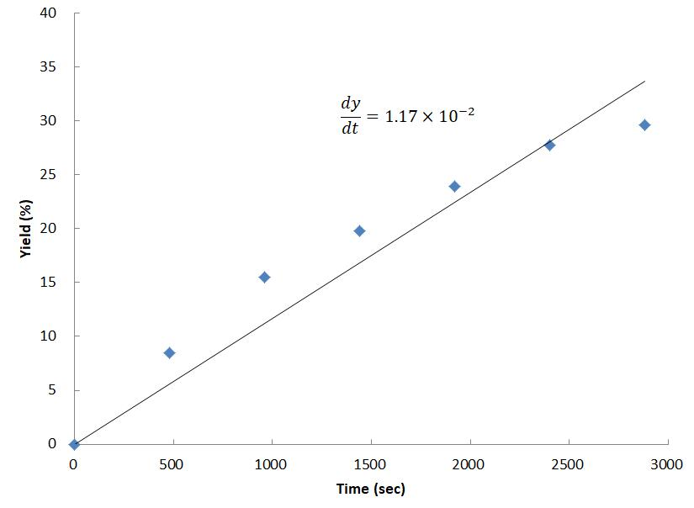
The reaction quantum yield (Φ) was determined with the following formula:
$$Φ=\frac{\text{mole of product formation rate}}{\text{photon flux} ×f}$$
Where, f is the fraction of light absorbed at λ_{max} = 452 nm by the reaction mixture. An absorption spectrum gave an A(452 nm) value of 0.3449, indicating that the fraction of absorbed light (f) is 0.5480.
$$Φ=\frac{\text{2.34}\text{×}{10}^{-8}}{4.481×{10}^{-8}×0.5480}=0.953$$
The reaction quantum yield (Φ) was thus determined to be Φ = 0.953 (95.3%). Thus, a radical chain pathway may be ruled out.

References
- Nicolai, S., Piemontesi, C. & Waser, J. A Palladium-Catalyzed Aminoalkynylation Strategy towards Bicyclic Heterocycles: Synthesis of (±)-Trachelanthamidine. Angew. Chem. Int. Ed. 50, 4680–4683 (2011).
- Cai, G. et al. Pd-Catalyzed C(sp³)–C(sp²) cross-coupling of Y(CH₂SiMe₃)₃ (THF)₂ with vinyl bromides and triflates. Org. Biomol. Chem. 14, 8702–8706 (2016).
- Zhang, G., Bai, R.-X., Li, C.-H., Feng, C.-G. & Lin, G.-Q. Halogenation of 1,1-diarylethylenes by N-halosuccinimides. Tetrahedron 75, 1658–1662 (2019).
- Tripathi, C. B. & Mukherjee, S. Catalytic Enantioselective Iodoetherification of Oximes. Angew. Chem. Int. Ed. 52, 8450–8453 (2013).
- Srikrishna, A. & Hemamalini, P. Chiral synthons from carvone. Part 4. Radical cyclization strategies to bridged systems. Synthesis of bicyclo[3.2.1]octan-3-ones from (S)-carvone. J. Org. Chem. 55, 4883–4887 (1990).
- Spangler, J. E., Kobayashi, Y., Verma, P., Wang, D.-H. & Yu, J.-Q. α-Arylation of Saturated Azacycles and N -Methylamines via Palladium(II)-Catalyzed C(sp³)–H Coupling. J. Am. Chem. Soc. 137, 11876–11879 (2015).
- Jakobsche, C. E., Choudhary, A., Miller, S. J. & Raines, R. T. n → π* Interaction and n )(π Pauli Repulsion Are Antagonistic for Protein Stability. J. Am. Chem. Soc. 132, 6651–6653 (2010).
- Domino, K. et al. Direct Access to Aryl Bis(trifluoromethyl)carbinols from Aryl Bromides or Fluorosulfates: Palladium-Catalyzed Carbonylation. Angew. Chem. Int. Ed. 57, 6858–6862 (2018).
- Paul, S. & Guin, J. Radical C(sp³)–H alkenylation, alkynylation and allylation of ethers and amides enabled by photocatalysis. Green Chem. 19, 2530–2534 (2017).
- Zhang, J., Li, P. & Wang, L. KOAc-promoted alkynylation of α-C–H bonds of ethers with alkynyl bromides under transition-metal-free conditions. Org Biomol Chem 12, 2969–2978 (2014).
- Wu, J.-J. et al. Copper-Catalyzed Carbamoylation of Terminal Alkynes with Formamides via Cross-Dehydrogenative Coupling. ACS Catal. 6, 1263–1267 (2016).
- Zhang, R.-Y. et al. Metal-free alkynylation of α-C–H bonds of ethers with ethynylbenziodoxolones. RSC Adv 4, 54349–54353 (2014).
- Gong, J. & Fuchs, P. L. Alkynylation of C−H Bonds via Reaction with Acetylenic Triflones ¹. J. Am. Chem. Soc. 118, 4486–4487 (1996).
- Uenoyama, Y. et al. Trifluoromethyl-Radical-Mediated Carbonylation of Alkanes Leading to Ethynyl Ketones. Helv. Chim. Acta 89, 2483–2494 (2006).
- Kong, D.-L. et al. A metal-free yne-addition/1,4-aryl migration/decarboxylation cascade reaction of alkynoates with C_{sp3}–H centers. Org. Biomol. Chem. 14, 2210–2217 (2016).
- Yan, H. et al. Functionalization of Amides via Copper-Catalyzed Oxyalkylation of Vinylarenes and Decarboxylative Alkenylation of sp³ C–H. J. Org. Chem. 79, 7103–7111 (2014).
- Hatchard, C. G. & Parker, C. A. A new sensitive chemical actinometer - II. Potassium ferrioxalate as a standard chemical actinometer. Proc. R. Soc. Lond. Ser. Math. Phys. Sci. 235, 518–536 (1956).
- Cismesia, M. A. & Yoon, T. P. Characterizing chain processes in visible light photoredox catalysis. Chem. Sci. 6, 5426–5434 (2015).

NMR Spectra
Supplementary Figure 5. Compound 3 ¹H NMR
Supplementary Figure 6. Compound 3 ¹³C NMR
Supplementary Figure 7.Compound 4 ¹H NMR
Supplementary Figure 8.Compound 4 ¹³C NMR
Supplementary Figure 9. Compound 5 ¹H NMR
Supplementary Figure 10. Compound 5 ¹³C NMR
Supplementary Figure 11. Compound 6 ¹H NMR
Supplementary Figure 12. Compound 6 ¹³C NMR
Supplementary Figure 13. Compound 7 ¹H NMR
Supplementary Figure 14. Compound 7 ¹³C NMR
Supplementary Figure 15. Compound 8 ¹H NMR
Supplementary Figure 16. Compound 8 ¹³C NMR
Supplementary Figure 17. Compound 9 ¹H NMR
Supplementary Figure 18. Compound 9 ¹³C NMR
Supplementary Figure 19. Compound 10 ¹H NMR
Supplementary Figure 20. Compound 10 ¹³C NMR
Supplementary Figure 21. Compound 11 ¹H NMR
Supplementary Figure 22. Compound 11 ¹³C NMR
Supplementary Figure 23. Compound 12 ¹H NMR
Supplementary Figure 24. Compound 12 ¹³C NMR
Supplementary Figure 25. Compound 12 ³¹P NMR
Supplementary Figure 26. Compound 13 ¹H NMR
Supplementary Figure 27. Compound 13 ¹³C NMR
Supplementary Figure 28. Compound 14 ¹H NMR
Supplementary Figure 29. Compound 14 ¹³C NMR
Supplementary Figure 30. Compound 15 ¹H NMR
Supplementary Figure 31. Compound 15 ¹³C NMR
Supplementary Figure 32. Compound 16 ¹H NMR
Supplementary Figure 33. Compound 16 ¹³C NMR
Supplementary Figure 34. Compound 17 ¹H NMR
Supplementary Figure 35. Compound 17 ¹³C NMR
Supplementary Figure 36. Compound 18 ¹H NMR
Supplementary Figure 37. Compound 18 ¹³C NMR
Supplementary Figure 38. Compound 19 ¹H NMR
Supplementary Figure 39. Compound 19 ¹³C NMR
Supplementary Figure 40. Compound 20 ¹H NMR
Supplementary Figure 41. Compound 20 ¹³C NMR
Supplementary Figure 42. Compound 21 ¹H NMR
Supplementary Figure 43. Compound 21 ¹³C NMR
Supplementary Figure 44. Compound 22 ¹H NMR
Supplementary Figure 45. Compound 22 ¹³C NMR
Supplementary Figure 46. Compound 23 ¹H NMR
Supplementary Figure 47. Compound 23 ¹³C NMR
Supplementary Figure 48. Compound 24 ¹H NMR
Supplementary Figure 49. Compound 24 ¹³C NMR
Supplementary Figure 50. Compound 24 ¹⁹F NMR
Supplementary Figure 51. Compound 25 ¹H NMR
Supplementary Figure 52. Compound 25 ¹³C NMR
Supplementary Figure 53. Compound 26 ¹H NMR
Supplementary Figure 54. Compound 26 ¹³C NMR
Supplementary Figure 55. Compound 27 ¹H NMR
Supplementary Figure 56. Compound 27 ¹³C NMR
Supplementary Figure 57. Compound 28 ¹H NMR
Supplementary Figure 58. Compound 28 ¹³C NMR
Supplementary Figure 59. Compound 29 ¹H NMR
Supplementary Figure 60. Compound 29 ¹³C NMR
Supplementary Figure 61. Compound 30 ¹H NMR
Supplementary Figure 62. Compound 30 ¹³C NMR
Supplementary Figure 63. Compound 31 ¹H NMR
Supplementary Figure 64. Compound 31 ¹³C NMR
Supplementary Figure 65. Compound 31 ¹⁹F NMR
Supplementary Figure 66. Compound 32 ¹H NMR
Supplementary Figure 67. Compound 32 ¹³C NMR
Supplementary Figure 68. Compound 33 ¹H NMR
Supplementary Figure 69. Compound 33 ¹³C NMR
Supplementary Figure 70. Compound 34 ¹H NMR
Supplementary Figure 71. Compound 34 ¹³C NMR
Supplementary Figure 72. Compound 34 ¹⁹F NMR
Supplementary Figure 73. Compound 35 ¹H NMR
Supplementary Figure 74. Compound 35 ¹³C NMR
Supplementary Figure 75. Compound 36 ¹H NMR
Supplementary Figure 76. Compound 36 ¹³C NMR
Supplementary Figure 77. Compound 37 ¹H NMR
Supplementary Figure 78. Compound 37 ¹³C NMR
Supplementary Figure 79. Compound 38 ¹H NMR
Supplementary Figure 80. Compound 38 ¹³C NMR
Supplementary Figure 81. Compound 39 ¹H NMR
Supplementary Figure 82. Compound 39 ¹³C NMR
Supplementary Figure 83. Compound 40 ¹H NMR
Supplementary Figure 84. Compound 40 ¹³C NMR
Supplementary Figure 85. Compound 41 ¹H NMR
Supplementary Figure 86. Compound 41 ¹³C NMR
Supplementary Figure 87. Compound 42 ¹H NMR
Supplementary Figure 88. Compound 42 ¹³C NMR
Supplementary Figure 89. Compound 43 ¹H NMR
Supplementary Figure 90. Compound 43 ¹³C NMR
Supplementary Figure 91. Compound 47 ¹H NMR
Supplementary Figure 92. Compound 47 ¹³C NMR

