Appendix A. Teacher interview guide
- How do you understand Assessment?
- What assessment tools do you use to rank them?
- When you are grading your student, what kind(s) of feedback do you find to be the most helpful?
Appendix B. TAP Survey Questionnaire Reliability
Case Processing Summary
 |  | N | %
Cases | Valid | 42 | 100.0
Cases | Excluded ª | 0 | .0
Cases | Total | 42 | 100.0
a. Listwise deletion based on all variables in the procedure.

Reliability Statistics
Cronbach's Alpha | Cronbach's Alpha Based on Standardized Items | N of Items
.736 | .710 | 20

Appendix C: Permission Letter to Conduct the Study
Approval Letters/Documents

Approval from the Ministry of Basic, Higher and Technical Education (MBHTE)

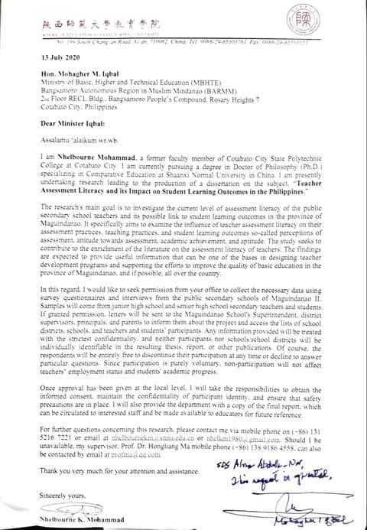

Approval from the Provincial Superintendent Office of Maguindanao II

