Supplementary Information

[(EtO)₃Si(CH₂)₃NH₃⁺][CH₃COO⁻] functionalized on magnetic silica: a novel magnetically recyclable nanocatalyst for synthesis of new (phenylsulfonyl)dihydropyrido[2,3-d]pyrimidine derivatives
Farhad Shirzaei, Hamid Reza Shaterian*

Department of Chemistry, Faculty of Science, University of Sistan and Baluchestan, PO Box:987-98155, Postal Code: 98197-45845, Zahedan, Iran Tel: 0098-54-33447010, Fax: 0098-54-33431067; E-mail: hrshaterian@chem.usb.ac.ir

Title Page.................................................................................................................................S1
Preparation of Fe₃O₄@SiO₂.....................................................................................................S2
Preparation and characterization of Fe₃O₄@SiO₂@[(CH₂)₃NH₃⁺][CH₃COO⁻]...................... S3
General Experimental Details..................................................................................................S9
FT-IR, spectra of compounds 4A……...................................................................................S10
FT-IR, ¹H NMR and ¹³C NMR spectra of compounds 4B....................................................S11
FT-IR, 4C-4H.................................................................................................................S13-S18
FT-IR, ¹H NMR and ¹³C NMR spectra of compounds 4I......................................................S19
FT-IR, ¹H NMR and ¹³C NMR spectra of compounds 4J.....................................................S21
FT-IR, ¹H NMR and ¹³C NMR spectra of compounds 4K....................................................S23
FT-IR, ¹H NMR and ¹³C NMR spectra of compounds 4L.....................................................S25
FT-IR, ¹H NMR and ¹³C NMR spectra of compounds 4M...................................................S27
FT-IR, 4N-4O.................................................................................................................S29-S30
FT-IR, ¹H NMR and ¹³C NMR spectra of compounds 4P.....................................................S31

1. Preparation of Fe₃O₄@SiO₂
Fe₃O₄ magnetic nanoparticles were prepared by dissolving FeCl₃·6H₂O (20 mmol) and FeCl₂·4H₂O (10 mmol) in deionized H₂O (100 mL) with vigorous stirring (800 rpm), and then dropwise adding NH₄OH (25% aq, 30 mL) at room temperature until the pH increased to 11. The resulting black dispersion was continuously stirred for 1h at room temperature, and then the mixture was refluxed for 1h. EtOH (40 mL) was added to the nanoparticles and the mixture was heated for 1 h at 40 °C. Tetraethyl orthosilicate (10 mL) was then added and the mixture was continuously stirred for 24 h. The silica-coated nanoparticles were collected by using an external magnet, washed with EtOH and Et₂O (2×5 mL), and then dried in a vacuum at 100 °C for 12 h
Fe₃O₄. IR (KBr) (ν_{max}/cm⁻¹): 3391, 2923, 1622, 1020, 586.
Fe₃O₄@SiO₂. IR (KBr) (ν_{max}/cm⁻¹): 3416, 1618, 1095, 954, 800, 632, 471.
2. Preparation and characterization of Fe₃O₄@SiO₂@[(CH₂)₃NH₃⁺][CH₃COO⁻]
In a two-necked flask equipped with a dropping funnel and reflux condenser in the ice bath, APTES ((3-aminopropyl) triethoxy silane) (30 mmol) was added. Then, acetic acid (30 mmol) added dropwise to the flask slowly. Stirring was continued at room temperature for 24 hours. After 24 h, ionic liquid [(EtO)₃Si(CH₂)₃NH₃⁺][CH₃COO⁻] was obtained as a yellow viscous liquid. The ionic liquid [(EtO)₃Si(CH₂)₃NH₃⁺][CH₃COO⁻] can be stored for 6 months without any decomposition. [(EtO)₃Si(CH₂)₃NH₃⁺][CH₃COO⁻] (6.0 g) was added to Fe₃O₄@SiO₂ (3.0 g) nanoparticles at room temperature in about 15 minutes. The mixture was then refluxed in toluene (30 mL) as solvent for 24 hours. Finally, Fe₃O₄@SiO₂@[(CH₂)₃NH₃⁺][CH₃COO⁻] nanoparticles were separated using an external magnet. Then nanoparticles first washed with toluene (2×3 mL), and then washed with EtOH (2×5 mL), subsequently, nanoparticles dried at 80 °C for 6 h in an oven.
[(EtO)₃Si(CH₂)₃N⁺H₃][CH₃COO⁻]. Yellow oil. IR (KBr) (νmax/cm⁻¹): 2974, 2920, 2174, 1888, 1710, 1617, 1569, 1403, 1334, 1295, 1225, 1166, 1079, 1007, 964, 885, 774, 650, 617, 498, 1H NMR (300 MHz, DMSO-d₆): δH (ppm) 1.06 (9H, t, J=6.9 Hz, CH₃), 1.75 (3H, s, CH₃), 1.79 (2H, s, CH₂), 2.73 (2H, s, CH₂), 3.45 (6H, q, J1=7.2 Hz, J2=6.91 Hz, CH₂), 3.75 (2H, t, J=3.6 Hz, CH₂), 7.26 (3H, s, NH₃), 13C NMR (75 MHz, DMSO-d₆): δC (ppm) 18.39, 18.49, 18.81, 24.26, 41.78, 56.45, 175.51.
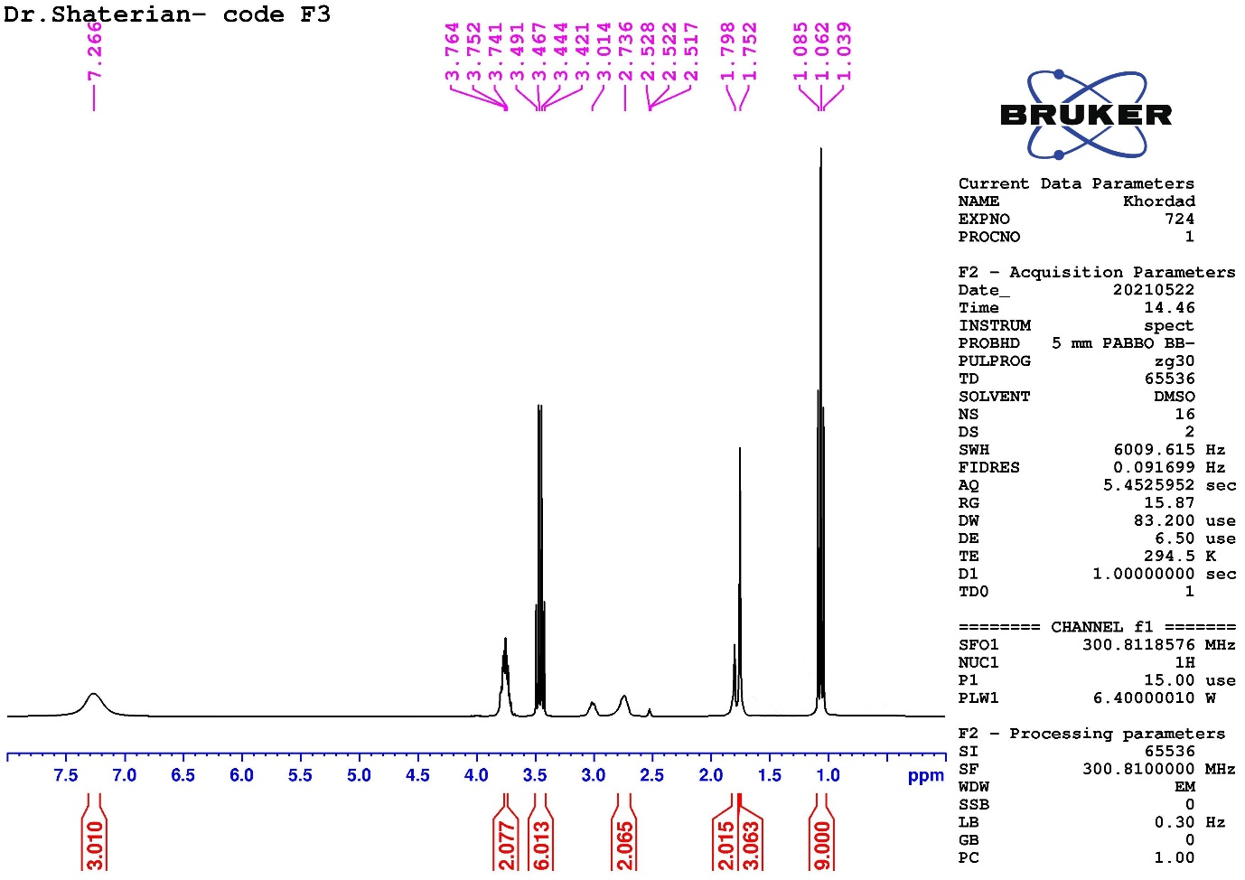

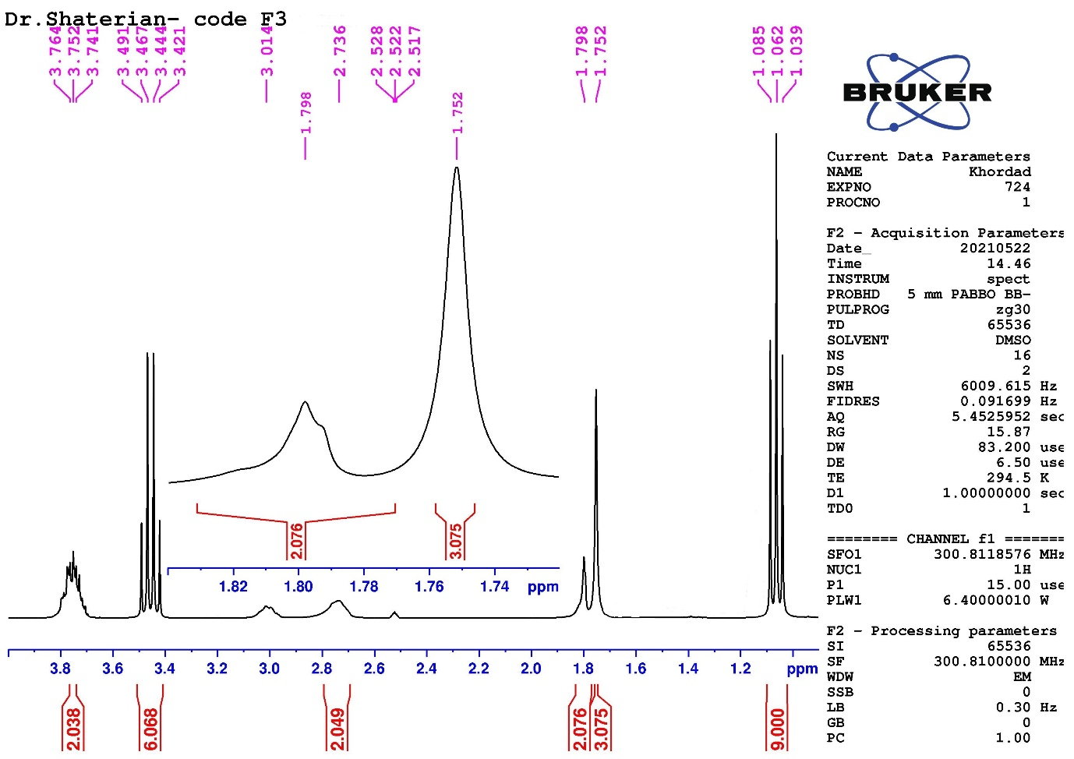

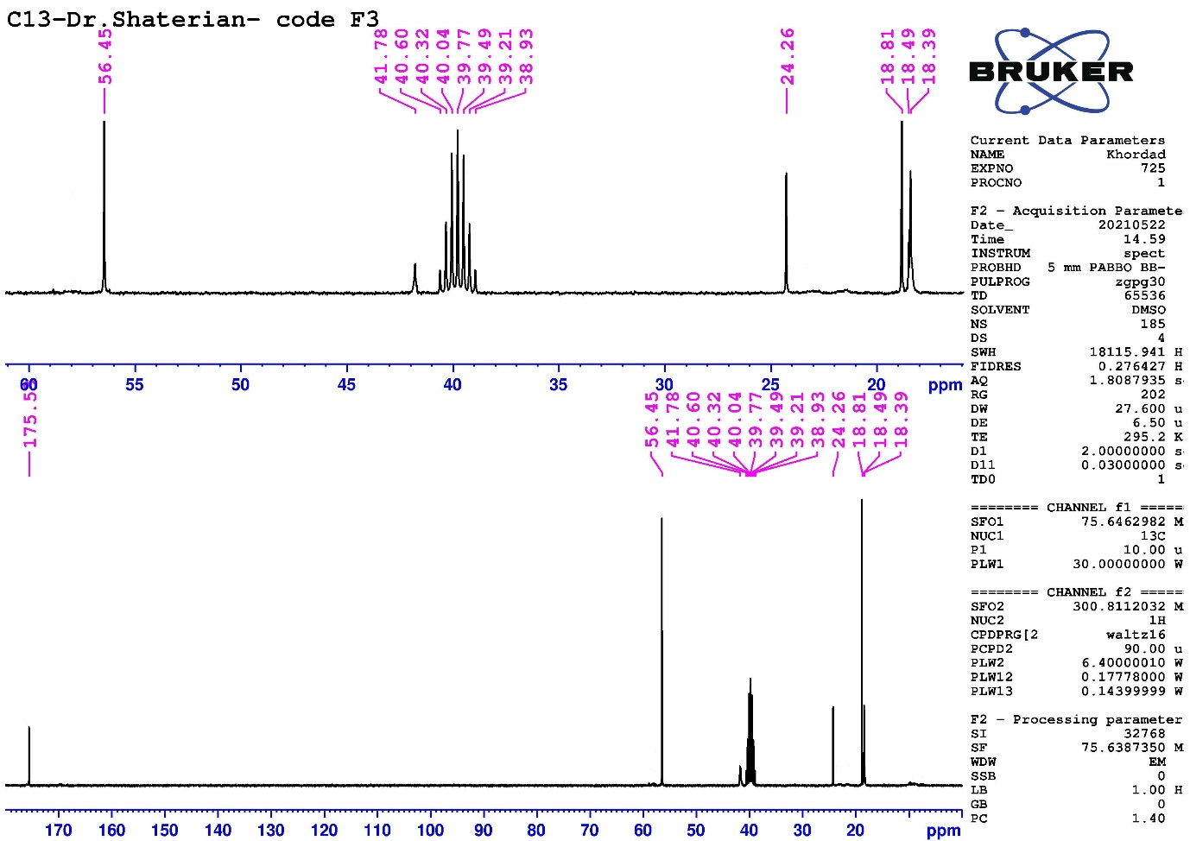

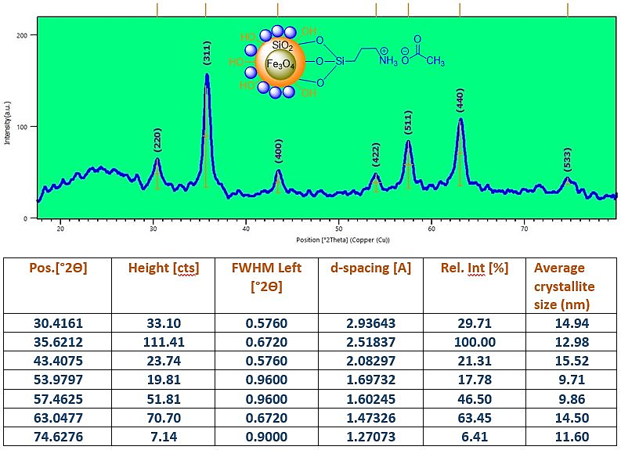
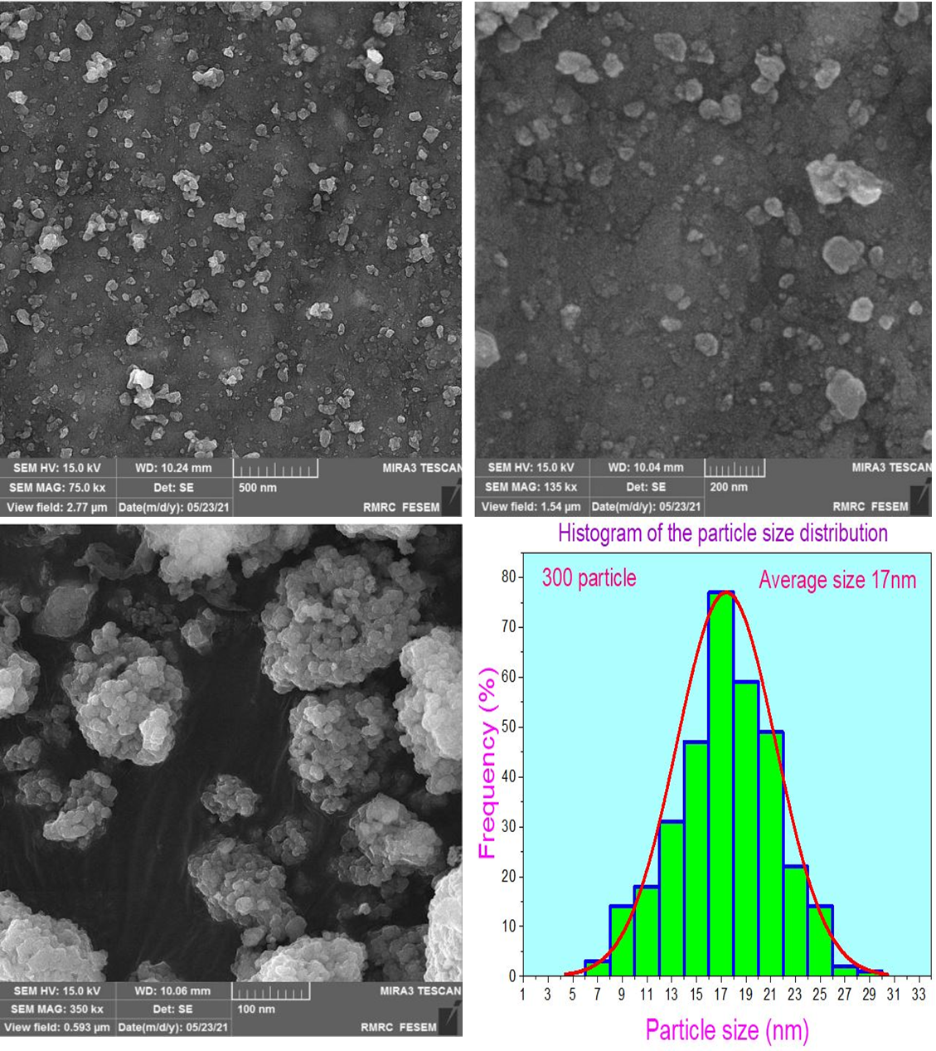
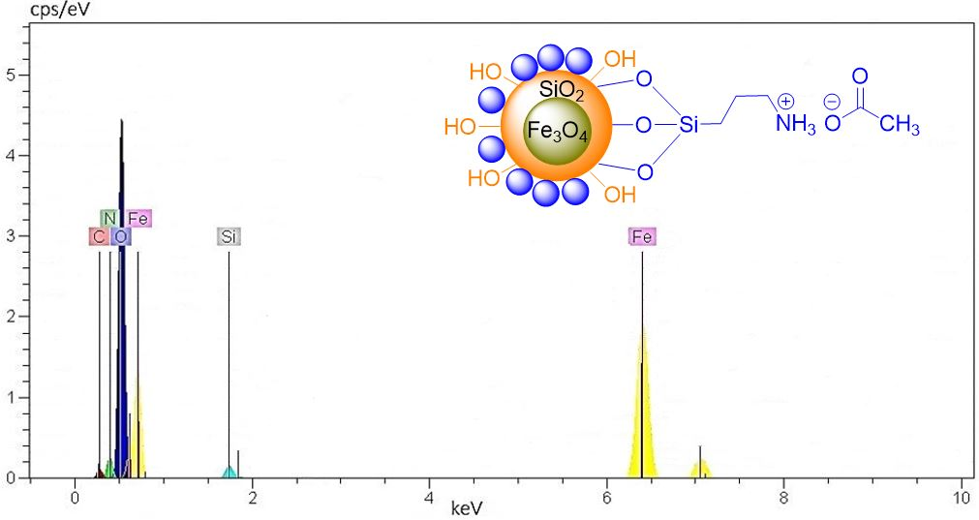
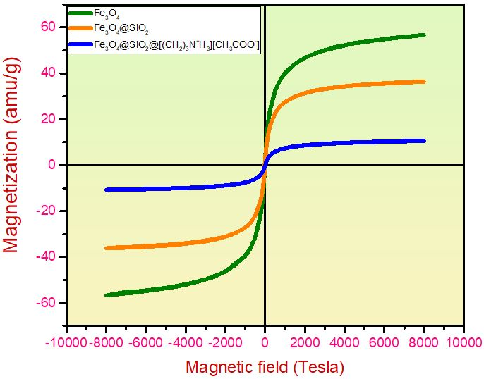
General procedure for the synthesis of (phenylsulfonyl)dihydropyrido[2,3-d]pyrimidine derivatives over Fe₃O₄@SiO₂@[(CH₂)₃NH₃⁺][CH₃COO⁻] and ionic liquid [(EtO)₃Si(CH₂)₃NH₃⁺][CH₃COO⁻] catalysts.
In a 50 mL round bottom flask, added Arylaldehydes (1 mmol), Benzenesulfonylacetonitrile (1 mmol), 6-Amino-1,3-dimethyluracil (1 mmol), and nanocatalyst Fe₃O₄@SiO₂@[(CH₂)₃NH₃⁺][CH₃COO⁻] 0.015 g were stirred under stirring in ethanol as solvent (3 mL) conditions at reflux for the specific time. TLC monitored the progress of the reaction (ethyl acetate / petroleum benzene: 3 / 1). The solid crude product was separated easily. Fe₃O₄@SiO₂@[(CH₂)₃NH₃⁺][CH₃COO⁻] was separated by an external magnet after adding sufficient ethanol to the solid and heat mixture. The nanocatalyst was dried after three washing with ethanol. The hot ethanol solution containing the crude product was cooled to precipitate the pure product.
In a 50 mL round bottom flask, added arylaldehydes (1 mmol), benzenesulfonylacetonitrile (1 mmol), 6-Amino-1,3-dimethyluracil (1 mmol), and [(EtO)₃Si(CH₂)₃NH₃⁺][CH₃COO⁻] 30 mol% were added under stirring in ethanol as solvent (3 mL) conditions at reflux for the specific time. TLC monitored the progress of the reaction (ethyl acetate / petroleum benzene: 3 / 1). After completion of the reaction, the mixture was cooled, the ionic liquid was dissolved in ethanol but the desired product was precipitated in ethanol. The ethanolic solution containing the ionic liquid as catalyst was separated from solid crude product, and the resulting solid crude product was subsequently recrystallized in ethanol to give the final pure solid desired product. The products were identified by FT-IR, ¹H NMR and ¹³CNMR spectroscopy.

7-Amino-1,3-dimethyl-5-phenyl-6-(phenylsulfonyl)-6,8a-dihydropyrido[2,3-d]pyrimidine-2,4-(1H,3H)-dione (4A), M.p: >280 °C.; IR (KBr) (ν_{max}/cm⁻¹): 3417, 3350, 1653, 1626 , 1567, 1490, 1445, 1370, 1273, 1263, 1192, 1137, 1110, 1091, 1063, 1038, 1021, 945, 877, 811, 772, 754, 696, 686, 638, 625, 576, 517.
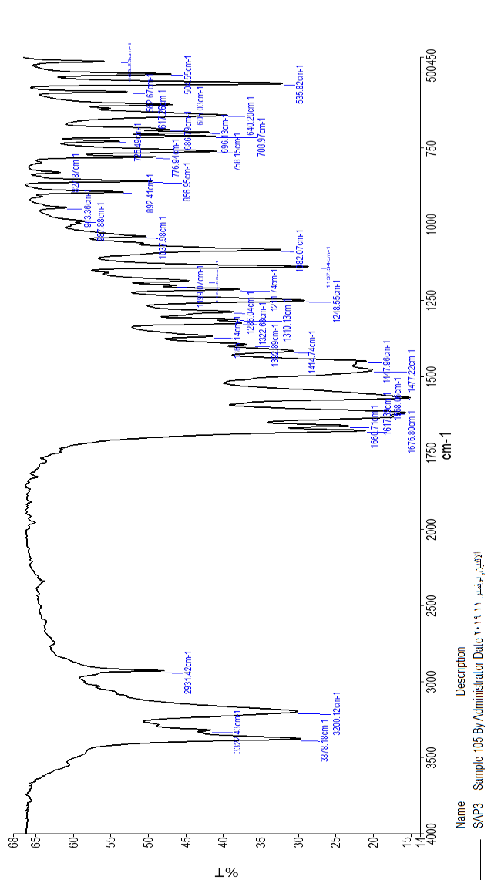

7-Amino-1,3-dimethyl-5-(2-nitrophenyl)-6-(phenylsulfonyl)-6,8a-dihydropyrido[2,3-d]pyrimidine-2,4-(1H,3H)-dione (4B), M.p: >280 °C.; IR (KBr) (ν_{max}/cm⁻¹): 3621, 3478, 3380, 3317, 3227, 3066, 2925, 1683, 1638, 1586, 1530, 1475, 1446, 1407, 1348, 1313, 1279, 1243, 1216, 1175, 1078, 1020, 986, 947, 915, 874, 863, 809, 778, 754, 705, 686, 648, 627, 609, 584, 534, 486, 475.; ¹HNMR (300 MHz, DMSO-d₆): δ_{H} (ppm) 2.9 (3H, s, CH₃), 3.0 (3H, s, CH₃), 4.5 (1H, s, C-H), 5.0 (1H, s, C-H), 7.0 (1H, d, J = 7.2 H_{Z}, Ar-H), 7.5-7.7 (7H, m, Ar-H), 8.0 (1H, d, J = 7.5 H_{Z}, Ar-H), 8.4 (1H, s, NH₂), 8.8 (1H, s, NH₂); ¹³CNMR (75 MHz, DMSO-d₆): δ_{C} (ppm) 27.6, 29.6, 32.5, 39.1, 39.4, 39.7, 40.0, 40.2, 40.5, 40.8, 66.8, 87.6, 125.2, 129.0, 129.2, 129.7, 129.8, 133.5, 134.3, 134.8, 136.8, 148.8, 151.4, 154.7, 159.6, 160.8.
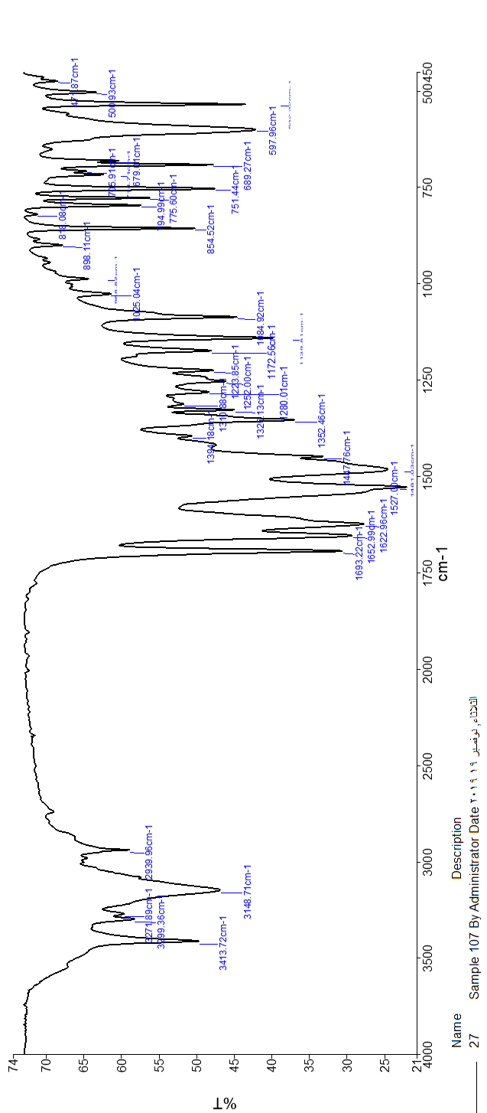
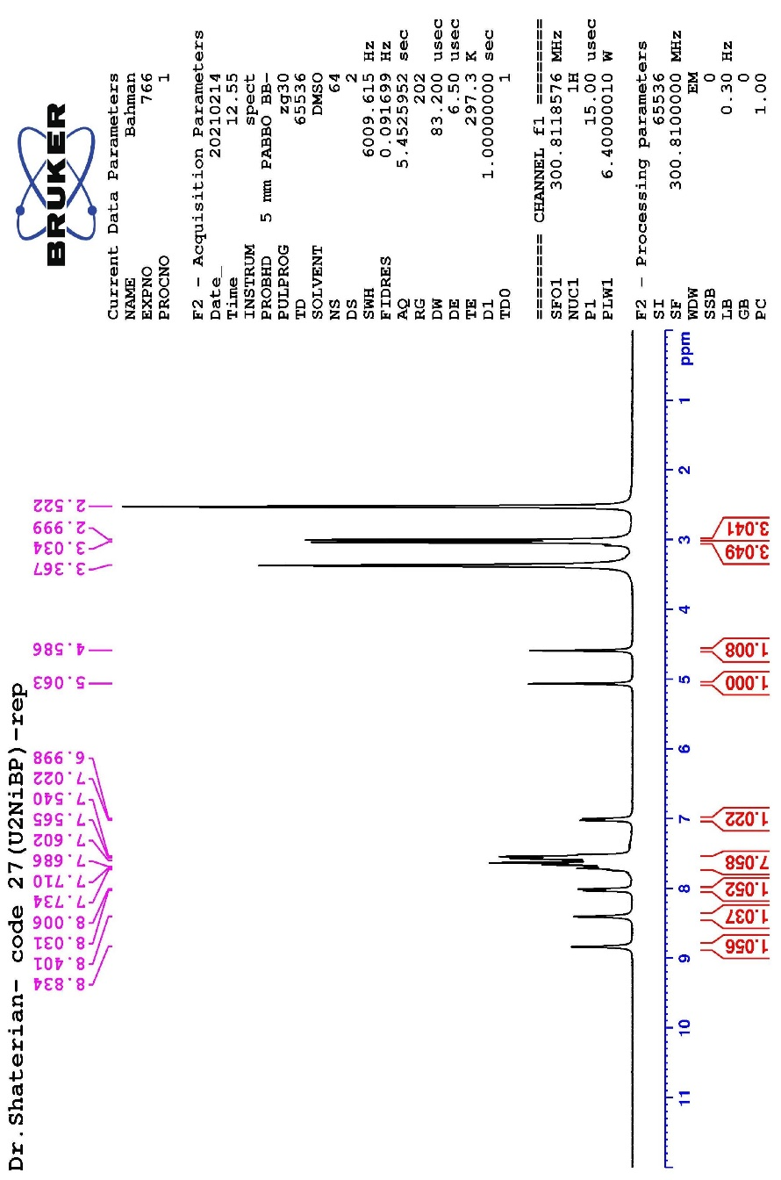
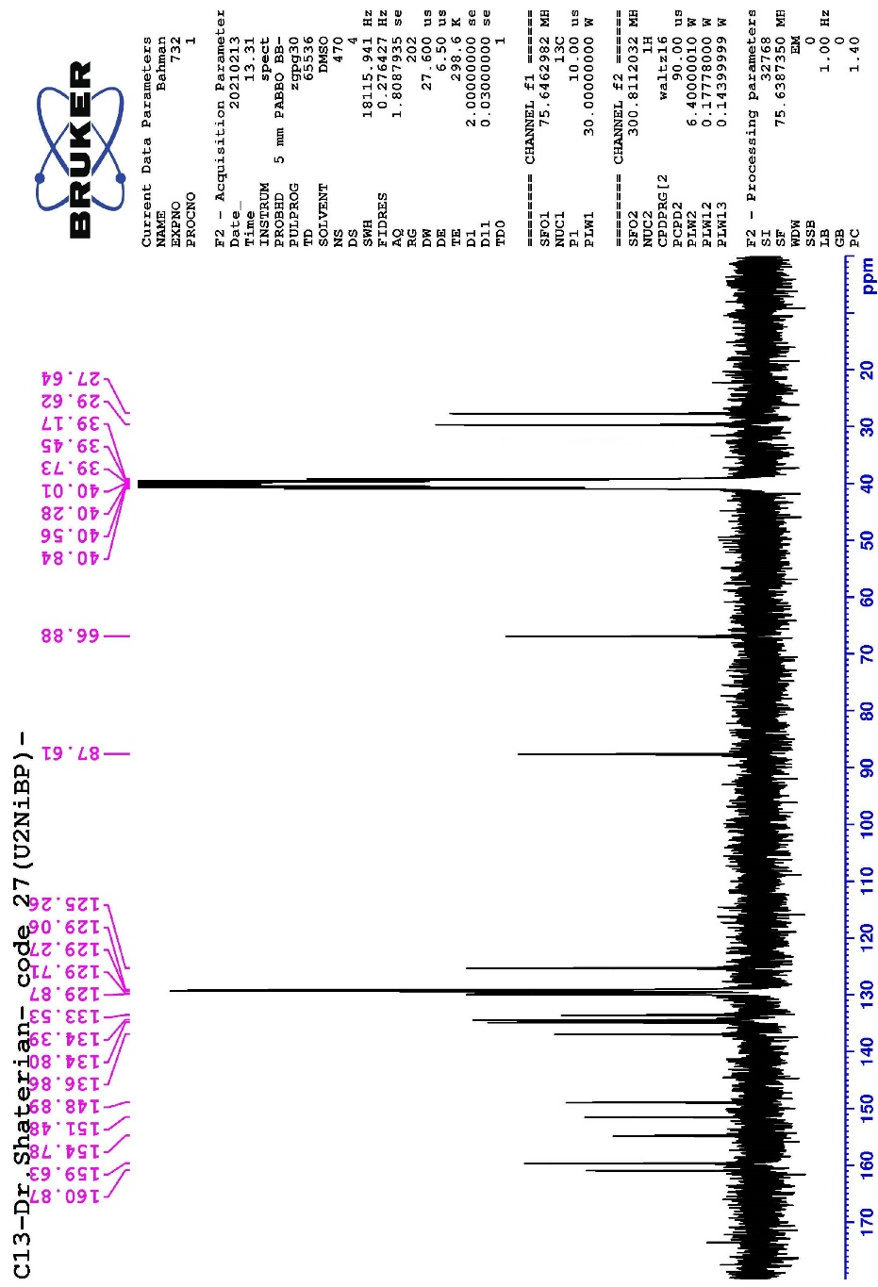

7-Amino-1,3-dimethyl-5-(3-nitrophenyl)-6-(phenylsulfonyl)-6,8a-dihydropyrido[2,3-d]pyrimidine-2,4-(1H,3H)-dione (4C), M.p: >280 °C.; IR (KBr) (ν_{max}/cm⁻¹): 3413, 3299, 3271, 3148, 2939, 1693, 1652, 1622, 1527, 1491, 1447, 1394, 1352, 1326, 1280, 1252, 1223, 1172, 1084, 1025, 898, 854, 818, 794, 775, 751, 705, 689, 679, 597, 500, 471.
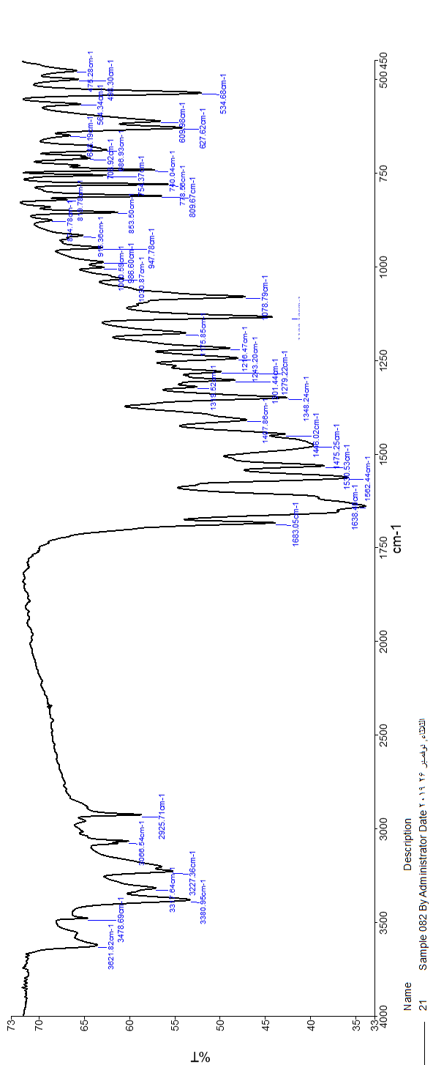

7-Amino-1,3-dimethyl-5-(4-nitrophenyl)-6-(phenylsulfonyl)-6,8a-dihydropyrido[2,3-d]pyrimidine-2,4-(1H,3H)-dione (4D), M.p: 276-277 °C.; IR (KBr) (ν_{max}/cm⁻¹): 3625, 3551, 3431, 3389, 3321, 3088, 2930, 1680, 1668, 1616, 1581, 1555, 1524, 1482, 1446, 1419, 1364, 1371, 1336, 1325, 1309, 1278, 1248, 1218, 1079, 1058, 1055, 1010, 985, 964, 903, 889, 860, 842, 810, 775, 762, 752, 728, 687, 632.

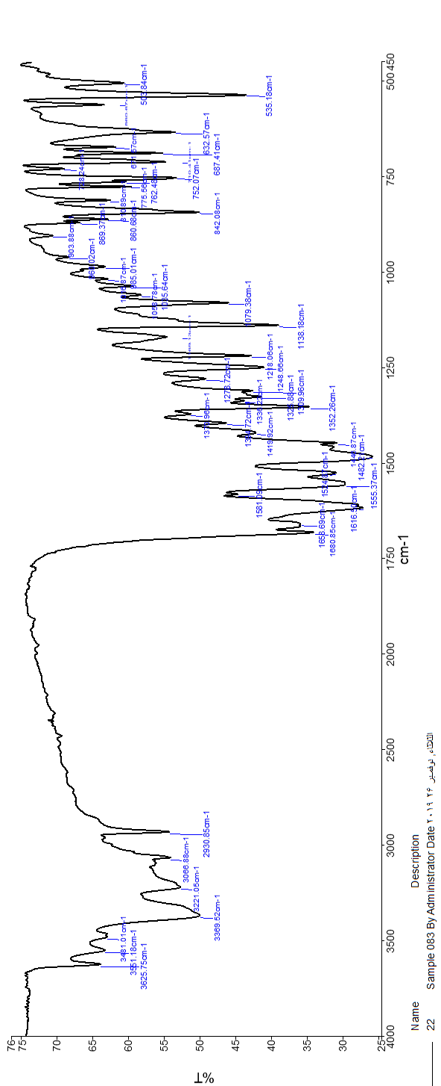

7-Amino-5-(2-chlorophenyl)-1,3-dimethyl-6-(phenylsulfonyl)-4a,7-dihydropyrido[2,3-d]pyrimidine-2,4(1H,3H)-dione (4E), M.p: >280 °C.; IR (KBr) (ν_{max}/cm⁻¹): 3442, 3265, 3137, 2921, 1693, 1675, 1625, 1564, 1476, 1446, 1412, 1365, 1336, 1319, 1309, 1282, 1254, 1243, 1213, 1178, 1138, 1080, 1049, 1030, 968, 891, 851, 818, 773, 755, 708, 688, 644, 608, 574, 557, 535, 449.

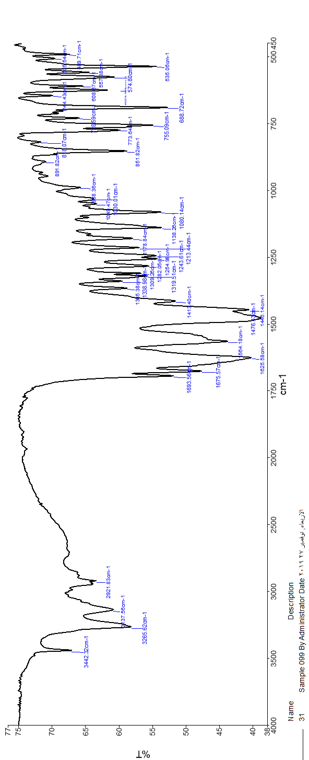

7-Amino-5-(2,6-dichlorophenyl)-1,3-dimethyl-6-(phenylsulfonyl)-6,8a-dihydropyrido[2,3-d]pyrimidine-2,4-(1H,3H)-dione (4F), M.p: >280 °C.; IR (KBr) (ν_{max}/cm⁻¹): 3392, 3223, 3029, 2919, 1682, 1656, 1614, 1557, 1449, 1429, 1346, 1322, 1282, 1244, 1211, 1161, 1081, 858, 826, 708, 567, 479.

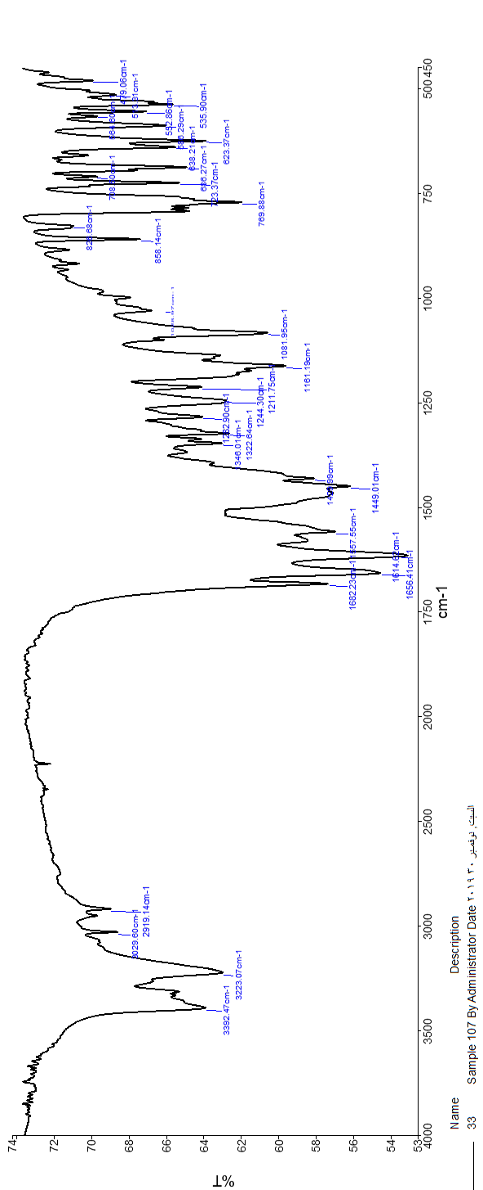

7-Amino-5-(4-chlorophenyl)-1,3-dimethyl-6-(phenylsulfonyl)-6,8a-dihydropyrido[2,3-d]pyrimidine-2,4-(1H,3H)-dione (4G), M.p: >280 °C.; IR (KBr) (ν_{max}/cm⁻¹): 3639, 3376, 3207, 2934, 1168, 1665, 1622, 1581, 1554, 1479, 1446, 1423, 1324, 1307, 1262, 1252, 1215, 1174, 1139, 1081, 1035, 1015, 997, 898, 852, 839, 810, 773, 767, 727, 720, 689, 635, 535, 506, 486, 458.

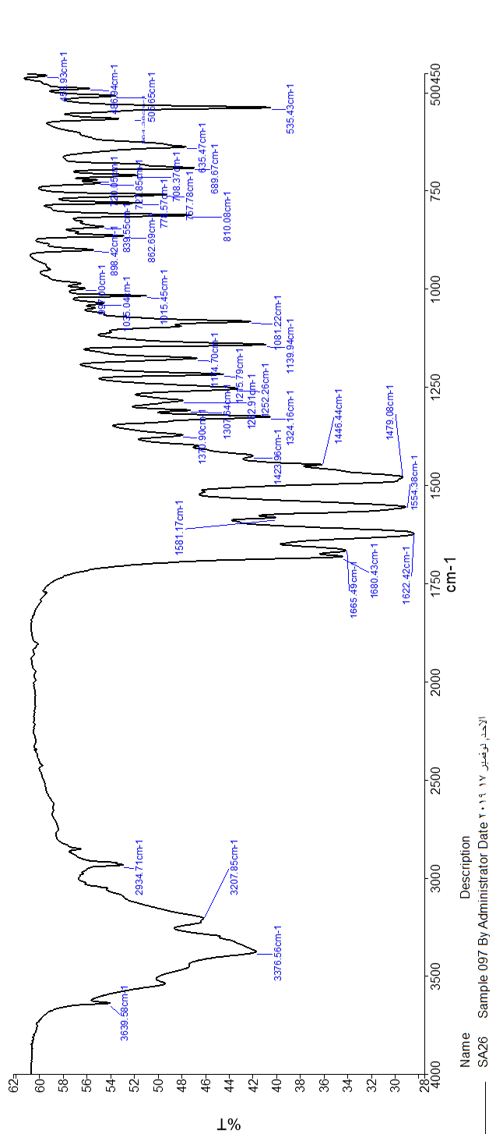

7-Amino-5-(4-bromophenyl)-1,3-dimethyl-6-(phenylsulfonyl)-6,8a-dihydropyrido[2,3-d]pyrimidine-2,4-(1H,3H)-dione (4H), M.p: >280 °C.; IR (KBr) (ν_{max}/cm⁻¹): 3373, 3196, 2935, 1678, 1661, 1622,1570, 1609, 1483, 1448, 1413, 1387, 1324, 1306, 1288, 1249, 1223, 1177, 1138, 1081, 1036, 894, 861, 833, 804, 789, 758, 598, 571, 556, 501, 438.

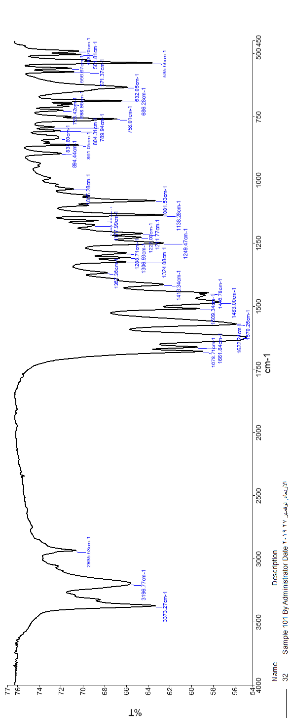

7-Amino-5-(3-hydroxyphenyl)-1,3-dimethyl-6-(phenylsulfonyl)-4a,7-dihydropyrido[2,3-d]pyrimidine-2,4(1H,3H)-dione (4I), M.p: >280 °C.; IR (KBr) (ν_{max}/cm⁻¹): 3639, 3376, 3207, 2934, 1680, 1665, 1622, 1581, 1554, 1479, 1423, 1370, 1262, 1252, 1215, 1174, 1139, 1081, 1035, 1015, 997, 898, 862, 839, 810, 773, 757, 727, 708, 689, 635, 535, 506, 486, 456.; ¹HNMR (300 MHz, DMSO-d₆): δ_{H} (ppm) 3.03 (3H, s, CH₃), 3.04 (3H, s, CH₃), 4.33 (1H, s, C-H), 4.45 (1H, s, C-H), 6.42-6.69 (2H, m, NH₂), 6.47 (1H, dd, J₁ = 6.0 H_{Z}, J₂ = 1.8 H_{Z,} Ar-H), 7.09 (1H, t, J = 7.8 H_{Z}, Ar-H), 7.50-7.55 (2H, m, Ar-H), 7.64-7.71 (3H, m, Ar-H), 8.35 (1H, s, NH₂), 8.72 (1H, s, NH₂); 9.42 (1H, s, OH).; ¹³CNMR (75 MHz, DMSO-d₆): δ_{C} (ppm) 27.61, 29.52, 39.14, 39.41, 39.69, 39.97, 40.25, 40.52, 40.80, 68.07, 87.84, 113.89, 114.82, 117.65, 129.04, 129,09, 130.45, 134.73, 136.50, 141.91, 151.44, 153.48, 158.18, 159.05, 161.07.

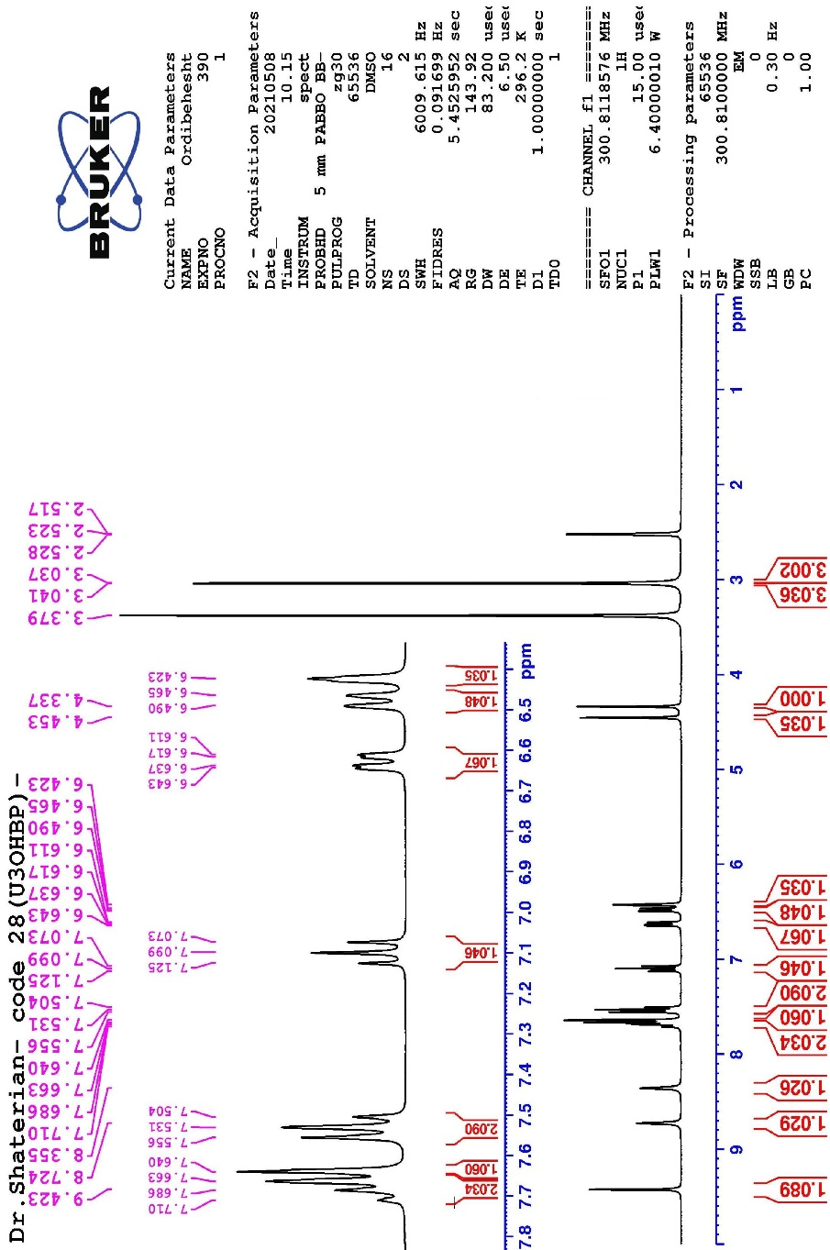
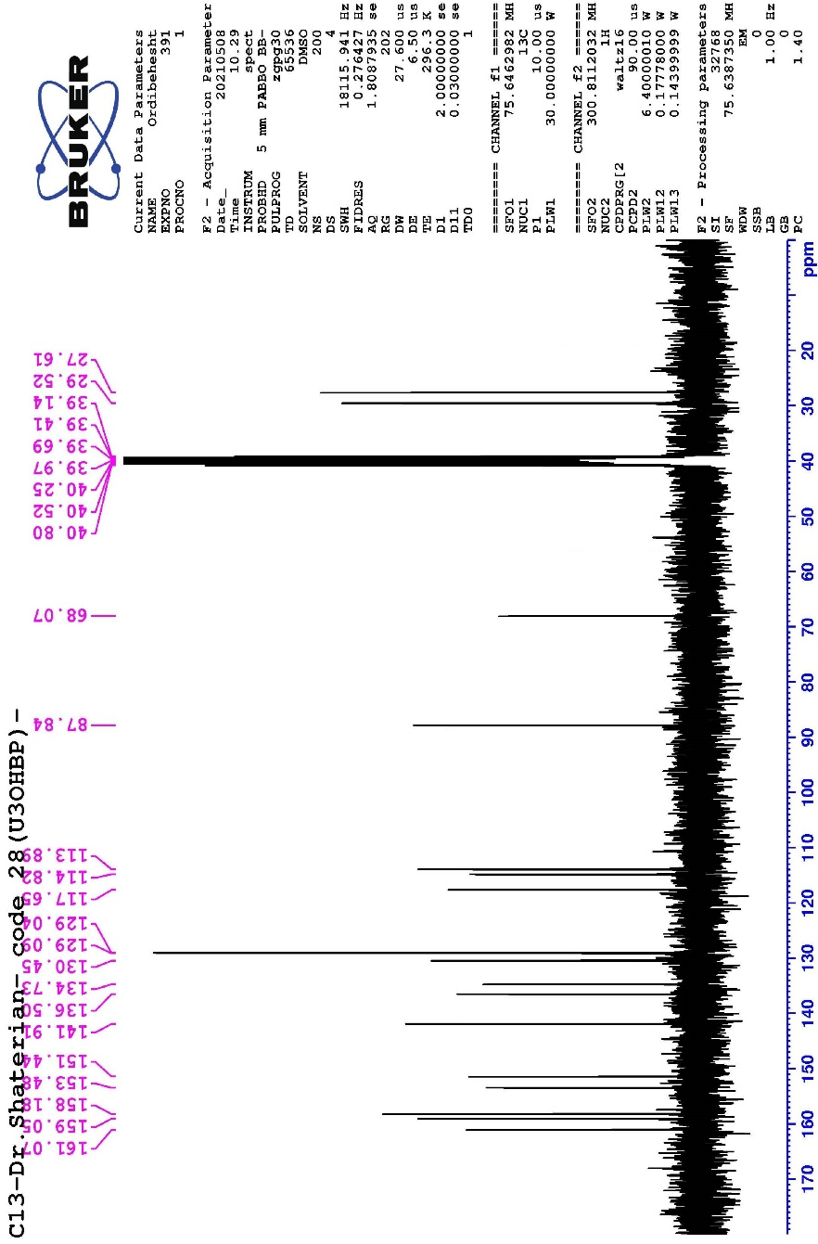

7-Amino-5-(2,3-dimethoxyphenyl)-1,3-dimethyl-6-(phenylsulfonyl)-6,8a-dihydropyrido[2,3-d]pyrimidine-2,4-(1H,3H)-dione (4J), M.p: >280 °C ; IR (KBr) (ν_{max}/cm⁻¹): 3405, 3348, 3238, 3208, 3093, 3001, 2975, 2927, 2828, 1683, 1658, 1641, 1567, 1517, 1479, 1462, 1447, 1430, 1390, 1366, 1320, 1308, 1287, 1266, 1248, 1209, 1180, 1167, 1138, 1070, 1029, 942, 915, 892, 851, 812, 759, 717, 685, 627, 611, 588, 541, 530, 497.; ¹HNMR (300 MHz, DMSO-d₆): δ_{H} (ppm) 0.3 (3H, s, CH₃), 3.1 (3H, s, CH₃), 3.4 (3H, s, CH₃), 3.8 (3H, s, CH₃), 4.3 (1H, s, C-H), 4.9 (1H, s, C-H), 6.2 (2H, d, J = 7.2 H_{Z}, Ar-H), 6.86-6.96 (2H, m, Ar-H), 7.5 (2H, m, Ar-H), 7.7 (3H, m, Ar-H), 8.3 (1H, s, NH₂), 8.6 (1H, s, NH₂).; ¹³CNMR (75 MHz, DMSO-d₆): δ_{C} (ppm) 26.6, 30.8, 39.03, 39.0, 39.3, 39.6, 39.9, 40.1, 40.1, 40.4, 40.7, 56.1, 60.4, 66.9, 87.4, 112.7, 119.3, 124.4, 129.0, 129.2, 133.2, 134.9, 149.1, 151.6, 153.0, 154.3, 159.1, 161.0.

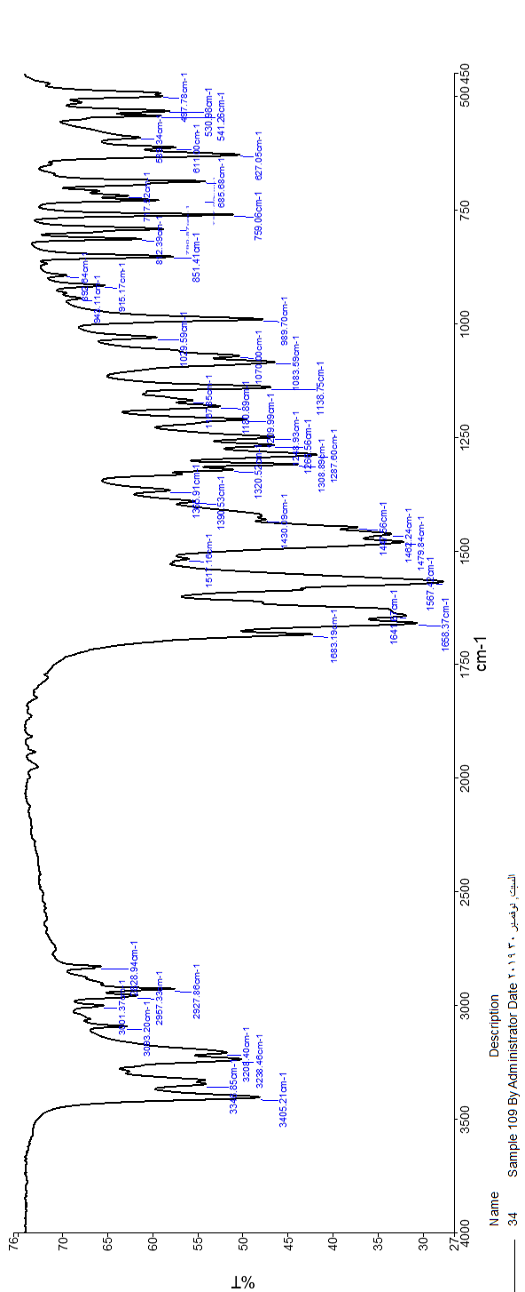
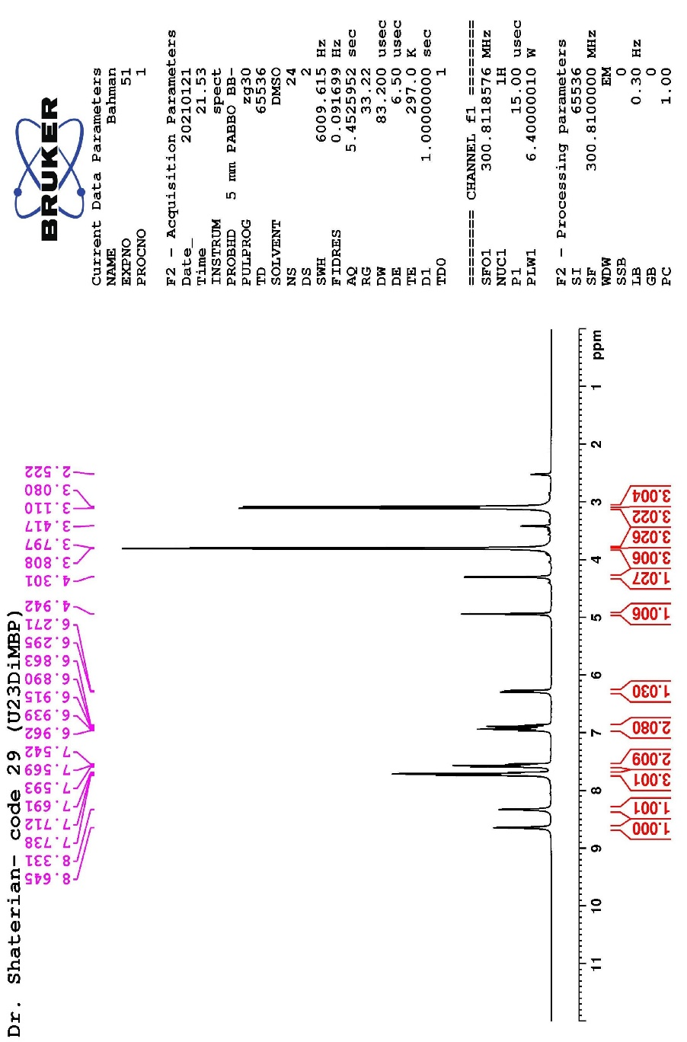
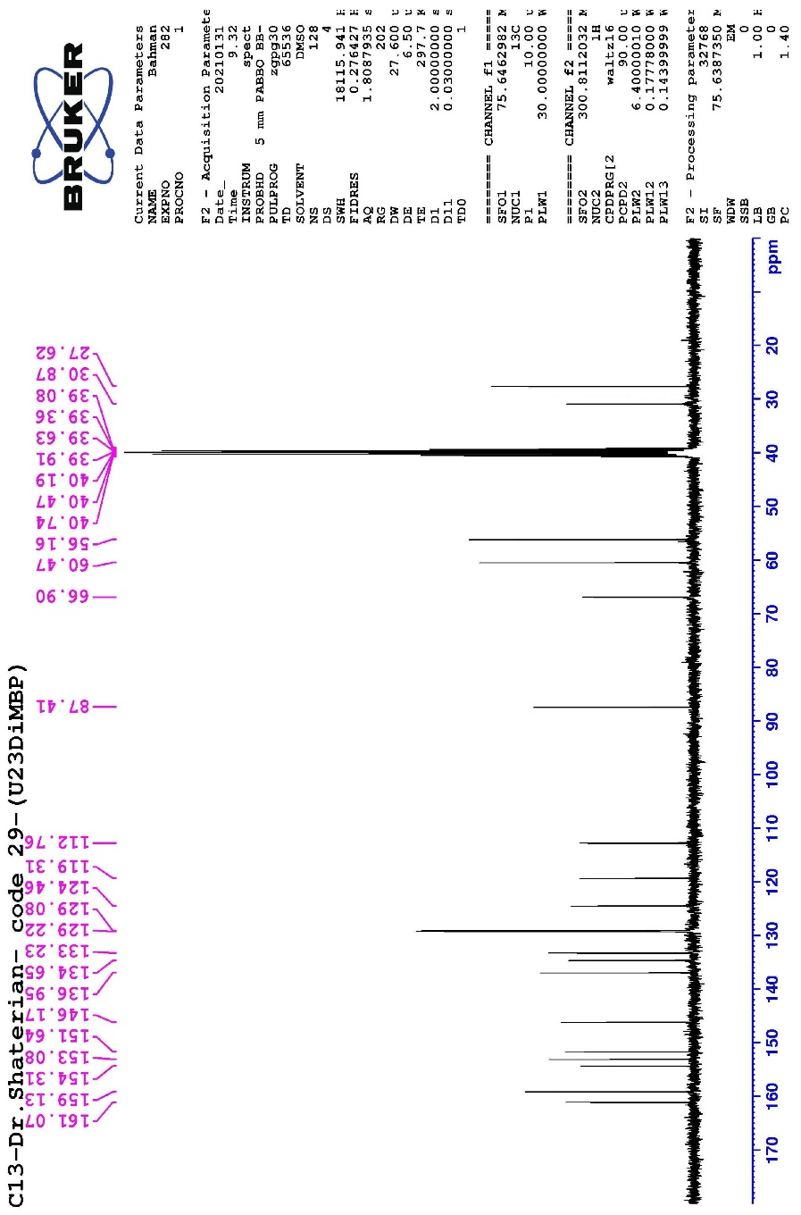

7-Amino-5-(3,4-dimethoxyphenyl)-1,3-dimethyl-6-(phenylsulfonyl)-6,8a-dihydropyrido[2,3-d]pyrimidine-2,4-(1H,3H)-dione (4K), M.p: >280 °C ; IR (KBr) (ν_{max}/cm⁻¹): 3379, 3321, 3234, 3206, 2961, 2934, 2837, 1683, 1633, 1560, 1511, 1443, 1415, 1307, 1235, 1210, 1172, 1134, 1080, 1022, 862, 841, 796, 770, 757, 704, 686, 642, 626, 608, 578, 533, 516, 488, 441, 426, 413.; ¹HNMR (300 MHz, DMSO-d₆): δ_{H} (ppm) 3.02 (3H, s, CH₃), 3.05 (3H, s, CH₃), 3.70 (3H, s, CH₃), 3.73 (3H, s, CH₃), 4.41 (1H, s, C-H), 4.45 (1H, s, C-H), 6.48-6.84 (3H, m, Ar-H), 7.50-7.54 (2H, m, Ar-H), 7.64-7.67 (3H, m, Ar-H), 8.34 (1H, s, NH₂), 8.73 (1H, s, NH₂).; ¹³CNMR (75 MHz, DMSO-d₆): δ_{C} (ppm) 27.62, 29.53, 39.14, 39.41, 39.69, 39.97, 40.25, 40.52, 40.80, 56.00, 68.12, 88.27, 111.00, 112.49, 118.95, 128.98, 129.09, 132.64, 134.66, 136.62, 148.66, 149.44, 151.44, 153.36, 159.23, 161.17.

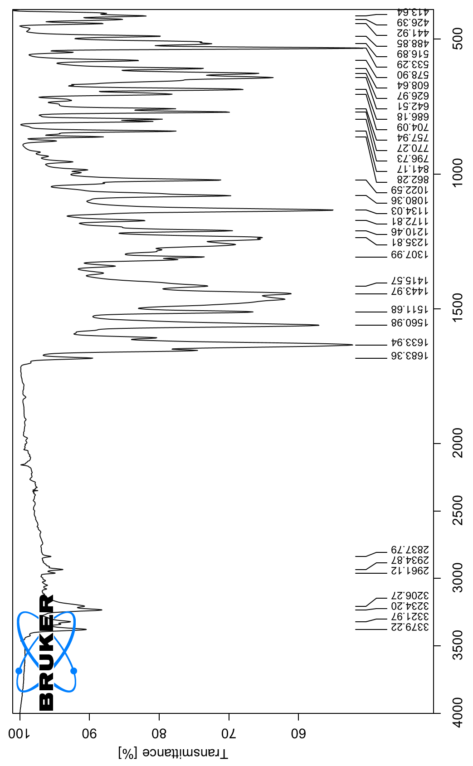
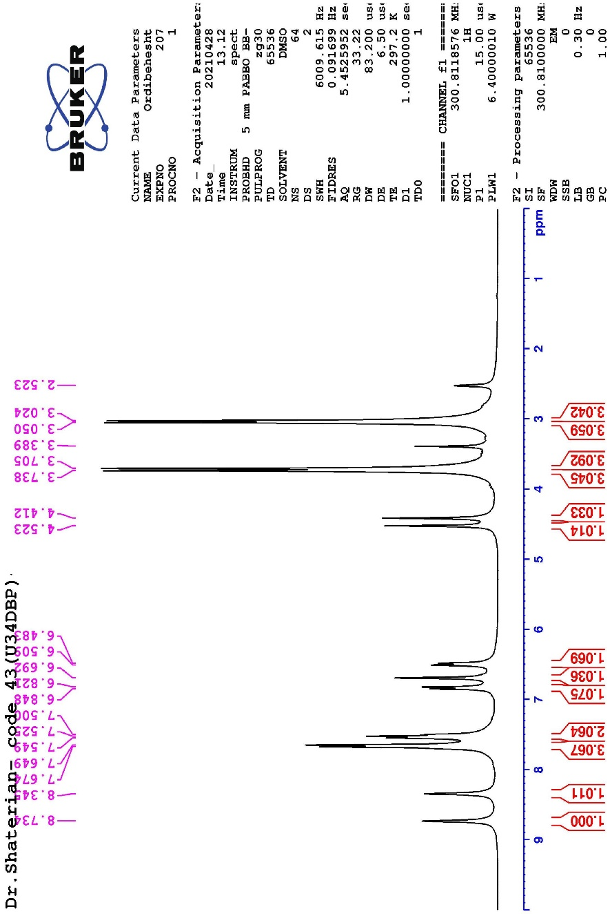
پیوست 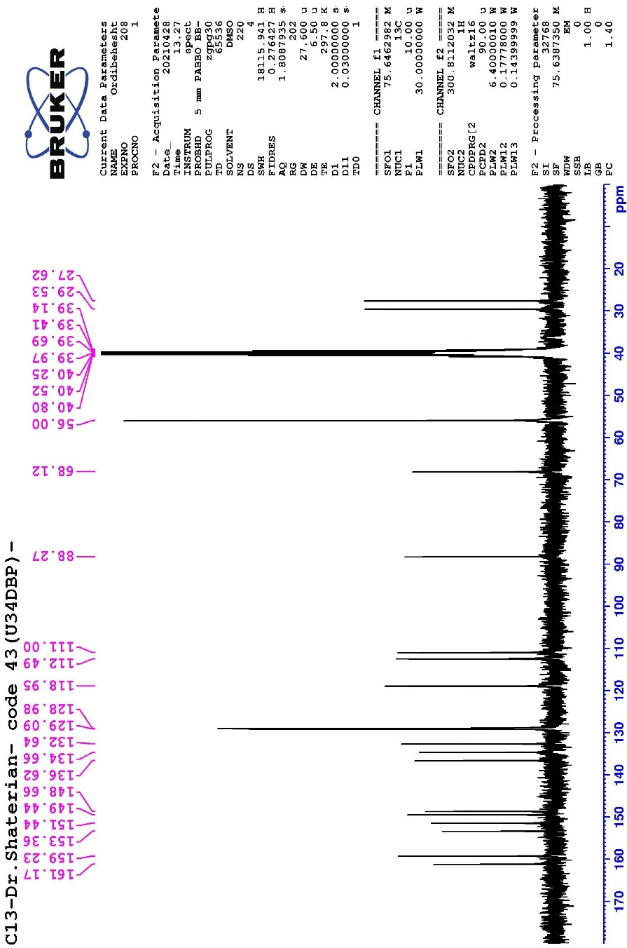

7-Amino-1,3-dimethyl-6-(phenylsulfonyl)-5-(3,4,5-trimethoxyphenyl)-4a,7-dihydropyrido[2,3-d]pyrimidine-2,4(1H,3H)-dione (4L), M.p: >280 °C ; IR (KBr) (ν_{max}/cm⁻¹): 3425, 3313, 3220, 3200, 2952, 1700, 1624, 1561, 1487, 1444, 1416, 1326, 1294, 1244, 1206, 1167, 1127, 1078, 1030, 991, 860, 823, 800, 777, 754, 727, 710, 682, 630, 596, 562, 528, 512, 493, 447, 419, 400.; ¹HNMR (300 MHz, DMSO-d₆): δ_{H} (ppm) 3.02 (3H, s, CH₃), 3.06 (3H, s, CH₃), 3.62 (3H, s, CH₃), 3.72 (6H, s, CH₃), 4.47 (1H, s, C-H), 4.54 (1H, s, C-H), 6.63 (2H, s, Ar-H), 7.50-7.53 (2H, m, Ar-H), 7.65-7.68 (3H, m, Ar-H), 8.39 (1H, s, NH₂), 8.80 (1H, s, NH₂).; ¹³CNMR (75 MHz, DMSO-d₆): δ_{C} (ppm) 27.64, 29.57, 39.10, 39.38, 39.65, 39.93, 40.21, 40.49, 40.77, 56.37, 60.40, 67.78, 88.12, 104.39, 129.00, 129.10, 134.68, 136.35, 136.55, 137.31, 151.45, 153.49, 153.56, 159.43, 167.28.

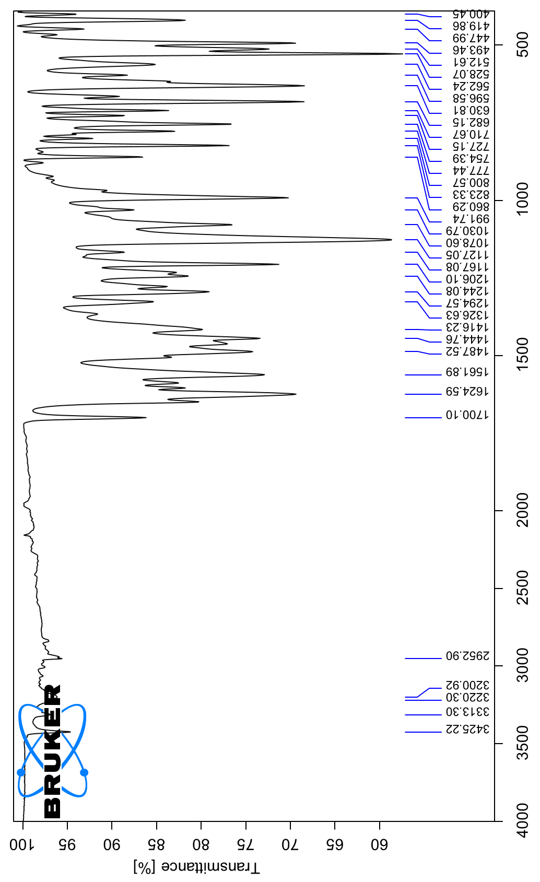
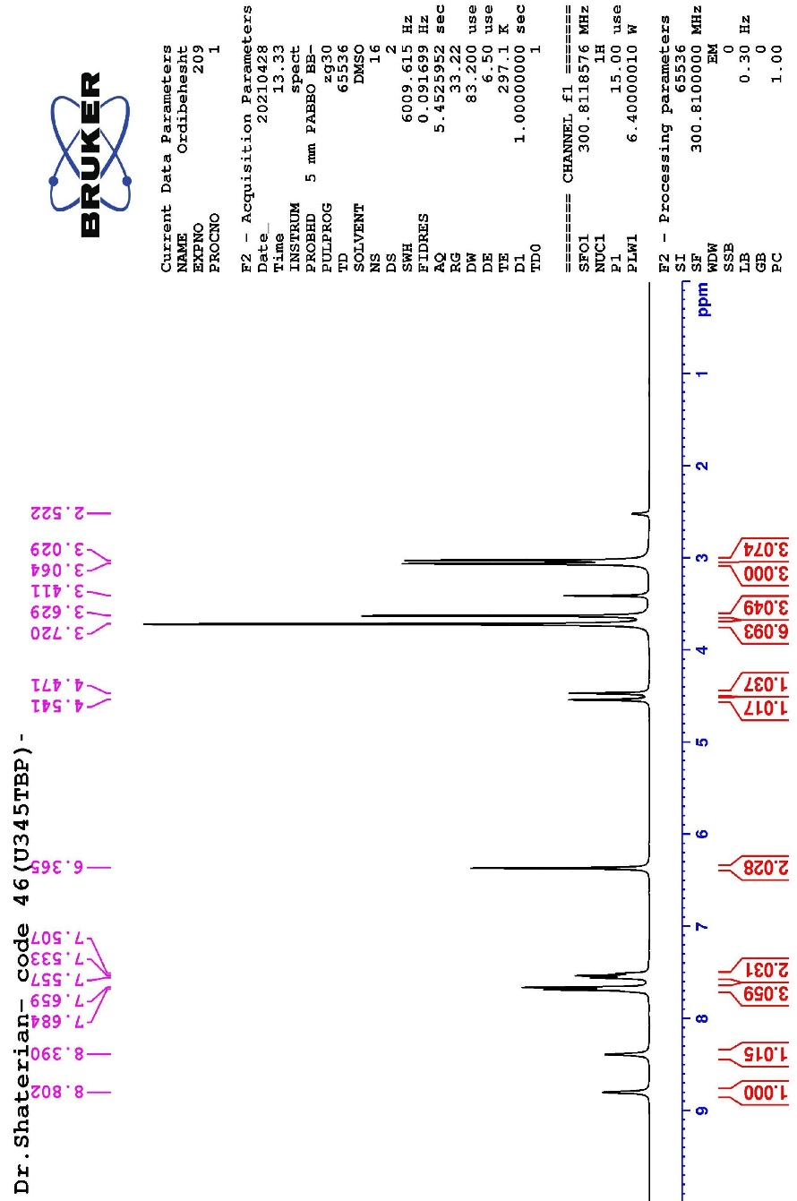
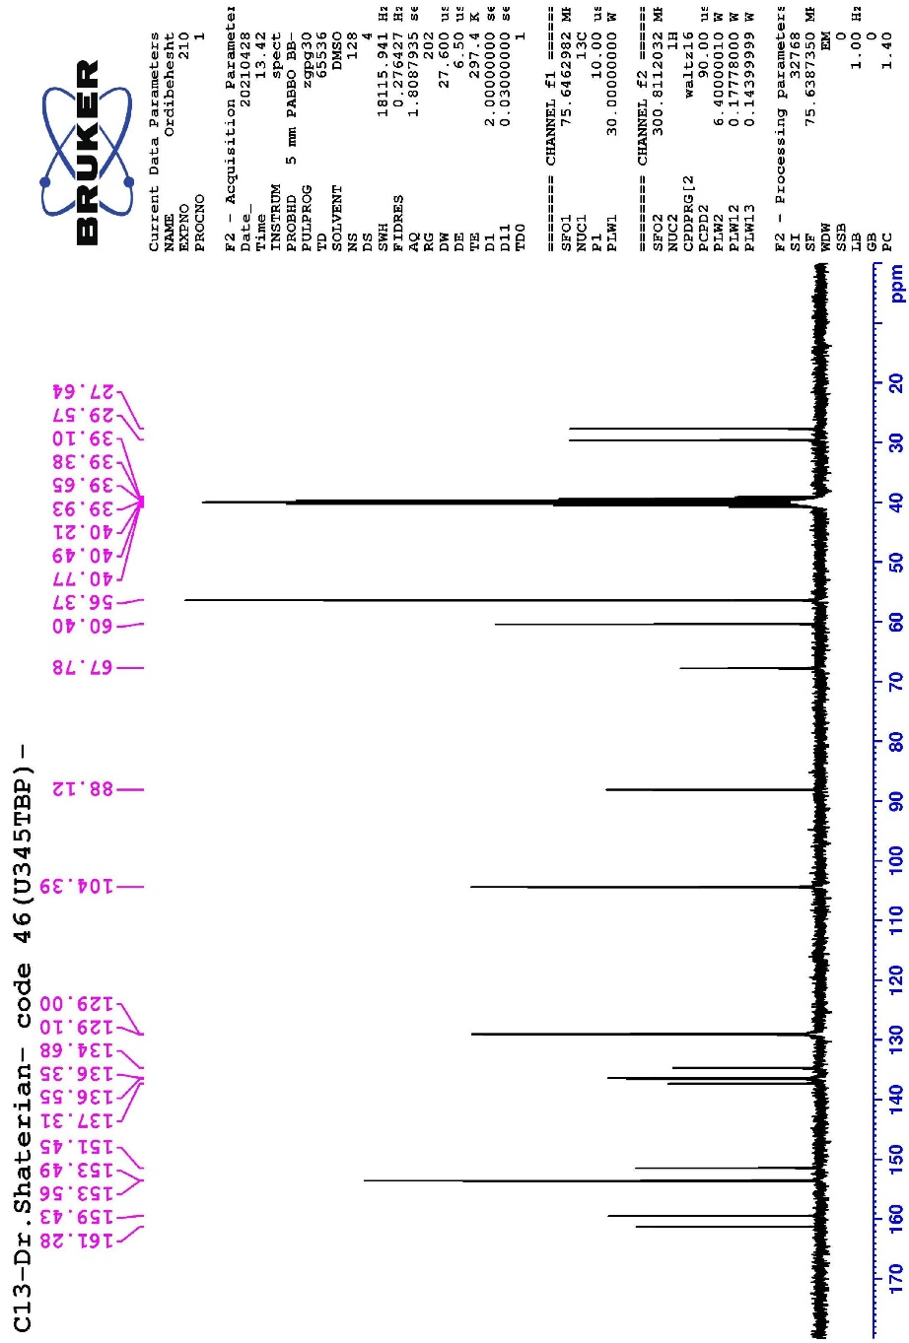

7-Amino-5-(2,5-dimethoxyphenyl)-1,3-dimethyl-6-(phenylsulfonyl)-4a,7-dihydropyrido[2,3-d]pyrimidine-2,4(1H,3H)-dione (4M), M.p: >280 °C ; IR (KBr) (ν_{max}/cm⁻¹): 3534, 3459, 3323, 3203, 3063, 3025, 2937, 2839, 1655, 1620, 1562, 1496, 1462, 1419, 1368, 1316, 1280, 1239, 1212, 1178, 1135, 1076, 1050, 1016, 944, 847, 800, 768, 757, 717, 683, 620, 536, 513, 491, 461, 428, 413.; ¹HNMR (300 MHz, DMSO-d₆): δ_{H} (ppm) 3.09 (6H, s, CH₃), 3.58 (3H, s, CH₃), 3.75 (3H, s, CH₃), 4.33 (1H, s, C-H), 4.84 (1H, s, C-H), 6.17 (1H, s, Ar-H), 6.76-6.96 (2H, m, Ar-H), 7.54-7.59 (2H, m, Ar-H), 7.69-7.71 (3H, m, Ar-H), 8.34 (1H, s, NH₂), 8.61 (1H, s, NH₂).; ¹³CNMR (75 MHz, DMSO-d₆): δ_{C} (ppm) 27.69, 29.64, 39.11, 39.39, 39.66, 39.94, 40.22, 40.49, 40.77, 55.66, 56.29, 65.97, 86.66, 111.86, 112.32, 115.20, 127.78, 129.05, 129.19, 134.59, 137.15, 150.87, 151.67, 153.50, 154.56, 159.37, 161.08.

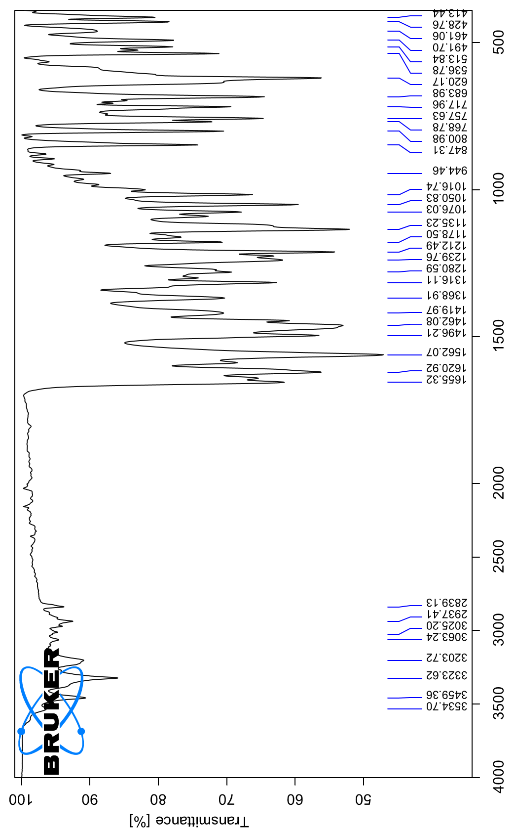
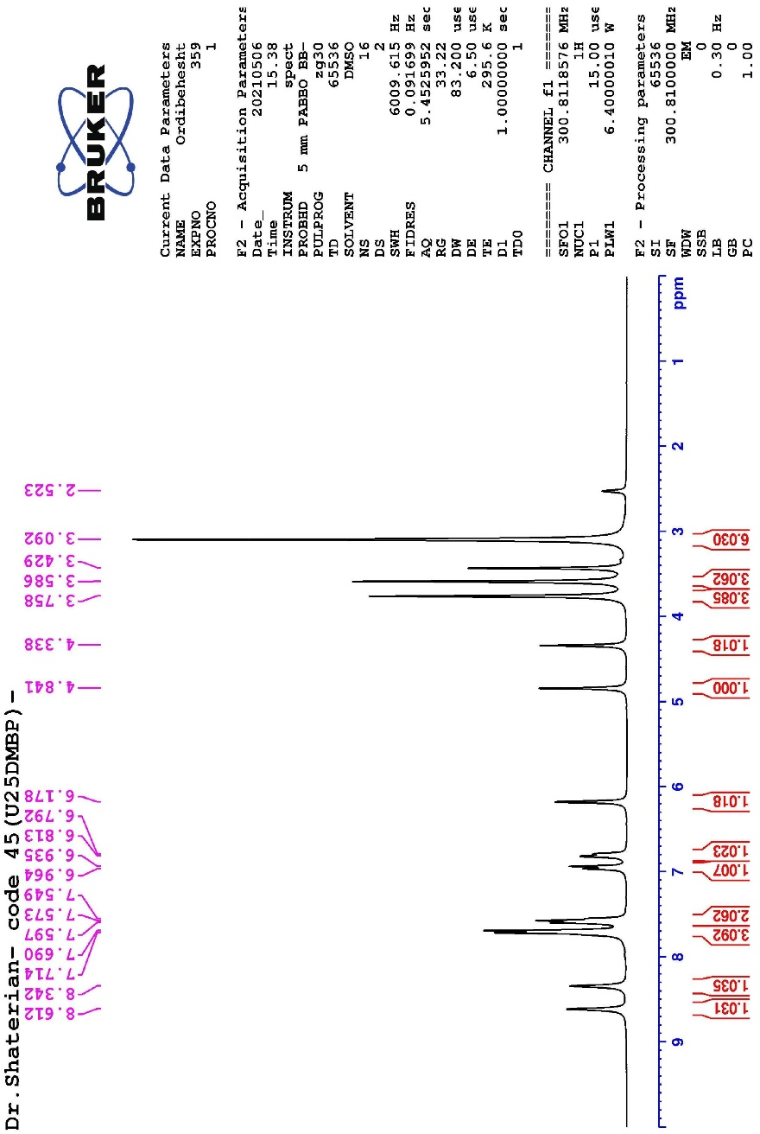
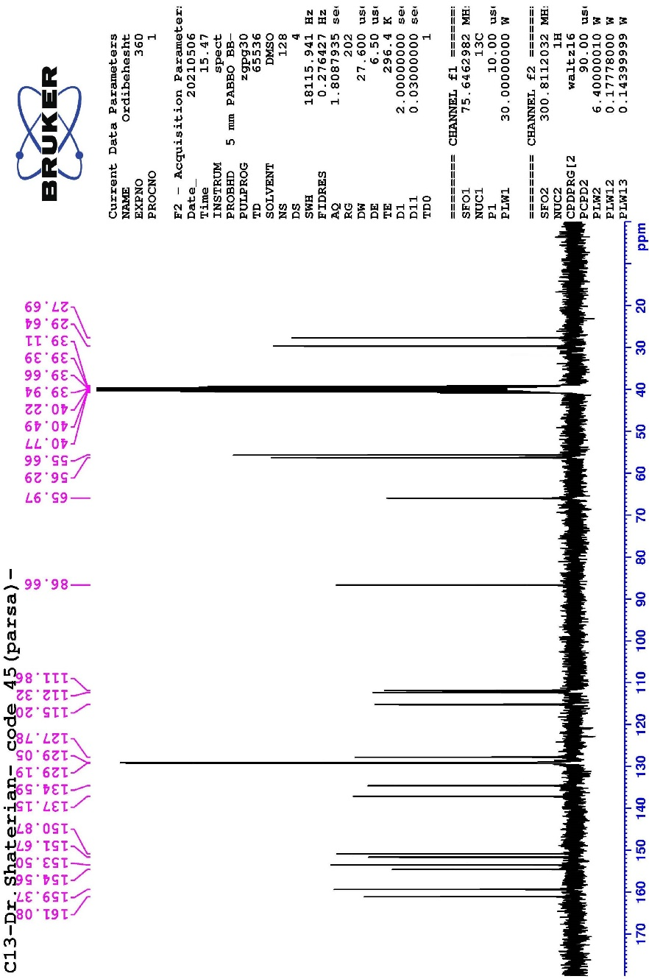

7-Amino-1,3-dimethyl-6-(phenylsulfonyl)-5-(m-tolyl)-4a,7-dihydropyrido[2,3-d]pyrimidine-2,4(1H,3H)-dione (4N), M.p: >280 °C ; IR (KBr) (ν_{max}/cm⁻¹): 3365, 3208, 2924, 1684, 1660, 1619, 1551, 1464, 1446, 1364, 1323, 1311, 1279, 1244, 1200, 1174, 1137, 1100, 1083, 1037, 999, 924, 880, 853, 803, 775, 758, 712, 700, 688, 612, 570, 540, 532, 510, 484.

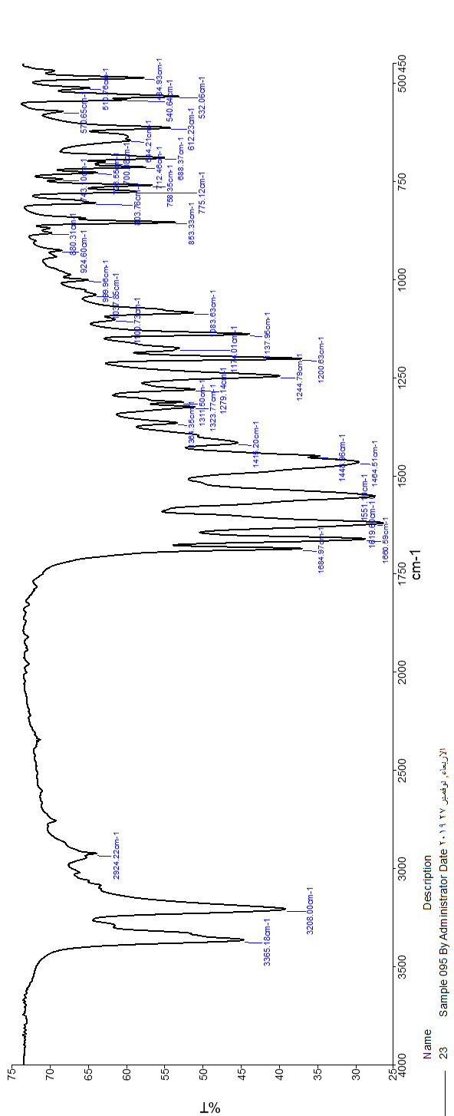

7-Amino-1,3-dimethyl-6-(phenylsulfonyl)-5-(p-tolyl)-4a,7-dihydropyrido[2,3-d]pyrimidine-2,4(1H,3H)-dione (4O), M.p: >280 °C ; IR (KBr) (ν_{max}/cm⁻¹): 3652, 3524, 3345, 3201, 2931, 1682, 1666, 1617, 1554, 1477, 1446, 1420, 1387, 1337, 1319, 1280, 1248, 1212, 1173, 1137, 1079, 1023, 997, 889, 861, 842, 809, 796, 757, 707, 685, 631, 572, 553, 538, 497, 481.

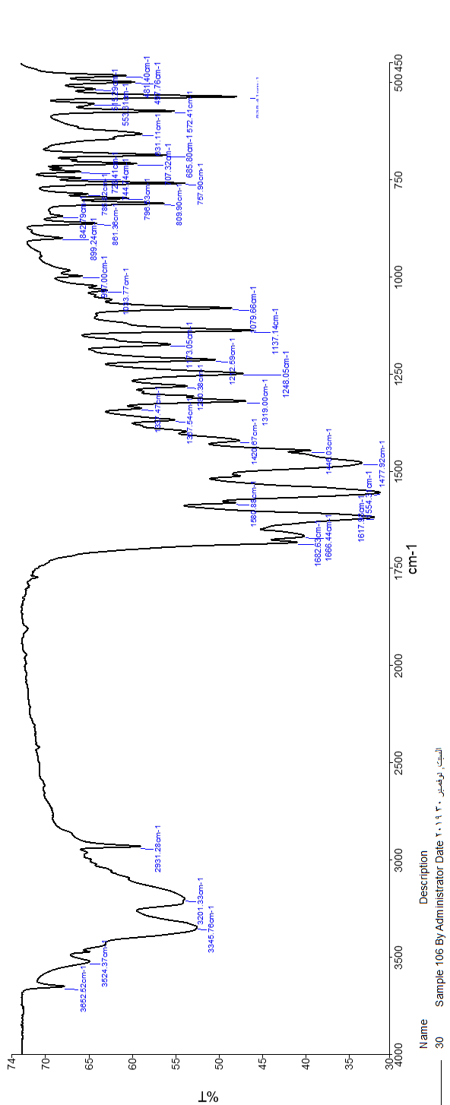

7-Amino-5-(5-bromo-2-hydroxyphenyl)-1,3-dimethyl-6-(phenylsulfonyl)-4a,7-dihydropyrido[2,3-d]pyrimidine-2,4(1H,3H)-dione (4P), M.p: >280 °C ; IR (KBr) (ν_{max}/cm⁻¹): 3469, 3334, 1651, 1622, 1565, 1514, 1446, 1393, 1373, 1334, 1259, 1185, 1129, 1190, 1056, 1022, 965, 942, 880, 822, 811, 776, 756, 725, 686, 635, 612, 584, 556.; ¹HNMR (300 MHz, DMSO-d₆): δ_{H} (ppm) 3.01 (3H, s, CH₃), 3.08 (3H, s, CH₃), 4.38 (1H, s, C-H), 4.89 (1H, s, C-H), 6.61 (1H, s, Ar-H), 6.82-7.25 (2H, m, Ar-H), 7.51-7.54 (2H, m, Ar-H), 7.64-7.66 (3H, m, Ar-H), 8.41 (1H, s, NH₂), 8.63 (1H, s, NH₂), 10.26 (1H, s, OH).; ¹³CNMR (75 MHz, DMSO-d₆): δ_{C} (ppm) 27.70, 29.61, 39.09, 39.37, 39.65, 39.93, 40.21, 4048, 40.76, 65.88, 86.38, 110.59, 117.92, 127.57, 128.90, 129.16, 129.86, 131.63, 134.52, 137.08, 151.57, 154.52, 154.68, 159.59, 161.11.

