Supplementary Materials

Synthesis and characterization of silver doped magnetic-nanoclay montmorillonite/iron oxide/silver nanocomposite for environmental applications throught effective dye degradation
Environmental Science and Pollution Research

Musa Kazim Acarª, Turkan Altun^{a*}, Ilkay Hilal Gubbuk^{b}

ªDepartment of Chemical Engineering, Konya Technical University, Konya, 42150, Turkey
^{b}Department of Chemistry, Selcuk University, Campus, 42075, Konya, Turkey

* All correspondence should be addressed. E-mail: taltun@ktun.edu.tr

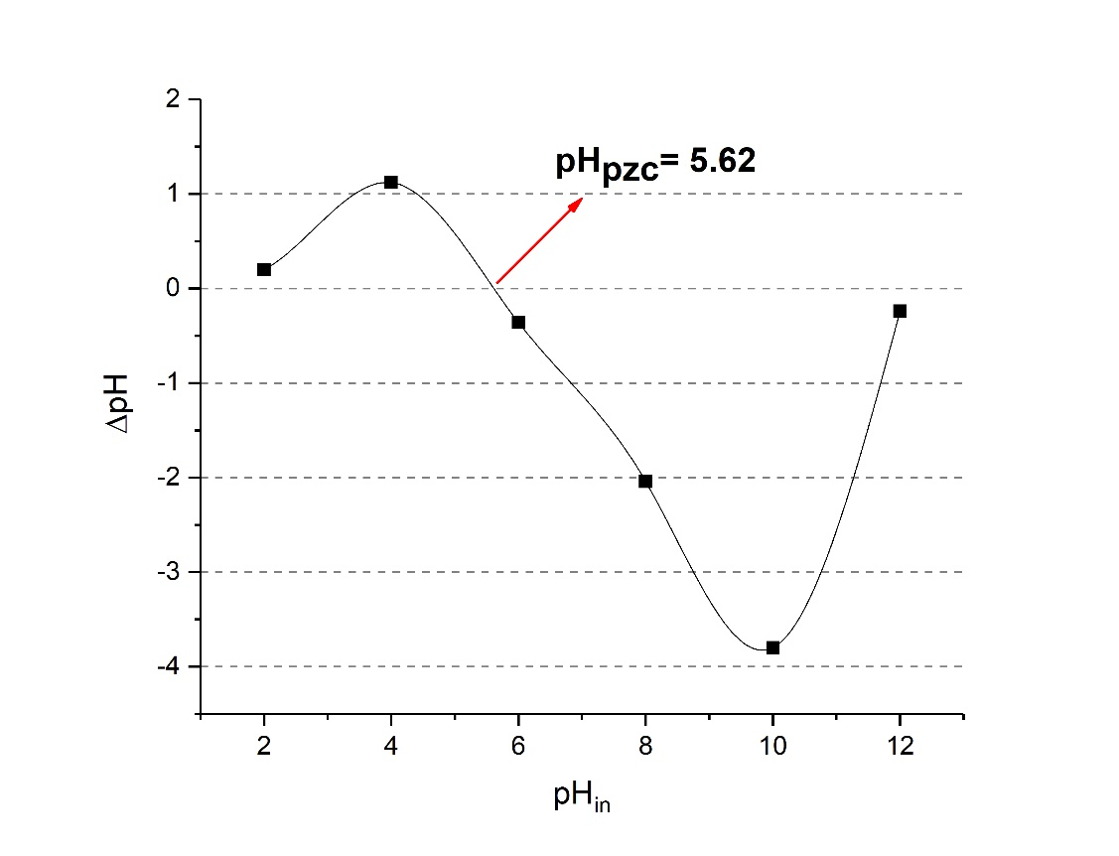
Fig. A1 Point of zero charge of MMT/Fe₃O₄/Ag nanocomposite

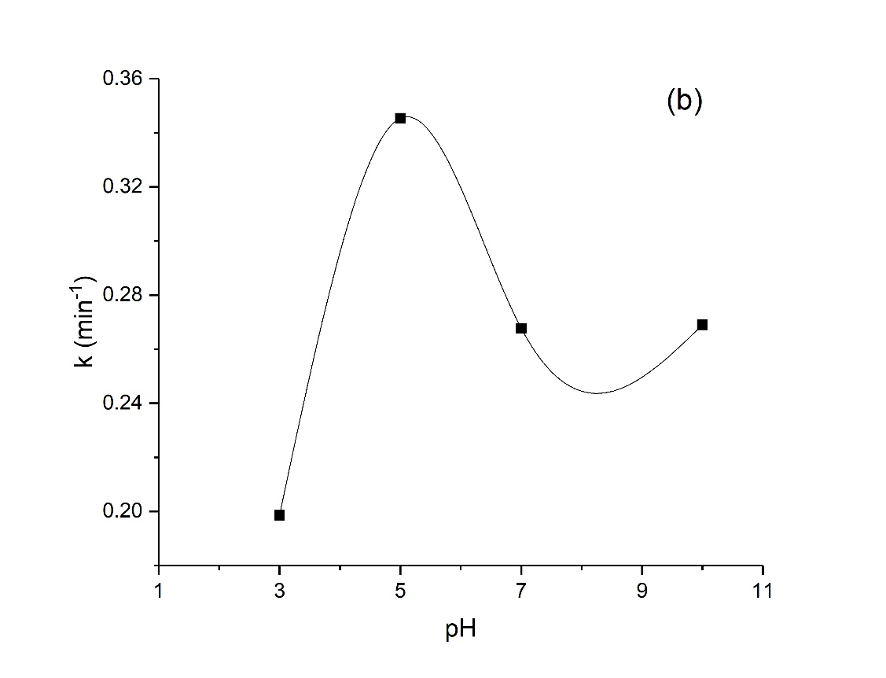
Fig. A2 Rate constants calculated from various pH values

Fig. A3 The effect of different pH values on RhB degradation

Fig. A4 Possible mechanism of degradation of RhB dye using MMT/Fe₃O₄/Ag nanoparticle in the presence of NaBH₄

