Supplementary information

Long-term and extensive population decline drives elevated expression of genetic load in a critically endangered seabird

Guoling Chen^{1,2}, Chenqing Zheng¹, Lanhui Peng^{1,3}, Jia Yang⁴, Feng Dong⁵, Yiwei Lu⁴, Siyu Wang⁴, Zhongyong Fan⁴, Gang Song⁶*, Shuihua Chen^{4,7}*, Yang Liu^{1,7}*

- State Key Laboratory of Biocontrol, School of Ecology, Sun Yat-sen University, Shenzhen, 518107, China
- School of Biological Sciences, The University of Hong Kong, Hong Kong, China
- School of Life Sciences, Peking University, 100071, Beijing, China
- Zhejiang Museum of Natural History, Zhejiang Biodiversity Research Center, Hangzhou, 310014, China
- State Key Laboratory of Genetic Resources and Evolution, Kunming Institute of Zoology, Chinese Academy of Sciences, Kunming 650223, China
- Key Laboratory of Zoological Systematics and Evolution, Institute of Zoology, Chinese Academy of Sciences, Beijing, 100101, China
- Zhejiang Provincial Museum, Hangzhou, 310007, China
- Lead contact

*Correspondence: songgang@ioz.ac.cn (G. S.), chensh@zjmuseum.cn (S.H.C), liuy353@mail.sysu.edu.cn (Y.L.)

TABLE OF CONTENTS

Appendix S1: Results (Genome assembly and annotation)
Supplementary Figure 1
Supplementary Figure 2
Supplementary Figure 3
Supplementary Figure 4
Supplementary Figure 5
Supplementary Figure 6
Supplementary Figure 7
Supplementary Figure 8
Supplementary Figure 9
Supplementary Figure 10
Supplementary Table 1
Supplementary Table 2
Supplementary Table 3
Supplementary Table 4
Supplementary Table 5
Supplementary Table 6
Supplementary Table 7
Supplementary Table 8
Supplementary Table 9
Supplementary Table 10
Supplementary Table 11
Supplementary Table 12

Appendix S1: Results (Genome assembly and annotation)

We sequenced and conducted a de novo genome assembly to build the reference genomes of the Chinese crested tern (CCT) and Great crested tern (GCT) separately. The assembled CCT genome is 1.26 Gb in length (sequencing depth = 51-fold) containing 131,109 scaffolds (scaffold N50: 6.8 Mb; contigs N50: 70.6 Kb, Table S2). The assembled GCT genome is 1.22 Gb in length (sequencing depth = 45-fold) containing 84,817 scaffolds (scaffold N50: 1.5 Mb; contigs N50: 50 Kb; Table S3).

For genome annotation, roughly 11.64% of the CCT genome and 9.95% of the GCT genome were predicted as transposable elements (Table S6), consistent with the composition of other avian genomes, and we identified 17922 and 17708 functionally annotated genes for these two genomes. The completeness of our draft genomes was high (Table 5): we identified 94.2% completeness for the CCT genome and 93.8% completeness for the GCT genome, consistent with the composition of 93.7% for Gallus gallus.

We performed whole-genome re-sequencing for 37 individuals (including 13 CCT, 21 GCT and three little tern (LT) as the outgroup) with an average of 94.26% (range from 69.0% to 97.7%) genome coverage and 26.6-fold (range from 9-fold to 45-fold) sequencing depth for each individual based on the CCT (Supplementary Table S1). After careful calibration and filtration, we identified a total of 4,872,896 biallelic single nucleotide polymorphisms (SNPs) from the reference genome and 37 re-sequenced individuals for further analysis.

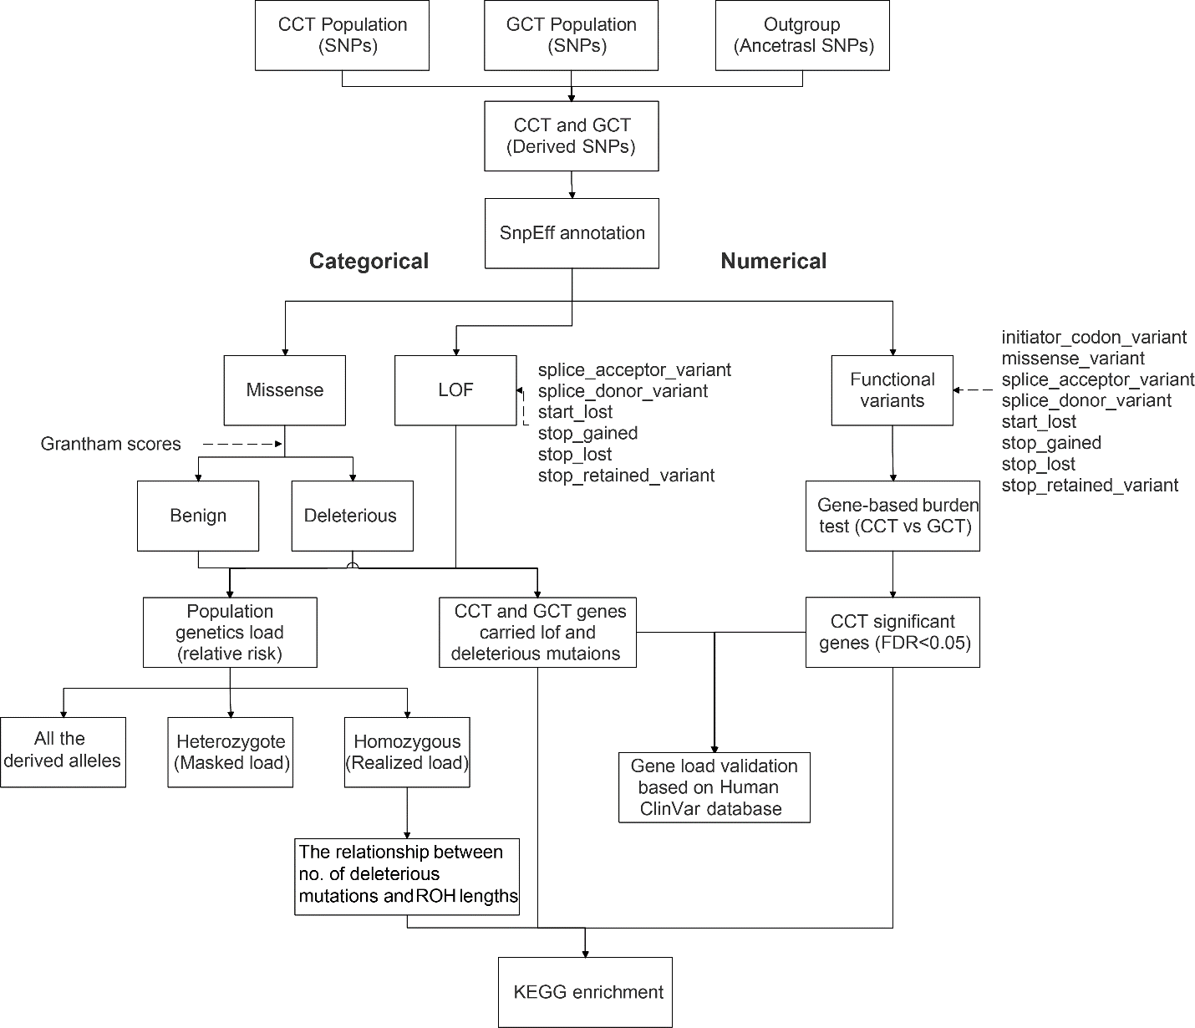

Figure S1. Flow chart of genetic load analysis and gene load validation.

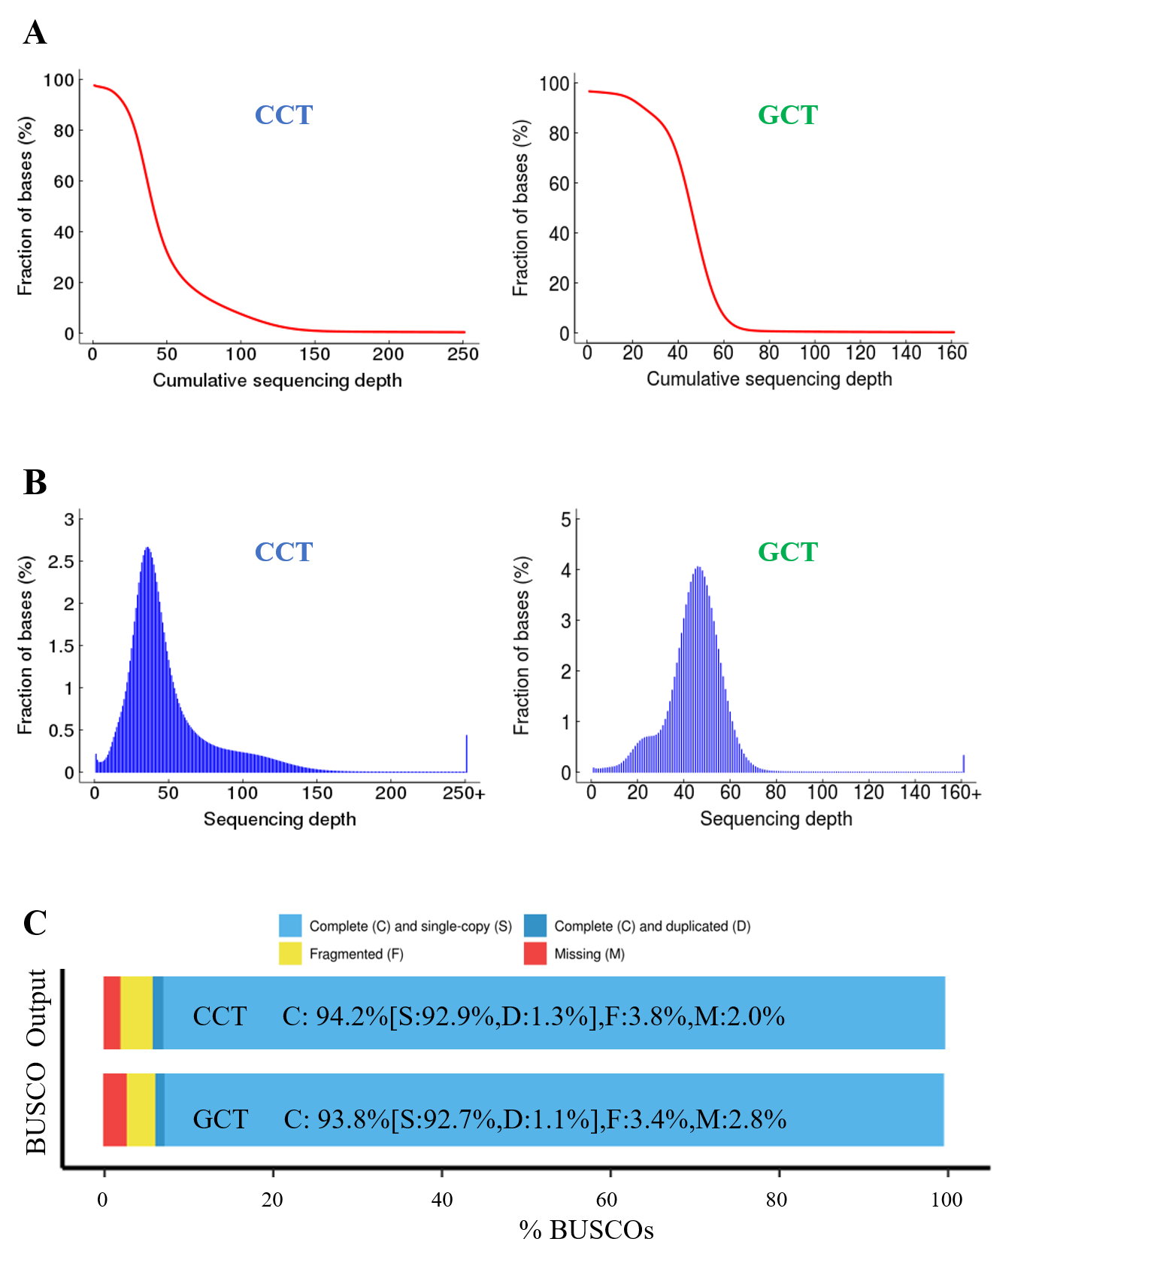
Figure S2. Assembly quality and completeness of the Chinese crested Tern (CCT) and Great crested tern (GCT) genome. (a) Statistics of the coverage of the CCT and GCT genomes; (b) Statistics of the depth of the CCT and GCT genomes; (c) Statistics of the level of completeness of the CCT and GCT genomes.

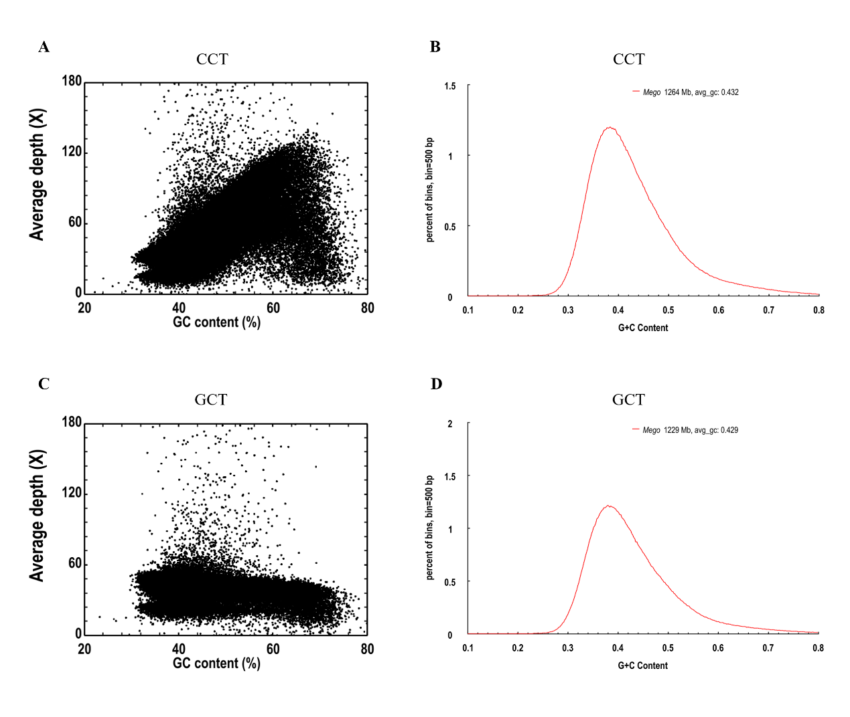
Figure S3. Average sequencing depth and the distribution of GC content of the Chinese crested Tern (CCT) and Great crested tern (GCT) genomes. (a) Sequencing depth and GC content of the CCT genome; (b) Distribution of GC content of the CCT genome; (c) Sequencing depth and GC content of the GCT genome; (d) Distribution of GC content of the GCT genome.

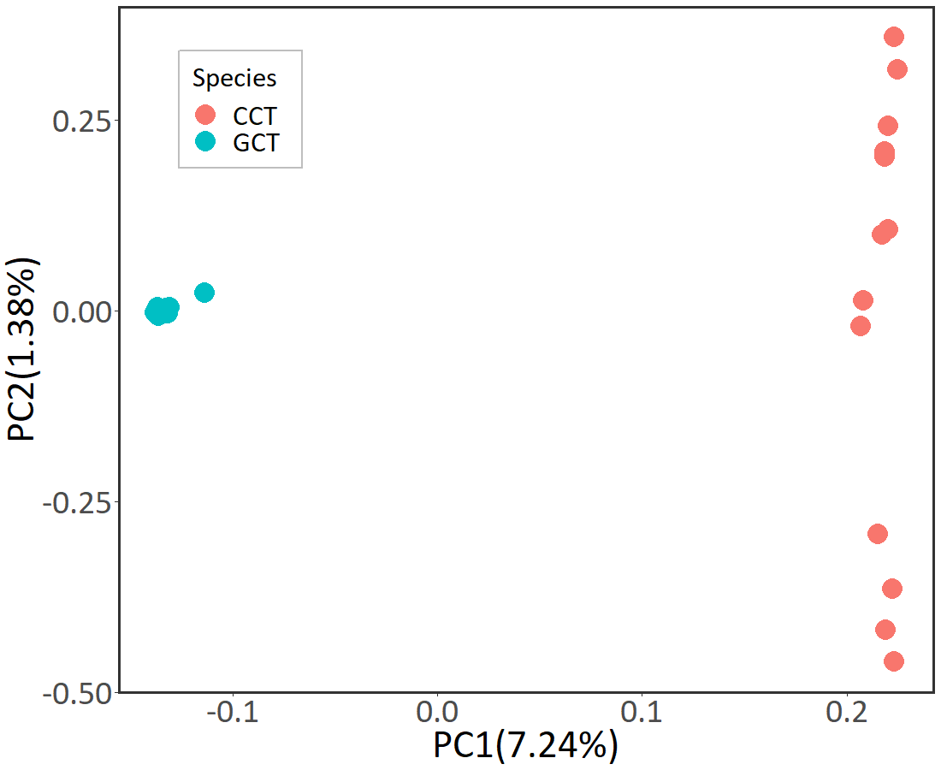
Figure S4. Principal Component Analysis plot of the Chinese crested tern (CCT, red) and Great crested tern (GCT, blue).

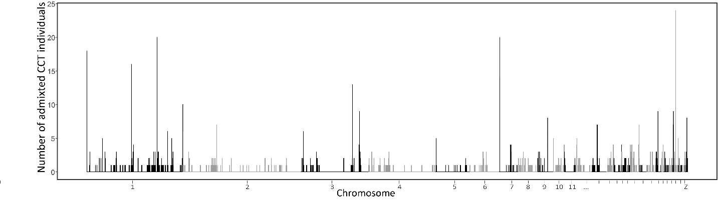
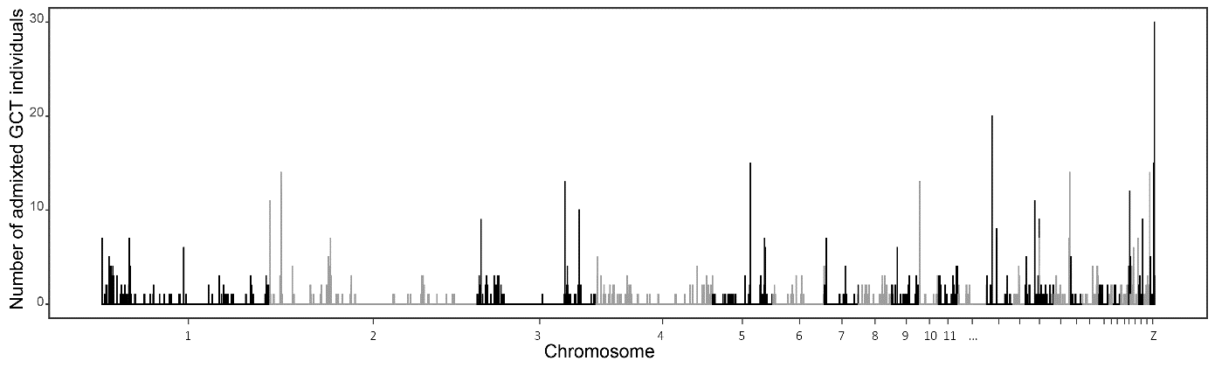
Figure S5. RFMix results showing the number of admixed individuals of Chinese crested tern (CCT, above one) and Great crested tern (GCT, below one) across the genome.

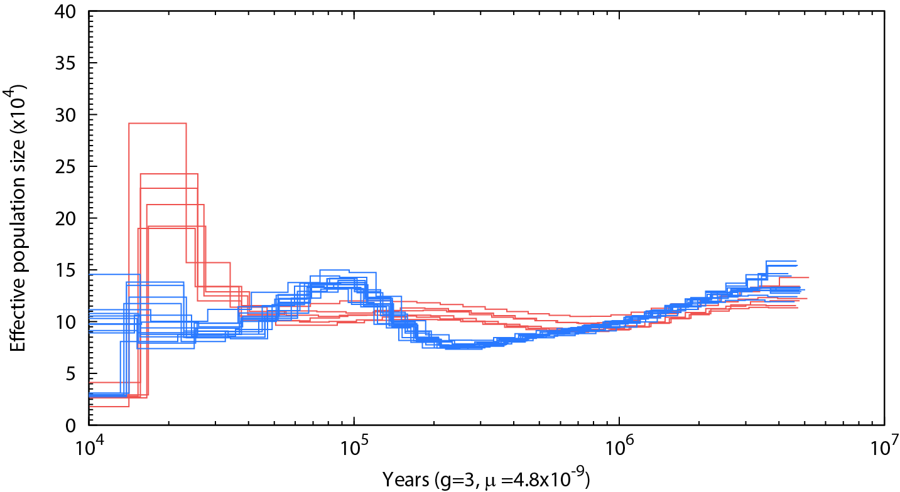
Figure S6. Inference of ancient effective population size (N_{e}) history using PSMC algorithm for individuals of the Chinese crested tern (red) and Great crested tern (blue) with high sequencing depth (>18X), with three years as the generation time and 4.8×10⁻⁹ per base pair per generation as the autosomal mutation rate.

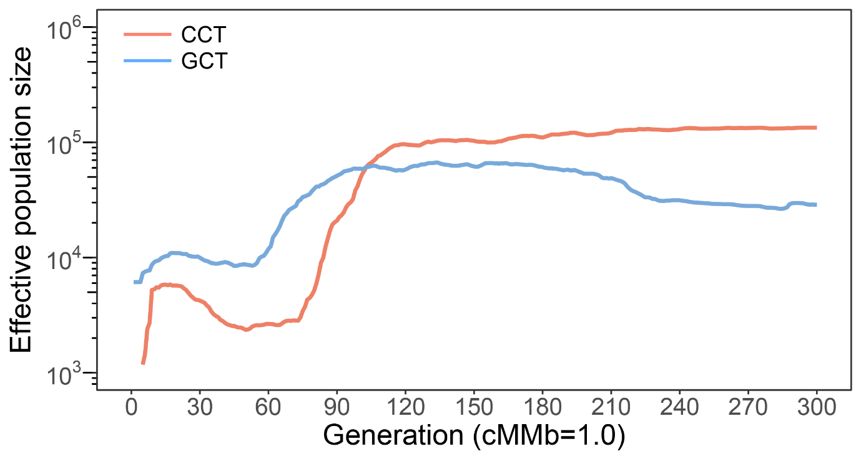
Figure S7. Inference of recent effective population size (N_{e}) history for the Chinese crested tern (CCT, red) and Great crested tern (GCT, blue) using GONE. “cMMb = 1.0” indicates use of a constant recombination rate of 1 cM/Mb to estimate the demographic history.

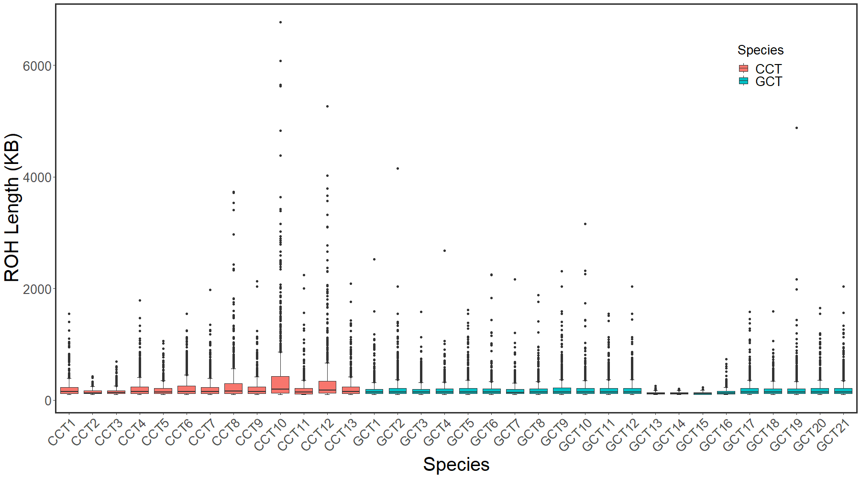
Figure S8. Box plot of length of ROH in each individual of the Chinese crested tern (CCT) and Great crested tern (GCT).

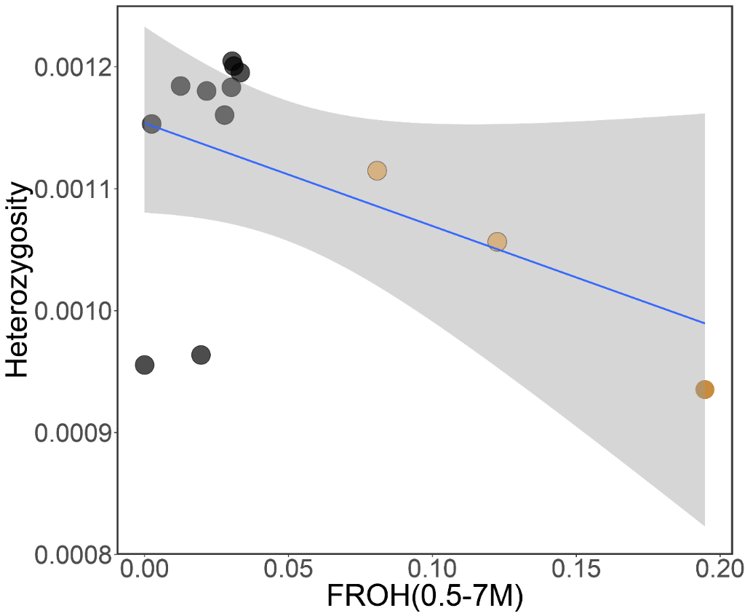
Figure S9. The relationship between the genome-wide heterozygosity and F_{ROH} (0.5–7 Mb) of the Chinese crested tern population. Yellow dots indicate the three highly inbred individuals in this population.

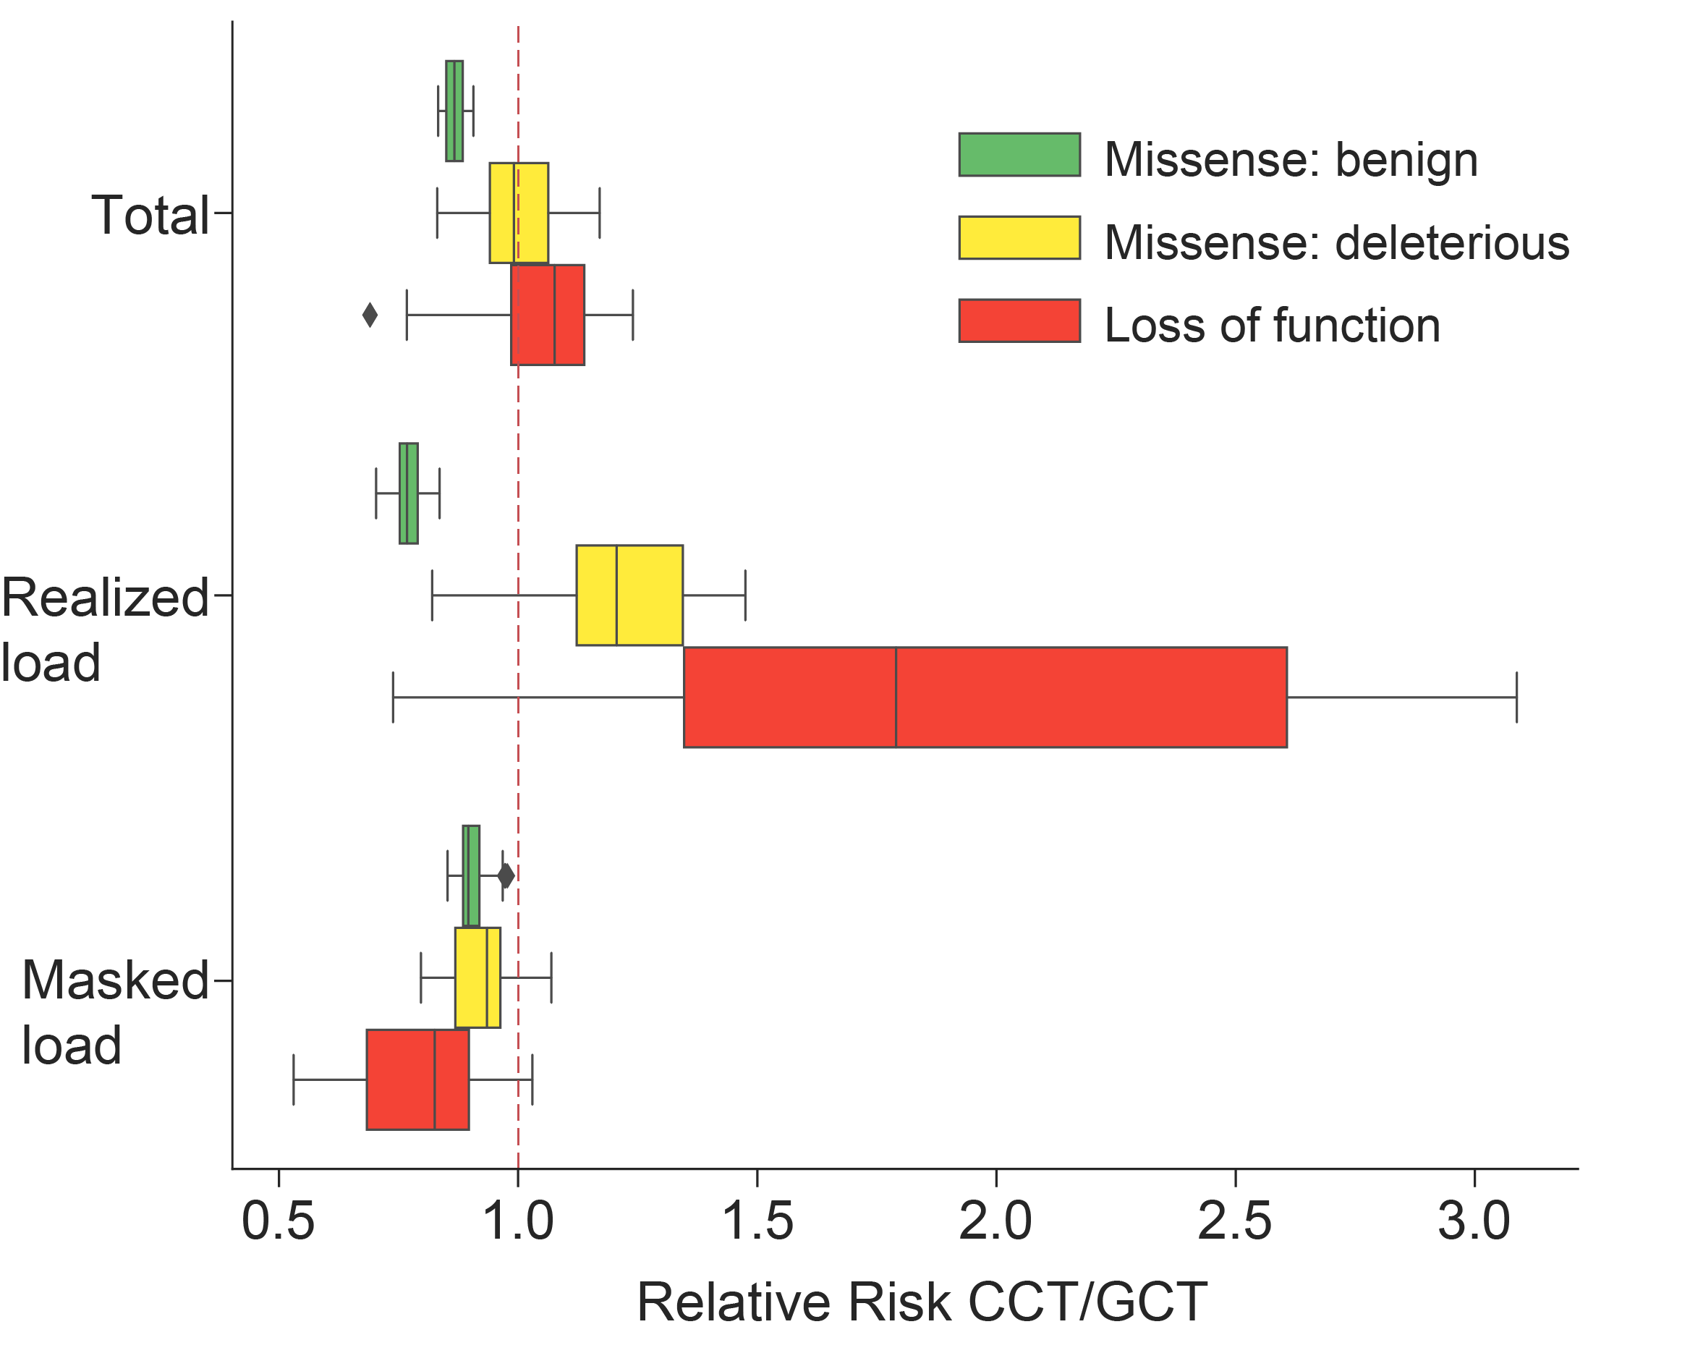
Figure S10. The relative risk (CCT/GCT) of the genetic load was calculated based on ten CCT individuals (excluding three highly inbred individuals) and 21 GCT individuals. The relative risk score (X-axis) of LoF mutations (red), deleterious missense mutations (yellow), and benign missense mutations (green) were calculated with three categories (Y-axis). Total: total genetic load in both homozygous and heterozygous sites; Realized load: realized load in homozygous sites; Masked load: masked load in heterozygous sites. CCT: Chinese crested tern; GCT: Great crested tern.

Table S1. Sampling information of Chinese crested tern (CCT), Great crested tern (GCT), and Little tern (LT) used in this article.

Species | Locality | Sample ID | Voucher | Sequencing | Sequencing Depth (×) | Mapping rate | Converge
Chinese crested tern | Tiedundao, Jiushan Archipelago, Xiangshan | CCT1 | AB0001123 | de novo, Re-sequencing | 50.99 | 99.44% | 97.67%
Chinese crested tern | Tiedundao, Jiushan Archipelago, Xiangshan | CCT2 | CCT2 | Re-sequencing | 9.18 | 98.70% | 68.98%
Chinese crested tern | Tiedundao, Jiushan Archipelago, Xiangshan | CCT3 | CCT3 | Re-sequencing | 10.64 | 99.14% | 84.99%
Chinese crested tern | Tiedundao, Jiushan Archipelago, Xiangshan | CCT4 | CCT4 | Re-sequencing | 32.07 | 99.66% | 96.34%
Chinese crested tern | Tiedundao, Jiushan Archipelago, Xiangshan | CCT5 | AB00001802 | Re-sequencing | 30.34 | 99.35% | 95.85%
Chinese crested tern | Tiedundao, Jiushan Archipelago, Xiangshan | CCT6 | SYSb6745 | Re-sequencing | 27.87 | 98.89% | 97.05%
Chinese crested tern | Tiedundao, Jiushan Archipelago, Xiangshan | CCT7 | SYSb6746 | Re-sequencing, RNA-Seq | 24.98 | 98.96% | 96.98%
Chinese crested tern | Tiedundao, Jiushan Archipelago, Xiangshan | CCT8 | SYSb6747 | Re-sequencing, RNA-Seq | 28.22 | 99.30% | 97.03%
Chinese crested tern | Tiedundao, Jiushan Archipelago, Xiangshan | CCT9 | SYSb008268 | Re-sequencing | 32.39 | 99.70% | 96.32%
Chinese crested tern | Tiedundao, Jiushan Archipelago, Xiangshan | CCT10 | Z001 | Re-sequencing | 20.36 | 100.00% | 97.01%
Chinese crested tern | Tiedundao, Jiushan Archipelago, Xiangshan | CCT11 | Z002 | Re-sequencing | 20.10 | 100.00% | 95.87%
Chinese crested tern | Tiedundao, Jiushan Archipelago, Xiangshan | CCT12 | Z003 | Re-sequencing | 22.44 | 100.00% | 97.10%
Chinese crested tern | Tiedundao, Jiushan Archipelago, Xiangshan | CCT13 | Z004 | Re-sequencing | 20.96 | 100.00% | 97.07%
Great crested tern | Tiedundao, Jiushan Archipelago, Xiangshan | GCT1 | GCT1 | Re-sequencing | 26.67 | 99.72% | 94.74%
Great crested tern | Tiedundao, Jiushan Archipelago, Xiangshan | GCT2 | GCT2 | Re-sequencing | 29.13 | 99.69% | 96.20%
Great crested tern | Tiedundao, Jiushan Archipelago, Xiangshan | GCT3 | GCT3 | Re-sequencing | 28.98 | 99.61% | 94.99%
Great crested tern | Tiedundao, Jiushan Archipelago, Xiangshan | GCT4 | GCT4 | Re-sequencing | 30.73 | 99.68% | 95.03%
Great crested tern | Tiedundao, Jiushan Archipelago, Xiangshan | GCT5 | GCT5 | Re-sequencing | 29.81 | 99.63% | 96.28%
Great crested tern | Tiedundao, Jiushan Archipelago, Xiangshan | GCT6 | GCT6 | Re-sequencing | 30.46 | 99.68% | 95.06%
Great crested tern | Tiedundao, Jiushan Archipelago, Xiangshan | GCT7 | GCT7 | Re-sequencing | 36.55 | 99.69% | 95.18%
Great crested tern | Tiedundao, Jiushan Archipelago, Xiangshan | GCT8 | GCT8 | Re-sequencing | 31.76 | 99.69% | 95.05%
Great crested tern | Tiedundao, Jiushan Archipelago, Xiangshan | GCT9 | GCT9 | Re-sequencing | 28.17 | 99.70% | 96.07%
Great crested tern | Tiedundao, Jiushan Archipelago, Xiangshan | GCT10 | GCT10 | Re-sequencing | 32.66 | 99.70% | 95.01%
Great crested tern | Tiedundao, Jiushan Archipelago, Xiangshan | GCT11 | F_CCT05 | Re-sequencing | 33.47 | 99.62% | 96.34%
Great crested tern | Tiedundao, Jiushan Archipelago, Xiangshan | GCT12 | AB0002001 | de novo, Re-sequencing | 45.24 | 98.07% | 96.66%
Great crested tern | Yaqueshan,Wuzhishan Archipelago, Zhoushan | GCT13 | AB0000353 | Re-sequencing | 9.63 | 82.29% | 93.58%
Great crested tern | Yaqueshan,Wuzhishan Archipelago, Zhoushan | GCT14 | AB0001004 | Re-sequencing | 9.71 | 67.50% | 93.11%
Great crested tern | Tiedundao, Jiushan Archipelago, Xiangshan | GCT15 | AB0001103 | Re-sequencing | 9.61 | 66.09% | 93.29%
Great crested tern | Yaqueshan,Wuzhishan Archipelago, Zhoushan | GCT16 | AB0002974 | Re-sequencing | 10.19 | 69.59% | 92.86%
Great crested tern | Tiedundao, Jiushan Archipelago, Xiangshan | GCT17 | SYSb008269 | Re-sequencing | 33.24 | 99.65% | 95.12%
Great crested tern | Yaqueshan,Wuzhishan Archipelago, Zhoushan | GCT18 | AB0002978 | Re-sequencing | 13.63 | 83.84% | 93.21%
Great crested tern | Tiedundao, Jiushan Archipelago, Xiangshan | GCT19 | SYSb6743 | Re-sequencing, RNA-Seq | 33.93 | 99.16% | 95.88%
Great crested tern | Tiedundao, Jiushan Archipelago, Xiangshan | GCT20 | SYSb6744 | Re-sequencing, RNA-Seq | 26.13 | 98.63% | 96.95%
Great crested tern | Tiedundao, Jiushan Archipelago, Xiangshan | GCT21 | SYSb6748 | Re-sequencing | 30.17 | 99.39% | 96.97%
Great crested tern | Haifeng, Shanwei, Guangdong, China | LT1 | HF001 | Re-sequencing | 31.18 | 99.10% | 94.75%
Little tern | Haifeng, Shanwei, Guangdong, China | LT2 | HF005 | Re-sequencing | 26.90 | 99.09% | 94.63%
Little tern | Haifeng, Shanwei, Guangdong, China | LT3 | HF008 | Re-sequencing | 28.89 | 99.16% | 93.80%

Table S2. Statistics of the assembly results of the Chinese crested tern (CCT) genome.

 | Scaffold |  | Contig
 | length(bp) | Number | length(bp) | number
max_len | 59,918,673 | — | 798,548 | —
N50 | 6,859,330 | 43 | 70,621 | 4743
N60 | 4,171,004 | 66 | 52,438 | 6800
N70 | 2,067,646 | 109 | 35,934 | 9,668
N80 | 923,515 | 204 | 20,839 | 14,174
N90 | 186,954 | 491 | 8,021 | 23,679
Total_length | 1,264,619,205 |  | 1,249,845,866
number>=100bp | 131,109 |  | 188,023
number>=2000bp | 6,484 |  | 42,400

Table S3. Statistics of the assembly results of the Great crested tern (GCT) genome.

 | Scaffold |  | Contig
 | length(bp) | number | length(bp) | number
max_len | 16,736,379 |  | 425,665
N50 | 1,542,460 | 201 | 50,087 | 6,872
N60 | 1,147,029 | 292 | 38,822 | 9623
N70 | 793,246 | 422 | 29,106 | 13,218
N80 | 471,161 | 623 | 19,885 | 18,241
N90 | 179,286 | 1033 | 10,390 | 26,469
Total_length | 1,229,498,961 |  | 1,211,618,603
number>=100bp | 84,817 |  | 139,712
number>=2000bp | 6,068 |  | 43,467

Table S4. Comparison of assemblies for Chinese crested tern (CCT), Great crested tern (GCT), and three other avian species.

Genome Feature | CCT | GCT | Gallus gallus | Taeniopygia guttata | Meleagris gallopavo
N50 Contig length | 70kb | 50kb | 36kb | 39kb | 12.6kb
N50 Scaffold length | 6.9Mb | 1.5Mb | 7Mb | 10Mb | 1.5Mb
Assembled bases | 1.26Gb | 1.23Gb | 1.06Gb | 1.2Gb | 931Mb
GC content (%) | 42.70 | 42.30 | 41.50 | 41.30 | 40.50

Table S5. Statistics of the level of completeness of genomes of Chinese crested tern (CCT), Great crested tern (GCT), and chicken (Gallus gallus).

Species | Complete BUSCOs(%) | Fragmented BUSCOs(%) | Missing BUSCOs(%)
CCT | 94.2 | 3.8 | 2.0
GCT | 93.8 | 3.4 | 2.8
Gallus gallus | 93.7 | 3.6 | 2.7

Table S6. Proportion of repeats in the Chinese crested tern (CCT) and Great crested tern (GCT) genomes as estimated by different methods.

Type | CCT |  | GCT
 | Length (Bp) | % in genome | Length (Bp) | % in genome
Repbase TEs | 87,518,459 | 6.92 | 86,623,775 | 7.05
TE Proteins | 55,061,142 | 4.35 | 56,125,519 | 4.56
De novo | 126,895,522 | 10.03 | 101,583,897 | 8.26
Combined TEs | 147,181,986 | 11.64 | 122,296,238 | 9.95

Table S7. Functional classification of the Chinese crested tern (CCT) and Great crested tern (GCT) genes by various databases.

Species | Values |  | Swissprot  Annotated | KEGG Annotated | Interpro Annotated | GO Annotated | Overall
CCT | Number |  | 17554 | 16139 | 16639 | 12592 | 17922
CCT | Percentage |  | 0.9613 | 0.8838 | 0.9112 | 0.6896 | 0.9815
GCT | Number |  | 17336 | 16051 | 16528 | 12640 | 17708
GCT | Percentage |  | 0.9605 | 0.8893 | 0.9157 | 0.7003 | 0.9811

Table S8. Summary of repeats in the Chinese crested tern (CCT) genome.

 | Repbase TEs |  | TE proteins |  | De novo |  | Combined TEs
Type | Length (bp) | % in genome | Length (bp) | % in genome | Length (bp) | % in genome | Length (bp) | % in genome
DNA | 7,404,482 | 0.59 | 154,958 | 0.01 | 8,265,831 | 0.65 | 15,668,636 | 1.24
LINE | 69,413,746 | 5.49 | 52,764,908 | 4.17 | 86,920,527 | 6.87 | 110,553,992 | 8.74
SINE | 1,212,534 | 0.10 | 0 | 0.00 | 744,533 | 0.06 | 1,875,081 | 0.15
LTR | 10,899,071 | 0.86 | 2,156,128 | 0.17 | 50,230,333 | 3.97 | 56,250,793 | 4.45
Other | 2,955 | 0.00 | 0 | 0.00 | 0 | 0.00 | 2,955 | 0.00
Unknown | 0 | 0.00 | 0 | 0.00 | 12,225,711 | 0.97 | 12,225,711 | 0.97
Total | 87,518,459 | 6.92 | 55,061,142 | 4.35 | 126,895,522 | 10.03 | 147,181,986 | 11.64

Table S9. Summary of repeats in the Great crested tern (GCT) genome.

 | Repbase TEs |  | TE proteins |  | De novo |  | Combined TEs
Type | Length (bp) | % in genome | Length (bp) | % in genome | Length (bp) | % in genome | Length (bp) | % in genome
DNA | 7,169,830 | 0.58 | 183,115 | 0.01 | 1,391,333 | 0.11 | 8,456,971 | 0.69
LINE | 69,120,512 | 5.62 | 53,718,328 | 4.37 | 72,705,357 | 5.91 | 93,884,799 | 7.64
SINE | 1,153,606 | 0.09 | 0 | 0.00 | 610,191 | 0.05 | 1,584,919 | 0.13
LTR | 10,463,883 | 0.85 | 2,236,930 | 0.18 | 26,513,708 | 2.16 | 33,107,431 | 2.69
Other | 3,050 | 0.00 | 156 | 0.00 | 0 | 0.00 | 3,206 | 0.00
Unknown | 0 | 0.00 | 0 | 0.00 | 11,896,607 | 0.97 | 11,896,607 | 0.97
Total | 86,623,775 | 7.05 | 56,125,519 | 4.56 | 101,583,897 | 8.26 | 122,296,238 | 9.95

Table S10. Proportion of mixed ancestry of each individual as detected by RFMix under different window sizes.
Group | Sample | 5 SNP | 50 SNP | 200 SNP
CCT | AB00001802 | 0.41% | 0.28% | 0.21%
CCT | CCT02 | 0.27% | 0.15% | 0.20%
CCT | CCT03 | 0.28% | 0.20% | 0.21%
CCT | CCT04 | 0.49% | 0.19% | 0.16%
CCT | CCT_4libs | 0.70% | 0.32% | 0.31%
CCT | SYSb008268 | 0.52% | 0.37% | 0.27%
CCT | SYSb6745 | 0.39% | 0.22% | 0.22%
CCT | SYSb6746 | 0.45% | 0.27% | 0.20%
CCT | SYSb6747 | 0.27% | 0.28% | 0.11%
CCT | Z001 | 0.32% | 0.30% | 0.15%
CCT | Z002 | 0.35% | 0.24% | 0.12%
CCT | Z003 | 0.43% | 0.45% | 0.16%
CCT | Z004 | 0.39% | 0.23% | 0.18%
GCT | CCT05 | 0.33% | 0.14% | 0.13%
GCT | GCT001 | 0.51% | 0.28% | 0.24%
GCT | GCT002 | 0.46% | 0.60% | 0.27%
GCT | GCT003 | 0.33% | 0.18% | 0.12%
GCT | GCT004 | 0.26% | 0.19% | 0.12%
GCT | GCT005 | 0.30% | 0.24% | 0.14%
GCT | GCT006 | 0.24% | 0.29% | 0.14%
GCT | GCT007 | 0.31% | 0.40% | 0.19%
GCT | GCT008 | 6.80% | 6.84% | 6.04%
GCT | GCT009 | 0.35% | 0.40% | 0.20%
GCT | GCT010 | 0.20% | 0.30% | 0.12%
GCT | GCT_4libs | 0.20% | 0.33% | 0.14%
GCT | GCT_AB0000353 | 0.33% | 0.36% | 0.15%
GCT | GCT_AB0001004 | 0.25% | 0.23% | 0.18%
GCT | GCT_AB0001103 | 0.15% | 0.33% | 0.19%
GCT | GCT_AB0002974 | 0.27% | 0.48% | 0.12%
GCT | GCT_AB0002978 | 0.19% | 0.22% | 0.16%
GCT | SYSb008269 | 0.31% | 0.21% | 0.11%
GCT | SYSb6743 | 0.22% | 0.25% | 0.12%
GCT | SYSb6744 | 0.25% | 0.30% | 0.10%
GCT | SYSb6748 | 0.22% | 0.21% | 0.11%
CCT: Chinese crested tern
GCT: Great crested tern

Table S11. Log marginal likelihoods, log Bayes factors, and migration model probabilities of ten independent runs of Migrate-N.

 | Model | Log(mL) | LBF | Model probability
1 | GCT to CCT | -2420160.13 | -8957.83 | 0
1 | CCT to GCT | -2419745.28 | -8542.98 | 0
1 | both directions | -2411202.3 | 0 | 1
2 | GCT to CCT | -824584.2 | -272 | 0
2 | CCT to GCT | -824652.64 | -340.44 | 0
2 | both directions | -824312.2 | 0 | 1
3 | GCT to CCT | -943622.91 | -728.18 | 0
3 | CCT to GCT | -943441.53 | -546.8 | 0
3 | both directions | -942894.73 | 0 | 1
4 | GCT to CCT | -3925128.77 | -8320.01 | 0
4 | CCT to GCT | -3923141.71 | -6332.95 | 0
4 | both directions | -3916808.76 | 0 | 1
5 | GCT to CCT | -1543465.78 | -4294.2 | 0
5 | CCT to GCT | -1541094.13 | -1922.55 | 0
5 | both directions | -1539171.58 | 0 | 1
6 | GCT to CCT | -1191369.55 | -3683.1 | 0
6 | CCT to GCT | -1189755.32 | -2068.87 | 0
6 | both directions | -1187686.45 | 0 | 1
7 | GCT to CCT | -3939431.51 | -15779.69 | 0
7 | CCT to GCT | -3940112.58 | -16460.76 | 0
7 | both directions | -3923651.82 | 0 | 1
8 | GCT to CCT | -351265.58 | -92.75 | 0
8 | CCT to GCT | -351327.03 | -154.2 | 0
8 | both directions | -351172.83 | 0 | 1
9 | GCT to CCT | -32745312.23 | -28709197.68 | 0
9 | CCT to GCT | -32829324.76 | -28793210.21 | 0
9 | both directions | -4036114.55 | 0 | 1
10 | GCT to CCT | -8931854.89 | -40435.24 | 0
10 | CCT to GCT | -8915697.05 | -24277.4 | 0
10 | both directions | -8891419.65 | 0 | 1

Abbreviation: Log(mL): Log (Marginal Likelihood); LBF: Log Bayes factor.; CCT: Chinese crested tern; GCT: Great crested tern.

Table S12. Genome-wide diversity, census population size, and conservation status of 59 published avian species.
Species  Latin name | Species  common name | Census population size | Conservation Status | Heterozygosity | Nucleotide diversity (π) | References
Alauda arvensis | Eurasian skylark | 410000000 | LC |  | 0.0114 | Dierickx et al. 2019¹
Alauda gulgula | Oriental skylark | 500000 | LC |  | 0.0041 | Dierickx et al. 2019¹
Alauda razae | Raso lark | 625 | CR |  | 0.001 | Dierickx et al. 2019¹
Strigops habroptila | Kakapo-Mainland | 116 | CR | 0.0009 |  | Dussex et al. 2021²
Strigops habroptila | Kakapo-Island | 116 | CR | 0.0005 |  | Dussex et al. 2021²
Columba livia | Rock dove | 260000000 | LC |  | 0.0036 | Hung et al. 2014³
Dryobates pubescens | Downy woodpecker | 13000000 | LC |  | 0.0039 | Hung et al. 2014³
Ficedula albicollis | Collared flycatcher | 4600000 | LC |  | 0.0036 | Hung et al. 2014³
Ficedula hypoleuca | European pied flycatcher | 47500000 | LC |  | 0.0021 | Hung et al. 2014³
Sinosuthora webbiana bulomachus | Vinous-throated parrotbill | 500000 | LC | 0.0027 |  | Lai et al. 2019⁴
Acanthisitta chloris | Rifleman | unknown | LC | 0.00167 |  | Li et al. 2014⁵
Anas platyrhynchos | Mallard | 19000000 | LC | 0.00291 |  | Li et al. 2014⁵
Apaloderma vittatum | Bar-tailed trogon | unknown | LC | 0.00218 |  | Li et al. 2014⁵
Balearica regulorum | Grey crowned crane | 20000 | EN | 0.00188 |  | Li et al. 2014⁵
Calypte anna | Anna's hummingbird | 9600000 | LC | 0.00255 |  | Li et al. 2014⁵
Caprimulgus carolinensis | Chuck-will's-widow | 5700000 | NT | 0.00387 |  | Li et al. 2014⁵
Cariama cristata | Red-legged seriema | unknown | LC | 0.00255 |  | Li et al. 2014⁵
Cathartes aura | Turkey vulture | unknown | LC | 0.00118 |  | Li et al. 2014⁵
Charadrius vociferus | Killdeer | 1000000 | LC | 0.00305 |  | Li et al. 2014⁵
Chlamydotis macqueenii | Asian houbara | 50000 | VU | 0.00267 |  | Li et al. 2014⁵
Colius striatus | Speckled mousebird | unknown | LC | 0.00284 |  | Li et al. 2014⁵
Corvus brachyrhynchos | American crow | unknown | LC | 0.00172 |  | Li et al. 2014⁵
Cuculus canorus | Common cuckoo | 56000000 | LC | 0.00542 |  | Li et al. 2014⁵
Egretta garzetta | Little egret | 1905000 | LC | 0.00251 |  | Li et al. 2014⁵
Eurypyga helias | Sunbittern | 2750000 | LC | 0.00346 |  | Li et al. 2014⁵
Falco peregrinus | Peregrine falcon | 300000 | LC | 0.00101 |  | Li et al. 2014⁵
Fulmarus glacialis | Northern fulmar | 7000000 | LC | 0.00206 |  | Li et al. 2014⁵
Gavia stellata | Red-throated loon | 400000 | LC | 0.00224 |  | Li et al. 2014⁵
Geospiza fortis | Medium ground finch | unknown | LC | 0.0011 |  | Li et al. 2014⁵
Haliaeetus albicilla | White-tailed sea-eagle | 40000 | LC | 0.0004 |  | Li et al. 2014⁵
Haliaeetus leucocephalus | Bald eagle | unknown | LC | 0.00043 |  | Li et al. 2014⁵
Leptosomus discolor | Cuckoo roller | unknown | LC | 0.00247 |  | Li et al. 2014⁵
Manacus vitellinus | Golden-collared manakin | 2750000 | LC | 0.00402 |  | Li et al. 2014⁵
Melopsittacus undulatus | Budgerigar | 5000000 | LC | 0.00431 |  | Li et al. 2014⁵
Merops nubicus | Northern carmine bee-eater | unknown | LC | 0.00367 |  | Li et al. 2014⁵
Mesitornis unicolor | Brown mesite | 6250 | VU | 0.00134 |  | Li et al. 2014⁵
Nestor notabilis | Kea | 4000 | EN | 0.00091 |  | Li et al. 2014⁵
Nipponia nippon | Asian crested ibis | 330 | EN | 0.00043 |  | Li et al. 2014⁵
Opisthocomus hoazin | Hoatzin | unknown | LC | 0.00229 |  | Li et al. 2014⁵
Pelecanus crispus | Dalmatian pelican | 11900 | NT | 0.0006 |  | Li et al. 2014⁵
Phaethon lepturus | White-tailed tropicbird | 400000 | LC | 0.0015 |  | Li et al. 2014⁵
Phalacrocorax carbo | Great cormorant | 1750000 | LC | 0.00139 |  | Li et al. 2014⁵
Phoenicopterus ruber | American flamingo | 177500 | LC | 0.00334 |  | Li et al. 2014⁵
Platalea minor | Black-faced spoonbill | 4864 | EN | 0.00109 |  | Li et al. 2014⁵
Podiceps cristatus | Great crested grebe | 1157500 | LC | 0.00208 |  | Li et al. 2014⁵
Pterocles guturalis | Yellow-throated sandgrouse | unknown | LC | 0.00146 |  | Li et al. 2014⁵
Struthio camelus | Common ostrich | unknown | LC | 0.00171 |  | Li et al. 2014⁵
Tauraco erythrolophus | Red-crested turaco | unknown | LC | 0.00248 |  | Li et al. 2014⁵
Tyto alba | Common barn owl | 7000000 | LC | 0.00125 |  | Li et al. 2014⁵
Platalea regia | Royal spoonbill | 62500 | LC | 0.00105 |  | Li et al. 2014⁵
Patagioenas fasciata | Northern band-tailed Pigeon | unknown | LC |  | 0.004 | Murray et al. 2017⁶
Thalasseus bergii | Great crested tern | 625000 | LC | 0.00101 |  | This article
Thalasseus bernsteini | Chinese crested tern | 100 | CR | 0.00111 |  | This article
Crossoptilon auritum | Blue-eared pheasant | unknown | LC |  | 0.000825 | Wang et al. 2021⁷
Crossoptilon mantchuricum | Brown-eared pheasant | 7150 | VU |  | 0.000096 | Wang et al. 2021⁷
Falco cherrug | Saker falcon | 21000 | EN | 0.0008 |  | Zhan et al. 2013⁸
Gallus gallus | Chicken/red junglefowl | unknown | LC | 0.0045 |  | Zhan et al. 2013⁸
Meleagris gallopavo | Wild turkey | unknown | LC | 0.0017 |  | Zhan et al. 2013⁸
Taeniopygia guttata | Sunda zebra finch | unknown | LC | 0.0014 |  | Zhan et al. 2013⁸

*Abbreviation: CR: Critically Endangered; EN: Endangered; VU: Vulnerable; NT: Near Threatened; LC: Least Concern.

References

1 Dierickx, E. G. et al. Genetic diversity, demographic history and neo-sex chromosomes in the Critically Endangered Raso lark. Proc Royal Soc B 287 (2020).
2 Dussex, N. et al. Population genomics of the critically endangered kākāpō. Cell Genomics 1, 100002 (2021).
3 Hung, C. M. et al. Drastic population fluctuations explain the rapid extinction of the passenger pigeon. P Natl Acad Sci USA 111, 10636-10641 (2014).
4 Lai, Y. T. et al. Standing genetic variation as the predominant source for adaptation of a songbird. P Natl Acad Sci USA 116, 2152-2157 (2019).
5 Li, S. B. et al. Genomic signatures of near-extinction and rebirth of the crested ibis and other endangered bird species. Genome Biol 15 (2014).
6 Murray, G. G. R. et al. Natural selection shaped the rise and fall of passenger pigeon genomic diversity. Science 358, 951-954 (2017).
7 Wang, P. C. et al. Genomic Consequences of Long-Term Population Decline in Brown Eared Pheasant. Mol Biol Evol 38, 263-273 (2021).
8 Zhan, X. J. et al. Peregrine and saker falcon genome sequences provide insights into evolution of a predatory lifestyle. Nat Genet 45, 563-U142 (2013).

