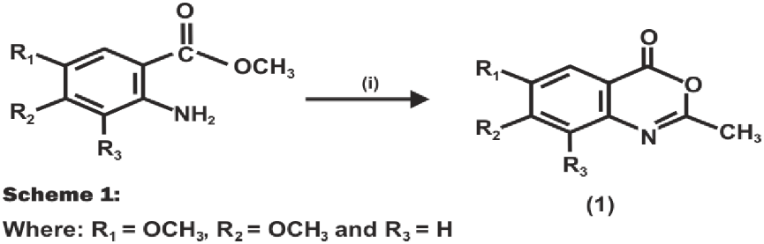

Where: R₁ ₌ H, R₂ = OCH₃ and R₃ = H
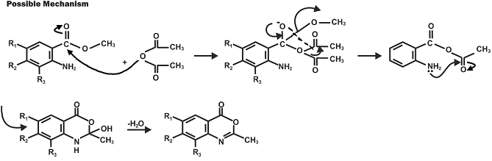

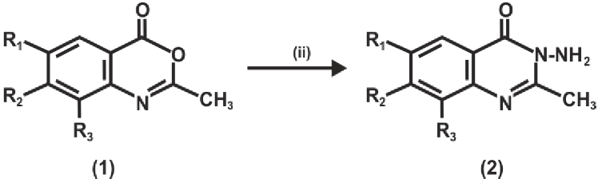

Scheme 2
Possible mechanism

