Table 2: ¹³C-NMR of Synthesized compounds
Compound No | δ (ppm) Carbon atom number
z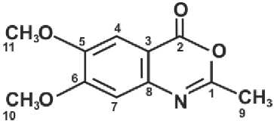 | 168.28(C-2), 155.80(C-6), 149.23(C-8) 140.28 (C-1), 113.37 (C-5), 100.56 (C-4) 100.05 (C-3), 100.01 (C-7), 16.95 (C-9) 56.13 (C-10), 51.93 (C-11)
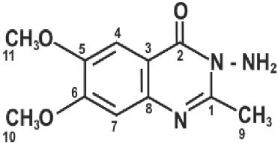 | 160.28 (C-2), 155.29 (C-6), 154.57 (C-1) 149.07 (C-8), 143.77 (C-5), 113.65 (C-1) 108.24 (C-3), 105.64 (C-7), 56.80 (C-10) 56.63 (C-11), 22.58 (C-9)

Table 3: ¹³C-NMR of Synthesized compounds
Compound No | δ (ppm)
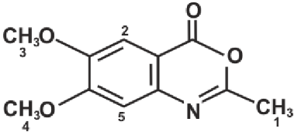 | 7.16 (s, 1H), 6.40 (s, 1H), 3.78 (s, 6H), 3.68 (s, 3H)
 | 7.41 (s, H), 7.10 (s, 1H), 5.80 (s, 2H), 3.90 (s, 6H), 2.58 (s, 3H)

