Sup Table 1 The gradient elution procedures of UPLC in the positive and negative ion mode
Positive |  |  |  | Negative
Time (min) | Water(%) | ACN(%) |  | Time (min) | Water(%) | ACN(%)
0 | 98 | 2 |  | 0 | 98 | 2
0.5 | 98 | 2 |  | 0.5 | 98 | 2
1.5 | 80 | 20 |  | 2 | 80 | 20
6 | 30 | 70 |  | 3 | 30 | 70
10 | 2 | 98 |  | 7.5 | 25 | 75
12 | 2 | 98 |  | 10.5 | 2 | 98
14 | 98 | 2 |  | 12 | 2 | 98
16 | 98 | 2 |  | 14 | 98 | 2
- | - | - |  | 16 | 98 | 2

Sup Table 2 The gradient elution procedures of UPLC in the positive mode

Sample names | V1 | V2 | V3 | V4 | V5
L1 | 0.99-86.0996 | 2.47-632.8042 | 4.50-274.2791 | 7.07-496.3124 | 8.12-524.3435
L2 | 0.99-86.1003 | 2.47-632.8018 | 4.51-274.2788 | 7.08-496.3114 | 8.15-524.3439
L3 | 0.99-86.1008 | 2.47-632.8027 | 4.51-274.2781 | 7.07-496.3124 | 8.13-524.3452
L4 | 0.99-86.1000 | 2.47-632.8030 | 4.51-274.2791 | 7.07-496.3116 | 8.13-524.3470
L5 | 0.99-86.1013 | 2.47-632.8030 | 4.51-274.2797 | 7.08-496.3130 | 8.14-524.3492
L7 | 0.99-86.1009 | 2.47-632.8022 | 4.52-274.2796 | 7.08-496.3118 | 8.13-524.3488
L8 | 0.99-86.1009 | 2.47-632.7998 | 4.51-274.2787 | 7.08-496.3112 | 8.15-524.3427
L9 | 0.99-86.1004 | 2.47-632.8033 | 4.51-274.2768 | 7.09-496.3120 | 8.15-524.3417
L10 | 0.99-86.0993 | 2.48-632.8022 | 4.52-274.2790 | 7.08-496.3109 | 8.14-524.3436
C1 | 1.00-86.0997 | 2.47-632.8027 | 4.51-274.2801 | 7.08-496.3120 | 8.12-524.3417
C2 | 0.99-86.0995 | 2.47-632.8037 | 4.51-274.2794 | 7.08-496.3141 | 8.14-524.3457
C3 | 1.00-86.1000 | 2.47-632.8040 | 4.51-274.2791 | 7.08-496.3136 | 8.13-524.3470
C4 | 1.00-86.1013 | 2.47-632.8030 | 4.51-274.2797 | 7.08-496.3132 | 8.12-524.3492
C5 | 1.00-86.1009 | 2.47-632.8027 | 4.51-274.2791 | 7.08-496.3140 | 8.13-524.3488
C6 | 1.00-86.1009 | 2.47-632.8022 | 4.51-274.2801 | 7.08-496.3120 | 8.12-524.3474
C7 | 1.00-86.1004 | 2.47-632.8032 | 4.51-274.2787 | 7.08-496.3145 | 8.13-524.3405
C8 | 1.00-86.1018 | 2.48-632.8033 | 4.51-274.2772 | 7.09-496.3117 | 8.15-524.3417
C9 | 1.00-86.0998 | 2.48-632.8022 | 4.52-274.2785 | 7.08-496.3109 | 8.14-524.3436
C10 | 1.00-86.1003 | 2.47-632.8018 | 4.51-274.2791 | 7.08-496.3126 | 8.15-524.3460
RSD | 0.5157(0.0008) | 0.1516(0.0002) | 0.1017(0.0003) | 0.0741(0.0002) | 0.1382(0.0005)

Sup Table 3 The gradient elution procedures of UPLC in the negative ion mode
Sample names | V1 | V2 | V3 | V4 | V5
L1 | 1.04-167.0191 | 3.78-175.0240 | 5.98-540.3157 | 7.18-568.3532 | 9.62-327.2299
L2 | 1.04-167.0206 | 3.78-175.0240 | 5.97-540.3160 | 7.15-568.3515 | 9.62-327.2298
L3 | 1.04-167.0203 | 3.78-175.0236 | 5.98-540.3138 | 7.17-568.3535 | 9.64-327.2293
L4 | 1.04-167.0197 | 3.79-175.0228 | 5.98-540.3159 | 7.17-568.3564 | 9.64-327.2300
L5 | 1.04-167.0197 | 3.78-175.0246 | 5.97-540.3175 | 7.15-568.3541 | 9.63-327.2305
L7 | 1.04-167.0194 | 3.78-175.0235 | 5.97-540.3143 | 7.17-568.3575 | 9.63-327.2294
L8 | 1.04-167.0204 | 3.78-175.0242 | 5.98-540.3167 | 7.14-568.3542 | 9.64-327.2305
L9 | 1.04-167.0202 | 3.78-175.0231 | 5.96-540.3158 | 7.15-568.3536 | 9.61-327.2303
L10 | 1.04-167.0208 | 3.78-175.0244 | 5.96-540.3134 | 7.15-568.3527 | 9.63-327.2276
C1 | 1.04-167.0193 | 3.78-175.0230 | 5.98-540.3158 | 7.17-568.3525 | 9.63-327.2265
C2 | 1.04-167.0203 | 3.78-175.0238 | 5.98-540.3132 | 7.17-568.3538 | 9.64-327.2274
C3 | 1.04-167.0198 | 3.78-175.0241 | 5.98-540.3130 | 7.16-568.3505 | 9.64-327.2282
C4 | 1.04-167.0200 | 3.78-175.0237 | 5.98-540.3128 | 7.17-568.3520 | 9.63-327.2284
C5 | 1.04-167.0206 | 3.78-175.0244 | 5.98-540.3155 | 7.17-568.3550 | 9.64-327.2276
C6 | 1.03-167.0206 | 3.78-175.0244 | 5.98-540.3138 | 7.17-568.3536 | 9.64-327.2282
C7 | 1.04-167.0198 | 3.78-175.0249 | 5.98-540.3122 | 7.14-568.3526 | 9.62-327.2273
C8 | 1.04-167.0194 | 3.76-175.0253 | 5.98-540.3161 | 7.15-568.3568 | 9.61-327.2278
C9 | 1.04-167.0206 | 3.78-175.0248 | 5.99-540.3159 | 7.19-568.3550 | 9.65-327.2294
C10 | 1.04-167.0194 | 3.79-175.0239 | 6.00-540.3164 | 7.18-568.3574 | 9.65-327.2275
RSD | 0.2207(0.0003) | 0.1527(0.0004) | 0.1535(0.0003) | 0.1977(0.0003) | 0.1227(0.0004)

Sup Table 4 The differential variables of calcium deficiency in positive ion mode by EZ-info software
Retention Time | Mass | VIP | P-value | AUC
0.63 | 158.9731 | 4.39 | 0.006 | 0.862
0.63 | 294.9503 | 2.34 | 0.041 | 0.825
0.63 | 906.8225 | 3.62 | 0.001 | 0.950
0.64 | 174.9487 | 2.48 | 0.020 | 0.875
0.64 | 226.9579 | 9.93 | 0.001 | 0.975
0.64 | 242.9360 | 3.74 | 0.005 | 0.900
0.64 | 362.9346 | 6.10 | 0.000 | 1.000
0.64 | 430.9170 | 5.70 | 0.000 | 1.000
0.64 | 498.9059 | 6.29 | 0.027 | 0.756
0.64 | 634.8770 | 4.79 | 0.000 | 1.000
0.64 | 770.8497 | 3.25 | 0.001 | 1.000
0.70 | 270.0048 | 2.15 | 0.000 | 0.938
0.72 | 191.0511 | 2.38 | 0.000 | 0.975
0.72 | 204.1242 | 4.44 | 0.000 | 0.975
0.76 | 258.1115 | 3.23 | 0.000 | 0.925
0.77 | 118.0875 | 4.44 | 0.001 | 0.875
0.78 | 148.0641 | 3.56 | 0.000 | 0.938
0.79 | 203.0627 | 3.12 | 0.017 | 0.825
0.79 | 116.0778 | 2.25 | 0.000 | 1.000
0.80 | 61.0493 | 2.32 | 0.006 | 0.837
0.83 | 292.1115 | 2.30 | 0.005 | 0.888
0.92 | 261.1046 | 3.27 | 0.003 | 0.937
0.94 | 262.1298 | 2.82 | 0.041 | 0.825
0.95 | 280.1484 | 2.91 | 0.000 | 1.000
0.98 | 182.0822 | 1.91 | 0.041 | 0.788
1.00 | 132.1039 | 1.52 | 0.046 | 0.825
1.44 | 229.1646 | 2.18 | 0.042 | 0.800
2.10 | 120.0865 | 2.28 | 0.008 | 0.838
2.20 | 310.1387 | 2.42 | 0.001 | 0.913
2.46 | 579.2791 | 2.80 | 0.016 | 0.775
2.46 | 632.8018 | 8.36 | 0.000 | 0.938
2.46 | 777.3585 | 3.06 | 0.000 | 0.987
2.47 | 203.1454 | 2.07 | 0.000 | 0.900
2.47 | 582.2833 | 5.15 | 0.000 | 0.962
2.47 | 588.2869 | 2.16 | 0.000 | 0.987
2.59 | 834.8696 | 6.34 | 0.000 | 0.978
2.92 | 225.1337 | 3.29 | 0.001 | 0.931
2.93 | 157.0630 | 2.80 | 0.000 | 1.000
5.69 | 542.3262 | 3.54 | 0.010 | 0.850
5.70 | 560.3378 | 3.31 | 0.004 | 0.888
6.00 | 424.3485 | 2.53 | 0.013 | 0.837
6.26 | 400.3497 | 4.39 | 0.000 | 0.962
6.35 | 468.3130 | 3.05 | 0.018 | 0.825
6.40 | 426.3641 | 2.91 | 0.014 | 0.850
6.44 | 185.1602 | 2.25 | 0.017 | 0.925
7.07 | 991.6612 | 3.19 | 0.034 | 0.778
7.07 | 184.0817 | 3.81 | 0.042 | 0.838
7.33 | 522.3576 | 2.14 | 0.000 | 0.938
7.47 | 544.3421 | 4.37 | 0.030 | 0.794
7.72 | 303.2411 | 4.20 | 0.019 | 0.850
7.73 | 605.4590 | 2.76 | 0.011 | 0.913
7.75 | 464.3177 | 3.60 | 0.019 | 0.738
7.76 | 548.3729 | 4.36 | 0.000 | 1.000
7.78 | 510.3530 | 3.75 | 0.015 | 0.913
7.99 | 524.3772 | 2.68 | 0.041 | 0.725
8.53 | 550.3875 | 4.85 | 0.024 | 0.850
8.61 | 141.1474 | 3.31 | 0.005 | 0.900
8.66 | 466.3359 | 2.63 | 0.013 | 0.875
9.60 | 552.4059 | 3.05 | 0.039 | 0.762

Sup Table 5 The differential variables of calcium deficiency in negative ion mode by EZ-info software
Retention Time | Mass | VIP | P-value | AUC
0.58 | 180.9726 | 2.97 | 0.015 | 0.833
0.68 | 520.9087 | 3.40 | 0.002 | 0.877
0.69 | 588.8979 | 3.40 | 0.002 | 0.901
0.70 | 452.9203 | 4.17 | 0.006 | 0.852
0.70 | 316.9447 | 3.92 | 0.004 | 0.877
0.70 | 384.9333 | 3.67 | 0.001 | 0.914
0.70 | 180.9721 | 3.16 | 0.001 | 0.901
0.71 | 248.9557 | 5.02 | 0.030 | 0.889
0.81 | 124.0076 | 1.62 | 0.004 | 0.889
1.00 | 91.0047 | 2.12 | 0.034 | 0.759
1.21 | 89.0231 | 2.93 | 0.010 | 0.808
1.21 | 133.0137 | 2.56 | 0.000 | 0.617
1.21 | 187.0410 | 2.06 | 0.036 | 0.642
1.21 | 115.0048 | 1.68 | 0.000 | 1.000
1.53 | 194.9450 | 1.94 | 0.027 | 0.800
1.54 | 96.9701 | 2.52 | 0.005 | 0.864
2.23 | 177.0393 | 2.40 | 0.001 | 1.000
2.52 | 386.0335 | 3.38 | 0.003 | 0.883
2.87 | 630.7886 | 7.52 | 0.000 | 1.000
2.89 | 775.3502 | 2.81 | 0.005 | 0.889
2.90 | 580.2681 | 4.91 | 0.000 | 0.998
3.07 | 832.8617 | 5.09 | 0.000 | 1.000
3.22 | 197.8081 | 2.40 | 0.021 | 0.827
3.34 | 417.1503 | 3.92 | 0.005 | 1.000
3.39 | 241.1158 | 12.28 | 0.000 | 1.000
3.40 | 198.1125 | 2.72 | 0.000 | 1.000
3.46 | 697.2991 | 2.47 | 0.010 | 0.914
3.49 | 255.0979 | 3.31 | 0.000 | 1.000
3.65 | 239.1030 | 2.69 | 0.000 | 1.000
4.01 | 283.0701 | 2.52 | 0.002 | 0.926
4.87 | 281.0902 | 3.22 | 0.000 | 1.000
4.87 | 129.0565 | 2.69 | 0.000 | 1.000
4.95 | 377.1705 | 2.46 | 0.000 | 1.000
4.96 | 225.1139 | 9.36 | 0.000 | 1.000
4.96 | 541.2249 | 2.96 | 0.000 | 1.000
4.96 | 721.3508 | 2.34 | 0.001 | 1.000
4.97 | 473.2313 | 2.46 | 0.000 | 1.000
4.98 | 293.1120 | 3.62 | 0.000 | 1.000
5.02 | 313.1197 | 2.47 | 0.006 | 0.901
5.37 | 220.8520 | 2.81 | 0.000 | 0.951
5.37 | 218.8560 | 2.62 | 0.000 | 0.951
5.37 | 176.8635 | 2.38 | 0.001 | 0.926
5.37 | 174.8658 | 2.14 | 0.000 | 0.938
5.43 | 512.2987 | 2.91 | 0.002 | 0.901
5.58 | 538.3111 | 3.13 | 0.024 | 0.802
5.59 | 212.0009 | 2.31 | 0.001 | 0.951
5.59 | 590.2766 | 2.53 | 0.003 | 0.877
5.59 | 478.2925 | 2.37 | 0.014 | 0.827
5.63 | 118.9046 | 2.83 | 0.016 | 0.784
5.64 | 185.1497 | 2.15 | 0.006 | 0.988
6.18 | 540.3090 | 8.45 | 0.000 | 1.000
6.39 | 566.3339 | 5.80 | 0.008 | 0.827
6.39 | 506.3234 | 3.23 | 0.041 | 0.753
6.49 | 343.2279 | 2.20 | 0.004 | 0.975
6.64 | 301.2172 | 2.85 | 0.001 | 0.951
6.64 | 814.5634 | 2.39 | 0.001 | 0.914
6.64 | 257.2272 | 2.29 | 0.000 | 0.988
6.64 | 840.5790 | 2.02 | 0.003 | 0.951
6.65 | 179.1078 | 2.43 | 0.000 | 0.988
6.72 | 554.3447 | 4.56 | 0.003 | 0.827
6.87 | 319.2272 | 3.13 | 0.030 | 0.796
7.04 | 319.2271 | 3.40 | 0.012 | 0.827
7.64 | 347.2585 | 3.56 | 0.000 | 0.951
9.63 | 327.2293 | 6.52 | 0.001 | 0.889
9.63 | 283.2422 | 3.33 | 0.003 | 0.926
9.83 | 327.2331 | 2.41 | 0.012 | 0.802
9.96 | 303.2297 | 3.68 | 0.028 | 0.840
10.25 | 279.2289 | 3.68 | 0.028 | 0.733
10.25 | 379.1560 | 4.77 | 0.022 | 0.815
10.26 | 442.0724 | 2.16 | 0.007 | 0.864

Sup Table 6 The differential variables of calcium deficiency in negative ion mode by MetaboAnalystR.
No | RT(min) | Mass | T-stat | P-value | #NAME? | FDR
1 | 0.52 | 309.1775 | -2.889 | 0.010 | 1.991 | 0.148
2 | 0.52 | 359.0399 | -2.539 | 0.021 | 1.674 | 0.211
3 | 0.53 | 177.0720 | -3.030 | 0.008 | 2.122 | 0.127
4 | 0.54 | 884.8326 | -3.356 | 0.004 | 2.426 | 0.081
5 | 0.54 | 517.0074 | -2.671 | 0.016 | 1.792 | 0.182
6 | 0.63 | 566.8919 | 4.962 | 0.000 | 3.925 | 0.008
7 | 0.63 | 106.9600 | 4.329 | 0.000 | 3.342 | 0.020
8 | 0.63 | 294.9503 | 3.014 | 0.008 | 2.107 | 0.129
9 | 0.63 | 906.8225 | 2.586 | 0.019 | 1.716 | 0.204
10 | 0.63 | 940.8042 | 2.402 | 0.028 | 1.553 | 0.251
11 | 0.64 | 362.9346 | 6.612 | 0.000 | 5.356 | 0.001
12 | 0.64 | 174.9487 | 5.359 | 0.000 | 4.283 | 0.004
13 | 0.64 | 242.9360 | 5.382 | 0.000 | 4.304 | 0.004
14 | 0.64 | 498.9059 | 4.722 | 0.000 | 3.706 | 0.010
15 | 0.64 | 430.9170 | 3.644 | 0.002 | 2.697 | 0.053
16 | 0.64 | 219.0959 | 2.676 | 0.016 | 1.797 | 0.181
17 | 0.64 | 634.8770 | 2.434 | 0.026 | 1.581 | 0.243
18 | 0.64 | 982.7919 | 2.314 | 0.033 | 1.475 | 0.272
19 | 0.69 | 355.0687 | 3.303 | 0.004 | 2.376 | 0.088
20 | 0.70 | 270.0048 | -5.188 | 0.000 | 4.130 | 0.005
21 | 0.70 | 473.9637 | -3.427 | 0.003 | 2.493 | 0.077
22 | 0.70 | 167.0432 | 3.260 | 0.005 | 2.337 | 0.093
23 | 0.70 | 226.1167 | 3.071 | 0.007 | 2.160 | 0.121
24 | 0.70 | 559.0219 | 3.018 | 0.008 | 2.111 | 0.129
25 | 0.70 | 405.9792 | -2.896 | 0.010 | 1.998 | 0.148
26 | 0.70 | 745.9080 | -2.879 | 0.010 | 1.982 | 0.148
27 | 0.70 | 949.8610 | -2.577 | 0.020 | 1.708 | 0.204
28 | 0.70 | 266.0699 | 2.226 | 0.040 | 1.400 | 0.303
29 | 0.70 | 309.0201 | 2.151 | 0.046 | 1.335 | 0.331
30 | 0.70 | 935.8510 | -2.134 | 0.048 | 1.321 | 0.335
31 | 0.70 | 595.9222 | -2.113 | 0.050 | 1.304 | 0.339
32 | 0.71 | 327.0296 | 6.400 | 0.000 | 5.181 | 0.001
33 | 0.71 | 299.0322 | -4.937 | 0.000 | 3.903 | 0.008
34 | 0.71 | 313.0382 | -4.873 | 0.000 | 3.845 | 0.008
35 | 0.71 | 541.9514 | -4.480 | 0.000 | 3.482 | 0.016
36 | 0.71 | 484.9780 | 4.124 | 0.001 | 3.150 | 0.028
37 | 0.71 | 162.1209 | -3.677 | 0.002 | 2.729 | 0.051
38 | 0.71 | 300.0194 | 3.431 | 0.003 | 2.497 | 0.077
39 | 0.71 | 677.9212 | -3.376 | 0.004 | 2.445 | 0.081
40 | 0.71 | 281.0253 | 3.340 | 0.004 | 2.411 | 0.082
41 | 0.71 | 386.0658 | 3.119 | 0.006 | 2.205 | 0.111
42 | 0.71 | 370.0695 | -2.707 | 0.015 | 1.825 | 0.178
43 | 0.71 | 395.0170 | 2.707 | 0.015 | 1.825 | 0.178
44 | 0.71 | 609.9365 | -2.637 | 0.017 | 1.762 | 0.191
45 | 0.71 | 503.9812 | 2.557 | 0.020 | 1.690 | 0.208
46 | 0.72 | 204.1324 | 6.253 | 0.000 | 5.058 | 0.002
47 | 0.72 | 191.0511 | 5.929 | 0.000 | 4.783 | 0.002
48 | 0.72 | 356.0560 | 4.425 | 0.000 | 3.431 | 0.017
49 | 0.72 | 413.0963 | -4.009 | 0.001 | 3.041 | 0.034
50 | 0.72 | 470.1268 | -3.920 | 0.001 | 2.958 | 0.039
51 | 0.72 | 617.0602 | -3.894 | 0.001 | 2.933 | 0.040
52 | 0.72 | 495.0733 | 3.869 | 0.001 | 2.909 | 0.040
53 | 0.72 | 250.0917 | 3.770 | 0.002 | 2.816 | 0.045
54 | 0.72 | 692.1376 | -3.660 | 0.002 | 2.712 | 0.052
55 | 0.72 | 315.9966 | 3.428 | 0.003 | 2.494 | 0.077
56 | 0.72 | 429.1041 | -3.152 | 0.006 | 2.235 | 0.109
57 | 0.72 | 631.0503 | 3.136 | 0.006 | 2.221 | 0.111
58 | 0.72 | 506.0353 | -2.940 | 0.009 | 2.038 | 0.140
59 | 0.72 | 502.9931 | -2.857 | 0.011 | 1.962 | 0.152
60 | 0.72 | 220.0787 | 2.809 | 0.012 | 1.918 | 0.161
61 | 0.72 | 448.0047 | 2.773 | 0.013 | 1.885 | 0.167
62 | 0.72 | 563.0550 | 2.762 | 0.013 | 1.875 | 0.169
63 | 0.72 | 275.0728 | -2.739 | 0.014 | 1.854 | 0.174
64 | 0.72 | 302.0850 | -2.731 | 0.014 | 1.847 | 0.176
65 | 0.72 | 638.1526 | -2.614 | 0.018 | 1.741 | 0.198
66 | 0.72 | 749.1504 | -2.604 | 0.019 | 1.732 | 0.200
67 | 0.72 | 177.0393 | 2.577 | 0.020 | 1.708 | 0.204
68 | 0.72 | 261.0575 | -2.578 | 0.020 | 1.709 | 0.204
69 | 0.72 | 536.0628 | 2.502 | 0.023 | 1.641 | 0.222
70 | 0.72 | 456.1155 | 2.406 | 0.028 | 1.556 | 0.251
71 | 0.72 | 435.9968 | 2.395 | 0.028 | 1.546 | 0.253
72 | 0.72 | 244.0421 | 2.358 | 0.031 | 1.514 | 0.259
73 | 0.72 | 754.1760 | -2.359 | 0.031 | 1.515 | 0.259
74 | 0.72 | 613.1435 | -2.301 | 0.034 | 1.465 | 0.276
75 | 0.72 | 342.0650 | -2.202 | 0.042 | 1.380 | 0.313
76 | 0.72 | 590.0315 | 2.156 | 0.046 | 1.340 | 0.331
77 | 0.72 | 527.1477 | 2.133 | 0.048 | 1.321 | 0.335
78 | 0.73 | 499.1363 | -6.076 | 0.000 | 4.909 | 0.002
79 | 0.73 | 506.0990 | 5.491 | 0.000 | 4.400 | 0.004
80 | 0.73 | 359.0998 | 3.900 | 0.001 | 2.939 | 0.040
81 | 0.73 | 668.1772 | 3.130 | 0.006 | 2.215 | 0.111
82 | 0.73 | 611.1551 | -3.125 | 0.006 | 2.210 | 0.111
83 | 0.73 | 338.0510 | 2.720 | 0.015 | 1.837 | 0.178
84 | 0.73 | 388.1252 | 2.706 | 0.015 | 1.824 | 0.178
85 | 0.73 | 151.0559 | 2.605 | 0.018 | 1.733 | 0.200
86 | 0.73 | 731.1048 | 2.231 | 0.039 | 1.404 | 0.303
87 | 0.73 | 169.0687 | 2.216 | 0.041 | 1.392 | 0.306
88 | 0.73 | 164.0375 | 2.166 | 0.045 | 1.349 | 0.327
89 | 0.73 | 83.0700 | 2.111 | 0.050 | 1.302 | 0.339
90 | 0.74 | 112.0592 | 4.974 | 0.000 | 3.937 | 0.008
91 | 0.74 | 234.1075 | -3.758 | 0.002 | 2.805 | 0.045
92 | 0.74 | 184.0857 | -3.264 | 0.005 | 2.340 | 0.093
93 | 0.74 | 274.1014 | -3.161 | 0.006 | 2.243 | 0.108
94 | 0.74 | 484.1279 | 2.531 | 0.022 | 1.667 | 0.213
95 | 0.75 | 216.0947 | -4.557 | 0.000 | 3.554 | 0.014
96 | 0.75 | 152.0413 | 2.418 | 0.027 | 1.567 | 0.248
97 | 0.76 | 258.1192 | -4.275 | 0.001 | 3.291 | 0.021
98 | 0.76 | 175.0833 | -2.242 | 0.039 | 1.413 | 0.299
99 | 0.77 | 118.0910 | -4.317 | 0.000 | 3.330 | 0.020
100 | 0.77 | 252.1127 | -2.894 | 0.010 | 1.997 | 0.148
101 | 0.78 | 148.0685 | -5.241 | 0.000 | 4.177 | 0.005
102 | 0.78 | 278.1419 | -2.424 | 0.027 | 1.572 | 0.246
103 | 0.79 | 203.0627 | 8.793 | 0.000 | 7.006 | 0.000
104 | 0.79 | 116.0778 | -2.782 | 0.013 | 1.894 | 0.165
105 | 0.79 | 70.0747 | -2.494 | 0.023 | 1.634 | 0.224
106 | 0.80 | 61.0493 | 3.099 | 0.007 | 2.186 | 0.115
107 | 0.82 | 298.1512 | 3.007 | 0.008 | 2.100 | 0.129
108 | 0.83 | 292.1115 | -3.184 | 0.005 | 2.265 | 0.105
109 | 0.85 | 449.0854 | -3.972 | 0.001 | 3.006 | 0.037
110 | 0.86 | 310.1162 | -2.538 | 0.021 | 1.674 | 0.211
111 | 0.88 | 243.1051 | 2.960 | 0.009 | 2.057 | 0.136
112 | 0.91 | 102.0639 | -2.367 | 0.030 | 1.522 | 0.259
113 | 0.92 | 261.1046 | 4.900 | 0.000 | 3.869 | 0.008
114 | 0.94 | 133.0395 | -2.686 | 0.016 | 1.806 | 0.181
115 | 0.94 | 104.0613 | -2.479 | 0.024 | 1.621 | 0.230
116 | 0.94 | 244.1276 | -2.160 | 0.045 | 1.343 | 0.330
117 | 0.94 | 262.1371 | -2.110 | 0.050 | 1.301 | 0.339
118 | 0.95 | 280.1484 | -4.754 | 0.000 | 3.735 | 0.010
119 | 0.96 | 160.0841 | 2.966 | 0.009 | 2.062 | 0.136
120 | 0.96 | 123.0577 | -2.746 | 0.014 | 1.860 | 0.173
121 | 0.98 | 312.1243 | -2.331 | 0.032 | 1.491 | 0.267
122 | 0.98 | 182.0902 | -2.249 | 0.038 | 1.420 | 0.296
123 | 0.99 | 294.1425 | -2.169 | 0.045 | 1.351 | 0.327
124 | 0.99 | 344.1438 | -2.142 | 0.047 | 1.328 | 0.332
125 | 1.00 | 132.1078 | 2.543 | 0.021 | 1.677 | 0.211
126 | 1.07 | 61.0504 | -3.883 | 0.001 | 2.923 | 0.040
127 | 1.31 | 274.1031 | -3.886 | 0.001 | 2.925 | 0.040
128 | 1.44 | 229.1646 | -2.125 | 0.049 | 1.313 | 0.338
129 | 1.56 | 256.9638 | 3.030 | 0.008 | 2.122 | 0.127
130 | 1.59 | 233.0731 | 5.477 | 0.000 | 4.388 | 0.004
131 | 1.59 | 219.0114 | 3.716 | 0.002 | 2.765 | 0.048
132 | 1.60 | 613.1597 | -2.291 | 0.035 | 1.456 | 0.279
133 | 1.65 | 243.0328 | -2.507 | 0.023 | 1.645 | 0.221
134 | 2.09 | 294.1654 | -2.547 | 0.021 | 1.681 | 0.211
135 | 2.10 | 120.0865 | -2.860 | 0.011 | 1.965 | 0.152
136 | 2.10 | 131.0580 | -2.461 | 0.025 | 1.605 | 0.235
137 | 2.20 | 310.1387 | -3.296 | 0.004 | 2.370 | 0.088
138 | 2.24 | 497.2371 | 2.684 | 0.016 | 1.804 | 0.181
139 | 2.26 | 246.1803 | -2.458 | 0.025 | 1.602 | 0.235
140 | 2.37 | 349.1495 | -2.336 | 0.032 | 1.495 | 0.266
141 | 2.38 | 229.1106 | -2.376 | 0.029 | 1.530 | 0.259
142 | 2.42 | 647.8047 | 2.149 | 0.046 | 1.334 | 0.331
143 | 2.44 | 698.3281 | 3.416 | 0.003 | 2.482 | 0.078
144 | 2.45 | 947.4964 | 3.001 | 0.008 | 2.095 | 0.129
145 | 2.45 | 713.8308 | 2.155 | 0.046 | 1.339 | 0.331
146 | 2.46 | 632.8018 | 8.000 | 0.000 | 6.438 | 0.000
147 | 2.46 | 579.2791 | 6.067 | 0.000 | 4.901 | 0.002
148 | 2.46 | 674.9910 | -4.080 | 0.001 | 3.108 | 0.030
149 | 2.46 | 675.3210 | -3.378 | 0.004 | 2.447 | 0.081
150 | 2.46 | 777.3585 | 3.221 | 0.005 | 2.300 | 0.099
151 | 2.47 | 582.2833 | 8.097 | 0.000 | 6.509 | 0.000
152 | 2.47 | 203.1454 | 6.477 | 0.000 | 5.245 | 0.001
153 | 2.47 | 588.2869 | 5.201 | 0.000 | 4.142 | 0.005
154 | 2.47 | 290.1819 | 5.065 | 0.000 | 4.020 | 0.007
155 | 2.47 | 573.2821 | 4.780 | 0.000 | 3.759 | 0.010
156 | 2.47 | 522.7450 | 4.289 | 0.000 | 3.304 | 0.020
157 | 2.47 | 623.8018 | 3.941 | 0.001 | 2.978 | 0.038
158 | 2.47 | 874.4120 | 2.823 | 0.012 | 1.931 | 0.158
159 | 2.47 | 668.3227 | 2.526 | 0.022 | 1.662 | 0.214
160 | 2.48 | 537.7630 | 5.648 | 0.000 | 4.539 | 0.003
161 | 2.48 | 961.4455 | 5.354 | 0.000 | 4.279 | 0.004
162 | 2.48 | 860.4678 | 4.351 | 0.000 | 3.362 | 0.020
163 | 2.48 | 528.7573 | 3.378 | 0.004 | 2.447 | 0.081
164 | 2.48 | 943.4374 | 3.010 | 0.008 | 2.103 | 0.129
165 | 2.53 | 870.3949 | 2.704 | 0.015 | 1.822 | 0.178
166 | 2.54 | 860.4218 | 8.600 | 0.000 | 6.871 | 0.000
167 | 2.54 | 478.2387 | 3.865 | 0.001 | 2.906 | 0.040
168 | 2.54 | 531.7593 | 3.744 | 0.002 | 2.792 | 0.046
169 | 2.56 | 327.2090 | 2.360 | 0.031 | 1.516 | 0.259
170 | 2.58 | 845.8581 | 3.498 | 0.003 | 2.560 | 0.071
171 | 2.58 | 517.2768 | 2.559 | 0.020 | 1.692 | 0.208
172 | 2.59 | 834.8696 | 7.760 | 0.000 | 6.259 | 0.000
173 | 2.59 | 295.1397 | -2.661 | 0.016 | 1.784 | 0.184
174 | 2.63 | 783.8308 | -2.221 | 0.040 | 1.396 | 0.304
175 | 2.70 | 713.8244 | 4.290 | 0.000 | 3.305 | 0.020
176 | 2.84 | 699.3107 | 2.678 | 0.016 | 1.799 | 0.181
177 | 2.91 | 203.1219 | 2.230 | 0.040 | 1.403 | 0.303
178 | 2.92 | 225.1337 | 6.323 | 0.000 | 5.117 | 0.001
179 | 2.92 | 265.1288 | 3.339 | 0.004 | 2.410 | 0.082
180 | 2.92 | 130.0592 | 2.175 | 0.044 | 1.356 | 0.326
181 | 2.93 | 157.0706 | 10.897 | 0.000 | 8.363 | 0.000
182 | 2.93 | 792.3462 | 4.581 | 0.000 | 3.576 | 0.013
183 | 2.93 | 243.1442 | 3.029 | 0.008 | 2.121 | 0.127
184 | 3.09 | 756.8228 | 3.836 | 0.001 | 2.878 | 0.041
185 | 3.13 | 286.2109 | 2.443 | 0.026 | 1.589 | 0.241
186 | 3.20 | 251.1144 | 2.180 | 0.044 | 1.361 | 0.326
187 | 3.21 | 457.2495 | 2.330 | 0.032 | 1.490 | 0.267
188 | 3.22 | 841.6054 | 2.382 | 0.029 | 1.535 | 0.257
189 | 3.71 | 247.1624 | 2.897 | 0.010 | 1.999 | 0.148
190 | 3.71 | 229.1550 | 2.710 | 0.015 | 1.828 | 0.178
191 | 3.82 | 292.1921 | 2.260 | 0.037 | 1.429 | 0.291
192 | 4.26 | 86.3654 | 2.294 | 0.035 | 1.459 | 0.278
193 | 4.36 | 885.0180 | 2.367 | 0.030 | 1.522 | 0.259
194 | 4.64 | 299.2110 | -2.793 | 0.012 | 1.903 | 0.164
195 | 4.65 | 227.1451 | 3.249 | 0.005 | 2.326 | 0.094
196 | 4.68 | 386.2973 | 3.661 | 0.002 | 2.713 | 0.052
197 | 4.82 | 347.2310 | 2.356 | 0.031 | 1.512 | 0.259
198 | 4.83 | 329.2177 | 2.884 | 0.010 | 1.987 | 0.148
199 | 4.90 | 368.2890 | 2.307 | 0.034 | 1.469 | 0.275
200 | 4.93 | 388.3138 | 2.132 | 0.048 | 1.320 | 0.335
201 | 5.03 | 213.1589 | 3.763 | 0.002 | 2.809 | 0.045
202 | 5.03 | 185.1631 | 3.169 | 0.006 | 2.251 | 0.107
203 | 5.03 | 231.1696 | 2.644 | 0.017 | 1.769 | 0.190
204 | 5.12 | 628.3277 | -5.480 | 0.000 | 4.391 | 0.004
205 | 5.40 | 440.3468 | 2.830 | 0.012 | 1.937 | 0.157
206 | 5.40 | 518.3266 | -2.120 | 0.049 | 1.309 | 0.339
207 | 5.45 | 396.3196 | 3.765 | 0.002 | 2.811 | 0.045
208 | 5.51 | 633.2572 | 2.459 | 0.025 | 1.602 | 0.235
209 | 5.60 | 372.3188 | 2.284 | 0.035 | 1.450 | 0.281
210 | 5.68 | 584.3350 | -2.703 | 0.015 | 1.822 | 0.178
211 | 5.69 | 542.3262 | -2.898 | 0.010 | 2.000 | 0.148
212 | 5.69 | 566.3304 | -2.300 | 0.034 | 1.464 | 0.276
213 | 5.70 | 560.3378 | -3.301 | 0.004 | 2.374 | 0.088
214 | 5.75 | 378.2503 | -2.675 | 0.016 | 1.796 | 0.181
215 | 5.81 | 398.3355 | 2.967 | 0.009 | 2.064 | 0.136
216 | 6.00 | 424.3485 | 3.455 | 0.003 | 2.519 | 0.076
217 | 6.15 | 299.2088 | 2.558 | 0.020 | 1.691 | 0.208
218 | 6.18 | 588.3678 | -2.143 | 0.047 | 1.329 | 0.332
219 | 6.20 | 142.1660 | -2.596 | 0.019 | 1.725 | 0.202
220 | 6.26 | 400.3497 | 5.277 | 0.000 | 4.210 | 0.005
221 | 6.35 | 450.3064 | -4.318 | 0.000 | 3.331 | 0.020
222 | 6.40 | 426.3641 | 3.800 | 0.001 | 2.845 | 0.044
223 | 6.43 | 213.1582 | 2.442 | 0.026 | 1.588 | 0.241
224 | 6.43 | 516.2970 | 2.401 | 0.028 | 1.552 | 0.251
225 | 6.44 | 185.1602 | 2.892 | 0.010 | 1.994 | 0.148
226 | 6.44 | 369.1436 | 2.410 | 0.028 | 1.559 | 0.250
227 | 6.44 | 111.1248 | 2.318 | 0.033 | 1.479 | 0.272
228 | 6.44 | 253.1510 | 2.116 | 0.049 | 1.306 | 0.339
229 | 6.60 | 987.6379 | -2.177 | 0.044 | 1.358 | 0.326
230 | 6.77 | 518.3389 | -2.230 | 0.039 | 1.404 | 0.303
231 | 6.79 | 504.3138 | -3.356 | 0.004 | 2.426 | 0.081
232 | 6.89 | 831.9525 | 2.676 | 0.016 | 1.797 | 0.181
233 | 7.02 | 508.3461 | -2.339 | 0.032 | 1.498 | 0.266
234 | 7.07 | 525.3047 | -2.777 | 0.013 | 1.889 | 0.166
235 | 7.07 | 184.0817 | -2.430 | 0.026 | 1.577 | 0.245
236 | 7.10 | 957.6335 | -2.830 | 0.012 | 1.937 | 0.157
237 | 7.26 | 524.3074 | 3.213 | 0.005 | 2.293 | 0.099
238 | 7.26 | 478.3373 | 2.112 | 0.050 | 1.303 | 0.339
239 | 7.27 | 76.1180 | -2.620 | 0.018 | 1.747 | 0.196
240 | 7.27 | 134.6472 | -2.374 | 0.030 | 1.528 | 0.259
241 | 7.29 | 494.7513 | 2.283 | 0.036 | 1.449 | 0.281
242 | 7.33 | 991.6566 | -5.437 | 0.000 | 4.352 | 0.004
243 | 7.34 | 570.3621 | -2.466 | 0.025 | 1.609 | 0.235
244 | 7.46 | 100.1200 | 2.272 | 0.036 | 1.439 | 0.285
245 | 7.47 | 544.3421 | -2.413 | 0.027 | 1.562 | 0.249
246 | 7.48 | 797.9774 | -3.043 | 0.007 | 2.134 | 0.127
247 | 7.52 | 933.6311 | -3.033 | 0.008 | 2.125 | 0.127
248 | 7.72 | 343.2357 | -3.404 | 0.003 | 2.471 | 0.080
249 | 7.72 | 201.1518 | -3.387 | 0.004 | 2.455 | 0.081
250 | 7.72 | 285.2315 | -2.848 | 0.011 | 1.954 | 0.153
251 | 7.72 | 303.2411 | -2.317 | 0.033 | 1.478 | 0.272
252 | 7.72 | 377.1712 | -2.146 | 0.047 | 1.332 | 0.332
253 | 7.73 | 183.1340 | -3.470 | 0.003 | 2.533 | 0.074
254 | 7.73 | 219.1515 | -2.881 | 0.010 | 1.984 | 0.148
255 | 7.73 | 175.1497 | -2.796 | 0.012 | 1.907 | 0.164
256 | 7.73 | 605.4590 | -2.783 | 0.013 | 1.895 | 0.165
257 | 7.73 | 697.4008 | -2.174 | 0.044 | 1.355 | 0.326
258 | 7.74 | 187.1331 | -3.367 | 0.004 | 2.436 | 0.081
259 | 7.74 | 587.4516 | -2.905 | 0.010 | 2.006 | 0.148
260 | 7.74 | 215.1589 | -2.588 | 0.019 | 1.718 | 0.204
261 | 7.75 | 464.3177 | -2.640 | 0.017 | 1.765 | 0.191
262 | 7.76 | 548.3729 | -6.206 | 0.000 | 5.018 | 0.002
263 | 7.76 | 570.3590 | -2.985 | 0.008 | 2.080 | 0.133
264 | 7.77 | 446.3113 | -2.272 | 0.036 | 1.440 | 0.285
265 | 8.00 | 305.2603 | -4.872 | 0.000 | 3.844 | 0.008
266 | 8.10 | 574.4144 | -3.845 | 0.001 | 2.886 | 0.041
267 | 8.14 | 866.5871 | -3.144 | 0.006 | 2.227 | 0.110
268 | 8.36 | 523.3847 | 2.390 | 0.029 | 1.542 | 0.254
269 | 8.36 | 97.7330 | -2.351 | 0.031 | 1.508 | 0.260
270 | 8.43 | 331.2743 | -3.531 | 0.003 | 2.591 | 0.067
271 | 8.54 | 538.3960 | -2.361 | 0.030 | 1.517 | 0.259
272 | 8.61 | 141.1474 | 2.849 | 0.011 | 1.955 | 0.153
273 | 8.66 | 466.3359 | -2.362 | 0.030 | 1.518 | 0.259
274 | 8.90 | 142.1644 | -2.748 | 0.014 | 1.863 | 0.173
275 | 9.01 | 496.3301 | -2.572 | 0.020 | 1.704 | 0.205
276 | 9.32 | 538.4023 | -2.700 | 0.015 | 1.819 | 0.178
277 | 9.57 | 329.2598 | -2.513 | 0.022 | 1.650 | 0.219
278 | 9.60 | 552.4059 | 2.150 | 0.046 | 1.335 | 0.331
279 | 9.77 | 546.3305 | 2.166 | 0.045 | 1.349 | 0.327
280 | 9.94 | 604.4384 | -2.223 | 0.040 | 1.397 | 0.304
281 | 10.05 | 725.5547 | -2.810 | 0.012 | 1.919 | 0.161
282 | 10.09 | 139.1305 | 2.121 | 0.049 | 1.310 | 0.339
283 | 10.34 | 830.5659 | -2.957 | 0.009 | 2.054 | 0.136
284 | 10.35 | 794.6006 | 2.543 | 0.021 | 1.678 | 0.211

Sup Table 7 The differential variables of calcium deficiency in negative ion mode by MetaboAnalyst
No | RT(min) | Mass | T-stat | P-value | #NAME? | FDR
1 | 0.52 | 270.9477 | 19.258 | 0.000 | 12.256 | 0.000
2 | 0.53 | 408.9349 | 18.566 | 0.000 | 11.997 | 0.000
3 | 0.53 | 446.9019 | 13.364 | 0.000 | 9.720 | 0.000
4 | 0.55 | 586.8854 | -13.362 | 0.000 | 9.719 | 0.000
5 | 0.58 | 180.9726 | -10.468 | 0.000 | 8.103 | 0.000
6 | 0.68 | 520.9087 | 10.229 | 0.000 | 7.955 | 0.000
7 | 0.69 | 588.8979 | 10.008 | 0.000 | 7.816 | 0.000
8 | 0.70 | 180.9721 | 9.802 | 0.000 | 7.683 | 0.000
9 | 0.70 | 316.9447 | 9.647 | 0.000 | 7.583 | 0.000
10 | 0.70 | 384.9333 | -9.449 | 0.000 | 7.452 | 0.000
11 | 0.70 | 452.9203 | 9.432 | 0.000 | 7.441 | 0.000
12 | 0.71 | 248.9557 | 8.447 | 0.000 | 6.763 | 0.000
13 | 0.72 | 824.9420 | 8.303 | 0.000 | 6.659 | 0.000
14 | 0.73 | 349.0325 | 8.244 | 0.000 | 6.617 | 0.000
15 | 0.74 | 156.0284 | 8.051 | 0.000 | 6.475 | 0.000
16 | 0.74 | 224.0166 | 7.811 | 0.000 | 6.297 | 0.000
17 | 0.74 | 359.9934 | 7.790 | 0.000 | 6.281 | 0.000
18 | 0.74 | 495.9664 | 7.461 | 0.000 | 6.031 | 0.000
19 | 0.74 | 631.9473 | 7.196 | 0.000 | 5.825 | 0.000
20 | 0.74 | 699.9342 | -7.048 | 0.000 | 5.708 | 0.000
21 | 0.74 | 767.9231 | 6.892 | 0.000 | 5.583 | 0.000
22 | 0.75 | 281.0385 | 6.595 | 0.000 | 5.343 | 0.000
23 | 0.75 | 292.0123 | -6.509 | 0.000 | 5.272 | 0.000
24 | 0.75 | 427.9900 | 6.371 | 0.000 | 5.157 | 0.001
25 | 0.76 | 104.0361 | -6.290 | 0.000 | 5.089 | 0.001
26 | 0.76 | 667.9159 | -6.032 | 0.000 | 4.871 | 0.001
27 | 0.79 | 302.0992 | 6.020 | 0.000 | 4.861 | 0.001
28 | 0.80 | 236.0150 | 6.003 | 0.000 | 4.846 | 0.001
29 | 0.80 | 310.1121 | 5.765 | 0.000 | 4.640 | 0.001
30 | 0.81 | 124.0076 | 5.745 | 0.000 | 4.623 | 0.001
31 | 0.81 | 268.1001 | -5.673 | 0.000 | 4.560 | 0.002
32 | 0.81 | 405.1211 | 5.636 | 0.000 | 4.529 | 0.002
33 | 0.84 | 157.0365 | 5.597 | 0.000 | 4.494 | 0.002
34 | 0.84 | 296.1331 | 5.510 | 0.000 | 4.417 | 0.002
35 | 0.85 | 132.0301 | -5.320 | 0.000 | 4.248 | 0.003
36 | 0.85 | 348.0749 | 5.317 | 0.000 | 4.246 | 0.003
37 | 0.87 | 425.0828 | 5.199 | 0.000 | 4.140 | 0.004
38 | 0.87 | 447.0636 | -5.144 | 0.000 | 4.091 | 0.004
39 | 0.87 | 469.0472 | 5.062 | 0.000 | 4.017 | 0.004
40 | 0.87 | 665.2076 | 5.000 | 0.000 | 3.960 | 0.005
41 | 0.93 | 296.0964 | 4.997 | 0.000 | 3.957 | 0.005
42 | 0.95 | 237.0971 | 4.848 | 0.000 | 3.822 | 0.006
43 | 0.97 | 328.1023 | -4.827 | 0.000 | 3.802 | 0.006
44 | 1.00 | 91.0047 | -4.810 | 0.000 | 3.787 | 0.006
45 | 1.05 | 198.0745 | -4.808 | 0.000 | 3.785 | 0.006
46 | 1.19 | 201.0369 | -4.807 | 0.000 | 3.784 | 0.006
47 | 1.21 | 115.0071 | 4.706 | 0.000 | 3.691 | 0.008
48 | 1.21 | 133.0137 | 4.684 | 0.000 | 3.671 | 0.008
49 | 1.21 | 187.0410 | -4.609 | 0.000 | 3.602 | 0.009
50 | 1.21 | 89.0231 | 4.554 | 0.000 | 3.551 | 0.010
51 | 1.32 | 308.0967 | 4.528 | 0.000 | 3.527 | 0.011
52 | 1.36 | 96.9693 | -4.499 | 0.000 | 3.500 | 0.011
53 | 1.43 | 249.0608 | 4.461 | 0.000 | 3.465 | 0.012
54 | 1.43 | 258.0362 | 4.454 | 0.000 | 3.458 | 0.012
55 | 1.43 | 258.0362 | 4.446 | 0.000 | 3.450 | 0.012
56 | 1.51 | 412.8818 | 4.392 | 0.000 | 3.400 | 0.013
57 | 1.52 | 292.9224 | -4.392 | 0.000 | 3.400 | 0.013
58 | 1.52 | 314.9028 | -4.360 | 0.000 | 3.370 | 0.013
59 | 1.52 | 346.8430 | -4.354 | 0.000 | 3.365 | 0.013
60 | 1.52 | 488.8778 | -4.322 | 0.000 | 3.335 | 0.014
61 | 1.53 | 176.9352 | 4.289 | 0.000 | 3.304 | 0.015
62 | 1.53 | 194.9450 | 4.276 | 0.001 | 3.292 | 0.015
63 | 1.53 | 78.9616 | 4.274 | 0.001 | 3.290 | 0.015
64 | 1.54 | 96.9701 | -4.265 | 0.001 | 3.281 | 0.015
65 | 1.56 | 357.0000 | -4.254 | 0.001 | 3.271 | 0.015
66 | 1.57 | 259.0213 | -4.246 | 0.001 | 3.264 | 0.015
67 | 1.58 | 306.0763 | -4.242 | 0.001 | 3.260 | 0.015
68 | 1.60 | 611.1468 | 4.226 | 0.001 | 3.245 | 0.015
69 | 1.63 | 103.0408 | -4.223 | 0.001 | 3.242 | 0.015
70 | 1.64 | 215.0714 | 4.207 | 0.001 | 3.227 | 0.015
71 | 1.83 | 195.8113 | 4.182 | 0.001 | 3.204 | 0.016
72 | 2.06 | 80.9773 | 4.058 | 0.001 | 3.087 | 0.019
73 | 2.17 | 195.8111 | -4.048 | 0.001 | 3.078 | 0.019
74 | 2.23 | 177.0393 | 3.993 | 0.001 | 3.026 | 0.022
75 | 2.33 | 164.0722 | -3.985 | 0.001 | 3.019 | 0.022
76 | 2.38 | 488.2091 | -3.974 | 0.001 | 3.008 | 0.022
77 | 2.39 | 538.7336 | -3.944 | 0.001 | 2.980 | 0.023
78 | 2.52 | 386.0335 | -3.880 | 0.001 | 2.919 | 0.026
79 | 2.55 | 235.0600 | -3.870 | 0.001 | 2.910 | 0.027
80 | 2.59 | 145.0133 | 3.854 | 0.001 | 2.895 | 0.027
81 | 2.60 | 101.0247 | -3.830 | 0.001 | 2.873 | 0.028
82 | 2.60 | 581.2598 | 3.829 | 0.001 | 2.872 | 0.028
83 | 2.78 | 257.1139 | 3.827 | 0.001 | 2.870 | 0.028
84 | 2.81 | 645.7937 | 3.825 | 0.001 | 2.868 | 0.028
85 | 2.82 | 945.4978 | 3.823 | 0.001 | 2.866 | 0.028
86 | 2.87 | 630.7886 | -3.818 | 0.001 | 2.861 | 0.028
87 | 2.87 | 641.7845 | -3.798 | 0.001 | 2.843 | 0.028
88 | 2.87 | 711.8193 | 3.742 | 0.002 | 2.790 | 0.032
89 | 2.88 | 621.7878 | 3.736 | 0.002 | 2.784 | 0.032
90 | 2.88 | 724.8285 | -3.717 | 0.002 | 2.766 | 0.033
91 | 2.89 | 661.2953 | 3.695 | 0.002 | 2.745 | 0.034
92 | 2.89 | 775.3502 | 3.661 | 0.002 | 2.713 | 0.036
93 | 2.90 | 571.2630 | -3.638 | 0.002 | 2.692 | 0.037
94 | 2.90 | 580.2681 | 3.621 | 0.002 | 2.676 | 0.038
95 | 2.90 | 591.2571 | -3.620 | 0.002 | 2.675 | 0.038
96 | 2.90 | 858.4605 | -3.597 | 0.002 | 2.653 | 0.039
97 | 2.99 | 868.3836 | 3.588 | 0.002 | 2.645 | 0.040
98 | 3.00 | 529.7463 | 3.573 | 0.002 | 2.630 | 0.041
99 | 3.07 | 62.1718 | 3.568 | 0.002 | 2.626 | 0.041
100 | 3.07 | 62.3722 | -3.555 | 0.002 | 2.613 | 0.041
101 | 3.07 | 832.8617 | 3.553 | 0.002 | 2.612 | 0.041
102 | 3.07 | 843.8558 | -3.553 | 0.002 | 2.611 | 0.041
103 | 3.07 | 844.3493 | -3.545 | 0.002 | 2.604 | 0.041
104 | 3.11 | 516.2679 | 3.536 | 0.003 | 2.596 | 0.041
105 | 3.11 | 781.8283 | -3.534 | 0.003 | 2.594 | 0.041
106 | 3.22 | 197.8081 | -3.495 | 0.003 | 2.557 | 0.044
107 | 3.34 | 417.1503 | -3.494 | 0.003 | 2.556 | 0.044
108 | 3.39 | 241.1158 | 3.475 | 0.003 | 2.538 | 0.045
109 | 3.40 | 198.1125 | 3.459 | 0.003 | 2.523 | 0.047
110 | 3.40 | 505.2291 | -3.443 | 0.003 | 2.508 | 0.048
111 | 3.41 | 263.0373 | 3.430 | 0.003 | 2.495 | 0.049
112 | 3.43 | 195.8131 | 3.426 | 0.003 | 2.492 | 0.049
113 | 3.45 | 646.7772 | 3.425 | 0.003 | 2.491 | 0.049
114 | 3.46 | 697.2991 | 3.408 | 0.003 | 2.475 | 0.050
115 | 3.49 | 255.0979 | 3.396 | 0.003 | 2.464 | 0.051
116 | 3.51 | 241.8223 | 3.394 | 0.003 | 2.462 | 0.051
117 | 3.60 | 206.8546 | 3.364 | 0.004 | 2.434 | 0.053
118 | 3.61 | 172.0965 | -3.364 | 0.004 | 2.434 | 0.053
119 | 3.65 | 155.0439 | 3.346 | 0.004 | 2.417 | 0.055
120 | 3.65 | 239.1030 | 3.331 | 0.004 | 2.403 | 0.056
121 | 3.65 | 790.3328 | -3.327 | 0.004 | 2.399 | 0.056
122 | 3.93 | 278.0715 | -3.326 | 0.004 | 2.398 | 0.056
123 | 3.94 | 754.8120 | 3.322 | 0.004 | 2.395 | 0.056
124 | 3.98 | 241.1207 | -3.266 | 0.005 | 2.341 | 0.062
125 | 4.01 | 283.0813 | -3.262 | 0.005 | 2.338 | 0.062
126 | 4.12 | 206.0833 | -3.244 | 0.005 | 2.321 | 0.064
127 | 4.73 | 387.2373 | -3.238 | 0.005 | 2.315 | 0.065
128 | 4.76 | 358.1499 | -3.233 | 0.005 | 2.311 | 0.065
129 | 4.76 | 423.1390 | -3.227 | 0.005 | 2.305 | 0.065
130 | 4.77 | 401.1560 | -3.206 | 0.005 | 2.286 | 0.068
131 | 4.82 | 155.1080 | -3.201 | 0.005 | 2.281 | 0.068
132 | 4.85 | 291.0998 | 3.196 | 0.005 | 2.276 | 0.068
133 | 4.86 | 223.1000 | 3.190 | 0.005 | 2.271 | 0.068
134 | 4.87 | 129.0565 | 3.190 | 0.005 | 2.270 | 0.068
135 | 4.87 | 281.1003 | 3.177 | 0.006 | 2.258 | 0.069
136 | 4.90 | 173.0826 | -3.175 | 0.006 | 2.257 | 0.069
137 | 4.90 | 433.1556 | -3.173 | 0.006 | 2.255 | 0.069
138 | 4.90 | 626.3106 | -3.172 | 0.006 | 2.254 | 0.069
139 | 4.93 | 209.0840 | -3.172 | 0.006 | 2.253 | 0.069
140 | 4.94 | 305.1271 | -3.101 | 0.006 | 2.187 | 0.079
141 | 4.94 | 399.1514 | 3.095 | 0.007 | 2.183 | 0.079
142 | 4.94 | 495.2230 | -3.093 | 0.007 | 2.180 | 0.079
143 | 4.94 | 529.2170 | 3.088 | 0.007 | 2.175 | 0.079
144 | 4.95 | 182.1180 | 3.075 | 0.007 | 2.163 | 0.081
145 | 4.95 | 285.0895 | -3.073 | 0.007 | 2.161 | 0.081
146 | 4.95 | 315.1000 | 3.063 | 0.007 | 2.152 | 0.082
147 | 4.95 | 345.0810 | 3.056 | 0.007 | 2.146 | 0.083
148 | 4.95 | 367.0575 | 3.050 | 0.007 | 2.140 | 0.084
149 | 4.95 | 377.1705 | 3.035 | 0.007 | 2.127 | 0.085
150 | 4.95 | 445.1600 | 3.032 | 0.008 | 2.124 | 0.085
151 | 4.95 | 513.1521 | -3.031 | 0.008 | 2.123 | 0.085
152 | 4.95 | 609.2221 | 3.017 | 0.008 | 2.110 | 0.087
153 | 4.95 | 625.2845 | 2.993 | 0.008 | 2.087 | 0.091
154 | 4.96 | 225.1201 | -2.974 | 0.009 | 2.070 | 0.094
155 | 4.96 | 247.1034 | 2.960 | 0.009 | 2.057 | 0.096
156 | 4.96 | 337.1453 | -2.960 | 0.009 | 2.057 | 0.096
157 | 4.96 | 429.1021 | -2.956 | 0.009 | 2.053 | 0.096
158 | 4.96 | 531.2033 | 2.956 | 0.009 | 2.053 | 0.096
159 | 4.96 | 541.2249 | -2.943 | 0.009 | 2.041 | 0.098
160 | 4.96 | 585.2538 | -2.939 | 0.009 | 2.038 | 0.098
161 | 4.96 | 721.3508 | -2.937 | 0.009 | 2.035 | 0.098
162 | 4.97 | 473.2313 | -2.930 | 0.009 | 2.029 | 0.099
163 | 4.98 | 293.1120 | 2.924 | 0.009 | 2.024 | 0.099
164 | 4.98 | 345.1834 | -2.921 | 0.010 | 2.021 | 0.099
165 | 4.98 | 361.1070 | 2.921 | 0.010 | 2.021 | 0.099
166 | 4.98 | 475.2690 | 2.918 | 0.010 | 2.018 | 0.099
167 | 4.99 | 381.1839 | 2.914 | 0.010 | 2.015 | 0.099
168 | 4.99 | 391.2131 | -2.902 | 0.010 | 2.004 | 0.101
169 | 5.00 | 580.3166 | -2.898 | 0.010 | 2.000 | 0.102
170 | 5.01 | 267.1247 | -2.895 | 0.010 | 1.997 | 0.102
171 | 5.02 | 281.1010 | -2.890 | 0.010 | 1.993 | 0.102
172 | 5.02 | 313.1197 | -2.885 | 0.010 | 1.988 | 0.102
173 | 5.02 | 571.3346 | 2.885 | 0.010 | 1.988 | 0.102
174 | 5.03 | 113.0242 | -2.879 | 0.010 | 1.982 | 0.102
175 | 5.03 | 175.0246 | 2.877 | 0.010 | 1.981 | 0.102
176 | 5.03 | 405.1866 | -2.877 | 0.010 | 1.980 | 0.102
177 | 5.03 | 473.1845 | -2.870 | 0.011 | 1.974 | 0.103
178 | 5.03 | 525.1405 | 2.862 | 0.011 | 1.967 | 0.104
179 | 5.03 | 629.2396 | -2.858 | 0.011 | 1.963 | 0.104
180 | 5.03 | 85.0309 | 2.854 | 0.011 | 1.959 | 0.105
181 | 5.05 | 229.1413 | 2.851 | 0.011 | 1.957 | 0.105
182 | 5.08 | 628.3274 | 2.826 | 0.012 | 1.934 | 0.109
183 | 5.10 | 656.2931 | -2.817 | 0.012 | 1.925 | 0.110
184 | 5.11 | 544.3000 | -2.813 | 0.012 | 1.922 | 0.110
185 | 5.12 | 335.2216 | 2.810 | 0.012 | 1.919 | 0.110
186 | 5.13 | 630.3402 | -2.803 | 0.012 | 1.913 | 0.112
187 | 5.14 | 376.2255 | 2.789 | 0.013 | 1.900 | 0.114
188 | 5.16 | 255.1229 | -2.780 | 0.013 | 1.891 | 0.116
189 | 5.16 | 281.2460 | 2.772 | 0.013 | 1.884 | 0.117
190 | 5.22 | 158.9857 | 2.765 | 0.013 | 1.878 | 0.119
191 | 5.25 | 199.0881 | -2.761 | 0.013 | 1.874 | 0.119
192 | 5.26 | 445.1986 | 2.749 | 0.014 | 1.864 | 0.121
193 | 5.28 | 571.3383 | -2.745 | 0.014 | 1.860 | 0.121
194 | 5.31 | 904.4364 | 2.742 | 0.014 | 1.857 | 0.121
195 | 5.32 | 902.4465 | 2.736 | 0.014 | 1.852 | 0.122
196 | 5.33 | 276.8166 | -2.734 | 0.014 | 1.850 | 0.122
197 | 5.33 | 362.7503 | 2.725 | 0.014 | 1.842 | 0.124
198 | 5.33 | 402.7491 | -2.716 | 0.015 | 1.834 | 0.125
199 | 5.33 | 588.6300 | 2.714 | 0.015 | 1.831 | 0.125
200 | 5.33 | 590.6251 | 2.710 | 0.015 | 1.828 | 0.126
201 | 5.33 | 716.5510 | 2.707 | 0.015 | 1.825 | 0.126
202 | 5.33 | 900.4478 | -2.672 | 0.016 | 1.794 | 0.134
203 | 5.34 | 532.6651 | 2.671 | 0.016 | 1.793 | 0.134
204 | 5.34 | 722.5432 | -2.662 | 0.016 | 1.785 | 0.135
205 | 5.35 | 194.9161 | -2.660 | 0.016 | 1.783 | 0.135
206 | 5.37 | 174.8658 | -2.655 | 0.017 | 1.778 | 0.135
207 | 5.37 | 176.8635 | -2.654 | 0.017 | 1.777 | 0.135
208 | 5.37 | 218.8560 | 2.653 | 0.017 | 1.777 | 0.135
209 | 5.37 | 220.8520 | 2.642 | 0.017 | 1.766 | 0.137
210 | 5.37 | 92.9301 | 2.641 | 0.017 | 1.765 | 0.137
211 | 5.39 | 213.1487 | 2.632 | 0.017 | 1.757 | 0.139
212 | 5.39 | 445.2862 | 2.621 | 0.018 | 1.748 | 0.142
213 | 5.43 | 452.2782 | 2.616 | 0.018 | 1.743 | 0.142
214 | 5.43 | 512.2987 | -2.616 | 0.018 | 1.743 | 0.142
215 | 5.43 | 564.2638 | -2.612 | 0.018 | 1.740 | 0.143
216 | 5.44 | 662.2309 | 2.601 | 0.019 | 1.729 | 0.145
217 | 5.50 | 630.3101 | 2.596 | 0.019 | 1.725 | 0.146
218 | 5.51 | 380.2568 | -2.590 | 0.019 | 1.720 | 0.147
219 | 5.56 | 450.2647 | 2.586 | 0.019 | 1.716 | 0.147
220 | 5.57 | 622.3694 | 2.584 | 0.019 | 1.715 | 0.147
221 | 5.59 | 212.0009 | 2.582 | 0.019 | 1.712 | 0.147
222 | 5.59 | 478.2925 | 2.580 | 0.019 | 1.711 | 0.147
223 | 5.59 | 590.2766 | 2.577 | 0.020 | 1.708 | 0.147
224 | 5.59 | 705.3204 | 2.576 | 0.020 | 1.708 | 0.147
225 | 5.62 | 407.2211 | -2.576 | 0.020 | 1.707 | 0.147
226 | 5.63 | 118.9046 | 2.568 | 0.020 | 1.700 | 0.149
227 | 5.63 | 253.1764 | -2.762 | 0.013 | 1.875 | 0.171
228 | 5.63 | 722.4642 | 2.724 | 0.014 | 1.840 | 0.180
229 | 5.64 | 185.1497 | -2.719 | 0.015 | 1.836 | 0.180
230 | 5.67 | 239.1649 | -2.715 | 0.015 | 1.833 | 0.180
231 | 5.67 | 457.2364 | -2.699 | 0.015 | 1.818 | 0.184
232 | 5.71 | 656.3546 | -2.670 | 0.016 | 1.792 | 0.191
233 | 5.72 | 478.3050 | 2.666 | 0.016 | 1.788 | 0.191
234 | 5.76 | 74.2432 | 2.665 | 0.016 | 1.787 | 0.191
235 | 5.83 | 518.3240 | 2.662 | 0.016 | 1.784 | 0.191
236 | 5.92 | 552.3285 | -2.635 | 0.017 | 1.760 | 0.200
237 | 5.94 | 538.3206 | -2.628 | 0.018 | 1.754 | 0.200
238 | 5.97 | 854.5831 | -2.625 | 0.018 | 1.751 | 0.200
239 | 5.98 | 955.6253 | 2.613 | 0.018 | 1.740 | 0.201
240 | 6.07 | 317.2120 | 2.612 | 0.018 | 1.739 | 0.201
241 | 6.12 | 682.3418 | -2.607 | 0.018 | 1.735 | 0.201
242 | 6.16 | 146.0498 | -2.579 | 0.020 | 1.709 | 0.210
243 | 6.16 | 387.9833 | 2.558 | 0.020 | 1.691 | 0.215
244 | 6.18 | 540.3090 | -2.558 | 0.020 | 1.691 | 0.215
245 | 6.21 | 624.3891 | -2.550 | 0.021 | 1.684 | 0.216
246 | 6.22 | 145.7940 | 2.536 | 0.021 | 1.671 | 0.219
247 | 6.39 | 51.4469 | -2.534 | 0.021 | 1.670 | 0.219
248 | 6.39 | 566.3339 | -2.526 | 0.022 | 1.662 | 0.221
249 | 6.49 | 343.2279 | 2.518 | 0.022 | 1.655 | 0.223
250 | 6.49 | 864.5776 | -2.511 | 0.022 | 1.649 | 0.224
251 | 6.64 | 208.1108 | 2.499 | 0.023 | 1.638 | 0.227
252 | 6.64 | 257.2272 | -2.495 | 0.023 | 1.635 | 0.227
253 | 6.64 | 301.2172 | 2.485 | 0.024 | 1.626 | 0.229
254 | 6.64 | 814.5634 | 2.483 | 0.024 | 1.624 | 0.229
255 | 6.64 | 840.5790 | -2.473 | 0.024 | 1.615 | 0.232
256 | 6.65 | 179.1078 | 2.460 | 0.025 | 1.604 | 0.232
257 | 6.65 | 318.5299 | -2.458 | 0.025 | 1.602 | 0.232
258 | 6.65 | 387.2152 | 2.457 | 0.025 | 1.601 | 0.232
259 | 6.67 | 592.3408 | 2.424 | 0.027 | 1.572 | 0.243
260 | 6.67 | 644.3262 | 2.418 | 0.027 | 1.567 | 0.245
261 | 6.68 | 195.8119 | -2.411 | 0.027 | 1.561 | 0.246
262 | 6.71 | 160.8823 | 2.407 | 0.028 | 1.557 | 0.246
263 | 6.72 | 554.3447 | 2.396 | 0.028 | 1.548 | 0.250
264 | 6.74 | 357.1107 | 2.372 | 0.030 | 1.526 | 0.258
265 | 6.81 | 345.2434 | -2.364 | 0.030 | 1.519 | 0.259
266 | 6.81 | 618.3016 | 2.362 | 0.030 | 1.518 | 0.259
267 | 6.83 | 560.2697 | -2.353 | 0.031 | 1.510 | 0.262
268 | 7.02 | 560.2899 | 2.313 | 0.034 | 1.475 | 0.275
269 | 7.42 | 313.2366 | 2.297 | 0.035 | 1.461 | 0.275
270 | 7.47 | 174.6602 | -2.297 | 0.035 | 1.461 | 0.275
271 | 7.48 | 258.0890 | -2.292 | 0.035 | 1.457 | 0.275
272 | 7.49 | 175.9377 | -2.286 | 0.035 | 1.452 | 0.276
273 | 7.64 | 329.2492 | -2.283 | 0.036 | 1.449 | 0.276
274 | 7.64 | 347.2585 | -2.271 | 0.036 | 1.439 | 0.281
275 | 7.64 | 870.6270 | -2.258 | 0.037 | 1.427 | 0.287
276 | 8.10 | 522.3559 | 2.202 | 0.042 | 1.379 | 0.314
277 | 8.19 | 353.2132 | 2.202 | 0.042 | 1.379 | 0.314
278 | 9.20 | 375.2887 | 2.193 | 0.043 | 1.371 | 0.318
279 | 9.63 | 229.1953 | -2.133 | 0.048 | 1.320 | 0.343
280 | 9.63 | 283.2422 | -2.132 | 0.048 | 1.319 | 0.343
281 | 9.63 | 327.2293 | 2.124 | 0.049 | 1.313 | 0.343
282 | 9.83 | 327.2331 | 2.119 | 0.049 | 1.309 | 0.343
283 | 9.87 | 321.2039 | 2.119 | 0.049 | 1.308 | 0.343
284 | 9.96 | 303.2263 | 2.113 | 0.050 | 1.304 | 0.343
285 | 10.25 | 379.1560 | -4.174 | 0.001 | 3.196 | 0.016
286 | 10.26 | 442.0724 | -4.164 | 0.001 | 3.187 | 0.016
287 | 10.27 | 475.2001 | -4.144 | 0.001 | 3.169 | 0.017
288 | 10.28 | 445.0731 | -4.073 | 0.001 | 3.101 | 0.019
289 | 10.46 | 894.5547 | -4.060 | 0.001 | 3.089 | 0.019

Sup Table 8 Summary of pathway analysis with MetaboAnalyst
Pathway names | Total | Expected | Hits | Raw p | FDR | Impact
Valine, leucine and isoleucine biosynthesis | 8 | 0.084824 | 3 | 5.31E-05 | 0.00446 | 0
Biosynthesis of unsaturated fatty acids | 36 | 0.38171 | 4 | 0.000406 | 0.01703 | 0
Valine, leucine and isoleucine degradation | 40 | 0.42412 | 3 | 0.00761 | 0.21307 | 0.0108
Aminoacyl-tRNA biosynthesis | 48 | 0.50895 | 3 | 0.012645 | 0.26555 | 0
Pyruvate metabolism | 22 | 0.23327 | 2 | 0.021524 | 0.3616 | 0
Phenylalanine, tyrosine and tryptophan  biosynthesis | 4 | 0.042412 | 1 | 0.041783 | 0.58497 | 0.5
Linoleic acid metabolism | 5 | 0.053015 | 1 | 0.05197 | 0.62364 | 1
Tyrosine metabolism | 42 | 0.44533 | 2 | 0.070935 | 0.74482 | 0.1643
Taurine and hypotaurine metabolism | 8 | 0.084824 | 1 | 0.081926 | 0.76464 | 0.4286
Ubiquinone and other terpenoid-quinone  biosynthesis | 9 | 0.095427 | 1 | 0.091712 | 0.77038 | 0
Phenylalanine metabolism | 12 | 0.12724 | 1 | 0.12049 | 0.92008 | 0
Arginine biosynthesis | 14 | 0.14844 | 1 | 0.13919 | 0.97435 | 0
Pantothenate and CoA biosynthesis | 19 | 0.20146 | 1 | 0.18434 | 1 | 0
Citrate cycle (TCA cycle) | 20 | 0.21206 | 1 | 0.1931 | 1 | 0.0298
Glycolysis/Gluconeogenesis | 26 | 0.27568 | 1 | 0.24383 | 1 | 0
Alanine, aspartate and glutamate metabolism | 28 | 0.29689 | 1 | 0.26006 | 1 | 0.0024
Glycerophospholipid metabolism | 36 | 0.38171 | 1 | 0.32179 | 1 | 0.01736
Arachidonic acid metabolism | 36 | 0.38171 | 1 | 0.32179 | 1 | 0.3329
Primary bile acid biosynthesis | 46 | 0.48774 | 1 | 0.39216 | 1 | 0.0224
Purine metabolism | 66 | 0.6998 | 1 | 0.51287 | 1 | 0

Sup Figure 1 Overlap of all total ion chromatographic of all serum samples

ESI-
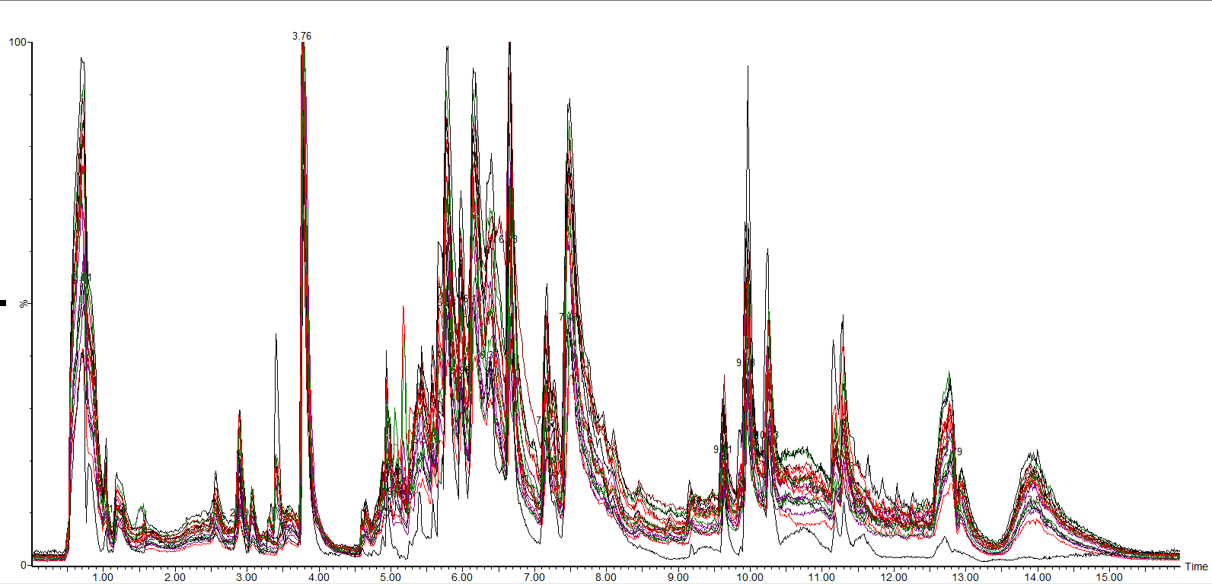

ESI+
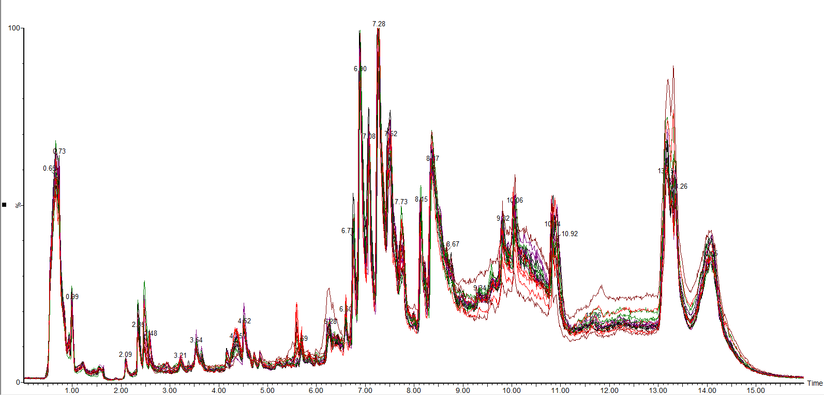

Sup Figure 2 The PCA and PLS-DA score plots of analysis of the LCG and NCG with MetaboAnalystR
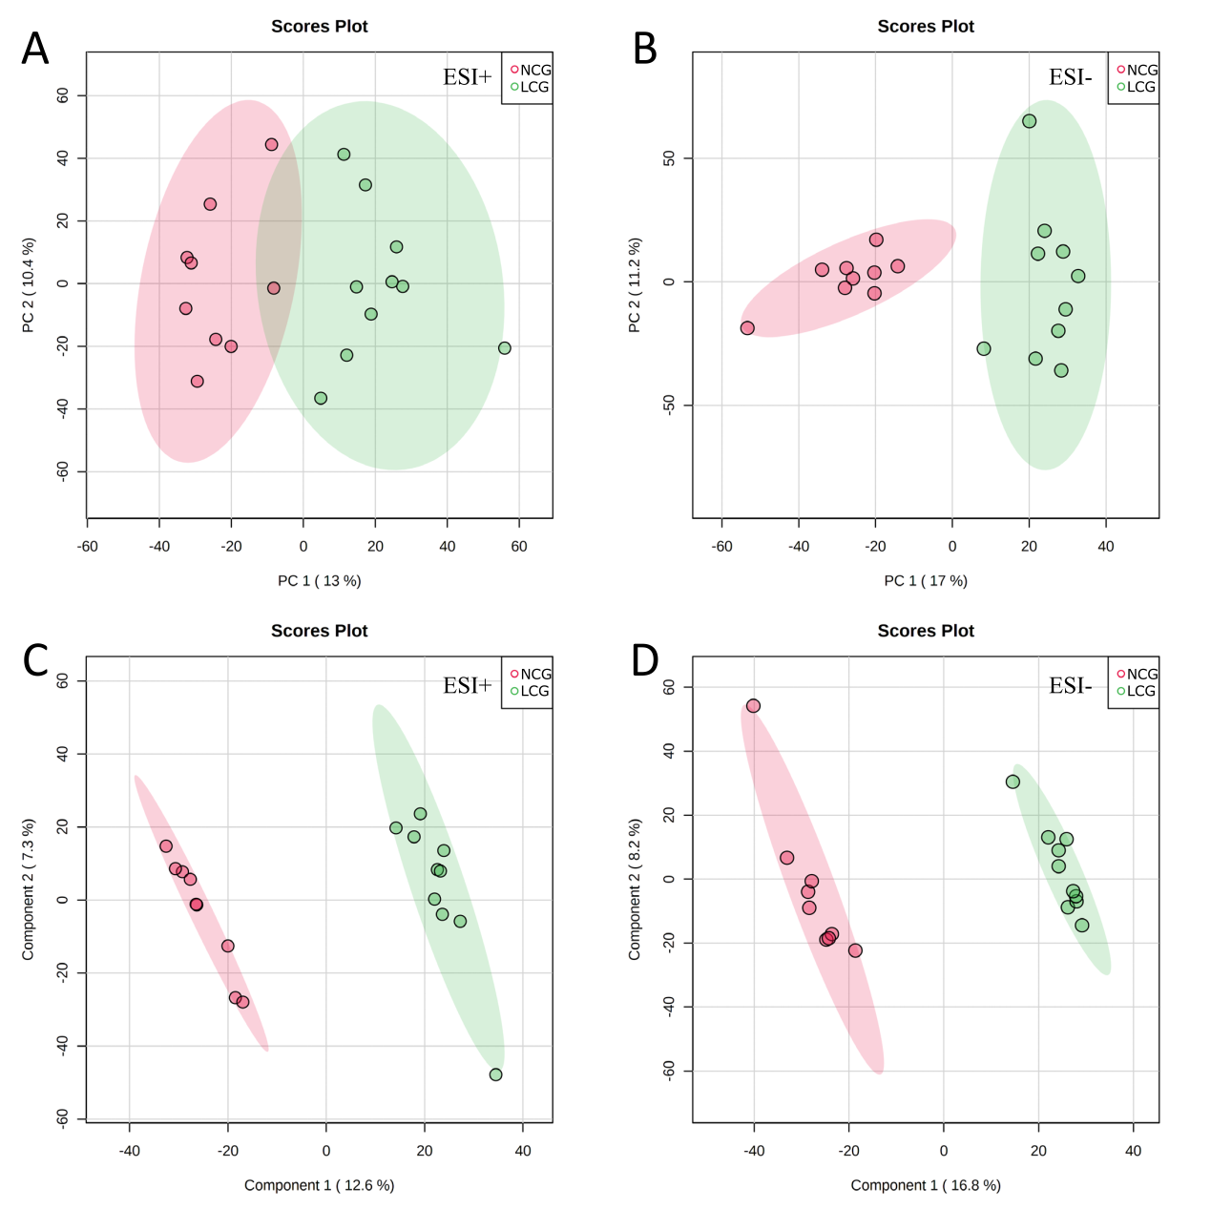

PLS-DA cross validation details:
POS
Measure | 1 comps | 2 comps | 3 comps | 4 comps | 5 comps
Accuracy | 1.0 | 1.0 | 1.0 | 1.0 | 1.0
R2 | 0.95486 | 0.99371 | 0.99946 | 0.99996 | 1.0
Q2 | 0.69665 | 0.72631 | 0.72465 | 0.72496 | 0.72641

PLS-DA cross validation details:
NEG
Measure | 1 comps | 2 comps | 3 comps | 4 comps | 5 comps
Accuracy | 1.0 | 1.0 | 1.0 | 1.0 | 1.0
R2 | 0.96577 | 0.99527 | 0.99935 | 0.99984 | 0.99998
Q2 | 0.83705 | 0.86856 | 0.87309 | 0.8725 | 0.87139

Sup Figure 3 MSMS spectrum of biomarkers
ESI Positive mode:
L-Valine: 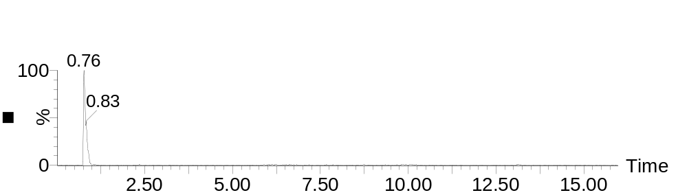
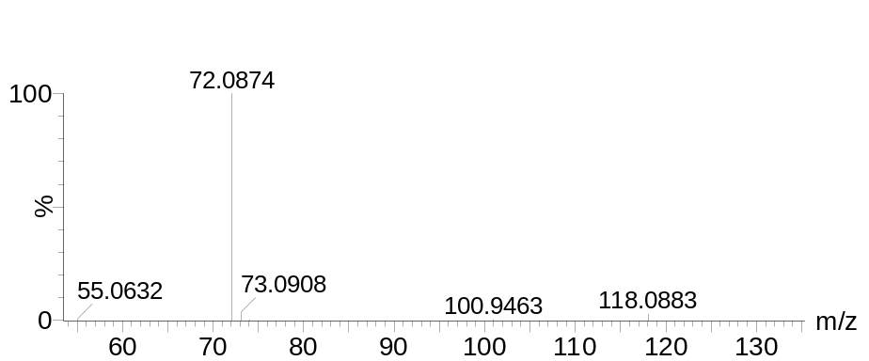
Standard compound:
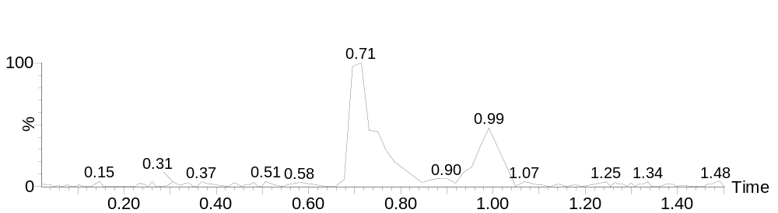

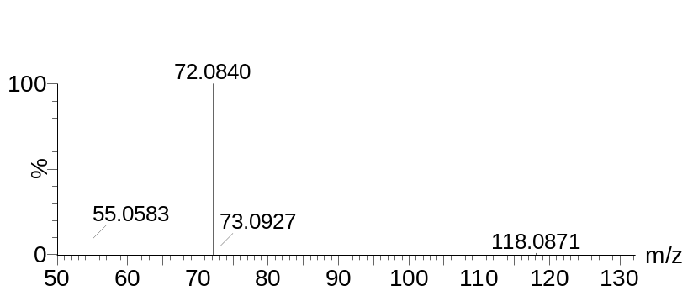
L-Tyrosine: 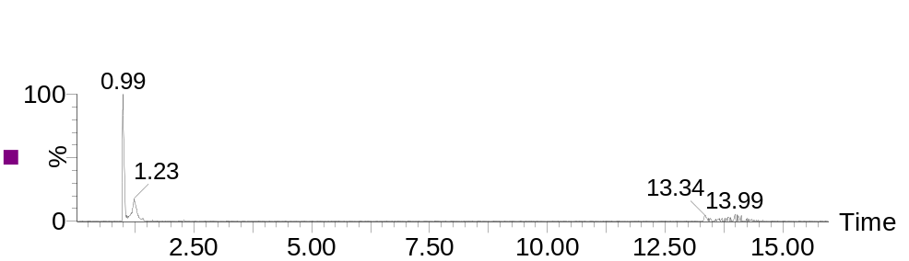

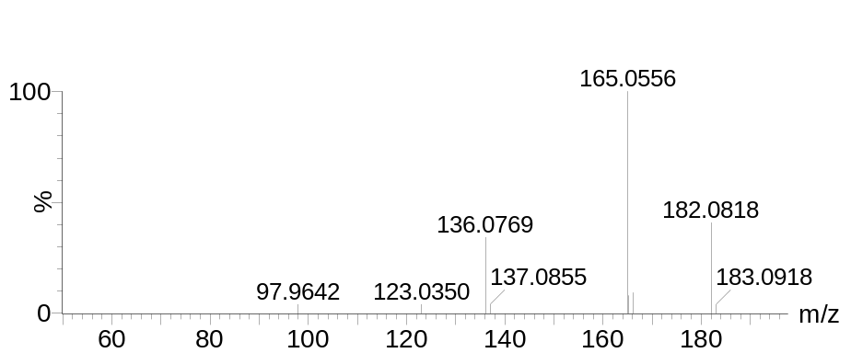
Standard compound:

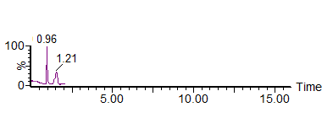
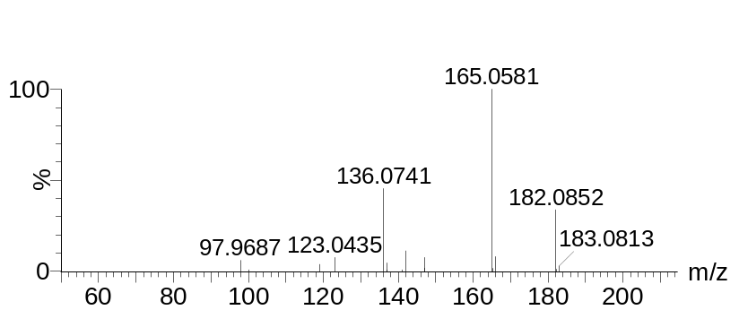

L-Leucine:
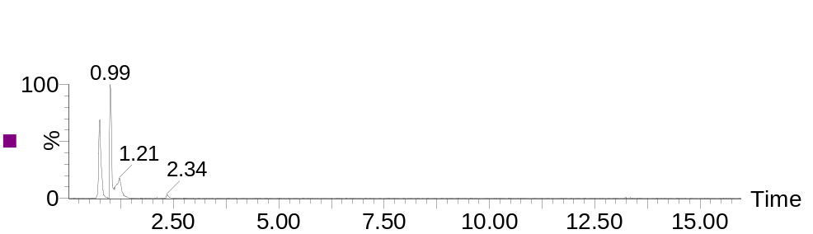

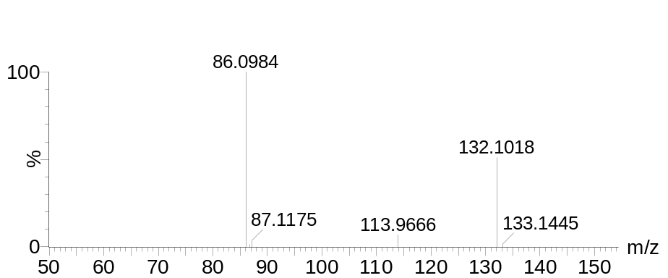
Standard compound:

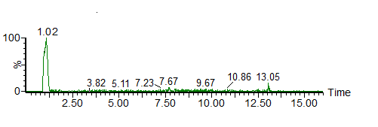
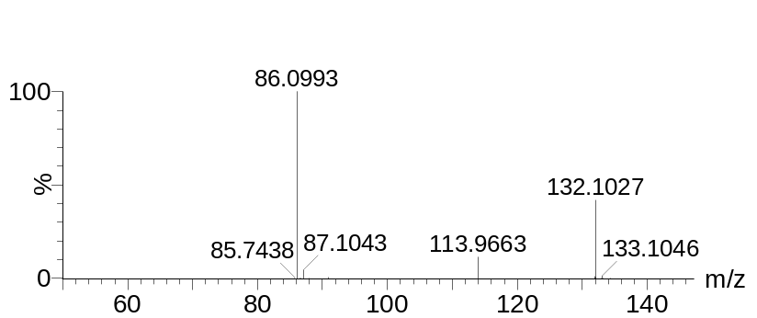

Penmacric acid:
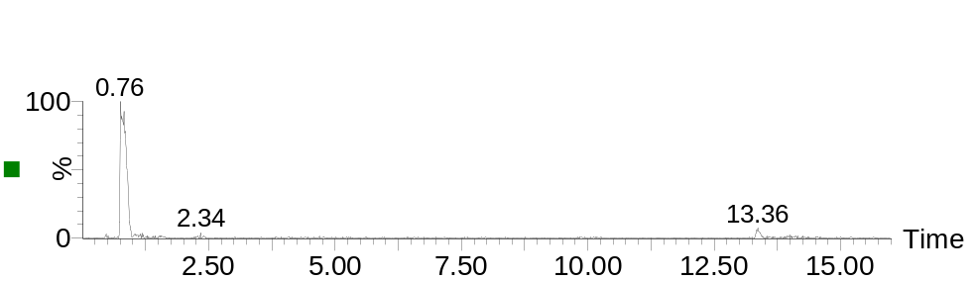
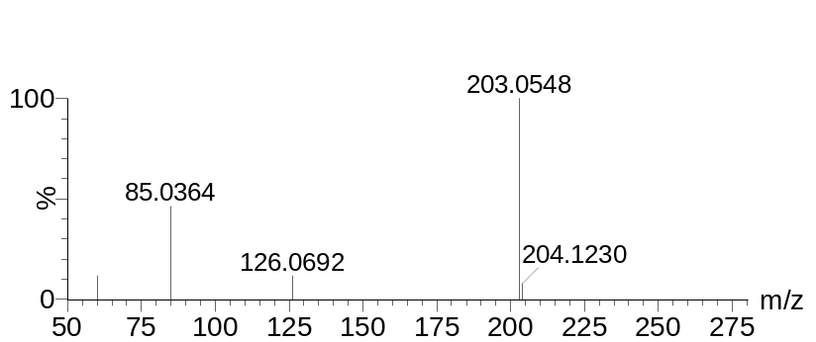
Standard compound:

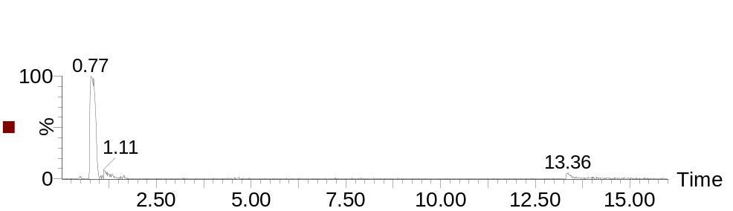
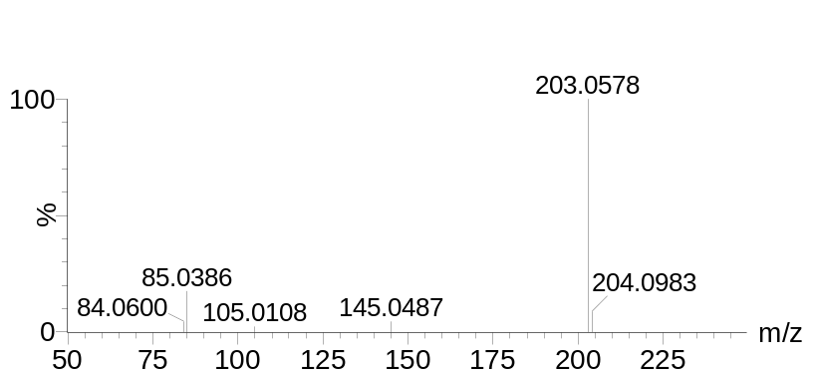

ESI Negative mode:

Taurine:
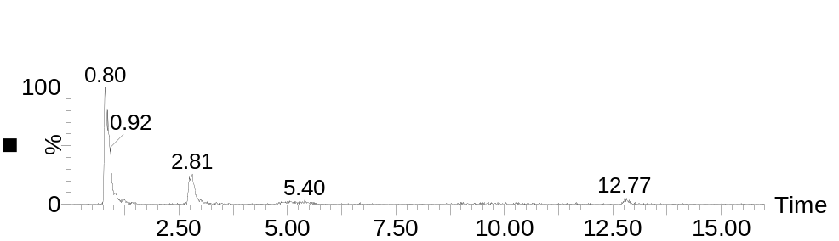

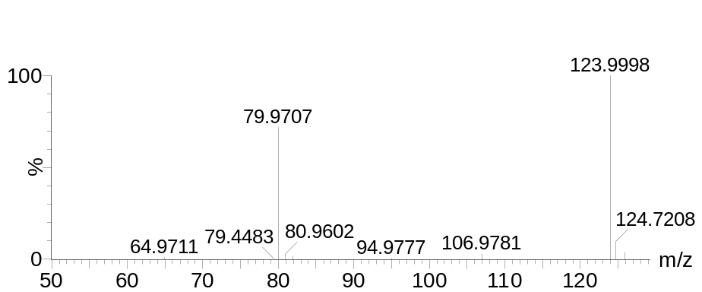
Standard compound:

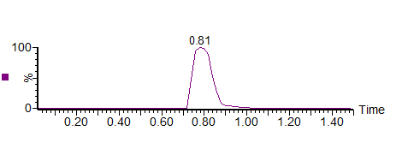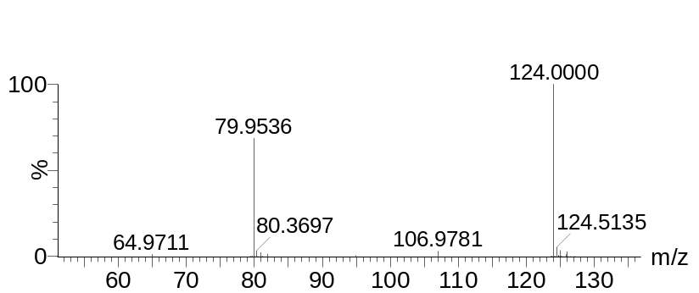
L-Lactic acid:
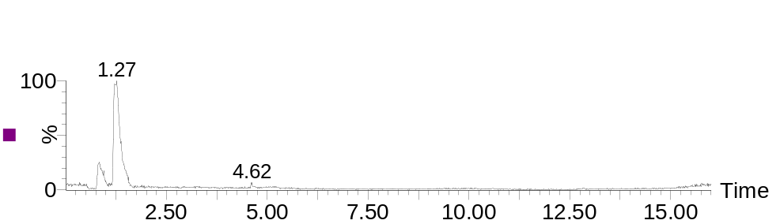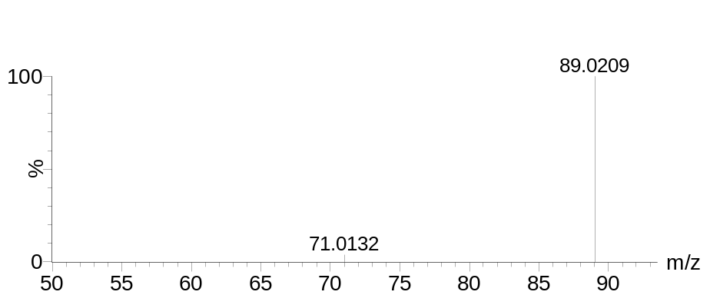
Standard compound:
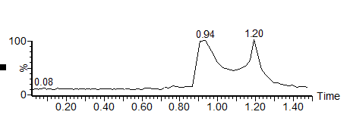
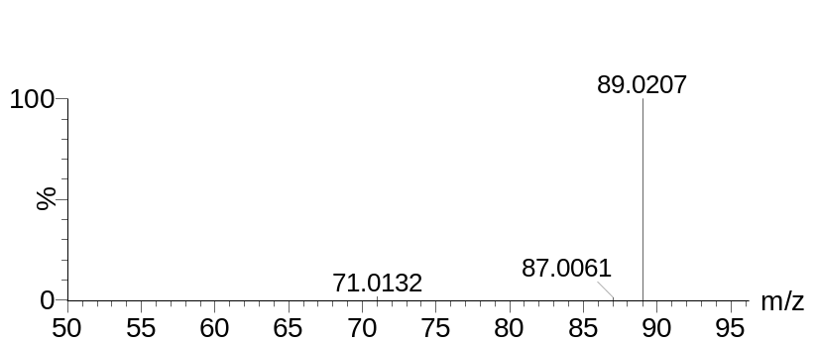

Eicosapentaenoic acid:
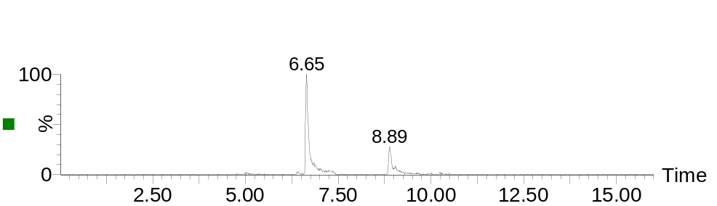
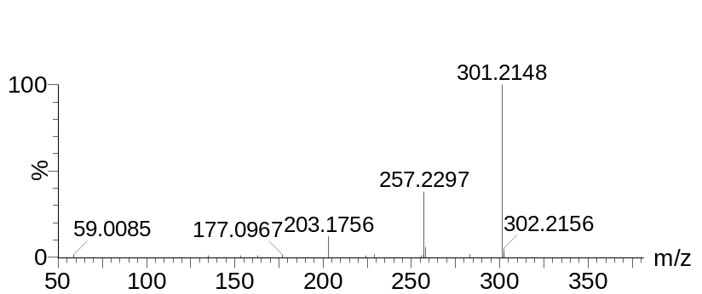
Standard compound:

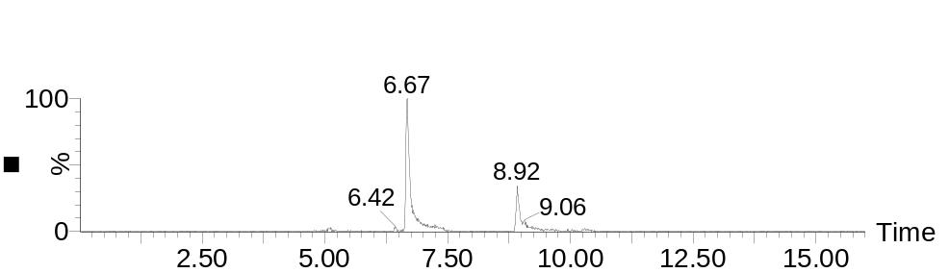
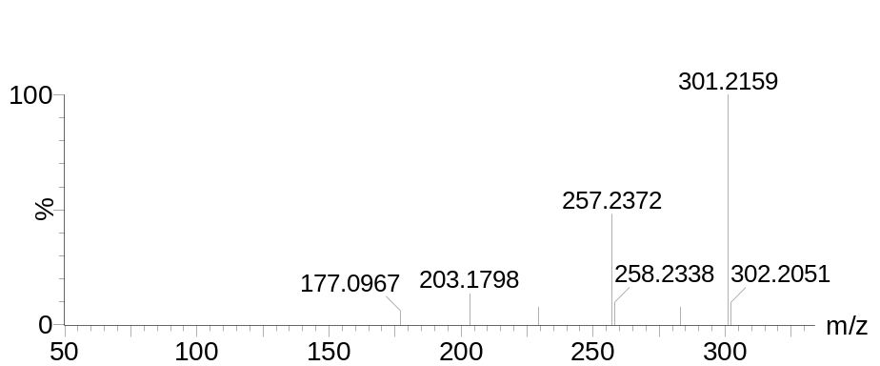

Docosahexaenoic acid:
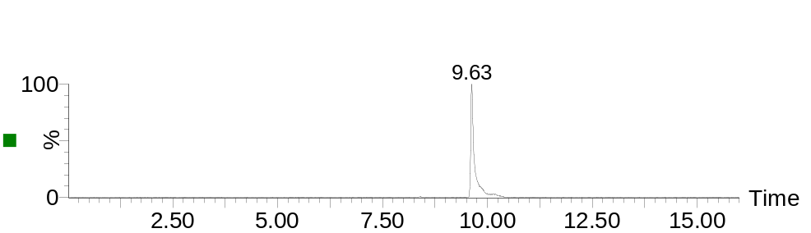
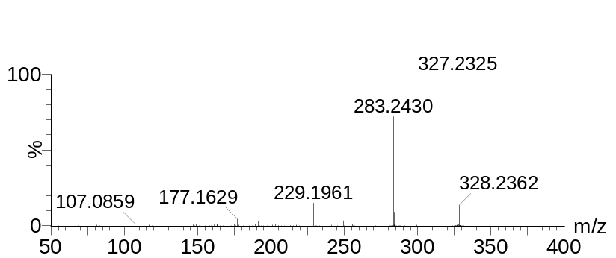
Standard compound:

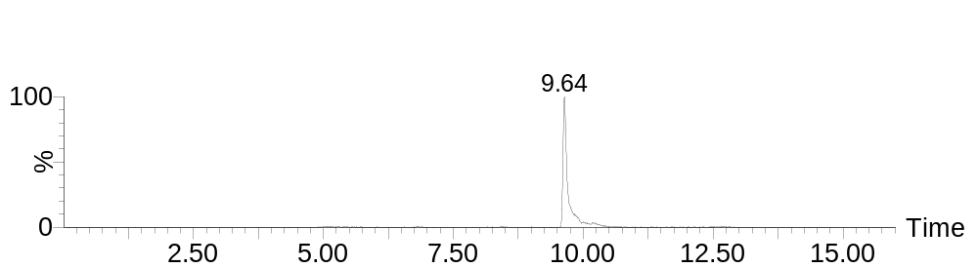
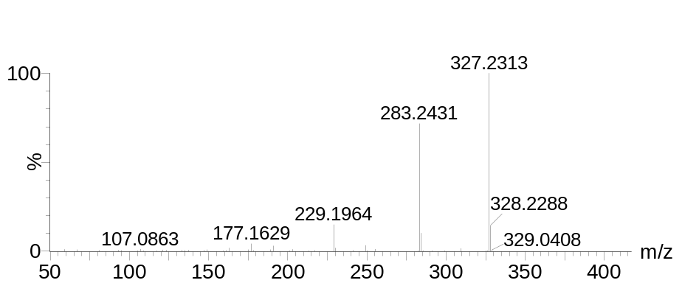

Arachidonic acid:

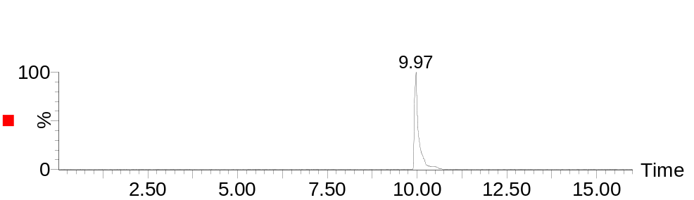
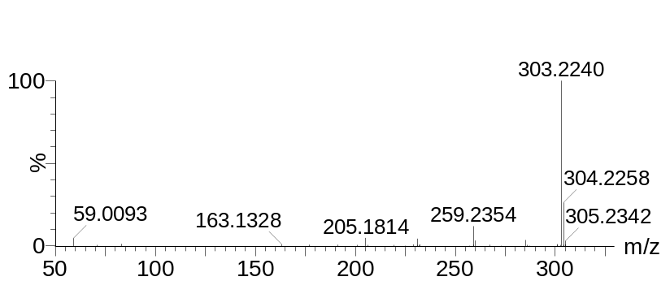
Standard compound:

