Graphical Abstract

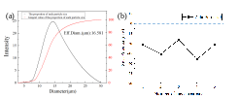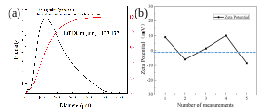
Fig. 1 Schematic of the precipitation-flocculation-ultrafiltration process
In this study, we combined potassium ferricyanide precipitation with ultrafiltration for deep Fe removal. The effects of the potassium ferrocyanide dosage, reaction temperature, reaction time, stirring speed, and ultrafiltration membrane specifications on Fe removal were systematically studied. Furthermore, the experimental conditions were optimized to achieve the lowest Fe content of 8.1 mg/L in the solution. The size distribution and zeta potential of the precipitate particles were determined, and the results revealed that the effective diameter of the particles was 16.581 μm and the zeta potential of the surface groups was negative. A cationic flocculant was added to eliminate the static repulsion between precipitate particles and promote their growth. The Fe content reached 3.8 mg/L after 0.1 mL of flocculant solution was added to the solution. Lastly, the Fe removal mechanism was determined.

