supplementary materials
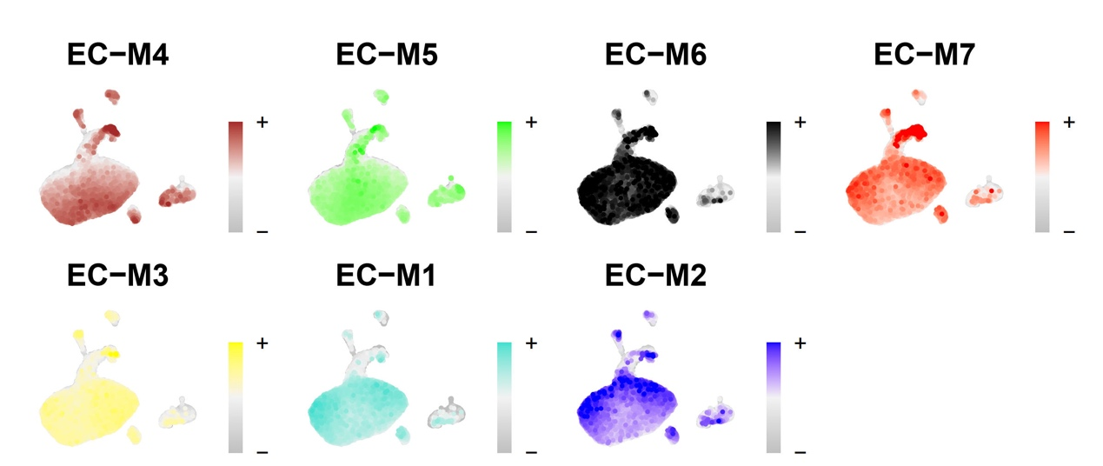
Supplementary Figure S1 Expression distribution of the 7 modules in the RIF single-cell dataset, where darker colors represent higher expression levels of module features.
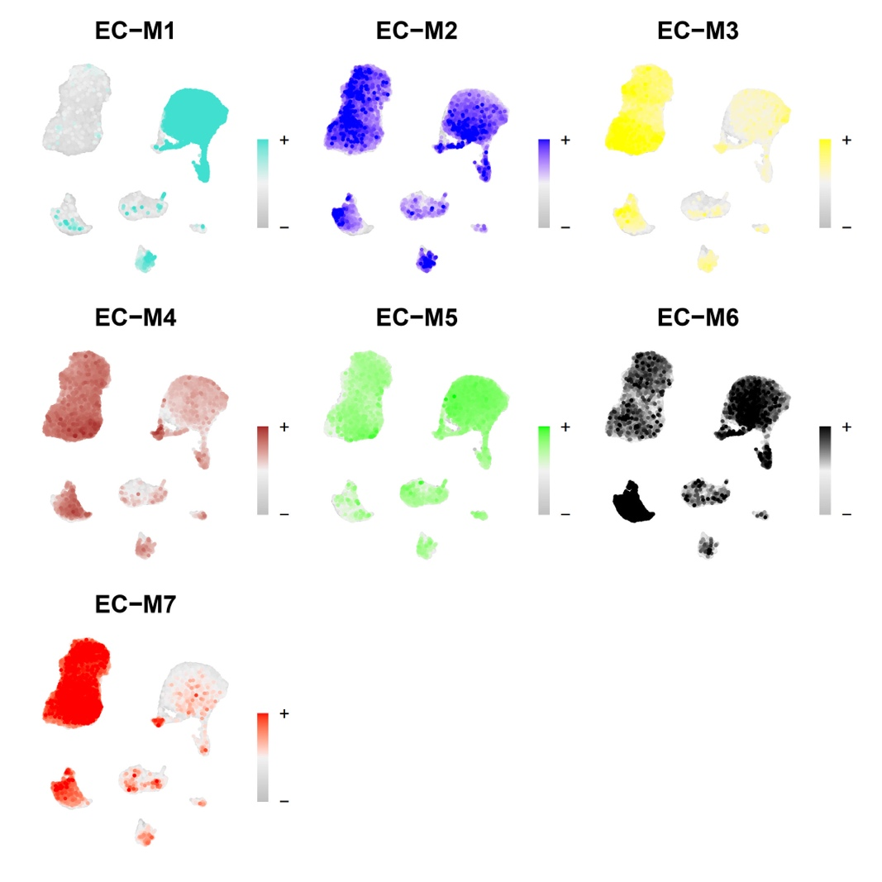
Supplementary Figure S2 Expression distribution of the 7 modules in the menstrual cycle single-cell dataset, where darker colors represent higher expression levels of module features.

