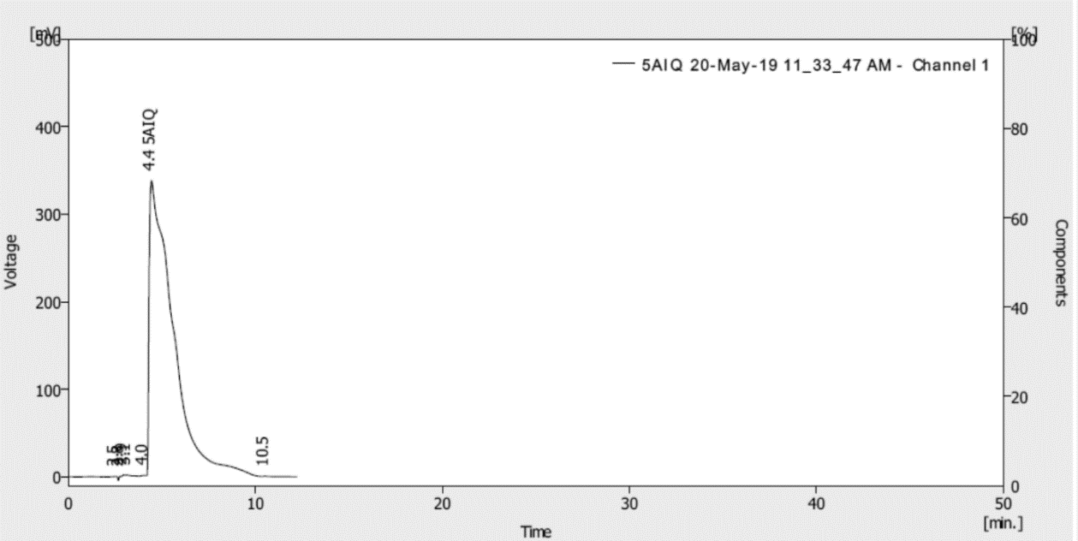
(A)

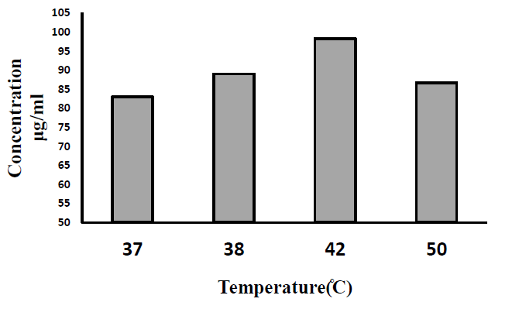
B))

S. Figure 1: the chromatogram of 5-aminoisoquinoline (5-AIQ)

Figure S 1. (A) HPLC chromatogram of 5-AIQ, (B) 5-AIQ release profile of MTN.5AIQ with the temperature for MTN.5-AIQ. 5-AIQ; 5-aminoisoquinoline.

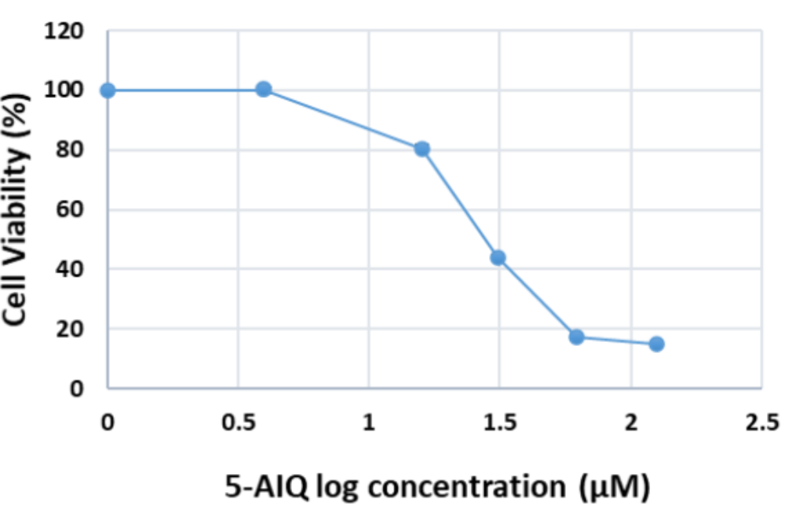

Figure S 2. IC50 value of 5-AIQ-induced Cytotoxicity on colorectal adenocarcinoma (Caco-2) cell.

Table S1. Drug loading procedure; the magnetic thermoresponsive nanocomposites (MTN) and the drug (5AIQ) weights and their ratios

MTN to drug ratio wt/wt | Volume of drug solution(ml) | 5AIQ (mg) | MTN (mg) | Sample
10:1 | 4 | 5 | 50 | MTN.5AIQ.1
10:2 | 4 | 10 | 50 | MTN.5AIQ.2
10:4 | 4 | 20 | 50 | MTN.5AIQ.3
10:6 | 4 | 30 | 50 | MTN.5AIQ.4

