Supplementary materials
Supplementary Figures
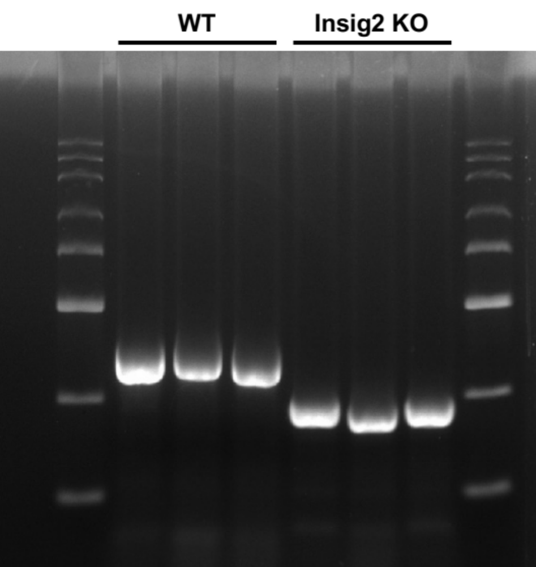
Figure S1. Genotyping of WT/Insig2 KO mice.

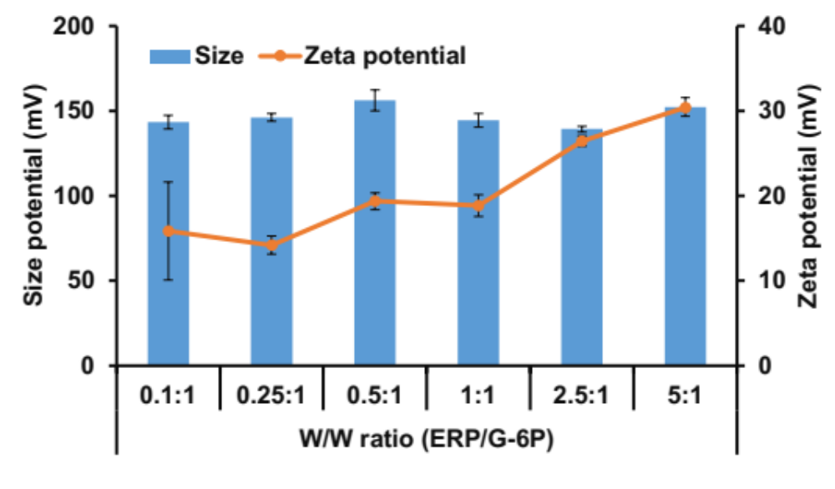
Figure S2. sizes and zeta potentials of the ERP/G-6P polyplexes complexed at various mass ratios. Error bars represent the Standard deviation.

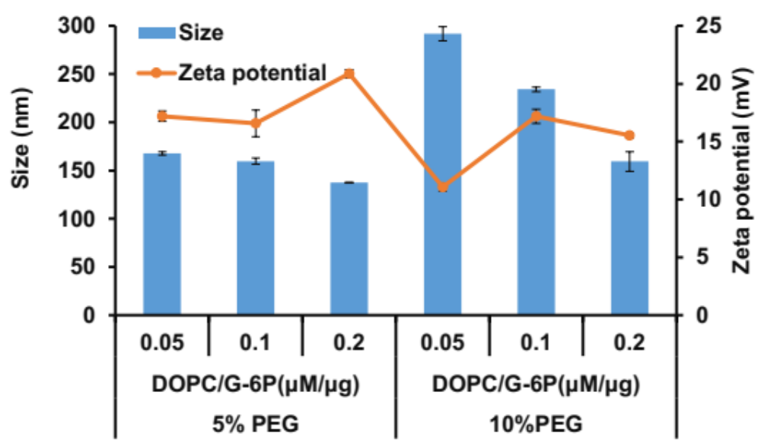
Figure S3. Sizes and zeta potentials of ERP/G-6P polyplexes (Mass ratio=0.1) coated with different concentrations of lipids layer and DSPC-PEG-Gal. Error bars represent the standard deviation.

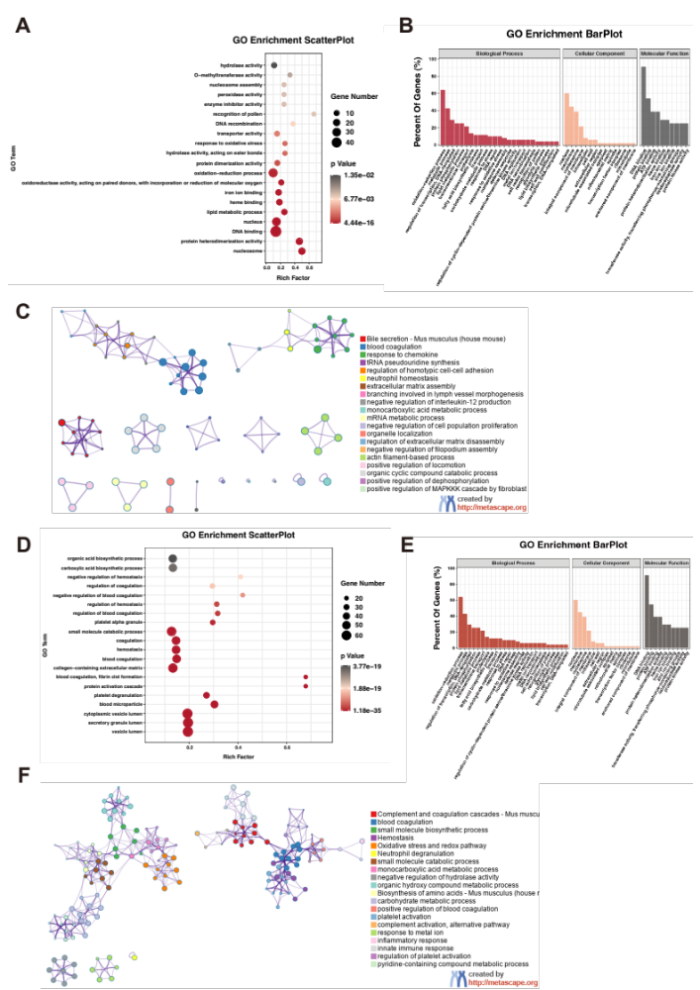
Figure S4. GO and Metascape enrichment analysis reveal after hepatic IR injury. (A-B) GO of RNA-seq data showing the most significantly enriched pathways in the livers of Insig2-OE and controlled WT mice. (C) Metascape enrichment analysis showing groups of several categories based on gene functional relevance, and construction of a network was based on relevance and similarity. In the figure, different colors are used to represent different categories. (D-E) GO of proteomics data showing the most significantly enriched pathways. (F) The functional enrichment analysis of DEPs using Metascape.

Supplementary Tables
Table S1. Primers for real-time qPCR detection
Gene |  | Sequence5'---3'
Mouse Insig2 | F | GGAGTCACCTCGGCCTAAAAA
Mouse Insig2 | R | CAAGTTCAACACTAATGCCAGGA
Mouse IL6 | F | CTGCAAGAGACTTCCATCCAG
Mouse IL6 | R | AGTGGTATAGACAGGTCTGTTGG
Mouse IL1β | F | TTCAGGCAGGCAGTATCACTC
Mouse IL1β | R | GAAGGTCCACGGGAAAGACAC
Mouse TNF-α | F | CAGGCGGTGCCTATGTCTC
Mouse TNF-α | R | CGATCACCCCGAAGTTCAGTAG
Mouse Ccl2 | F | TAAAAACCTGGATCGGAACCAAA
Mouse Ccl2 | R | GCATTAGCTTCAGATTTACGGGT
Mouse Cxcl10 | F | CCAAGTGCTGCCGTCATTTTC
Mouse Cxcl10 | R | GGCTCGCAGGGATGATTTCAA
Mouse β-actin | F | GTGACGTTGACATCCGTAAAGA
Mouse β-actin | R | GCCGGACTCATCGTACTCC

Table S2. Antibodies for immunoblot analyses
Antibody | Cat No. | Manufacture
Insig2 | 24766-1-AP | Proteintech
Bax | 2772S | CST
Bcl2 | ab182858 | Abcam
β-actin | 66009-1-Ig | Proteintech

