Supplementary Online Content
Exercise-primed extracellular vesicles improve cell-matrix adhesion and chondrocyte health

†Hirotaka Iijima, PhD, PT^{1,2,3}, Kai Wang, PhD^{4,5}, Ella D'Amico, MD³, Wan-Yee Tang, PhD⁶,
Renee J. Rogers, PhD, FACSM⁷, John M Jakicic, PhD⁷, *Fabrisia Ambrosio, PhD, MPT^{3,4,5}

¹Institute for Advanced Research, Nagoya University, Nagoya, Japan
²Biomedical and Health Informatics Unit, Graduate School of Medicine, Nagoya University, Nagoya, Japan
³Department of Physical Medicine and Rehabilitation, University of Pittsburgh, Pittsburgh, PA
⁴Discovery Center for Musculoskeletal Recovery, Schoen Adams Research Institute at Spaulding, Boston, MA
⁵Department of Physical Medicine & Rehabilitation, Harvard Medical School, Boston, MA
⁶Department of Environmental and Occupational Health, University of Pittsburgh, Pittsburgh, PA
⁷Department of Internal Medicine, Divisiont of Physical Activity and Weight Management, University of Kansas Medical Center, Kansas City, KS
*Corresponding author. fambrosio@mgh.harvard.edu, †Co-corresponding author. iijima@met.nagoya-u.ac.jp

The PDF file includes:
Figure S1 Characterization of circulating EVs before and after 3 months aerobic exercise

This supplementary material has been provided by the authors to give readers additional information about their work.

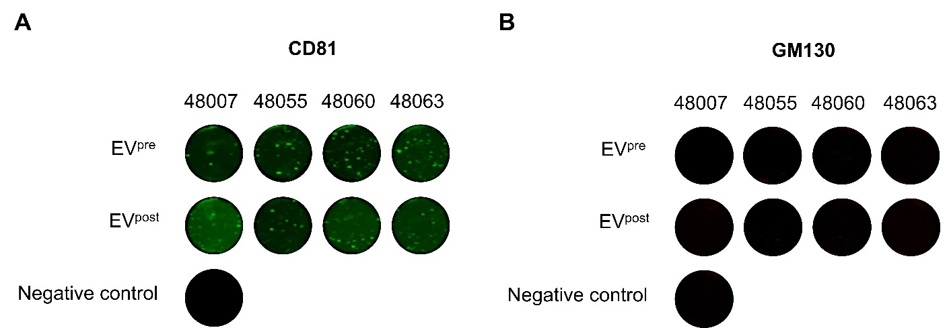
Figure S1. Characterization of circulating EVs before and after 3 months aerobic exercise
In-well immunofluorescence western analysis of isolated EVs revealed the presence of EV surface marker, CD81, and absence of cytosolic contaminant protein, GM130.

