Supporting information

Supplementary Table 1. Primer and probe sequences used for F. nucleatum and Pan-fusobacterium
Assay name | Forward primer | Reverse primer | Probe
 | sequence | sequence | sequence
Fuso. nucleatum | CAACCATTACTTTAACTCTACCATGTTCA | GTTGACTTTACAGAAGGAGATTATGTAAAAATC | 6FAM-TCAGCAACTTGTCCTTCTTGATCTTTAAATGAACC--MGB non-fluorescent quencher
Pan-fusobacterium | GGATTTATTGGGCGTAAAGC | GGCATTCCTACAAATATCTACGAA | 6FAM-CTCTACACTTGTAGTTCCG-TAMRA
PGT | ATCCCCAAAGCACCTGGTTT | AGAGGCCAAGATAGTCCTGGTAA | 6FAM-CCATCCATGTCCTCATCTC-MGB non-fluorescent quencher

Supplementary Table 2. Primer sequences used for TP53 mutation analysis
Assay name | Forward primer | Reverse primer | Sequence primer
 | sequence | sequence | sequence
TP53 Exon 5-6 | CCAGTTGCTTTATCTGTTCACTTG | CACTGACAACCACCCTTAACC | CACTTGTGCCCTGACTTTCA
TP53 Exon 7-8 | AAAAGGCCTCCCCTGCTT | AAAAGTGAATCTGAGGCATAACTG | CCACAGGTCTCCCCAAGG

Supplementary Table 3. Summary of TP53 mutation observed in EAC samples
Case No. | Variant datail | Chromosomal position in GRCh37/hg19 | Function
Case 1 | R248W | chr17:7577539 G/A | DAMAGING
Case 2 | E180* | chr17:7578392 C/A | Damaging due to stop codon
Case 3 | R273C | chr17:7577121 G/A | DAMAGING
Case 4 | R282W | chr17:7,577094 G/A | DAMAGING
Case 5 | A138V | chr17:7578517 G/A | DAMAGING
Case 6 | C275S | chr17:7577114 C/G | DAMAGING
Case 7 | L257R | chr17:7577511 A/C | DAMAGING
Case 8 | L257R | chr17:7577511 A/C | DAMAGING
Case 9 | H179Y | chr17:7578395 G/A | DAMAGING
Case 10 | C275S | chr17:7577114 C/G | DAMAGING
Case 11 | C275S | chr17:7577114 C/G | DAMAGING
Case 12 | R282W | chr17:7577094 G/A | DAMAGING

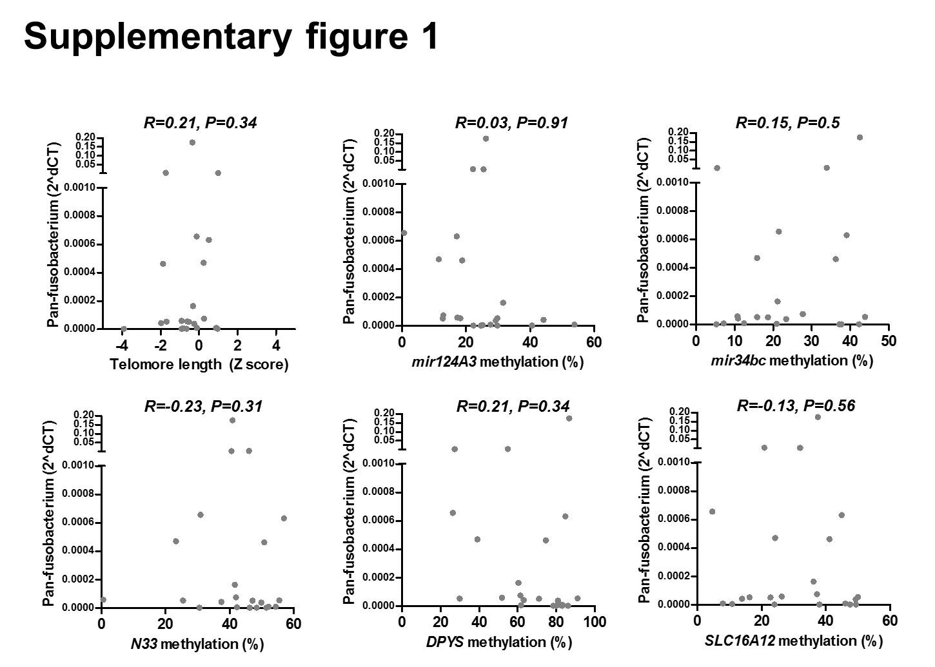
Supplementary figure 1
Association between amount of Pan-fusobacterium and molecular changes in EAC tissues. Upper left, telomere length; others, methylation status of candidate gene promoters (mir124A3, mir34bc, N33, DPYS, and SLC16A12); Statistical analysis was performed using the Spearman correlation analysis.

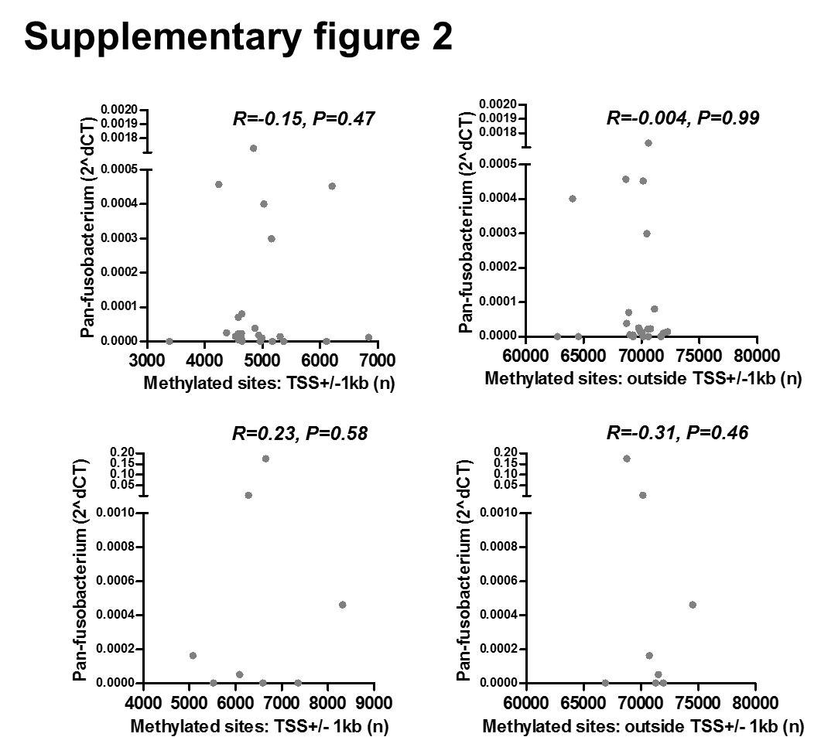

Supplementary figure 2
Association between amount of Pan-fusobacterium and number of methylated CpG sites in non-neoplastic BE (upper) and EAC (lower) tissues examined by the RRBS. All sites were divided into within TSS +/- 1kb (left) and other regions (right). Statistical analysis was performed using the Spearman correlation analysis.

