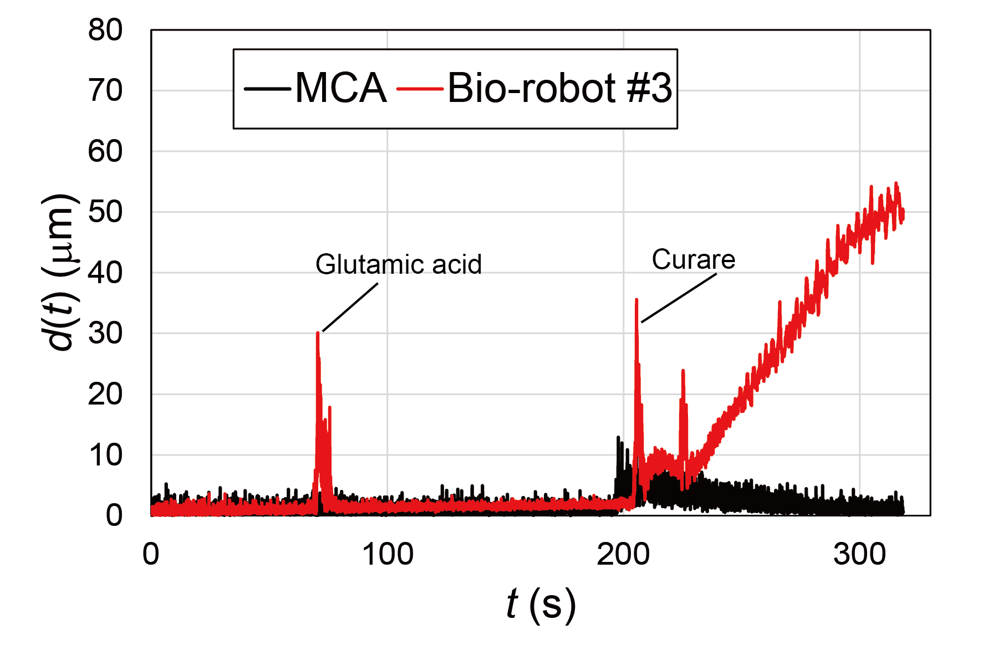
Fig. S1. A CO connection is required to maintain the shape of the MCA. The time course of the displacement of bio-robot #3 and the MCA during the glutamate and curare stimuli experiments. The large displacements observed near the 60 s, and 180 s are attributed to the pipetting flow of the glutamate and curare solutions, respectively.

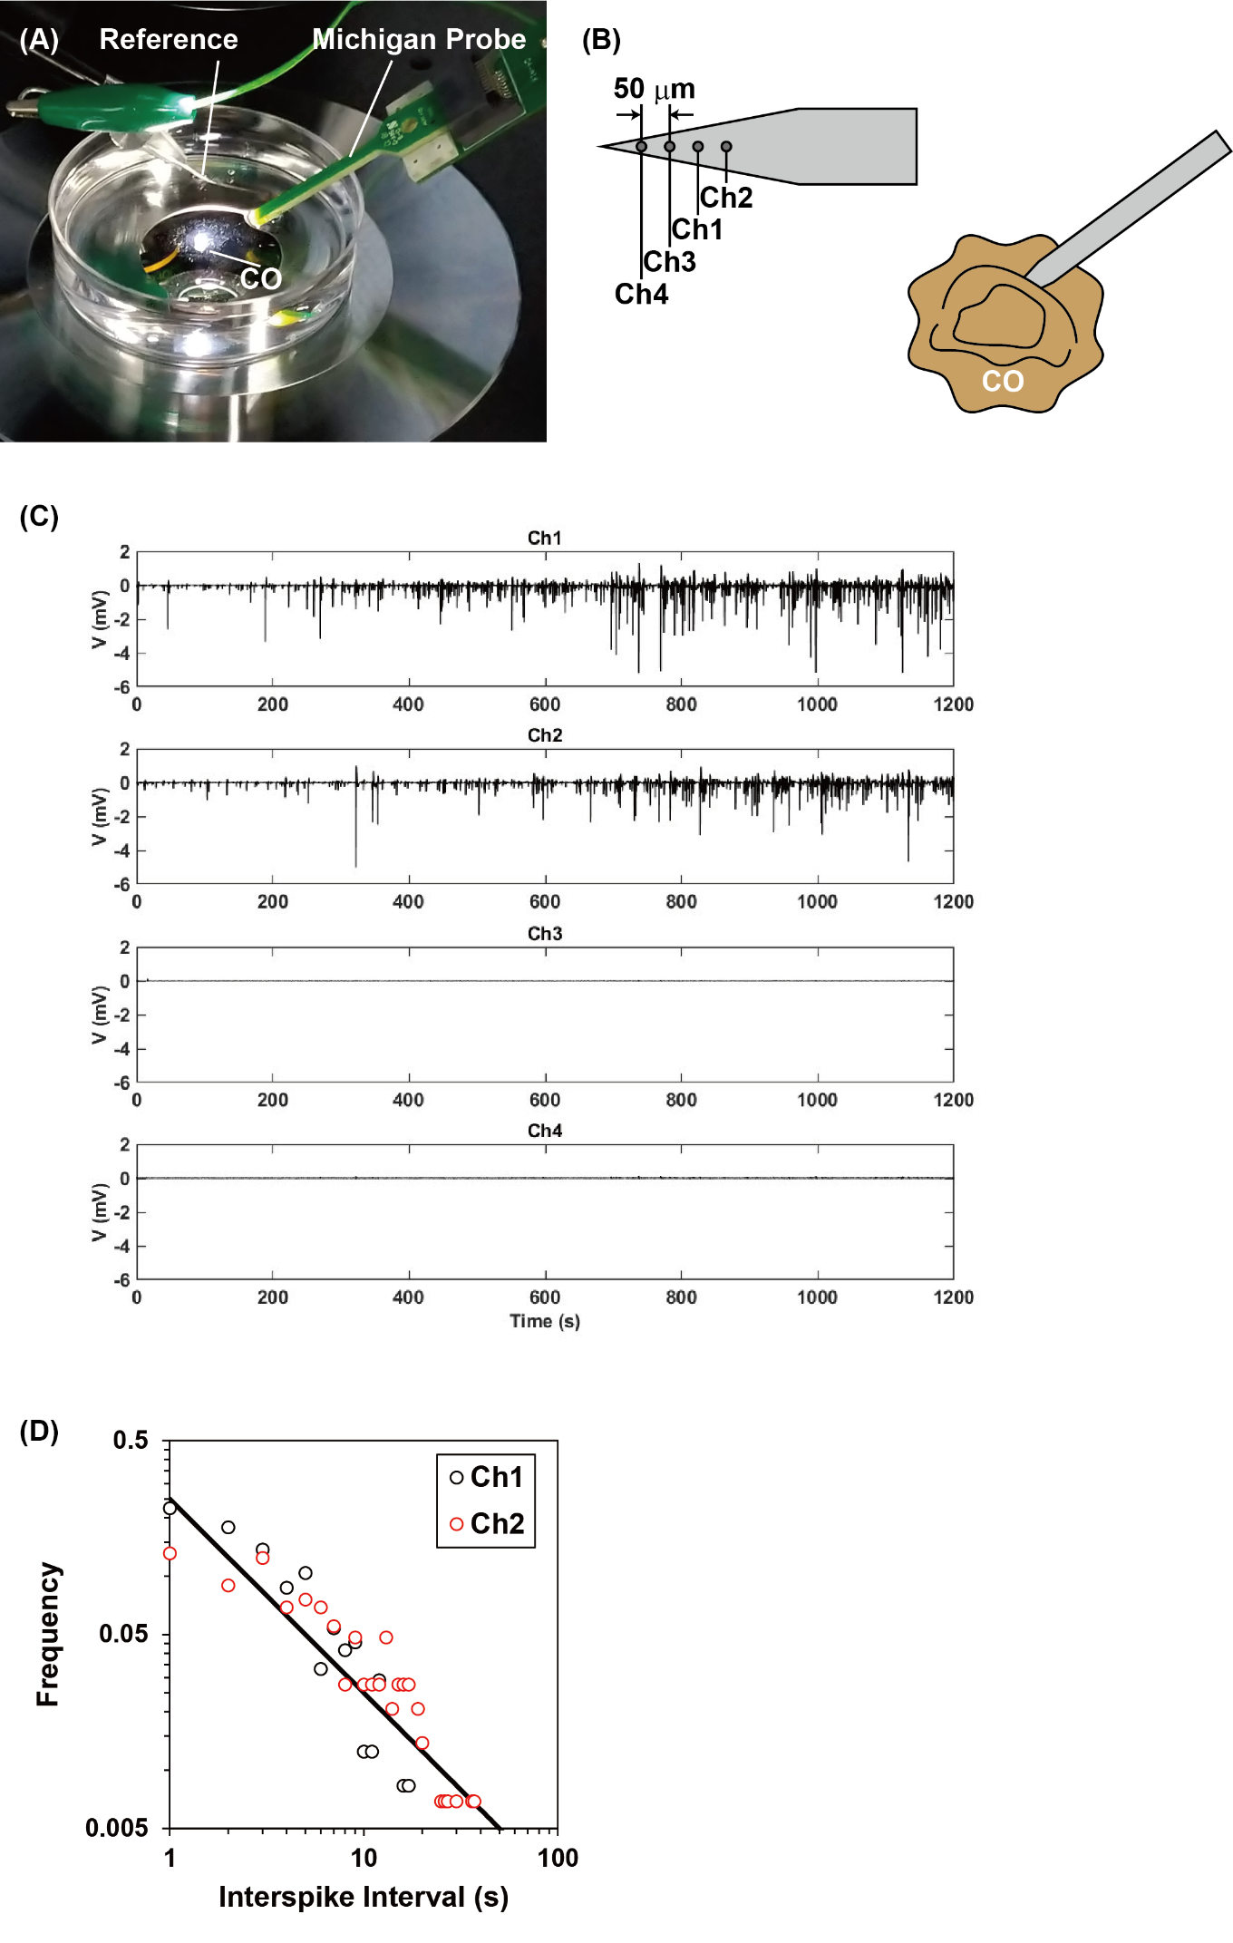
Fig. S2. The CO generates the local field potential randomly. (A): The equipment used to measure the local field potential (LFP). The CO was placed on the 60 mm polystyrene dish on day 67. The LFP was measured using a Michigan probe with a linear geometry of four electrodes from Ch1 to Ch4 (Qtrodes Q4 NeuroNexus Technologies Inc.). The signals obtained were amplified with a 4-channel amplifier system (HAS-4, Bioresearch Center Co. Ltd.) and then digitized with an A/D converter (PowerLab 4/26, AD Instruments). The raw data were filtered with a band pass filter from 0.1 Hz – 2 kHz, and then they were further filtered with the digital low pass filter at 1 kHz on the LabChart (LabChart v8.1.16, AD Instruments) to separate the LFP. The LFP was detected on Ch1 and Ch2, but not on Ch3 and Ch4. (B): Schematic diagrams of the microelectrodes geometry on the Michigan probe and the stabbing of the probe to the CO. (C): The LFP of CO at day 67 measured as a function of time. To obtain this graph, the filtered data were down sampled from 10 kHz to 1 kHz using Matlab (Matlab R2022b, The MathWorks Inc.). (C) The double logarithmic plot of the number of spikes against the interval between spikes. The results were roughly expressed as a power law function with an exponent of 1.0, independent of the detection channels. The results show that there are no specific frequencies in the LFP, indicating random generation of the LFP.

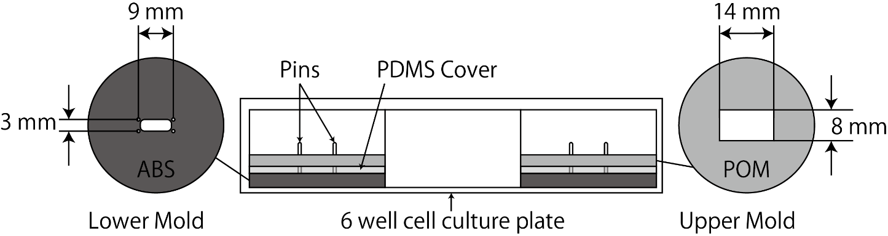
Fig. S3. Schematic diagram of the mold used to construct the MCA. The mold consisted of three parts: A lower mold and a polydimethylsiloxane (PDMS) cover to attach the four pins to the surface of a 6-well cell culture plate, and an upper mold for shaping the MCA. A central rectangular hole in the lower mold was opened to observe the sample with an inverted phase contrast microscope, and it was filled with the PDMS. After the MCA was prepared, the upper mold was removed. The initial shape of the MCA was a rectangle with dimensions of 14 mm (W), 8 mm (D), and 1.8 mm (H). The MCAs were initially anchored to the four pins at each corner.

