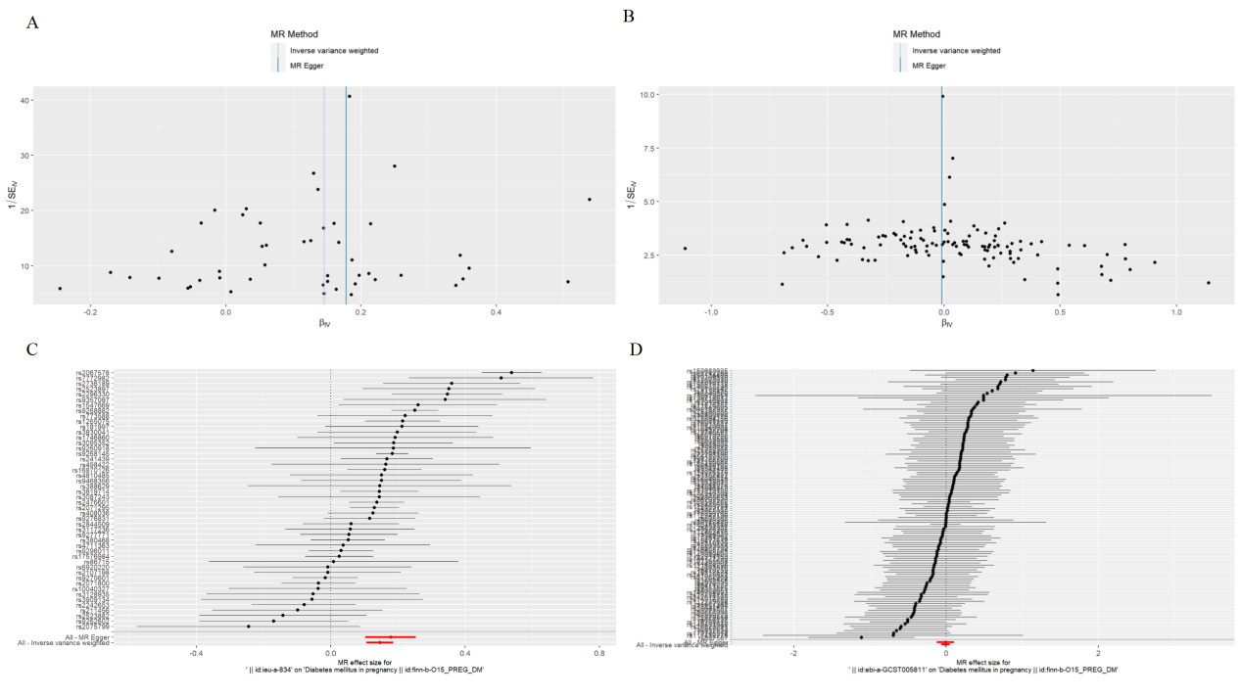
Figure 4. 4A,4B: The funnel plot showed no significant horizontal pleiotropy among SNPs in the study of the causal effect of OA(4B) on GDM, but of RA (4A, P < 0.05). The slope of each line corresponds to the estimated MR effect in different models. 4C,4D: Leave-one-out analysis plots show the stability for the risk of RA(4C) and OA(4D) on GDM.

