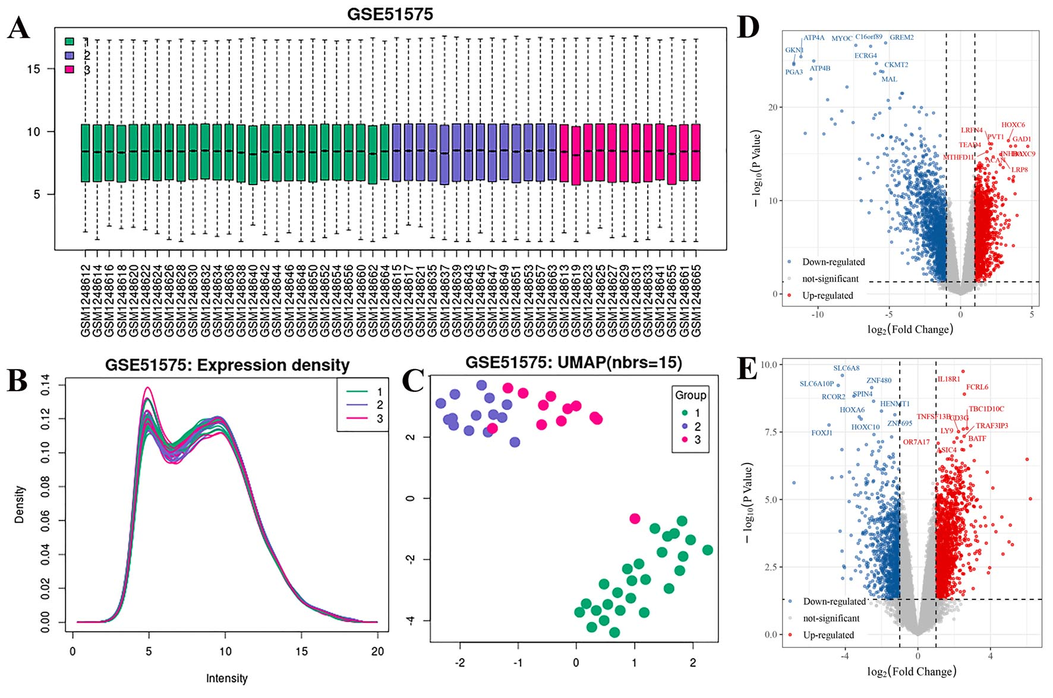
Figure S1, Quality control of sequencing data GSE51575. A, All samples were divided into 3 groups: normal tissue (green), EBVnGC (blue) and EBVaGC (red). B, The expression density of each samples. C, The PCA dimensionality reduction and clustering of all samples. D and E, The different expression genes of normal tissue vs. GC tissue and EBVnGC vs. EBVaGC. The blue and red points represent the down- and up-regulated genes, respectively.

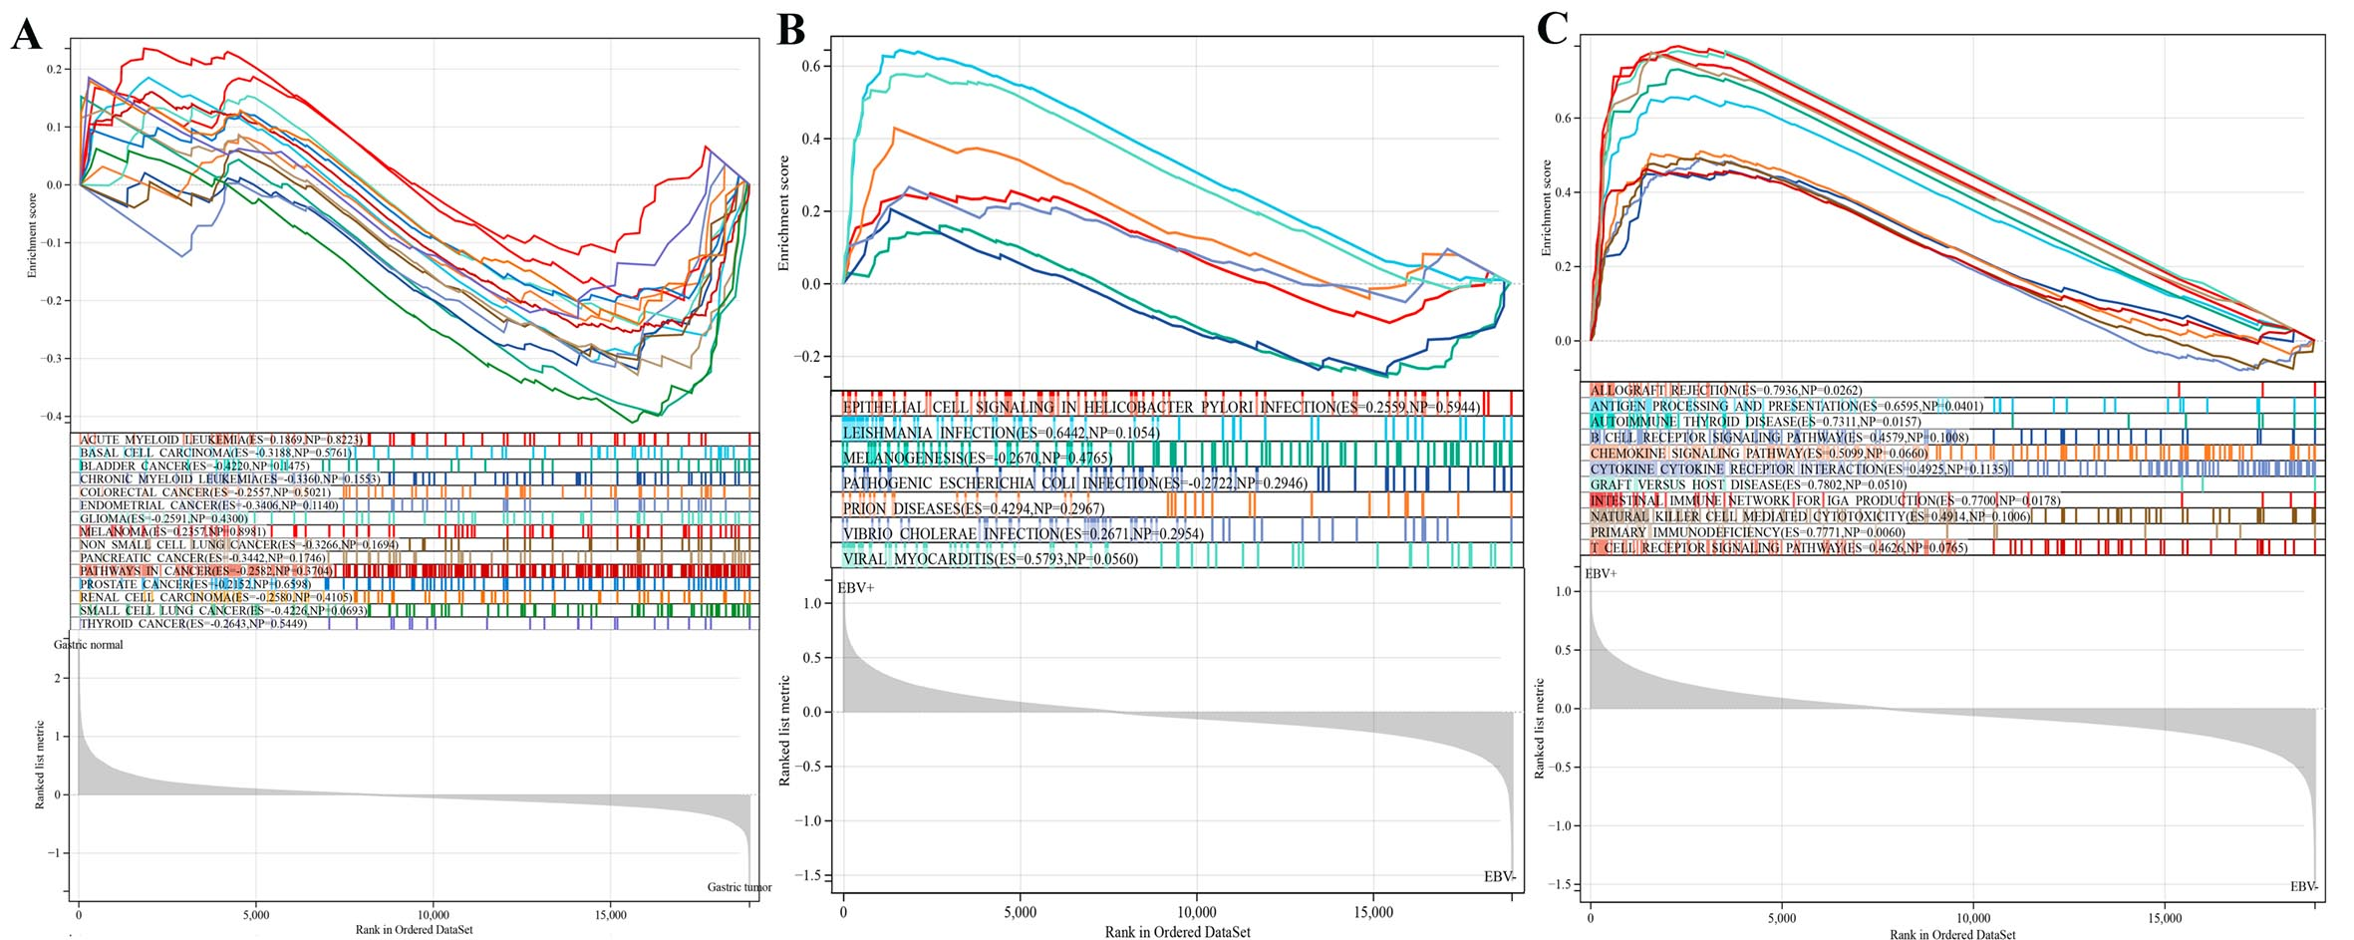
Figure S2, The GSEA charts of the whole genes in different compares. A, The pathways associated with various cancer types. B, The pathways associated with pathogenic microbial infection. C, The pathways associated with immune response. The lines with various colors represent different pathways. The gray curve represents the sequencing of pathway-related genes according to their expressions.

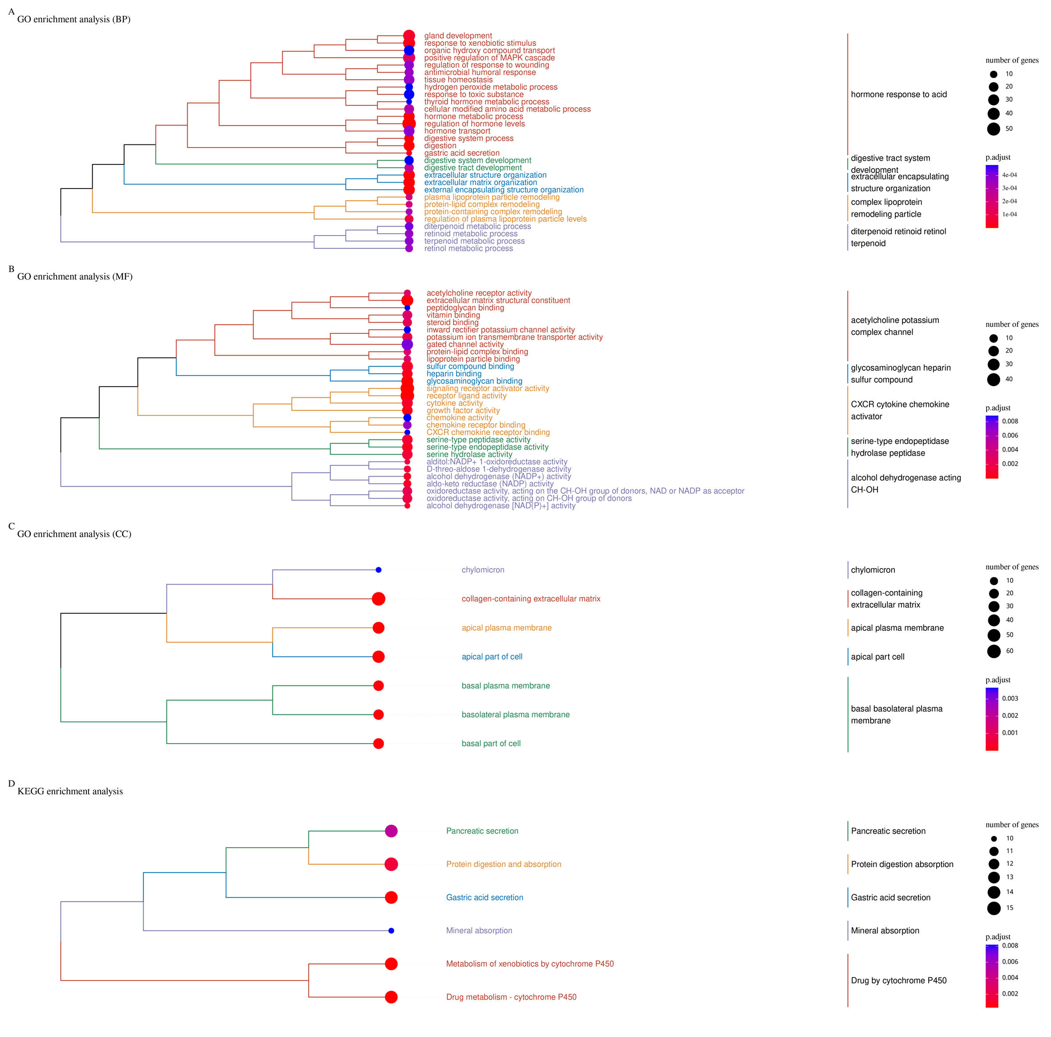
Figure S3, The dendrogram of enrichment analysis according to the DEGs in normal tissue vs. GC tissue. From the top to the bottom，the BP, MF, CC and KEGG were listed. The size and color of circles represent gene counts and p-value of each item.

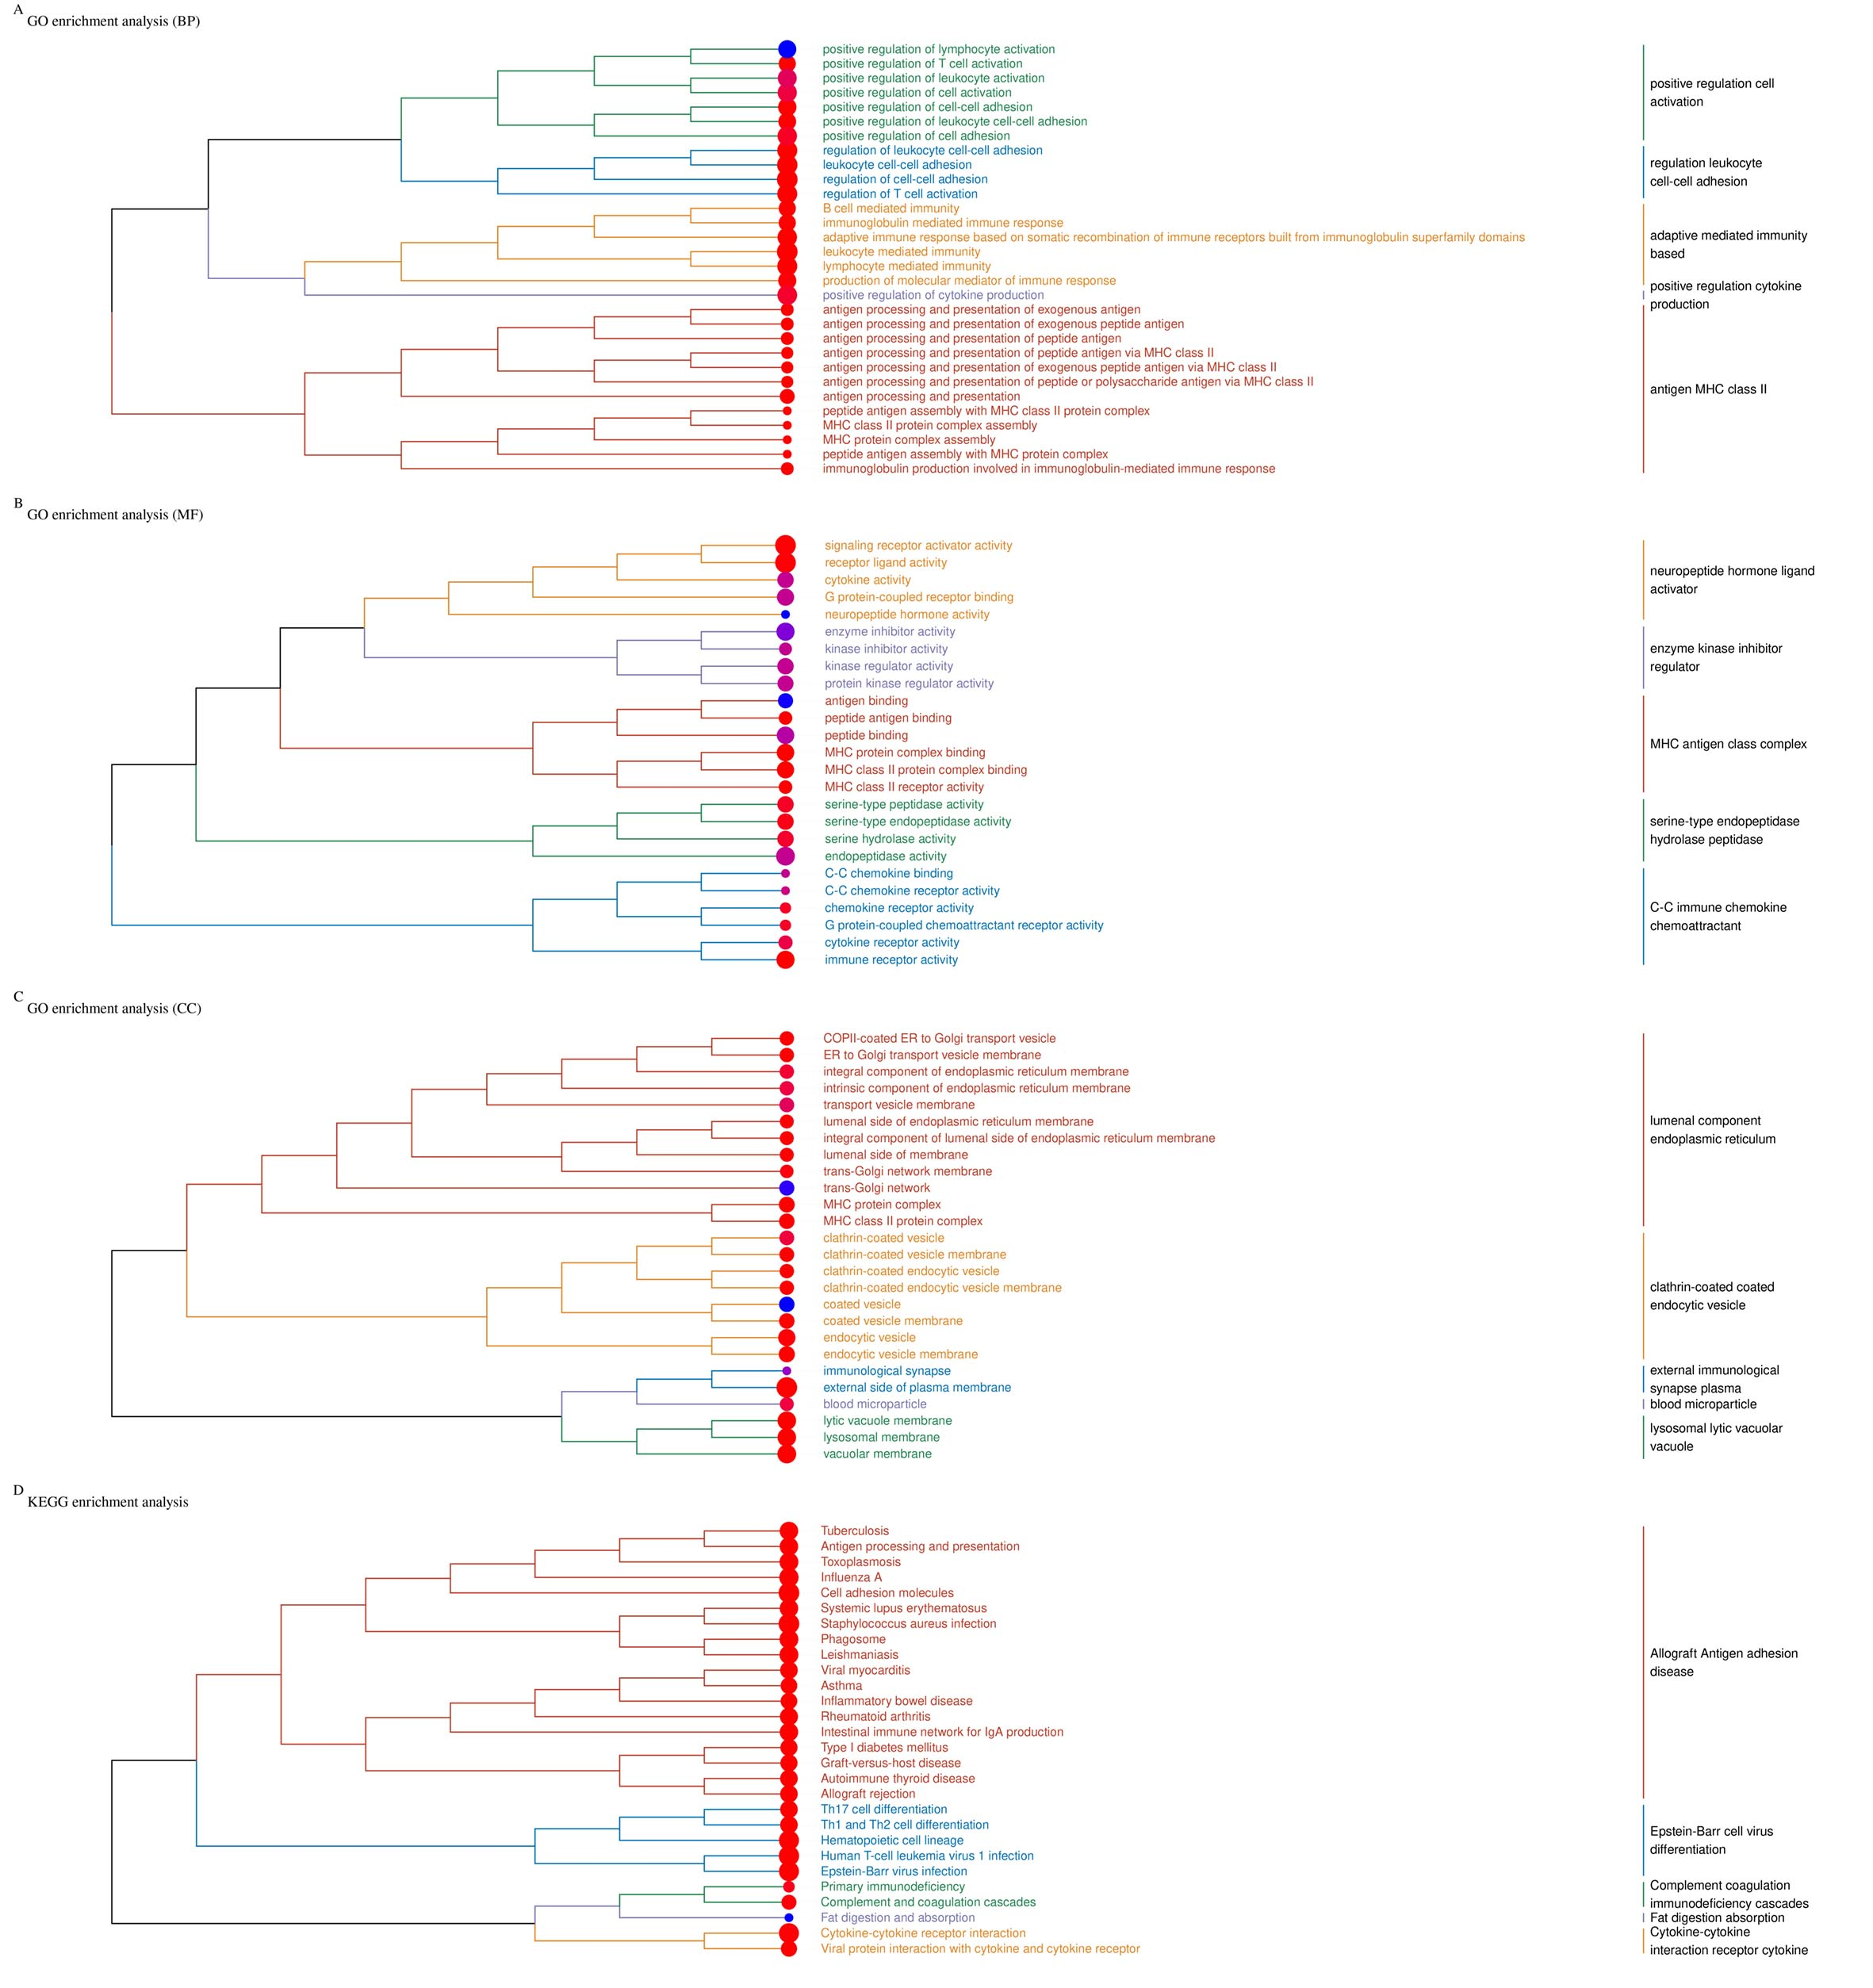
Figure S4, The dendrogram of enrichment analysis according to the DEGs in EBVnGC vs. EBVaGC. From the top to the bottom，the BP, MF, CC and KEGG were listed. The size and color of circles represent gene counts and p-value of each item.

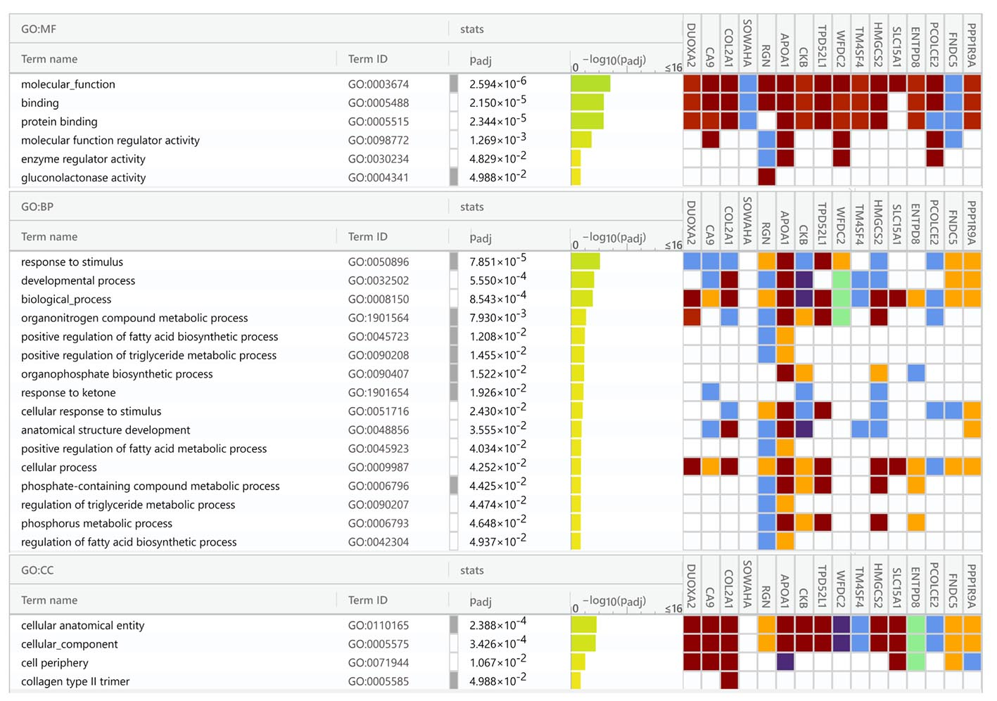
Figure S5, The heatmap of enrichment analysis according to the 16 repeated down-regulated genes in both normal tissue vs. GC tissue and EBVnGC vs. EBVaGC. From the top to the bottom，the BP, MF and CC were listed with a panel shown associated genes.

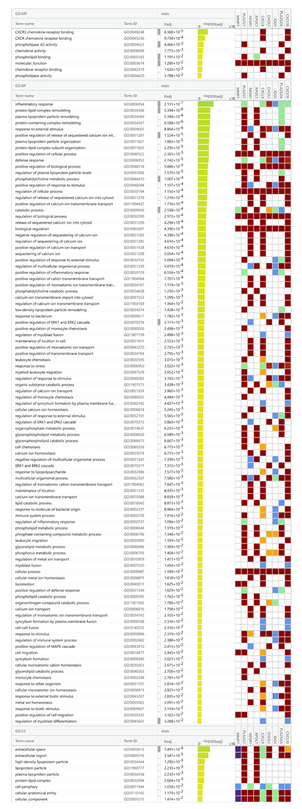
Figure S6, The heatmap of enrichment analysis according to the 9 repeated up-regulated genes in both normal tissue vs. GC tissue and EBVnGC vs. EBVaGC. From the top to the bottom，the BP, MF and CC were listed with a panel shown associated genes.

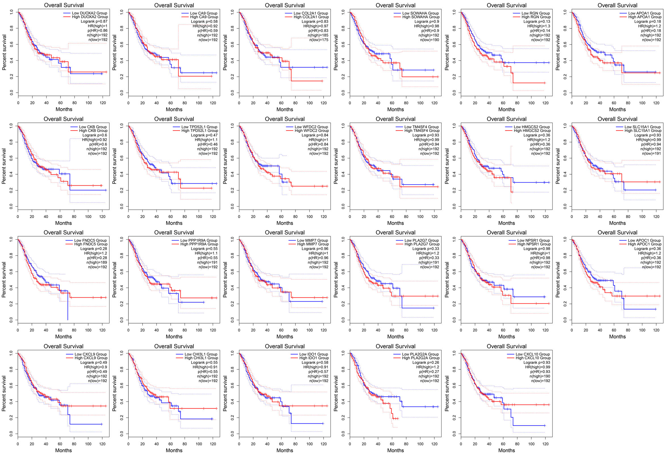
Figure S7, The overall survival curves of other 23 DEGs without significance in GC. The red and blue lines represent the samples with a higher or lower gene level, respectively. The legend was listed on the right.

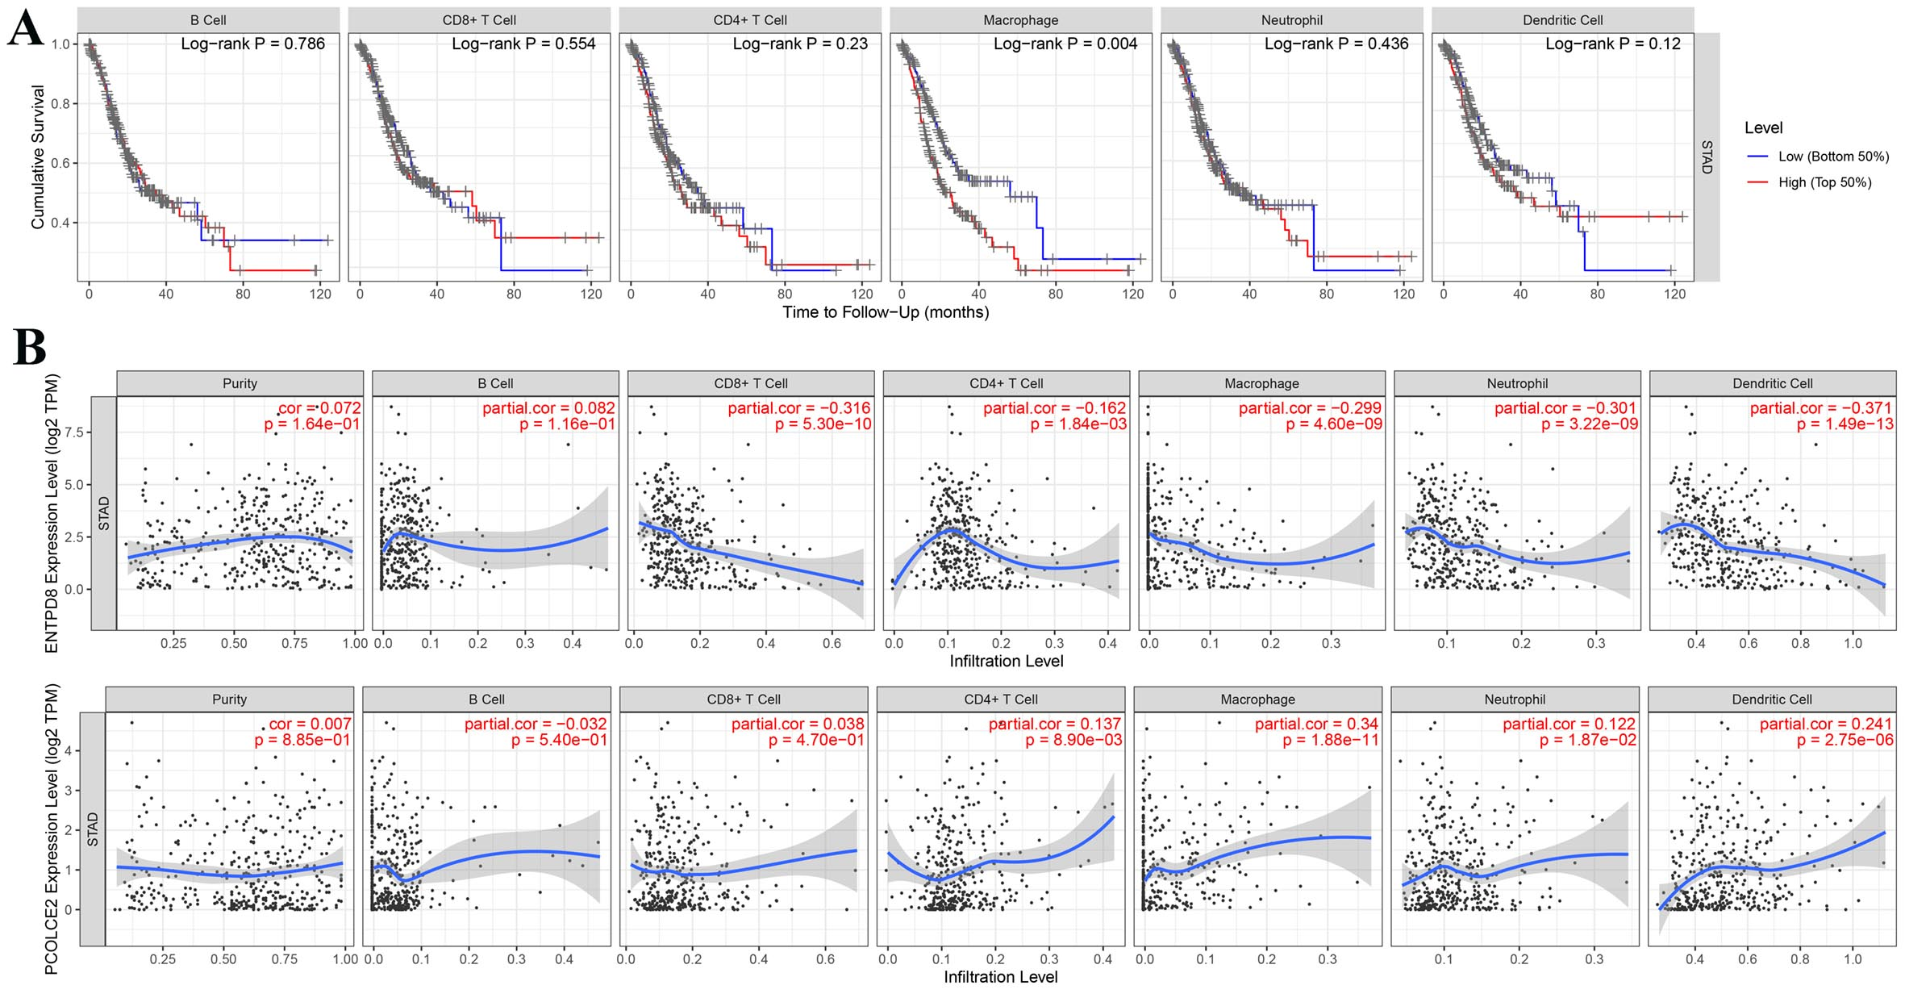
Figure S8, The correlation between immune cell infiltration and ENTPD8/PCOLCE2 expressions. A, The survivorship curves of GC show the correlation between immune cell infiltration and prognosis. The red and blue curves represent the higher or lower level of infiltration. B, The correlation between each infiltration of immune cell and ENTPD8 or PCOLCE2 expression. Each point represents a single GC samples. The blue lines represent the correlation coefficient.

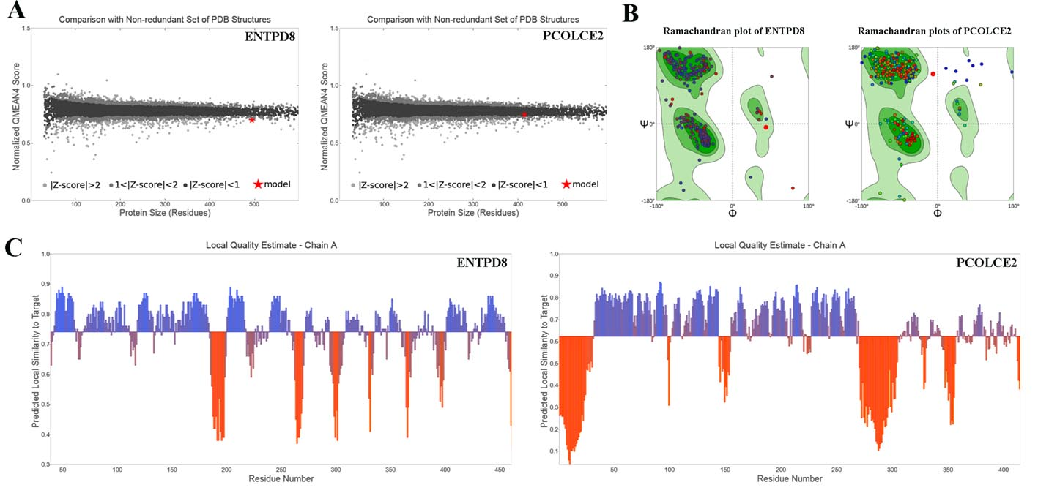
Figure S9, The 3D modeling of protein based on the amino acid sequence of ENTPD8 and PCOLCE2. A, The comparison with non-redundant set of PDB structures. B, Ramachandran plot of ENTPD8 and PCOLCE2. C, The local quality estimate of ENTPD8 and PCOLCE2.

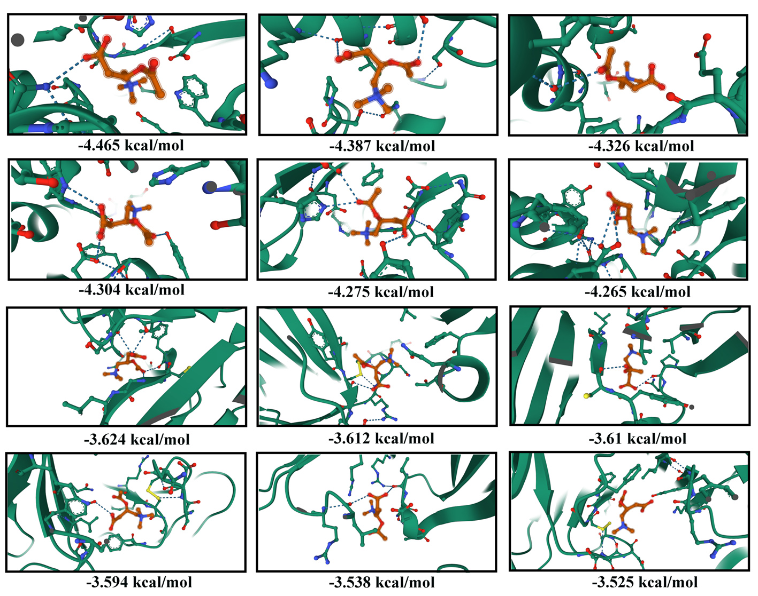
Figure S10, The top 4-9 stable binding modes of BLM to ENTPD8 and PCOLCE2 were shown via cartoon representation, respectively. In the local magnification, the dashed lines represent hydrogen bonds.

