Supplementary Appendix

The effect of preoperative endoscopic tattooing on lymph node retrieval in colorectal cancer: a systematic review and meta-analysis

Supplementary Tables
Title | Page
Supplementary Table 1: Search strategy used in each database searched. | 2
Supplementary Table 2: Quality assessment of the included RCTs in the meta-analysis. | 3
Supplementary Table 3: Quality assessment of the included non-randomized studies in the meta-analysis. | 4

Supplementary Figures:
Title | Page
Supplementary Figure 1: Forest plot for postoperative complications. | 5
Supplementary Figure 2: Forest plot for anastomotic leakage. | 5
Supplementary Figure 2: Forest plot for operative time. | 5

Supplementary Table 1: Search strategy used in each database searched.
Database | Search Strategy | Articles retrieved
PubMed | ("tattooing"[MeSH Terms] OR "tattooing"[All Fields] OR "tattoo"[All Fields] OR "tattoos"[All Fields] OR ("tattoing"[All Fields] OR "tattooed"[All Fields] OR "tattooing"[MeSH Terms] OR "tattooing"[All Fields] OR "tattooings"[All Fields])) AND ("rectal neoplasms"[MeSH Terms] OR ("rectal"[All Fields] AND "neoplasms"[All Fields]) OR "rectal neoplasms"[All Fields] OR ("rectal"[All Fields] AND "cancer"[All Fields]) OR "rectal cancer"[All Fields] OR ("colorectal neoplasms"[MeSH Terms] OR ("colorectal"[All Fields] AND "neoplasms"[All Fields]) OR "colorectal neoplasms"[All Fields] OR ("colorectal"[All Fields] AND "cancer"[All Fields]) OR "colorectal cancer"[All Fields]) OR ("colonic neoplasms"[MeSH Terms] OR ("colonic"[All Fields] AND "neoplasms"[All Fields]) OR "colonic neoplasms"[All Fields] OR ("colon"[All Fields] AND "cancer"[All Fields]) OR "colon cancer"[All Fields])) AND ("lymph nodes"[MeSH Terms] OR ("lymph"[All Fields] AND "nodes"[All Fields]) OR "lymph nodes"[All Fields] OR ("lymph"[All Fields] AND "node"[All Fields]) OR "lymph node"[All Fields]) | 38
Embase | ('tattoo'/exp OR tattoo OR 'tattooing'/exp OR tattooing) AND ('rectal cancer'/exp OR 'rectal cancer' OR (rectal AND ('cancer'/exp OR cancer)) OR 'colorectal cancer'/exp OR 'colorectal cancer' OR (colorectal AND ('cancer'/exp OR cancer)) OR 'colon cancer'/exp OR 'colon cancer' OR (('colon'/exp OR colon) AND ('cancer'/exp OR cancer))) AND ('lymph node'/exp OR 'lymph node' OR (('lymph'/exp OR lymph) AND node)) | 85
Web of Science | ALL=((tattoo OR tattooing) AND (rectal cancer OR colorectal cancer OR colon cancer) AND (lymph node)) | 37

Supplementary Table 2: Quality assessment of the included RCTs in the meta-analysis.
RCTs | Random Sequence Generation (Selection Bias) | Allocation Concealment (Selection bias) | Blinding of Participants and personnel (performance Bias) | Blinding of outcome assessment (detection Bias) | Incomplete outcome data (attrition bias) | Selective Reporting (Reporting Bias)
Cipe, 2016 | + | + | ? | - | + | +
Okada, 2017 | + | + | + | - | + | +
(+) low risk of bias, (-) High risk of bias, (?) Unclear risk of bias

Supplementary Table 3: Quality assessment of the included non-randomized studies in the meta-analysis.
Non-randomized studies | Selection |  |  |  | Comparability | Outcome |  |  | Quality score
Non-randomized studies | Representativeness of the exposed cohort | Selection of non-exposed cohort | Ascertainment of exposure | Demonstration that outcome of interest was not present at start of study | Comparability of the cohorts on the basis of design or analysis | Assessment of outcome | Was follow up long enough for outcomes to occur | Adequacy of follow up cohorts | Quality score
Aldecoa, 2017 | 0 | 1 | 1 | 1 | 1 | 1 | 1 | 1 | 7
Chen, 2019 | 0 | 1 | 1 | 1 | 0 | 1 | 1 | 1 | 6
Dawson, 2010 | 1 | 1 | 1 | 1 | 1 | 1 | 1 | 1 | 8
Feo, 2015 | 1 | 1 | 1 | 1 | 1 | 1 | 1 | 1 | 8
Goo, 2019 | 1 | 1 | 1 | 1 | 0 | 1 | 1 | 1 | 7
Imaoka, 2021 | 1 | 1 | 1 | 1 | 1 | 0 | 1 | 1 | 7
Kang, 2015 | 0 | 1 | 1 | 1 | 1 | 0 | 1 | 1 | 6
Wlodarczyk, 2022 | 1 | 1 | 1 | 1 | 1 | 1 | 1 | 1 | 8

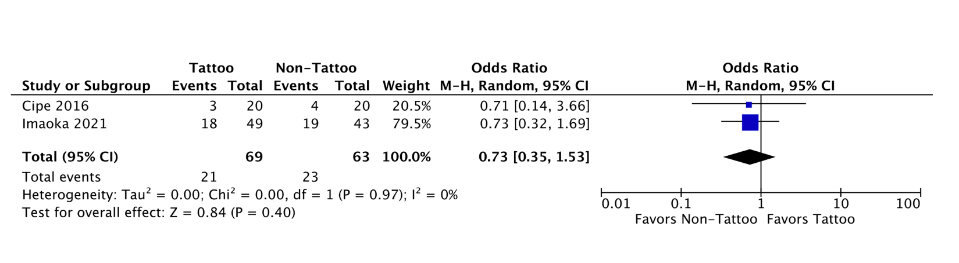
Supplementary Figure 1: Forest plot for postoperative complications.

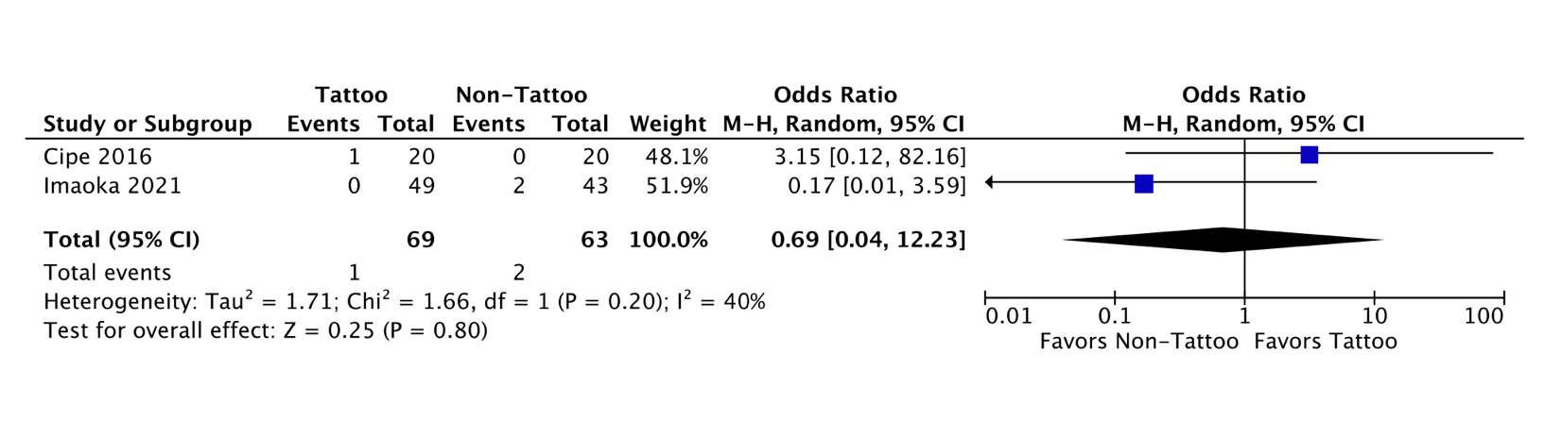
Supplementary Figure 2: Forest plot for anastomotic leakage.

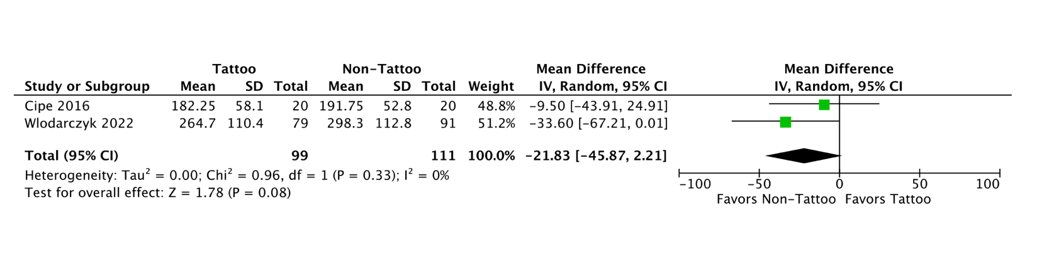
Supplementary Figure 3: Forest plot for operative time.

