Figure S1. Histograms of the distributions of A) filtered Illumina read counts per sample and B) normalized read count per bin relative to the median for each bin. Vertical red line represents the median read count per sample in A
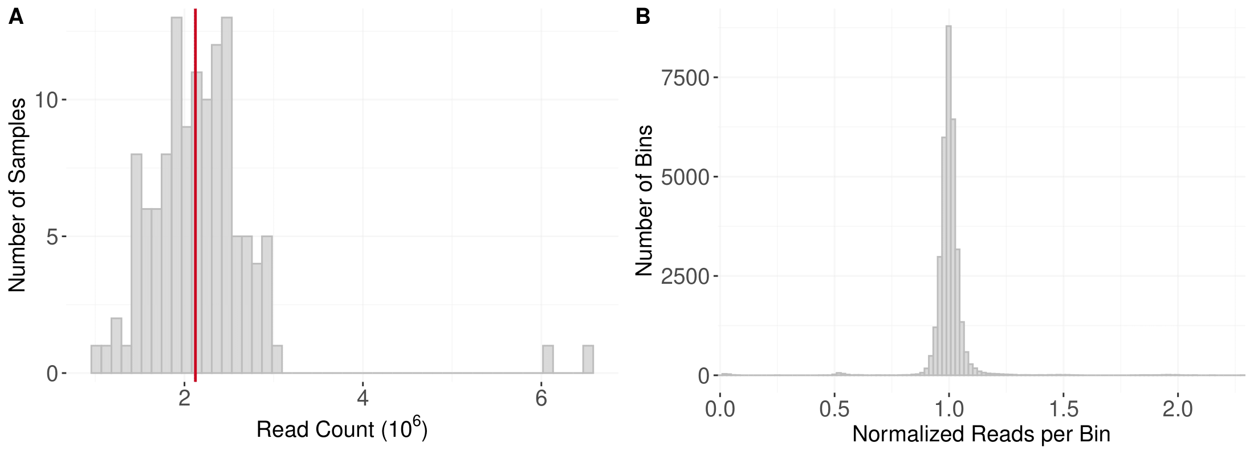

Figure S2. Karyotype plots of parents MN07098-6, CItr 11390, and the 30 aneuploid RILs of the 15xR012 population. Centromeres are represented by black circles. Chromosome copy number is indicated by color
See attachment FigureS2.pdf

Figure S3. Mean linearized infection types to TTRTF of 15xR012 RILs included in phenotypic analysis. Error bars indicate the 95% confidence interval. The red dashed line indicates the threshold for resistance of 6.0
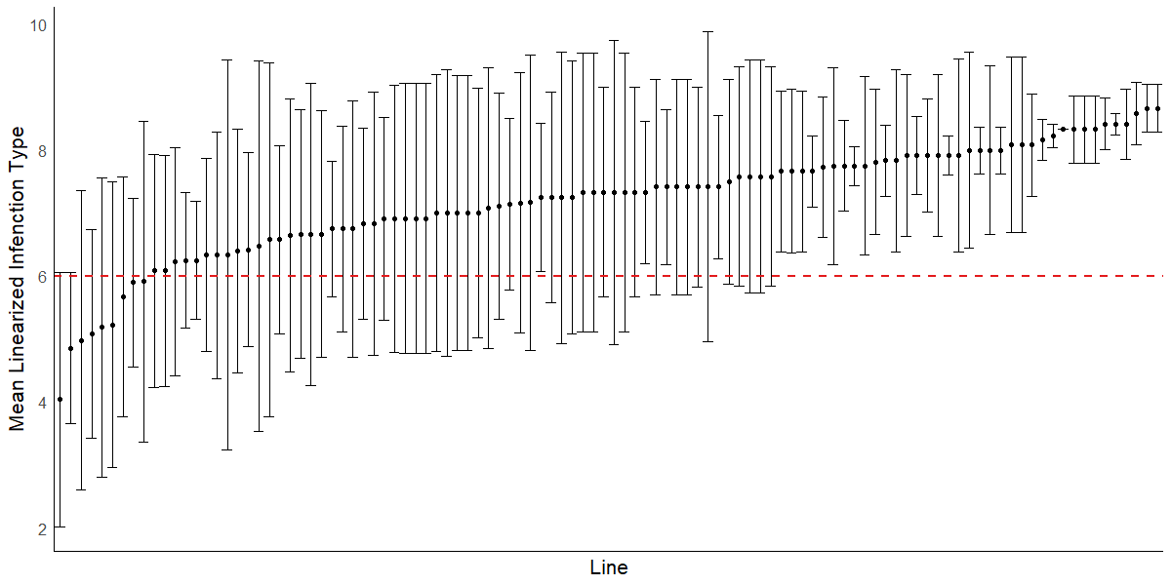

Figure S4. Distribution of linearized infection type (IT) to TKTTF of 15xR012 RILs included in phenotypic analysis. Mean IT of MN07098-6 is represented by the solid line, and that of CItr 11390 is represented by a dashed line
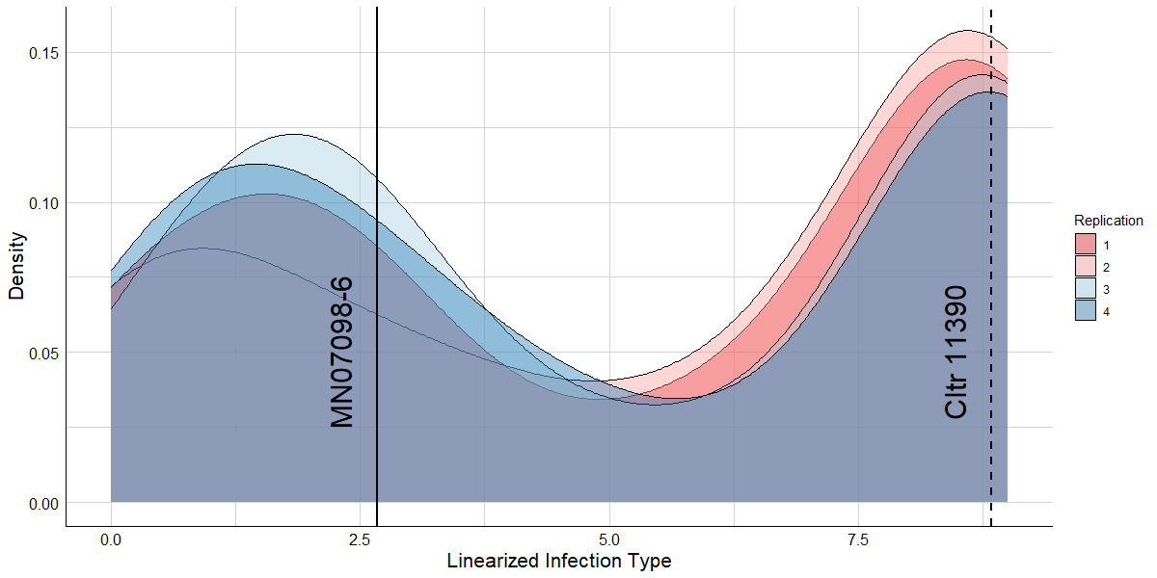

Figure S5. LOD curve of quantitative trait loci (QTL) for seedling resistance to Pgt race TKTTF in the 15xR012 population detected by multiple QTL mapping. The red horizontal line indicates the significance threshold (α = 0.05) determined from 1,000 permutations
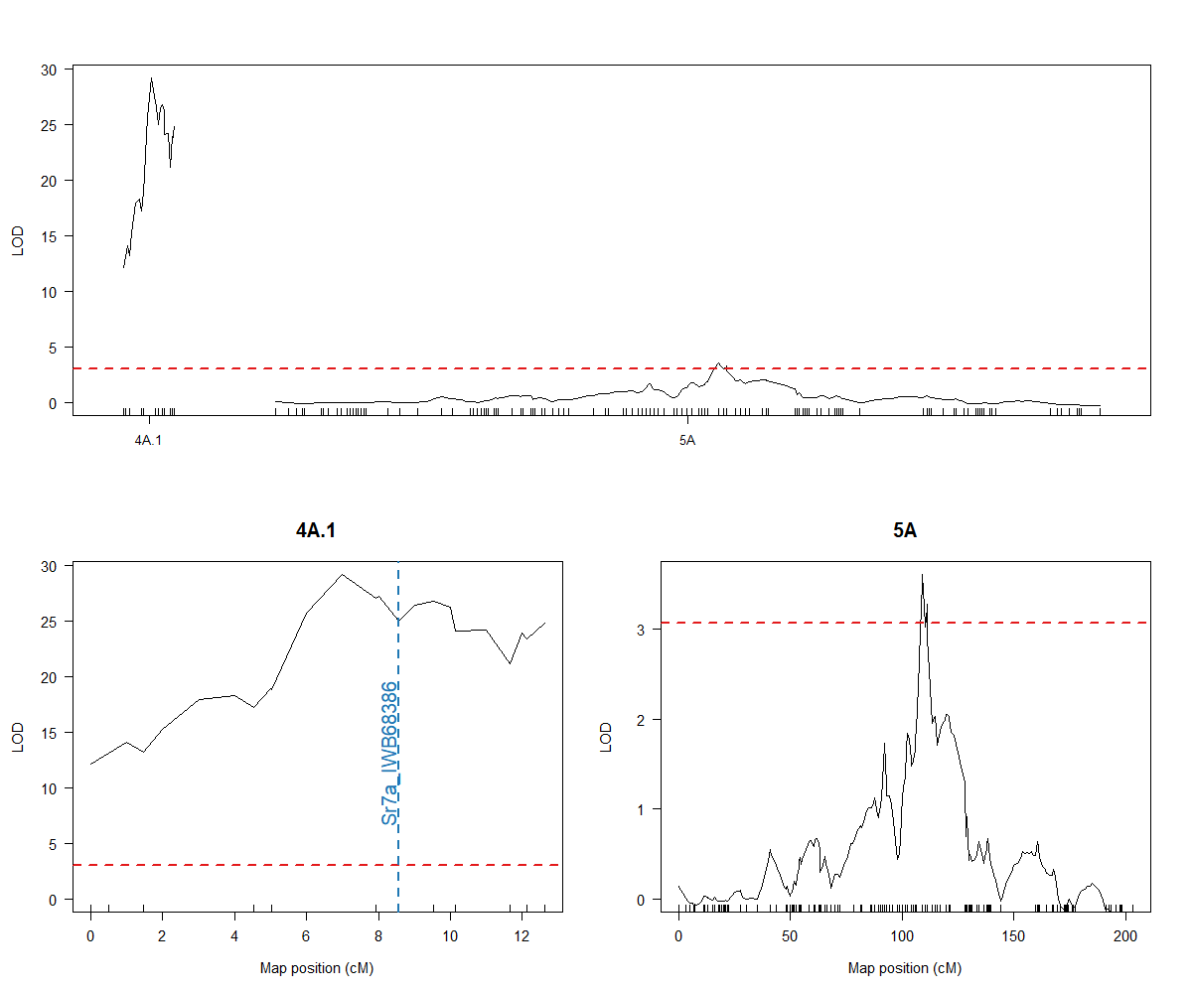

Figure S6. LOD curves of quantitative trait loci (QTL) for field-based stem rust resistance in the 15xR012 population detected by multiple QTL mapping. Horizontal red lines indicate significance threshold (α = 0.05) determined from 1,000 permutations. Eth20 = Debre Zeit, Ethiopia 2020; Ken19 = Njoro, Kenya 2019; Ken20 = Njoro, Kenya 2020
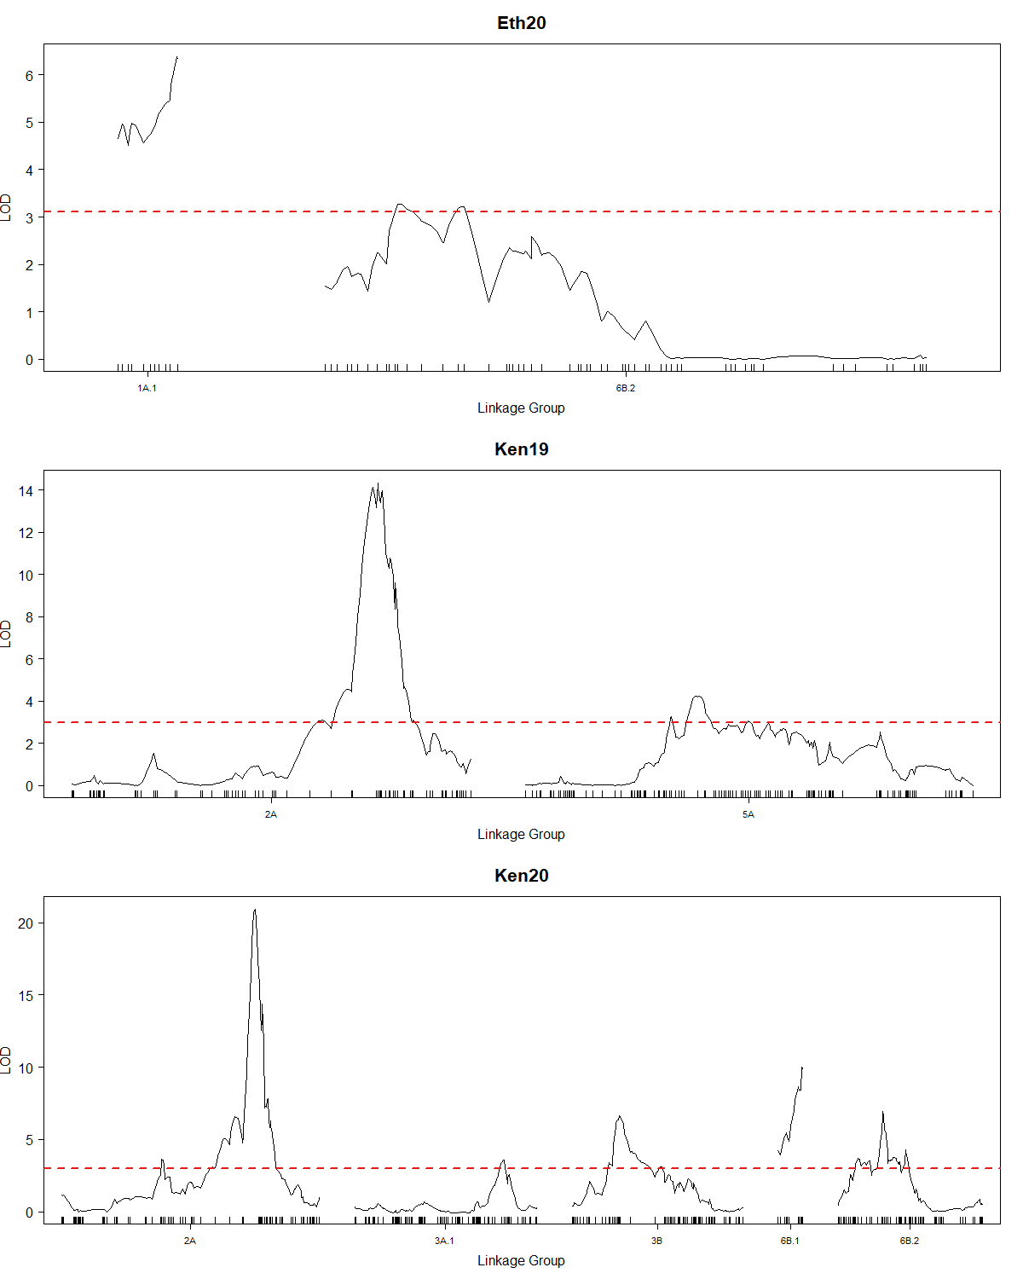
Table S1. Types, designations, chromosome numbers, meiotic pairing configurations of lines with chromosome abnormalities based on in silico aneuploidy detection. Nomenclature is adapted from Kimber and Sears (1968)
Line | Chromosome | Type | Designation | Chromosome Number | Meiotic Pairingª
15xR012-2-1-1-1-1 | 6D | Ditelosomic | Dt6DS | 42 | 20''+t"
15xR012-2-13-1-1-1 | 6A/6D | Nullisomic-Tetrasomic | N6DT6A | 42 | 19"+1""
15xR012-2-15-1-1-1 | 1B | Trisomic | Tri1B | 43 | 20"+1"'
15xR012-2-21-1-1-1 | 1B | Trisomic | Tri1B | 43 | 20"+1"'
15xR012-2-22-1-1-1 | 6D | Monosomic | M6D | 41 | 20"+1'
15xR012-2-30-1-1-1 | 6B/6D | Nullisomic-Tetrasomic | N6DT6B | 42 | 19"+1""
15xR012-2-32-1-1-1 | 6D | Monosomic | M6D | 41 | 20"+1'
15xR012-2-45-1-1-1 | 4B | Monotelodisomic | MtD1BS | 42 | 20"+t1"
15xR012-2-47-1-1-1 | 6D | Monosomic | M6D | 41 | 20"+1'
15xR012-2-49-1-1-1 | 4A/4D | Monosomic-Trisomic | M4DTri4A | 42 | 19"+1"'+1'
15xR012-2-59-1-1-1 | 6D | Monosomic | M6D | 41 | 20"+1'
15xR012-2-62-1-1-1 | 1B | Monosomic | M1B | 41 | 20"+1'
15xR012-2-63-1-1-1 | 6D | Monosomic | M6D | 41 | 20"+1'
15xR012-2-64-1-1-1 | 6A/6D | Nullisomic-Tetrasomic | N6DT6A | 42 | 19"+1""
15xR012-2-68-1-1-1 | 5A | Monoisodisomic | MiD5AS | 42 | 20"+i1"
15xR012-2-71-1-1-1 | 6D | Monosomic | M6D | 41 | 20"+1'
15xR012-2-74-1-1-1 | 7A | Teloisodisomic or Tritelosomic | Dti7AS or Trit7AS | 42 or 43 | 20"+ti" or 20"+t"'
15xR012-2-84-1-1-1 | 6D | Nullisomic | N6D | 40 | 20"
15xR012-2-86-1-1-1 | 4D | Monosomic | M4D | 41 | 20"+1'
15xR012-2-87-1-1-1 | 2B | Monotelotrisomic | MtTri2BL | 43 | 20"+t2"
15xR012-2-89-1-1-1 | 6D | Monosomic | M6D | 41 | 20"+1'
15xR012-2-90-1-1-1 | 6D | Monosomic | M6D | 41 | 20"+1'
15xR012-2-91-1-1-1 | 6D | Monosomic | M6D | 41 | 20"+1'
15xR012-2-92-1-1-1 | 4D | Monosomic | M4D | 41 | 20"+1'
15xR012-2-93-1-1-1 | 6B/6D | Nullisomic-Tetrasomic | N6DT6B | 42 | 19"+1""
15xR012-2-97-1-1-1 | 6A/6D | Nullisomic-Tetrasomic | N6DT6A | 42 | 19"+1""
15xR012-2-107-1-1-1 | 4D | Monosomic | M4D | 41 | 20"+1'
15xR012-2-108-1-1-1 | 6D | Monosomic | M6D | 41 | 20"+1'
15xR012-2-112-1-1-1 | 4B/4D | Nullisomic-Tetrasomic | N4DT4B | 42 | 19"+1""
15xR012-2-121-1-1-1 | 6D | Monosomic | M6D | 41 | 20"+1'
ª ', ", "' and "" indicate univalent, bivalent, trivalent, and quadrivalent, respectively.

Table S2. Raw mean values, standard deviations, and ranges of stem rust severity (%) in the 15xR012 mapping population in four field environments
Environmentsª | Parent mean coefficient of severity |  | Population
 | CItr 11390 | MN07098-6 | Mean ± SD | Range
Eth19 | 60.0 | 60.0 | 58.5 ± 3.1 | 45.0-60.0
Eth20 | 40.0 | 65.0 | 59.3 ± 12.2 | 30.0-80.0
Ken19 | 10.0 | 60.0 | 48.4 ± 19.3 | 5.0-90.0
Ken20 | 17.5 | 75.0 | 50.1 ± 16.0 | 15.0-100
ª Eth19 = Debre Zeit, Ehtiopia 2019; Eth20 = Debre Zeit, Ethiopia 2020; Ken19 = Njoro, Kenya 2019; Ken20 = Njoro, Kenya 2020
Table S3. Raw mean values, standard deviations, and ranges of stem rust linearized infection response in the 15xR012 mapping population in four field environments
Environmentsª | Parent mean linearized infection response |  | Population
 | CItr 11390 | MN07098-6 | Mean ± SD | Range
Eth19 | 1.00 | 0.97 | 1.00 ± 0 | 1.00-1.00
Eth20 | 1.00 | 1.00 | 1.00 ± 0.02 | 0.80-1.00
Ken19 | 0.24 | 0.70 | 0.68 ± 0.20 | 0.27-1.00
Ken20 | 0.47 | 1.00 | 0.77 ± 0.22 | 0.40-1.00
ª Eth19 = Debre Zeit, Ehtiopia 2019; Eth20 = Debre Zeit, Ethiopia 2020; Ken19 = Njoro, Kenya 2019; Ken20 = Njoro, Kenya 2020
Table S4. Quantitative trait loci for field-based stem rust resistance and seedling resistance to TKTTF in the 15xR012 population detected by a single-QTL and two-dimensional genomes scan using multiple imputation
Environment/Raceª | QTL^{b} | Chr | Flanking markers^{c} |  | Pos (cM) | LOD^{d}
 |  |  | Left | Right
Eth20 | QSr.umn-1A | 1AS | S1A_5849745 | S1A_15479164 | 10.0 | 6.4
 | QSr.umn-6BL | 6BL | S6B_467576061 | S6B_675524521 | 13.0 | 3.3
Ken19 | QSr.umn-2A | 2AL | S2A_681051011 | S2A_702504398 | 136.0 | 12.3
 | QSr.umn-6BL | 5AL | S6B_591308578 | S6B_704385489 | 44.4 | 3.3
Ken20 | QSr.umn-2A | 2AL | S2A_681051011 | S2A_693852557 | 137.0 | 10.6
 | QSr.umn-6BL | 6BL | S6B_553365830 | S6B_696156316 | 44.4 | 3.4
TKTTF | QSr.umn-4A | 4AL | S4A_720268179 | Sr7a_IWB12146 | 7.0 | 26.5
ª Eth20 = Debre Zeit, Ethiopia 2020; Ken19 = Njoro, Kenya 2019; Ken20 = Njoro, Kenya 2020
^{b} Named according to McIntosh et al. (2020)
^{c} 95% Bayes credible interval
^{d} Peak logarithm of odds

Table S5. Comparison of adjusted square root of stem rust coefficients of infection of 15xR012 RILs carrying each pairwise combination of QSr.umn-2A and QSr.umn-6BL in the Ken20 environment. QTL combinations that do not share letters (a, b, and c) following mean CI values are significantly different based on Tukey’s HSD test
QTL Combination | Number of RILs | Adjusted $\sqrt{\text{Coefficient} \text{of} \text{Infection}}$ (Mean ± SD) | R²
No QTL | 21 | 8.2 ± 0.6ª | -
QSr.umn-6BL | 33 | 7.3 ± 0.8^{b} | 16.2
QSr.umn-2A | 22 | 6.4 ± 0.9^{c} | 44.6
QSr.umn-2A + QSr.umn-6BL | 28 | 6.4 ± 0.8^{c} | 10.9

Table S6. Multi-environment comparison of unadjusted stem rust coefficients of infection of 15xR012 RILs carrying each pairwise combination of Sr63 and QSr.umn-6BL. QTL combinations within an environment that do not share letters (a, b, c, d, e, and f) following mean CI values are significantly different based on Tukey’s HSD test
QTL Combination | Number of RILs | Coefficient of Infection (Mean ± SD) |  |  | Mean
 |  | Eth20 | Ken19 | Ken20
No QTL | 18 | 67.8 ± 8.6ª | 57.1 ± 21.1ª | 63.8 ± 9.4ª | 62.9
Sr57 | 11 | 60.9 ± 8.6^{abc} | 47.9 ± 12.6^{ab} | 44.9 ± 14.5^{bcd} | 51.2
Sr63 | 11 | 64.1 ± 9.7^{ab} | 34.7 ± 20.0^{bcd} | 47.0 ± 16.1^{bc} | 48.6
QSr.umn-6BL | 10 | 60.5 ± 6.0^{abc} | 41.5 ± 12.6^{abc} | 61.9 ± 16.1^{ab} | 64.6
Sr57 + Sr63 | 6 | 51.7 ± 8.8^{bc} | 19.1 ± 6.1^{cd} | 23.9 ± 14.9^{ef} | 34.9
Sr57 + QSr.umn-6BL | 15 | 56.8 ± 7.5^{bc} | 37.5 ± 17.8^{bc} | 29.8 ± 13.9^{def} | 41.4
Sr63 + QSr.umn-6BL | 17 | 56.7 ± 9.0^{bc} | 22.8 ± 8.7^{cd} | 35.6 ± 10.8^{cde} | 38.4
Sr57 + Sr63 + QSr.umn-6BL | 16 | 52.0 ± 9.2^{c} | 17.4 ± 10.3^{d} | 18.5 ± 8.4^{f} | 29.3

Table S7. Primer sequences for PACE™ SNP genotyping assays designed within the 95% Bayes credible interval of QSr.umn-6BL. HEX and FAM tail sequences are italicized
Marker | Resistant allele (HEX) | Susceptible allele (FAM) | Common primer
PACE_S6B_655795233 | GAAGGTCGGAGTCAACGGATTGTGACGAGCTGGTGCTCCTGT | GAAGGTGACCAAGTTCATGCTGACGAGCTGGTGCTCCTGC | GAAGGAATGAGTTCGTTGCAGGCTA
PACE_S6B_675524532 | GAAGGTCGGAGTCAACGGATTCGCGAACATACCCGCTCTCG | GAAGGTGACCAAGTTCATGCTGCGCGAACATACCCGCTCTCA | CGGCGGCGGCGCGGGAAA

Table S8. SNP genotyping calls for a subset of RILs with PACE™ assays at the loci flanking the 95% Bayes credible interval of QSr.umn-6BL
 |  |  |  | Phenotypic Rank among all RILs (n = 104)
Line | QSr.umn-6BL^{ab} | PACE_S6B_655795233ª | PACE_S6B_675524532ª | Ken19^{cd} | Ken20^{cd} | TKTTF^{e}
MN07098-6-Lr34 | 0 | 0 | 0
CItr 11390 | 1 | 1 | 1
15xR012-2-35-1-1-1 | 1 | 1 | 1 | 50 | 20 | 16
15xR012-2-48-1-1-1 | 1 | 1 | 1 | 10 | 57 | 37
15xR012-2-55-1-1-1 | 1 | 1 | 1 | 13 | 41 | 35
15xR012-2-56-1-1-1 | 1 | 1 | 1 | 17 | 19 | 12
15xR012-2-65-1-1-1 | 1 | 1 | 1 | 1 | 3 | 71
15xR012-2-70-1-1-1 | 1 | 1 | 1 | 6 | 16 | 24
15xR012-2-79-1-1-1 | 0 | 0 | 0 | 4 | 12 | 9
15xR012-2-103-1-1-1 | 1 | 1 | 1 | 8 | 2 | 21
15xR012-2-109-1-1-1 | 1 | 1 | 1 | 16 | 14 | 10
15xR012-2-111-1-1-1 | 1 | 1 | 1 | 3 | 1 | 6
15xR012-2-117-1-1-1 | 1 | 1 | 1 | 2 | 4 | 63
ª 1 = homozygous for resistant allele; 0 = homozygous for susceptible allele
^{b} Genotypes at the peak genotyping-by-sequencing SNP of the QTL
^{c} Ken19 = Njoro, Kenya 2019; Ken20 = Njoro, Kenya 2020
^{d} Rankings assigned according to the raw coefficient of infection values
^{e} Rankings assigned according to linearized infection types calculated from the mean of four replications

 |  |  |  |  | Phenotypic Rank among all RILs (n = 104)
Line | KASP_IWB68386 (Sr7a)ª | wMAS000003 (Sr57/Lr34/Yr18)ª | KASP_IWB32429 (Sr63)ª | QSr.umn-6BL^{ab} | Ken19^{cd} | Ken20^{cd} | TKTTF^{e}
MN07098-6-Lr34 | 1 | 1 | 0 | 0 | - | - | -
CItr 11390 | 0 | 0 | 1 | 1 | - | - | -
15xR012-35 | 1 | 1 | 1 | 1 | 50 | 20 | 16
15xR012-48 | 1 | 0 | 1 | 1 | 10 | 57 | 37
15xR012-55 | 1 | 0 | 1 | 1 | 13 | 41 | 35
15xR012-56 | 1 | 0 | 1 | 1 | 17 | 19 | 12
15xR012-65 | 0 | 1 | 1 | 1 | 1 | 3 | 71
15xR012-70 | 1 | 0 | 1 | 1 | 6 | 16 | 24
15xR012-79 | 1 | 1 | 1 | 0 | 4 | 12 | 9
15xR012-103 | 1 | 1 | 1 | 1 | 8 | 2 | 21
15xR012-109 | 1 | 0 | 1 | 1 | 16 | 14 | 10
15xR012-111 | 1 | 1 | 1 | 1 | 3 | 1 | 6
15xR012-117 | 0 | 1 | 1 | 1 | 2 | 4 | 63
Table S9. The subset of 11 RILs from the 15xR012 population that carry at least three of four stem rust resistance alleles at Sr7a, Sr57/Lr34/Yr18, Sr63, and QSr.umn-6BL. The phenotypic ranks of each RIL in the Ken19 and Ken20 nurseries among the entire population, as well as linearized infection type to race TKTTF, are presented for each RIL
ª 1 = homozygous for resistant allele; 0 = homozygous for susceptible allele
^{b} Genotypes at the peak genotyping-by-sequencing SNP of the QTL
^{c} Ken19 = Njoro, Kenya 2019; Ken20 = Njoro, Kenya 2020
^{d} Rankings assigned according to the raw coefficient of infection values
^{e} Rankings assigned according to linearized infection types calculated from the mean of four replications

