Conspecific interactions predict social transmission of fear in female rats
Sydney-O. Seese*, Carolyn-E. Tinsley*, Grace Wulffraat, J. Gregory Hixon,
Marie-H. Monfils

* These two authors contributed equally to this work and share first authorship

Supplementary Figures p2-p6

Contact Information:
Marie H. Monfils
marie.monfils@utexas.edu

The University of Texas at Austin
Department of Psychology
108 E. Dean Keeton Stop A8000
Austin, TX 78712-1043

Social Determination of Dominance - Social Interactions

Not all cages had clear dominance assignments, as determined by nape contacts received and response to nape contacts. Cages 7 and 12 demonstrated unclear assignments, with no clear dominant arising in Cage 12 and Cage 7 having unclear S2 and S1 roles based on nape contacts initiated and received. In addition, Cage 1 was removed from consideration for all analyses, as the S1 role was fear conditioned instead of the D or S2 role. Please note, Cage 12 has 2 points on the S2 bin due to the subordinate ranking uncertainty. A potential future direction is to have a larger group of female cages and evaluate a greater number of inconsistent cages for individual characteristics that make the hierarchy unique (such as indistinct estrus phases).

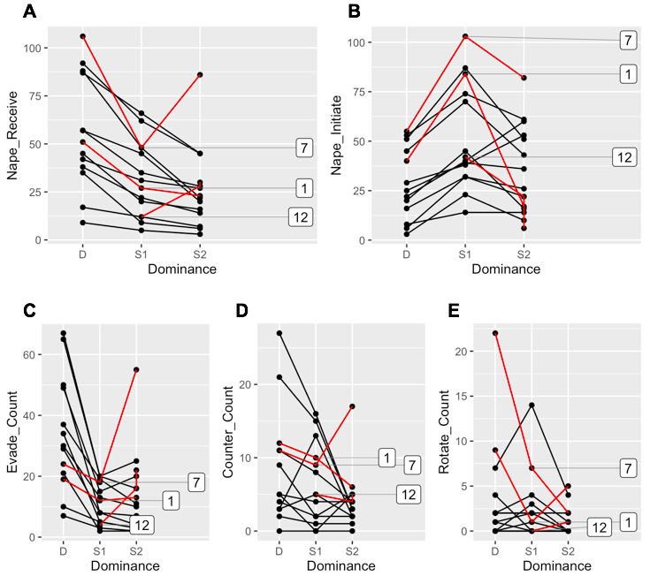
Figure S1: Cages 1, 7, and 12 were removed from play behavior analysis due to unclear dominance hierarchy. Cages 1, 7 and 12 were removed from Fear Conditioning by Proxy analysis due to inconsistent demonstrator/observer assignment. A: number of nape contacts received by each member of the cage triad. B: number of nape contacts initiated by each member of the cage triad. C: number of evasions by each member of the cage triad. D: number of counterattacks shown by each member of the cage triad. E: number of rotations shown by each member of the cage triad.

Effect of Social Rank Cue on Conditioned Freezing

Cue did appear to have an effect on freezing behavior in the fear conditioning by proxy (FCbP) condition in both males and females. Freezing to the first cue, in both males and females, was reduced compared to Cues 2 and 3. This increase was stable in females between cues 2 and 3. In males, the increase appeared to affect S2 males first at Cue 2, then D males at Cue 3. As such, it seems that for both males and females, conditioning by-proxy intensified throughout the session.
Importantly, the male data presented below and in the main paper are selected for male demonstrators and observers that were only S2 and D. These males either went through fear conditioning (FC), or were fear conditioned by proxy (FCbP). The remaining S1 males are only presented if they were in the no fear conditioning group (NFC). As such, even though the subject pool was larger for males (with S1 males going through FC and FCbP, as well as D and S2 males going through NFC), we are providing a reduced subject number for the sake of comparison with the female group, including only observers (fear conditioned by proxy) that were S2 and D as well as demonstrators (directly fear conditioned) that were S2 and D, with S1 males as the no fear conditioning group.

Figure S2 (A): CS freezing at LTM in females
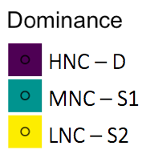
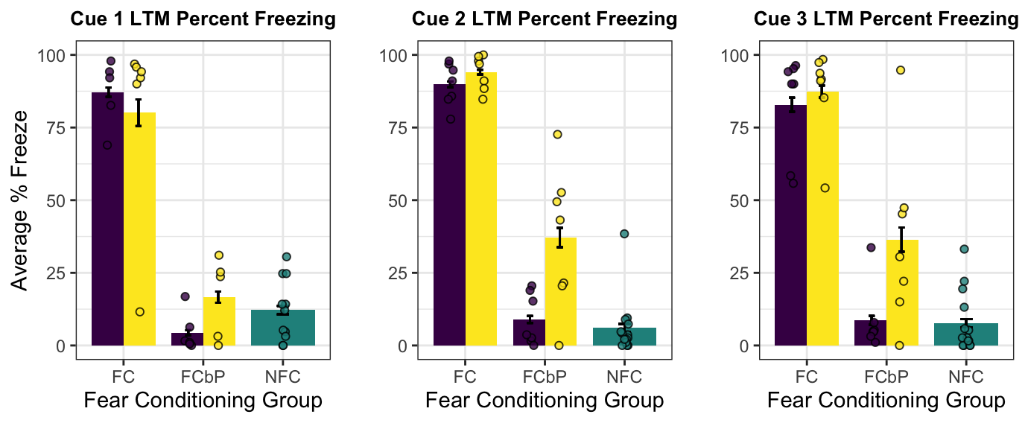
Figure S2 (B): CS Freezing at LTM in males.
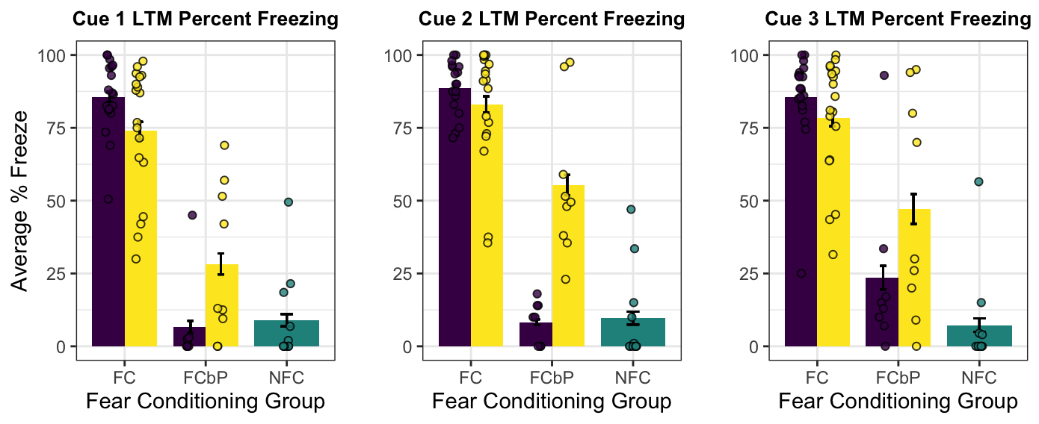
Figure S2 (A): Mean CS freezing by all females based on social rank and number of cue presentations (three conditioned stimuli were presented total during the LTM test). Figure S2 (B): Mean CS freezing by a subset of all males tested (including only demonstrators and observers who were S2 or D and only S1 NFC subjects) based on social rank and number of cue presentations.

Effect of Sex on Nape Contacts Initiated and Received

Literature has long supported that males have a higher frequency play behavior than females once puberty is reached [Meaney & Stewart 1981]. This was demonstrated in our data as well, with males showing significantly more nape contacts that were received during play and a trend towards more nape contacts initiated during play [initiated: $χ^{2}\left(1\right)= 3.17, p=0.075$, received: $χ^{2}\left(1\right)= 13.83, p=2.01e-04$]. These findings are plotted below.

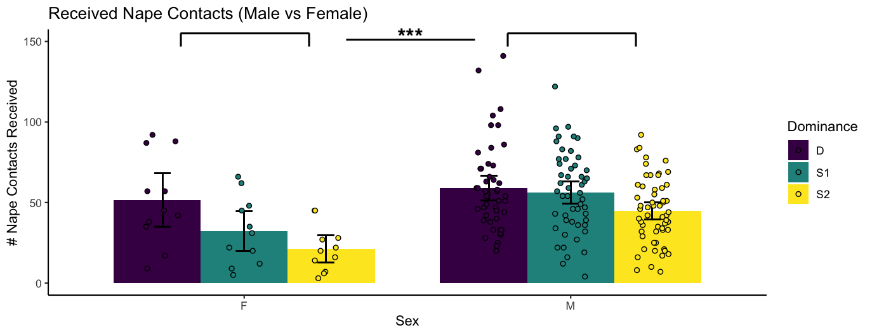
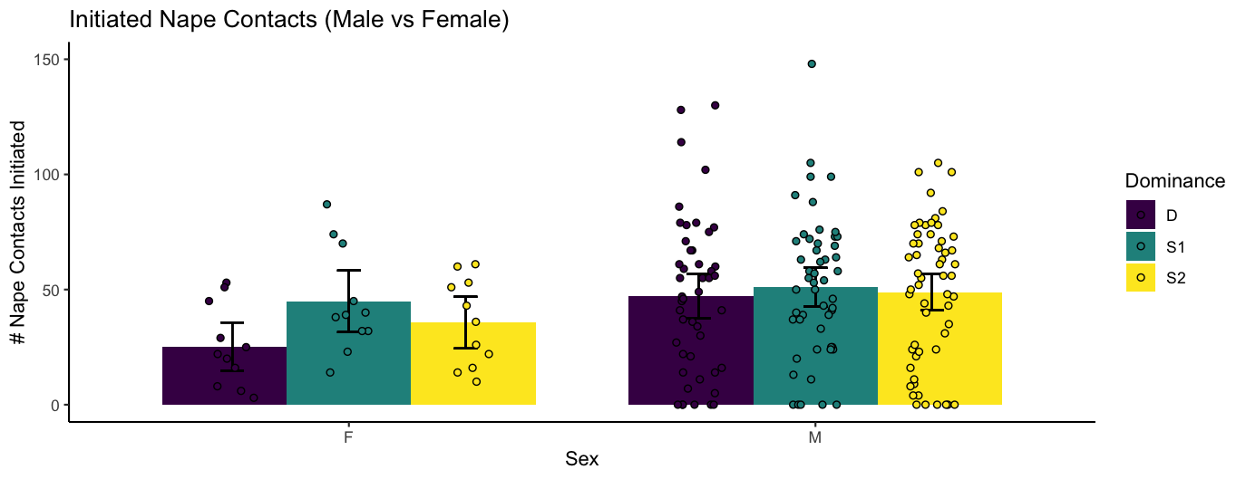
Figure S3 (Top): Number of nape contacts received in male and female cages based on dominance status (as assigned by HNC – D, MNC – S1, LNC – S2). Males had significantly more nape contacts received than females, perhaps indicating greater play frequency.
Figure S3 (Bottom): Number of nape contacts initiated in male and female cages based on dominance status (as assigned by HNC – D, MNC – S1, LNC – S2). Males showed a trend towards significantly more nape contacts initiated than females.
Methods for Scoring Play Behaviors

Table S1. Social Behaviors Scored During Dominance Tests
Descriptions of offensive and defensive behaviors tallied across three social interaction sessions.

